CHEMICAL ENGINEERING TRANSACTIONS  VOL. , 2023 | A publication of
The Italian Association
of Chemical Engineering
Online at www.cetjournal.it

Guest Editor: Sauro Pierucci
Copyright © 2023, AIDIC Servizi S.r.l.
ISBN 978-88-95608-98-3; ISSN 2283-9216

Viscosity modelling of Deep Eutectic Solvents via the use of a Residual-entropy Scaling
Donaldo Pereda-Cruz, Ricardo Macías-Salinas*
SEPI ESIQIE, Instituto Politécnico Nacional Ave., Zacatenco, Gustavo A. Madero, Mexico City, 07738.
*rms@ipn.mx
To best of our knowledge, we presently introduce, for the first time, the use of the residual-entropy scaling approach to adequately represent the dynamic viscosity of deep eutectic solvents (DESs) as a function of temperature and density. In this regard, various unreduced and reduced viscosity forms (total viscosity, Rosenfeld, and dilute gas) were tested and compared. The use of a cubic Equation of State (Cubic EoS: Soave-Redlich-Kwong, SRK or Peng-Robinson, PR) served here to provide sufficiently accurate residual entropy data needed by the present scalings. The resulting modeling approach was successfully validated by representing experimental dynamic viscosity data taken from the literature of three of the most representative choline chloride (ChCl) based deep eutectic solvents (DESs): ChCl:Urea(1:2), ChCl:Ethylene Glycol(1:2), and ChCl:Glycerol(1:2). The validation was conducted within a temperature range varying from 10 to 100 °C and at pressures ranging from 1 to 1,000 bar.
  - Introduction
Deep eutectic solvents (DES), also named by some authors as low transition temperature mixtures (Francisco et al., 2012), low melting mixtures (Imperato et al., 2005) and deep eutectic ionic liquids (Jhong et al., 2009) (LTTM, LMM, DEIL), are generally defined as a combination of two species: a salt (a hydrogen bond acceptor, HBA) and a hydrogen bond donor (HBD). This type of solvents gets its name from the fact that, when these two species are mixed in a certain molar ratio and heated to a moderate temperature, form a transparent liquid (Smith et al., 2014) with hues ranging from white to amber (Hansen et al., 2020). The resulting liquid has a melting point considerably lower than those of its individual constituents in the mixture. Generally, DES have important characteristics such as biodegradability, low toxicity (Morrison et al., 2009), near-zero vapor pressure (Earle et al., 2006) and low production cost, which make them ideal as replacements for some conventional solvents. Moreover ChCl-Based DES are biocompatible (Singh et al., 2012) and widely used due to their availability and low cost. These solvents are among the few that can be prepared without the need for purification and low energy cost. DES have been used in a variety of applications due to the aforementioned physicochemical properties. In metallurgy, metal salts exhibit high solubilities and electrical conductivities in DES, making them ideal for recycling and extraction of metals in solution, as well as for electroplating and mineral refining (Bernasconi et al., 2017). In addition, DES have also been applied in gas separation and capture, battery and power systems technologies, biocatalysis and organic chemistry, biomass processing, genomics, pharmaceutical and medical research, and nanomaterial synthesis (Hansen et al., 2020). Given their favorable physicochemical properties and the range of potential applications, the number of DES-related publications has steadily increased since their first mention in 2004 and is expected to continue growing in the future, as it can be seen in Figure 1, according to Web of Science. The growing use of DES in various fields of research will foster the development of new applications and may result in new technological advancements. Aiming to provide tools that encourage their implementation in different applications, a dynamic viscosity model for Deep Eutectic Solvents based on a residual-entropy scaling approach is proposed, as this property is key for the design and analysis of chemical processes.
Figure 1: Increase in the number of DES-related publications per year.
  - Modelling approach
Originally proposed by Rosenfeld (1977), residual-entropy scaling is a thermodynamic approach on the relation of transport properties and the internal entropy of a system. In this work, the use of such approach was tested for complex fluids such as DES. If $S\left(ρ,T\right)$ is the entropy of a system, the residual entropy, also known as departure entropy or excess entropy $S^{res}\left(ρ,T\right)$, is defined as the difference between the entropy of the system and the entropy of an ideal gas at the same temperature ($T$) and density ($ρ$), $S^{id}(ρ,T)$ (Dehlouz et al., 2021), this can be expressed by the following equation:
$$S^{res}\left(ρ,T\right)=S\left(ρ,T\right)-S^{id}(ρ,T)$$ | (1)
Residual-entropy scaling for dynamic viscosity can be described by the following equation (Rosenfeld, 1977):
$$\tilde{η}=\frac{η}{η^{R}}=f\left(-\frac{S^{res}\left(ρ,T\right)}{R}\right)$$ | (2)
Where $\tilde{η}$ is the reduced dynamic viscosity, $η$ is the unreduced dynamic viscosity, $η^{R}$ is a reference viscosity, $R$ is the gas constant, $f$ is an applicable scaling function and $S^{res}\left(ρ,T\right)$ is the residual entropy. The residual entropy can be calculated with the aid of an Equation of State. Indeed, the Equation of State capabilities for estimating this property will impact on the quality of the scaling.
For the sake of keeping the model simplicity, two cubic Equations of State were used: SRK and PR. For a pressure-explicit cubic Equation of State, a residual entropy equation can be obtained with the following expression (Olivera-Fuentes et al., 1991):
$$S^{res}\left(ρ,T\right)=\int_{∞}^{v}{\left[{\left(\frac{∂P}{∂T}\right)}_{v}-\frac{R}{v}\right]dv}$$ | (3)
Therefore, a shared equation for calculating residual entropy with both SRK and PR Equations of State is presented below:
$$S^{res}\left(ρ,T\right)=-\frac{da}{dT}\frac{1}{b\left(δ_{1}-δ_{2}\right)}\ln\left(\frac{1+bρδ_{2}}{1+bρδ_{1}}\right)-R\ln\left(\frac{1}{1-bρ}\right)$$ | (4)
Where the values of $δ_{2}$ and $δ_{1}$ define which Equation of State is being used (PR EoS: $δ_{1}=1+\sqrt{2}$, $δ_{2}=1-\sqrt{2}$, SRK EoS: $δ_{1}=1$, $δ_{2}=0$), $ρ$ is the molar density and $b$ and $\frac{da}{dT}$ are the co-volume term and the derivative of the attraction term, respectively, for the chosen Equation of State.
Regarding the use of a reference viscosity, three reduced viscosity variations were used: the reduced form originally proposed by Rosenfeld, the use of the Chung et al. variation of the Chapman-Enskog dilute gas equation as reference viscosity (Poling et al., 2001), and an unreduced form ($η^{R}=1$).
The Rosenfeld reference viscosity can be expressed as follows:
$$η^{R}=η_{R}=ρ_{M}^{\frac{2}{3}}\sqrt{mk_{B}T}$$ | (5)
Where $ρ_{M}$ is the molecular density, $m$ is the molecular mass, $k_{B}$ is the Boltzmann constant and $T$ is an absolute temperature.
Meanwhile, the Chung et al. variation of the Chapman-Enskog dilute gas equation can be expressed as follows (Poling et al., 2001):
$$η^{R}=η_{CE}=40.785\frac{F_{c}\sqrt{M_{w}T}}{v_{c}^{2/3}Ω^{*}}$$ | (6)
$$Ω^{*}=\frac{1.16145}{{T^{*}}^{0.14874}}+\frac{0.52487}{\exp{(0.77320T^{*})}}+\frac{2.16178}{\exp{(2.43787T^{*})}}-6.43*{10}^{-4}{T^{*}}^{0.14874}\sin{(18.0323{T^{*}}^{-0.76830}-7.27371)}$$ | (7)
$$T^{*}=1.2594T_{r}$$ | (8)
$$F_{c}=1-0.2756ω+0.0590035μ_{r}^{4}+κ$$ | (9)
Where $η_{CE}$($μP$) is the dilute gas viscosity, $M_{w}$(g/mol) is the molecular weight, $v_{c}$(cm³/mol) is the critical volume, $T_{r}$ is the reduced temperature, $T$(K) is an absolute temperature, $Ω^{*}$ is Neufeld’s collision integral, $F_{c}$ is an empirical factor that improves predictions for polar substances, $ω$ is the acentric factor, $κ$ is an associating parameter for highly polar and associating substances such as alcohols and acids and $μ_{r}$ is the reduced dipole moment. For the sake of model simplicity, $F_{c}$ is assumed to be 1.
    - Methodology
To use the residual entropy approach with SRK and PR Equations of State, it is necessary to obtain the critical properties and acentric factors for various types of DES. Mirza et al. (2015) estimated these properties using the modified Lydersen−Joback−Reid (LJR) method and the Lee−Kesler mixing rules for 39 DES. In addition, to confirm that a DES exhibits a residual-entropy scaling behaviour, dynamic viscosity data at various temperatures and pressures are crucial. However, only three DES meet this requirement: ChCl:Ethylene Glycol (1:2), ChCl:Ethylene Glycol (1:2), and ChCl:Urea (1:2), commercially referred to as Ethaline, Glyceline, and Reline. According to the information at hand, Crespo et al. (2019) is the only source who has characterized dynamic viscosity of DES at high pressure, and their experimental data can be found in the supplementary data of their article. Consequently, this work is focused on these three DES.
Reduced dynamic viscosity experimental data (${\tilde{η}}_{exp}$) was found to increase nearly exponentially with increasing reduced residual entropy. To model this relationship, the reduced viscosity data were fit to the following exponential scaling function (Mairhofer, 2021):
$$\tilde{η}\left(ρ,T\right)=\exp{(A+BX+CX^{2})}$$ | (10)
where $\tilde{η}$ is the reduced dynamic viscosity model, $X$ is the reduced residual entropy ($-\frac{S^{res}\left(ρ,T\right)}{R}$) and $A$, $B$ and $C$ are the model fitting parameters.
The objective function used for the model fitting was:
$$F_{OBJ}=\sum_{i=1}^{N}{{\left(\ln\left({\tilde{η}}_{exp}\right)-\ln\left(\tilde{η}\left(ρ,T\right)\right)\right)}^{2}}$$ | (11)
The goodness of fit was measured using two statistical parameters, the absolute average deviation (AAD%) and the maximum deviation (MD%), which are expressed using the following equations:
$$AAD\%=\frac{100}{N}\sum_{i=1}^{N}{\left|1-\frac{\tilde{η}\left(ρ,T\right)}{{\tilde{η}}_{exp}}\right|}$$ | (12)
$$MD\%=100\max\left(\left|1-\frac{\tilde{η}\left(ρ,T\right)}{{\tilde{η}}_{exp}}\right|\right)$$ | (13)
Furthermore, given that several authors have reported that systems exhibiting residual-entropy scaling behaviour may also conform to the principles of the "isomorph theory," which stipulates that state points with equal residual entropy have the same microscopic dynamic (Dyre, 2018), this study proposes two scaling variations. The first, referred to as the Regressed Master Curve (RMC), incorporates dynamic viscosity data at various temperatures and pressures. The second variation, referred to as Regressed Alternative Curve (RAC), considers dynamic viscosity at various temperatures, but only at pressures below 1 atmosphere, as experimental data is typically reported only at this pressure. If the two variations are found to be highly similar, this will indicate that the DES studied in this work conforms to the isomorph theory, and that dynamic viscosity behaviour at high pressures can be predicted even if only data reported at atmospheric pressure is available.
In closing, if an adequate scaling is not observed for a particular DES with the properties described by Mirza et al. (2015), a vapor pressure fitting will be incorporated into the objective function to empirically determine the critical properties and the acentric factor. This can be expressed by the following equation:
$$F_{OBJ}=\sum_{i=1}^{N}{{\left(\ln\left(\frac{η_{exp}}{η_{CE}}\right)-\ln\left(\frac{η\left(ρ,T\right)}{η_{CE}}\right)\right)}^{2}}+\sum_{i=1}^{N}{{\left(P_{exp}^{sat}-P_{EoS}^{sat}\right)}^{2}}$$ | (14)
  - Results
The results obtained using the methodology previously described for the RMC are summarized in Table 1.
Table 1. Comparison of results obtained with SRK and PR Equations of State
DES | Ω | T_{c}  (K) | P_{c}  (MPa) | v_{c}  (cm³/mol) | M_{w}  (g/mol) | Reference Viscosity | SRK AAD% | SRK MD% | PR AAD% | PR MD%
Ethaline | 0.952 | 602 | 4.039 | 259.67 | 87.92 | 1 | 2.25 | 6.02 | 2.73 | 4.99
 |  |  |  |  |  | Rosenfeld | 2.42 | 8.61 | 2.30 | 6.23
 |  |  |  |  |  | CE | 2.52 | 8.99 | 2.27 | 6.70
Glyceline | 1.251 | 680.67 | 3.306 | 315.17 | 107.93 | 1 | 3.27 | 10.33 | 3.27 | 12.43
 |  |  |  |  |  | Rosenfeld | 3.67 | 11.17 | 3.20 | 11.03
 |  |  |  |  |  | CE | 3.73 | 11.24 | 3.20 | 10.70
Reline | 0.5138ª  0.5848^{b} | 927.49ª  902.31^{b} | 8.537ª  7.095^{b} | 508.53ª  313.82^{b} | 86.58 | 1 | 2.91 | 9.22 | 2.95 | 9.27
 |  |  |  |  |  | Rosenfeld | 2.81 | 8.75 | 2.82 | 8.81
 |  |  |  |  |  | CE | 2.80 | 8.6211 | 2.80 | 8.66
ª For SRK EoS, ^{b} For PR EoS
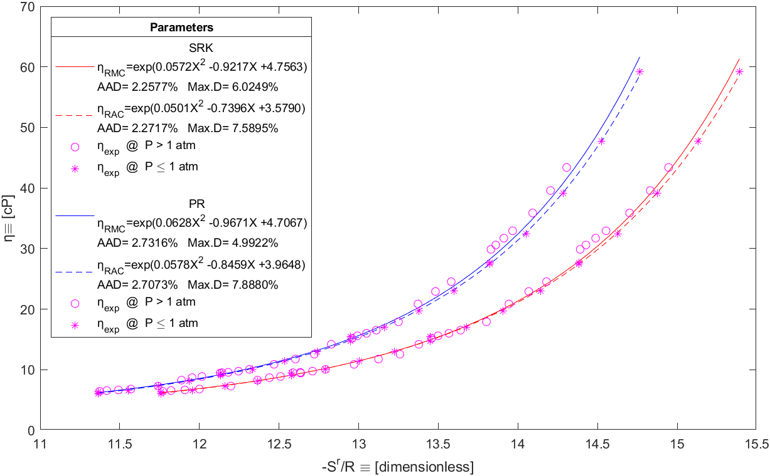
The most accurate scaling for each DES is shown in the following figures:
Figure 2: Resulting Regressed Master Curve (solid line) and Regressed Alternative Curve (dashed line) obtained with SRK (red) and PR (blue) Cubic Equations of State using dynamic viscosity experimental data at high pressure (circle) and pressures below 1 atm (asterisk) for the ChCl:Ethylene Glycol (1:2) DES.
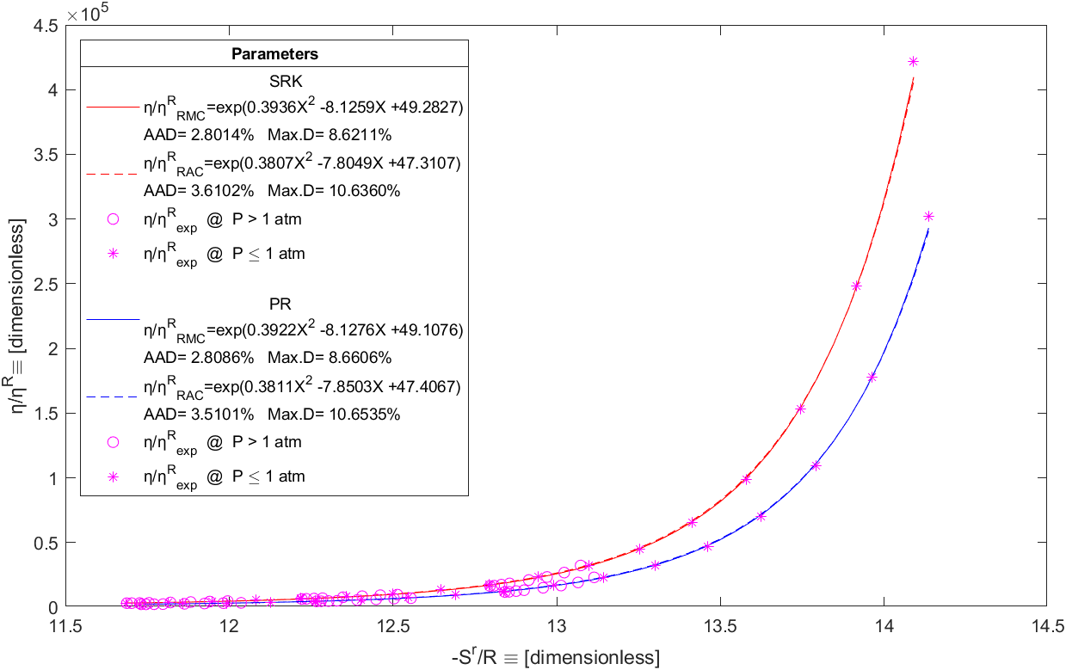
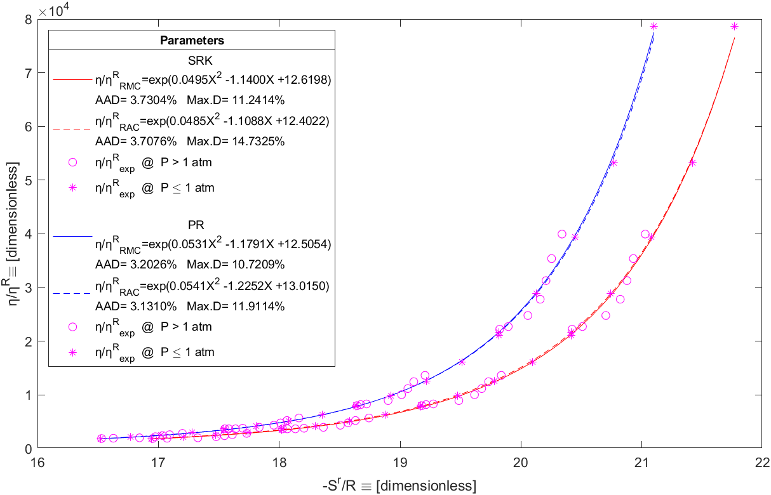
Figure 3: Resulting Regressed Master Curve (solid line) and Regressed Alternative Curve (dashed line) obtained with SRK (red) and PR (blue) Cubic Equations of State using dynamic viscosity experimental data at high pressure (circle) and pressures below 1 atm (asterisk) for the ChCl:Glycerol(1:2) DES.
Figure 4: Resulting Regressed Master Curve (solid line) and Regressed Alternative Curve (dashed line) obtained with SRK (red) and PR (blue) Cubic Equations of State using dynamic viscosity experimental data at high pressure (circle) and pressures below 1 atm (asterisk) for the ChCl:Urea(1:2) DES.
All residual entropy scaling variations using different reference viscosities proposed in this work produced satisfactory results, except for the reline, which required fitting vapor pressure data (Ravula et al., 2019) using Eq(14).
  - Conclusions
It was observed that the residual-entropy scaling approach can adequately represent the dynamic viscosity of complex fluids such as the DES considered in the present work. Based on previously reported results, the following conclusions can be drawn. An adequate superposition of dynamic viscosity data with respect to residual entropy can be achieved using simple Equations of State, such as SRK and PR, with the SRK equation generally achieving better results. No significant difference was observed between the use of a reference viscosity and scaling with unreduced viscosity, presumably because the DES are only in the liquid phase, so for simplicity it is recommended to use unreduced viscosity. There was no significant difference between the RMC and RAC scaling, so the methodology may have important predictive capabilities. This may be highly advantageous for chemical engineering applications that require viscosity data at a wide range of temperatures and pressures, despite limited availability of experimental data.
References
Bernasconi R., Panzeri G., Accogli A., Liberale F., Nobili L., Magagnin L., 2017, Electrodeposition from deep eutectic solvents. Progress and Developments in Ionic Liquids.
Crespo E. A., Costa J. M. L., Palma A. M., Soares B., Martín M. C., Segovia J. J., Carvalho P. J., Coutinho J. A. P., 2019, Thermodynamic characterization of deep eutectic solvents at high pressures. Fluid Phase Equilibria, 500, 112249.
Dehlouz A., Privat R., Galliero G., Bonnissel M., Jaubert J.-N., 2021, Revisiting the entropy-scaling concept for shear-viscosity estimation from cubic and saft equations of state: Application to pure fluids in gas, liquid and supercritical states. Industrial & Engineering Chemistry Research, 60(34), 12719–12739.
Dyre J. C., 2018, Perspective: Excess-entropy scaling. The Journal of Chemical Physics, 149(21), 210901.
Earle M. J., Esperança J. M. S. S., Gilea M. A., Canongia Lopes J. N., Rebelo L. P. N., Magee J. W., Seddon K. R., Widegren J. A. (2006). The distillation and volatility of ionic liquids. Nature, 439(7078), 831–834.
Francisco M., van den Bruinhorst A., Kroon M. C., 2012, New natural and renewable low transition temperature mixtures (lttms): Screening as solvents for lignocellulosic biomass processing. Green Chemistry, 14(8), 2153.
Hansen B. B., Spittle S., Chen B., Poe D., Zhang Y., Klein J. M., Horton A., Adhikari L., Zelovich T., Doherty B. W., Gurkan B., Maginn E. J., Ragauskas A., Dadmun M., Zawodzinski T. A., Baker G. A., Tuckerman M. E., Savinell R. F., Sangoro J. R., 2020, Deep eutectic solvents: A review of fundamentals and applications. Chemical Reviews, 121(3), 1232–1285.
Imperato G., Eibler E., Niedermaier J., König B., 2005, Low-melting sugar–urea–salt mixtures as solvents for Diels–Alder reactions. Chem. Commun., (9), 1170–1172.
Jhong H.-R., Wong D. S.-H., Wan C.-C., Wang Y.-Y., Wei T.-C., 2009, A novel deep eutectic solvent-based ionic liquid used as electrolyte for dye-sensitized solar cells. Electrochemistry Communications, 11(1), 209–211.
Mairhofer J., 2021, A residual entropy scaling approach for viscosity based on the gerg-2008 equation of State. Industrial & Engineering Chemistry Research, 60(6), 2652–2662.
Mirza N. R., Nicholas N. J., Wu Y., Kentish S., Stevens G. W., 2015, Estimation of normal boiling temperatures, critical properties, and acentric factors of deep eutectic solvents. Journal of Chemical & Engineering Data, 60(6), 1844–1854.
Morrison H. G., Sun C. C., Neervannan S., 2009, Characterization of thermal behavior of deep eutectic solvents and their potential as drug solubilization vehicles. International Journal of Pharmaceutics, 378(1-2), 136–139.
Olivera-Fuentes C., 1991, Multicomponent fugacity coefficients and residual properties from pressure-explicit equations of State. Chemical Engineering Science, 46(8), 2019–2029.
Poling B. E., Prausnitz J. M., O'Connell J. P., 2001, The properties of gases and liquids. McGraw-Hill, Texas, USA.
Ravula S., Larm N. E., Mottaleb M. A., Heitz M. P., Baker G. A, 2019, Vapor pressure mapping of ionic liquids and low-volatility fluids using graded isothermal thermogravimetric analysis. ChemEngineering, 3(2), 42.
Rosenfeld Y., 1977, Relation between the transport coefficients and the internal entropy of Simple Systems. Physical Review A, 15(6), 2545–2549.
Singh B. S., Lobo H. R., Shankarling G. S., 2012, Choline chloride based eutectic solvents: Magical catalytic system for carbon–carbon bond formation in the rapid synthesis of β-hydroxy functionalized derivatives. Catalysis Communications, 24, 70–74.
Smith E. L., Abbott A. P., Ryder K. S., 2014, Deep eutectic solvents (DESS) and their applications. Chemical Reviews, 114(21), 11060–11082.

