CHEMICAL ENGINEERINGTRANSACTIONS  VOL. ,2023 | A publication of
The Italian Association
of Chemical Engineering
Online at www.cetjournal.it

Guest Editor:SauroPierucci
Copyright © 2023, AIDIC ServiziS.r.l.
ISBN978-88-95608-98-3;ISSN 2283-9216

Implementation and Experimentation of a Low-Cost DIY Photovoltaic System
Bartolomeo Cosenzaª, Michele Miccio^{b}, Carmelo Greco^{c}
ª Dipartimento di Scienze Psicologiche, Pedagogiche, dell’Esercizio Fisico e della Formazione, Scienze della formazione primaria, Università degli Studi di Palermo, Piazza Marina 61, 90133 Palermo, Italy
^{b} Dipartimento di Ingegneria Industriale (DIIn), Università degli Studi di Salerno, via Giovanni Paolo II 132, 84084 Fisciano (SA), Italy
^{c} I.I.S.S. “Gioeni-Trabia”, Palermo, Italy
Corresponding Author: carmelo.greco7@posta.istruzione.it

Scientific research is increasingly committed to exploiting renewable energy sources to ensure a sustainable energy supply for both our planet and its inhabitants. This article describes a research project, based on the exploitation of energy from the sun, carried out in a secondary school, precisely a fourth class of a technical institute, made up of 19 students. The project aims at making students responsible and aware of the issue of energy saving and the use of renewable and sustainable energy sources, in particular the energy source that is supplied directly by the sun, i.e., photovoltaic energy. After an in-depth study of the subject, the students, duly guided by the teacher, move on to the implementation of the system designed by the authors, a DIY (do-it-yourself) small-scale photovoltaic system consisting of photovoltaic panels with variable absorption power and a digital data acquisition and control unit. It allows to power electrical tools of various kinds as computers, household appliances, etc. The teacher takes care to explain every constructive detail and function of all the devices used (there are many links to disciplines such as electrotechnics and machine, which are transversal to chemical engineering). After having assembled the solar-powered photovoltaic system, it is put into operation. The outcome is very encouraging in terms of students’ engagement and appreciation, as documented by the results of the final project evaluation sheet assigned to students at the end of the activities. Small-size equipment of this type could be the answer to humanity's growing energy needs.
1. Introduction
It is well known that oil is not a renewable source. By decreasing its production, prices will begin to rise with drastic economic and geopolitical consequences. The Russia-Ukraine conflict has exacerbated an already critical economic situation due to the recent pandemic. The energy crisis is becoming an increasingly crucial problem. Every country is required to solve a triple problem: ensuring energy security, affordability and sustainability. At present, energy safety and accessibility are privileged at the expense of sustainability, but until when will this be possible? An economy based on fossil fuels solves neither energy security nor the climate crisis, which is why it is necessary to adopt long-term strategies focused on increasing investments (Armaroli and Balzani, 2007) and the diffusion of renewable energies (Sayigh, 2022). However, this strategy cannot be just an investment, it must also be supported by a more responsible and conscientious lifestyle on the part of citizens. This work has focused on the use of photovoltaics (Barker and Bing, 2005). In fact, what better resource than the one that is provided every day by the sun? The sun is a raw material that does not need to be extracted, processed, transported and burned to produce energy (Foster et al., 2009). Our society imposes energy needs on us that could be met through a massive development of photovoltaics to guarantee a sustainable electricity supply (Park et al., 2016). The advent of photovoltaics redefines the role of the chemical engineer, no longer tied to fossil energies, offering new attractive challenges and opportunities.
There are many applications of photovoltaics (Stanojevic, 2021), ranging from the production of electricity on a large scale to the simple use of the most common household appliances (hairdryer, washing machine, warmer, etc.): Kalogirou and Tripanagnostopoulos (2006) show that a considerable amount of thermal and electrical energy is produced by photovoltaics/thermal systems for domestic hot water and electricity production; Giwa et al. (2016) realized a humidification–dehumidification desalination process driven by photovoltaic thermal energy recovery for small-scale sustainable water and power production; an optimal design of stand-alone reverse osmosis desalination driven by a photovoltaic and diesel generator hybrid system was proposed by Wu et al. (2018). More recently Opoku et al. (2023) proposed to unlock the potential of solar electric vehicles for post-Covid recovery and growth in the transport sector in Ghana; Semeraro et al. (2022) presented an innovative approach to combine solar photovoltaic gardens with agricultural production and ecosystem services.
The authors' project aims at the creation of a do-it-yourself photovoltaic system in a class of a technical institute, i.e., at secondary school level. The goal is obviously not just the construction of the plant, but the empowerment and awareness of students about energy saving and the use of renewable and sustainable energy sources (Panwar et al., 2011). Photovoltaic topic in fact is very popular in the educational-didactic field: Erdemand Erdem (2013) proposed a model of photovoltaic module in Matlab/Simulink for distance education. Ibrahimi et al. (2017) presented a design analysis of MVC desalination unit powered by a grid connected photovoltaic system; a mobile educational tool designed for teaching and dissemination of grid connected photovoltaic systems was realized by Torres et al. (2019); Gonçalves et al. (2020) developed an educational; Premkumar et al. (2020) designed and developed educational tool for low-cost photovoltaic module characterization; Vargas et al. (2022) proposed a low-cost dual-axis solar tracker with photovoltaic energy processing for education.
The project aims at making students responsible and aware of issues like energy saving and use of renewable and sustainable energy sources; moreover, it gives them the opportunity to put into practice everything studied so far in the lessons of Electrotechnics. Others will be added to the notions already acquired during the studies (and which students will be able to take up and put into practice). In this way students will be able to understand that what they have studied is not just a theoretical abstraction, but can find application in everyday life. In the lessons, nothing is taken for granted. The transmissive lesson gives way to a laboratory teaching that favors the problem-solving approach (Anderson, 2022). The paper describes the dedicated lessons and, in particular, how the lessons motivated and activated the students in order to favor a meaningful learning process.
2. Problem solving approach
For a teaching to be meaningful, it must be "experienced" by the students. It is therefore necessary to involve the students, to make them participate in the problem (Trna, 2012), so that they can become protagonists of the learning process and not mere spectators (Osborne and Dillon, 2008).
2.1 Reading articles, brainstorming activity, initial survey
Starting from a problem-type approach, the professor reads and shares newspaper articles (also online) with the class regarding the problem of energy sustainability without making any mention of photovoltaics. Then a brainstorming activity is started in which each student expresses his own thoughts on the topics just shared (Batini and Capecchi 2005, Bezzi and Badini 2010). This activity consists in bringing out ideas aimed at solving a problem. Each student freely proposes solutions of all kinds to the problem of sustainability, without any of them being censored in the slightest. This activity helps students to increase the processes of participation in learning, and is very useful for the personal training. Among the solutions to the problem there are those concerning alternative sources energy (the most popular solution). The teacher then conducts a second brainstorming activity, this time on alternative energy sources. There are several proposals and among these there is the sun, from which heat and electricity can be obtained, obviously. At this point, some students propose photovoltaics. An introductory questionnaire is assigned to test the knowledge level of the class on photovoltaics. The results show that knowledge about this alternative source is incomplete and fragmented.
2.2 Research and explanation activities
The teacher divides the class into groups and assigns each group the task of researching the operating principle of the photovoltaic. Each group leader was then required to briefly report the operating principle of a photovoltaic system. After listening to the various speeches, the teacher takes stock of the situation on the subject of study and application. A photovoltaic system captures and converts the energy radiated by the sun directly into electricity. This is possible by making use of some special components called "photovoltaic modules" which in turn consist of single cells. The photovoltaic cell is the fundamental electrical component that transform solar radiation into electricity and consists of an association between two thin layers of different semiconductor materials as silicon. With the addition of sunlight energy, the electrons in semiconductor of the photovoltaic system are activated and pass from a lower energy state to a higher energy state. This leads to the generation of electricity, in a semiconductor. Silicon is the most used material to make photovoltaic systems because of its suitability and efficiency. When multiple photovoltaic modules are connected to each other in series they form a string. When strings are connected to each other in parallel they form the photovoltaic generator.
The prices shown for each device are current market prices (all devices are also easily available on Amazon).
3. Implementation of photovoltaic system
3.1 Solar panel
The photovoltaic panel is a device that allows the direct conversion of solar radiation into electricity, exploiting the photoelectric effect and is the basic element of the photovoltaic system (Figure 1). Improving the efficiency of photovoltaic panels without increasing costs is a research field in chemical and energy engineering. To date, the maximum efficiency of a commercial photovoltaic panel is around 20%.

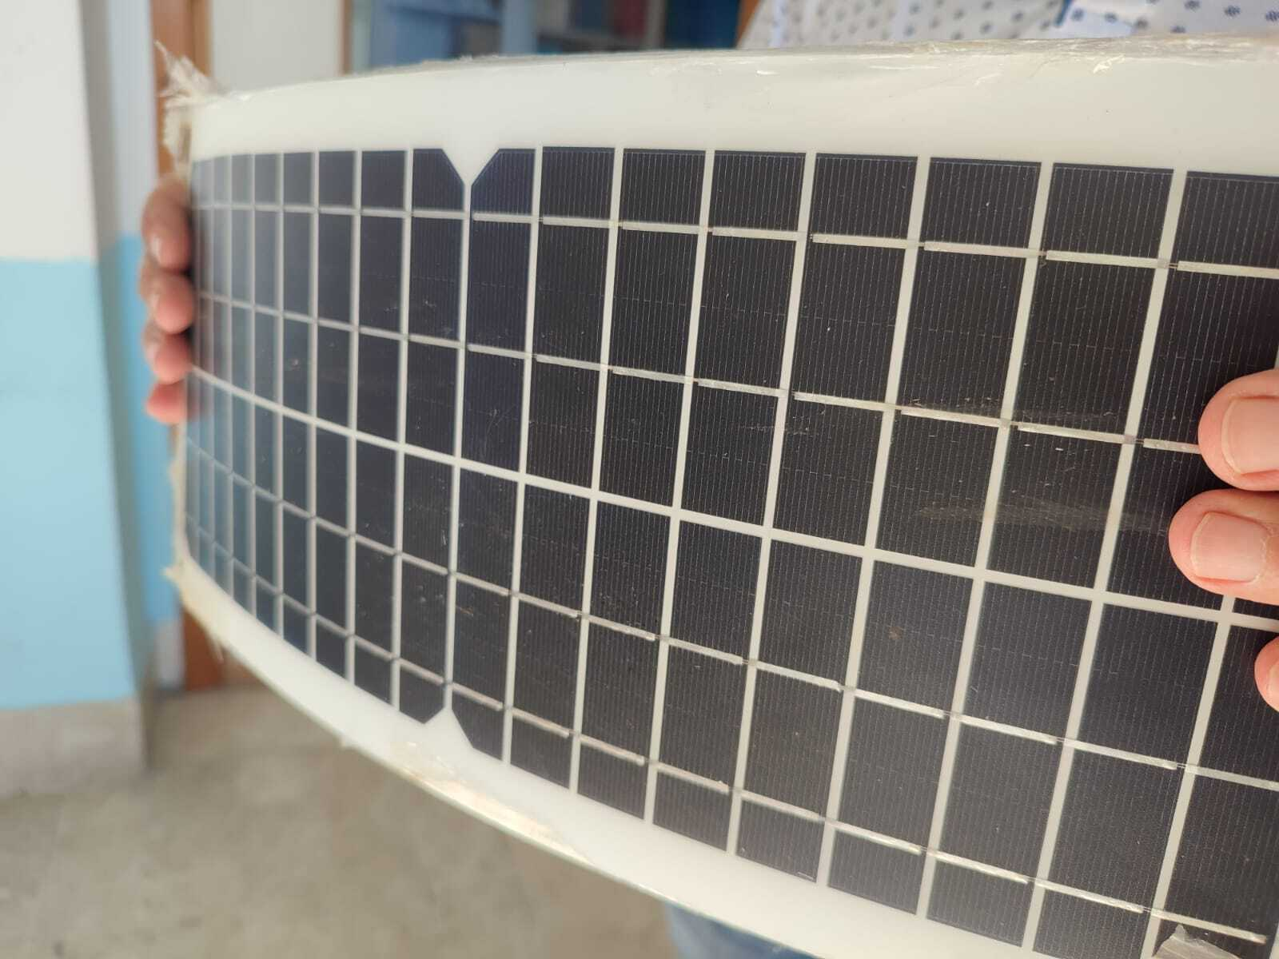
Figure 1: Thin, light and able to flex Solar panel, 0.40 m x 0.16 m, 10 W, 5V/12-18V, price 30 euro.
The other components of the photovoltaic system, such as the battery, the charge controller and the inverter are not immediately introduced to the students, but they are the result of reflection and research by the students themselves, following the presentation of a problem. Only in this way, significant learning is generated.
3.2 Battery
To introduce the battery component, the professor poses the following problem: how to power a user at night? In fact, there is no light and the photovoltaic panel is unusable. The students therefore understand that a charge accumulator is needed, such as a car battery (Figure 2). It converts electrical energy into chemical energy, which can be stored. The energy store is another field of research that sees chemical engineers in the front row.
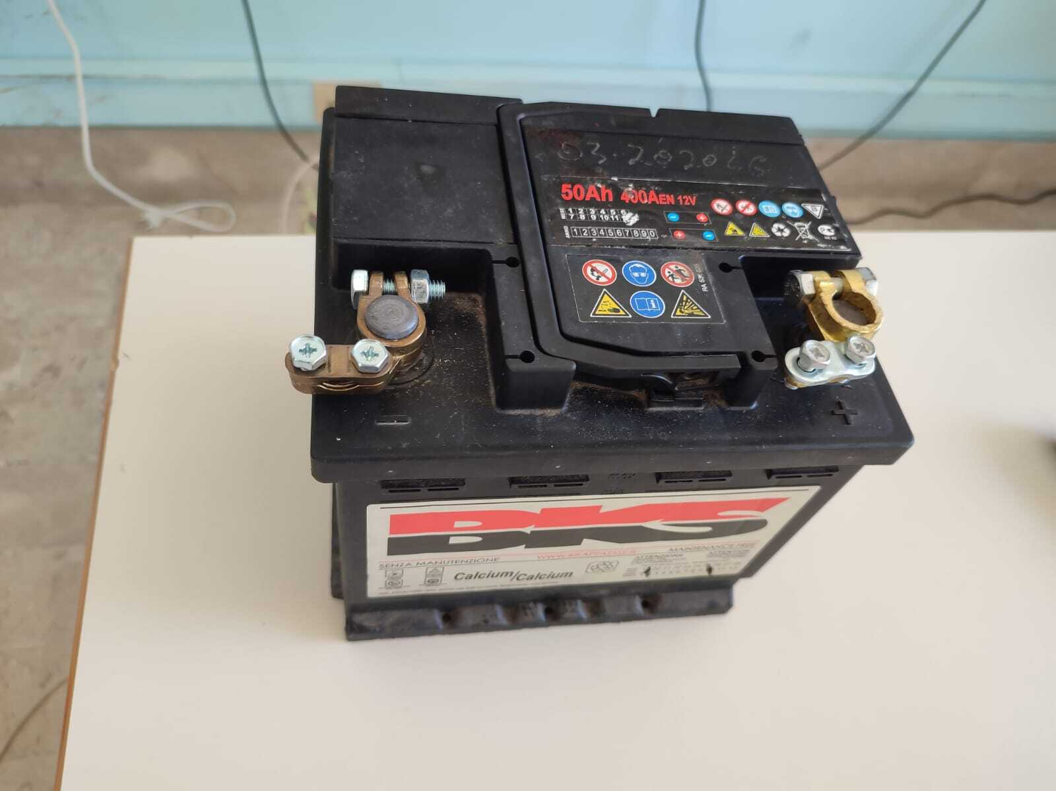
Figure 2: A car battery acts as an accumulator in the proposed system, price 70 euro.
3.3 Charge controller
To introduce the charge controller the professor poses the following problem: as long as a solar panel is exposed to the sun, it converts solar energy into DC current flowing into the battery. The risk is that, if this current flow is not regulated, then the battery will overload and could damage all other devices charged on the system. A solution must therefore be found by the student through research and consultation among group members: the charge controller (Figure 3).
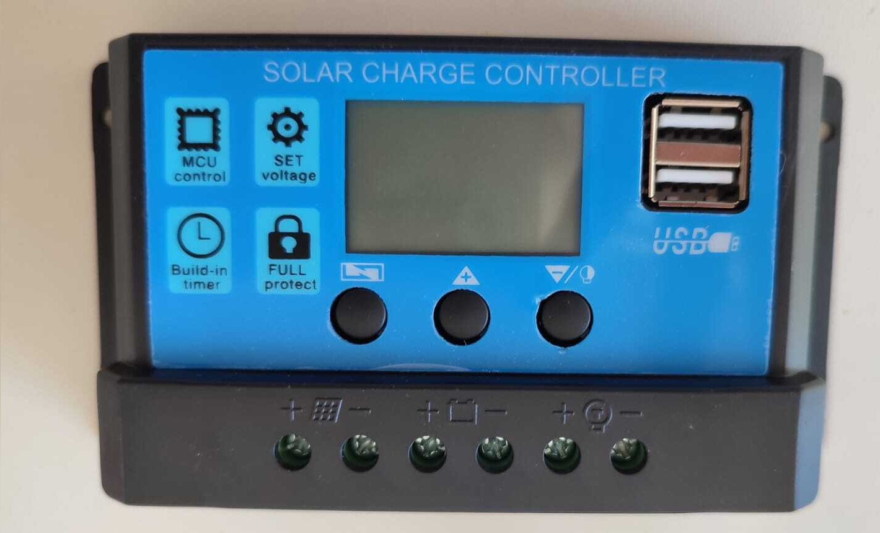
Figure 3: The charge controller adjusts the voltage of the solar panel by adapting it to that required for recharging the battery, avoiding overcharging of the same, price 10 euro.
This device is inserted between the battery and the solar panel, and will stop sending electricity to the battery once it is charged, then it protects the battery from reverse polarity. It allows to supply the right degree of current to the batteries, protecting them from excessive discharge or charge. In this way it is possible to prolong life of battery. The charge regulator has an output towards the storage batteries and shows the state of charge on a display, it also has two USB ports for possible uses and a 12 V output. This is fine for an unpretentious load, such as 12V LED bulbs, low consumption direct current lamps that allow you to save a lot of electricity and at the same time provide excellent lighting. A photovoltaic system only for this type of use is certainly very limiting.
3.4 Inverter
The professor asks the students the following question: what is necessary to add if a user wants to connect a hair dryer? In this way, attention is drawn to the fact that electrical appliances in the consumer’s home are powered by alternating current. The answer from the students that is not long in coming is “inverter”, i.e., an electronic input/output device capable of converting and transforming the voltage from 12V DC to 220V AC to power various types of household appliances (Figure 4).
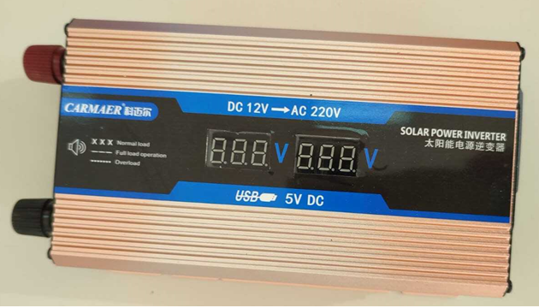
Figure 4: Inverter is a device that converts a direct voltage (12V) into an alternating voltage (220V), price 25 euro.
3.5 The photovoltaic system
Now that the role of each component is clear, it's time to move on to the assembly phase, to make a fully functional and operational photovoltaic system.

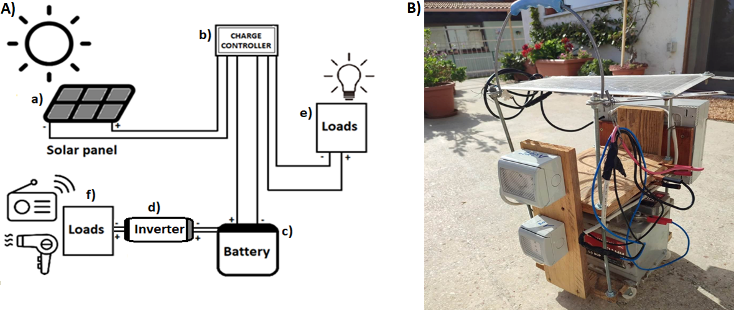
Figure 5: A) Scheme of the DIY photovoltaic system made in the classroom. The components are a) Solar panel; b) Charge controller; c) Battery; d) Inverter; e) 12V DC Loads; f) 220V AC Loads. B) Wheeled Portable system, price 175 euro.
The class proceeds with the construction of such a low-cost DIY photovoltaic system. It is shown in Figure 5A in a schematic way and in Figure 5B as an assembled wheeled apparatus. As such, it is able capable of powering a small house and thus saving energy (Tommassini, 2022; Petrova et al., 2009) or even to resell it. In fact, the average annual electricity consumption of a family made up of 4 people in Italy today (according to an ENEA source) is around 3600 kWh, with an annual cost of around 1200 € per year (cost around 0.35 €/kWh). The photovoltaic panel measures 0.40 m x 0.16 m = 0.064 m², considering an average daily solar radiation in Palermo equal to 1704 kWh/m² (according to ENEA source) therefore the radiation on the panel is 109 kWh/ day. Considering the minimum efficiency of the photovoltaic panel (15%), an amount of energy equal to 16.35 kWh/day is obtained. If it were possible to take full advantage of energy storage, it would be possible to obtain a daily saving of 5.78 €, for a total annual figure of 2088 €, much higher than the annual expenditure indicated above. This means that the bill could be zero and the energy surplus could be resold to utility companies.
4. Results
The class participated with great enthusiasm and interest in the proposed activity and the results were all positive. The activity was well evaluated, 17 out of 19 students gave full marks. The lesson as a whole was considered interesting, curious and inspiring. The students demonstrated that they have learned the topics and have developed both technological skills (some of them have decided to build their own DIY photovoltaic system) and a greater sensitivity to the problem related to sustainability. The results of the final survey, which include the questions of the first questionnaire aimed at probing the level of preparation of the students on the subject, are very satisfactory. If, for example, in the initial test, only one student provided a partially correct answer to the question "What devices are needed to build a photovoltaic system" (the inverter device was omitted), in the final test all the students provide an answer complete and correct. Some results of the survey are shown in Figure 6.

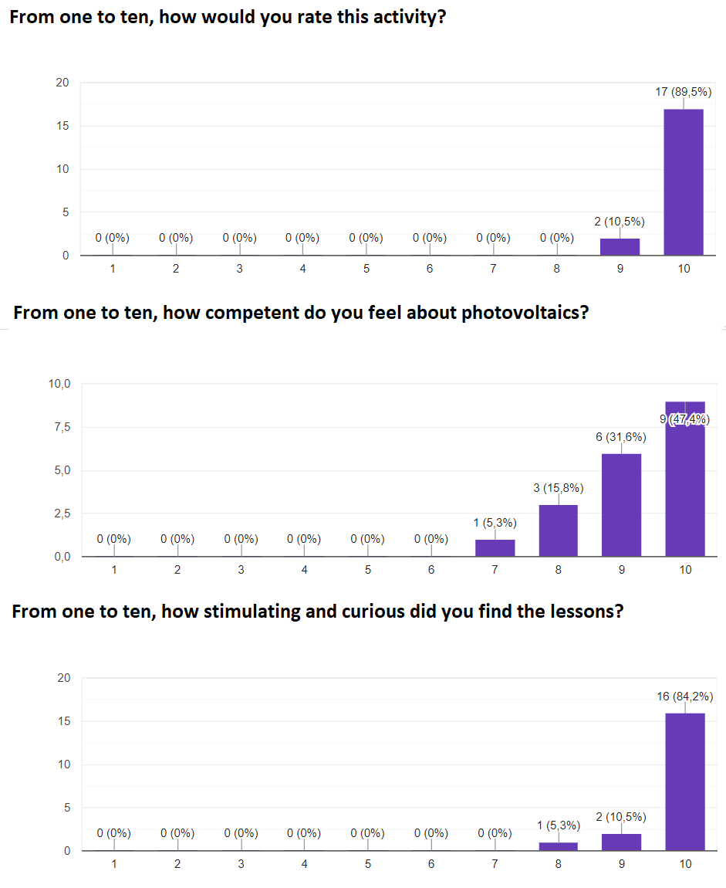
Figure 6: Some results of the survey conducted on secondary school students at the end of the project.
5. Conclusions
The photovoltaic activity was well appreciated by the students and the positive results of the verification test are very encouraging. The students understood the importance of resorting to alternative sources of energy and thus adopting a more sustainable lifestyle. They have managed to acquire the skills necessary to build a photovoltaic system, which can be implemented with very little expense. Fifteen out of nineteen students (about eighty percent) are willing to develop a photovoltaic system at home and use it to power electrical tools of various kinds as computers, household appliances or small personal tools. A small step towards a sustainable lifestyle.
References
Anderson R. D. 2022, Reforming science teaching: What research says about inquiry. Journal of Science Teacher Education, 13(1), 1–12.
Armaroli N., Balzani V., 2007, The future of energy supply: challenges and opportunities. Angew Chem Int Edit 46, 52-66.
Barker P.P., Bing J.M., 2005, Advances in solar photovoltaic technology: an applications perspective, Conference Paper. In: Presented at IEEE Power Engineering Society Summer Meeting.
Batini F., Capecchi G., 2005, Strumenti di partecipazione, Trento, Erickson 2005.
Bezzi C., Baldini I., 2010, Il brainstorming. Pratica e teoria, Franco Angeli, 2010.
Erdem Z., Erdem M.B., 2013, A Proposed Model of Photovoltaic Module in Matlab/SimulinkTM for Distance Education, Procedia - Social and Behavioral Sciences, 103, 55-62.
Foster R., Ghassemi M., Cota A., 2009, Solar energy: Renewable energy and the environment. 1st Edition. Eds: Cota A, Foster R, Ghassemi M. Taylor & Francis eBooks, CRC Press.
Giwa A., Fath H., Hasan S.W., 2016, Humidification–dehumidification desalination process driven by photovoltaic thermal energy recovery (PV-HDH) for small-scale sustainable water and power production, Desalination, 377, 163-171.
Gonçalves R. S., Palmero-Marrero A. I., Oliveira A. C., 2020, Educational solar energy tool in Matlab environment, Energy Reports, 6, 490-495.
KalogirouS.A., Tripanagnostopoulos Y., 2006, Hybrid PV/T solar systems for domestic hot water and electricity production, Energy Conversion and Management, 47, 18-19, 3368-3382.
Ibrahimi M., ArbaouiA., Aoura Y. 2017, Design analysis of MVC desalination unit powered by a grid connected photovoltaic system, Energy Procedia, 139, 524-529.
Opoku R., Ahunu B., Ayetor G. K.K. , Ayitey D.T., Uba F., Asiedu N., Obeng G.Y., 2023, Unlocking the potential of solar electric vehicles for post-COVID recovery and growth in the transport sector in Ghana, Scientific African, 20.
Osborne J., Dillon J., 2008, Science Education in Europe: Critical Reflections: A Report to the Nuffield Foundation.
Panwar N, Kaushik S, Kothari S., 2011, Role of renewable energy sources in environmental protection: a review. Renew Sust Energ Rev 15, 1513-1524.
Park H.S., Jeong K., Hong T., Ban C., Koo C., Kim J., 2016, The optimal photovoltaic system implementation strategy to achieve the national carbon emissions reduction target in 2030: Focused on educational facilities, Energy and Buildings, 119.
Petrova-Koch V., Hezel R., Goetzberger A., 2009, High-Efficient Low-Cost Photovoltaics, in Springer Series in Optical Sciences (SOOS, 140).
Premkumar M., Sowmya R., Mosaad M., Fattah T.A.A., 2020. Design and development of low-cost photovoltaic module characterization educational demonstration tool Materials Today: Proceedings, 46, 5433-5440.
Sayigh A., 2022, Sustainable Energy Development and Innovation, Selected Papers from the World Renewable Energy Congress (WREC) 2020, Springer, in Innovative Renewable Energy.
Semeraro T, Scarano A., Santino A., Emmanuel R., Lenucci M., 2022, An innovative approach to combine solar photovoltaic gardens with agricultural production and ecosystem services, Ecosystem Services, 56.
Stanojevic B., 2021, Application of photovoltaic technology in the use of solar energy, Annals of Environmental Science and Toxicology , 5 (1), 094-098.
Tommassini D., 2022, Elettricità con il fotovoltaico. Dalle basi della tecnologia fotovoltaica fino all’installazione di un impianto completo, Libri SANDIT.
Torres P.F., Costa A.F.P., Chaar Junior V.L., Monteiro W.L., Galhardo M.A.B., Pinho J.T., Macêdo W. N., 2019, A mobile educational tool designed for teaching and dissemination of grid connected photovoltaic systems, Computers & Electrical Engineering, 76, 168-182.
Trna J., 2012, How to motivate science teachers to use science experiments. Journal of Systemics, Cybernetics and Informatics, 10 (5), 33-35.
Vargas A. N., Francisco G.R., Montezuma M.A.F., Sampaio L.P., Acho L., 2022, Low-cost dual-axis solar tracker with photovoltaic energy processing for education Sustainable Energy Technologies and Assessments, 53.
Wu B., Maleki A.,Pourfayaz F., Rosen M. A., 2018, Optimal design of stand-alone reverse osmosis desalination driven by a photovoltaic and diesel generator hybrid system, Solar Energy 163, 91-103.

