|  |  |
| --- | --- |
| cetlogo ***CHEMICAL ENGINEERING TRANSACTIONS***  ***VOL. , 2023*** | A publication of  aidiclogo_grande |
| The Italian Association  of Chemical Engineering  Online at www.cetjournal.it |
| Guest Editors: Sauro Pierucci, Jiří Jaromír Klemeš  Copyright © 2023, AIDIC Servizi S.r.l. **ISBN** 978-88-95608-98-3; **ISSN** 2283-9216 | |

Valorization of Biomass from Dairy Wastes: Integrated Resources and Energy Recovery

Andrea Maffinia, Marco Morandob, Antonio G. Sabab, Giorgio Bonvicinib, Bruno Fabianoc

a Maffini Engineering & Consulting, via D. Somma 80 – 16167 Genova, Italy

b RINA Consulting S.p.A., via A. Cecchi 6 - 16129 Genova, Italy

c DICCA - Civil, Chemical and Environmental Engineering Department, Polytechnic School - Genova University, via Opera Pia 15 - 16145 Genova, Italy

[andrea@maffiniconsulting.it](mailto:andrea@maffiniconsulting.it)

The focus of this paper is to critically analyse and draw quantitative balance indicators of several projects concerning process optimization, resources, and energy recovery from dairies wastes. Analysed quantitative data were collected by auditing activities and design studies in Eastern Europe and Asia, aimed at supporting the International Financial Institutions (IFIs) for better performances and reduction of global environmental impact of their customer Companies. Suggestions for the recovery of waste in the given sector are outlined discussing results from actual case-studies for recycling dairy waste and obtaining valuable products, seeking to contribute to increase income, as well as to minimize waste generation and GHGs emissions. Results evidencing the benefits of biomass valorisation to produce energy by-products can provide practical indications for dairy plant companies that are considering the issues of economic and environmental sustainability.

* 1. Introduction

As amply known, the dairy industries provide a large range of products, obtained from raw milk through a process including a series of unit operations. Final products include fresh and UHT milk, spread, crust and aged cheese, yoghurt, etc. The main final by-product in dairies is whey, separated from the cheese in large quantity, roughly 85-90% of raw milk and representing a valuable source to extract whey proteins and lactose (Pizzichini et al., 2001). Dairy industries demand significant energy resources along the production stages and supply chain and can suffer from energetic crises and climate change implications. Even though the occupational risk level and production downtime is low compared to other sectors (Fabiano et al., 2022), there are opportunities for process and management improvements. This paper is based on the experience of a team supporting dairy enterprises in Eastern Europe and Asia through implementation of new projects, with the aim of process optimization, minimizing waste and increase efficiency in use of resources and energy (European Commission, 2008), thus attaining production efficiency combined with GHGs emission cutting. In order to make further progress with a full integration the overall relevant issues of circular economy, sustainability and resource conservation need to be fully integrated also with the process safety paradigm moving towards industry 4.0 (Pasman et al., 2021). As illustrated in a previous paper (Maffini et al., 2021), the Resources and Energy Efficiency Audits (REEA) are in general focused on helping the industrial customers of the International Financing Institutes to identify the opportunities for efficiency investments. Additionally, it aims at covering any gap in fulfilling the environmental and safety laws and regulations. But, in the case of dairies, this brought also to a reconsideration of the “waste” definition that was penalizing valuable resources. For instance, in the dairy industry all over Europe, Asia and America there was historically some delay in recognizing the value of whey as a source of clean water, proteins, lactose and other products, sometimes even discharging it straight into the wastewater stream, implying the need of proper treating a large quantity of high COD liquid. The auditing activities on dairies were carried out over the time span ranging from 2013 to 2019. In addition to IPPC Directive (European Commission, 2010), the reference document during the audits, both for BAT application and for benchmarking, was the Integrated Pollution Prevention and Control Reference Document on BAT in the Food, Drink and Milk Industries (Santonja et al., 2019). Even though optimal results are attained by integrated approaches to implement process and environmental impact/risk analysis aprioristically at the conceptualization stage of a process/plant (Bassani et al., 2022), here the practical capability of the method based on REEA results to optimize existing processes is shown by the analysis of three relevant case-studies, thus identifying on field relevant key parameters.

* 1. Methodology

The purpose of the REEA is the investigation of investment opportunities with the objective of increasing the Resource Efficiency levels of industrial Companies, considering raw materials, water, by-products, solid waste, wastewater, recyclables, etc. A consequence of this improvement in resources use is the decarbonization of the process, assessed through an estimate of the GHGs savings achieved by each efficiency measure. The REEA analysis relies on the conceptual methodology previously developed for energy audits by Hasanbeigi and Price (2010). But, if there is an opportunity to consider more cases for the same industry, as it happened with dairies, some conclusions can be drawn that more specifically highlight the main problems vs. the relevant solutions of the resources and energy management of the specific sector. The developed framework was tailored to encompass all actors along the whole value chain of the milk transformation industry, including intermediate and end-products/services. It stands to reason the method may be refined in case of competing investment opportunities, e.g., by techniques implying AHP (Abrahamsen et al., 2019). Even though the REEA is specifically developed for and tested on the Chemicals and Agribusiness sectors, the method can be applied with success on the dairies within their system boundaries (ISO, 2006), following a logic diagram as schematized in Figure 1.

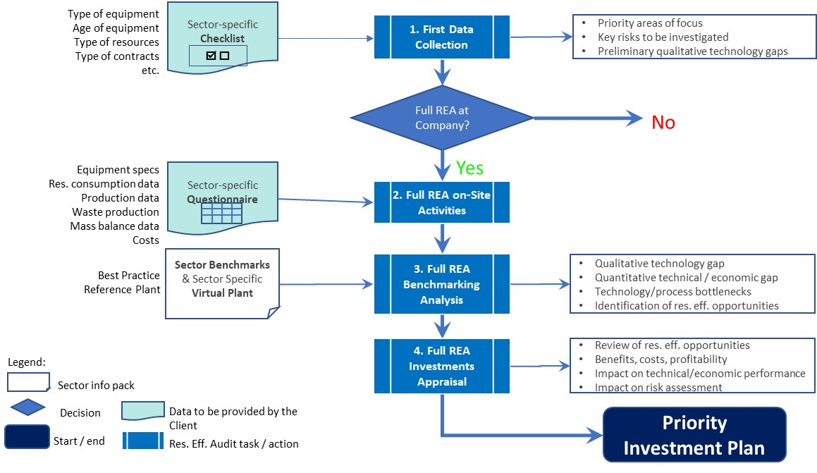

Figure 1: Logic diagram for the REEA analysis and benchmarking in the dairy industry.

* 1. Emerging environmental issues in the sector

It is a general result from the audits that the main resources and environmental issues for the dairy industry are:

* High fresh-water consumption due to low recycle, thus, giving high volumes of wastewater produced.
* A remarkable and diversified solid waste production.
* High energy consumption, especially as steam for heating and cleaning.

Globally, all these issues bring a relevant increase in GHGs emissions, mainly under scope 2, so that the audits will be finalized also to reduce the released CO2 equivalent amounts.

**Water**

The large consumption of clean water with generation of wastewater is the main environmental issue in the dairy sector. The largest user is wash-water used in operations such as equipment washing; then, also line purging at product changeover; start-up, shutdown as well as changeover of high temperature short time (HTST) pasteurisation units, and product washing. To comply with limit concentrations according to Water Pollution Control regulations, the wastewater originated in dairy industry is generally treated with an advanced wastewater treatment plant discharged to surface water or a pre-treatment plant if wastewater can be discharged to a close municipality sewage system. As required by FAO standards for the safety and quality of water use and reuse in the production and processing of dairy products, internal reuse and recycle of water should respect quality prescriptions to avoid contamination or build-up of pollutants in the process.

**Solid waste**

Solid waste in the process units comes from off-spec products, damaged products, expired duration products, but in general they give limited amounts, whereas the sludge separated in the wastewater treatment plant is normally the highest quantity. Packaging waste, sludge from separations (milk clarification, filtration), solid wastes from fat traps, and other wastes attributable to general industrial operations (e.g. lubricants, batteries, paint, laboratory chemicals, etc.) are the most likely wastes generated from dairy processing. Packaging waste in general is required to be sorted and recycled according to local legislations.

**Energy**

Main conclusion on BAT technologies for the dairies sector are that the process applied in the manufacturing of cheese requires lot of energy, but also that valid alternatives through BAT recommendations are available to reduce energy consumption: for instance, through continuous pasteurisation instead of batch, or by improving homogenisation. Large part of the energy consumed is used to generate steam and hot water for heating operations and cleaning, while a lesser amount is used to drive power machinery, refrigeration, ventilation, and lighting. The most energy consuming operations are the evaporation and drying of milk.

* 1. Results and discussions

Based on the above main environmental issues in the dairy sector, to determine the performance of the dairy sector were selected 6 main Key performance indicators, on 5 leading factories, to crosscheck their position. The dairy sector technical performances define the actual values of the Key Performance Indicators (KPIs) which are compared with the benchmarks according to the IPPC, Reference Document on BAT in the Food, Drink and Milk Industries, EU 2006 (the most updated edition at the time). The 6 KPIs are shown in Table 1.

Table 1: Definition of Key Performance Indicators covering the milk and cheese sector.

|  |  |  |
| --- | --- | --- |
| Technical KPI | Definition | Rationale for KPI definition |
| Product yield | tons of product / ton of raw milk  . | This indicator is used to estimate the efficiency of the dairy process in terms of product vs. raw milk |
| Primary Energy Use | kWh of total energy consumed / ton of raw milk | It is the specific energy consumption |
| Purchased Energy Use | kWh of purchased energy from external suppliers / ton of raw milk | It is the energy purchased outside of the factory boundaries, referred to inlet raw milk |
| GHGs Emission | kg of GHGs emission / ton of raw milk | It is used to indicate the total GHGs emission per unit of raw milk |
| Fresh water use | m3 of fresh water input / ton of raw milk | Fresh water is used as single indicator accounting both for process use of water and water recycling |
| Wastewater Discharge | m3 of wastewater output / ton of raw milk | Used to indicate the total wastewater residual output |

Starting from the definition of high-performance (HPB) and low-performance (LPB) benchmark scores respectively set equal to 100 and 40 to calculate KPIs score according to Eq. 1:

$KPIscore=\frac{HPB}{LPB-HPB}∙\left(40-100\right)+100$ (1)

Then, the Technical KPIs scores and the relevant Spider Diagram were developed using data from 5 main dairies, considering the KPI previously identified, and compared to the benchmarks, as in Table 2 and Figure 2.

Table 2 – Summary of calculated Dairy KPIs vs. benchmarks



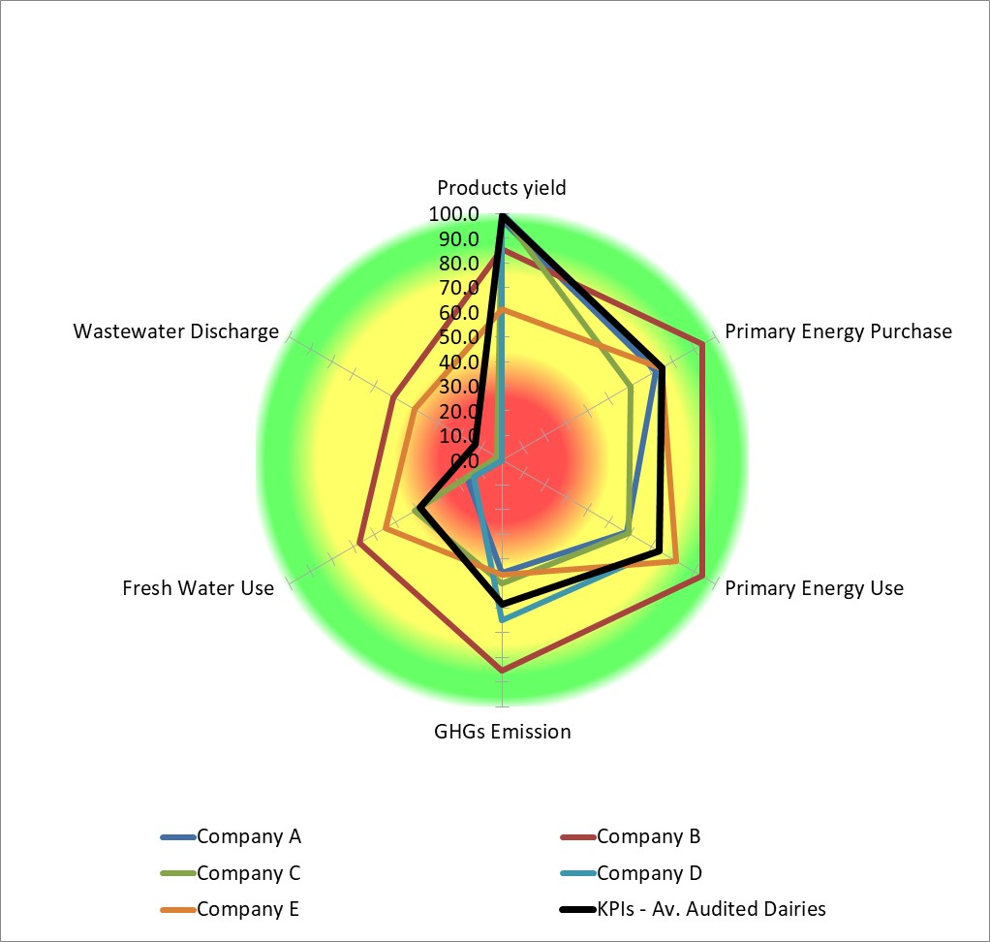

Figure 2: Spider diagram for KPIs vs. benchmarks in dairies.

From the above results, some actual case-studies with application of Resources Efficiency Measures (REMs) were selected in the following to better identify actual opportunities and challenges of improving the KPIs score.

REM type 1: Brine and whey integrated recovery

Brine is generally used in dairies for two main purposes on cheese production: for salting and for addition in the packaging stage: this means that every year a quantity of brine roughly 1/10 of the cheese weight produced is discharged as wastewater. Instead, whey is the typical by-product of dairies, being roughly 85-90% of processed milk to cheese, separated after coagulation of milk itself. Whey, for years considered a waste to be disposed of, is a valuable source of proteins and dextrose; the former, dried, is the main ingredient of the typical energetic food, going from WPC30 (whey protein concentrate) up to WPC80, depending on proteins concentration.

The proposed recovery process consists of a microfiltration unit applied continuously on a side-stream of brine through a step where, after a first screening to eliminate small rests of cheese, the liquid brine undergoes a purification stage, where the concentrate stream, having a high content of impurities and microorganisms, is disposed of, whereas the purified stream is returned to the main cycle. The unit for brine purification consists of following steps brine screening; microfiltration membranes unit; permeate tank; concentrate tank; slurry pumps. Concerning whey, its composition (wt/wt) is depending on the cheese process: in general, apart from water (93-94%), the dry substance consists of lactose (4.5-5%), whey protein (0.6-0.65%), lactic acid (up to 0.8%), citric acid (0.1%), minerals (0.5-0.7%). On these grounds, it exhibits high potential as a valuable by-product to obtain added value foods and bioactive compounds. Several routes are exploited for extraction of proteins, which are the most valuable substance in whey: a largely used process consists of an ultrafiltration step (Nissen, 2006) where, after a first screening to eliminate small rests of cheese, the liquid whey is filtered through membranes to separate two streams:

* A concentrate stream, having a high content of proteins, from roughly 30% of dry substance and rich on lactose; in this case, this stream can be exploited in a more optimal way to produce WPC 30;
* A permeate stream, characterized by a high lactose content and a higher water dilution rate; this stream could be treated to further extract lactose, but considering market uncertainty, it could be assumed that this stream is sent to the anaerobic digestion unit for biogas production.

The block diagram for the optimized brine and whey system is depicted in Figure 3.



Figure 3: Block diagram for the brine and whey system.

REM type 2: Biogas from solid waste integrated with wastewater treatment

Sometimes, the wastewater generated at the site, if close to a town, could be connected to the municipality sewer system. But the usual situation of a factory with large distance from sewers demands a complete wastewater treatment on the spot. COD value of wastewater from a dairy can be estimated between 3,000 and 5,000 mg/l on average even though this is a basic figure, since the wastewater parameters may be affected by the discharged condensate and pickling brine. Even if this issue is not as critical as in case of starch or fruit industry, where COD values are rather high, for the milk industries it could also be taken into consideration an anaerobic treatment to cut COD before the aerobic one and to produce biogas. On this basis, the treatment sequence could include, after some screening, some equalization to smooth peaks, neutralization to control pH, anaerobic digestion in UASB type reactor, and finally a conventional secondary treatment with aerobic reactor and sedimentation tanks. Solid waste (from cheese production, off-spec milk, etc.) possibly added with more biological waste from neighbouring farms and within the production chain (e. g. cow manure), and with sludge from the wastewater treatment, could be used for fermentation in anaerobic digester obtaining biogas and digestate; whey can also be added, after recovery of proteins and other substances. The biogas from wastewater treatment plus the one from solid waste fermentation can then be used to produce thermal and electrical energy in an engine (a CHP unit); solid and liquid digestate fractions can be used as fertilizers. In the audited dairies, the mixed feed to anaerobic digesters was formed by the internal solid waste plus other available biomass, with different compositions for each case. Whereas volatile solid content was defined for each feed stream, it was assumed as working hypothesis a biogas yield equal to 350 Nm3/t of total volatile solids and 45 days as minimum HRT in the digesters. The block diagram shown in Figure 4 provides a visualization of the integrated scheme. The application of this integrated scheme of biogas generation from solid waste and wastewater treatment yields a noteworthy reduction in terms of GHGs emissions.

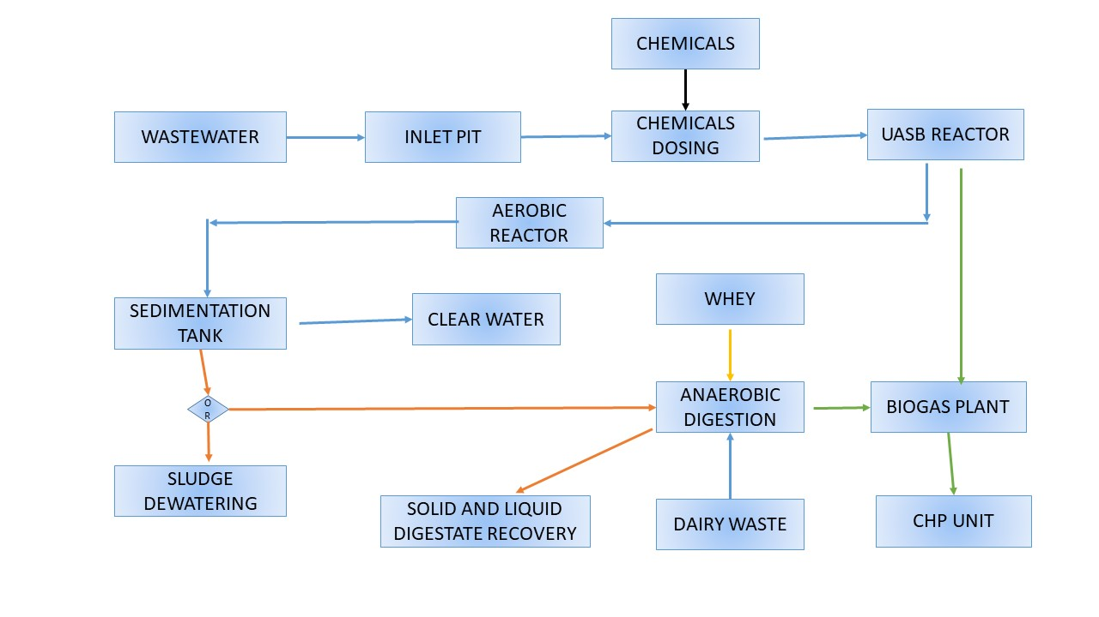

Figure 4: Solid waste anaerobic digestion integrated with wastewater treatment.

REM Type 3: Solid Digestate Treatment System with NPK Concentration

The process consists of mixing appropriate chemicals to the dried solid digestate to increase the nutrients content. The goal is to obtain a resulting fertiliser with optimum chemical and agronomic characteristics, i.e., a balanced NPK composition, so the dewatered solid digestate coming from the solid/liquid separation may need correction in terms of N, P and K content, e.g., by addition of urea, di-ammonium phosphate and potassium chloride. In this case, the energy consumption for the whole production cycle should be considered as well, being the N components of fertilizers the most energy-intensive, while the P and K components demand less than 5 MJ/kg. The plant unit operations consist mainly of mixing, granulation and drying. The fertiliser from digestate allows the replacement of synthetic products characterized by high GHGs production emissions.

* 1. Conclusions

From the different dairies which were thoroughly audited and the relevant assessment of the resource efficiency measures, five of them, having the most complete range of production and state-of-the-art technology, were selected for benchmarking. By the analysis, the calculation of KPIs and the comparison with benchmarks it is possible to draw the following conclusions. The audited dairies were already performing within the range of sector main benchmarks, with the single exception of water consumption and consequent wastewater generation, which is a main issue for dairies. This finding clearly demonstrates the wide room for internal water recycling, applying segregation of the different wastewater streams for specific treatments.

As a notable example, company A with the existing layout and process units yields a total GHGs emission (calculated only for scope 1 and 2) equal to 25,000 tons CO2eq/year. By applying to the plant the designed REMs, the following results in terms of GHGs emission savings can be calculated:

* Solid waste anaerobic digestion integrated with wastewater treatment: 3,000 tons per year.
* Brine and whey integrated recovery: 2,000 tons per year.
* Solid Digestate Treatment System with NPK concentration: as a final remark, from the analysis (neglecting for the sake of simplicity scope 3 emissions) it follows that synthetic fertilizer replacement implies a GHGs emissions saving, calculated according to IDEMAT (2014), corresponding to 3 kgCO2eq/kg fertiliser.

References

Abrahamsen E.B., Milazzo M.F., Selvik J.T., Asche F., Abrahamsen H.B., 2020, Prioritising investments in safety measures in the chemical industry by using the Analytic Hierarchy Process, Reliability Engineering and System Safety, 198, 106811.

Bassani, A., Vianello, C., Mocellin, P., Dell’Angelo, A., Spigno, G., Fabiano, B., Maschio, G., Manenti, F., 2023, Aprioristic integration of process operations and risk analysis: definition of weighted F&EI-based concept and application to AG2S technology. Ind. Eng. Chem. Res. 62(1), 500–510.

European Commission, 2008, Directive 2008/98/EC of the European Parliament and of the Council on waste and repealing certain directives. Official Journal of the European Union, Off J Eur Union L312, 3–30.

European Commission, 2010, Directive 2010/75/EU of the European Parliament and of the Council on industrial emissions (integrated pollution prevention and control). Off J Eur Union L334, 17–119.

Fabiano, B., Pettinato, M., Currò, F., Reverberi, A.P., 2022, A field study on human factor and safety performances in a downstream oil industry, Safety Science, 2022, 153, 105795.

Hasanbeigi A., Price L., 2010, Industrial Energy Audit Guidebook: guidelines for conduction an energy audit in industrial facilities, Energy Technologies Area, Berkeley Lab., California Univ. Publ., Berkeley, USA.

IDEMAT, 2014, Industrial Design & Engineering MATerials database, Sustainability Impact Metrics Foundation, Delft University of Technology (NL).

ISO, 2006, ISO standards 14040 Environmental management - Life cycle assessment – Principles and framework. International Organization for Standardization Ed., Vernier, CH.

Maffini A., Bonvicini G., Venturin A., Morando M., Saba A., Fabiano B., 2022, A framework towards resource integration and energy efficiency auditing with zero hazardous discharge program, Chemical Engineering Transactions, 91, 265-270 DOI:10.3303/CET2291045

Nissen O., 2006, Whey processing with Membrane Technology, EDM, European Dairy Magazine.

Pasman, H.J., Fabiano, B. 2021. The Delft 1974 and 2019 European Loss Prevention Symposia: highlights and an impression of process safety evolutionary changes from the 1st to the 16th LPS. Process Safety and Environmental Protection 147, 80-91.

Pizzichini, M., Montani, R., Ruscio, F., 2001, Whey: from husbandry waste to raw material for food and medicines, L’Informatore Agrario, 16.

Santonja, G., Karlis, P., Stubdrup, K., Brinkmann, T. and Roudier, S., 2019, Best Available Techniques (BAT) Reference Document for the Food, Drink and Milk Industries. Industrial Emissions Directive 2010/75/EU (Integrated Pollution Prevention and Control), EUR 29978 EN, Publications Office of the European Union, Luxembourg.