|  |  |
| --- | --- |
| cetlogo ***CHEMICAL ENGINEERING TRANSACTIONS***  ***VOL. , 2023*** | A publication of  aidiclogo_grande |
| The Italian Association  of Chemical Engineering  Online at www.cetjournal.it |
| Guest Editors: Sauro Pierucci, Jiří Jaromír Klemeš  Copyright © 2023, AIDIC Servizi S.r.l. **ISBN** 978-88-95608-98-3; **ISSN** 2283-9216 | |

Role of the electroactive and non-electroactive surface area (EASA and nEASA) for electroactive biofilms in bioelectrochemical systems

Lorenzo Cristiani\*, Laura Lorini, Marco Zeppilli, Marianna Villano

Department of Chemistry, University of Rome Sapienza, Piazzale Aldo Moro 5, Rome, 00185, Italy

lorenzo.cristiani@uniroma1.it

The role of the electroactive surface area (EASA) and of the non-electroactive surface area (nEASA) was studied to better understand electroactive biofilm’s (EAB) growth and performance in four different systems. Those systems consisted in four 1L glass bottles filled with mineral medium and substrates, a stainless-steel cathode and a bioanode. Four different types of bioanode were assembled in order to study the EASA and nEASA role. A potentiostat controlled the anodic potential, which was fixed in every system at + 0.2 V vs SHE (standard hydrogen electrode). To measure the EASA of every system, cyclic voltammetries (CVs) were carried out at different scan rates. Comparing them with the one obtained with a reference system, each EASA is easily calculated. The nEASA, instead, was measured calculating the geometric volume. The obtained results demonstrate the fundamental role of the EASA and, moreover, the necessity to reduce as much as possible the nEASA in order to enhance the performance.

* 1. Introduction

In literature, bioelectrochemical systems are utilized for many and different aims like wastewater treatment, biogas upgrading, pollution remediation and bioelectrosynthesis of compounds (Cristiani et al., 2021a; Zeppilli et al., 2021a; Zeppilli et al., 2022). Those systems are based on the interactions between electrodes and microorganisms, consisting in an exchange of electrons (Cristiani et al., 2021b). The electrons transfer can be performed through special membrane proteins and conductive pilii (Direct Electron Transfer, DET) or through redox mediator (Indirect Electron Transfer, IET)(Angelidaki et al., 2018). Moreover, some microorganisms are capable of communicating electrically (Direct Interspecies Electron Transfer, DIET) exchanging electrons between themselves (Cheng et al., 2013). Usually, in bioelectrochemical systems, biocompatible and conductive material are used for the electrodes in order to permit biofilm growth and electron transfer (Cristiani et al., 2020). Those materials can be expensive and reducing the necessary amount could mean a reduction of the initial investment (Zeppilli et al., 2020). For those reasons, the electroactive surface area plays a fundamental role inside the cost evaluation and the material choice. A material with a high surface area which is also 100 % electroactive with low internal resistance should be desirable; in this study, graphite granules were chosen as electrodic material for their high biocompatibility and conductivity. It’s a macroporous material compatible with the electroactive biofilm growth. To determine the electroactive surface area cyclic analysis were carried out at many different scan rates.

* 1. Material and methods
     1. Microbial Electrolysis Cell operation

The bioelectrochemical systems (BESs) consist in four single chamber glass bottles with a three holes cap. The holes permitted to place three electrodes inside the bottle avoiding the exchange of air. During the entire study, the BES were operated by a three-electrode configuration by using an anodic potential of +0.200 V vs SHE (Standard Hydrogen Electrode). The organic matter present in the synthetic wastewater was oxidized by electroactive microorganisms. Fresh synthetic feeding solution (Zeppilli et al., 2021b) was changed every week in order to maintain a relative high COD (Chemical Oxygen Demand) concentration (625 mgCOD/L). After every solution substitution, the systems were flushed with a gaseous mixture containing CO2 and N2 (30:70 v/v) in order to ensure the anaerobic conditions. The four anodes consisted in a single graphite granule connected with a titanium wire to the system. The main different between those electrodes was the amount of silica granules packed around the granule. Three different packed bed were assembled in order to change the amount of non-conductive material on which the biofilm could have grown. The small (B), medium (C) and big (D) packed bed were 3.5X1X2 cm, 5X1.5X2 cm, 7X2X2 cm big, respectively. The counter electrode (cathode) consisted in a 2X5 cm stainless steel plate and the reference electrode was an Ag/AgCl electrode (+0.198 vs SHE). The potentiostatic condition was ensured by a Nev 3.2 potentiostat controlled with NanoElectra software.

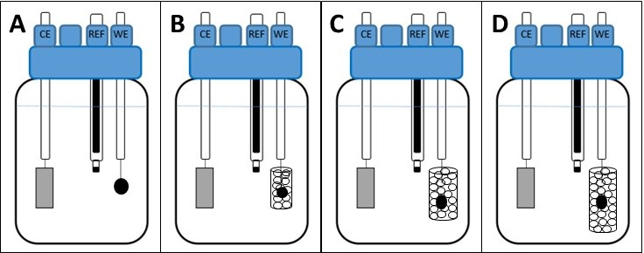

Figure 1: Schematic representation of the bioelectrochemical systems with four different anodes: (A) single granule, (B) small packed bed, (C) medium packed bed and (D) big packed bed. CE: Counter Electrode; REF: Reference electrode; WE: Working Electrode.

* + 1. Cyclic Voltammetry and EASA calculation

Cyclic voltammetries (CV) were performed at the anode between +0.4 to -0.3 V vs SHE at 9 different scan rates 200 – 100 – 60 – 50 – 40 – 30 – 20 – 10 – 1 mV/s. The CVs were conducted before the inoculation, using the same medium, setting the same distance between the electrodes, using identical counter electrodes whereas different granules in order to calculate their electroactive surface area (EASA). To calculate the specific capacitance (necessary to calculate the EASA) a preliminary test was made using two anodes with a known electroactive surface area, with the same settings as the one used for the four BESs (same distance between the electrodes, same scan rates, same medium, same vertexes, identical counter electrodes).

*Table 1: Main parameters calculations*

|  |  |
| --- | --- |
| **Specific capacitance (F/cm2)**   * **AreaCV (A\*V):** Area of the cyclic voltammetry * **ΔV (V):** Difference between the CV’s vertexes * **EASA (cm2):** Anodic known surface area * **rscan (V/s):** CV’s scan rate | $$C_{sp}=\frac{{Area}_{CV}}{\frac{2ΔV*EASA}{r_{scan}}}$$ |
| **EASA (cm2)** |  |
| **Current density (A/m2)**   * **ipeak(µA):** Maximum of electric current generated by the anode. * **10000 (cm2/m2):** Conversion factor cm2 🡪 m2 * **1000000 (µA/A):** Conversion factor µA 🡪 A |  |

* 1. Results and discussion
     1. Calculation of the EASAs through Cyclic Voltammetry technique

The CV technique allows to calculate the electroactive surface area of the electrodes. Hence, the first set of CVs has been performed using two systems assembled with anodes with a known surface area (3 and 9.5 cm2). The linearisation of the CVs’ area *vs* the scan rate gave as a result a specific capacitance of 202 ± 12 µF/cm2 (or µC/Vcm2). Subsequently, CVs were performed with granules with an unknown surface, applying the same experimental settings (i.e., scan rates, mineral medium, distance between electrodes, counter electrode, reference electrode). The four systems capacitances calculated after measuring the CVs’ areas, carried out at the 9 scan rates, resulted 13.5, 10.5, 10.1 and 9.8 mF for the granules to be used as single granule, inside the small, medium and big packed bed, respectively. Therefore, the EASAs resulted 67, 52, 50, 49 cm2, respectively. As shown in figures 2 and 3, the bigger the CV’s area, the higher the capacitance of the system will result.

*Table 2: Resulting Capacitances of the four granules and their calculated EASAs*

|  |  |  |  |  |
| --- | --- | --- | --- | --- |
|  | **Single granule** | **Small packed bed** | **Medium packed bed** | **Big packed bed** |
| **Capacitance (mF)** | 13.5 | 10.5 | 10.1 | 9.8 |
| **EASA (cm2)** | 67 | 52 | 50 | 49 |



Figure 2: Cyclic Voltammetries of the four anodes conducted at 100 mV/s.



Figure 3: Cyclic Voltammograms’ area of the granules obtained at different scan rates.

* + 1. Potentiostatic run at +0.20 V vs SHE

After a startup of the BESs which has been already described in the literature (Zeppilli et al., 2019a) the electroactive biofilms were fully formed and capable of producing a significant electric current. During the potentiostatic runs, the anodic potential was controlled with a three-electrode configuration at + 0.2 V vs SHE. The BESs received a fresh feeding solution every 5-7 days; therefore, fresh COD for the electroactive biofilm was periodically supplied, leading to higher oxidation rates and subsequently higher electric currents. Thus, these effects are clearly visible in figures 4A-B-C-D in which more than one current peak can be observed, due to many substitutions of the solution inside the glass bottles. The operating condition has been maintained for approximately 30 days which corresponded to about 4 replacements of the solution. The COD removal and its consequent decrease led to a lower current generation.

*Table 3: Bioelectrochemical performance of the cathodic biofilm during the two operating periods*

|  |  |  |  |  |
| --- | --- | --- | --- | --- |
|  | **Single granule** | **Small packed bed** | **Medium packed bed** | **Big packed bed** |
| **Average current (µA)** | 1152 ± 88 | 752 ± 66 | 698 ± 54 | 427 ± 47 |
| **Current peak (µA)** | 1824 | 1195 | 1129 | 756 |
| **Average current density (µA/cm2)** | 17.2 ± 1.3 | 14.5 ± 1.1 | 14 ± 1 | 8.7 ± 0.9 |
| **Current Peak density (µA/cm2)** | 27.2 | 23 | 22.6 | 15.4 |

Figures 4-A-B-C-D show how the packed bed negatively influenced the current generation. Increasing the volume of the non-conductive packed bed around the graphite granules, the electric current decreases. Table 3 shows how the graphite granules surfaces did not significantly modify the current generation, therefore, even if the currents are expressed in current densities the trend does not change significantly. Probably, the explanation of those results is a non-electroactive biofilm formation on the silica bed which consumes the COD present in the solution. A second reason why the packed bed affects the current generation could be the lower mass transport through the bed to the graphite granule’s surface. The decrease of the COD concentration inside the solution and on the graphite granule’s surface lowers the metabolic reactions of the electroactive biofilm and subsequently the current. It’s important to underline that the electric current is expressed as a velocity (A = C/s), therefore a lower electric current indicates a slower metabolic bioreaction.

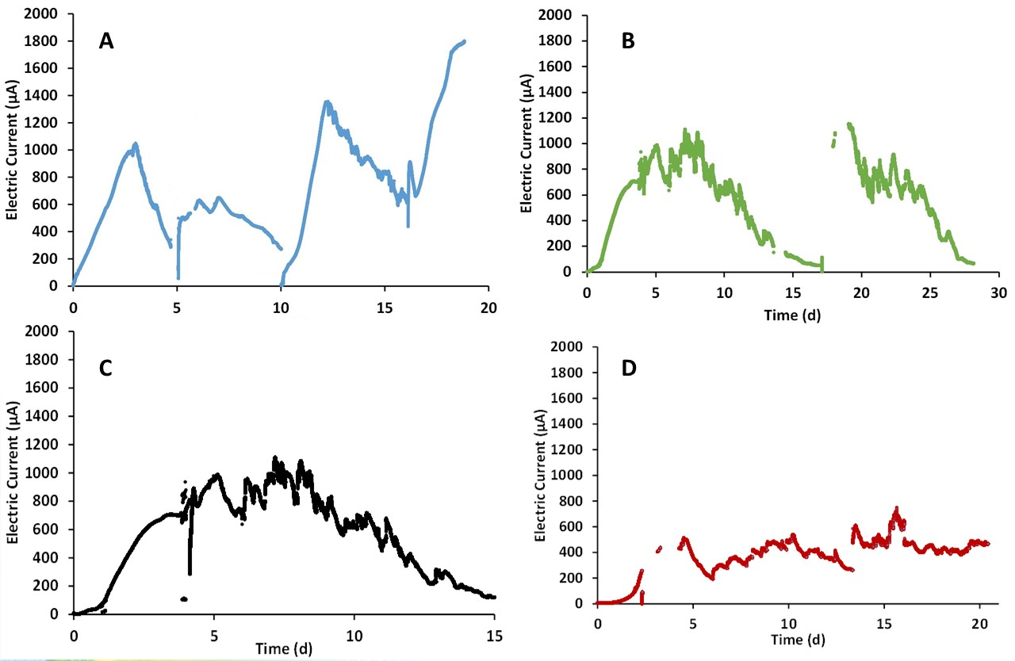

Figure 4: Electric current profile of (A) the single granule bioanode; (B) small packed bed anode; (C) medium packed bed; (D) big packed bed

* 1. Conclusions

The measurement of the EASA was successfully carried out measuring the CVs’ areas conducted at different scan rates. After the start up period, the electroactive biofilms on the granules produced electric current but with different intensities. The significant differences between the electric current generated by the electroactive biofilm were due to the mass transport limitation generated by the packed bed and by the non-electroactive biofilm grown on the bed. Moreover, this non-electroactive biofilm reduced the COD concentration also in the solution inside the reactor, lowering in two manners the COD availability for the electroactive biofilm. To conclude, this experiment demonstrates the need of using conductive materials inside BESs, not only as electrodes but also as fixed bed for supporting the biofilm formation. Those results imply that for a scaled up BES, big electrodes with the highest electroactive surface are necessary. Therefore, relative high investments are needed to build big systems.

References

Angelidaki, I., Treu, L., Tsapekos, P., Luo, G., Campanaro, S., Wenzel, H., Kougias, P.G. 2018. Biogas upgrading and utilization: Current status and perspectives. Biotechnology Advances, 36(2), 452-466.

Cheng, S., Logan, B. 2013. Electromethanogenic reactor and processes for methane production, Google Patents.

Cristiani, L., Zeppilli, M., Porcu, C., Majone, M. 2020. Ammonium Recovery and Biogas Upgrading in a Tubular Micro-Pilot Microbial Electrolysis Cell (MEC). Molecules, 25, 2723.

Cristiani, L., Zeppilli, M., Villano, M., Majone, M. 2021a. Role of the organic loading rate and the electrodes’ potential control strategy on the performance of a micro pilot tubular microbial electrolysis. Chemical Engineering Journal, 426

Cristiani, L., Ferretti, J., Zeppilli, M. 2021b. Electrons recycle concept in a microbial electrolysis cell for biogas upgrading. Chemical Engineering & Technology,

Zeppilli, M., Cristiani, L., Dell’Armi, E., Majone, M. 2020. Bioelectromethanogenesis reaction in a tubular Microbial Electrolysis Cell (MEC) for biogas upgrading. Renewable Energy, 158, 23-31.

Zeppilli, M., Matturro, B., Dell’Armi, E., Cristiani, L., Petrangeli Papini, M., Rossetti, S., Majone, M. 2021a. Redictive/oxidative sequential bioelectrochemical process for Perchloroethylene (PCE) removal: effect of the applied reductive potential and microbial community characterization. Journal of Enviromental Chemical Engineering,

Zeppilli, M., Cristiani, L., Villano, M., Majone, M. 2021b . Carbon Dioxide Abatement and Biofilm Growth in MEC equipped with a packed bed adsorption column. Chemical Engineering Transaction

Zeppilli, M., Cristiani, L., Ferretti, J., Majone, M., Villano, M. 2022. Acetogenic Inoculum Selection for Acetate Production from Waste Biomasses via Thermal Shock Treatment. Chemical Engineering Transaction