CHEMICAL ENGINEERING TRANSACTIONS  VOL. XX, YYYY | A publication of
The Italian Association
of Chemical Engineering
Online at www.cetjournal.it

Guest Editors: xxxxxxxxx
Copyright © 2023, AIDIC Servizi S.r.l.
ISBN 979-12-81206-xx-y; ISSN 2283-9216

Catalytic Steam Hydrolysis of Polyethylene Terephthalate to Terephthalic Acid followed by Repolymerisation
Hubertus Warsahartana^{a,}*, Abdulrahman Bashir^{b}, Adam Keyworthª, Ryan Daviesª, Marta Falkowskaª, Edidiong Asuquoª, Stephen Edmondson^{b}, Arthur Garforthª
ªDepartment of Chemical Engineering, The University of Manchester, Manchester, M13 9PL, UK
^{b}Department of Materials, The University of Manchester, Manchester, M13 9PL, UK
hubertus.warsahartana@manchester.ac.uk
A novel industrial cleaning process (DEECOM®, B&M Longworth, Blackburn) hydrolyses polyethylene terephthalate (PET) on contaminated filters using superheated steam at elevated temperature and pressure (300°C and 3 barg). The technology is being adapted to depolymerise waste textiles. This study first involved an assessment of the current large-scale cleaning process’ PET conversion and yield of terephthalic acid (TPA). Then a zinc chloride homogenous catalyst, and, zinc and platinum loaded zeolite beta heterogeneous catalysts, were investigated using a laboratory-scale autoclave reactor to mimic the process. In addition, the industrial waste stream of crude terephthalic acid (TPA) was then purified, repolymerised into PET via the dimethyl terephthalate (DMT) synthesis route, characterised and compared with commercial PET data. Characterisation methods of the repolymerised PET include DSC, TGA, GPC. While still a work in progress, this shows proof-of-concept in terms of closing the loop and moving to a circular economy.
  - Introduction
Synthetic polymers have become an integral part of modern life due to their many customisable properties. However, many polymer applications are single use, meaning products are often landfilled. Through landfilling, these polymers are known to pollute the environment, to the detriment of both human and animal health. (Alabi et al., 2019) Mechanical recycling has found success in recirculating a variety of polymer waste streams, but continually reduces the value of the recycled polymer due to declines in crystallinity, molecular weight, colour quality, etc after each cycle. (Rodriguez et al., 2014) Furthermore, contamination in mechanical recycling can present a significant challenge in re-extrusion. (Tocháček et al., 2021) Chemical recycling can return the waste polymer to its original monomers for repolymerisation. (Wang et al., 2022)

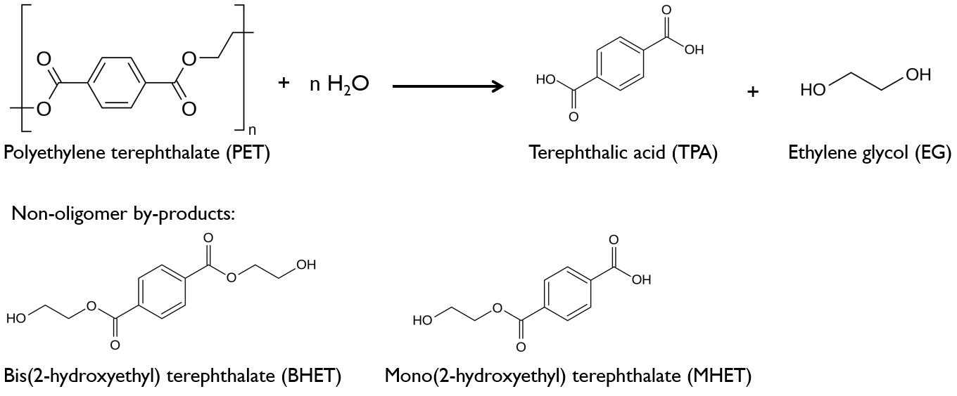
Figure 1: Hydrolysis of PET, and potential non-oligomer products
A novel cleaning process (DEECOM®, B&M Longworth) for the removal of polymer from industrial components has been found to depolymerise polyethylene terephthalate (PET) into terephthalic acid (TPA) and ethylene glycol (EG), despite being unoptimised to do so. DEECOM® is a batch process in which the industrial component contaminated with polymer is suspended in a vessel and exposed to cycles of superheated steam compression and decompression. The high temperature melts the polymer and pulses of steam penetrates the porous components and pushes the polymer melts out. The polymer melt (including TPA if the polymer was PET) collects at the bottom of the vessel and is emptied after each run. In the typical conditions of DEECOM® (300 °C, 3 barg), the EG formed boils out of the reactor. It is condensed later in the process along with the constant steam flow, causing the EG to be highly diluted. Therefore, EG is not recovered at the current process. Sublimation of TPA occurs to a certain extent, but the sublimed TPA can be largely recovered via a cyclone after the reactor.

Due to the prevalence of polyester’s use as face fibres in carpets (approx. 60 wt% of total carpet), DEECOM® is being investigated as a solution to carpet waste through the chemical recycling of polyester fibres. Previous studies on DEECOM® have only focused on the recycling of carbon fibres and composites, and no formal studies have previously been conducted on DEECOM® for the recycling of polymers. This initial study aims to first determine the current extent of conversion of PET and yield to TPA of typical filters being cleaned in DEECOM®, assess the viability of catalyst use in neutral hydrolysis of PET, and whether crude TPA from DEECOM® can be purified and repolymerised to PET.
  - Materials and methods
Reagent grade hydrochloric acid solution (37 vol%), sodium hydroxide pellets and PET pellets (containing 30 wt% glass reinforcer) were supplied by Sigma Aldrich. PET fibres were supplied by a local carpet manufacturer but were produced by AYM syntax Ltd. Zeolite beta (product code – CP814E, Si/Al 12.50) was purchased from Zeolyst International. Zinc nitrate hexahydrate, tetraamineplatinum(II) chloride hydrate, methanol, EG, sulfuric acid, and zinc acetate dihydrate were attained from Sigma Aldrich.
    - Catalyst preparation
The heterogeneous catalysts Zn zeolite-𝛽 (10 wt%) and Pt zeolite-𝛽 (1 wt%) were prepared by impregnation. Zeolite-𝛽 was added to zinc nitrate and tetraamineplatinum (II) chloride solutions respectively (10 g zeolite per 100 ml of solution). The mixtures were agitated for 24 h to ensure thorough mixing. Afterwards, the mixtures were centrifuged (20 min, 4000 rpm) to separate the solid phase, which was then dried in an oven at 80 °C for 24 h. The solids were deposited into an evacuable pellet die and compressed into discs withstanding 5 tons. The discs were then milled and sieved to collect the desired size range of 212 to 500 µm powders. Catalyst activation was conducted in a split tube furnace using hydrogen gas (5 ml min⁻¹) to a temperature of 500 °C for 16 h. The ZnCl₂ homogeneous catalyst was prepared by dissolving ZnCl₂ (4 g) in deionized water (36 ml).
    - Recrystallisation (purification of TPA)
Typically, a product mixture following depolymerisation will contain some or all of: PET, TPA, BHET, MHET, EG, water, insoluble contaminants. To determine the conversion of PET and yield to TPA, the unreacted PET and TPA produced need to be isolated through recrystallisation.

Firstly, the mixture is washed with excess water to remove the moderately soluble BHET and MHET. Then, 1M NaOH solution is added to the product mixture to dissolve the TPA and filtered to remove the unreacted PET and any insoluble impurities or heterogeneous catalyst. The TPA was then precipitated by adding 2M HCl to the filtered solution, and the resulting wet solids (unreacted PET and impurities, TPA) dried separately. The conversion of PET and yield to TPA was determined using the following equations by mass.
$${Conversion}_{PET}\left(\%\right)=\frac{{PET}_{in}-{PET}_{out}}{{PET}_{in}}×100$$ | (1)
$${Yield}_{TPA}\left(\%\right)=\frac{{TPA}_{out}}{{TPA}_{theoretical maximum}}×100$$ | (2)
    - Evaluation of commercial filter cleaning process
Four industrial polymer filters (F14, F15, F16, F19) were sent to B&M Longworth for cleaning. Each of them weighed around 380 kg and contained roughly 50 kg of PET and other inorganic contaminants (varied from filter to filter). The filters were cleaned using superheated steam (300 °C, 3 barg) for 16 hours each. As the process operates above the boiling point of EG, it is not recovered and instead sent off as waste. This process removes over 95 % of the PET and contaminants from the filters and collects at the bottom of the vessel as a solid-liquid mixture. Solids were also collected from the cyclone bottoms. After each cleaning run, these mixtures were dried, weighed, and homogenised. Samples of the homogenised mixture were recrystallised to determine the conversion of PET and yield to TPA. The filters were weighed before and after DEECOM® cleaning to calculate how much PET was initially present.

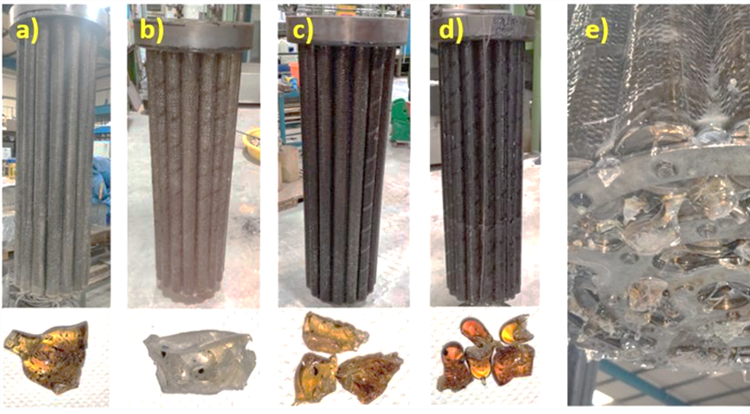
Figure 2: Filters contaminated with PET and other materials a) F14, b) F15, c) F16, d) F19, e) F15 close-up
    - Depolymerisation experiments
PET fibres and deionized water (40 g) were loaded into a 600 ml hastelloy autoclave reactor (Parr Instruments) along with the required catalyst (1 g for heterogeneous catalysts). For the homogeneous catalyst experiment the 40 g of water was replaced with 40 g of catalyst solution. The reactor was then heated to 250 °C generating an autogenous pressure of 41 bar. Each reaction was carried out for 2 hours with agitation. Once cooled, the product mixture is recrystallised as above.
    - Repolymerisation and characterisation
TPA (15.58 g) from DEECOM® was recrystallised as previously outlined. Then, the procedure to create PET by Cammidge (1999) was followed.
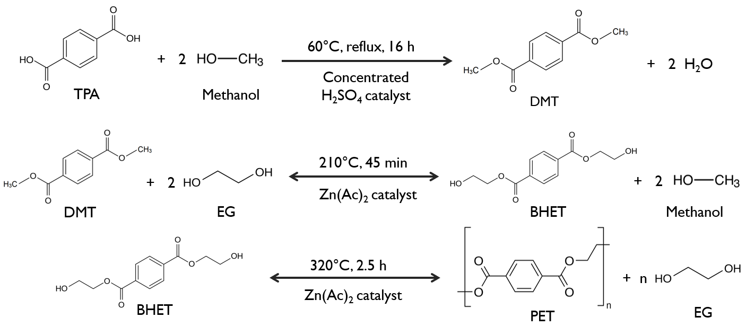
Figure 3: PET repolymerisation via the DMT route
The TPA was refluxed with methanol (200 ml, 60 °C for 16 hours) in the presence of concentrated sulfuric acid (5 ml). The resulting solid was filtered and purified by dissolution in methanol, decanted to remove insoluble impurities and the DMT precipitated was then dried in a vacuum desiccator. DMT (5 g) and EG (80 ml) were reacted to form bis(2-hydroxyethyl) terephthalate (BHET) in the presence of a zinc acetate dihydrate catalyst (8.5 mg) at 210 °C for 45 min. The resulting mixture was chilled to ‒24 °C (below the freezing point of EG) overnight which allows BHET crystals to form. The mixture is then warmed to ambient temperature and filtered, producing 11.51 g of BHET crystals. The BHET crystals (6.15 g) were then heated at 320 °C for 2.5 h with zinc acetate dihydrate (2.1 mg) catalyst to form PET.

Thermogravimetric analysis (TGA) and differential scanning calorimetry (DSC) was done on the resultant PET at 25 °C min⁻¹ under N₂ (TA instruments SDT 650). Gel permeation chromatography (GPC) measured the molecular weight of the PET sample (Agilent 1260 Infinity Diode Array GPC, chloroform solvent). 13 mg of PET was dissolved in 120 µl of 1,1,1,3,3,3-hexafluoroisopropanol (HFIP), and afterwards 1880 µl of chloroform was added to give a concentration of 6.5 mg ml⁻¹. (Moad et al., 1997)
  - Results and discussion
    - Commercial filter cleaning results
The analysis of the PET filters post cleaning (Figure 4) revealed that despite inconsistent levels of contamination,

Figure 4: PET conversion and yield to TPA through the DEECOM® process (300 °C, 3 barg steam)
and significant impurities present on the filters, there was a consistent hydrothermal non-catalytic conversion of PET and yield ~80 %. The moderately high conversion and yields plus tolerance to contamination levels highlights the potential of this technology in waste processing, especially for carpets which often contain many other components in addition to PET. However, the long process times negatively impact the energy efficiency of the system and catalysts were assessed for this reaction.
    - Assessment of catalysts
The laboratory experiments were designed to look at hydrolysis of different PET forms (pellets mimicking the PET on filters and carpet fibres), comparing a homogeneous versus heterogenous catalyst (ZnCl₂ vs Zn-β), and also considering the active metal (Zn vs Pt).

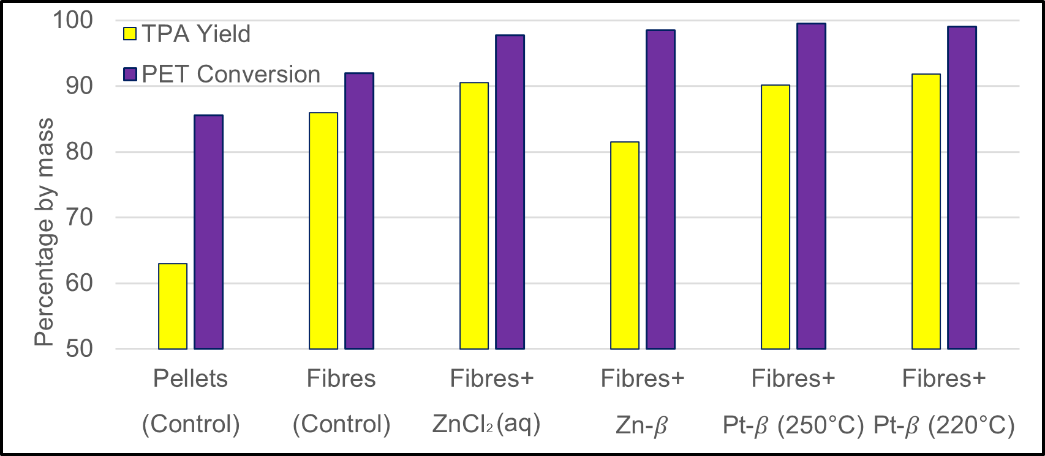
Figure 5: Conversion and yield to TPA of 10 g of PET, 40 g of water, for 2 h at 250 °C and 41 bar (except for the last experiment - 220 °C and 23 bar)

The non-catalysed control experiment with pellets (Figure 5), resulted in an 85 % PET conversion and 63 % yield to TPA. When switching to fibres, the conversion increased slightly to 93 %, while the yield significantly to 86 %, likely due to the higher surface area allowing for more hydrolysis to occur within the 2 h reaction time, a conclusion also reached elsewhere. (Mishra et al., 2003)

Upon the addition of any catalyst, the conversion increased slightly but consistently to near 100 %. Zinc was chosen as it is commonly used in industry to catalyse the esterification reaction between TPA and EG to form BHET before the polymerisation step to form PET. As this reaction is reversible, zinc has been found to catalyse the reverse reaction as well in previous studies in the form of zinc acetate (homogeneous). (Kamal et al., 1994) When comparing the zinc catalysts, the homogenous catalyst performed better with a 10% higher yield than the heterogeneous Zn-β. This is likely because of the nature of homogeneous catalysts being far less hindered in providing access to its active sites allowing for a faster reaction. The near 100 % conversion suggests that most of the PET was broken down into chains shorter than oligomers, but that some ester bonds remained unbroken as the yield was lower.

When comparing Zn vs Pt as the active metal, Pt was superior, having results closely matching the homogeneous ZnCl₂ catalyst. Interestingly, dropping the temperature to 220 °C for Pt-β did not reduce the conversion or yield. Overall, however, the non-catalytic or control experiments suggested from an industrial view that the purchase of catalysts were at present not justified.
    - Repolymerisation of crude TPA
The repolymerisation using the TPA produced from DEECOM® filter cleaning showed that the PET produced has characteristics in good agreement with literature, having a main degradation stage within 400 and 500 °C,

Figure 6: TGA of repolymerised PET compared to literature data
followed by a very slow degradation step which begins at approximately 20 wt% (Figure 6). This slow step is attributed to the formation of stabilized compounds from interlinking of PET decomposition products. (Adnan et al., 2015) An absence of any other degradation stages suggests the PET sample has no significant impurities. The DSC and GPC results will have implications on not only the resulting PET’s quality, but also its processability (Table 1). The molecular weight distribution (MWD) affects the polymer’s flow viscosity. Having a similar melting
Table 1: DSC and GPC results comparing the repolymerised PET to literature data for fibre-grade PET (DSC data from Demirel et al., 2011, GPC data from Farah et al., 2015)
Sample | T_{c} (°C) | T_{m} (°C) | M_{w} (g mol⁻¹) | M_{n} (g mol⁻¹)
Repolymerised PET | 149 | 247 | 29900 | 3000
Fibre-grade PET | 150 | 248 | 33700 | 20000

temperature and MWD to commercial PET would mean that the repolymerised PET can be a drop-in replacement for virgin PET. The crystallinity and melting temperatures have good agreement with literature. While the weight average molecular weight (M_{w}) approached that of commercial PET, the polymerisation was not fully completed leading to a low number average molecular weight (M_{n}). This incomplete polymerisation was due to the necessity of low to atmospheric pressure in the laboratory synthesis (DMT) route chosen. Future work will adapt the high pressure autoclave used in depolymerisation for repolymerisation via the TPA synthesis route which would require pressures of around 3 bar.
  - Conclusions
In summary, the present work has determined that the superheated steam industrial cleaning process (300°C, 3 barg, 16 hours) provides a consistent PET conversion and yield to TPA of approximately 80% across four filters with the presence of contaminants. Heterogeneous catalysts 10 wt% Zn-β and 1 wt% Pt-β and homogeneous catalyst ZnCl₂ were assessed for the neutral hydrolysis of PET in a laboratory scale reactor. The catalysts showed only a marginal improvement over the control experiment, and thus determined to be not worth the potential costs at present. Crude waste TPA from the industrial process was purified and repolymerised to PET via the DMT synthesis route. The TGA results showed the resulting PET was of a good purity, and through DSC the crystallisation and melting temperatures were found. They also showed good agreement with literature. The number and weight average molecular weights of the repolymerised PET were found through GPC. While the M_{w} neared that of commercial PET, there is room for improvement with the M_{n}.

Being an industrial pilot study, optimization of the process conditions to allow for kinetic data to be generated was difficult. This would form part of a further study looking at the hydrolysis reaction at lower conversions to more closely study the extent of the effects of feedstock surface area, compression and decompression pressures, temperature, and catalyst types. This work involves taking what traditionally would be a waste stream and returning it back into a near-virgin quality product. The work carried out here demonstrates the feasibility in simultaneously diverting landfill waste and turning it into a valuable material once again, exhibiting closed-loop circularity.
Nomenclature
T_{c} – crystallisation temperature, °C

T_{m} – melting temperature, °C
PET_{in} – mass of PET before experiment, g
PET_{out} – mass of PET after experiment, g
TPA_{out} – mass of TPA after experiment, g
TPA_{theoretical maximum} – Maximum amount of TPA assuming all PET_{in} was converted to TPA, g

Acknowledgments
The authors would like to express their gratitude to Innovate UK for funding the project under the Knowledge Transfer Partnership Scheme (KTP no. 11708) and to John Norris and the people at B&M Longworth for their continued support.
References
Adnan, Shah J., Jan M.R., 2015, Effect of polyethylene terephthalate on the catalytic pyrolysis of polystyrene: Investigation of the liquid products, Journal of the Taiwan Institute of Chemical Engineers, 51, 96–102.
Alabi O.A., Ologbonjaye K.I., Awosolu O., Alalade O.E., 2019, Public and Environmental Health Effects of Plastic Wastes Disposal: A Review, Journal of Toxicology and Risk Assessment, 5(1).
Cammidge A.N., 1999, An Undergraduate Experiment in Polyester (PET) Synthesis, Journal of Chemical Education, 76(2), 236-237.
Campanelli J.R., Cooper D.G., Kamal M.R., 1994, Catalyzed hydrolysis of polyethylene terephthalate melts, Journal of Applied Polymer Science, 53(8), 985–991.
Fox B., Moad G., van Diepen G. Willing, I., Cook, W.D., 1997, Characterization of poly(ethylene terephthalate) and poly(ethylene terephthalate) blends, Polymer, 38(12), 3035–3043.
López M. del M.C., Ares Pernas A.I., Abad López M.J., Latorre A.L., López Vilariño J.M., González Rodríguez M.V., 2014, Assessing changes on poly(ethylene terephthalate) properties after recycling: Mechanical recycling in laboratory versus postconsumer recycled material, Materials Chemistry and Physics, 147(3), 884–894.
Mishra S., Zope V.S., Goje A.S., 2003, Kinetics and thermodynamics of hydrolytic depolymerization of poly(ethylene terephthalate) at high pressure and temperature, Journal of Applied Polymer Science, 90(12), 3305–3309.
Tochácek, J., Gregor, J., Kropác, J., Pavlas, M., Poul, D. and Ucekaj, V., 2021, Plastics Recycling as a Part of Circular Economy, Chemical Engineering Transactions, 88, pp.1303–1308.
Yang R., Xu G., Dong B., Hou H., Wang Q., 2022, A ‘Polymer to Polymer’ Chemical Recycling of PLA Plastics by the ‘DE–RE Polymerization’ Strategy, Macromolecules, 55(5), 1726–1735.

