CHEMICAL ENGINEERING TRANSACTIONS  VOL. , 2023 | A publication of
The Italian Association
of Chemical Engineering
Online at www.cetjournal.it

Guest Editors: Sauro Pierucci, Jiří Jaromír Klemeš
Copyright © 2023, AIDIC Servizi S.r.l.
ISBN 978-88-95608-98-3; ISSN 2283-9216

Controlled Hydrodynamic Cavitation for Reduction of Toxic Metals in Metallurgical Residual Effluents
Harold Matos Maldonado^{a,*}, Elmer Benites-Alfaro^{b}
ªUniversidad Nacional Mayor de San Marcos, UPG FIGMMG, Av. Venezuela S/N, San Miguel, Lima Perú Perú
^{b} Universidad César Vallejo, Fac. de Ingeniería, Escuela de Ing. Ambiental, Av. Alfredo Mendiola 6232 Lima 15314, Perú
*corresponding author: harold.matos@unmsm.edu.pe
Wastewater must be treated before being disposed in receiving bodies, in order not to cause negative impacts on the environment. The goal of this research was to determine the effectiveness of treating metallurgical industry wastewater with controlled hydrodynamic cavitation (HC) in terms of removing metals, total suspended solids, and sulphates. A sample of wastewater was collected from a polymetallic (lead, coper and zinc) mineral processing facility in Peru and treated using a cavitation system. The system controlled flow, time, and pressure for 1.5 hours at 5 and 9 bars of pressure and temperatures between 22 and 64.4 ºC. The results showed that hydrodynamic cavitation effectively reduced the levels of metals, total suspended solids, and sulphates, with the best results achieved between 60 and 90 minutes of treatment at 9 bars of pressure. With an average removal of 73.6 %. for metals, 52.1 % for total solids in suspension, 3.9 % for sulphates and pH reduction of 14.7 %. This indicates that hydrodynamic cavitation is one of the sustainable technologies for wastewater treatment and low cost of operation and maintenance.
  - Introduction
The development of wastewater treatment techniques resulting from the discharge of polymetallic sulfide minerals (copper, zinc, silver, lead and derivatives) in discharge plants, is one of the most critical operational, environmental and economic processes for a mining company (Carrillo and Guillen, 2018). Its actions are associated with the goal of generating the smallest ecological footprint (Lamana and Aja, 2010), significantly improving the water-energy nexus (Golam and Bikash, 2016), the reuse of industrial effluent, the reuse and recycling of water, which are necessary processes due to reasons related to water scarcity, proper management of effluent discharge to tailings, and water supply management (Araya et al., 2021).
In Peru, there is no precedent for controlled Hydrodynamic Cavitation (HC) research for wastewater from metallurgical effluent, so this exploration is of special interest to evaluate the behaviour and performance of HC in the removal or reduction of metal contaminants from polymetallic mineral treatments (concentrates of lead, copper, zinc and others); the literature reports cavitation techniques in the forms of hydrodynamic, acoustic or ultrasonic, optical and particle (Gutiérrez-Mosquera et al., 2019).
Hydrodynamic cavitation (HC) has become a promising new non-traditional technology for the (Wan et al., 2021), treatment of different products, by-products, agro-industrial residues and elimination of heavy metals from wastewater (Yuequn et al., 2016), (Sun et al, 2021), (Wan et al., 2021), (Baowei et al., 2021), (Pugazhenthiran et al., 2016), based on the generation of a large number of bubbles in the fluid that favors chemical and/or physical modifications in the system, have an adequate scaling potential and have a high degree of associated technological development (Agarkoti, Thanekar and Gogate, 2021), validated by comparison experiments of the effectiveness of acoustic and hydrodynamic cavitation in combined treatment schemes for degradation of dye wastewater carried out by Gogate and Bhosale (2013); for their part, Carpenter et al., (2017), claims greater energy efficiency for the treatment of various bio refractory and metal contaminants present in aqueous effluents. Pandit et al., (2021), also indicates that hydrodynamic cavitation events create extreme conditions in a localized "bubble collapse" region, causing the water to break down and Hydroxyl (OH) and Hydrogen (H) free radicals to emerge (Dular et al., 2016), highly reactive by dissociation of the molecule, thus breaking down solid substances (heavy metals) through shock waves and high-speed microscopic jets that are useful for many chemical and physical transformation processes; that is, the HC process involves the formation, growth, implosion and subsequent collapse of cavities, which takes place in a very short period of time and releases large amounts of energy (Mancuso et al., 2020). The performance of HC is influenced by parameters such as: the physico-chemical properties (Dindar.2016) referred to pH, initial metal concentration, temperature, etc., pump inlet pressure (Patil and Gogate, 2012), flow rate and time (Benito and Arrojo, 2006), to the design of the reactor to obtain high energy efficiency, proper operation and facilities for industrial scaling (Tao et al., 2016).
The statistics of the National Water Authority (ANA) in Peru, on authorized industrial wastewater discharge for 2020 reached a total of 624,001,728.00 m³ (Carhuavilca and Sanchez, 2021), of which 24% (150,618,573.00 m³) corresponded to the mining sector, not specifying how much of these waters come from old mining drainage, mine drainage, flotation plants, cyanidation, smelting-refining, etc. The described volume has an upward trend, as for the year 2022, according to the Ministry of Energy and Mines (MEM), 63 projects were underway in 17 regions of the country and involved an investment of US$586 million (Palacios et al., 2022). Given this perspective, the objective of the research was to use HC to reduce the metal concentrations of polymetallic mining wastewater and the suspended solids that cause mud in the flotation processes, seeking to convert industrial waste into usable resources as they have recoverable elements, such as clean water, energy, and materials (Castañeda and Rodriguez, 2017). As a result, it would generate environmentally sustainable mining to help the industry comply with the environmental regulations established in D.S. 010-MINAM, Maximum Permissible Limits (LMP) for the discharge of liquid effluents from Mining-Metallurgical Activities), which is rigorously audited by the Environmental Assessment and Regulation Organism - OEFA (Cerna, 2021)
  - Methodology
    - Wastewater sample
For the research, 271 L of wastewater were used obtained with simple random sampling with a homogeneous population, where each sample has an equal probability of being chosen (Hernández and Escobar, 2019) from the discharge pipes of the concentrating plant to the tailing’s deposits with a composition of 35 % solids and 65 % water. Information was obtained that the average head grades with which the mine mineral entered the processing plant was 7.4 oz Ag, 0.97 % Pb, 0.8 % Zn, and their metallurgical balances showed recoveries of 92.5 % for Ag, 85.7 % for Pb and 73.6 % for Zn; the residual effluent after being processed by differential flotation showed grades in the tailings of 0.308 oz of Ag, 0.1 % Pb and 0.09 % Zn, but the presence levels of other metals, sulfates or oxides accompanying polymetallic minerals are unknown.
    - Hydrodynamic Cavitation System
For the wastewater treatment tests, a prototype hydrodynamic cavitation system was used with main components: a 10 m³/h and 10 bar pressure multi-stage centrifugal pump, a rectangular stainless steel Venturi cavitation device, a multiple-hole stainless steel orifice plate cavitation device, an ozone generator, a digital pH meter, a cooling system, a 25-liter stainless steel tank whose function is to dampen the turbulence of the process, a 25-liter enchased stainless steel tank for cooling and temperature, flow rate and pressure control devices.
    - Hydrodynamic Cavitation
Figure 1 shows the hydrodynamic cavitation (HC) process, which involves the formation, expansion and collapse and implosion of bubbles that occurs in periods of milliseconds or microseconds, releasing a large amount of energy in a minimum period of time (Schmid and Friedl, 2016). The high temperatures and pressures that are produced as a result of the hot spot, combined with the pressure jets of liquid that arise as a mechanical consequence of the implosion (Gutiérrez et al., 2019), directly destroy some contaminants (Dindar, 2016). In the figure, it can be appreciated from the formation of bubbles as the pressure decreases, the rupture of the bubble at the weakest point, the entry of water into the space occupied by the vapor and the subsequent micro-jet that breaks the remains of the bubble.
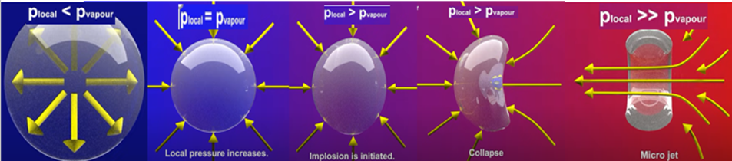
source: Graphic Adapted Cavitation - Easily explained, IET Institute for Energy Technology
Figure 1: Hydrodynamic cavitation, bubble formation process and implosion.
    - Treatment parameters
Flow: The wastewater was driven by an electric pump at a constant flow rate of 80 lt/min towards the cavitation chamber.
Pressure: The minimum outlet pressure was between 0.4 and 0.5 bar (which corresponds to the pressure drop below the vapor pressure) which allows the presence of cavities, as it affects the amount of cavity nuclei formed and the maximum size reached by each one. This parameter depends on the fluid velocity in the throttling device, which in turn is a function of the throat design and the liquid, volumetric flow (Arrojo and Benito, 2008).
Time: The monitored time periods were at 0, 30, 60, and 90 minutes. Low pressures are achieved in the throat of the cavitating device (figure 2). By the principle of Bernoulli's equation, the high velocity in the throat (>45 m/s) allows a pressure drop below the vapor pressure of water to be obtained, as can be seen in figure graph No. 3.
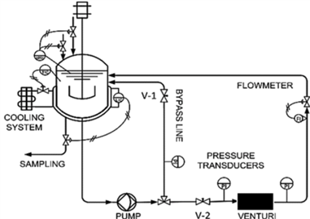  Source: Capocelli et al., (2014)  Figure 2: diagram, cavitation system | 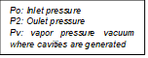  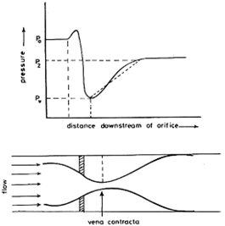  Source: Moholkar et al., (1999).  Figure 3: Mechanism of pressure recovery across an orifice
    - Analysis of treated samples
Wastewater from polymetallic mining was introduced into the HC system, and samples of this wastewater were collected during the HC process at various times. These samples were analyzed for total suspended solids (TSS), pH, SO₄, and total metals, according to laboratory testing methods (SGS - Inacal DA, 2021).
  - Results and Discussion
    - Metal Removal Efficiencies
Table 1 shows the initial values of the metals before treatment with HC in columns E1 and E2 and the concentrations of the metals throughout the treatment process in columns S2-30, S2-60, and S2-90 for the treatment of metallurgical effluent subjected to HC for 30, 60, and 90 minutes respectively. Pyrite (FeS₂) is the most impactful mineral in generating sulphide drainage due to its high acidification potential when it reacts with water under oxidizing conditions (Grieco et al, 2021).
Table 1: Metal concentration (ppm) at 9 and 5 bar
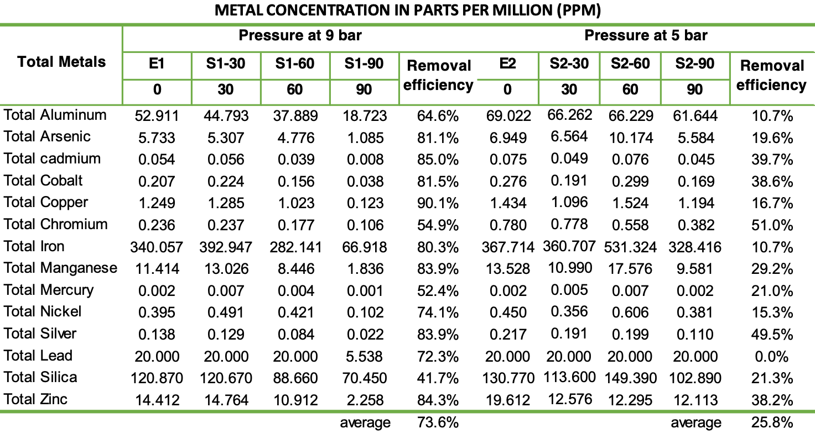
The removal of metal concentration, at pressures of 5 bar, reached greater efficiency at 90 minutes of HC, highlighting Cr (51 %), Ag (49.5 %), Cd (39.7 %) and Co (38.6 %), Zn (38.2 %) and in a lower percentage Si, Mn, Hg, As, Cu, Ni, Fe, Al. Lead, which remains unchanged (20 ppm) at 30, 60, and 90 minutes.
When subjected to 9 bar of pressure, metallurgical effluents had a removal efficiency in Cu (90.1 %), Zn (84.3 %), Ag (83.9 %) and Mn (83.9 %), Cd (85 %), As (81.1 %), Co (81.5 %) Fe (80.3 %), Ni (74 %), Pb (72.3 %), Si 41.7 %, among the most important.
The results evidence the effects that hydrodynamic cavitation causes on the degradation of various metal substances in metallurgical wastewater, it is a product of this non-traditional technology that causes the water to break down and in turn generates free radicals of hydroxyl and hydrogen that act on solid sulfide molecules (heavy metals) causing a reduction in the metal concentration through shock waves and high-speed microscopic jets that oxidize the unwanted compounds (Carpenter et al., 2017), in general, HC combined with oxidation processes seem to be an effective treatment strategy that can be successfully implemented at an industrial scale. The energy released during the cavitation phenomenon has several applications and, in particular, can be used to activate persulfate (PS) and peroximonosulfate (PMS) (Fedorov et al., 2021), HC was also applied for the extraction of chromium ions (Bolne et al., 2021), cobalt from wastewater (Parbat et al., 2020), and HC has even been used for the synthesis of nanoparticles with successful results.
    - Total Suspended Solids (TSS)
The residual effluents collected in the field were previously filtered through Tyler No. 325 mesh (0.043 mm) to retain and separate the particulate matter. After the HC treatment, the removal efficiencies of the TSS were 16 % at 5 bar (15810 +/- 3544 mg/l to 13280 +/- 3054 mg/l) and 52.1 % at 9 bars (15640 +/- 3597 mg/l to 7490 +/- 1723 mg/l). The finely dispersed air bubbles with hydroxide-air aggregate formation allow for effective elimination of hydroxide ions in the sediment (Viduetskiy et al., 2017).
    - Oxygen Potential (pH)
The input analysis of the metallurgical effluent before treatment indicated a degree of alkalinity with a pH of 9.96. Then, after being subjected to HC processes for 60 minutes, the alkalinity was reduced to 8.5, that is, it improved towards neutrality with a reduction of 14.7 %. This is probably due to there being no significant changes in dissolved oxygen, sulphates, flow, chlorides, alkalinity, and oils (García et al., 2019). This result is similar to research on the application of hydrodynamic cavitation in reducing the physical, chemical, and microbiological parameters of effluent from the textile and tanning industries, where a pH variation of 17.96 % and 18.6 % was achieved, respectively (Nieto, 2019). In this way, it is demonstrated that HC has effects on reducing alkalinity not only in metallurgical effluents but also in various industrial effluents. Furthermore, HC in a combined mode with other oxidation processes gave good results in reducing chemical oxygen demand (COD) (Thanekar and Gogate, 2019).
    - Sulfates (SO₄)
The presence of sulphates was determined by the presence of inorganic anions by ion chromatography in the samples after the HC treatment (Trujillo et al., 2009). Sulphates are directly related to the acidity generated by sulphide minerals (H₂SO₄) and are highly soluble because they have a high concentration of carbonates, bicarbonates and hydroxides (OH) (Foundation Chile, 2015). In Peru, in environmental regulations, the sulphate ion is not considered LMP for the discharge of effluents to receiving bodies.
At 5 bar of pressure the concentration of sulphates from 579.53 +/- 69.57 mg/l was reduced to 555.55 +/- 66.67 mg/l (3.9 % removal efficiency), while at 9 bar the concentration of sulphates was reduced from 557.08 +/- 66.85 to 530.51 +/- 64.38 mg/l with a removal efficiency of 1.7 %.
    - Advantages and importance of the HC method
Hydrodynamic cavitation processes do not require any kind of catalyst, as it is the water vapor itself that generates radicals, making it a non-complex technology with lower operating costs. The devastating impacts generated by metallurgical residual effluents on the environment or ecosystem could be mitigated by HC treatments in an efficient, effective, and innovative way, as one of its main benefits is a reduction in the concentration of heavy metals at lower operating costs than conventional technologies. Additionally, it does not use additional chemicals, does not require the help of ozone generators, and could have a positive impact on the reuse of mining wastewater, converting it from waste to resources in a circular economy context. Mining-metallurgical activities could be sustained over time as HC is a versatile method. For example, it can improve the physic-chemical parameters of effluents in the leather tanning industry, where, taking into account the cavitating element (orifice plate), there was a maximum removal of 32.6 % of the initial sulfur concentration without applying any chemical reagents (Agudelo Valencia et al., 2019I.
  - Conclusion
The reduction in metal concentration in metallurgical residual effluents is efficient by up to 90% for copper metal, using the controlled hydrodynamic cavitation process at 9 bar. Also, the physic-chemical properties of the metallurgical residual effluents vary in their metal concentration after the controlled HC process (pH, SST, conductivity), improving the environmental quality of the effluent. For example, reducing SST improves sedimentation and therefore takes up less volume in tailings deposits, extending their life and reducing their operating and maintenance costs. The HC was not efficient in removing SO₄, only achieving removal of between 1.7 % and 3.9 % at 9 and 5 bar, respectively. All results indicate that the use of HC has advantageous prospects in the treatment of mining wastewater, with a positive impact on the receiving bodies where this type of water is dumped, within an economically and environmentally sustainable process.

Acknowledgments

The authors thank Eng. Chemist Carlos Gamarra and the Company Promec Ingenieros S.A.C for providing the infrastructure and hydrodynamic cavitation equipment.
References
Agarkoti C., Thanekar P. D., Gogate P.R., 2021, Cavitation based treatment of industrial wastewater: A critical review focusing on mechanisms, design aspects, operating conditions and application to real effluents, Journal of Environmental Management, 300, 113786.
Agudelo-Valencia R. N., Ovalle-González D. P., Rodríguez-Rodriguez L. F., Camargo-Vargas G. de J., Almonacid-Jimenez, L. Y., 2019, Remoción de sulfuros presentes en el agua residual del proceso de curtido mediante cavitación hidrodinámica, Revista ION, 32(1), 21-33.
Araya N., Ramírez Y., Cisternas L. A., Kraslawski A., 2021, Use of real options to enhance water-energy nexus in mine tailings management, Applied Energy, 303.
Arrojo S., Benito Y., Martínez T., 2008, A theoretical study of hydrodynamic cavitation. Ultrasonic Sonochemistry, Volume 15, Issue 3, March 2008, pp 203-211.
Baowei W., Su H., Bojiin Z., 2021, Hydrodynamic cavitation as a promising route for wastewater treatment – A review. Chemical Engineering Journal 412, 128685.
Bolne P., Ghodke, S., Bhanvase, B., 2021, Intensified Hydrodynamic Cavitation-Based Process for the Production of Liquid Emulsion Membrane (LEM) for the Extraction of Chromium (VI) Ions. International Journal of Environmental Research 15(2), pp. 313-320.
Benito Y., Arrojo S., 2006, Treatment of industrial effluents by hydrodynamic cavitation. Center for Energy, Environmental and Technological Research (CIEMAT) 4.
Capocelli M., Musmarra D., Prisciandaro M.,Lancia A., 2014, Chemical effect of hydrodynamic cavitation: simulation and experimental comparison, Aiche journal 60, 7.
Carhuavilca B., Sanchez A., 2021, Perú, Yearbook of environmental statistics 2021, pp.386, National Institute of Statistics and Informatics.
Carpenter J., Badve M., Rajoriya S., George S., Saharan V. K., Pandit, A. B.,2017, Hydrodynamic cavitation: An emerging technology for the intensification of various chemical and physical processes in a chemical process industry. Reviews in Chemical Engineering, 33(5).
Carrillo L., Guillen F., 2018, Technical - economic evaluation of the disposal of mine tailings in the Tambomayo project using the filtered tailings method, instead of mineral pipelines, North Private University.
Castañeda S., Rodríguez JP., 2017, Model of sustainable use of organic solid waste in Cundinamarca, Colombia,Rev Univ. Salud. 2017;19(1):116-125.
Cerna E., 2021, The environmental policy of the maximum permissible limits (LMP) of mining effluents. Official Magazine of the Judiciary. Investigative Body of the Supreme Court of Justice of the Republic of Peru, 13(16), 175-189.
Dindar E., 2016 "An overview of the application of hydrodinamic cavitation for the intensification of wastewater treatment applications: A review," Innovative Energy & Research, vol. 5, pp. 137-143.
Dular M., Griessler B., Gutierrez E., Heath T., Kosjek A., Krivograd, et al., 2016, Use of hydrodynamic cavitation in (waste)water treatment," Ultrasonics Sonochemistry, vol. 29, pp. 577-588.
Fedorov K., Sun X., Boczkaj G., 2021, Combination of hydrodynamic cavitation and SR-AOPs for simultaneous
Fundacion Chile – Sernageomin, 2015. Estabilidad quimica de faenas e instalaciones mineras,pp 15-20.
García S. L., Arguello A., Parra R., Pilay M. P., 2019, Factors that influence the pH of water through the application of linear regression models, INNOVA Research Journal, 4(2), Art. 2.
Gogate P.R., Bhosale G. S., 2013, Comparison of effectiveness of acoustic and hydrodynamic cavitation in combined treatment schemes for degradation of dye wastewaters, Chemical Engineering and Processing, vol. 71, pp. 59-69.
Golam R., Bikash S., 2016), The nexus approach to water–energy–food security: an option for adaptation to climate change, Climate Policy, 16:6.
Grieco G., Sinojmeri A., Bussolesi M., Cocomazzi G., Cavallo, A., 2021, Environmental impact variability of copper tailing dumps in fushe arrez (Northern albania): The role of pyrite separation during flotation, Journal of Cleaner Production.
Gutiérrez Mosquera L., Arias G.S., Cardona N.D., 2019, Hydrodynamic Cavitation: An Approach from Engineering and Agroindustry, Scientia Et Technica, 24(2), 283-304.
Hernández Á.C., Escobar N.A., 2019, Introduction to the types of sampling. Alert, Scientific Journal of the National Institute of Health, 2(1 (January-June)), 75-79.
Lamana, N. R., Aja, A. H.,2010. Ecological footprint, http://habitat.aq.upm.es/temas/a-huella-ecologica.html
Mancuso G., Langone M., Andreottola G., 2020, A critical review of the current technologies in wastewater treatment plants by using hydrodynamic cavitation process: Principles and applications. Journal of environmental Health Science and Engineering, 18(1), 311-333.
Moholkar V.S., Kumar P.S., Pandit A.B.,1999, Hydrodynamic cavitation for sonochemical effects, Ultrasonics Sonochemistry 6, 53–65.
Nieto Z.S., 2019, Application of hydrodynamic cavitation to reduce the physicochemical and microbiological parameters of effluents from the textile and tanning industry, Lima 2019. Institutional Repository – UCV.
Pandit A. V., Sarvothaman V. P., & Ranade, V. V., 2021, Estimation of chemical and physical effects of cavitation by analysis of cavitating single bubble dynamics. Ultrasonics Sonochemistry, 77.
Patil P.N., Gogate P.R., 2012, Degradation of methyl parathion using hydrodynamic cavitation: Effect of operating parameters and intensification using additives,Separation and Purification Technology, vol. 95, pp. 172-179.
Palacios P., Mayta K., Dolmos,K., Portfolio of mining exploration projects 2022, Ministry of Energy and Mines. pp.7-9,2022.
Parbat S.A., Bhanvase B.A., Sonawane S.H., (2020). Investigation on liquid emulsion membrane (LEM) prepared with hydrodynamic cavitation process for cobalt (II) extraction from wastewater. Separation and Purification Technology 237,116385.
Pugazhenthiran N., Anandan S., Ashokkumar M., (2016). Removal of heavy metal from wastewater. Handbook of Ultrasonics and Sonochemistry pp 813-839.
SGS – Inacal DA., 2021, Informe de ensayo MA2136182. REv 0.
Schmid S. and Friedl M., 2016, Cavitation - Easily explained, IET Institute for Energy Technology, < www.youtube.com/@energy-tech > Accessed 09.04.2023.
Sun X., Xuan X., Song Y., Jia X., Ji L., Zhao S., Yong J., Chen S., Liu J., Wang G., 2021, Experimental and numerical studies on the cavitation in an advanced rotational hydrodynamic cavitation reactor for water treatment. Ultrasonics Sonochemistry, 70.
Tao y., Cai J., Huai X., Liu B., Guo Z., 2016, Application of Hydrodynamic Cavitation to Wastewater Treatment. Chemical Engineering & TechnologyVolume 39, Issue 8.
Thanekar P., Gogate P. R., 2019, Combined hydrodynamic cavitation-based processes as an efficient treatment option for real industrial effluent. Ultrasonics Sonochemistry, 53, 202-213.
Trujillo E.,Fonseca G.,Garcia M.,Martinez V., 2009 , Evaluation of Ion Chromatography to Promote its Use in Research and Graduate Studies in Water Sciences.pdf, s. f.).
Viduetskiy M.G., Garifulin I.F., Maltsev V.A., Purgin A.P., 2017. Technology for cleaning of mine, undercut, circulating and waste water in mining and metallurgical enterprises. Tsvetnye Metally (8), pp. 9-14
Wang B., Su H., Zhang B., 2021, Hydrodynamic cavitation as a promising route for wastewater treatment – A review. Chemical Engineering Journal, 412, 128685.

