CHEMICAL ENGINEERING TRANSACTIONS  VOL. , 2023 | A publication of
The Italian Association
of Chemical Engineering
Online at www.cetjournal.it

Guest Editor: Sauro Pierucci
Copyright © 2023, AIDIC Servizi S.r.l.
ISBN 978-88-95608-98-3; ISSN 2283-9216

Numerical Modelling of Gas Partial Oxidation Process in Modular Type Reactors
Girts Zagerisª*, Vadims Gezaª, Andris Jakovicsª, Martins Klevsª, Leonid Rodin^{b}
ªUniversity of Latvia, Riga, Jelgavas Str. 3, Latvia
^{b}ENCATA LLC, Riga, Pulka Str. 3, Latvia
girts.zageris@lu.lv
Methanol production units are key objects in combating atmosphere poisoning, as they can be used, for example, to successfully reuse the associated petroleum gas which forms during the separation of oil. However, the process of natural gas partial oxidation that takes place within such units is currently understudied. Experimentation for such a problem is very costly, and numerical models are an ideal candidate for studying the relevant physics and coming up with engineering solutions. In this study, various approaches are taken for numerically treating the problem, taking results from literature as benchmarking cases. Numerical models taking turbulent hydrodynamics, energy transport and chemical reactions in account are constructed in ANSYS Fluent and OpenFOAM, and various approaches and simplifications are tested to verify the models and to find the most efficient approach for solving such a system. As a result, recommendations for an optimal model setup for obtaining sufficiently accurate results are formulated so that the model can be used for further study of the natural gas partial oxidation process.
  - Introduction
Natural gas partial oxidation is an understudied object in terms of process mathematical modelling. Existing traditional approaches, based on thermodynamics, do allow to obtain only values of conversion reactor output composition and heat of reaction to get a material and heat balance of both synthesis gas production in particular and methanol production in general and accordingly calculate all the technological characteristics and consumption factors. The task of developing and designing partial oxidation reactors has been solved by many experimental studies to optimize the geometry of the mixing unit and combustion chamber.
A detailed mathematical model of natural gas partial oxidation is intended to replace a significant number of experimental studies with a computational experiment stage. Various studies show good correlation between numerical models based on finite volume method. Simple 1D models can predict output gas content in catalytic methane partial oxidation (Wang et al., 2016). More complex models involve full 3D resolution of methane oxidation equipment (Voloshchuk et al., 2017). Such models ensure reliable prediction of gas composition and flame characteristics. Although models have certain drawbacks (e.g. temperature tends to be overpredicted when using Eddy Dissipation Concept), results of these models provide valuable details for understanding of processes within the equipment.
That is why it is the goal of this paper to study the regularities of the interaction of gaseous hydrocarbons with oxygen and water vapor and develop a mathematical model of the partial oxidation process, based on kinetic relationships, and solutions of the equations of hydrodynamics and heat transfer.
To build a model that can be efficiently used for designing gas partial oxidation reactors, it must first be verified against experimental results. Such a comparison is presented in this paper, with conclusions drawn specifically for numerically modelling natural gas partial oxidation.

  - Model description
    - Model equations
To appropriately study the combustive processes within a natural gas reactor, one must adequately model the flow of the gas, thermal transport, and chemical reactions. A lot of care must especially be taken with modelling turbulent flows, as this also feeds into the calculations relating to chemistry.
In this study, the Navier-Stokes equations that govern incompressible fluid flow are used, as the fluid in consideration is a gas in subsonic flow. The equations are solved in the Reynolds-averaged (RANS) approach:
$$\frac{∂}{∂t}\overline{ρ}+\frac{∂}{∂x_{j}}\left(\overline{ρ} \overline{v_{j}}+\overline{ρ^{'}} \overline{{v^{'}}_{j}}\right)=0$$ | (1)
$$ρ\frac{∂{\overline{v}}_{i}}{∂t}+ρ\frac{∂}{∂x_{j}}{\overline{v}}_{j}{\overline{v}}_{i}=\frac{∂}{∂x_{j}}\left(μ\left(\frac{∂{\overline{v}}_{i}}{∂x_{j}}+\frac{∂{\overline{v}}_{j}}{∂x_{i}}\right)-\overline{p}δ_{ij}-ρ\overline{v_{i}^{'}v_{j}^{'}}\right)+f_{i}$$ | (2)
Here, $ρ$ is density, $v_{i}$ is the $i$-th component of velocity, $p$ is pressure, $μ$ is viscosity and $f_{i}$ are additional volume forces/sources. The apostrophe symbol denotes turbulent pulsations for these quantities.
These equations require closure for the Reynolds stress term $ρ\overline{v_{i}^{'}v_{j}^{'}}$. In this study, the $k-ε$ model, which allows for calculation of the turbulence energy $k$ and turbulent dissipation $ε$, is employed:
$$\frac{∂\left(ρk\right)}{∂t}+\frac{∂}{∂x_{i}}\left(ρkv_{i}\right)=\frac{∂}{∂x_{j}}\left[\left(μ+\frac{μ_{t}}{σ_{k}}\right)\frac{∂k}{∂x_{j}} \right]+G_{k}-ρε$$ | (3)
$$\frac{∂\left(ρε\right)}{∂t}+\frac{∂}{∂x_{i}}\left(ρεv_{i}\right)=\frac{∂}{∂x_{j}}\left[\left(μ+\frac{μ_{t}}{σ_{ε}}\right)\frac{∂ε}{∂x_{j}}\right]+C_{1}\frac{ε}{k}G_{k}-C_{2}\frac{ρε^{2}}{k}$$ | (4)
$μ_{t}=\frac{ρC_{μ}k^{2}}{ε}$ is turbulent viscosity, $C_{1}=1.44, C_{2}=1.92, C_{μ}=0.09, σ_{k}=1.0, σ_{ε}=1.3$ are empirical constants and $G_{k}=-ρ\overline{v_{i}^{'}v_{j}^{'}}\frac{∂v_{j}}{∂x_{i}}$ acts as a source term for turbulence.
Because this study deals with chemical reactions, it is imperative to also model thermal transport. This is done via the energy equation:
$$\frac{∂(ρE)}{∂t}+∇\left(\vec{v}\left(ρE+p\right)\right)=∇\left(λ_{\text{eff}}∇T-∑h_{j}{\vec{J}}_{j}+\left({\vec{\vec{τ}}}_{\text{eff}}⋅\vec{v}\right)\right)+S_{h}$$ | (5)
In Eq(5) $E$is energy, $T$ is temperature, $λ_{\text{eff}}$is the effective conductivity (which is the sum of the molecular and turbulent conductivities), ${\vec{J}}_{j}$ is the diffusive flux of the $j$-th species, $h_{j}$ is the sensible enthalpy of the $j$-th species, ${\vec{\vec{τ}}}_{\text{eff}}$ is the total stress tensor (due to molecular and turbulent viscosity), $S_{h}$ is a source term, in this case heat produced or consumed by reactions.
Both of the considered approaches together with chemistry modeling are dependent on one another – chemical reaction rates are determined by turbulence, they consequently produce or reduce heat, which can change the temperature locally, thus also changing e.g. the density of the mixture, which in turn changes the flow characteristics. Because of this feedback loop, care must be taken to adequately model all of these processes in a unified framework.
The transport of each chemical species is described by the species transport equation:
$$\frac{∂\left(ρY_{i}\right)}{∂t}+∇⋅\left(ρ\vec{v}Y_{i}\right)=-∇⋅{\vec{J}}_{i}+R_{i}$$ | (6)
Here, the left-hand side is the material derivative for $Y_{i}$, which is the mass fraction of the $i$-th species, $J_{i}$ is the diffusion flux of that species, $R_{i}$ is a production term representing chemical reactions in this case.
    - Eddy Dissipation concept model
Chemical reactions are also strongly dependent on the medium they occur in. Temperature and pressure are important parameters to chemical reactions, however, adequately describing the mixing of the reactive species is also crucial to accurately describe the relevant chemistry. This is even more crucial in turbulent flows, where mixing happens at the smaller, turbulent scales and must be taken in account.
The Eddy-Dissipation-Concept (EDC) model is an extension of the Eddy Dissipation model, developed and later improved by Magnussen (1981, 1989). It takes in account that chemical reactions take place in the finest turbulent scales. It assumes that these fine structures are isobaric, adiabatic, and perfectly stirred reactors. A volume fraction in each computational cell is calculated as follows:
$$γ=C_{γ}{\left(\frac{νε}{k^{2}}\right)}^{3/4}$$ | (7)
Here, $ν$ is kinematic viscosity and $C_{γ}$ is a volume fraction constant, and $γ$ is the turbulent length scale. The term in the brackets $\frac{νε}{k^{2}}$ is equal to the inverse of the turbulent Reynolds number $Re_{t}$. The chemical reactions occur over a turbulent fine structure time scale, which is described as follows:
$$τ^{*}=C_{τ}{\left(\frac{ν}{ε}\right)}^{1/2}$$ | (8)
Here, $C_{τ}$ is a time scale constant.
In these scales, reactions can be modeled with submodels according to the finite Arrhenius rates. This model considers both the laminar rate of the reaction and the mixing at a certain point of the gas. Furthermore, it allows for combustion modelling without the requirement for a spark.
It must be noted that each computational cell is divided into a fine structure fraction $γ^{3}$ and its surroundings $1-γ^{3}$. However, since $γ$ is obtained from turbulence and is independent of the geometry of the mesh, unphysical results where the reaction zone is greater than the size of the computational cell can arise. This sets an upper bound for $γ$, namely it must be $γ<0.75$ as shown by Farokhi and Birouk (2016). Taking in account this limitation, the default value of $C_{γ}=2.1$ means that the model is valid for $Re_{\text{t}}≥64$. As this is not always satisfied, some codes (e.g. Fluent) cap the maximum value of $γ=0.75$ for low turbulence regions. Both the value of $C_{γ}$ and the cap for $γ$ ar as per the ANSYS Fluent Theory Guide, Release 15.0.
Ultimately, the reaction rate for the EDC model is obtained as follows:
$$R_{i}=\frac{ργ^{2}}{τ^{*}\left(1-γ^{3}\right)}\left(Y_{i}^{*}-Y_{i}\right)$$ | (9)
Here, $Y_{i}^{*}$ is the fine structure mass fraction of species $i$. This result is used as a source in Eq. 6. To obtain the value of $Y_{i}^{*}$, reaction kinetics must be known, and in this study GRIMech 3.0., an aggregation of research data from the University of Berkeley (Smith et al.) is used. Altogether, GRIMech 3.0 describes 53 species and 325 reactions. It is described by Smith et al. and has been extensively used to describe combustion with good success.
    - Model geometry and physical setup
The goal of the numerical model is to accurately predict the output gas composition for a natural gas partial oxidation module at steady state. The verification benchmark is based on the reactor described by Richter et al. (2014), see Figure 1a. It was selected due to the axisymmetric shape of the reactor and the detailed experimental measurements for the output gas. In this study, “case 1” from the article is used as a reference to the numerical models.

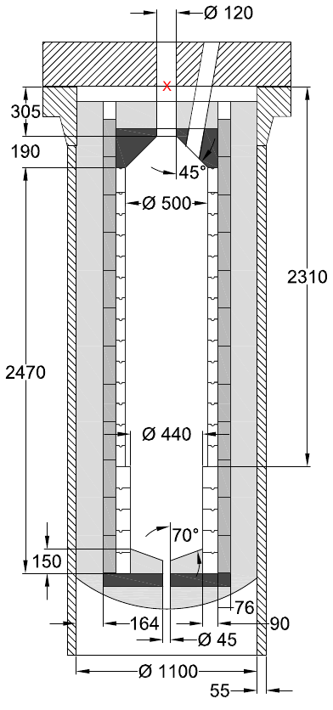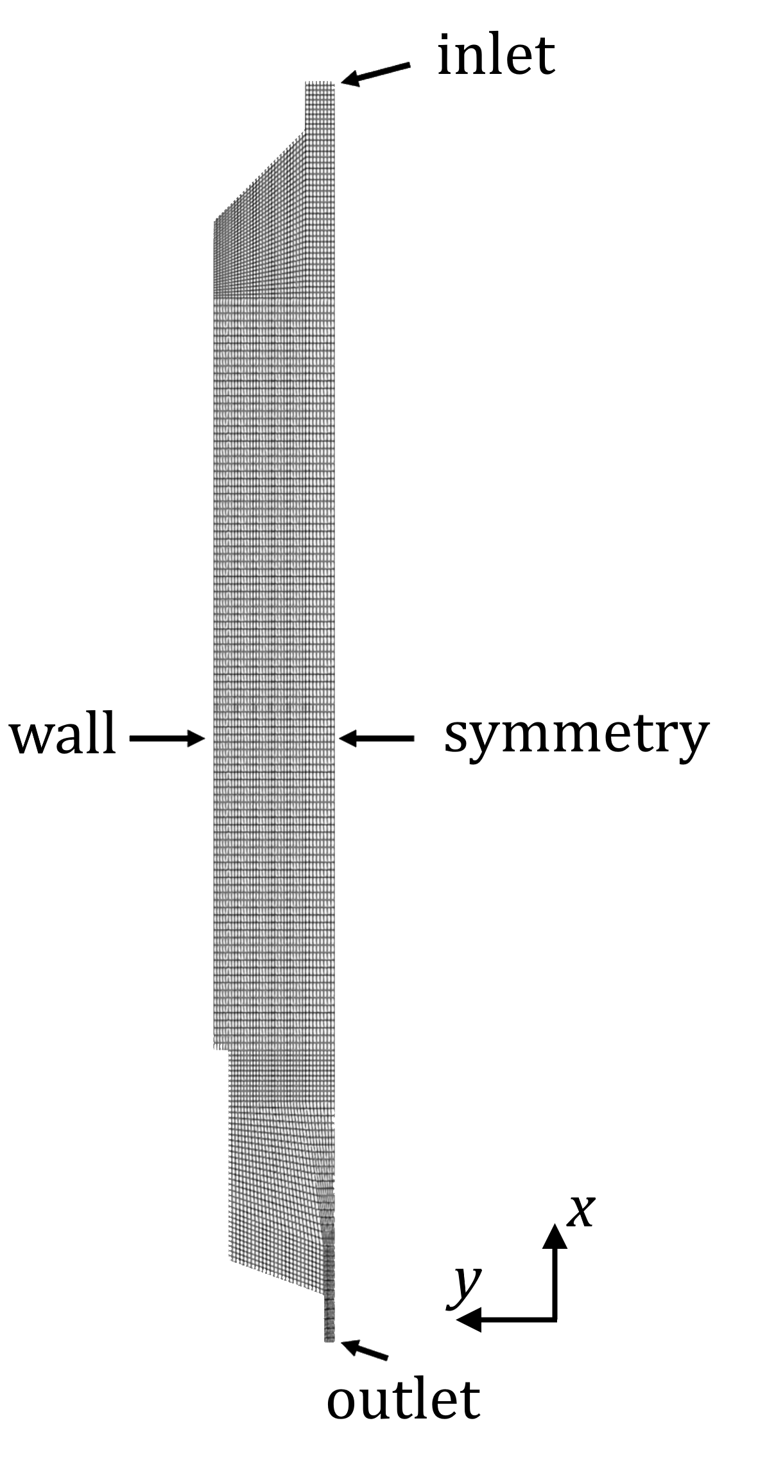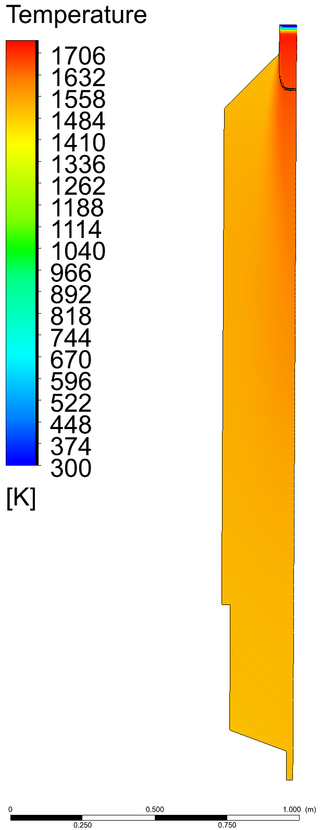
- (b) (c)
Figure 1. (a) Dimensions of the reactor from the verification experiments. [https://doi.org/10.1016/j.fuel.2014.12.004] (b) Example image of computational mesh and boundaries. (c) Example image of obtained steady state temperature field within reactor for base case with a 1 m reference line. Black line indicates the isoline of 1673 K.
The processes inside the reactor are assumed to be axisymmetric, therefore the numerical mesh is a 2D mesh that includes a half-slice of the reactor (see Figure 1b). Modelling a 2D system instead of a 3D system greatly reduces the time required for the computations, and it improves the stability of the solvers. This is very beneficial when running a highly complicated chemical reaction model. The +x direction corresponds to the +z direction in the reference paper. The reactor is upside-down, which explains the inlet being on the right side.
ANSYS Fluent is one of the software solutions capable of both modeling gas flow (k-ε turbulence and energy transport) and chemical reactions within it with the Eddy Dissipation method (among others). However, one should note that ANSYS Fluent is commercial software and thus requires a license to run, which can be problematic when attempting to scale the calculation in parallel for intensive calculations. For this reason, a proof-of-concept model is also replicated in OpenFOAM. Both software solutions also support the use of CHEMKIN files for specifying the chemistry mechanics, which is GRIMech 3.0 in this case.
The dimensions of the reactor, its physical setup and operating conditions were taken from the reference study. One deviation, however, was the use of an adiabatic boundary condition on the outer wall, while the walls are allowed to cool in the reference paper. While this does not correspond entirely with the reality in the experiment and artificially traps some heat, the reference paper by Richter et al. (2014) details that the heat losses via the walls are no larger than on the scale of 1% of the total energy generated by reactions, thus is judged to be a small effect and is left to be adiabatic for simplicity of study.
The equations described in Section 2 are solved in ANSYS Fluent as a steady state problem via using the coupled pressure-velocity solver with a distance based Rhie-Chow flux type. Spatial discretizations are second order for all quantities (second order upwind for momentum, turbulent kinetic energy, turbulent dissipation rate, species, and energy; second order for pressure). Gradients are discretized using the cell based least squares method.
In OpenFOAM, the convective (divergence) terms are discretized using the limitedLinear divergence scheme. The convective term for velocity is discretized using the limitedLinearV scheme, and the mass fraction convection term is discretized using the limitedLinearV01 scheme. The diffusive (Laplacian) terms are discretized using the linear corrected scheme. The gradient is discretized using the linear scheme. The time derivative is discretized using the localEuler time scheme. It is a pseudo-transient time scheme that is similar to backwards-Euler, but has a spatially varying time step. The local time step is adjusted to ensure a Courant number Co<0.3. Pressure and velocity coupling is solved using the PIMPLE algorithm. PIMPLE merges the PISO and SIMPLE algorithms for iteratively updating the pressure and velocity fields. The algorithm was run with 50 SIMPLE loops. This was done to increase the numeric stability of the simulation.
  - Results of model verification
A host of different model variations were tested to understand the impact of certain changes within the model. The cases are as follows, with enumeration used further in Table 1:
- The case as constructed according to the previous section, dubbed the “base model”. This is the case solved both in Fluent and OpenFOAM. All other cases are solved only in Fluent.
- The same case as No. 1, but with a volume fraction constant $C_{γ}=$ 10.0, instead of its default value in ANSYS Fluent $C_{γ}=$ 2.1. It was changed far beyond the typical value to see whether or not the solution is strongly dependent on this parameter (i.e. whether a precise determination of this constant is important to obtain precise results). Some studies, such as Rehm et al. (2008) and Voloshchuk et al. (2017), have shown that for natural gas partial oxidation a large value of $C_{γ}$ can give improved results.
- The same case as No. 2, but also with narrower inlet diameters (the new diameter is half of the original diameter). This modification came about by comparing the way the gas inlets are modeled and the way they are described in the benchmark paper. In the paper, the inlets consist of multiple concentric rings, while in the model they are simply considered as openings with no rings. Because of this, there is a discrepancy regarding the location where the flame spawns. In the paper, the flame begins a certain distance from the inlets, but in the model, due to the simplified inlets, it begins burning almost immediately after the inlets. To see if this affects the results for the gas composition at the outlet, the inlets in the model were made narrower to increase the velocity of the gases and have them ignite a flame further from the inlets.
- The same as case No. 3, but with gravitational effects included. So far, gravity has been neglected, but it could theoretically drive buoyant flows and affect the results.

All four cases were calculated to a steady state and successfully converged. The results are collected in Table 1.

Table 1 – Key parameters at reactor outlet for various models and the reference reactor.
Quantity\Case | 1 - Fluent | 1 - OpenFOAM | 2 | 3 | 4 | Reference
H₂, vol% | 41.81 | 42.39 | 45.54 | 45.28 | 45.57 | 48.27
N₂, vol% | 0.39 | 0.41 | 3.99 | 4.74 | 2.28 | 0.65
CO, vol% | 21.61 | 21.60 | 23.15 | 23.06 | 23.07 | 23.79
CO₂, vol% | 4.38 | 4.43 | 3.77 | 3.74 | 3.94 | 4.19
H₂O, vol% | 23.72 | 23.40 | 19.46 | 19.34 | 20.10 | 19.33
CH₄, vol% | 8.09 | 7.76 | 4.09 | 3.83 | 5.04 | 3.76
Temperature at outlet, K | 1549 | 1524 | 1520 | 1530 | 1500 | 1473

One can see that, within a certain tolerance, the results are all quite close to each other and the reference values. It is worth to quickly note that results for the base case in Fluent and OpenFOAM are very similar, which gives a degree of trustworthiness to the result and allows for a chance to scale the calculations for parallel computing without the need for commercial licenses, should the need arise. Furthermore, the flame length (taken as a region of temperature $T≥1673 K$ (see Figure 1c) and as measured with the line tool in ANSYS CFD-Post) in these models is approximately 190 – 200 mm, which is similar to what is reported in the reference paper by Richter et. al. (2014) – their flame length is approximately 230 – 275 mm. Because the inlet geometry is not reproduced one to one in this model, the flame width cannot directly be compared with that reference. Nevertheless, the results can be considered to be close for a proof of concept study.
The biggest difference is between results for case 1 (base) and case 2 ($C_{γ}$ = 10), after which the results from case 2 to case 4 do not meaningfully change. This allows to draw the conclusion that neither gravitational effects nor the exact location of the flame ignition is of much importance to the outlet composition of the gases. Interestingly, a volume fraction constant of 10 instead of the default value gives model results that are quite close to the reference values – all within one percent, excluding H₂ and N₂. However, it appears that the model overpredicts the remainder of the nitrogen and underpredicts the production of H₂ at the outlet of the reactor. This prompts further research into the optimal value for the volume fraction constant for this particular use case, and that is still ongoing work at present. The importance of correctly setting the volume fraction constant is determined by the precision required of the model.
These results lead to believe that the default value of $C_{γ}$ underestimates the volume fraction of active chemistry for the application of natural gas partial oxidation. It must be noted that such a large value of $C_{γ}=10$ in practice leads to ANSYS Fluent deploying the cutoff value for $γ=0.75$ for many computational cells. With the reaction kinetics sourced from GRIMech 3.0, which is extensively used for natural gas combustion modeling and thus trustworthy, and previous research showing similar results to this study (as mentioned above – Voloshchuk et al. (2017) and Rehm et al. (2008)), it appears that $C_{γ}$ should indeed be modified up from the default value for natural gas partial oxidation applications.
Another encouraging sign is that the temperature values are all quite close to approximately 1500 K, with all models slightly overestimating the temperature relative to the reference paper. This can be explained by the fact that the model does not yet consider heat losses via the reactor walls, which may be of importance (albeit are not expected to dramatically change the result), and by the tendency of the EDC model to overpredict temperature. This is also an avenue of further research in combination with the volume fraction constant studies.
  - Conclusions
The main conclusions from this research are as follows:
- The choice of the volume fraction constant $C_{γ}$ in the Eddy Dissipation concept settings in ANSYS Fluent can affect the resulting gas composition by a few percent. Even though the default value of $C_{γ}=2.1$ has been arrived at via fitting experimental data, some research, including this paper, points to better EDC model performance for natural gas partial oxidation with greater value of $C_{γ}$. Further research is required to obtain an optimal value for this constant for this particular research problem.
- The overall temperature at the outlet is currently being overestimated by the computational model. Adding heat losses correctly can help alleviate this problem, but also affect the reactions and the resultant gas composition. Further research is required here as well.
- Geometrical minutiae of the inlet construction can be neglected in favor of a simplified geometry with no appreciable effect on the outlet gas composition. Similarly, gravitational effects have little to no effect.
Nomenclature
$ρ$ – density, kg/m³

$v$ – flow velocity, m/s
$x$ – coordinate, m
$t$ – time, s
$μ$ – dynamic viscosity, Pa$⋅$s
$p$ – pressure, Pa
$δ_{ij}$ – Kronecker delta, -
$f$ – volume forces, N/m³
$k$ – turbulent energy, m²/s²
$μ_{t}$ – turbulent viscosity, Pa$⋅$s
$σ_{k}, σ_{ε}, C_{1}, C_{2}, C_{μ}$ – empirical model coefficients, -
$G_{k}$ – turbulence source term
$ε$ – turbulence kinetic energy dissipation rate, m²/s³
$E$ – energy, J/m³
$λ_{\text{eff}}$ – effective heat conductivity, kg$⋅$J/(m³$⋅$K)
$T$ – temperature, K
$h$ - sensible enthalpy
$J$ – flux, unit dependent on quantity
$τ_{\text{eff}}$ – total stress tensor, kg$⋅$J
$S_{\text{h}}$ – reaction source term, kg$⋅$J/(m³$⋅$s)
$Y$ – species mass fraction, -
$R$ – reaction rate, kg/(m³$⋅$s)
$γ$ – turbulent length scale, m
$C_{γ}$ – volume fraction constant, -
$ν$ – kinematic viscosity, m²/s
$τ^{*}$ - turbulent fine structure time scale, s
$Re_{\text{t}}$ – turbulent Reynolds number, -

Acknowledgements
This work was funded by European Regional Development Fund under contract: “Development of Syngas Production Method for Innovative Methanol Obtainment in Compact Plant Using Mathematical Modelling of Technological Processes. Project number: 1.1.1.1/20/A/110”.

References
ANSYS Fluent Theory Guide, Release 15.0, available online <http://www.pmt.usp.br/academic/martoran/notasmodelosgrad/ANSYS%20Fluent%20Theory%20Guide%2015.pdf>, accessed 11.01.2023.
Farokhi, M., Birouk, M. (2016). On the application of Eddy Dissipation Concept for modeling biomass combustion - Part I: Assessment of the model’s coefficients. Energy & Fuels. 30. 10.1021/acs.energyfuels.6b01947.
Magnussen B.F. On the Structure of Turbulence and a Generalized Eddy Dissipation Concept for Chemical Rea-ction in Turbulent Flow. Proc. of the “19t AIAA Aerospace Science Meeting”. St.Louis, Missouri, USA. 1981, pp. 1 – 6.
Magnussen B.F. Modeling of NOx and soot formation by the Eddy Dissipation Concept. Int.Flame Research Foundation. Proceedings of “11th Task Leaders Meeting, IEA Working Party on Energy Conservation in Combustion”, Őrenäs, Glumslöv, Sweden, 1989. pp. 248 – 268.
Rehm M., Seifert P., Meyer B., Theoretical and numerical investigation on the EDC-model for turbulence–chemistry interaction at gasification conditions, Computers & Chemical Engineering, Volume 33, Issue 2, 2009, Pages 402-407, ISSN 0098-1354, https://doi.org/10.1016/j.compchemeng.2008.11.006.
Richter A. et al. A large-scale benchmark for the CFD modeling of non-catalytic reforming of natural gas based on the Freiberg test plant HP POX. Fuel (2014), http://dx.doi.org/10.1016/j.fuel.2014.12.004
Smith G.P., Golden D.M., Frenklach M., et al. GRIMech 3.0. Available at: combustion.berkeley.edu/gri-mech/version30/text30.html
Voloshchuk Y., Vascellari M., Hasse Ch., et al. Numerical study of natural gas reforming by non-catalytic partial oxidation based on the Virtuhcon Benchmark. Chemical Engineering Journal. 2017, Vol.327, pp. 307 – 319. doi:10.1016/j.cej.2017.06.061.
Wang Y., Zeng H., Banerjee A., et al. Elementary reaction modeling and experimental characterization on methane partial oxidation within a catalyst-enhanced porous media combustor, Energy & Fuels. 2016, Vol.30 (9), pp. 7778 – 7785. DOI: 10.1021/acs.energyfuels.6b01624

