CHEMICAL ENGINEERING TRANSACTIONS  VOL. , 2023 | A publication of
The Italian Association
of Chemical Engineering
Online at www.cetjournal.it

Guest Editors: Sauro Pierucci, Jiří Jaromír Klemeš
Copyright © 2023, AIDIC Servizi S.r.l.
ISBN 978-88-95608-98-3; ISSN 2283-9216

A preliminary investigation on the mechanochemical degradation of 2,6 dichlorophenol in simulated sandy soils: modeling end experiments
Alessandro Concas^{a,b,}*, Francesco Deloguª, Nicola Laiª, Giacomo Cao^{a,b,c}
ª Department of Mechanical, Chemical and Materials Engineering, University of Cagliari, Via Marengo 2, 09123 Cagliari, Italy
^{b} Interdepartmental Center of Environmental Science and Engineering (CINSA), University of Cagliari, Via San Giorgio 12, 09124 Cagliari, Italy
^{c} Center for Advanced Studies, Research and Development in Sardinia (CRS4), Loc. Piscina Manna, 09050 Pula (CA), Italy

The possibility to degrade 2,6 - Dichlorophenol (2,6 DCP) in matrices simulating sandy soil via ball milling was investigated in this work. The experiments showed that under specific operating conditions a successful degradation of 2,6 DCP could be achieved even when its concentration in the simulated sandy soil was very high. The obtained experimental results were well interpreted by a mathematical model to provide a useful tool to develop a software to design, control and optimize the process at the industrial scale.
  - Introduction
Soil contamination is nowadays one of the main concerns to cope with due to the reduced availability of arable lands and the increased demand for food by a growing population (Montinaro et al., 2009). 2,6 - Dichlorophenol (2,6 DCP) is widely employed in the industry to produce pesticides, herbicides, preservatives, antiseptics, disinfectants, and other useful compounds. As a result, it can be frequently found as a dangerous pollutant in the soil (Dai et al., 2021). Relevant features of DCPs are their persistence in the soils and a partial recalcitrance to biological treatments. Therefore, albeit partially biodegradable, their uncontrolled discharge in the environment has resulted in diffuse contamination owing to their notable tendency to accumulate in the environment. Accordingly, various technologies to effectively degrade 2,6 DCP in real environmental matrices are currently the subject of intense research activity. Adsorption, electrocoagulation and chemical coagulation have been demonstrated to suitably reduce 2,6-DCP concentration in liquid matrices (Yadav and Khandegar, 2020). Other technologies capable to degrade this pollutant are photodegradation using TiO₂/pillared clays (Kumar et al., 2022) and oxidation through ferrate (VI) CuO (Yan et al., 2021) or activated peroxymonosulfate (Dai et al., 2021). Despite its effectiveness in the treatment of soils contaminated by different pollutants (Concas et al., 2012), mechanochemical methods to degrade 2,6-DCP in soils has not been evaluated so far. This work focuses on the use of mechanochemical degradation of 2,6 DCP using SiO₂, that mimics a sandy soil and act as a reducing agent capable to degrade the pollutant. Depending on the specific molar ratios adopted as well as on the operating conditions during milling, the mechanochemical processing induced a gradual degradation of 2,6 DCP. In particular, under specific experimental conditions, removal efficiencies close to 100% could be achieved even when considering high contamination levels. A mathematical model is then proposed and adopted to simulate the experimental data related to the dependence of the degradation efficiency on the energy dose, i.e. the cumulated mechanical energy provided during milling to the unit mixture mass, for the case where gradual degradation took place. The simulation results well capture the experimental data, thus demonstrating the reliability of the proposed model. The latter one can be used for a first stage evaluations of techno-economical feasibility of the proposed technique at the large scale. Finally, a possible proof of concept of a process operating at the industrial scale, involving the use of photovoltaic panels to fuel the mills, is proposed.
  - Materials and Methods
2.1 Contaminated sandy soils preparation
High purity (99%) SiO₂ and 2,6-DCP were purchased from Sigma Aldrich and then mixed in weight ratios equal to 5:1 and 10:1 to simulate sandy soils contaminated by 2.0 × 10⁵ and 1.0 × 10⁵ (ppm) of 2,6 -DCP, respectively.
2.2 Mechanochemical treatment
The powder mixtures were inserted, along with a variable number of stainless steel balls of 8 g, 10 mm in diameter, within a stainless steel vial, 606.75 g in weight, having the internal diameter equal to 3.8 cm and the internal height of 5.8 cm. The vial was mounted on a SPEX Mixer/Mill mod. 8000, operating at the standard milling frequency of about 870 rpm. The mechanical treatment was prolonged for times ranging from 6 to 48 hours during which the motion of mill permitted the spheres to hit the soil particles with locally high energies capable to trigger the endothermic reactions leading to 2,6-DCP degradation. At the end of these periods the powder mixture (simulating the contaminated soil) was withdrawn from the vial and then analyzed to determine the degree of degradation achieved because of the treatment. A scheme of the experimental procedure along with a summarizing table of the investigated operating conditions is reported in Figure 1
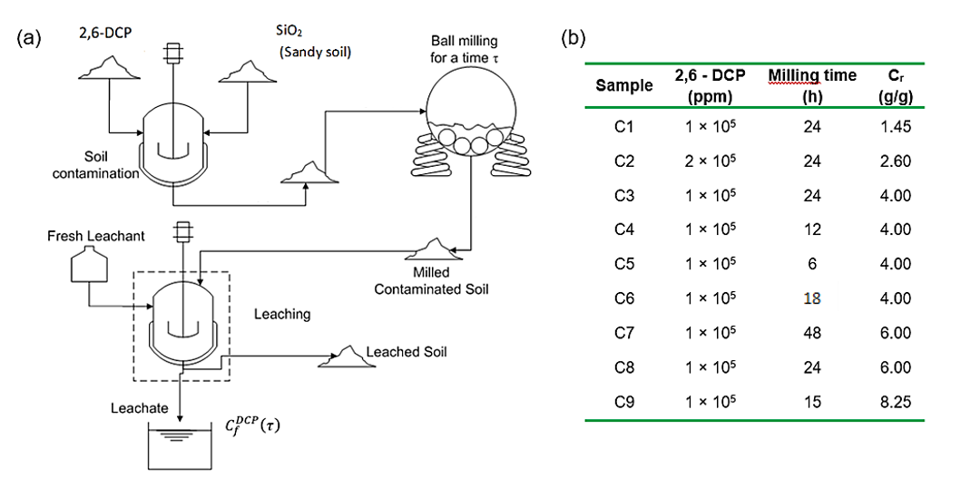
Figure 1. Scheme of the experimental procedure (a) and summary of investigated experimental conditions (b)
At least two replicates of each experimental condition were considered to ensure results reproducibility.
2.3 Treated soil analyses
High-Pressure Liquid Chromatography (HPLC) was adopted to evaluate the conversion of 2,6-DCP into the products resulting from the ball milling treatment. An Agilent 1100 Series Chromatograph, equipped with a quaternary pump, a solvent degassing system operating under vacuum conditions, a diode-array detector with a 500-nl flow cell, an auto-sampler and an integrating software for data acquisition was used. A Chromopack Spherisorb ODS-2 column (250 × 4.6 mm; particle size 5 μm) was used. The working temperature of the column was maintained constant at 25 °C through a thermostatic apparatus. A two-component mobile phase (40% methanol, 60% water) was used at a constant flow rate of 1.2 ml min⁻¹.
Chromatographic analyses were performed on the liquid solutions obtained by leaching the milled powders with distilled water to transfer the residual 2,6-DCP in the soil towards the liquid phase. The leaching time was such to ensure the complete solubilization of the remaining organic pollutant. Preliminary experiments proved that the solubilization of polar substances was completed in around 1 h.
The use of pure water to leach the treated soils might seem arguable since it only allows the dissolution of polar organic species (and in particular of 2,6-DCP) while non-polar species are not dissolved. However, since the present work only aims to verify the possibility of degrading the 2,6-DCP via mechanochemical techniques the use of pure is enough because it can dissolve the residual quantity of 2,6-DCP thus permitting to compare it with the amount of 2,6-DCP in the starting mixture. Ultimately, the 2,6-DCP efficiency could be evaluated.
  - Mathematical model
The ball milling treatment (BM) can trigger the degradation of 2,6-DCP in the soil into less harmful products according to the schematic reaction:
$$DCP\underset{→}{ BM }Products$$ | (1)
Let’s now consider to be an effective sphere-soil collision the one capable of triggering the 2,6 DCP degradation. As reported elsewhere, the unreacted fraction $ξ^{DCP}\left(mg {kg}^{-1}\right)$ of 2,6-DCP with respect to the total mass of soil, after a processing time $τ$ could be evaluated according to an equation of the type (Delogu et al., 2004; Delogu and Takacs, 2018, Carta et al., 2020):
$$ξ_{j}^{DCP}\left(τ\right)=ξ^{DCP}\left(0\right)\frac{{\left(k τ\right)}^{J}}{j!}e^{- k τ}$$ | (2)
where the parameter $k \left(h^{-1}\right)$ is related to the milling process dynamics via the collision frequency $f\left({hr}^{-1}\right)$, the collision energy and the charge ratio $Cr$ (i.e., the ratio between the mass of sphere and that one of soil). The symbol $j$indicates the number of effective collisions involving the mixture after milling the sample for a time $τ$. By considering that the mass of residual DCP plus the mass of its degradation products is conserved during the treatment one could calculate the mass fraction of degradation products Pr $\left(ψ^{Pr}\right)$ as:
$$ψ^{Pr}\left(τ\right)=ξ^{DCP}\left(0\right)-\sum_{j=0}^{J_{min}}{ξ_{j}^{DCP}\left(τ\right)}=ξ^{DCP}\left(0\right)\left[1-\sum_{j=0}^{J_{min}}{\frac{{\left(k τ\right)}^{j}}{j!}e^{- k τ}}\right]$$ | (3)
In Eq. (3) the symbol $J_{min}$ represents the minimum number of effective collisions that should be experienced by the soil for the transformation of Eq. (1) to take place. Since the unreacted fraction of 2,6-DCP in the solid phase ($ξ^{DCP}$) cannot be directly measured, a strategy similar to the one reported in the literature by Concas et al. (2020) was developed to evaluate 2,6 – DCP degradation degree starting from its concentration in the liquid phase after soil leaching with water. Such a strategy allows a comparison with experimental data by returning the time profile of the leached concentration $C_{f}^{DCP}\left(τ\right)$:
$$C_{f}^{DCP}\left(τ\right)=C_{f}^{DCP}\left(0\right)\left[\sum_{j=0}^{J_{min}}{\frac{{\left(k τ\right)}^{j}}{j!}}\right]e^{- k τ}$$ | (4)
This equation quantifies the concentration of the 2,6-DCP transferred from the solid to the liquid phase when the former is first subjected to a mechanical treatment for a time $τ$ and then undergone to leaching. From this equation one could simply evaluate the time evolution of the degradation degree of 2,6 DCP as $η\left(τ\right)=1-\left[{C_{f}^{DCP}\left(τ\right)}/{C_{f}^{DCP}\left(0\right)}\right]$. On the other hand, rather than the processing time, the key variable influencing the yield of a ball milling process is the energy supplied to the unit mass of soil. Indeed, degradation reactions can happen depending on the rate at which mechanical energy is provided to the mixture. Therefore, adjustment of the operating parameters affecting milling energy is crucial to achieve high conversions of 2,6 - DCP within a specific operating time $τ$. To this aim, it is important to express the degradation efficiency as a function of the energy provided to the sample. In this view the so-called milling intensity $I \left(J {hr}^{-1}\right)$ can be introduced:
$$I= \frac{1}{2} f\sum_{i=1}^{n_{b}}{m_{b,i}v_{b,i}^{2}}$$ | (5)
where $n_{b}\left(/\right)$ is the number of milling spheres,$f\left({hr}^{-1}\right)$ is their impact frequency, $m_{b,i}\left(g\right)$ their mass and $v_{b,i}^{}\left(m{ s}^{-1}\right)$ their relative impact velocity. The specific energy dose $D \left(J {mg}^{-1}\right)$ is the mechanical energy provided to the unit mixture mass at specific time $τ$ and according to the literature can be computed as:
$$D=\frac{Iτ}{m_{p}}=\frac{1}{2}\frac{f τ}{{ m}_{p}}\sum_{i=1}^{n_{b}}{m_{b,i}v_{b,i}^{2}}$$ | (6)
where${ m}_{p}\left(g\right)$ is the mass of mixture being processed. Since during the the experiments all the spheres had the same mass $m_{b}$ and dynamic simulations (Concas et al., 2020) demonstrated that at mill steady-state their impact velocity is constant $\left(v_{b,i}=v_{b}\right)$, the dose can be evaluated as:
$$D=\frac{1}{2}\frac{n_{b}m_{b}}{m_{p}} fv_{b}^{2} τ= \frac{1}{2}C_{r}fv_{b}^{2} τ$$ | (7)
where the term $C_{r}\left(/\right)=m_{b}/m_{p}$ is just the charge ratio, i.e. the ratio between the mass of milling bodies and the mass of soil being processed. Therefore, by dividing k so that the kinetics can be referred to the cumulative energy dose rather than to the process time we get:
$$k=k'\frac{1}{2}C_{r}fv_{b}^{2}$$ | (8)
and substituting in Eq. (4), the following relationship can be obtained:
$$C_{f}^{DCP}\left(D\right)=C_{f}^{DCP}\left(0\right)\left[\sum_{j=0}^{J_{min}}{\frac{{\left(k^{'} D\right)}^{j}}{j!}}\right]e^{- k^{'} D}$$ | (9)
From the latter one the 2,6 - DCP degradation efficiency can be evaluated according to the following Equation.
$$η\left(D\right)=1-\frac{C_{f}^{DCP}\left(D\right)}{C_{f}^{DCP}\left(0\right)}=1-\sum_{j=0}^{J_{min}}{\frac{{\left(k^{'} D\right)}^{j}}{j!}e^{-k^{'} D}}$$ | (10)
This form was used to fit experimental results by tuning the parameter $k^{'}$and setting $J_{min}=1$.
  - Results and discussions
By using the operating conditions specified in figure 1 for each sample ID the experimental results reported in Table 1 were obtained.
Table 1. Experimental results obtained with the samples IDs obtained with the operating conditions in Fig. 1.
Sample | $$C_{f}^{DCP}\left(τ=0\right)$$  $$(mg L^{-1})$$ | $$C_{f}^{DCP}\left(τ=τ_{final}\right)$$  $$(mg L^{-1})$$ | $$η_{exp}$$  $(/)$
C5 | 185.02 | 126.34 | 0.32
C1 | 223.35 | 146.1 | 0.35
C4 | 192.29 | 79.64 | 0.59
C2 | 302.38 | 173.5 | 0.43
C3 | 221.44 | 28.12 | 0.87
C6 | 180.93 | 34.37 | 0.81
C9 | 216.21 | 9.89 | 0.95
C8 | 215.6 | 0 | 1.00
C7 | 217.58 | 0 | 1.00

To analyse the evolution of the degradation efficiencies, those obtained with a fixed charge ratio ($Cr$) are reported as function of the milling time in Figure 2a and those, obtained after 24 hr long milling are shown as function of the charge ratio in Figure 2b.
Figure 2. Evolution of degradation efficiency as function of processing time (a) and Charge ratio (b)
It is apparent that, at fixed $Cr$, the prolongation of the milling time leads to an increase in the degradation efficiency of 2,6-DCP. This is because the energy needed to trigger the degradation reactions is accumulated by the solid mixture in the form of defects, dislocations as the mechanical treatment is prolonged (Caschili et al., 2006). While the possible reactions leading to this effect are not well known, based on the current literature a general reacting mechanism can be assumed. Indeed, it is well known that free radicals such as H, OH·, and O· can be produced as a result of high energy milling (Concas et al., 2020). Such free radicals could attack the 2,6-DCP molecule leading to its de-chlorination and possibly the rupture of the aromatic ring producing as a result a harmless, or less dangerous, final compounds (Benitez et al., 2000; Zhu et al., 2022).
Although this mechanism should be confirmed by further and more insight experimental activity, a well body of literature corroborate the possibility to perform de-chlorination of organic compounds via ball milling (Cagnetta et al., 2016). An increase of the degradation efficiency can be also observed (Fig. 2b) when the charge ratio is increased by keeping all the remaining operating parameters (including milling time) constant. Indeed, a higher number of spheres typically leads to a higher number of hits per unit time, i.e. a larger collision frequency, that in turn determines to an higher amount of energy transferred to the unit mass of powder per unit time. According to Eq. 7, milling time and charge ratio both contribute to increase the energy dose $D (J {mg}^{-1})$ provided to the unit weight of powders that, for the concerned experiments can be calculated as reported in Table 2 by using the values of collision frequency and impact velocity by Concas et al., 2020).
Table 2. Energy doses for each experimental condition. Values of $f$ and $v_{imp}$ are from Concas et al. (2020).
Sample | $$τ$$  $$(hr)$$ | $$Cr$$  $$(kg {mg}^{-1})$$ | $$v_{imp}$$  $$\left(m s^{-1}\right)$$ | $$f$$  $$({hr}^{-1})$$ | $$D$$  $$\left(J {mg}^{-1}\right)$$ | $$η_{exp}$$  $(/)$
C5 | 6 | 4.00 × 10⁻⁶ | 4.169 | 511200 | 106.62 | 0.32
C1 | 24 | 1.45 × 10⁻⁶ | 4.169 | 511200 | 154.60 | 0.35
C2 | 24 | 2.60 × 10⁻⁶ | 4.169 | 511200 | 277.21 | 0.43
C4 | 12 | 4.00 × 10⁻⁶ | 4.169 | 511200 | 213.24 | 0.59
C6 | 18 | 4.00 × 10⁻⁶ | 4.169 | 511200 | 319.86 | 0.81
C3 | 24 | 4.00 × 10⁻⁶ | 4.169 | 511200 | 426.48 | 0.87
C9 | 15 | 8.25 × 10⁻⁶ | 4.169 | 511200 | 549.76 | 0.95
C8 | 24 | 6.00 × 10⁻⁶ | 4.169 | 511200 | 639.72 | 1.00
C7 | 48 | 6.00 × 10⁻⁶ | 4.169 | 511200 | 1279.43 | 1.00

Ultimately, as also reported in Fig. 3a, a degradation efficiencies of 2,6-DCP close to 100% can be achieved (cf. experiments C7 and C8) by suitably increasing milling time and/or the charge ratio, i.e. the energy dose,. It should be stressed here, that such results are obtained by considering high contamination levels of 2,6 -DCP (1 – 2 x 105 ppm) that are higher than the typical one found in real contaminated soils.
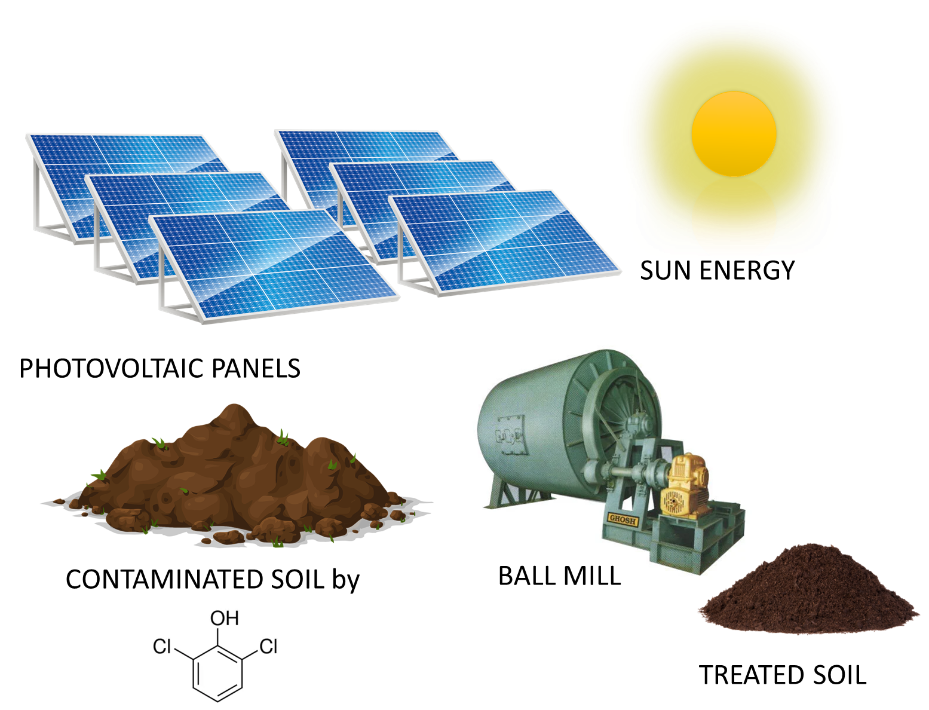
(a)
(b)
Figure 3. Comparison of experimental and model results (a) and conceptual scheme for the sustainable application of the technique at the real scale (b).
Therefore, it can be reasonably assumed that, by considering lower concentrations of 2,6-DCP that are typical of contaminated soils, a complete degradation could be obtained by using much lower doses of energy provided to the soil. This would increase the techno-economic feasibility of the proposed technique. Another possible way to increase the feasibility of the process would be for example to use renewable energy from photovoltaic to power the mills. In fact, remediation typically involves large surfaces of soils that can be exploited to gather the energy needed for the milling process according to the scheme reported in Fig. 3b. On the other hand such assumptions should be corroborated by further experiments. Still from Fig. 3a, it can be observed that the experimental results are well fitted by the proposed model when setting the value of Jmin to 1 according to the literature (Concas et al., 2020) and tuning the value of the kinetic constant $k$ to $8.4 × {10}^{-3 }\left(mg g^{-1}\right)$. In this way MSE (mean square error) and R² equal to $9.82 × {10}^{-3 }$and $0.88$, respectively, were obtained. Further experiments should be performed, under different operating conditions, and then simulated by keeping the parameter k fixed to evaluate the predictive capability of the model. Experiments involving larger amounts of soils and larger devices should also be performed to evaluate the scalability of this technology. If such activity were successful, the model would represent a good starting point to develop a software tool to design, optimize and control a plant operating on the real scale for the treatment of soils contaminated by high concentration of 2,6 – DCP.
  - Conclusions
High-energy milling has been proved to be a valuable technique to degrade 2,6-DCP in solid matrices simulating highly contaminated sandy soils. In fact, degradation degrees close to 100 % were achieved when using specific energy doses obtained by changing milling time and/or charge ratio. This effect is probably due to the reaction between 2,6 – DCP and the free radicals produced by the mechanical processing of SiO₂. However, further research is needed to confirm this mechanism as well as to better identify the 2,6-DCP degradation products and their harmfulness. The semi-empirical mathematical model proposed in this study was successfully used to evaluate the effects of the milling process on 2,6-DCP degradation by taking advantage of experimental data. Though further experiments should be simulated to confirm the predictive capability of the model, it could be used to identify scalable configurations of the proposed technique. The mechanochemical process combined with the use of photovoltaics to power the mills is proposed in this work.
References
Benitez F. J., Beltran-Heredia J., Acero J. L., Rubio F. J., 2000, Contribution of free radicals to chlorophenols decomposition by several advanced oxidation processes, Chemosphere, 41(8), 1271-1277.
Cagnetta G., Robertson J., Huang J., Zhang K., Yu G., 2016, Mechanochemical destruction of halogenated organic pollutants: A critical review, Journal of Hazardous Materials, 313, 85-102.
Carta M., Colacino E., Delogu F., Porcheddu A., 2020, Kinetics of mechanochemical transformations, Physical Chemistry Chemical Physics, 22, 14489.
Caschili S., Delogu F., Concas A., Pisu M., Cao G., 2006, Mechanically induced self-propagating reactions: analysis of reactive substrates and degradation of aromatic sulfonic pollutants, Chemosphere, 63, 987–995.
Concas A., Pisu M., Cao G., 2020, Mechanochemical immobilization of heavy metals in contaminated soils: a novel mathematical modeling of experimental outcomes, Journal of hazardous materials, 388, 121731.
Dai M., Luo Z., Luo Y., Zheng Q., Zhang B., 2021. Degradation of 2, 6-dichlorophenol by ferrate (VI) oxidation: Kinetics, performance, and mechanism, Separation and Purification Technology, 278, 119475.
Delogu F., Deidda C., Mulas G., Schiffini L., Cocco G., 2004, A quantitative approach to mechanochemical processes, Journal of Material Science, 39, 5121–5124.
Delogu, F., Takacs, L., 2018, Information on the mechanism of mechanochemical reaction from detailed studies of the reaction kinetics. Journal of Materials Science, 53, 13331-13342.
Kumar V. D., Balaji K. R., Viswanatha R., Ambika G., Roopa R., Basavaraja B. M., Chennabasappa M., Kumar R., Chen Z., Bui X-T, M. S., 2022. Visible light photodegradation of 2, 4-dichlorophenol using nanostructured NaBiS2: Kinetics, cytotoxicity, antimicrobial and electrochemical studies of the photocatalyst. Chemosphere, 287, 132174.
Montinaro S., Concas A., Pisu M., Cao G., 2009, Rationale of lead immobilization by ball milling in synthetic soils and remediation of heavy metals contaminated tailings. Chemical Engineering Journal, 155,123–131
Montinaro S., Concas A., Pisu M., Cao G., 2012, Rationale of heavy metals immobilization by ball milling in synthetic soils and remediation of heavy metals contaminated tailings. Chemical Engineering Transactions, 28, 263–268.
Yadav A., Khandegar V., 2020, Removal comparison and cost evaluation of 2, 6-dichlorophenol, Journal of Hazardous, Toxic, and Radioactive Waste, 24(4), 04020033.
Yan P., Shen J., Wang S., Zhou Y., Kang J., Yuan L., Bi L., Li Y., Chen, Z. (2021). Removal of 2, 6-dichlorophenol in water by CuO activated peroxymonosulfate: Efficiency, mechanism and degradation pathway. Separation and Purification Technology, 254, 117630.
Zhu M., Lu J., Dong L., Hu S., Pen S., Zhu C., 2022, Photochemical transformations of 2, 6-dichlorophenol and 2-chlorophenol with superoxide ions in the atmospheric aqueous phase, Journal of Molecular Structure, 1261, 132910.

