CHEMICAL ENGINEERING TRANSACTIONS  VOL. , 2023 | A publication of
The Italian Association
of Chemical Engineering
Online at www.cetjournal.it

Guest Editors: Sauro Pierucci, Jiří Jaromír Klemeš
Copyright © 2023, AIDIC Servizi S.r.l.
ISBN 978-88-95608-98-3; ISSN 2283-9216

Modelling the Solubility of Acid and Sour Gases in Deep Eutectic Solvents
Valeria Alejandra Villegas-Peña, Ricardo Macías-Salinas*
ESIQIE-Departamento de Ingeniería Química, Instituto Politécnico Nacional, Zacatenco, México, D.F. 07738
*rms@ipn.mx
In the present work, an equation-of-state-based approach has been used to correlate the experimental gas solubility data of carbon monoxide (CO), carbon dioxide (CO₂), methane (CH₄), ammonia (NH₃), nitrogen dioxide (NO₂), sulfur dioxide (SO₂) and hydrogen sulfide (H₂S) in some representative deep eutectic solvents (DESs) having a common halide salt (choline chloride). Accordingly, two cubic equations of state (CEoS): Peng-Robinson and Soave-Redlich-Kwong coupled with van der Waals mixing rules, were considered here. As a matter of fact, in addition to the Soave alpha function, the one proposed by Yokozeki was also tested in an attempt to obtain improved solubility estimations at low gas concentrations. The best possible representation of experimental solubility data was achieved by adjusting the value of two binary interaction parameters present in the mixing rules (assuming that the DES is a pseudo-pure component), namely, $k_{i,j}$ (enthalpic differences due to hydrogen-bonding effects) and $l_{i,j}$ (entropic differences due to diverse molecular structures of the constituents) using a least-square procedure for each CEoS. Furthermore, it was found that the Yokozeki alpha function in the CEoS correlates the phase equilibria of some of the Gas-DES systems slightly better than the Soave alpha function. Overall speaking, the performance of the present modelling approach was quite good in representing the experimental solubility of the aforementioned acid and sour gases in several choline chloride-based DESs within their corresponding experimental uncertainties in the majority of the cases.
  - Introduction
A deep eutectic solvent (DES) is a mixture of two solid components known as HBA (hydrogen bond acceptor) and HBD (hydrogen bond donor), the resulting mixture is a liquid at room temperature. A very popular compound widely used to synthesize DESs, due to its cost and availability, is the quaternary ammonium salt of choline chloride, this salt mixed with hydrogen bond donors such as urea, glycerol and ethylene glycol, produces the so-called DESs based on choline chloride (Moura et al., 2021).

Choline chloride based DESs possess low vapour pressures, low toxicity and are non-flammable, thus the use of these solvents has been considered in different areas of science, for example, pharmaceutics, electro-chemistry, separation processes and catalysis (Moura et al., 2021). One of the most important contributions of these solvents is their application in the capture/separation of toxic gases such as CO₂, H₂S, NO_{x}, etc. It has been demonstrated that several choline chloride-based DESs are capable of separating the previously mentioned gases and have been considered as an alternative to another solvents called "Ionic Liquids" or ILs, which are deemed as being high cost and environmentally unfriendly. Although DESs share similar physicochemical properties with ILs, the formers have the advantage of being able to be synthesized at a low cost therefore they are the perfect choice for using in various large-scale industrial processes since they can be produced in large quantities, in less time and at an affordable cost (García et al., 2015). Several authors including Rhoda et al. (2013), Li et al. (2022), and Yang et al. (2013) have determined the solubility of different gases in various choline chloride based DESs, and thermodynamic models have been proposed to evaluate the phase behaviour of these Gas-DES systems. Among the most common used thermodynamic models are those that utilise the equations of state of van der Waals, Redlich-Kwong, Peng-Robinson, Soave-Redlich-Kwong, COSMO-RS, PC-SAFT, CPA, etc., some of them coupled with activity coefficient models such as NRTL and UNIQUAC.

A thermodynamic model that uses either the Peng-Robinson or the Soave-Redlich-Kwong cubic equations of state to correlate the experimental solubility data of various gases in choline chloride based deep eutectic solvents has been proposed in this research work. It should also be stated that to get a better fit of the experimental data, the alpha function originally presented by author Yokozeki has been included in the model.
  - Model Description
Experimental solubility data were fitted by means of the cubic equations of state of Peng-Robinson and Soave-Redlich-Kwong coupled with the classic van der Waals mixing rules by optimising the value for the binary interaction parameters $k_{i,j}$ (energetic interactions) and $l_{i,j}$ (size and shape differences) for each CEoS to minimise the relative errors between the experimental equilibrium data and the ones calculated by the equation of state.

Soave’s equation (Soave, 1972), commonly known as Soave-Redlich-Kwong equation or SRK is given by:
$$P=\frac{RT}{V-b}-\frac{a_{c}α\left(T_{R},ω\right)}{V(V+b)}$$ | (1)
with,
$$a_{c}=0.42748\frac{R^{2}T_{c}^{2}}{P_{c}}$$ | (2)
$α\left(T_{R},ω\right)={\left[1+m\left(1-T_{R}^{0.5}\right)\right]}^{2}$and $T_{R}=\frac{T}{T_{c}}$ | (3a, 3b)
$$b=0.08664\frac{RT_{c}}{P_{c}}$$ | (4)
$$m=0.480+1.574ω-0.176ω^{2}$$ | (5)
With $T_{c}$, $P_{c}$, and $ω$ corresponding to the critical temperature (K), critical pressure (bar), and acentric factor ($ω$), respectively.

After Soave's proposal, several modifications were proposed to improve the determination of one or another property. These works were not limited to suggesting new temperature models for $α\left(T_{R},ω\right)$but also considered modifications of the volume dependence of the attractive pressure term. The most popular of these modifications is the one proposed by Peng and Robinson (Valderrama, 2003) which improved Soave’s equation by recalculating the $α\left(T_{R},ω\right)$function and by modifying the volume dependence of the attractive term (Peng and Robinson, 1976). Peng and Robinson (PR) proposed equation is the following:
$$P=\frac{RT}{V-b}-\frac{a_{c}α\left(T_{R},ω\right)}{V(V+b)+b(V-b)}$$ | (6)
with,
$$a_{c}=0.45724\frac{R^{2}T_{c}^{2}}{P_{c}}$$ | (7)
$$b=0.07780\frac{RT_{c}}{P_{c}}$$ | (8)
Since some DESs are highly non-spherical, as reflected in their acentric factor, Peng and Robinson suggested a modified expression for $m\left(ω\right)$ hence adding a fourth term to the original equation.

$$m\left(ω\right)=0.37464+1.54226ω-0.26992ω^{2}$$ | (9)
If $ω≤0.49$. And
$$m\left(ω\right)=0.379642+1.48503ω-0.1644ω^{2}+0.016667ω^{3}$$ | (10)
if $ω>0.49$.
For both SRK and PR equations, the parameters $a$, $b$ and $α$ are empirical functions of the critical temperature, critical pressure, Pitzer's acentric factor and the temperature of the system.

    - van der Waals Mixing Rules

Classical mixing rules have been proposed to calculate the mixing parameters of equations of state, one of them being the van der Waals mixing rules. They provide the mixing parameters from the parameters of the constituents of pure species. For a multi-component system mixing rules are defined as shown:
$a=\sum_{i}{ }\sum_{j}{ }x_{i}x_{j}a_{ij}$ and $a_{ij}=\sqrt{a_{i}a_{j}}\left(1-k_{ij}\right)$ | (11a, 11b)
$b=\sum_{i}{ }\sum_{j}{ }x_{i}x_{j}b_{ij}$ and $b_{ij}=\frac{\left(b_{i}+b_{j}\right)}{2}\left(1-l_{ij}\right)$ | (12a, 12b)
With $a_{ij}=a_{ji}$ and $b_{ij}=b_{ji}$. The mole fraction, $x_{i}$, applies to both liquid and vapour mixtures. $a_{ij}$ and $b_{ij}$ can be of two types: pure species parameters for same subscripts and interaction parameters for different subscripts. The interaction parameters $a_{ij}$ and $b_{ij}$ are often evaluated by combination rules involving a geometric and an arithmetic mean, respectively. The binary interaction parameters $k_{ij}$ and $l_{ij}$ are determined by regression of phase-equilibria experimental data.

    - The Yokozeki Alpha $\left(α\right)$ Function

Yokozeki (2001) modelled the solubility data of refrigerant-lubricant mixtures using the cubic equations of state of van der Waals (vdW), Soave-Redlich-Kwong (SRK) and Peng-Robinson (PR). The temperature-dependence part of the $a\left(T\right)$parameter in the CEoS was modelled with the following empirical function for pure refrigerants, including oils:
$$α(T)=\sum_{k=0}^{⩽3}{ }β_{k}{\left(\frac{T_{c}}{T}-\frac{T}{T_{c}}\right)}^{k}$$ | (13)
The coefficients $β_{k}$ are determined to reproduce the vapour pressure of each pure refrigerant. As there were not vapour pressure data available for refrigerants and lubricants, the author analysed the solubility data of the mixtures and found that only one adjustable parameter $\left(β_{1}\right)$ was enough for the equation, therefore it can be written with just the first two terms:
$$α(T)=1+β_{1}\left(\frac{T_{c}}{T}-\frac{T}{T_{c}}\right)$$ | (14)
The above equation was used for another work of Yokozeki and co-author Shifflet (Shifflet and Yokozeki, 2005) in which they determined the solubility of CO₂ in ionic liquids and correlated their experimental results with an CEoS model using the Redlich-Kwong equation. They used only one adjustable parameter for the mentioned study.

Ionic liquids exhibit similar properties to DESs (low vapour pressures); therefore, this function will be used to obtain a better fit of the gas solubility data in the DESs. The adjustable parameter $β_{k}$ was estimated from the regression of vapour pressure data of the pure compounds.

For pure DESs, $β_{0}=1$ and $β_{1}$ were considered as the only adjustable parameters given that the experimental vapour pressures were measured in a limited temperature range. In the case of the pure gases, it is required to cover a widest temperature range, from the triple point to the critical point, so the adjustment of the parameters $β_{1}$ and $β_{2}$ (including $β_{0}=1$) was sufficient.
  - Results and Discussion
    - Estimation of Pure Compound Parameters

Pure component parameters such as molecular weight ($MW)$, critical temperature $(T_{c})$, critical pressure ($P_{c})$, and the acentric factor $(ω)$, are required in the modelling. For pure gases and several DEss, these parameters can be easily found in the literature, however, physical properties of some DESs need to be calculated and this can be achieved using the Joback group contribution method. For this work, the critical properties and acentric factor of the gases were obtained from the NIST webpage and from Mirza et al. (2015) and Animasahun et al. (2017) for pure DESs.

Since the critical properties and the acentric factor of DESs were theoretically estimated, it was decided to perform an optimisation of these parameters so that 𝛼 (Soave or Yokozeki) using either the Peng-Robinson or Soave-Redlich-Kwong equations reproduces the experimental vapour pressures of the pure solvents. In this way it is intended to corroborate if the model can accurately represent the solubility of gases in solvents using the modified properties of the latter. Table 1 lists the calculated parameters for solvents choline chloride + urea (1:2), choline chloride + glycerol (1:2) and choline chloride + ethylene glycol (1:2). AAD denotes the absolute average deviation of the fitted vapour pressure.
Table 1: Parameter estimation of three choline chloride based DESs.
DES | CEoS | $$α$$ | $$β_{1}$$ | $T_{c}$ (K) | $$ω$$ | AAD (%)
ChCl + U (1:2) | SRK | Yokozeki | 0.296 | 1070.42 | - | 8.86
 |  | Soave | - | 926.08 | 0.461 | 7.73
 | PR | Yokozeki | 0.278 | 1050.16 | - | 8.80
 |  | Soave | - | 916.01 | 0.507 | 7.69
ChCl + G (1:2) | SRK | Yokozeki | 0.214 | 1148.72 | - | 9.56
 |  | Soave | - | 1003.50 | 0.281 | 10.37
 | PR | Yokozeki | 0.200 | 1125.05 | - | 9.61
 |  | Soave | - | 992.07 | 0.320 | 10.40
ChCl + EG (1:2) | SRK | Yokozeki | 0.139 | 1065.21 | - | 7.70
 |  | Soave | - | 918.18 | 0.148 | 8.15
 | PR | Yokozeki | 0.130 | 1038.70 | - | 7.74
 |  | Soave | - | 906.46 | 0.184 | 8.16
    - Solubility Modelling

The present modelling approach was applied to the correlation of experimental solubilities of seven gases in forty-two DESs based on choline chloride combined with urea, glycerol, ethylene glycol and other compounds gathered from existing literature. The experimental data values ​​of the chosen Gas-DES systems were determined in a temperature range from 293.15 K to 353.15 K and pressures from 0.01 MPa up to 12 MPa.

Also, a least-square fit based on the Levenberg-Marquadt method was performed to obtain the model parameters ($k_{\text{1,2}}$ and $l_{\text{1,2}}$). The minimisation of the following objective function served for this purpose:
$$\text{min f=}\sum_{\text{j=}1}^{N}{{\left[1-{P_{j}^{\text{cal}}}/{P_{j}^{\text{exp}}}\right]}^{\text{ 2}}}+\sum_{\text{j=}1}^{N}{{\left[1-Y_{\text{liq}\text{,}j}^{\text{cal}}\right]}^{\text{ 2}}}$$ | (15)
where N is the number of experimental points, exp and cal stand for the experimental and calculated gas composition, and Y is the equilibrium composition of the liquid in the gas.

The correlating results obtained for CO₂ in three DESs at 303.15 K and CH₄ in ChCl + U (1:2) at 313.2 K-353.2 K are shown in Figure 1 and Figure 2 respectively. Also, Tables 2 and 3 summarise the numerical values for the binary interaction parameters calculated using the SRK CEoS with the Yokozeki alpha function for the CO₂-DES systems and the PR CEoS with a fitted Soave alpha function (optimised physical properties of the pure solvents) for the CH₄-DES system. The resulting percent of absolute average deviations (AAD) between calculated and total pressures is also included.
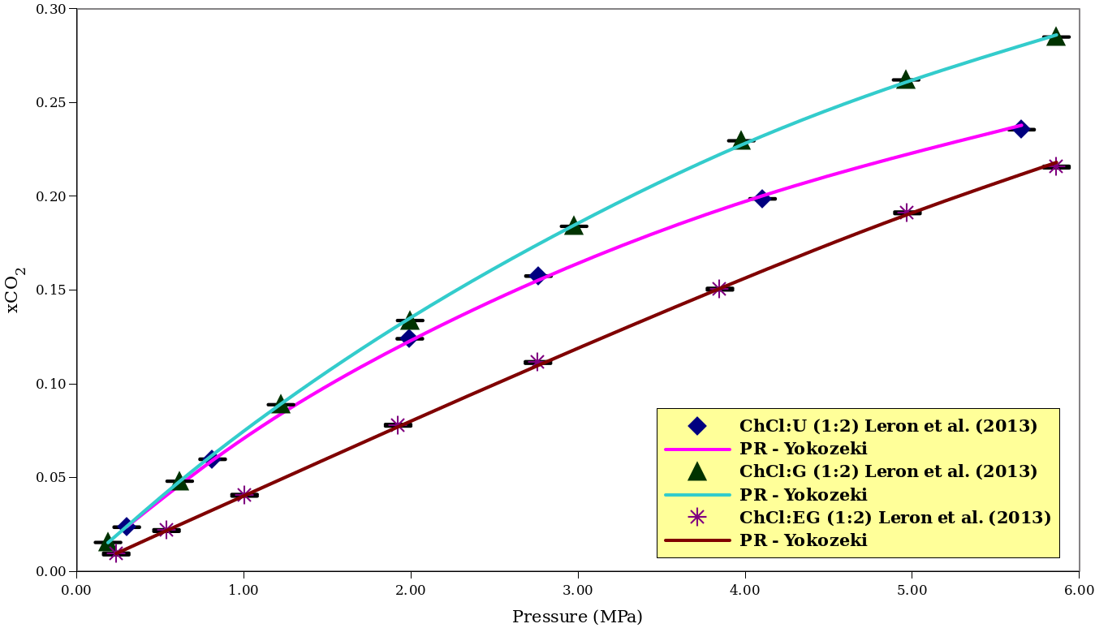
Figure 1: Correlation of CO₂ solubilities in three choline chloride based DESs using the SRK equation
Table 2: Regressed parameters of three CO₂-DES systems for the SRK CEoS and resulting deviations
CO₂-DES | $$k_{ij}$$ | $$l_{ij}$$ | $$x_{{CO}_{2}}$$ | AAD (%)
CO₂-ChCl + U (1:2) | 0.198205 | 0.045287 | 0.0235 – 0.2356 | 1.09
CO₂-ChCl + G (1:2) | 0.225056 | 0.023673 | 0.0154 – 0.2850 | 0.87
CO₂-ChCl + EG (1:2) | 0.170279 | -0.029320 | 0.0093 – 0.2156 | 0.98

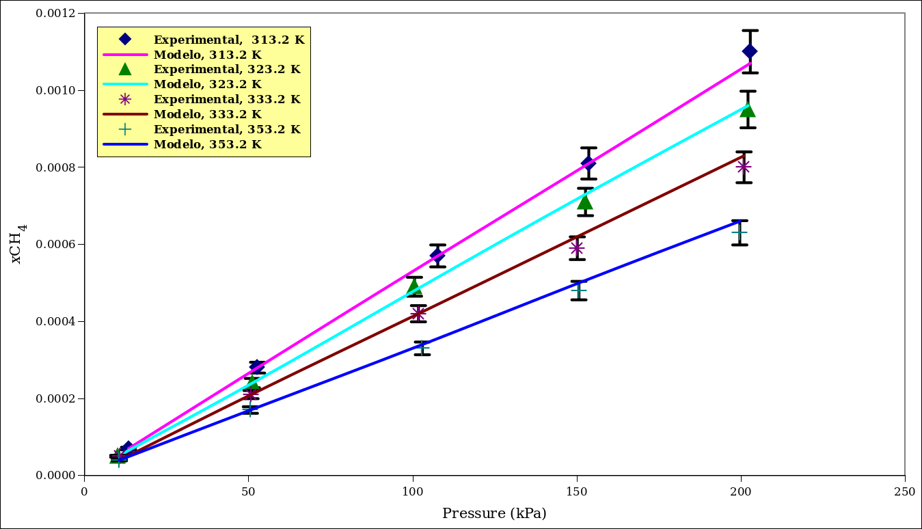
Figure 2: Correlation of CH₄ solubilities in ChCl + U (1:2) using the PR equation
Table 3: Regressed parameters of the NH₄-ChCl + U (1:2) system for the PR CEoS and resulting deviations
CH₄-DES | T (K) | $$α$$ | $$k_{ij}$$ | AAD (%)
CH4-ChCl + U (1:2) | 313.2 | Soave | 0.161695 | 0.86
 |  | Yokozeki | 0.136861 | 0.97
 |  | F. Soave | 0.083536 | 0.97
 | 323.2 | Soave | 0.188071 | 2.82
 |  | Yokozeki | 0.157000 | 2.18
 |  | F. Soave | 0.101606 | 2.18
 | 333.2 | Soave | 0.224817 | 5.44
 |  | Yokozeki | 0.186716 | 4.13
 |  | F. Soave | 0.128644 | 4.14
 | 353.2 | Soave | 0.293248 | 9.31
 |  | Yokozeki | 0.241923 | 5.07
 |  | F. Soave | 0.179530 | 5.07
Tables 2 and 3 show that the ability of the present approach in representing the experimental gas solubility data is quite good for the Gas-DES systems and both CEoS give comparable results for the four Gas-DES mixtures presented. In the case of CH₄, the thermodynamic model fails to give a reasonably good correlation of the experimental solubilities as pressure and temperature increases with an AAD value as high as 9.31% using the Soave alpha function (original physical properties of the pure solvents).

Figure 1 and Figure 2 graphically depict the comparison between experimental and calculated composition for CO₂ in ChCl + U (1:2), ChCl+ G (1:2) and ChCl + EG (1:2), also CH₄ in ChCl + U (1:2) over a wide pressure range. As shown by these figures, the present approach provides a very good fit to experimental gas solubilities. As for the CH₄ the best fit was obtained in the infinite diluted region at very low pressures. It should be acknowledged that the agreement between experimental and predicted solubility data is reasonably good and within experimental uncertainty for most of the Gas-DES systems.
  - Conclusions
Overall, the present model correlated satisfactorily the experimental solubility data of the seven chosen gases in choline chloride based DESs. Likewise, the use of both Yokozeki and fitted Soave alpha functions are suitable in correlating said experimental data, though the Yokozeki function performed with greater accuracy for many Gas-DES systems. For a few systems, using only the temperature-dependent $k_{ij}$ values improved gas-solubility estimations.
References
Animasahun O.H., Khan M.N., Prediction of the CO₂ Solubility in Deep Eutectic Solvents: A Comparative Study between PC-SAFT and Cubic equations of State, 2017, Society of Petroleum Engineers - SPE Abu Dhabi International Petroleum Exhibition and Conference 2017.
García G., Aparicio S., Ullah R., Atilhan M., 2015, Deep Eutectic Solvents: Physicochemical Properties and Gas Separation Applications, Energy & Fuels, 29, 2616–2644.
Mirza N.R., Nicholas N.J., Wu Y., Kentish S., Stevens G.W., 2015, Estimation of Normal Boiling Temperatures, Critical Properties, and Acentric Factors of Deep Eutectic Solvents, Journal of Chemical and Engineering Data, 60, 1844–1854.
Moura L., Kollau L., Gomes M.C., 2021, Deep Eutectic Solvents for Medicine, Gas Solubilization and Extraction of Natural Substances, Environmental Chemistry for a Sustainable World, 56.
Leron R.B., Caparanga A., Li M.H., 2013, Carbon dioxide solubility in a deep eutectic solvent based on choline chloride and urea at T = 303.15-343.15K and moderate pressures, Journal of the Taiwan Institute of Chemical Engineer, 44, 879–885.
Li C., Cai Z., Ma Y., Cao Y., Huang K., Jiang L., 2022, Densities and viscosities of, and solubilities of acidic gases (SO₂ and H₂S) in natural deep eutectic solvents, J. Chem. Thermodynamics, 167, 106713.
Peng D.Y., Robinson D.B., 1976, A New Two-Constant Equation of State, Industrial and Engineering Chemistry Fundamentals, 15, 59–64.
Shiflett M.B., Yokozeki A., 2005, Solubilities and Diffusivities of Carbon Dioxide in Ionic Liquids: [bmim][PF₆]
and [bmim][BF₄], Industrial and Engineering Chemistry Research, 44, 4453–4464.
Soave G., 1972, Equilibrium Constants from a Modified Redlich-Kwong Equation of State, Chemical Engineering Science, 27, 1197–1203.
Valderrama J.O., 2003, The State of the Cubic Equations of State, Industrial and Engineering Chemistry Research, 42, 1603–1618.
Yang D. Hou M., Ning H., Zhang J., Ma J., Yang G., Han B., 2013, Efficient SO2 absorption by renewable choline chloride–glycerol deep eutectic solvents, Green Chemistry, 15, 2261–2265.
Yokozeki A., 2001, Solubility of Refrigerants in Various Lubricants, International Journal of Thermophysics, 22, 1057–1071.

