CHEMICAL ENGINEERING TRANSACTIONS  VOL. , 2023 | A publication of
The Italian Association
of Chemical Engineering
Online at www.cetjournal.it

Guest Editors: Sauro Pierucci, Jiří Jaromír Klemeš
Copyright © 2023, AIDIC Servizi S.r.l.
ISBN 978-88-95608-98-3; ISSN 2283-9216
A Viscosity Model for Deep Eutectic Solvents Based on the Friction Theory.

Inés M. Romero-Rueda^{a,*}, Ricardo Macías-Salinas^{b}
ESIQIE-Departamento de Ingeniería Química, Instituto Politécnico Nacional, Zacatenco, México, D.F. 07738
E-mail: *rms@ipn.mx, iromeror2000@alumno.ipn.mx

A previously developed six-parameter viscosity model based on the friction theory (FT) in combination with a cubic equation of state (CEoS), and applied to pure ionic liquids, was modified here to represent the dynamic viscosity of deep eutectic solvents (DES). Upon analyzing the different viscous contributions of the aforementioned model to the total viscosity, we found out that, in the case of DES, the second-order repulsive term was the most dominant dragging force contribution within the FT framework; it is actually the main responsible in capturing, at least qualitatively, the correct variation of viscosity with both temperature and pressure exhibited by a DES. This finding allowed us to reasonably reduce the number of adjustable parameters of the model without sacrificing model accuracy. Thus, by preserving the same form of second-order repulsive term, simplifying the first-order attractive term and neglecting the first-order repulsive term, the new model now contains three parameters. As earlier mentioned, the use of a simple CEoS (Soave-Redlich-Kwong or Peng-Robinson) served to calculate the first-order attractive and second-order repulsive pressures. Interestingly, we were also able to confirm the predictive capabilities of the present 3-parameter viscosity model by applying the model to estimate high-pressure DES viscosity data using the same model parameters previously obtained only using viscosity data at atmospheric pressure, thus, developing a model capable of representing the viscosity and density variations of DES with respect to different 𝑇 and 𝑃 range.

- Introduction

Deep eutectic solvents can be defined as a mixture of a hydrogen bond donor (HBD) and a hydrogen bond acceptor (HBA) that can associate with each other to form an eutectic mixture. In most cases, they are created by mixing a quaternary ammonium salt (e.g., choline chloride) and a hydrogen bond donor. DES share many properties with traditional ionic liquids: they are non-volatile, thermally stable, highly conductive and have a high dissolving capacity.

Viscosity is one of the most important physical properties of DES, this variable is of great importance in the design of engineering applications involving this ecological solvent, however, it is not always easy to determine these values experimentally, so the need arises to develop a model capable of representing the viscosity variations with respect to temperature and pressure of these solvents.

There are few models developed for the estimation of the transport properties of DES and those available are very elaborated and require the use of complex equations of state (PC-SAFT) and the use of a large number of characteristic parameters (up to 13 parameters). Based on the above, the main purpose of the present work is to contribute with a simple model capable of representing the viscosity variations of DES, using the friction theory in combination with a cubic equation of state for the estimation of the viscosity of DES within temperature and pressure ranges between 293-368.15 K and 1-500 bar, respectively.

- Modelling Approach

The Friction Theory Model for viscosities has proven to be successful in estimating viscosities, taking the equation $η=η_{0}+η_{f}$ [Quinones-Cisneros, 2000] and considering that $η_{0}=0$ (the dilute-gas contribution is negligible because DES as well as ILs are fluids that always behave as liquids), the total viscosity of a pure DES can be calculated by the equation:

$$η_{f}=κ_{r}P_{r}+κ_{a}P_{a}+κ_{rr}P_{r}^{2} \left(1\right)$$
For a DES:
$$η_{DES}=κ_{r}P_{r}+κ_{a}P_{a}+κ_{rr}P_{r}^{2} \left(1a\right)$$
Repulsive pressure
Attractive pressure
Second-order repulsive pressure
These are the temperature-dependent parameters of the residual viscosity.
$$\left.\begin{matrix}κ_{r} \\ κ_{a} \\ κ_{rr}\end{matrix}\right\}$$ | $$\left.\begin{matrix}P_{r} \\ P_{a} \\ P_{rr}\end{matrix}\right\}$$
DESs share great similarities with ILs [Macías-Salinas, 2018], so the expressions $κ_{i}$ appearing in equation (1), originally based on the FT are defined as:

$$κ_{r}=a_{1}Ψ_{1}+a_{2}Ψ_{2} (2)$$
$$κ_{a}=b_{1}Ψ_{1}+b_{2}Ψ_{2} (3)$$
$$κ_{rr}=c_{2}Ψ_{2}+c_{3}Ψ_{3} (4)$$
Where:
$$Ψ_{i}=exp\left(2^{i}Γ\right) (5)$$

And:
$$Γ= \frac{Tc}{T} (6)$$

In equation ($1a$) we substitute the values of the temperature dependent parameters ($κ_{r}, κ_{a}, κ_{rr}$), which yields a model of only 6 adjustable parameters ($a_{1}, { a_{2}, { b}_{1}, b_{2}, c}_{2}, c_{3}$).

The terms ($P_{r}$, $P_{a}$, $P_{r}^{2}$) were estimated using the Soave Redlich-Kwong and Peng Robinson cubic equations of state. Substitution of the corresponding terms along with the friction coefficients ($κ$) into the $η_{DES}$ equation provides the final form of the current FT-based viscosity model for application in DES.

$$η_{DES}=\sum_{i=1}^{2}{a_{i}}exp\left(2^{i}Γ\right)\frac{RT}{\left(V -b\right)}$$
$$-\sum_{i=1}^{2}{b_{i}}exp\left(2^{i}Γ\right)\frac{a}{\left(V+δ_{1}b\right)\left(V+δ_{2}b\right)} (7)$$
$$+\sum_{i=2}^{3}{c_{i}}exp\left(2^{i}Γ\right)\frac{R^{2}T^{2}}{{\left(V -b\right)}^{2}}$$

2.1 Parameter reduction in the Friction Theory Viscosity Model

The analysis of the different contributions of the terms $η_{r}, η_{a}$and $η_{rr}$ helped to identify which were the most dominant contributions. In the following isotherms and isobars for the Choline Chloride + Ethylene Glycol (1:2) Viscosity data taking the points at a pressure of 1 bar, it can be observed the terms: first order repulsive ($η_{r}$), first order attractive ($η_{a}$) and second order repulsive term ($η_{rr}$).

It is observed that the second-order repulsive term is the dominant one and that the attractive and first-order repulsive terms cancel each other out, which allows to disregard them and to go from a six-parameter model to a three-parameter model, containing two parameters for the second-order repulsive term and only one parameter for the first-order attractive term.

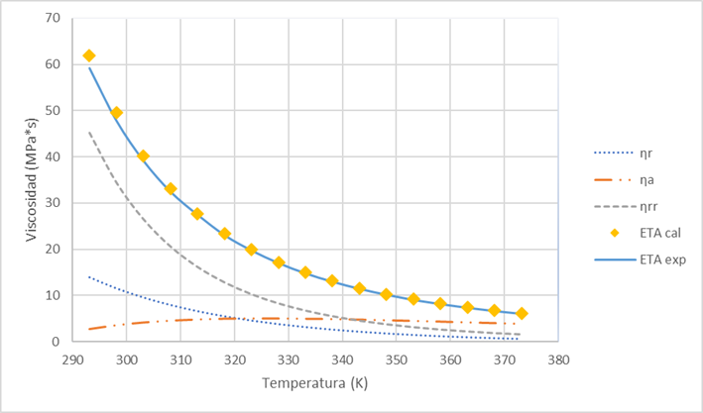 | 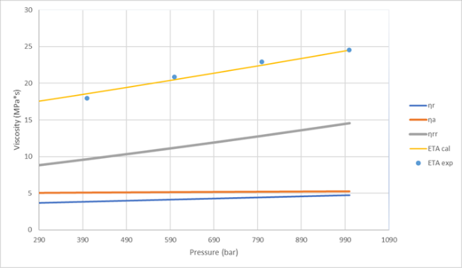
Figure 1: Isobar at 1.01325 bar of Choline Chloride + Ethylene Glycol 1:2 | Figure 2: Isotherm at 333.15 K of Choline Chloride + Ethylene Glycol 1:2
For the resulting model, two parameters remain, the first order respulsive term is neglected and the final model is obtained:
$$η_{DES}=\sum_{i=1}^{2}{a_{i}}exp\left(2^{i}Γ\right)\frac{RT}{\left(V -b\right)}$$
$$-\sum_{i=1}^{2}{b_{i}}exp\left(2^{i}Γ\right)\frac{a}{\left(V+δ_{1}b\right)\left(V+δ_{2}b\right)} (8)$$
$$+\sum_{i=2}^{3}{c_{i}}exp\left(2^{i}Γ\right)\frac{R^{2}T^{2}}{{\left(V -b\right)}^{2}}$$

The second order repulsive term will remain the same with the two parameters, $c_{2}$ and $c_{3}$. The attractive term will have one term eliminated leaving only b1, remaining as follows:

$$η_{DES}=b_{1}exp\left(2Γ\right)\frac{a}{\left(V+δ_{1}b\right)\left(V+δ_{2}b\right)}$$
$$+\sum_{i=2}^{3}{c_{i}}exp\left(2^{i}Γ\right)\frac{R^{2}T^{2}}{{\left(V -b\right)}^{2}} (9)$$
At high temperatures the cohesion energy increases so the contribution of the first term of the equation will be more significant at high pressures and temperatures and of greater magnitude than the first order repulsive pressure contribution ηr, thus justifying its exclusion from the present model. The attractive parameter, being almost linear, is considered as a single parameter, shows no curvature and remains with the one-parameter attractive term. At high temperatures and pressures the attractive term contributes the most.

The performance of the two viscosity models containing six and three adjustable parameters coupled to the two equations of state (SRK and PR) will be used, which will provide the attractive and repulsive pressures needed in the proposed viscosity models, are discussed below.

- Results and Discussion

Pure DES were selected from twenty-four common systems based on choline chloride, N,N-diethylethanolammonium chloride and methyltriphenylphosphonium bromide, with different hydrogen bond donors with incipient amounts of water.

We initially considered the six-parameter model with different equations of state (FT6-SRK and FT6-PR), however, by reducing the parameters we also obtained satisfactory results with the three-parameter model (FT3-SRK and FT3-PR).

The results obtained from the proposed thermodynamic model at different pressure and temperature ranges were satisfactory with low values of average absolute deviations (AAD) varying from 1.14 to 1.75% based on a total number of 271 experimental points. The following figure shows of the graphical comparison of the experimental viscosities versus those calculated with the model in terms of individual relative deviations.

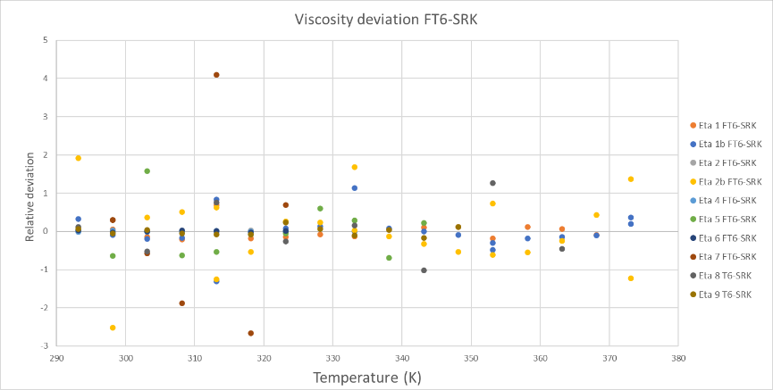
Figure 3: Comparison of relative deviations of the six-parameter model.

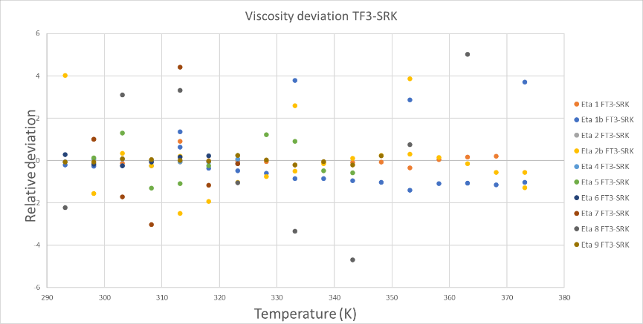
Figure 4: Comparison of relative deviations of the three-parameter model.

According to the four versions of the present Model (FT3-SRK, FT3-PR, FT6-SRK and FT6-PR) and to the AAD values obtained with each version of the model, it was determined that the reduction of the characteristic parameters did not affect adversaly the efficiency of the Model developed here.

Obtaining an overall deviation for the three-parameter models of 1.75% using FT3-SRK and 1.13% for the six-parameter models using FT6-SRK. This demonstrates that the simplifications made to the model were reasonable and provide satisfactory results.

Table 1: Deviations obtained with three and six parameters and different equation of state

DES | NP | DAP - FT3- |  | DAP -FT6-
 |  | FT3-SRK | FT3-PR | FT6-SRK | FT6-PR
1 | 15 | 0.1743 | 0.1756 | 0.1587 | 0.1586
1b | 21 | 1.1526 | 1.1537 | 0.2988 | 0.3100
1c* | 53 | 2.2578 | 2.4538 | 2.3101 | 2.3628
2 | 7 | 0.0527 | 0.0528 | 0.0089 | 0.0089
2b | 21 | 1.0988 | 1.0998 | 0.7681 | 0.6200
3* | 35 | 4.3697 | 3.8979 | 2.0877 | 2.1860
4 | 7 | 0.0606 | 0.0606 | 0.0111 | 0.0111
5 | 10 | 0.7492 | 0.7490 | 0.5301 | 0.5300
6 | 7 | 0.1874 | 0.1888 | 0.0169 | 0.0170
7 | 7 | 1.7804 | 1.7816 | 1.4984 | 1.4986
8 | 8 | 2.9337 | 2.9376 | 0.5688 | 0.5694
8b* | 27 | 2.4712 | 2.4003 | 1.4666 | 1.6208
9 | 12 | 0.1058 | 0.1038 | 0.0920 | 0.0920
10 | 12 | 0.1956 | 0.1959 | 0.1935 | 0.1933
11 | 11 | 0.1590 | 0.1606 | 0.0872 | 0.0872
12 | 11 | 1.2469 | 1.2473 | 1.1227 | 1.1228
13 | 7 | 2.8217 | 2.8217 | 1.5307 | 1.5305
Global DAP |  | 1.7475354 | 1.7182881 | 1.1362977 | 1.1640608

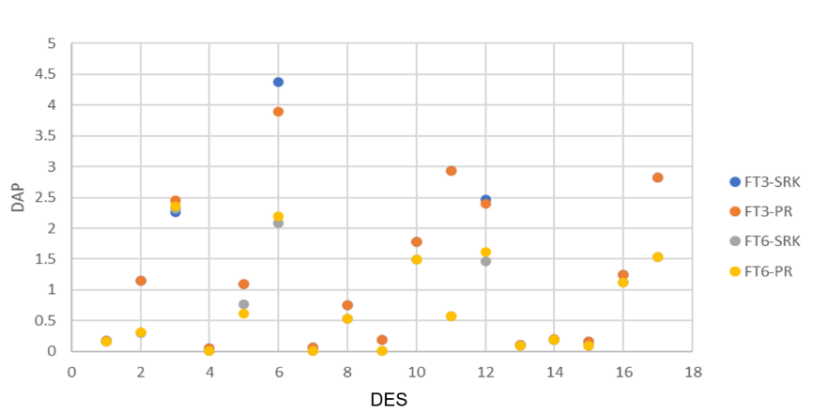
Figure 5: Comparison of deviations for the four models

- Conclusions

- The resulting modeling procedure was successfully validated during the representation of experimental dynamic viscosities of various types of DES (mainly containing ChCl as the inorganic part, and either Urea or Glycerol or Ethylene Glycol as the hydrogen bonding donor) within a temperature range varying from 0 to 80 °C and at pressures from 1 to 1,000 bar.

- The performance of the Model for the viscosities at 1 bar and in the T ranges from 293.15 to 373.15 K was satisfactory, as well as for the data reported at high pressures, from 1 to 1000 bar, obtaining an overall of 0.021% for the 13 DES selected for viscosity estimation including those reported at atmospheric pressure and high pressures.

- It was possible to reduce the number of parameters initially used to a total of 3, which showed that satisfactory values could be obtained without the need to use a large number of adjustable as in the models previously reported in the literature, such as: 8 parameters in the case of Quiñones-Cisneros et al. (2000), 7 parameters reported in 2002 by Zeberg-Misneros et al., 9 parameters reported in 2006 by Quiñones & Dieters, even in 2017 Haghbakhsh et al. reported a Model with a total of 12 parameters, until reaching 6 and finally 3 adjustable parameters.

References
Abbott, A., Glen Capper, David L. Davies, Raymond K. Rasheed, Vasuki Tambyrajah., 2003, Novel solvent properties of choline chloride/urea mixtures, Royal Society of Chemistry, pages 70-71.

Crespo Emanuel A., João M. L. Costa, André M. Palma, Belinda Soares, Carmen Martín M., José J. Segovia, Pedro J. Carvalho, and João A. P. Coutinho, 2019. Thermodynamic characterization of deep eutectic solvents at high pressures., Fluid Phase Equilibria Volume 500, pages112249.

Guo, W., Hou, Y., Ren, S., Tian, S., & Wu, W., 2013. Formation of deep eutectic solvents by phenols and choline chloride and their physical properties. Journal of Chemical & Engineering Data, volumen 58(4), pages 866–872.

Haghbakhsh R., Bardool R., Bakhtyari A., Duarte A.R.C., Raeissi S., 2019, Simple and global correlations for the densities of deep eutectic solvents, Journal of Molecular Liquids, Volume 209, pages 111830.

Leron, R. B., Wong, D. S., &amp; Li, M.-H., 2012. Densities of a deep eutectic solvent based on choline chloride and glycerol and its aqueous mixtures at elevated pressures. Fluid Phase Equilibria, Volume 335, pages 32–38.

Li Guobing, Jiang Y., Liu, X., Deng, D., 2016, New Levulinic acid-based deep eutectic solvents: synthesis and physicochemical property determination, Journal of Molecular Liquid, Volume 222, pages 201 – 207.

Mirza, N. R., Nicholas, N. J., Wu, Y., Kentish, S., &amp; Stevens, G. W., 2015. Estimation of normal boiling temperatures, critical properties, and acentric factors of deep eutectic solvents. Journal of Chemical &amp; Engineering Data, Volume 60, pages 1844–1854.

Quinones-Cisneros, Stenby, E., 2000, The friction theory (f-theory) for viscosity modeling, Fluid Phase Equilibria Volume 169, pages 249-276.

Shahbaz, K., Mjalli, F. S., Hashim, M. A., AlNashef, I. M., 2011. Prediction of deep eutectic solvents densities at different temperatures. Thermochimica Acta volume 515, pages 67–72.

Shahbaz, K., Baroutian, S., Mjalli, F. S., Hashim, M. A., &amp; AlNashef, I. M. 2012. Densities of ammonium and phosphonium based deep eutectic solvents: Prediction using artificial intelligence and group Contribution Techniques. Thermochimica Acta 527, pages 59–66.

Soave, G. 1972. Equilibrium constants from a modified Redlich-kwong equation of State. Chemical Engineering Science, Volumen 27(6), pages 1197–1203.

Yokozeki, A. 2001. Solubility of Refrigerants in Various Lubricants. International Journal of Thermophysics, volumen 22 no. 4 pages 1057-1071.

