|  |  |
| --- | --- |
| cetlogo ***CHEMICAL ENGINEERING TRANSACTIONS***  ***VOL. , 2023*** | A publication of  aidiclogo_grande |
| The Italian Association  of Chemical Engineering  Online at www.cetjournal.it |
| Guest Editors: Sauro Pierucci, Jiří Jaromír Klemeš  Copyright © 2023, AIDIC Servizi S.r.l. **ISBN** 978-88-95608-98-3; **ISSN** 2283-9216 | |

A Continuum and Molecular Dynamics-based Simulation Study of Boiling in Liquid Nitrogen

Indradev kumar, Abhiram Hens\*

Department of Chemical Engineering, National Institute of Technology Durgapur, Durgapur713209, India

Email: abhiram.hens@che.nitdgp.ac.in

Phase changes associated with the boiling of cryogenic liquids are interesting phenomena. In the present study, liquid nitrogen, which has applications in microelectronics, semiconductors, and the space sector, has been considered as a representative cryogenic fluid. The boiling of liquid nitrogen was investigated at different lengths and time scales. At the micro level, classical molecular dynamics (MD) based simulations were performed to understand various facets of boiling, considering a film of liquid nitrogen on a solid surface. For macroscale study, the route of computational fluid dynamics (CFD) has been adopted. For accurately tracking the dynamic interface, coupled level set volume of fluid approach (CLSVOF) has been implemented. CFD results show the formation of vapour bubbles in liquid nitrogen at different degrees of wall superheats. Temporal variation of heat flux has been evaluated. Finally, the results obtained from MD and CFD simulations have been compared.

* 1. Introduction

The boiling of cryogenic liquids, such as liquid nitrogen, is a complex phenomenon that requires a comprehensive understanding due to its various applications in semiconductor cooling, cryogenic storage, rocketry etc. (Darr et al., 2016, Kumar et al., 2022) The extremely low temperature and highly dynamic nature of such phenomena makes it difficult to do experimental investigations. Numerical simulations reveal many important aspects of film boiling of such fluids (Hens et al., 2014, Pandey et al., 2017). In order to study the boiling of cryogenic liquids, various computational methods have been developed over the years. Two of the most widely used methods are classical molecular dynamics (MD) simulations (for micro-level studies) and computational fluid dynamics (CFD) based simulations (for macrolevel studies).

MD simulation is a powerful tool that allows the study of molecular-level changes that take place during boiling. These simulations provide detailed information about the behaviour of individual molecules and the interactions between them. This is useful for understanding the underlying physics involved during such boiling and for developing new technologies that use these liquids. Hens et al., 2014 studied the film boiling of liquid argon on the Pt surface using MD simulations. Heat flux and molecular movements during film boiling were analysed at nanoscale. Wang et al., 2023 also used molecular dynamics simulations to analyse the film boiling of liquid argon on both solid and liquid substrates. The effect of liquid film thickness and surface flexibility was analysed on the film boiling of liquid argon. Wu et al., 2022 studied the film boiling of water with some insoluble gas using MD simulations. However, molecular-level simulation of cryogenics like liquid nitrogen and its boiling is rare in the existing literature.

On the other hand, CFD simulations are used for studying fluid dynamics and heat transfer in large-scale systems. CFD simulations provide information about the behaviour of fluids at a macro-scale and can be used to study the formation of vapour bubbles, the temporal variation of heat flux, and the Nusselt number etc [Pandey et al., 2017]. Studies of Hens et al., 2014 gives an insight into the film boiling of water near critical conditions. Using the CFD simulations, analysis was done to check the interface morphology and heat flux variations during film boiling. Kumar et al., 2022 have done a similar study for liquid nitrogen boiling and examined the effect of electric field on bubble morphology and heat flux at 120 K temperature. These results indicated that film boiling of liquid nitrogen poses different characteristics of boiling than that of other refrigerants. Pandey et al., 2017 and many others worked in a similar direction using the CLSVOF (coupled level set volume of fluid) method of interface tracking.

Although the above-mentioned studies explain the film boiling at different lengths and time scales separately for many liquids, there exist very few studies that compare these phenomena with cryogenic liquids. Especially, MD simulation of boiling with liquid nitrogen is not reported so far.

The present study aims to investigate the boiling of liquid nitrogen using both MD and CFD simulations. LAMMPS (an open-source molecular simulator) package was used to investigate the boiling characteristics at the microscale and an in-house code containing the CLSVOF method was used in interface tracking at macroscale CFD simulations. The results obtained from both simulations were compared and the molecular-level insights causing the film boiling of liquid nitrogen were explored.

* 1. Mathematical model
     1. Molecular dynamics simulation

For the molecular dynamics simulation, a film of liquid nitrogen molecules (consisting of 2000 nitrogen molecules) were considered to be placed on a Pt substrate. Figure-1(a) shows the initial configuration of the MD simulation. Periodic boundary conditions were applied in all three directions. The simulation box height was kept higher in the z-direction to avoid the effect of upper boundary conditions. At the bottom, a Pt substrate of 1.2 nm thickness was considered which contained 4000 atoms of Pt. The force field was considered based on Leonard-jones (LJ) 12-6 potential. L-J model can be expressed mathematically as mentioned below:

 -(1)

Where i, j denotes the interacting molecules. LJ potential parameters for the interaction between nitrogen molecules were considered as =3.69 and energy parameter ()= 0.0083 eV [Zou and Hual., 2010]. Interaction parameters between Pt atoms were considered as =2.34 and =0.4095 eV [Hens et al 20141]. The solid-liquid interaction was calculated based on Lorentz -Berthelot mixing rule (Zhang et al. 2016), following the formula for the length parameter and for the energy parameter. More details of potential parameters and equations of motion involved can be found in the work of Hens et al., 20141. The simulation box was first equilibrated to 70 K for liquid nitrogen and 300 K, 600 K respectively for separate cases for Pt layer. NVT ensemble continued to be applied on Pt layers, and liquid nitrogen was kept in NVE ensemble without the effect of any thermostat. The temperature of the Pt surface was maintained using Nose-hover thermostat. All the simulations were performed using LAMMPS simulator developed by Sandia national laboratory USA [Plimpton S., 1995].

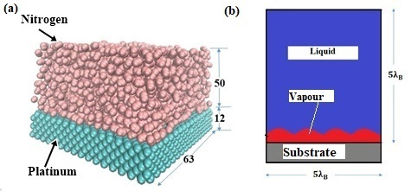

*Figure 1: Initial simulation condition for film boiling analysis (a) for MD simulation (dimensions are in unit) and (b) CFD simulation*

* + 1. Continuum (CFD )simulation

To perform the CFD simulations, a thin vapor film was considered over a heated surface. The vapor film was perturbed randomly in horizontal direction, as shown in the schematic diagram of Fig. 1(b). Conventional incompressible flow Navier-Strokes equation was solved for pure liquid and pure vapor cells. For the cells containing the interface, modified form of Navier-Strokes and continuum equations were solved which can be shown as :

 - (1)



The energy equation used in the simulations is shown as:



Detailed description of the equations (including the meaning of symbols) along with the other details of simulation methodology can be found in our recent study (Kumar et al., 2022). It also contains the table containing the material properties of liquid nitrogen that are used in the present work.

.

4. Results and discussion

Boiling of liquid nitrogen was investigated through the route of MD and CFD based simulations using the above-mentioned methodology and boundary conditions. For CFD simulations a fluid domain of  size was considered for the analysis. Where  is the Taylor’s most dangerous wavelength and can be given as, where  is the surface tension,  represents density of liquid and gas phase (indicated by subscript *l* and *g* respectively) and  denotes acceleration due to gravity. The liquid phase present in the domain was kept at a constant temperatureduring the simulation.The time step was determined based on the capillary instability criteria. For the present case, time step size was considered to be 5×10-6 sec. The continuum-based simulation was performed for analysis of bubble spacing, height and temporal heat flux variations at near critical pressure.

Figure-2 shows the interface growth of the nitrogen vapor film at 10 K superheat (temperature difference between solid substrate and nitrogen vapor) at different instants of time. The first bubble departure happens at 0.36 sec (Fig. 2(a)). The shape of bubble after departure is shown in Fig. 2(c-d). The state of interface after release of first set of bubble from node positions can be seen at t=1 sec (Fig. 2(d). It was observed that the interface growth during film boiling of liquid nitrogen follows Rayleigh-Taylor instability at 10 K superheat with the formation of 6 bubbles in a  domain. However, after first cycle of bubble release, number of bubble formation sites is reduced to 5. The reduction in number of bubble formation sites may be attributed to the increased turbulence inside the liquid domain after first set of bubble release. Earlier study (Kumar et al*.,* 2022) described the film boiling analysis at intermediate pressure ratio and it was observed that at 10 K superheat, the number of bubble formation site was 3 for a 3 domain, following the Taylor-Helmholtz instability. The formation of higher number of bubbles can be due to the high pressure ratio, leading to more randomness at the interface.

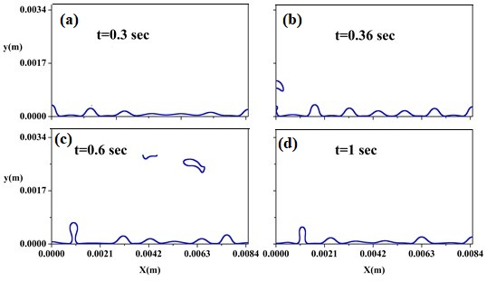

*Figure 2: Bubble growth during film boiling of liquid nitrogen at 10 K superheat. (CFD results)*

Figure-3(a) shows the results of MD simulations exhibiting the temporal variation of the nitrogen layer during 300 K wall superheat. Due to low degree of superheat only evaporation was observed. Number of nitrogen vapor molecules were found to increase with time. Figure 3(b) shows the results at an increased degree of wall superheat (600K). It clearly shows the explosive film boiling with the formation of vapor film above the heating surface. It is interesting to note that, in case of CFD simulations, an initial vapor film was assumed on the solid surface and it’s growth was observed. Whereas, in MD simulations, we observed the formation of the vapor film from the molecular level due to high wall temperature.

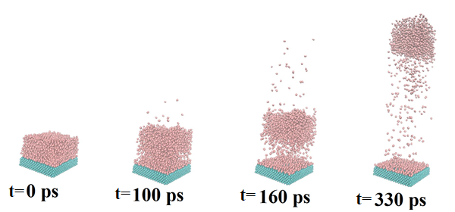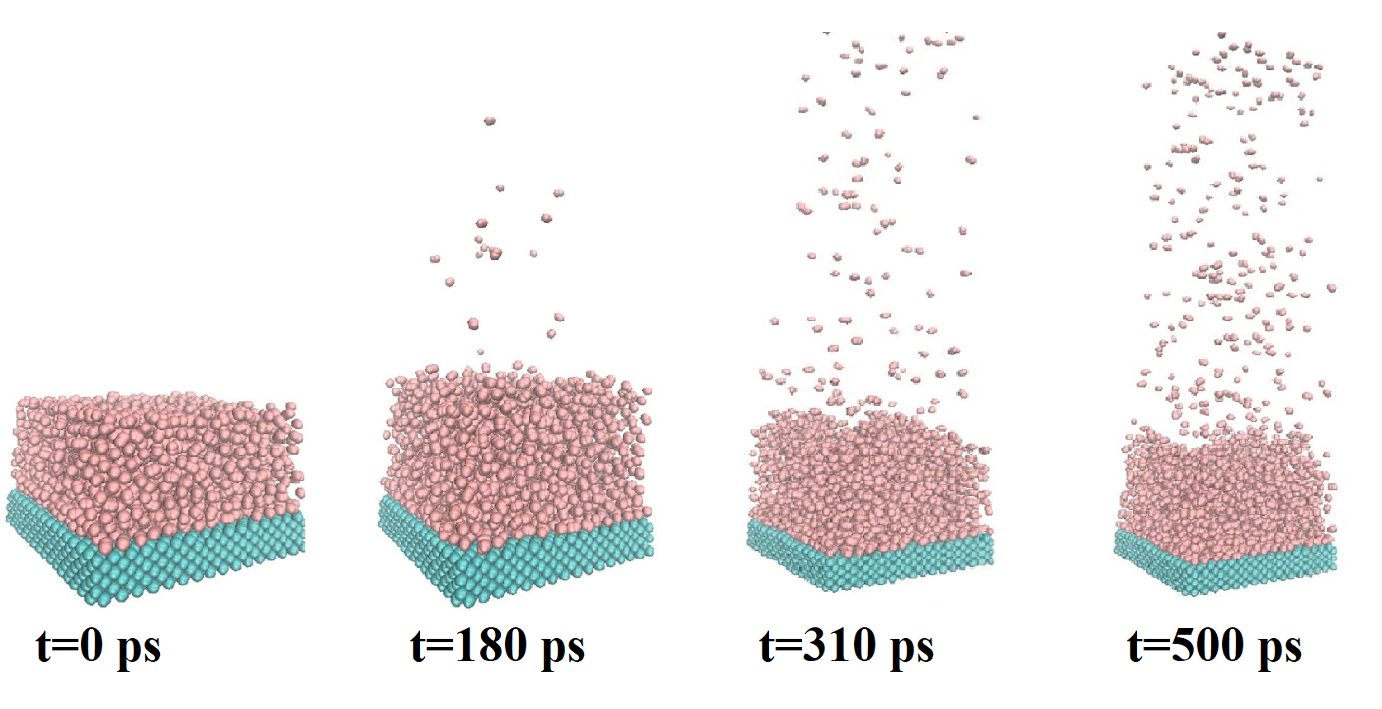

**(a)**

**(b)**

*Figure 3: (a) Evaporative boiling as a superheat of 300 K during and (b) explosive film boiling of liquid nitrogen at a wall temperature of 600 K (temporal evolution from MD simulations)*

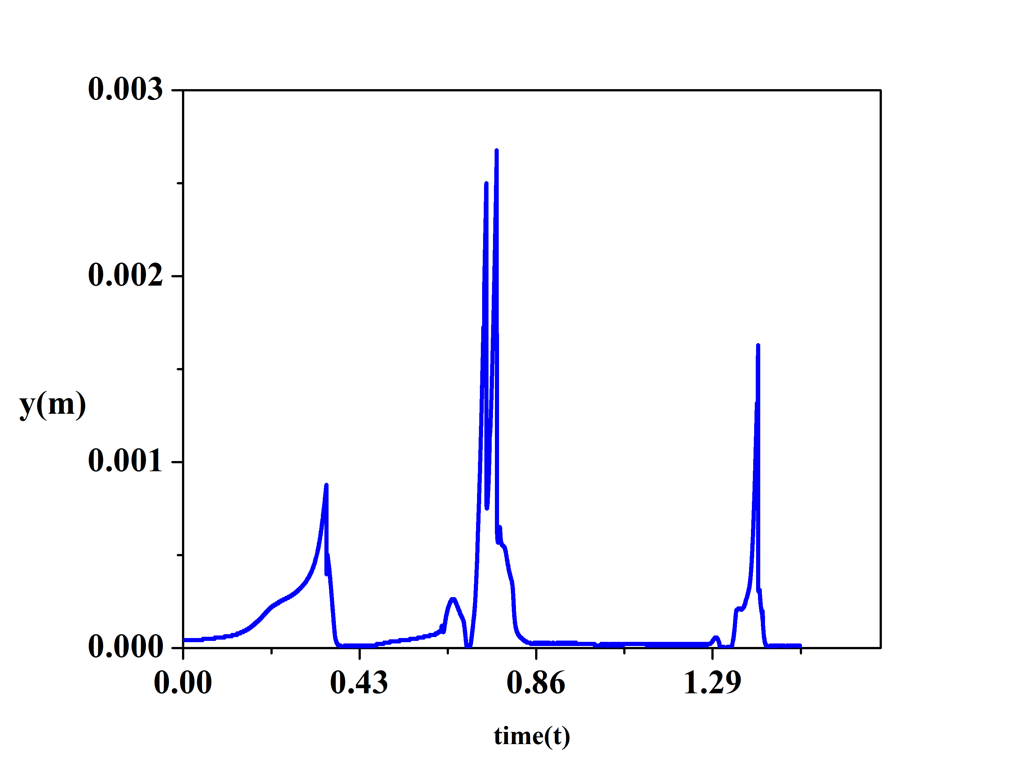

*Figure 4: Variation of height during film boiling at 10 K degree of superheat (CFD simulations)*

Heat transfer during the film boiling is dependent on the size and frequency of bubble release. Size of the bubble can be analysed with the help of bubble height. Larger size of bubble formation results in higher heat transfer in single bubble release but lowers the frequency of bubble detachments. Also, larger bubble detachments can cause high recoiling effect on the interface creating randomness for next bubble release. Figure-4 show the variation of bubble height with time during the film boiling of liquid nitrogen from CFD simulations. The number of peaks present indicates the bubble release instants which indicates the interval between two bubble release cycles. For the first cycle of bubble release maximum height shows a single and uniform peak indicating no disturbance in bubble formations. But after the first bubble release, a disturbance in the height variation can be seen. This is due to effect of other bubble inside the liquid domain and the recoiling effect to adjust the interface after the bubble release. At the time interval between 0.5 sec and 0.86 sec, two peaks at very small-time interval can be seen, which indicates the formation of two bubble simultaneously. This formation can be also confirmed from the temporal interface growth indicated in Fig. 2(c). The maximum height of the bubble is varying at each peak.

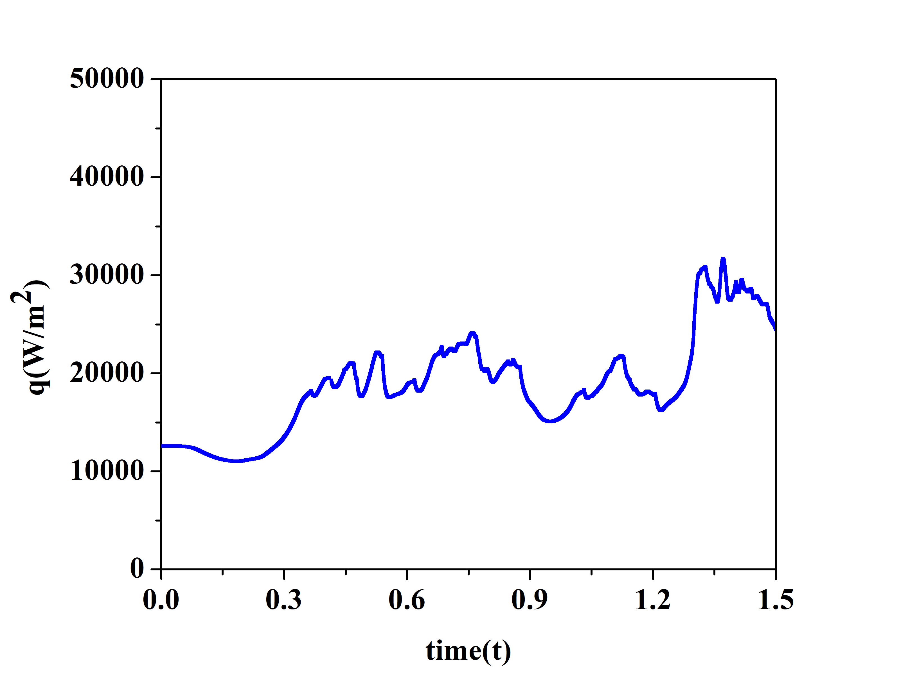

*Figure 5: Temporal variation of heat flux during film boiling of liquid nitrogen at 10 K superheat. (CFD simulations)*

Figure-5 shows the variation of heat flux with time during film boiling from CFD simulations. Heat flux is mainly dependent on the bubble release frequency and amount of vapour carried in a single bubble release. Heat flux increases as bubble growth takes place. After the detachment of the grown bubble there is a sudden drop in heat flux, again the formation of next bubble causes the same. But increase in turbulence after the release of first bubble, causes some variations in the interface growth, resulting smaller peaks in between major peaks in the heat flux profile. The average heat flux for the present case was 20.73 KW/m2. At 20 K superheat, it was found to be 43 KW/m2. For the similar range of superheat, Hens et al., 2014 reported a heat flux in the range of 175 KW/m2 in case of saturated water. Apart from the latent heat of vaporization, the heat capacity of the vapour plays an important role in determining the variation in the heat flux. For water, it is the in the range of 350 KJ/K whereas, in case of liquid nitrogen it is 10 KJ/K only near critical conditions.

5. Conclusions

The present study gives an overview of analysis of film boiling of liquid nitrogen using molecular dynamics and CFD based simulations. It was attempted to show the film boiling at different length and time scales. In continuum based CFD simulations, the boiling started from an assumed pre-existing vapor film. Whereas MD simulation shows the formation of such vapor film from molecular level. Effect of wall temperature on the boiling was also investigated. The dynamics of vapour film after the bubble detachments and number of bubble formations sites after each cycle of bubble release were also shown. The temporal variation in the maximum height of the bubble as well as the heat flux from the solid surface were also evaluated. The recoiling effect after the bubble detachment on the interface were also examined. The effect of the physico-chemical structure of the surface and the effect of external field on the boiling at different length and time scale will be studied in our future research.

**Nomenclature**

**CFD** -Computational fluid dynamics

**MD**- molecular dynamics

**CLSVOF**-Coupled level set and volume of fluid

**LAMMPS**-Large-scale Atomic/Molecular Massively Parallel Simulator

**References**

Darr S., Dong J., Glikin N., Hartwig J., Majumdar A., Leclair A., Chung J., 2016, The effect of reduced gravity on cryogenic nitrogen boiling and pipe chilldown, NPJ Microgravity, 2(1), 16033

Hens A., Agarwal R., Biswas G., 2014 ,Nanoscale study of boiling and evaporation in a liquid Ar film on a Pt heater using molecular dynamics simulation, International Journal of Heat and Mass Transfer, 71,303-312,

Hens A., Biswas G., De. S., 2014, Analysis of interfacial instability and multimode bubble formation in saturated boiling using coupled level set and volume-of-fluid approach, Physics of Fluids, 26, 012105

Kumar I., Hens A., Lahiri K.S. , and Biswas G., **2022**, Study of Cryogenic Film Boiling in the Presence of External Electric Field Using a Variant of Volume of Fluid-Based Interface Tracking Algorithm, Industrial & Engineering Chemistry Research,  61 (49),18176-18186

Pandey V, Biswas G., Dalal A., 2017, Saturated film boiling at various gravity levels under the influence of electrohydrodynamic forces, Physics of Fluids, 29, 032104

Plimpton S., 1995, Fast Parallel Algorithms for Short-Range Molecular Dynamics, Journal of Computational Physics, 117, 1-19

Wang X., Liu L.,Yang C.,Dong X.,Yang X.,2023, Molecular dynamics simulation of liquid film boiling on solid metal and liquid metal surfaces, International Journal of Heat and Mass Transfer,200,123528

Wu. L.F, Tang Y.Z, Ma L.X., Feng S.Y, He Y., 2022, Molecular dynamics simulation study on nanofilm boiling of water with insoluble gas, International Journal of Thermal Sciences,171,107212

Zhang, J., Borg, M.K., Ritos, K., Reese, J.M., 2016. Electrowetting Controls the Deposit Patterns of Evaporated Salt Water Nanodroplets. Langmuir, 32 (6), 1542–1549

Zou Yu., Hual X., 2010, Molecular Dynamics Simulation for Homogenous Nucleation of Water and Liquid Nitrogen in Explosive Boiling. ASME International Mechanical Engineering Congress and Exposition, Proceedings. 9, 1735-1740