CHEMICAL ENGINEERING TRANSACTIONS  VOL. , 2023 | A publication of
The Italian Association
of Chemical Engineering
Online at www.cetjournal.it

Guest Editors: Sauro Pierucci, Jiří Jaromír Klemeš
Copyright © 2023, AIDIC Servizi S.r.l.
ISBN 978-88-95608-98-3; ISSN 2283-9216

Analysis of Syngas Production from Catalytic Biogas Reforming and Upgrading
Nadia M. V. Ramos^{a,*}, Giuliana V. G. Lesakª, Luiz Fernando L. L. Júniorª, Marcos L. Corazzaª.
ªDepartment of Chemical Engineering, Federal University of Paraná, Av. Cel. Francisco H. dos Santos, 100 - Jardim das Américas, Curitiba, Paraná, Brazil.
*nadia.ramos@ufpr.br
The development of alternative and sustainable technologies for the production of liquid biofuels has gained ground worldwide. Biogas is one of the most potential feedstocks to be used and the Fischer-Tropsch (FT) route is one of the most studied processes for the production of these liquid biofuels. In this work, different processes for the conversion of biogas to syngas by catalytic reforming were studied, in order to evaluate the better route to obtain the syngas and its usage as feedstock in FT synthesis. Two steps were analyzed using Aspen Plus V12.1®: 1) biogas upgrading; and 2) catalytic reforming process. Dry reforming (DR) and Bi reforming (BR) were selected for the reforming process assessment. CH₄ and CO₂ conversions were selected to evaluate the process performance. Results showed that water scrubbing is a better route to perform biogas upgrading, based on the H₂S final content and the CH₄ recovery. Besides, for the biogas reforming process, all scenarios presented an increase in conversions when the temperature was increased. For bi reforming, which uses biogas and water steam as reactants, a decrease in the molar fraction of H₂O contributed to higher CO₂ conversion. The BR process with a molar ratio of CH₄, CO₂, and H₂O at 3:2:1, respectively, at elevated temperatures and pressure of 0.1 MPa, showed the most promising combination of results for syngas production, considering environmental and operational factors. The CH₄ and CO₂ conversions obtained in 900 °C were 96.45% and 98.06%, respectively.
  - Introduction
Recently, there has been growing concern about global warming and the greenhouse effect. Because of that environmental and energy solutions have been developed to contribute for a sustainable future, reducing some negative impacts caused by industrial and technologic activities (Ashraf et al., 2015). Biofuels are a fundamental element of this context. Although substantial research has been devoted to their production, there is still great potential for computer modelling and simulation of these processes.
To produce biofuels, one of the most potential feedstocks to be used is biogas, composed mostly of CH₄, CO₂ and minor amounts of other compounds (Angelidaki et al., 2018). Meanwhile, Fischer-Tropsch (FT) synthesis is one of the most prominent processes for the production of renewable fuels (Dieterich et al., 2020). It uses syngas (a mixture of CO and H₂) as a reactant and produces different hydrocarbon chains, which can be refined to some specific fuels, lubricants and other compounds (Ramos et al., 2011). The first step of FT route is the production of syngas by catalytic reforming, in this case using biogas as feedstock, mitigating greenhouse gases emissions (Zhao et al., 2020). An additional stage for cleaning biogas is required to remove some impurities of the mixture, such as H₂S (Angelidaki et al., 2018; Ashraf et al., 2015). It can be conducted by physical, chemical or biological processes, such as adsorption, absorption or membrane separation (Chen et al., 2015).
In the present work, processes for the biogas conversion to syngas by catalytic reforming were studied, in order to assess the better route and process configuration for the syngas production from biogas, aiming its application in the bio-fuel production by FT route. The two upgrading/reforming stages were analyzed using software Aspen Plus V12.1®: 1) biogas upgrading by water scrubbing and membrane separation; and 2) catalytic reforming process by dry reforming and bi reforming.
  - Methodology
    - Biogas Upgrading
To produce syngas by the catalytic reforming of biogas, it is necessary to remove some impurities, such as H₂S and in some cases CO₂. Water scrubbing is a physical absorption process, and it has the ability to dissolve H₂S and CO₂ in a single stage (Angelidaki et al., 2018). Considering the CO₂ demand for dry reforming or bi reforming processes, a water scrubbing system to remove particularly H₂S from biogas was proposed using Aspen Plus V12.1®. A flowsheet of the process is presented in Figure 1. The fed biogas contains 60 % CH₄, 38 % CO₂, 2 % N₂, 2,000 ppm H₂S and 100 ppm NH₃ (Ashraf et al., 2015). The electrolytic NRTL thermodynamic model with the Redlich-Kwong equation of state was selected. The absorber and stripping columns were modeled using the RadFrac model. Since the focus of this research was on the efficiency of the absorber column, pressurization and heating equipment were not considered.
On the other hand, membrane technology is a competitive and compact alternative to perform biogas desulphurization. The principle relies on the selective permeability properties of membranes, allowing the separation of biogas components (Angelidaki et al., 2018). Makaruk et. al. studied a system to upgrade the biogas using a rubbery polyimide membrane of poly(amide-6-b-ethylene oxide), capable of permeate H₂S. It’s selectivity for H₂S/CH₄ is 54 and for CO₂/CH₄ is 12 (Makaruk et al., 2013; Miltner et al., 2016). This membrane was used for biogas upgrading and compared with the proposed water scrubbing system on this paper.
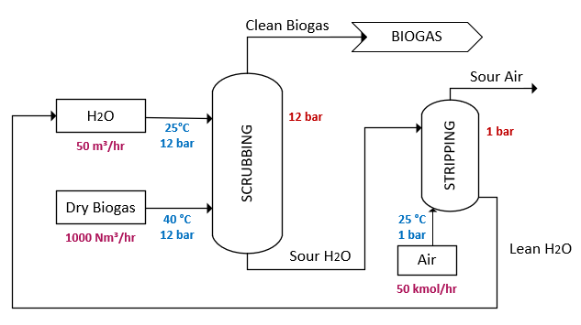
Figure 1 - Simulation flowsheet representing Water Scrubbing.
    - Catalytic Reforming
The dry reforming (DR) is a reaction that occurs using both CO₂ and CH₄ reforming agent, generating CO and H₂. The main reaction (1), presented in Table 1, is endothermic occurring at temperatures above 850 °C and atmospheric pressure. The DR catalysis can be operated with noble metals or nickel, supported on alumina. The biggest challenge of this technology is the catalyst deactivation, caused by coke formation (Ashraf et al., 2015; Cao et al., 2018; Zhao et al., 2020). The combination of DR with steam reforming is called bi reforming (BR), a process that uses CO₂ and H₂O vapor reacting with CH₄ to produce syngas. It has higher endothermicity than DR, occurring at temperatures above 800 °C and pressures from 1 to 7 bar. Due to the addition of steam into the reactor, coke formation is minimized when compared to DR. Moreover, the conversion of biogas fed as a reactant to syngas is lower, when compared to DR technology (Entesari et al., 2020; Zhao et al., 2020).
Table 1 shows several side reactions that take place along with the reforming processes. CH₄ decomposition, Boudouard reaction, reverse water-gas shift and carbon-water reaction occur in DR (Cao et al., 2018). Meanwhile, due the presence of steam and the operating temperature above 800 °C, coke formation in BR can be neglected (Entesari et al., 2020). Thus, reactions 1, 3, 4 and 6 were dismissed for BR simulations.
Table 1: Main reactions of reforming processes.
Nº | Reaction | Description | ΔH 298 K (kJ/mol) | Reforming process
1 | $${CH}_{4}+{CO}_{2}↔2 CO+2 H_{2}$$ | Dry reforming | + 247 | DR
2 | $${3 CH}_{4}+{2 H}_{2}O+ {CO}_{2}↔4 CO+8 H_{2}$$ | Bi reforming | + 659 | BR
3 | $${CH}_{4}→C_{(s)}+2 H_{2}$$ | Methane Decomposition | + 75 | DR
4 | $$2 CO↔C_{(s)}+ {CO}_{2}$$ | Boudouard reaction | - 171 | DR
5 | $${CO}_{2}+ H_{2}↔CO+ H_{2}O$$ | Reverse Water Gas Shift | + 41 | DR and BR
6 | $$C+2 H_{2}O↔{CO}_{2}+ {2 H}_{2}$$ | Carbon-Water reaction | + 90 | DR
To simulate the two catalytic reforming processes (DR and BR) using the Aspen Plus V12.1® simulator, the Peng-Robinson equation of state was selected to represent the liquid-vapor equilibrium. Also, for both processes, RGibbs equilibrium reactor was used. Two outputs were established to evaluate the systems behavior: CH₄ and CO₂ conversions (equations 1 and 2, respectively). The impact caused on these responses was analyzed based on changes in temperature, pressure and feed composition. The proposed scenarios are described in Table 2 and 3 for both dry reforming and bi reforming processes, respectively.
$${CH}_{4} conversion \left(\%\right)= 100\% ∙ \frac{{CH}_{ 4} in- {CH}_{4} out}{{CH}_{ 4} in}$$ | (1)
$${CO}_{2} conversion \left(\%\right)= 100\% ∙ \frac{{CO}_{2} in- {CO}_{2} out}{{CO}_{2} in}$$ | (2)
Table 2: Analyzed scenarios for the dry reforming process (DR).
Scenarios | Temperature (ºC) | Pressure (MPa) | Composition (CH₄:CO₂)
01 | 400 - 1100 | 0.05, 0.1, 1.0, 5.0 | 3:2
02 | 400 - 1100 | 0.1 | 2:1, 3:2, 1:1
Table 3: Analyzed scenarios for the bi-reforming process (BR).
Scenarios | Temperature (ºC) | Pressure (MPa) | Composition (CH₄:CO₂:H₂O)
01 | 400 - 1100 | 0.05, 0.1, 1.0, 5.0 | 3:2:2
02 | 400 - 1100 | 0.1 | 6:3:4, 3:2:2, 3:3:2
03 | 400 - 1100 | 0.1 | 3:2:1, 3:2:2, 3:2:3
  - Results and Discussions
    - Biogas Upgrading
Table 4 shows the results of both systems proposed for biogas upgrading. For water scrubbing process, the results imply that it is possible to perform almost 99.7 % of H₂S removal, assuming an initial content of 2,000 ppm. Although CH₄ recovery was higher than 98 %, CO₂ losses were significant, considering its demand for DR or BR processes. This can be justified by the effectiveness of water scrubbing technology to also remove CO₂ from biogas, since it is more soluble in water than CH₄ (Ashraf et al., 2015). To ensure the complete withdrawn of CO₂ from 1,000 Nm³/hr of biogas, it will be necessary around 200 m³/hr of water (Angelidaki et al., 2018). Also, this system guarantees the full regeneration of H₂O, which minimizes the environmental and economic impacts. Meanwhile, the membrane system proposed by Makaruk et. al. was also able to remove almost entirely the content of H₂S. Similarly, it is possible to ensure the complete removal of CO₂ by using a second stage equipped with a glassy membrane, which has higher selectivity for CO₂, achieving 70 % of CH₄ recovery.
Considering the H₂S final content on clean biogas, both processes can achieve values within the recommended limit of less than 10 ppm (Chen et al., 2015). However, water scrubbing was superior to membrane separation analyzing the CH₄ recovery, which makes this process better for biogas upgrading. Nevertheless, it is necessary to study the economic and energetic perspective and extending the criteria for choosing the best process. Besides, it is crucial to consider the CO₂ losses, since it is a reforming agent on both dry and bi reforming.
Table 4: Simulation results for water scrubbing and theoretical results for membrane separation.
Technology | CO₂ losses | CH₄ recovery | H₂S final content | Reference
Water Scrubbing | 41.52 % | 98.24 % | 8.9 ppm | This study
Membrane system | - | 70 % | < 3.3 ppm | (Makaruk et al., 2013)
    - Catalytic Reforming
Primarily, the DR was simulated in Aspen Plus V12.1®. Figure 2(a-b) depicts the results considering the effect of the pressure in CH₄ and CO₂ conversions, respectively. Regardless of the chosen pressure, both conversions increased with the increase in temperature due to the endothermicity of the DR, which ends up being favored at higher temperatures. Moreover, at temperatures below 700 °C, the pressure showed a significant impact on both conversions by influencing the reactions 1 and 3, presented in Table 1. Also, higher pressures changed the chemical equilibrium of the main reaction of DR towards the reactants side. Thus, higher temperatures and lower pressures have a positive impact on both CH₄ and CO₂ conversions. As shown in Figure 1b, the CO₂ conversion had a different trend at temperatures within 400 °C to 700 °C, represented by a slight decrease in the profiles. At temperatures below 643 °C, the DR (reaction 1) is influenced by equilibrium limitations, decreasing the CO₂ conversion. Particularly, at 1 MPa and 5 MPa, the initial trend proposes that higher pressures would provide better conversions. Since carbon-water reaction (6) is favorable at temperatures above 630 °C, it is expected a change in the equilibrium in lower conditions, consuming CO₂ (Cao et al., 2018). Besides, based on Le Chatelier's Principle, the increased pressure is favorable for the balance to move in the direction of the reactants, consuming CO₂ and promoting better conversions for it.
A second scenario was proposed for DR. Figure 3(a-b) shows the results of the effect of feedstock composition in CH₄ and CO₂ conversions for DR, respectively. For the same operational conditions, higher ratios of CH₄ to CO₂ (2:1) decreased the CH₄ conversion and increased the CO₂ conversion. This behavior indicates that CO₂ is the limiting reactant for the DR (reaction 1), so its feed ratio controls the conversion of the mixture. Similarly to the first scenario, the CO₂ conversion showed a slight decrease at lower temperatures, also given by the spontaneity of the DR reverse reaction under these conditions.
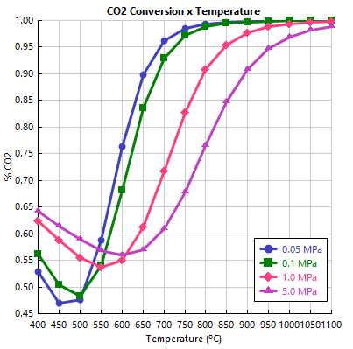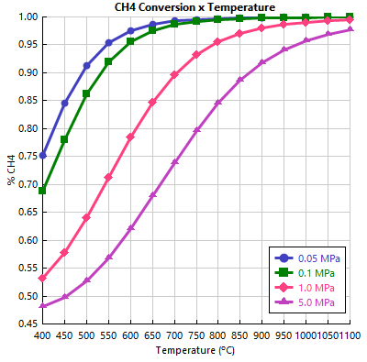
Figure 2 - Pressure effect on DR process in terms of a) CH₄ conversion; and b) CO₂ conversion.
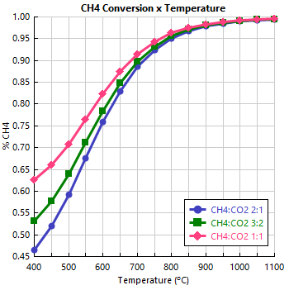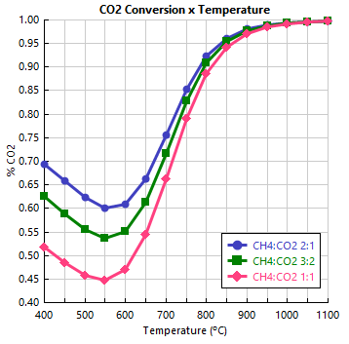
Figure 3 - Feedstock composition effect on DR process in terms of a) CH₄ conversion; and b) CO₂ conversion.
Figure 4(a-b) shows the results for the pressure effect in CH₄ and CO₂ conversions for the BR process. Notably, the conversions behavior in BR reactions is similar to that presented in DR. Both increased with increasing temperature due to the extremely endothermic character of BR (reaction 2). Figure 4b exhibits that CO₂ conversion does not reach 100 % for any of the proposed pressures, as reported by other researchers (Entesari et al., 2020). This behavior indicates that the steam shifts the chemical equilibrium of the water gas shift reaction towards the products, increasing the amount of H₂ and CO₂. This concept also justifies the null and negative conversion of CO₂ at temperatures below 550 °C. Under these conditions, specifically below 827 °C, the direct water gas shift reaction is favored, producing more H₂ and CO₂ for all pressure conditions. With increasing temperatures, the system tends to follow the reverse order and ends up increasing CO₂ consumption. The lasts scenarios proposed for BR show the impact of the input composition in the system. Figure 5 shows the results of the CO₂ composition effect in CH₄ conversion for BR reactions. They were similar to those previously presented for the DR process, where all of which can reach values close to 100 % at high temperatures. Also, it is clear that higher ratios of H₂O enhance the CH₄ conversion, due to the thermodynamics of reaction 2.
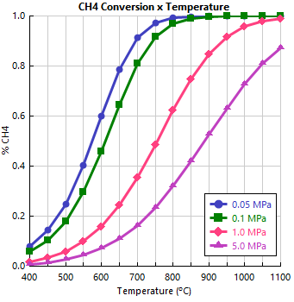
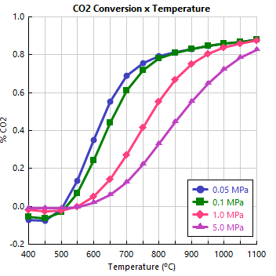
Figure 4 - Pressure effect on BR process in terms of a) CH₄ conversion; and b) CO₂ conversion.
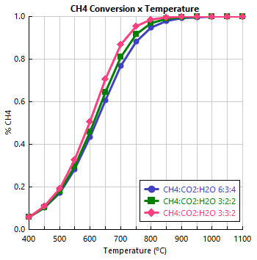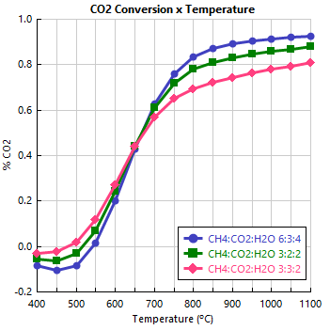
Figure 5 - CO₂ composition effect on BR reaction in terms of a) CH₄ conversion; and b) CO₂ conversion.
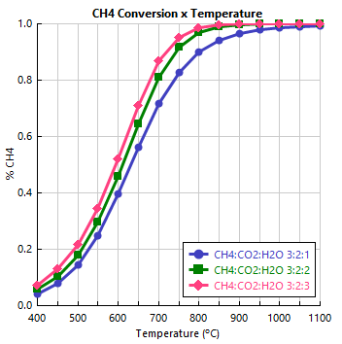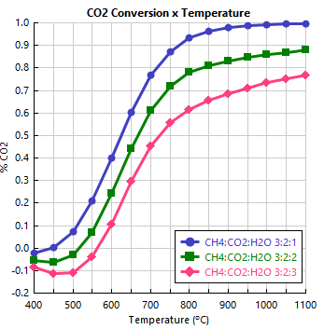
Figure 6 - H₂O composition effect on BR reaction in terms of a) CH₄ conversion; and b) CO₂ conversion.
Figure 5b depicts the lower conversion of CO₂, one of the biggest challenges of BR, when compared to DR. However, in Figure 6b, where only the steam feed was changed, the results showed that smaller amounts of H₂O guaranteed better CO₂ conversions. This can be attributed to the water gas shift reaction (WGS), linked to the Le Chatelier’s Principle. Smaller compositions of a given compound shift the chemical balance of the reaction so as to produce that same compound, which in this case is water. Consequently, the reverse WGS is shifted to the product side, consuming CO₂. In opposite situations (greater amount of water), the equilibrium tends to the reactants side, to produce CO₂.
  - Conclusions
In this study, the production of syngas by catalytic biogas reforming and upgrading was analyzed using software Aspen Plus V12.1®. Water scrubbing and membrane separation proved to be feasible processes for biogas upgrading, considering an H₂S removal above 99 % for both approaches evaluated. However, for catalytic reforming that uses biogas as a feedstock (CH₄ and CO₂), improvements in the recovery of these gases are necessary to minimize environmental, economic and production impacts. In this work, the H₂S final content and the CH₄ recovery were used to choose the best process. Since water scrubbing offered a better combination of results for it, it was superior to membrane separation for biogas upgrading.
It was also possible to compare DR and BR for catalytic biogas reforming process. At high pressures and low temperatures condition (5 MPa and 600 ºC), CH₄ and CO₂ conversions are lower in BR (7.08 % and 1.75 %, respectively) than DR (62.06 % and 56.00 %, respectively). This suggests that the presence of steam had a negative impact in both conversions. Nevertheless, at low pressures and high temperatures, in both processes, the conversions reached values near 100 %. Especially for CO₂ conversion in BR, this happened when steam feed was in smaller ratios (Figure 6b). Considering the environmental impact, BR is a better process, since it can achieve similar results to those obtained in DR, but without coke formation. The best operational condition was on scenario 03 for the BR process, at temperatures above 900 °C and CH₄:CO₂:H₂O composition of 3:2:1.
Acknowledgments
The authors thank the CNPq (Grant number 310038/2020-0), Fundação Araucária (Grant number 164/2021) and the Human Resources Program of the National Agency of Petroleum, Natural Gas and Biofuels – PRH -ANP. NMVR also acknowledge for financial support and scholarships.
References
Angelidaki, I., Treu, L., Tsapekos, P., Luo, G., Campanaro, S., Wenzel, H., & Kougias, P. G., 2018, Biogas upgrading and utilization: Current status and perspectives, Biotechnology Advances, 36(2), 452–466, DOI: 10.1016/j.biotechadv.2018.01.011
Ashraf, M. T., Bastidas-Oyanedel, J.-R., & Schmidt, J. E., 2015, Conversion Efficiency of Biogas to Liquids Fuels through Fischer-Tropsch Process, 23rd European Biomass Conference and Exhibition, 23, DOI: 10.5071/23rdEUBCE2015-3CO.15.5.
Cao, P., Adegbite, S., Zhao, H., Lester, E., & Wu, T., 2018, Tuning dry reforming of methane for F-T syntheses: A thermodynamic approach, Applied Energy, 227, 190–197, DOI: 10.1016/j.apenergy.2017.08.007.
Chen, X. Y., Vinh-Thang, H., Ramirez, A. A., Rodrigue, D., & Kaliaguine, S., 2015, Membrane gas separation technologies for biogas upgrading, RSC Advances, 5(31), 24399–24448, DOI: 10.1039/C5RA00666J.
Dieterich, V., Buttler, A., Hanel, A., Spliethoff, H., & Fendt, S., 2020, Power-to-liquid via synthesis of methanol, DME or Fischer–Tropsch-fuels: a review, Energy & Environmental Science, 13(10), 3207–3252, DOI: 10.1039/D0EE01187H.
Entesari, N., Goeppert, A., & Prakash, G. K. S., 2020, Renewable Methanol Synthesis through Single Step Bi-reforming of Biogas, Industrial & Engineering Chemistry Research, 59(22), 10542–10551, DOI: 10.1021/acs.iecr.0c00755.
Makaruk, A., Miltner, M., & Harasek, M., 2013, Biogas desulfurization and biogas upgrading using a hybrid membrane system – modeling study, Water Science and Technology, 67(2), 326–332, DOI: 10.2166/wst.2012.566.
Miltner, M., Makaruk, A., & Harasek, M., 2016, Selected methods of advanced biogas upgrading, Chemical Engineering Transactions, 52, DOI: 10.3303/CET1652078.
Ramos, A. L. D., Marques, J. J., Santos, V. dos, Freitas, L. dos S., Santos, R. G. V. de M., & Souza, M. de M. V. M., 2011, Atual estágio de desenvolvimento da tecnologia GTL e perspectivas para o Brasil, Química Nova, 34(10), 1704–1716, DOI: 10.1590/S0100-40422011001000004.
Zhao, X., Joseph, B., Kuhn, J., & Ozcan, S., 2020, Biogas Reforming to Syngas: A Review. IScience, 23(5), 101082, DOI: 10.1016/j.isci.2020.101082.

