A Viscosity Model Based on a Modified Free Volume Theory for Pure Fluids

Ricardo Macías-Salinas*
SEPI-ESIQIE, Departamento de Ingeniería Química, Instituto Politécnico Nacional, UPALM, Zacatenco, Ciudad de México 07738
* rms@ipn.mx

A thermodynamic model based on the use of a modified free volume theory (MFVT) coupled with a cubic equation of state (CEoS) was developed here to obtain improved representations of the dynamic viscosity of some representative pure fluids (in both gaseous and dense states). In the original free volume theory, there is a barrier energy that is connected to the energy necessary for a molecule to cross a barrier and diffuse and is proportional to the density. In this work, we found that the aforementioned barrier energy was better expressed in terms of (rather than the density) a cohesive energy between molecules, namely the internal energy which accounts for all the intermolecular forces that hold the molecules together. The various thermodynamic potentials present in the resulting MFVT model (internal energy an density) were estimated from two simple cubic equations of state of the van der Waals type (Soave or Peng-Robinson). The present three-parameter model was successfully validated during the representation of experimental dynamic viscosities of two polar and associating fluids (water and methanol), one non-polar fluid (CO2) and one non-polar and long-chain fluid (n-decane) within temperature and pressure ranges covering both the compressed-liquid and dense-gas states.

1. Introduction
A precise knowledge of viscosity of pure fluids over wide ranges of temperature and density is paramount during the design and simulation of many petroleum and chemical engineering processes. Apart from counting on with a vast number of experimental works on the viscosity of pure fluids, a significant amount of modeling efforts has been also reported in an attempt to estimate this property over diverse temperature and pressure conditions. Of particular interest are those existing viscosity models capable of representing both the gaseous and dense states of non-polar, polar and associating substances within wide ranges of temperature and pressure. Good examples of these models are the ones proposed by Guo et al. (2001) (based on the phenomenological similarity between the P-ρ-T and T-η-P surfaces), Quiñones-Cisneros et al. (2000) and Quiñones-Cisneros and Dieters (2006) (based on the friction theory coupled to diverse equations of state), Allal et al. (2001a, 2001b), Tan et al. (2005) and Burgess et al. (2012) (based on the free volume theory in combination with diverse equations of state), Yarranton and Satyro (2009) and Polishuk (2012) (based on the expanded fluid theory coupled to diverse equations of state), and more recently, Pensado et al. (2008) and Lopez et al. (2011) (based on a thermodynamic scaling using densities), and lastly, Novak (2011) and Lötgering-Lin and Gross (2015) (based on a thermodynamic scaling using residual entropies). Although many of these works are applicable to both gases and dense fluids, they still present some various drawbacks that may limit their use; for example, other than using a large number of fluid-specific parameters (up to twelve), they require the use of a suitable equation of state to obtain density and entropy data of reasonable accuracy; accordingly, they are usually coupled with sophisticated multi-parameter equations of state, largely of the SAFT type, thus making the majority of these viscosity models cumbersome to use. It is worth noting that of all the aforementioned modeling approaches, viscosity models based on the free volume theory (FVT) result in simple yet theoretically based expressions for estimating the dense-state viscosity by relating the free-volume fraction to the system density of the fluid; moreover, unlike many of the aforementioned models, FVT-based models contain only three characterisitic parameters that capture to some extent the molecular structure and energy of the fluid of interest. As a matter of fact, previous modeling works using the FVT approach reveal that the required density by the model can be either obtained from experimental data or from a suitable equation of state; in regards to the latter, practically all authors of these works (Tan et al., 2005; Burgess et al., 2012; Llovell et al., 2013) employed complex equations of state of the SAFT type to estimate density data of reasonable accuracy in order to ensure a good performance of the FVT model. To best of our knowledge, no one has so far attempted to couple a simpler PVT expression, such as a cubic equation of state, with a FVT viscosity model. Interestingly, the current form of the FVT approach for the dense-state viscosity has remained unchanged since the major modification introduced by Allal et al. in 2001 to the empirical relation of Doolittle (1951). Based on the aforementioned facts, the purpose of the present work was first to couple a simple cubic equation of state of the van der Waals type to the FVT viscosity model and then to modify the intermolecular energy expression of the FVT approach by introducing the residual internal energy (rather than the density) into the energy barrier that a molecule has to overcome to diffuse within the FVT formalism. The resulting form of the FVT viscosity model should be applicable to the gaseous and dense states over wide ranges of temperature and density (encompassing the zero-density limit, the high-density region, and the vicinity to the critical point) and be able to handle pure fluids of diverse characteristics: non-polar ranging from low to high molar masses and highly polar and associating.

2. Description of the Model
The present modeling work is based on previously developed FVT-based viscosity models all using the same modification of Allal et al (2001a) to the Doolittle empirical equation. All of these models assume that the dynamic viscosity of a fluid η can be obtained from the sum of two contributions:

$η=η_{0}+Δη$ (1)

where η₀ is the dilute-gas viscosity contribution and η is the dense-state viscosity contribution. The form of Eq.(1) is intented to correctly capture the gas to dense-state viscosity transition.

2.1 Dilute-Gas Contribution
The expressions given by Chung et al. (1988), based on the kinetic theory of Chapman-Enskog, were used here to estimate the viscosity of the dilute gas (at very low density). Chung et al.’s approach applies in the limit of dilute gas for non-polar, polar and associating fluids within a wide range of temperatures. The equations of Chung et al. are given below,

${η_{0}}/{\text{mPa·s}}=4\text{.}\text{0785}×{\text{10}}^{−3}\frac{\sqrt{M⋅T}}{V_{c}^{2/3}Ω^{\text{*}}}⋅F_{c}$ (2)

where M is the molar mass in g/mol, T is the absolute temperature in K, V_{c} is the critical volume in cm³/mol and Ω* is the reduced integral collision, its mathematical expression depends on the selection of a suitable intermolecular potential in terms of a reduced temperature T*; such an expression is as follows:

$\begin{aligned}Ω^{\text{*}}=\frac{1.16145}{{\left(T^{\text{*}}\right)}^{0.14874}}+\frac{0.52487}{exp\left(0.7732T^{\text{*}}\right)}+\frac{2.16178}{exp\left(2.4378T^{\text{*}}\right)}−6.435×{10}^{−4}{\left(T^{\text{*}}\right)}^{0.14874} \\ sin\left[18.0323{\left(T^{\text{*}}\right)}^{−0.7683}−7.27371\right]\end{aligned}$ (3)

with

$T^{\text{*}}=1\text{.}{\text{2593}⋅T}/{T_{c}}$ (4)

Lastly, the correction factor F_{c} in Eq. (2) serves to account for the nonsphericity as well as the polarity and the hydrogen bonding (self association) of the substance of interest as follows:

$F_{c}=1−0\text{.}\text{2756}ω+0\text{.}\text{059035}μ_{r}^{4}+κ$ (5)

where ω is the acentric factor, μ_{r} is a dimensionless dipole moment (greater than zero for polar substances), and κ is an empirical factor for the hydrogen bonding formation. Values of κ have been also given by Chung et al. (1988).

2.2 Dense-State Contribution

The dense-state term, that is, the viscosity of the fluid at high density, is estimated via the use of the current form of the FVT which originally visualizes the molecules of a fluid as consisting of hard spheres connected by a spring. This visualization (the generalized dumbbell model) allowed Allal et al (2001a), on the one hand, to link viscosity of the dense-state to the micro-structure of the molecule through a microscopic friction factor; and on the other hand, by means of the fluctuation-dissipation theory, they were able to relate the free-volume fraction with a intermolecular energy responsible of controlling the potential field through which the molecular diffusion occurs. The final form of their FVT-based proposal for the dense-state viscosity is given by,

$Δη/{\text{mPa·s}}=1×{\text{10}}^{−4}ρ⋅L⋅E\sqrt{\frac{{\text{10}}^{3}M}{3RT}}⋅\text{exp}\left(B{\left(\frac{E}{RT}\right)}^{3/2}\right)$ (6)

where ρ is the molar density in mol/cm³, M is the molar mass in g/mol, R is the universal gas constant (8.3144598 J/mol-K), T is the absolute temperature in K and E is an approximation of the aforementioned intermolecular energy which in turn is estimated from the sum of two energy terms:

$E=α⋅ρ⋅M×{10}^{3}+\frac{P}{ρ}$ (7)

here the first term represents an energy barrier that a molecule has to overcome in order to diffuse whereas the second term stands for the energy required to form vacant sites so that diffusion can take place; the latter is given in terms of pressure (P) in MPa and molar density. Eqs. (6) and (7) demonstrate that the FVT model contains three characteristic parameters: L is a length parameter in Å that captures both an average quadratic length (size of the molecule) and a length of energy dissipation (characteristic relaxation time), α is the proportionality between the energy barrier and the density in J-m³/mol-kg, and B is a positive number representing the free-volume overlap.

2.3 Present Modifications to the FVT approach

As a matter of fact, the FVT approach resembles that of the activated-state theory of Eyring (1935) in that both are exponential forms of the Arrhenius type; moreover, they share similar expressions of the intermolecular energy present in the exponential term. Following the recent work of Macías-Salinas (2018) who modified the Eyring’s theory to model the viscosity of ionic liquids, the author proposed an activated-state energy expression almost identical to Eq. (7) where his energy barrier (energy necessary for a molecule to overcome a potential barrier and then jump to a vacant site) was related to the residual internal energy. Due to the similarities between the two theories, we opted here to also express the energy barrier in terms of the residual internal energy of the fluid of interest; accordingly, Eq. (7) is modified as follows:

$E=α⋅ΔU^{r}⋅RT+\frac{P}{ρ}$ (8)

where α is now a dimensionless proportionality factor. The use of ΔU^{r} to estimate the energy barrier seems to be more reasonable than using the density alone; after all, ΔU^{r} represents a cohesive energy between molecules, namely, all intermolecular forces that hold the molecules together and oppose to the breaking of bonds and thus the formation of vacant passages for a molecule to diffuse; based on this reasoning, we expect to obtain negative values of α during the parameter regression process. As a matter of fact, the two thermodynamic quantities (ρ and ΔU^{r}) appearing in Eqs. (6) and (8) were conveniently calculated from two well-known cubic equations of state (CEoS): either Soave-Redlich-Kwong (SRK) or Peng-Robinson (PR); as mentioned earlier, this seems to be the first attempt to ever couple these simple PVT expressions with the FVT approach. At this point, it is important to recognize that neither the SRK nor the PR CEoS is expected to yield phase densities of good accuracy, however, it is our belief that the three FVT model parameters will absorb to some extent such inaccuracies.

3. Results and Discussion
The present modeling approach was applied to the correlation of experimental viscosities of selected pure fluids within wide temperature and pressure ranges (covering both low- and high-density regions as well as the critical region). The chosen pure fluids were two polar and associating fluids (water and methanol), one non-polar fluid (CO₂) and one non-polar and long-chain fluid (n-decane). A least-square fit based on the Nelder-Mead optimization method was then performed to obtain the model parameters, namely L, α, and B. The minimization of the following objective function served for such a purpose:

$\text{min }f=\sum_{\text{j=}1}^{N}{{\left[1−{η_{j}^{\text{cal}}}/{η_{j}^{\text{exp}}}\right]}^{2}}$ (9)

where N is the number of experimental points, whereas η^{exp} and η^{cal} stand for the observed and calculated viscosities, respectively. It is noteworthy that the use here of a global optimization method based on the Nelder-Mead approach (rather than the gradient-based Levenberg-Marquardt method) ensured the best possible set of optimized model parameters; this is particularly important since several authors (Tan et al., 2005; Burgess et al., 2012; Llovell et al., 2013) have previously found multiple sets of optimized FVT-model parameters for a given fluid. Table 1 lists the pure fluids considered here along with their temperature and pressure ranges and the sources of their experimental viscosity data. As seen in this table, experimental viscosities cover, overall speaking, a wide temperature range (from 180 to 1,100 K) and also a wide pressure range (from 0.1 to 1,000 bar).

Table 1: Experimental reference data for the 4 fluids considered here
Component | N | T, K | P, bar | Source
Water | 339 | 273.16 – 1,073.15 | 0.1 – 1,000 | NIST Webbook (2019)
Methanol | 217 | 180 – 620 | 0.1 – 1,000 | NIST Webbook (2023)
CO₂ | 172 | 220 – 1,100 | 0.1 – 1,000 | NIST Webbook (2023)
n-Decane | 172 | 250 – 675 | 0.1 – 1,000 | NIST Webbook (2023)

Prior to the application of the present FVT-based viscosity model, critical properties, acentric factors, dipole moments and association factors of each fluid should be available as inputs needed by both CEoS and Eqs. (2) to (5). These properties are listed in Table 2.

Table 2: Pure-component physical properties needed as model inputs
Component | M, g/mol | P_{c}, bar | T_{c}, K | V_{c}, cm³/mol | ω | μ, debye | κ
Water | 18.0153 | 220.8975 | 647.286 | 55.9481 | 0.3438 | 1.855 | 0.076
Methanol | 32.0419 | 81.035 | 512.6 | 116.2791 | 0.5625 | 1.7 | 0.215
CO₂ | 44.0095 | 73.773 | 304.1282 | 94.1185 | 0.22394 | 0 | 0
n-Decane | 142.2817 | 21.03 | 617.7 | 609.7561 | 0.4884 | 0.07 | 0

On the other hand, Table 3 summarizes for each fluid the correlating results in terms of absolute average deviations (AAD) between experimental and calculated viscosities, that is the AAD values yielded by the present parameter regression process for both original and modified FVT-based models which in turn were coupled to the SRK and PR CEoS (namely the FVT-SRK and FVT-PR approaches, respectively). Table 3 reveals that the ability of the original FVT approach (Eqs. (2), (6) and (7)) in representing the experimental viscosity data was reasonably good with overall AAD values of 6.17% using the SRK CEoS, and 6.34% using the PR CEoS based on a total of 900 data points. Also shown in Table 3 are the overall AAD values yielded by the modified FVT model (4.85% using the SRK CEoS and 4.93% using the PR CEoS) which are lower than those of the original approach thus demonstrating the suitability of the present modification through Eq. (8).

Table 3: Model performance in terms of AAD values
Component | N | Original FVT model  % AAD SRK % AAD PR | Modified FVT model  % AAD SRK % AAD PR
Water | 339 | 9.88 10.1 | 9.02 9.13
Methanol | 217 | 5.23 5.72 | 2.62 2.81
CO₂ | 172 | 2.04 1.91 | 1.59 1.51
n-Decane | 172 | 4.19 4.16 | 2.72 2.73
OVERALL | 900 | 6.17 6.34 | 4.85 4.93

This finding also applies to each individual fluid where the present FVT model gave improved viscosity determinations using either the SRK or PR CEoS. As a matter of fact, the use of these two CEoS within the present FVT approach yielded quite comparable results for the four fluids; very likely, the capability differences between the two CEoS canceled out during the regression process of the viscosity data by being eventually absorbed by the three model parameters (L, α, and B). Example correlating results are graphically shown for Methanol using the modified FVT-SRK approach and for CO₂ using the modified FVT-PR approach in Figures 1 and 2, respectively. As shown by these figures, the present FVT-based model represents remarkably well the whole P-η-T surface of the two fluids, particularly those experimental viscosity isotherms near the critical point of the fluid (513 K for Methanol, 304 K for CO₂) for which the model captures reasonably well the abrupt viscosity change (gas-liquid transition) with pressure across the critical pressure (depicted by the red line in both figures).

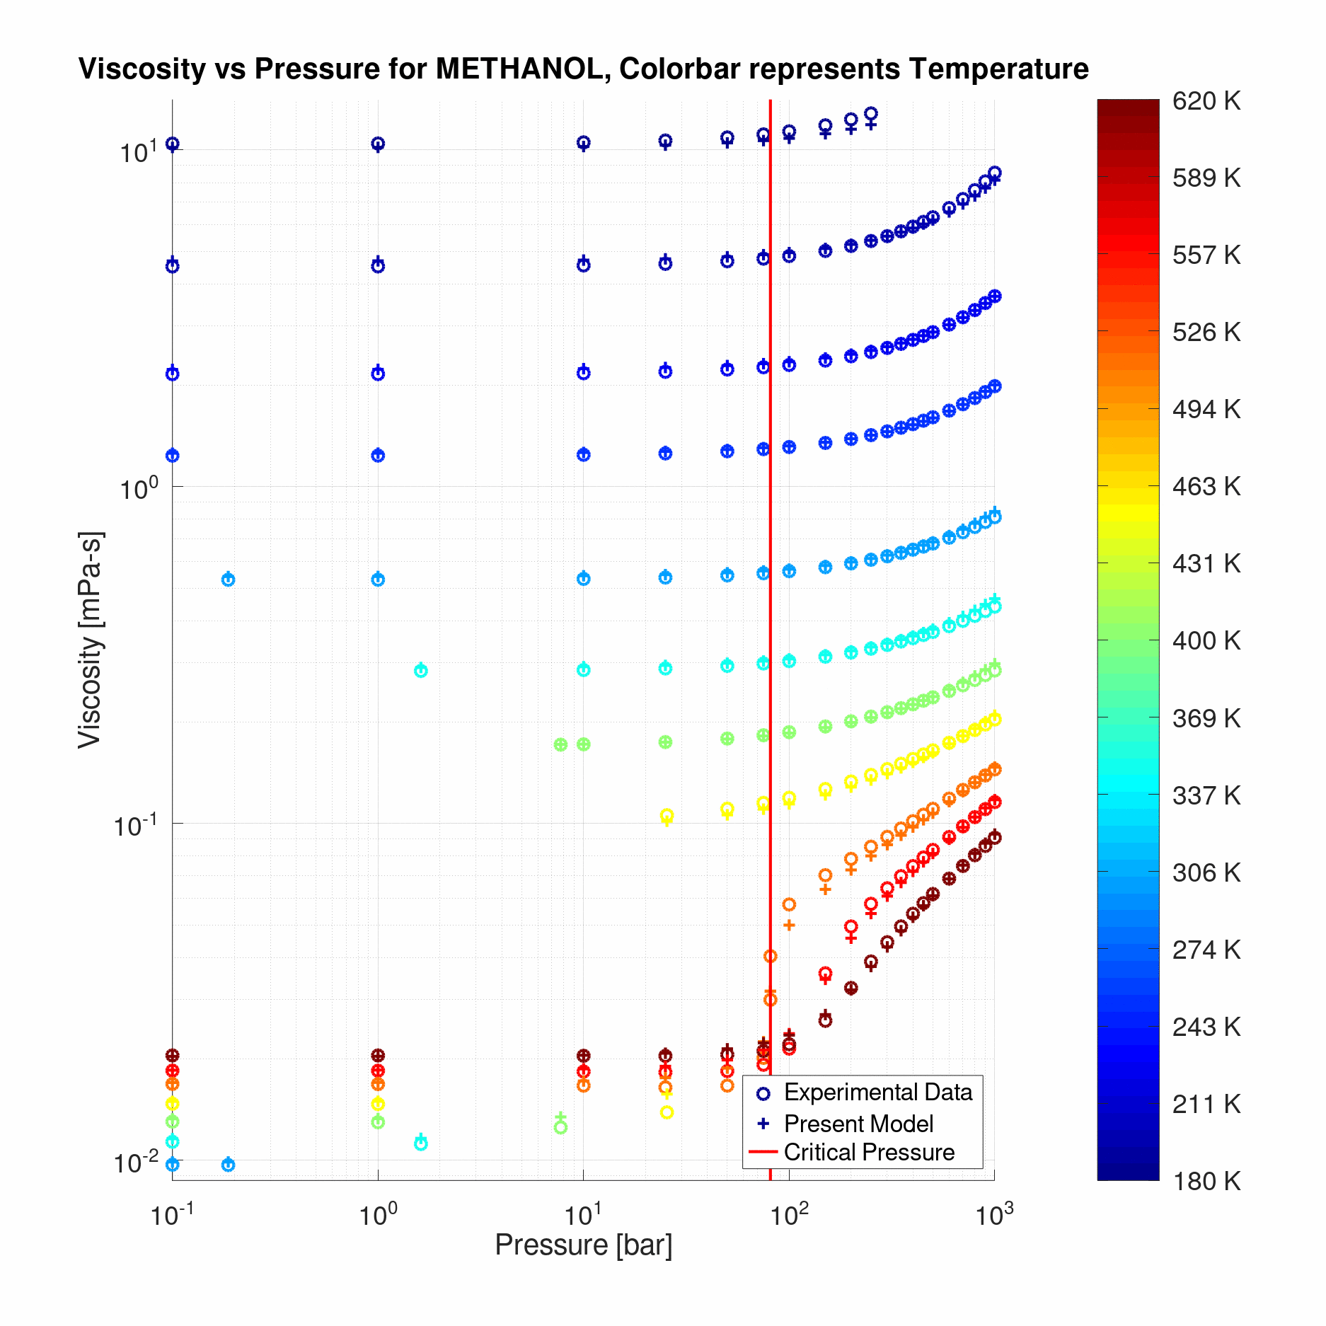  Figure 1: Model performance in correlating the methanol viscosity | 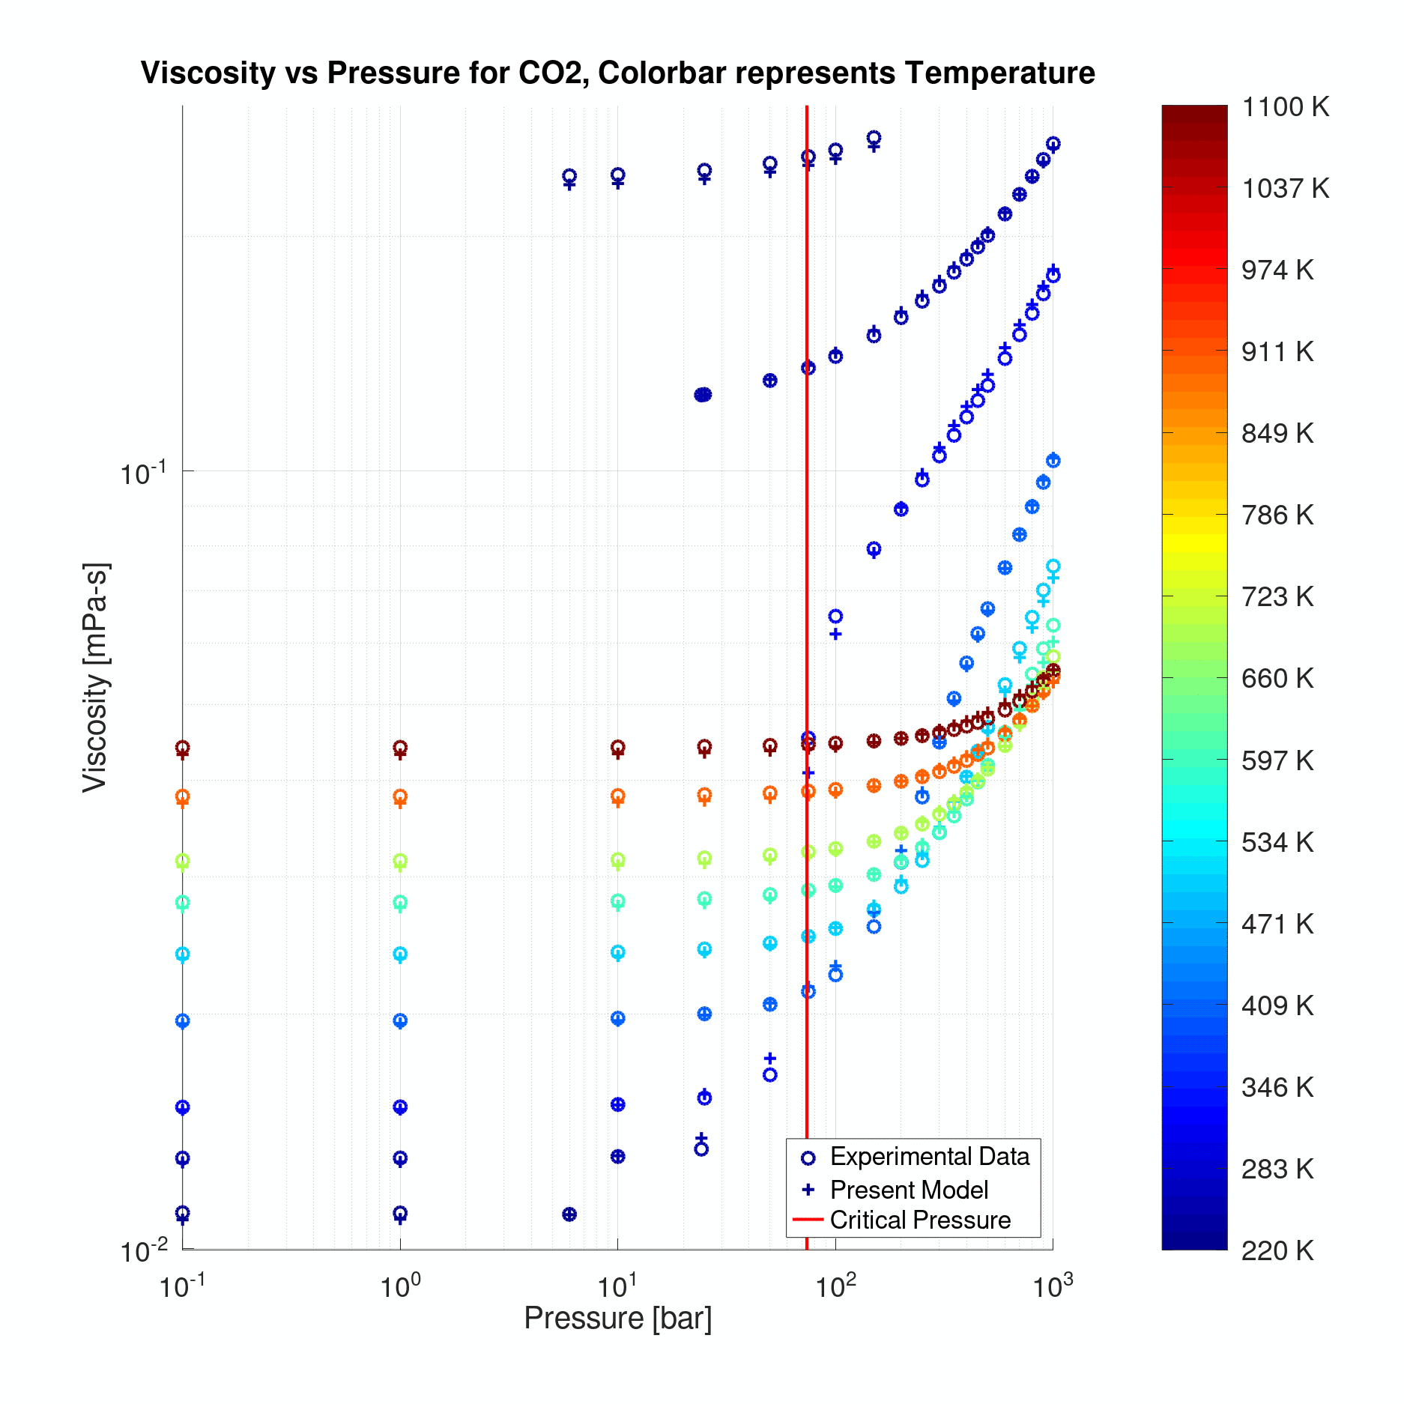  Figure 2: Model performance in correlating the CO₂ viscosity

Lastly, of all pure fluids considered here, the variation of water viscosity with pressure and temperature was a difficult one to model using the present FVT approach. In this case, although the modified FVT approach yielded an slightly improved viscosity representation, the resulting AAD values remained high (about 9% as shown in Table 3). Water is quite an important but also an intriguing substance (one of the few in nature, actually); besides being a highly polar and associating fluid, water exhibits minima behavior in its variation of viscosity with pressure from very low temperatures (about -15 ºC) up to 35 ºC. De facto, we do not expect to capture this peculiar viscosity behavior of water with the present modeling approach, however, we can substantially improve its correlating performance by treating water differently within the FVT formalism. Some diffraction studies suggest that water has an open 3-D structure with hydrogen bonds connecting its molecules further apart than in a close-packed liquid; this holds at low temperatures but as temperature increases hydrogen bonds are broken thus liberating extra free volume. One way to take this into account within the present FVT approach is through the length parameter L which is defined as L_{m}²/b_{f} where L_{m}² is the average quadratic length (structure of the molecule) and b_{f} is the dissipation length of the energy E; accordingly, we found that the quantity L_{m}² for water should vary with the free-volume fraction assuming that water is a close-packed molecule, that is L_{m}² = (L_{m}*)² (1 – ρb_{w}) where the close-packed molar volume b_{w} of water is estimated from the corresponding CEoS. Since b_{f} remains constant, the new length parameter in the particular case of water is (L_{m}*)² / b_{f} (1 – ρb_{w}) or L*(1 – ρb_{w}). A regression process with the new set of characteristic parameters (L*, α, and B) yielded quite encouraging results in the case of water with much lower AAD values: 4.22% using the FVT-SRK approach and 4.20% using the FVT-PR approach.

Conclusions
A simple yet theoretically sound viscosity model, based on a modified free volume theory and coupled to a simple cubic equation of state, was developed here for the improved viscosity representation of pure fluids over wide temperature and density ranges. The performance of the present modeling approach was highly satisfactory during the representation of experimental viscosity data of several fluids varying in polarity from low to high molar masses. In the particular case of water, the present viscosity model yielded a significantly improved viscosity representation as compared to the original FVT formulation.

References
Allal A., Boned C., Baylaucq A., 2001a, Free-Volume Viscosity Model for Fluids in the Dense and Gaseous
States. Phys Rev E, 64, 011203.
Allal A., Moha-Ouchane M., Boned C., 2001b, A New Free Volume Model for Dynamic Viscosity and Density
of Dense Fluids Versus Pressure and Temperature. Phys. Chem. Liq., 39, 1.
Burgess W.A., Tapriyal D., Gamwo I.K., Morreale B.D., McHugh M.A., Enick R.M., 2012, Viscosity Models
Based on the Free Volume and Frictional Theories for Systems at Pressures to 276 MPa and Temperatures
to 533 K. Ind. Eng. Chem. Res., 51, 16721.
Chung T.-H., Ajlan M., Lee L.L., Starling K.E., 1988, Generalized Multiparameter Correlation for Nonpolar
and Polar Fluid Transport Properties. Ind. Eng. Chem. Res., 27, 671.
Doolittle A.K., 1951, Studies in Newtonian Flow. II. The Dependence of the Viscosity of Liquids on Free-
Space. J. Appl. Phys., 22, 1471.
Eyring H., 1935, The Activated Complex in Chemical Reactions. J. Chem. Phys., 3, 107.
Guo X.-Q., Sun C.-Y., Rong S.-X., Chen G.-J., Guo T.-M., 2001, Equations of State Analog Correlations for
the Viscosity and Thermal Conductivity of Hydrocarbons and Reservoir Fluids. J. Pet. Sci. Eng., 30, 15.
López E.R., Pensado A.S., Comuñas M.J.P., Pádua A.A.H., Fernández J., Harris K.R., 2011, Density
Scaling of the Transport Properties of Molecular and Ionic Liquids. J. Chem. Phys., 134, 144507.
Llovell F., Marcos R.M., Vega L.F., 2013, Free-Volume Theory Coupled with Soft-SAFT for Viscosity
Calculations: Comparison with Molecular Simulation and Experimental Data. J. Phys. Chem. B, 117, 8159.
Lötgering-Lin O., Gross J., 2015, Group Contribution Method for Viscosities Based on Entropy Scaling Using
the Perturbed-Chain Polar Statistical Associating Fluid Theory. Ind. Eng. Chem. Res., 54, 7942.
Macías-Salinas R., 2018, A Viscosity Model for Ionic Liquids Based on the Eyring’s Theory and a Cubic EoS.
J. Mol. Liq., 262, 161.
Novak L.T., 2011, Fluid Viscosity-Residual Entropy Correlation. Int. J. Chem. React. Eng., 9, A107.
Pensado A.S., Pádua A.A.H., Comuñas M.J.P., Fernández J., 2008, Relationship Between Viscosity
Coefficients and Volumetric Properties Using a Scaling Concept for Molecular and Ionic Liquids. J. Phys.
Chem. B, 112, 5563.
Polishuk I., 2012, Modeling of Viscosities in Extended Pressure Range Using SAFT + Cubic EoS and
Modified Yarranton–Satyro Correlation. Ind. Eng. Chem. Res., 51, 13527.
Quiñones-Cisneros S. E., Zéberg-Mikkelsen C. K., Stenby E. H., 2000, The Friction Theory (f-theory) for
Viscosity Modeling. Fluid Phase Equilib., 169, 249.
Quiñones-Cisneros S. E., Dieters U., 2006, Generalization of the Friction Theory for Viscosity Modeling. J.
Phys. Chem. B, 110, 12820.
Tan S.P., Adidharma H., Towler B.F., Radosz M., 2005, Friction Theory and Free-Volume Theory Coupled
with Statistical Associating Fluid Theory for Estimating the Viscosity of Puro n-Alkanes. Ind. Eng. Chem.
Res., 44, 8409.
Yarranton H.W., Satyro M.A., 2009, Expanded Fluid-Based Viscosity Correlation for Hydrocarbons. Ind. Eng.
Chem. Res., 48, 3640.

