CHEMICAL ENGINEERING TRANSACTIONS  VOL. , 2023 | A publication of
The Italian Association
of Chemical Engineering
Online at www.cetjournal.it

Guest Editors:
Copyright © 2023, AIDIC Servizi S.r.l.
ISBN 979-12-81206-XX-X; ISSN 2283-9216

Coupled Biological and Thermochemical Process for Plastic Waste Conversion into Biopolymers
Flavia Marzulli^{a,*}, Sogand Musivand^{b}, Miriana Arengiª, Benedetta De Caprariis^{b},
Paolo De Filippis^{b}, Angela Marchettiª, Mauro Majoneª, Marianna Villanoª
ªDepartment of Chemistry, Sapienza University of Rome, P. le Aldo Moro 5, 00185, Rome, Italy
^{b}Department of Chemical, Environmental and Material Engineering, Sapienza University of Rome, Via Eudossiana 18, 00184, Rome, Italy
flavia.marzulli@uniroma1.it

The aqueous phase produced from the hydrothermal liquefaction (HTL) of three matrices (Plasmix treated with different operative conditions and polystyrene) was subjected to acidogenic fermentation (AF) batch tests to obtain organic acids, which are the ideal substrates for biopolymers (e.g., polyhydroxyalkanoates, PHA) production from mixed microbial cultures (MMC). Parallel tests in the presence of only HTL water fractions or only glucose (an easily biodegradable compound), or in presence of both, were conducted and compared to assess any possible recalcitrant or inhibitory effect of plastic waste from the HTL treatment during the AF process. These tests resulted, within approximately 30 days of operation, in a conversion of 96 ± 21% (COD/COD) of the Plasmix by-products after a 2h thermochemical treatment into organic acids, a 54 ± 7% (COD/COD) of conversion for Plasmix by-products treated 4h, and 29 ± 1% (COD/COD) of conversion in the presence of polystyrene residual water.
  - Introduction
One of the major issues in plastic waste management dwells in the heterogeneity of post-consumer plastic waste streams, from which arises what is known as Plasmix, defined as the part of the plastic waste which cannot be mechanically recycled. Therefore, Plasmix represents a heterogeneous mixture of waste, also containing other materials such as paper, glass and organic residues that cannot be further separated from each other. On this background, thermochemical treatments such as hydrothermal liquefaction (HTL) represents a promising strategy for the decomposition of plastic wastes when the separation is neither technically nor economically viable. Indeed, HTL allows to break down polymers into smaller molecules: monomers, petrochemical and organic water-soluble compounds (Zhao et al., 2018). For these reasons, here the possibility to convert the aqueous by-product generated by the HTL decomposition of Plasmix into organic acids has been investigated. These latter are aliphatic compounds that represent the main intermediate products in the anaerobic digestion (AD) process (Aboudi et al., 2021). As a potential renewable carbon source, they have been found very suitable as a raw material for a wide variety of uses, such as biopolymers synthesis (Yu et al., 2016), being in fact the ideal substrates for polyhydroxyalkanoates (PHA) production with mixed microbial cultures (MMC) through multi-stage processes (Chen et al., 2015). PHA are completely biodegradable biopolymers of microbial origin, which represents an interesting and valid alternative to traditional plastics (Lorini et al., 2020). The possibility of a direct conversion of pyrolysis pre-treated plastic waste into PHAs by pure microbial cultures has already been demonstrated (Guzik et al., 2014; Kenny et al., 2008). However, due to the high costs associated with the use of the latter (Reis et al., 2011), the possibility of exploiting MMC supplied with organic acids obtained from acidogenic fermentation of HTL by-products, presents itself as a viable alternative. Driven by these considerations, in this study an HTL treatment was performed on Plasmix for 2 h or 4 h, as well as on polystyrene (PS) for 4 hours. The latter was assayed in parallel being one of the main plastic wastes, its recycling rate is currently less than 1%, and PS products, especially expanded foams, account for approximately a third of the content in landfills in the world (Sewon and Stache, 2022). The aqueous by-product resulting from HTL was supplied as substrate to an anaerobic sludge in 45-days batch acidogenic fermentation tests to obtain organic acids, with the ultimate purpose of studying the possibility of re-employing them in aerobic processes for PHA production with mixed microbial cultures.
  - Materials and methods
    - Plastic wastes treatment through hydrothermal liquefaction (HTL)
The hydrothermal liquefaction (HTL) process was applied to either mixed plastic waste (i.e., Plasmix) or polystyrene. Experiments on polystyrene were carried out using a 20 mL stainless steel tubular microreactor. Each experiment involved the addition of 1 g of plastic solid and 10 g of water into the reactor, which was then sealed and heated in a preheated sand bath to reach the target temperature of 330 ˚C. Mechanical stirring was applied to ensure homogeneous mixing during the reaction, which lasted for 4 h. The reactor was then quenched to rapidly reduce the temperature in cold water and subsequently opened to extract the products for further analysis. The gas phase was quantified by venting the reactor, while solid and liquid phases were separated by filtration. After the water phase was filtered, a suspension of water and organic compounds was recovered for further analysis. For other plastic wastes the experiments were conducted in a high-pressure autoclave with a volume of 500 mL, which was equipped with an electronic heating jacket controlled by a K-type thermocouple for the heating and a mechanical stirrer to ensure good mixing during the process. Experiments lasted 2h or 4h; after the completion of the reaction the reactor was quenched, and the products separated. The water herein used is referred to as Plasmix 2h and Plasmix 4h, respectively.
    - Acidogenic fermentation of the aqueous fraction from HTL: setup and operative conditions
Acidogenic fermentation (AF) tests were performed by incubating the aqueous fraction from HTL of the three plastic waste samples with anaerobic sludge taken from a laboratory-scale anaerobic digester treating food waste. Prior to being used, the anaerobic sludge was settled, and the supernatant was replaced with a mineral medium buffered at pH 5.5 to inhibit the methanogenic activity, as reported elsewhere (Villano et al., 2017). The final concentration of volatile suspended solids (VSS) in the sludge accounted for 9.8 ± 0.3 gVSS/L. The aqueous HTL fraction of the used plastic wastes was characterized in terms of Chemical Oxygen Demand (COD) content, both total (tCOD) and soluble (sCOD), which were very similar. Therefore, all data are herein referred to the tCOD. AF experiments were performed with HTL samples either supplied or not with glucose, chosen as a model substrate to assess the microbial activity of the used sludge. Control tests in the absence of HTL water were also set up. Overall, eight conditions were investigated as reported in Table 1, whereby “Plasmix 2h”, “Plasmix 4h”, and “Polystyrene” refer to the HTL aqueous phase of the specific plastic waste. All conditions were performed in duplicate.

Table 1: Experimental setup of the acidogenic fermentation tests
Test | ID | HTL water (mgCOD(L) | Glucose (mgCOD/L) | V liquid phase (mL)
Plasmix 2h | A | 585 | -- | 120
Plasmix 2h + glucose | Ag | 585 | 585 | 120
Plasmix 4h | B | 585 | -- | 120
Plasmix 4h + glucose | Bg | 585 | 585 | 120
Polystyrene | C | 585 | -- | 60
Polystyrene + glucose | Cg | 585 | 585 | 60
Inoculum | I | -- | -- | 120
Inoculum + glucose | Ig | -- | 585 | 120

In all tests, the initial sludge concentration was the same (3 gVSS/L), as well as the initial COD concentration and all the other operating conditions. The only exception was polystyrene, which did not allow to perform experiments in the same volume as the other two substrates due to its lower COD, and for which tests were set up in a smaller volume of the liquid phase. The latter consisted of the same mineral medium used to wash the anaerobic sludge. Both the liquid phase and headspace of each serum bottle were flushed with nitrogen gas to establish anaerobic conditions. During the study, samples of the liquid phase of each serum bottle were periodically taken for pH and organic acids analysis. The gas phase was periodically analyzed to check for the presence of methane.
    - Analytical methods
The COD determination was performed with a colorimetric method, by using a COD determination kit (Tube test NANOCOLOR COD 15000, Macherey Nagel). After digestion of the samples at 148°C for 2 hours and after cooling, samples were read out using a spectrophotometer at 605 nm (SHIMADZU Spectrophotometer UV- 1800). Volatile suspended solids were measured according to Standard Methods (APHA, 2005). Methane concentration of the gas phase was determined by injecting 50 µL of the headspace of each serum bottle with a gas-tight Hamilton syringe into a gas-chromatograph (Dani Master, Milan, Italy) equipped with a stainless-steel column packed with molecular sieve and a thermal conductivity detector (TCD). Organic acids were determined by gas-chromatography on filtered samples (0.2 µm porosity). Analyses were carried out using an Agilent GC 8860 equipped with a flame ionization detector (FID) and a DB-FFAP column. Organic acids concentrations were converted into COD according to the oxidation stoichiometry of 1.07 gCOD/g (acetic acid); 1.51 gCOD/g (propionic acid); 1.82 gCOD/g (butyric acid and isobutyric acid); 2.04 gCOD/g (valeric and isovaleric acid) and 2.20 gCOD/g (hexanoic acid). The conversion of the supplied COD into organic acids (throughout all the manuscript expressed as %, COD/COD) was calculated as:

$$Conversion yield \left(\%, \frac{COD}{COD}\right)= \frac{{Organic acids}_{Produced} \left(\frac{mgCOD}{L}\right)}{{COD}_{Supplied} \left(\frac{mgCOD}{L}\right)} . 100$$
  - Results and discussion
    - HTL treatment
Prior to performing batch fermentation tests, the three water solutions deriving from HTL treatment have been characterized in terms of COD content. From this analysis, a tCOD of 14.7 ± 0.8 g/L, 14.2 ± 0.1 g/L and 4.4 ± 0.1 g/L was determined for Plasmix 2h, Plasmix 4h, and polystyrene HTL water, respectively. Comparable values were obtained for the two Plasmix samples. Also, for these samples, the tCOD was similar to the sCOD (14.0 ± 0.1 gCOD/L and 13.7± 0.1 gCOD/L for mixed waste 2h and 4h, respectively) whose value, indeed, resulted to be significantly higher than the sCOD for polystyrene (2.5 ± 0.1 gCOD/L).
    - Acidogenic fermentation tests: organic acids production
Here, the anaerobic biodegradability of three aqueous by-products deriving from hydrothermal liquefaction of Plasmix and polystyrene is discussed with main reference to their conversion into organic acids. As for the two tested Plasmix HTL samples, although they represent the same plastic waste material with a 2-hour processing difference, it was not observed the same convertibility into organic acids. Indeed, comparing the concentration of acids analyzed in the tests over time, it was found that, out of 585 mgCOD/L of each HTL water supplied at the beginning of the experiments, the A test (containing only Plasmix 2h) was characterized by a higher conversion yield than the similar B test (Plasmix 4h). In particular, the anaerobic sludge inoculated with Plasmix treated 2h reached an overall acids concentration of approximately 560 ± 124 mgCOD/L in correspondence to the 27th day of operation (data not shown), resulting in a conversion yield of 96 ± 21% of the initial COD. In comparison, in test B an amount of fermented products corresponding to a little more than half of what obtained in test A was detected. As shown in Figure 1a, about 315 ± 40 mgCOD/L of organic acids were obtained after 20 days of AF operation, accounting for a conversion yield of 54 ± 7%. Comparing these results with those obtained in the tests conducted on polystyrene, a stronger recalcitrance of the latter to acidogenic fermentation has emerged. In fact, as shown in Figure 1b, the maximum acids concentration (about 167 ± 5 mgCOD/L) was detected in correspondence of day 20th of operation of AF tests with the residual water from the liquefaction of polystyrene, corresponding to an overall conversion yield into acids of 29 ± 1%. Finally, as expected, a low production of acids was detected in the tests (I) performed without HTL samples or glucose, up to 43 ± 8 mgCOD/L (in correspondence of around day 22 of operation of AF tests), likely due to the endogenous metabolism. However, when the anaerobic sludge was supplied with glucose (Ig test) a total of 562 ± 85 mgCOD/L of organic acids (Figure 1a and Figure 1b) was produced after 22 days of operation, corresponding to a conversion yield of 96 ± 14%. This is a clear indication of the effective biological activity of the used anaerobic sludge. In almost all cases, the acids concentration started to slightly decrease after around 20 days of operation likely due to the onset of the methanogenic activity, as also confirmed by the analysis of the headspace composition in each serum bottle, which revealed, after about 30 days of fermentation, the presence of methane specifically in tests with Plasmix 4h and polystyrene, respectively.

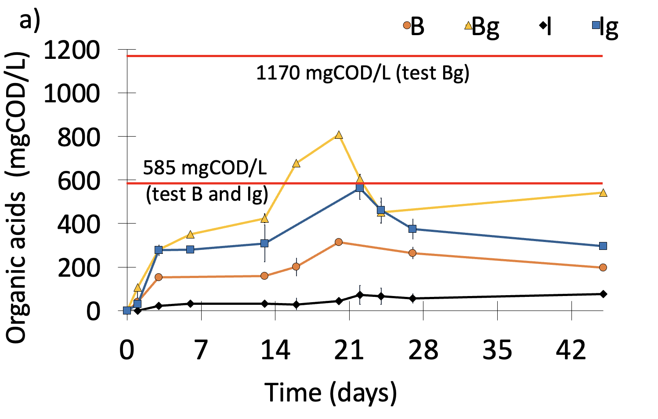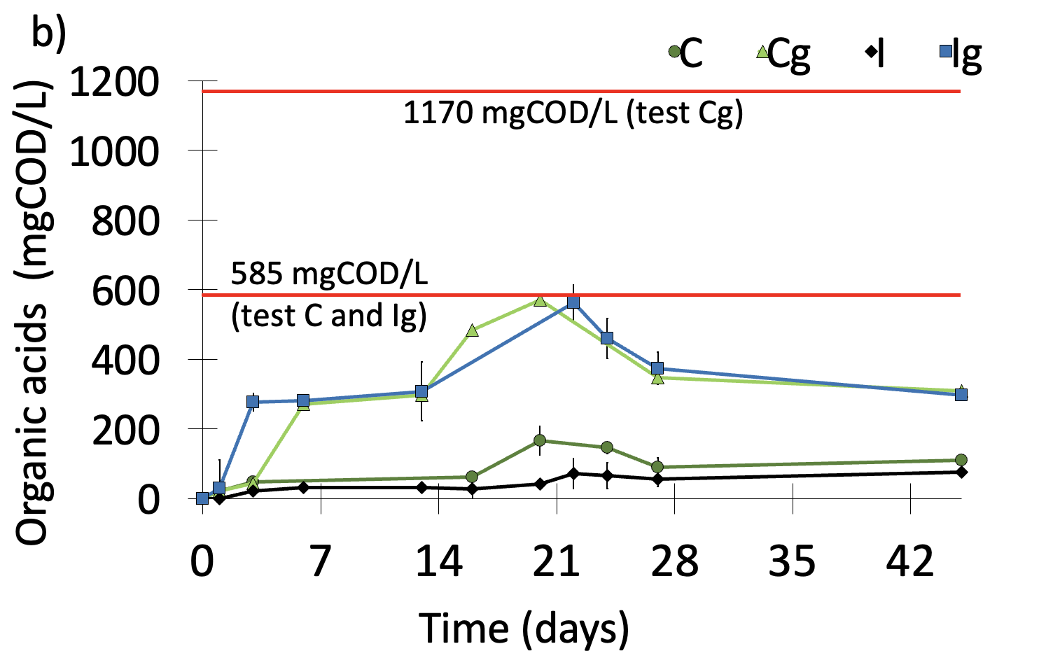
Figure 1: Trend of organic acids concentration over time for tests B and Bg (i.e., Plasmix 4h and Plasmix 4h + glucose) (a) and for tests C and Cg (i.e., polystyrene and polystyrene + glucose) (b), compared with results obtained in control tests I (Inoculum) and Ig (Inoculum + glucose). The red lines represent the COD concentrations initially provided.

Tests performed in presence of both HTL water and glucose were conducted to evaluate the existence of recalcitrant and inhibitory compounds to the microbial activity. Data obtained from these tests were compared in terms of maximum achieved conversion yields (Figure 2). In particular, it was observed that, even when supplied with glucose, Plasmix 4h resulted in a lower conversion yield into organic acids than Plasmix 2h. However, in presence of glucose, with Plasmix 4h an acid concentration of 808 ± 50 mgCOD/L was reached after 20 days of fermentation (Figure 1a) with an overall conversion yield (i.e., taking into account the COD provided as both HTL water and glucose) slightly higher (69 ± 1%) than that (54 ± 7%) obtained in the tests without glucose. Although a distinction cannot be made between the contribution to the overall acids production deriving from glucose and HTL 4h water, this finding suggests the presence of both recalcitrant and inhibitory substances in the HTL Plasmix 4h water to the microbial activity, which avoided a complete fermentation of the HTL water and glucose, respectively. This aspect, however, warrants further investigations. As for tests with Plasmix 2h supplied with glucose, an almost doubled acids production (1024 ± 249 mgCOD/L on day 24th) was obtained with respect to tests performed in absence of glucose, resulting in a conversion yield (88 ± 21%) very close to that observed in the tests with the same HTL water but in the absence of glucose. The latter clearly suggests the absence of significant inhibitory or recalcitrant compounds in the HTL Plasmix 2h water, indicating that the duration of the HTL treatment plays a pivotal role on the composition of the final aqueous phase. Lastly, when polystyrene HTL water (C) was supplied with glucose (Cg test), the total conversion yield into organic acids accounted for 49 ± 1% in correspondence of day 20 of operation, corresponding to an acids production of 570 ± 11 mgCOD/L (Figure 1b). According to these results, in the presence of both polystyrene HTL water and glucose, the acids production increased by about 70% with respect to the tests performed without glucose, confirming the presence of recalcitrant compounds in this HTL water. Also, by taking into account the concentration of overall acids produced (very close to the initial glucose concentration), a negligible or absent inhibitory effect on the microbial activity can be hypothesized and further investigations will be required to confirm this hypothesis.
    - Organic acids composition
The composition of organic acids obtained during the acidogenic fermentation process is of great importance in the general context of polyhydroxyalkanoates (PHA) production as it affects the polymer composition and, in turn, the end-use of the final products and their market value (Khatami et al., 2021). In particular, the ratio between acids having an even or odd number of carbon atoms plays a crucial role on both the PHA production processes and the final polymer properties. Indeed, as an example, the presence of precursors (e.g., propionic and valeric acid) of the hydroxyvalerate monomer leads to the production of the poly(3-hydroxybutyrate-co-3- hydroxyvalerate) (PHBV) copolymer, which is characterized by better mechanical and thermal properties than the poly-3-hydroxybutyrate homopolymer (Kourmentza et al., 2017; Melendez-Rodriguez et al., 2021), synthesized by PHA-storing microorganisms from acids with even carbon atoms (i.e., acetic and butyric acids). Also, the hydroxyhexanoate monomer is obtained from hexanoic acid (Silva et al., 2022).
The organic acids distribution obtained during all AF experiments herein performed, in correspondence to the day of the greatest yield of conversion of the initial COD into fermentation products for each of the substrates, is reported in Figure 2.

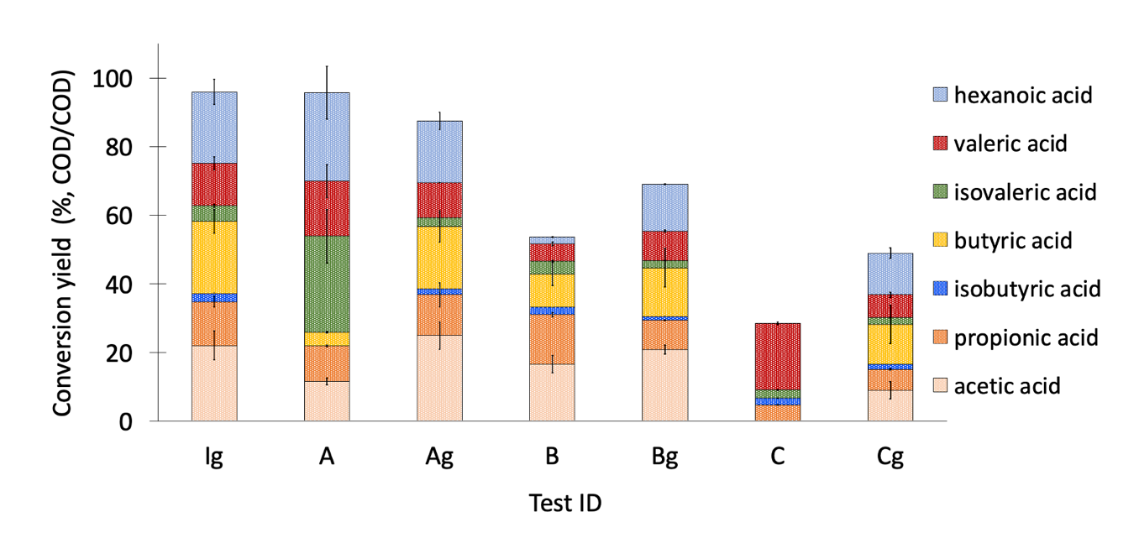
Figure 2: Composition of the organic acids mixture obtained in correspondence to the maximum conversion yield of the supplied COD for test A and Ag (i.e., Plasmix 2h and Plasmix 2h + glucose), B and Bg (i.e., Plasmix 4h and Plasmix 4h + glucose), and C and Cg (i.e., polystyrene and polystyrene + glucose), compared with results obtained in the Ig test (Inoculum + glucose).

From a detailed analysis of the fermentation products during the experiments, similarities in acids composition were found for Plasmix 2h and 4h (test A and test B, respectively). Both were, in fact, characterized by a high concentration of acetic and propionic acids in the first days of fermentation, compared to polystyrene HTL water (test C). However, as the fermentation process progressed, the production of these two acids eventually gave way to acids with a greater number of carbon atoms. Specifically in test A, upon reaching day 27 of operation (corresponding to the highest conversion yield), the obtained acids mixture was composed by isovaleric, valeric and hexanoic acids as main products (accounting for 28 ± 8%; 16 ± 5%; and 26 ± 8% with respect to the supplied COD, respectively) and, to a lower extent, by acetic (12 ± 1%), propionic (10 ± 1%) and butyric (4 ± 1%) acids. By comparing these results to those obtained in Ig control test (inoculum supplied with glucose), it was observed that C-4, C-5, and C-6 acids were produced, albeit minimally, from the earliest days of the experiments, determining within 22 days (at which the maximum conversion yield was achieved) an acids composition, respect to the supplied COD, consisting of acetic (22 ± 4%), propionic (13 ± 1%), isobutyric (2 ± 1%), butyric (21 ± 3%), isovaleric (5 ± 1%), valeric (12 ± 2%), and hexanoic (21 ± 4%) acids. On the other hand, in test B with only Plasmix 4h HTL water, once reached the maximum conversion yield of 54 ± 7% after about 20 days of operation, a different acids distribution was observed in comparison to Plasmix 2h. Indeed, in test B the acids mixture was mostly composed of acetic and propionic acids (accounting for 31 ± 3% of the overall conversion yield). When glucose was supplied along with Plasmix HTL water ( i.e., Ag and Bg tests), acids with more than 4 carbon atoms began to be produced from the very first days of operation of the tests, resulting in a very similar acid distribution (in correspondence to the highest obtained conversion yield) mainly consisting of acetic (25 ± 4% and 21 ± 1% for Ag and Bg tests, respectively), propionic (12 ± 4% and 8 ± 1%, respectively), butyric (18 ± 5% and 14 ± 6%, respectively), valeric (10 ± 1% and 9 ± 1% , respectively) and hexanoic (18 ± 2% and 14 ± 1%, respectively) acids. In tests with polystyrene HTL water (test C), unlike the other two HTL water by-products, once its maximum conversion of 29 ± 1% was achieved on day 20th, an acids mixture mostly composed of propionic (5 ± 1%) and valeric (19 ± 1%) acid was detected. In contrast, in the test supplied with glucose (Cg), the acids distribution was similar to that observed in the other tests in which this substrate was also present. Indeed, after 20 days of fermentation, the highest yield reached (49 ± 1%) contained all organic acids as in the other tests, with high percentages of acetic (9 ± 2%), butyric (12 ± 5%), and hexanoic acid (12 ± 1%).
  - Conclusions
Here, three aqueous by-products from hydrothermal liquefaction treatment (HTL) of plastic waste (i.e., Plasmix and polystyrene) were tested to be converted through acidogenic fermentation (AF) into organic acids which, in turn, can be used for biopolymers (e.g., polyhydroxyalkanoates, PHA) production. During AF tests (45-day of operation), main attention was paid to evaluating the potential of HTL waters conversion into acids as well as to assessing the possible occurrence of their inhibitory effects on the microbial activity. A conversion yield of the initial COD into acids up to 96 ± 21%, 54 ± 7%, and 29 ± 1% was detected for Plasmix 2h, Plasmix 4h, and polystyrene; respectively. These results suggest that a two-hour longer hydrothermal treatment applied on Plasmix determines significant differences in its convertibility into organic acids, likely due to the presence of recalcitrant compounds in the Plasmix 4h HTL water. Finally, with polystyrene HTL water a higher recalcitrance to the biological activity was observed than with the other tested HTL waters which, however, presented a negligible or absent inhibitory effect (as revealed by tests performed with both HTL and glucose as reference substrate). Acids from 2 to 6 carbon atoms were obtained with Plasmix 2h and 4h, and this is particularly relevant in the general context of PHA production. Overall, this preliminary study indicates a good potential for plastic waste conversion into organic acids and, in turn, into biopolymers.
Acknowledgments
This research was supported by Sapienza University of Rome (Ateneo 2020 grant n. RG120172B794BC2D).
References
Aboudi K., Álvarez-Gallego C.J., Romero-García L. I., Fernández-Güelfo L. A., 2021, Biogas, biohydrogen, and polyhydroxyalkanoates production from organic waste in the circular economy context, Sustainable Biofuels: Opportunities and Challenges, 305–343.
APHA, 2005, Standard Methods for the Examination of Water and Wastewater, 21st Edition, Washington DC.
Chen Z., Huang L., Wen Q., Guo Z., 2015, Efficient polyhydroxyalkanoate (PHA) accumulation by a new continuous feeding mode in three-stage mixed microbial culture (MMC) PHA production process, Journal of Biotechnology, 209, 68–75.
Guzik M. W., Kenny S. T., Duane G. F., Casey E., Woods T., Babu R. P., Nikodinovic-Runic J., Murray M., O’Connor K. E., 2014, Conversion of post consumer polyethylene to the biodegradable polymer polyhydroxyalkanoate, Applied Microbiology and Biotechnology, 98(9), 4223–4232.
Kenny S. T., Runic J. N., Kaminsky W., Woods T., Babu R. P., Keely C. M., Blau W., O’Connor K. E., 2008, Up-cycling of PET (Polyethylene Terephthalate) to the biodegradable plastic PHA (Polyhydroxyalkanoate), Environmental Science and Technology, 42(20), 7696–7701.
Khatami K., Atasoy M., Ludtke M., Baresel C., Eyice Ö., Cetecioglu Z., 2021, Bioconversion of food waste to volatile fatty acids: Impact of microbial community, pH and retention time, Chemosphere, 275.
Kourmentza C., Plácido J., Venetsaneas N., Burniol-Figols A., Varrone C., Gavala H. N., Reis M. A. M., 2017, Recent advances and challenges towards sustainable polyhydroxyalkanoate (PHA) production, Bioengineering, 4(2), 1–43.
Lorini L., di Re F., Majone M., Valentino F., 2020, High rate selection of PHA accumulating mixed cultures in sequencing batch reactors with uncoupled carbon and nitrogen feeding, New Biotechnology, 56, 140–148.
Melendez-Rodriguez B., Reis M. A. M., Carvalheira M., Sammon C., Cabedo L., Torres-Giner S., Lagaron J. M., 2021, Development and Characterization of Electrospun Biopapers of Poly(3-hydroxybutyrate- co- 3-hydroxyvalerate) Derived from Cheese Whey with Varying 3-Hydroxyvalerate Contents, Biomacromolecules Biomacromolecules, 22 (7), 2935-2953
Reis M., Albuquerque M., Villano M., Majone M., 2011, Mixed Culture Processes for Polyhydroxyalkanoate Production from Agro-Industrial Surplus/Wastes as Feedstocks, In Comprehensive Biotechnology, Second Edition, Elsevier B.V., 6, 669-683.
Sewon O., Stache E.E., 2022, Chemical Upcycling of Commercial Polystyrene via Catalyst-Controlled Photooxidation, J. Am. Chem. Soc. 144(13), 5745–5749.
Silva F., Matos M., Pereira B., Ralo C., Pequito D., Marques N., Carvalho G., Reis M.A.M., 2022, An integrated process for mixed culture production of 3-hydroxyhexanoate-rich polyhydroxyalkanoates from fruit waste, Chemical Engineering Journal, 427.
Villano M., Paiano P., Palma E., Miccheli A., Majone M., 2017, Electrochemically Driven Fermentation of Organic Substrates with Undefined Mixed Microbial Cultures, ChemSusChem, 10(15), 3091–3097.
Yu X., Yin J., Wang K., Shen D., Long Y., Chen T., 2016, Enhancing Food Waste Hydrolysis and the Production Rate of Volatile Fatty Acids by Prefermentation and Hydrothermal Pretreatments, Energy and Fuels, 30(5), 4002–4008.
Zhao X., Zhan L., Xie B., Gao B., 2018, Products derived from waste plastics (PC, HIPS, ABS, PP and PA6) via hydrothermal treatment: Characterization and potential applications, Chemosphere, 207, 742– 752.

