|  |  |
| --- | --- |
| cetlogo ***CHEMICAL ENGINEERING TRANSACTIONS***  ***VOL. , 2023*** | A publication of  aidiclogo_grande |
| The Italian Association  of Chemical Engineering  Online at www.cetjournal.it |
| Guest Editors: Sauro Pierucci,  Copyright © 2023, AIDIC Servizi S.r.l. **ISBN** 978-88-95608-98-3; **ISSN** 2283-9216 | |

Spectrophotometric Detection of Nickel in Water by Lab-on-a-chip Technology: Application to Electroplating

Giulia Mossotti\*,a, Felice Cataniaa, Francesco Perruccia, Luciano Scaltritoa, Monica Periolattoa and Sergio Ferreroa

a Politecnico di Torino, C.so Duca degli Abruzzi, 24 10129 Torino - Italia

[giulia.mossotti@polito.it](mailto:giulia.mossotti@polito.it)

Nickel is a metal member of the transition series in the periodic table, and as such shows outstanding properties interesting to the world of industry, namely corrosion resistance to air, water and alkali and electrical conductivity. In fact, nickel is widely employed in electroplating, where high analyte concentrations, up to 100g/L, are required to achieve excellent final results. The process monitoring is required not only to ensure constant and adequate metal-finishing concentration but also to guarantee the safety of wastewater products. To detect nickel, either in high and low metal concentration, a colorimetric method was selected. The spectrophotometric study reveals a well-defined absorption peak at 396nm, giving a calibration curve with remarkable linearity toward metal concentrations, ranging from 1 to 22g/L. By proper optimization process, the detection field can be simply enlarged at least from 100 g/L (100000ppm) to 3\*10-3 g/L (3ppm). Due to the presence of an acid part in the electroplating bath, the behaviour of the metal in an acid solution has also been investigated, and the calibration curve still depicts a good linearity of the system.

Achieved results pointed out the suggested colorimetric method as a promising candidate for addressing the requirement for capillary and regular monitoring of nickel in water, throughout a wide range of concentrations. The laboratory method may be readily improved and adapted for microfluidic technology by lowering sample and reagent amounts, miniaturizing sensors, and automating the entire process, from sampling to data recovery.

* 1. Introduction

Electroplating is a commercial, common and versatile method for coating a substrate, either metal or polymeric, with a thin layer of another metal. Among all the metals that can be used in this process, one of the most extensively used is Nickel, which manifests some peculiar characteristics appealing for three main industrial sectors: decorative, functional and electroforming. The first field accounts for approximately 80% of nickel consumption in plating (Di Bari et al. 2000). Nickel is a transition metal, thus it shows outstanding properties from a chemical-physical point of view, such as corrosion resistance to air, water and alkali, electrical conductivity, wear resistance, solderability and magnetic characteristic.

In order to create a thin metal coating on the substrate material's surface, the plating process generally exploits an electrochemical mechanism where a direct current is applied between two electrodes immerse in an aqueous conductive solution of metal salt. At the anode, the metal dissolution occurs while at the cathode), the deposition of metallic Nickel on the substrate takes place. Two major reactions are involved: oxidation at the counter electrode (1) and reduction at the working electrode (2).

Ni0 → Ni 2+ + 2 e− (1)

Ni2+ + 2 e− → Ni0 (2)

As a direct consequence, metallic Nickel adheres to the surface of the material as a thin Ni seed layer, shaping a pattern for the electroplating current. Because the nickel ions discharged at the cathode are replenished by the nickel ions formed at the anode, the nickel-plating process can be run continuously for an extended period of time. (Oluranti et al. 2012)

The most crucial aspect of the entire procedure is the conductive bath solution in which the electrodes are immersed. Nowadays, the Watts nickel solution is the most wildly used and requires a mixture of nickel chloride, nickel sulphate and boric acid with high metal concentration, as far as 100g/L. The ability to monitor the concentration of the Watt solution over time using appropriate sensor ensures, on one hand, the correct and homogeneous distribution of the metal on the chosen substrate and, on the other, it guarantees no leak of Ni, a metal harmful either to the environment and human, from the bath.

In fact, Nickel is an essential micronutrient for plant growth, the II oxidation state is the most common one in biological systems so its uptake is very fast and at high concentration is strongly phytotoxic inhibiting plant growth, photosynthesis, seed germination, transport of sugar and as a long-term final consequence it could enter in the food chain with harmful effects on animals and humans. For prolonged exposure to low doses in mammals, Nickel has been revealed to have negative effects on the reproductive system and to prevent these effects, EFSA (European Food Safety Authority) in 2020 established a Tolerable Daily Intake (TDI) of 13 µg/kg body weight per day. In exposed workers at occupational level at much higher doses than the general population, effects and reactions have been observed on the skin and kidneys, but most notably, the appearance of chronic bronchitis, reduced lung function, and lung and sinus cancer. As a result, the International Agency for Research on Cancer (IARC) has classified some nickel compounds, taken only by inhalation, as carcinogenic to humans, while nickel metal has been classified as possibly carcinogenic to humans, owing to a lack of sufficient scientific evidence.

To the best of our knowledge, UV-Vis colorimetry, based on the well-known Lambert & Beer law, is a suitable and adequate standard approach for Nickel detection analysis.

The purpose of this pilot study is to confirm the possibility of developing and integrating a sensor based on a colorimetric evaluation by UV-Vis spectroscopy, into a microfluid device, coupled with lab-on-a-chip technology for the detection of a wide range of Nickel concentrations in water linked to industrial use. This sensor, which features ease of use, speed, sensitivity, selectivity, reliability, portability, robustness, and safety, will be able to detect a wide range of Nickel concentrations in water and could be used for a variety of aims. The same authors have previously published research on colorimetric analysis applied to microfluidic devices for online monitoring of metal ions in water. As a result, prototype for detecting Chromium (VI) and Arsenic has been studied and developed (Manachino et al. 2020, Periolatto et al. 2022). Moreover, the innovation in the automation of the entire process could lead to increase the monitoring frequency and the ability to intervene immediately in the occasion of anomalies in metal concentration levels; in fact, there is no longer a time-consuming gap between sampling *in situ* and analysis in the laboratory. Furthermore, through IoT technologies, the transmission of the data to competent authorities can be immediate.

The proposed method's ability to monitor Nickel across a wide concentration range was demonstrated by laboratory tests, and the effects of chemical and physical parameters like medium pH, aging, or salt dilution were negligible.

* 1. Materials and method

To determine Nickel concentration, in terms of the detection limits and linearity of the calibration curve, analyte solutions with increasing metal concentrations were prepared and analysed using UV-vis spectroscopy in the wavelength range 400−900 nm. The quality of spectra and the absorbance peak were likewise investigated. The samples with different Ni concentrations, in the range of 1 – 25 g/L, were prepared used a standard volume of 50mL of distilled water (neutral pH) where proper amounts of the commercial high-purity quality Nickel (II) nitrate hexahydrate (Ni (NO3)2 · 6H2O) (Sigma-Aldrich) were dissolved at room temperature. Only for the solutions with highest concentration of Ni, to obtain the complete dissolution of the metal, a vigorous magnetic stirring was necessary for few minutes. However, the real samples from plants can be analysed as such, even at high ions concentrations, because process parameters ensure complete salt dissolution, so this sample pre-treatment is only required for the calibration curve.

A UV-Vis spectrophotometer (LAMBDATM 35, PerkinElmer) was used to examine the as-prepared samples, in an optical glass cuvette (10 or 20 mm optical path), versus pure distilled water as a reference. First, the solutions were examined at room temperature and neutral pH without dilution to assess the quality of the spectra and the peak wavelength. Then pH=4 and pH=10 buffer solutions (Sigma-Aldrich) were used to test the behaviour of the metallic analyte in acidic and basic media.

* 1. Results and discussions
     1. Colorimetric evaluation at neutral pH

Nickel can be quickly, easily and directly detected using UV-Vis spectrophotometry colorimetric detection method. The tested solutions cover a wide range of metal analyte concentrations, with experiments ranging from 20 g/L to 3\*10-3 g/L. All mentioned solutions, particularly those with higher concentrations, exhibit, even at necked eye, an intense green color, that is directly proportional to the contraction of nickel ions (Figure 1).

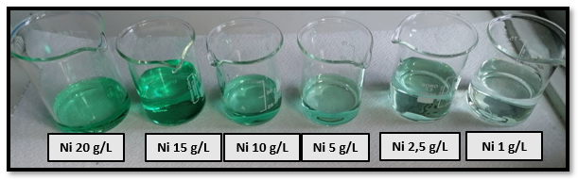

Figure 1: Nickel nitrate solutions with increasing metal concentration, from right to left.

The spectrum for Ni solutions from 1 to 20 g/L showed the maximum absorbance at the well-defined wavelength of 396 nm, when compared to distilled water as a reference and using a 1cm optical length. (Fig. 2a) The calibration curve based on the specific absorbance values is shown in Figure 2b; the R2 value, which is close to 1 (R2=0,99), confirms the high linearity toward metal concentrations. Nevertheless, at the higher metal concentration, a greater deviation respect to the others was revealed. This is most likely due to the start of signal saturation, which in the spectrum results within a constant growth of a spike at 378nm. The linearity of the system, up to a certain concentration, is unaffected by this saturation because this spike is quite far from the maximum wavelength. However, as it is depicting in the magnification of Figure 2a, at 25 g/L solution the spike shows complete saturation of the signal and as result the value R2 in the calibration curve is far from unit. The highest nickel concentration that can be detected for industrial calibration purposes is 20 g/L.

After resting for a period of 24h, the prepared solutions were once again analysed in order to determine whether metal deposition might cause the samples to deteriorate or change colour. As illustrates in Figure 3a both spectra resembled each other and R2 value for the calibration curve by resting solutions is close to unit (Fig. 3b). These results suggest no modification occurs in the coordinating structure around the Ni2+ hexa-aqua complex (no shift of the maximum absorbance peak) and that the completely dissolution of the salt in the freshly prepared solution occurs immediately, thus instrument calibration can be carried out instantly.

Figure 2: (a) UV-vis spectra of Ni solutions with increasing metal concentrations (b) Calibration curve (λMAX = 396 nm).

**(a)**

**(b)**

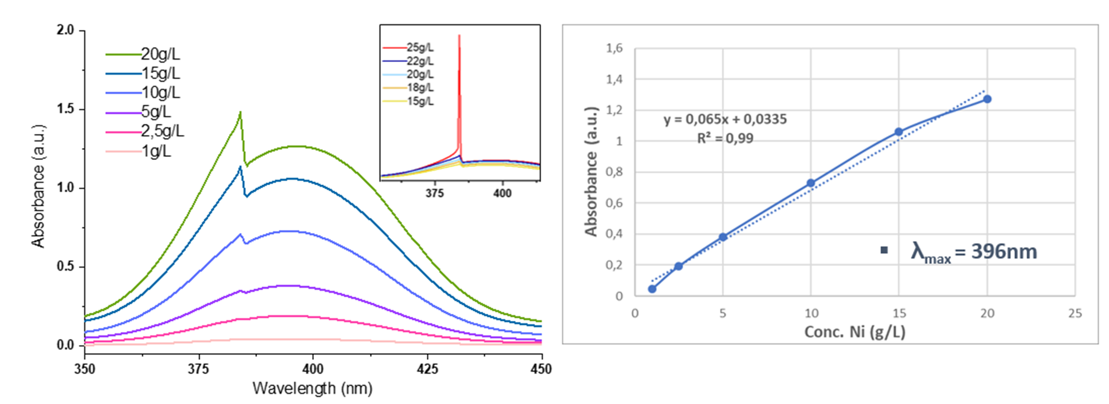

**3.1.1 Colorimetric evaluation at neutral pH: influence of the optical length**

In order to determine the lowest concentration of Nickel that could be detected in the absence of any external agents, the proposed method was tested using a longer optical length.

In the concentration range below 1g/L, the linearity of the system was lost when an optical length of 1cm was used, due to lowest amount of metal ions in solution. However, the spectra referred to 1g/L solution, demonstrates an improvement in the spectrum definition by extending the optical length from 1cm to 2 cm but the same wavelength was maintained. As show in Figure 4c, by means of the preparation of a new set of samples in a lower range, below 0,1 g/L, despite the colour of solutions was barely visible to the necked eye, the UV-Vis technique was still able to discern differences. In fact, the spectra are similar in form to the previous ones, showing the same peak at the same wavelength (Figure 4a), and the calibration curve (Figure 4c) confirms a good linearity (R2=0,9974). For Ni concentrations below 3\*10-3 g/L (3ppm), which is assumed to be the lowest concentration detectable with this asset, the absorbance peak disappears. However, it is reasonable to assume that the minimum detectable concentration can be further decreased by further extending the optical length in absorbance.

In these experimental conditions (neutral pH and 2cm optical length) two additional test sets were run in the same concentration range to confirm the minimum detectable concentration, which was determined to be 3\*10-3 g/L (SD=1,7%, calculated using the Bessel Correction (n-1)). The proposed method of analysis was considered effective and robust, yielding excellent results, even at low concentrations usually more subject to interference.

Figure 3: (a) UV-vis spectra of Ni solutions from 1 to 20 g/L, freshly prepared and 24h aged; (b) Calibration curve for aged solutions (λMAX = 396 nm).

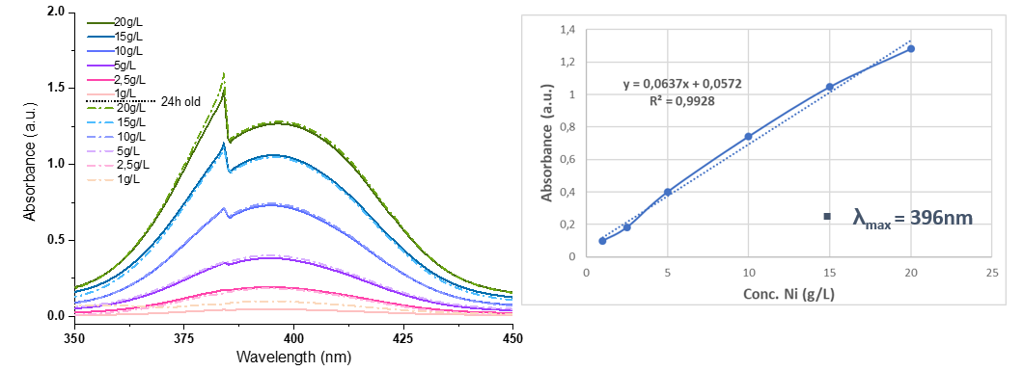

**(a)**

**(b)**

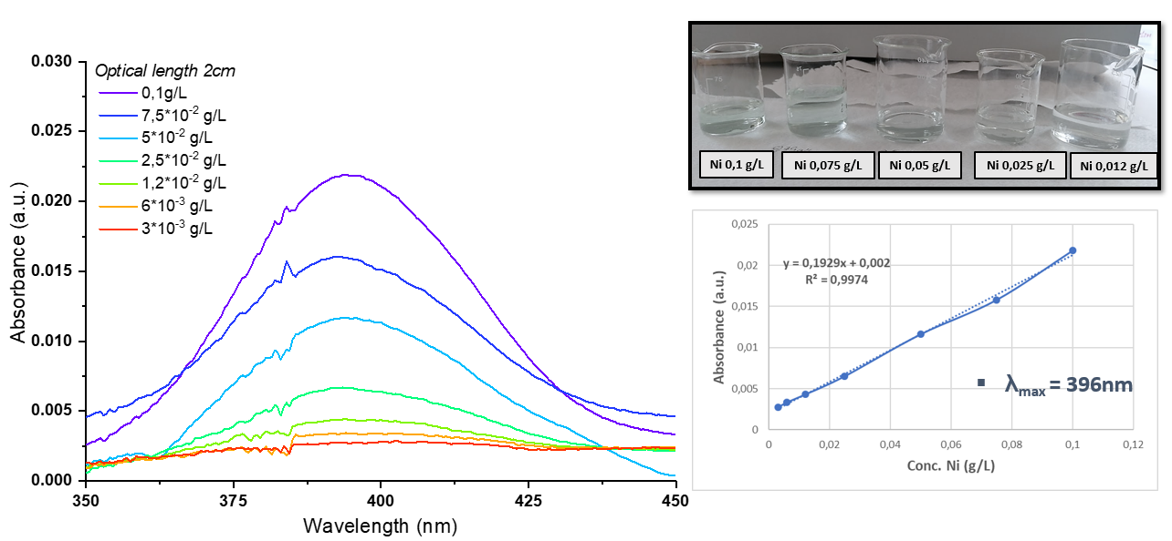

**(c)**

**(b)**

**(a)**

Figure 4: (a) UV-vis spectra of Ni solutions range from 0,1 to 3\*10-3 g/L, 20 mm optical length (b) Colourless solutions with low Ni concentration (c) Calibration curve for 20 mm optical length (λMAX = 396 nm).

**(a)**

**(c)**

**(b)**

**3.2 Colorimetric evaluation: influence of different pH**

The influence of pH was tested on two Ni solutions 10 g/L in both buffer solution in acid and basic conditions. The Nickel salt behaves differently depending on different pH (Figure 5). Indeed, as expected, for the same solution of 10 g/L, salt has not been dissolved by basic pH giving a turbid solution, whereas salt dissolution occurs at acidic pH, resulting in a bright green solution.

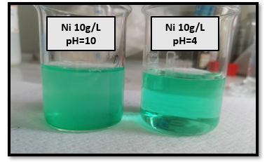

*Figure 5: Influence of pH on 10 g/L Ni solutions.*

**3.2.1 Colorimetric evaluation at acidic pH**

For the aim of this paper, strictly correlated to industrial monitoring, the acid solution (pH=4) was selected for deeper investigations. As depicted Figure 6b, with respect to neutral pH, acidification causes higher absorbance values, due to the better salt dissolution, while maintaining the same maximum absorbance peak. Spectroscopic analyses were carried out in a concentration range from 20 to 25 g/L using 10mm optical length and it was estimated that the maximum detectable concentration is 22 g/L (Figure 6a). In fact, despite the fact the 25 g/L solution does not show a clear sign of saturation in the spectrum, it affects the linearity of the calibration curve (R2<0,98). Likewise, for the minimum detectable concentration, as expected, as the optical path lengthens so does the spectrum resolution, depicted in magnification of Figure 7a. Solutions from 1 to 1,8\*10-3 g/L were tested under acidic pH conditions: despite losing their color (Figure 7b), however a minimum detectable concentration of about 2 ppm can be achieved due to the action of strong dissolution by the acid media. The calibration curve for this set shows a good linearity (Figure 7c), and the low limit of detectable metal concentration decreases to 1,8\*10-3 g/L, with an improvement with respect to neutral solutions.

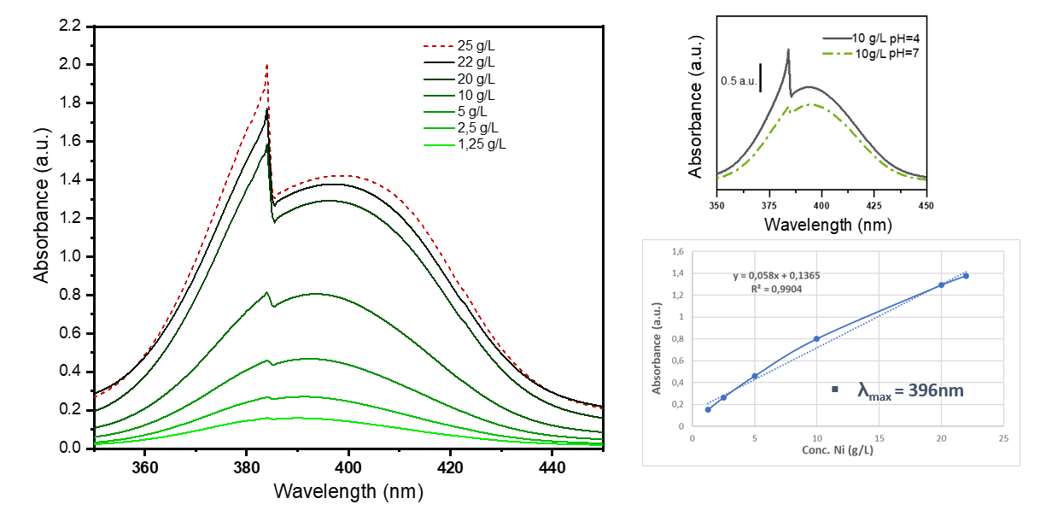

**(c)**

**(b)**

**(a)**

Figure 6: Influence of acidic media on absorbance: a) UV-vis spectra of Ni solutions range from 1,25 to 25 g/L in acidic pH; (b) UV-Vis spectra of the improvement in 10g/L detection using acidic pH as media (c) Calibration curve (λMAX = 396 nm).

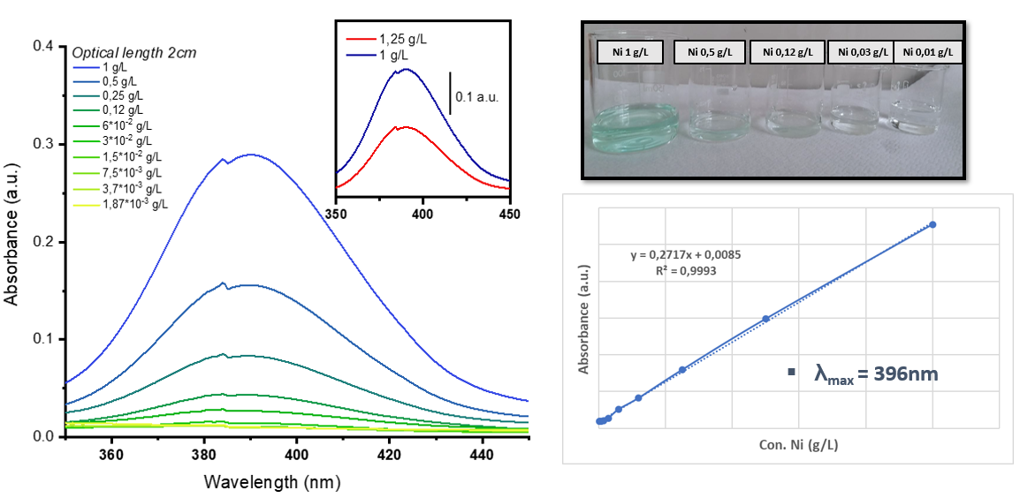

**(c)**

**(b)**

**(a)**

Figure 7: Influence of acidic media on absorbance: a) UV-vis spectra of Ni solutions range from 1 to 1,8\*10-3 g/L; the magnification shows the improvement in absorbance for the same solution (b) Colourless solutions with low Ni concentration (c) Calibration curve (λMAX = 396 nm).

**(a)**

**(b)**

**(c)**

**3.2.3 Colorimetric evaluation at acidic pH: aging test and dilutions**

Finally, since the electroplating required high metal concentration, were performed dilutions of two solutions at higher concentrations, namely 75 and 50 g/L, in order to determine whether and under what conditions the system linearity could be maintained. As reported in Figure 8a, the 1:5 diluted spectra perfectly overlap to those freshly prepared, without any shift of the absorbance peak. Figure 8b demonstrates that the same diluted solutions hold the salt good solubility even after 24 hours of preparation. In conclusion, metal solutions even with very high concentrations can be analyzed by a simple water dilution, to bring back the concentration in the detectable range.

Figure 8: Sample dilution 1:5; (a) Spectra of the diluted solutions overlapping the analogous fresh one; (b) Effect of 24 hours aging.



**(a)**

**(b)**

* 1. Conclusions

Monitoring the presence of dangerous metal ions in water media could significative improve process control and reveal potential water source pollution in the industrial and environmental fields. Based on UV-Vis spectrophotometric detection, the proposed direct colorimetric analyses proves to be quick and effective enough to be integrated into a sensor since no external complexing agent has been used to achieve remarkable results. In order to refine and adapt the procedure, a discrete number of samples have been examined at different concentrations, pH values, and times. The analysis shows that when the sample media and optical path are properly adjusted, colorimetric analysis can reliably detect metal in a wide range of concentrations in water and acid pH. It is possible to determine 20 g/L of Nickel as maximum concentration in a neutral media and 22 g/L in acid environment with a standard optical length of 1 cm. Since the analysis has been performed mainly in neutral medium at room temperature, the operational conditions making the detection astonishingly secure and straightforward. By a simple 1:5 dilution, the system can detect up to 100 g/L of Nickel, that is the required concentrations for the metal electrodeposition process and the analysis could be done *in situ* and automatically. Regarding the lowest detectable concentration, concentrations up to 3\*10-3 g/L (3ppm) and 1,8\*10-3 g/L (~2ppm) can be detected in neutral and acidic media respectively, by properly adjusting the optical length. Finally, ageing tests were performed to test the salt's dissolution over time, resulting in a possible constant linearity of the calibration over time. Hopefully, even lower concentrations can be detected without the use of external chelating agents, simply by further lengthening the optical path. Due to the rapid absorption of Nickel by plants, detection of such low concentrations is crucial to environmental protection.

Over and above the suggested method has the added benefit of being cost-efficient for a portable device employing a microfluidic system due to the limited use of regents and volume. With the investigated method, Nickel presence in the electroplating bath and water can be detected in a wide range of concentrations, opening up numerous applications in water contamination monitoring and electroplating control.

**References**

Di Bari G. A., 2000, Electrodeposition of nickel. Modern electroplating, 5, 79-114.

Oluranti S. A., Emmanuel R. S., Olusesan F. B., 2012, The properties and the effect of operating parameters on nickel plating. International Journal of Physical Sciences, 7(3), 349-360.

Manachino M., Periolatto M., Catania F., Scaltrito L., Pirri F., Ferrero S., 2020, Miniaturization and Optimization of the Standard Spectrophotometric Analysis for Autonomous, Continuous and On-site Heavy Metal Detection in Water, Chemical Engineering Transactions, 82, 181-186.

Periolatto M., Mossotti G., Catania F., Piscitelli A., Scaltrito L., Ferrero S., 2022, Routine Monitoring of Trace Arsenic in Water by Lab-on-a-chip Technology: a Preliminary Study. Chemical Engineering Transactions, 91, 379-384.