CHEMICAL ENGINEERING TRANSACTIONS  VOL. , 2023 | A publication of
The Italian Association
of Chemical Engineering
Online at www.cetjournal.it

Guest Editor: Sauro Pierucci
Copyright © 2023, AIDIC Servizi S.r.l.
ISBN 978-88-95608-98-3; ISSN 2283-9216

Current Municipal Solid Waste Management in a Large City and Evaluation of Alternative Management Scenarios
Elisa Magnanelli*, Cansu Birgen, Michaël Becidan
SINTEF Energy Research, Sem Saelands vei 11, 7034, Trondheim, Norway
elisa.magnanelli@sintef.no
Sustainable waste management is a fundamental aspect in a circular economy. The focus of this work is to evaluate the performance of the current MSW management system in the city of Oslo, and to understand how to possibly close the gap between today's recycling rate and the EU sorting and recycling targets for 2025 and 2030. The adoption of innovative solutions such as central sorting and chemical recycling of plastic might help achieving a higher overall recycling rate. While the achievement of a higher source sorting can help achieving the EU recycling targets without undergoing large investments, it might be challenging to find measures and incentives that succeed in reaching the desired citizen involvement. The work focuses on the waste fractions for which specific targets are set by the EU, i.e., biowaste, plastic, paper and cardboard, glass and metal. This study can help waste management companies to understand how the introduction of different technologies within their waste management system might help achieving the EU recycling targets, and help policymakers understand the fundamental role of citizen involvement and source sorting.
  - Introduction
In its Circular Economy Action Plan (European Union, 2020), the European Commission sets an agenda for achieving a cleaner and more sustainable Europe. Production and management of packaging and packaging waste are one of the focus points. Concrete targets for the separate collection and recycling of packaging waste are set by a directive of the European Parliament and Council (European Union, 2018b). The corresponding Norwegian legislative texts exhibit small differences (MCE, 2022) but aim to achieve the same overarching goal: increased recycling. Waste packaging is one of the main fractions in municipal solid waste (MSW), which is defined as the waste generated by households as well as by commercial activities that generate waste with similar properties (e.g., shops and offices).
While the waste hierarchy indicates waste reduction as the most effective action to reduce the impact of waste, the yearly MSW generation in the EU has been stable at 505 kg/capita from 2005 to 2020. On the other hand, Norwegian MSW generation has increased by 70 % during this period, from 426 kg/capita in 2005 to 604 kg/capita in 2020 (Eurostat, 2022). This increase combined with a population growth of 16 % has caused the total reported MSW generation in Norway to largely increase over the last 15 years.
The focus of this work is to evaluate the performance of the current MSW management system in the city of Oslo, Norway, and to understand how to possibly close the gap between today's recycling rate and the EU recycling targets for 2025 and 2030. Technologies such as central sorting might help achieving a higher overall sorting rate. The adoption of innovative technologies such as chemical recycling might help increasing recycling efficiency of challenging waste fractions such as plastic. While the achievement of a higher source sorting can help increasing recycling without undergoing large investments, it might be challenging to find measures and incentives that succeed in reaching the required citizen involvement. The work focuses on the waste fractions for which specific targets are set in the EU directive as well as Norwegian legislation, i.e., biowaste, plastic, paper, glass and metal. This study can help waste management companies to understand how the introduction of different technologies within their waste management system might help achieving the EU recycling targets, and help policymakers understand the role of citizen involvement and sorting at source.
  - Methodology
The present work investigates the waste management system applied to the MSW collected, sorted and sent to treatment by the Agency for Waste Management (acronym REG), in the City of Oslo, Norway. REG is responsible for the collection of household waste, and some household-like commercial and industrial (C&I) waste. The analysis was done for 2019 to avoid any effects caused by the pandemic.
    - The current MSW management system
MSW generated in Oslo is gathered via door-step collection and drop-off collection points. Separate containers are dedicated to door-step collection of mixed, paper, food, and plastic waste, while drop-off stations cover the collection of other fractions such as garden, hazardous, electronic, construction and demolition waste. The different recyclable fractions are sent to different recycling plants, while non-recyclable streams are mainly incinerated, with the exception of separately collected inert materials, which are landfilled. Source sorted food waste is sent to anaerobic digestion plants for biogas and fertilizer production. Anaerobic digestion is the most common treatment method for separately collected food waste in Norway, while composting is mostly applied to garden waste. The only rejects from the anaerobic digestion process are materials that are wrongly sorted, and all food waste that enters the process can be accounted for as recycled. Paper waste is sent to different recycling facilities, both inside and outside the country. Plastic waste is currently sent to three recycling plants in Germany, where recyclable plastic fractions are recycled, while the non-recyclable ones are incinerated (with energy recovery). Glass and metal waste are further sorted at a facility in Øra, Fredrikstad, Norway, which separates high- and low-quality glass, and the different metals.
    - Sorting rate, recycling efficiency and recycling rate
For a recyclable waste fraction, the sorting rate (SR) is defined as the ratio between the amount of correctly sorted waste and the overall amount of generated waste belonging to that fraction. Sorting can take place where waste is generated before being collected by the responsible operator (i.e., source sorting) or in dedicated plants after collection (i.e., central sorting). In Oslo, source sorting, followed by optical post-sorting of the different garbage bags, is the main solution. Hence, citizens and citizens’ involvement play a fundamental role in reaching a high SR. In this work, SR of the different waste fractions and subfractions is derived on data on generated waste streams.
The recycling efficiency takes into account that not all sorted waste can actually be recycled. This might be due to impurities or subfractions that are not technically recyclable e.g., composite materials. The recycling efficiency is defined as the ratio between the amount of sorted waste that is actually recycled, after cleaning and pre-processing, and the amount of correctly sorted waste that is sent to recycling. Table 1 shows the recycling efficiencies used for this study.
The recycling rate (RR), as described in the most recent EU Directive (European Union, 2018b), should be calculated as the ratio between the amount of waste that is actually recycled and the amount of waste that is generated. RR can therefore be calculated as the product between SR and recycling efficiency. This means that when trying to increase the RR, focus can be put on either increasing SR or the recycling efficiency or both. As seen in Table 1, except for plastic, the recycling efficiency of most recyclable fractions is quite high and efficiency penalties are mostly due to impurities. There is therefore a relatively low margin for improving the recycling efficiency of these fractions. On the other hand, plastic has a relatively low recycling efficiency. This is because several plastic subfractions cannot be mechanically recycled and are therefore rejected by the recycling process. Chemical recycling is an emerging technology that could allow to recycle some of the plastic fractions that cannot be mechanically recycled, hence increasing recycling efficiency of plastic waste (Rahimi and Garcia, 2017). A second way to improve the RR is to increase the SR. At the moment, sorting of recyclable waste fractions relies on source sorting. Measures to increase citizen involvement could improve source sorting. A second option is to introduce central sorting in dedicated plants.
Table 1: Weighted average recycling efficiency of the different waste fractions.
Waste fraction | Subfraction | Recycling efficiency | Reference
Food waste | All | 100 % | -
Paper waste | Packaging | 97 % | Grønt Punkt (2022)
 | Non-packaging | 81 % | Raadal et al. (2010)
Glass waste | All | 99 % | Grønt Punkt (2022)
Metal waste | All | 81 % | Grønt Punkt (2022)
Plastic waste | All | 55 % | Furberg et al. (2022)
Table 2: Amount and type of chemicals that can be produced through chemical recycling of different plastic fractions from Meys et al. (2020) and Jeswani et al. (2021).
 | kg/kg | Plastic subfractions
 |  | HDPE | LDPE | PP | PS | PET | Mixed plastic
Products | Ethylene | 0,846 | 0,828
 | Propylene |  |  | 0,846
 | Styrene |  |  |  | 0,846
 | Ethylene glycol |  |  |  |  | 0,285
 | Cyclohexanedimethanol |  |  |  |  | 0,662
 | LDPE |  |  |  |  |  | 0,495

    - Chemical recycling and central sorting
Chemical recycling is a thermochemical process that breaks down plastic into chemicals that can be used to produce new plastic with virgin-like properties. The recycling efficiency of the process depends on the composition of the input plastic waste. Table 2 details what and how much chemicals can be produced from different plastic subfractions. The introduction of central sorting after waste collection could help increasing the SR of some recyclable waste fractions. The ROAF and IVAR central sorting plants are two Norwegian facilities that use Near Infrared technology to sort out paper, metal and five different plastic subfractions from residual waste (Hertzenberg, 2020). These plants' operation performances are used to calculate an average sorting efficiency for the different fractions in a hypothetical central sorting plant in Oslo (Table 3). Waste fractions that are centrally sorted from mixed waste have a higher amount of dirt and impurities compared to source sorting, which is typically related to the amount of food and other wet fractions present in the mixed waste. The amount of waste that is sorted out is therefore corrected with specific factors (Avfall Sverige, 2014).
  - Results and discussion
Approximately 240,000 t MSW was generated in Oslo in 2019, of which 58 % was directly incinerated, 39 % was sent to material recycling and 3 % was landfilled (Figure 1a). Not all the MSW that is sent to material recycling can actually be recycled. This is due to two factors: (1) some of the waste sent to recycling is incorrectly sorted, (2) some of the subfractions, while correctly sorted, are not recyclable e.g., some plastic subfractions or composite materials. These are rejected at the recycling facilities and sent to incineration. Only 3% of MSW was landfilled, which is well below the target set by the European Union (2018a) of maximum 10% MSW sent to landfill by 2035. This is a consequence of the landfill ban on biodegradable waste that entered into force in Norway in 2009 (MCE, 2022). On the other hand, a fraction of the waste sent to incineration could have been recycled, if it had been separated at source. Figure 1b shows the composition of MSW sent to incineration. Almost two thirds of the incinerated waste belong to a fraction that could have been sent to material recycling if correctly sorted out.
The SR of the different waste fractions varies considerably. Food waste is the overall largest waste fraction. Figure 2a shows that of the 57,000 t of food waste that were generated, only 20,000 t were sorted as food waste and treated through anaerobic digestion. This gives a SR of 35 %, which is significantly lower than targets of 55 % food waste SR by 2025 and of 70 % by 2035 (MCE, 2022). Since Norwegian regulations prescribe that food waste must be separated at source, efforts should be put into promoting the separation of food waste by citizens at home (and relevant businesses). Food waste can be categorized into edible food waste (i.e., food that could have been consumed by humans) and inedible food waste (i.e., food residues such as vegetable peels). Edible food waste made up approximately 53 % of the generated wood waste. It is interesting to observe that edible and inedible food have very different SRs. While 47 % of inedible food waste is correctly sorted at source, edible food waste has a SR of only 24 %. A possible explanation is that edible food that has passed expiration date is often thrown into the residual waste container together with its packaging, rather than being removed from the packaging and sorted into the food waste container.
Table 3: Average sorting efficiency for the different waste fractions at ROAF and IVAR central sorting plants (Hertzenberg, 2020). Their average is used in this work to describe a hypothetical new sorting facility.
Waste fraction | Sorting efficiency at ROAF | Sorting efficiency at IVAR | Average
Paper waste | 27 % | 29 % | 28 %
Metal waste | 65 % | 92 % | 79 %
Plastic waste | 35 % | 53 % | 44 %
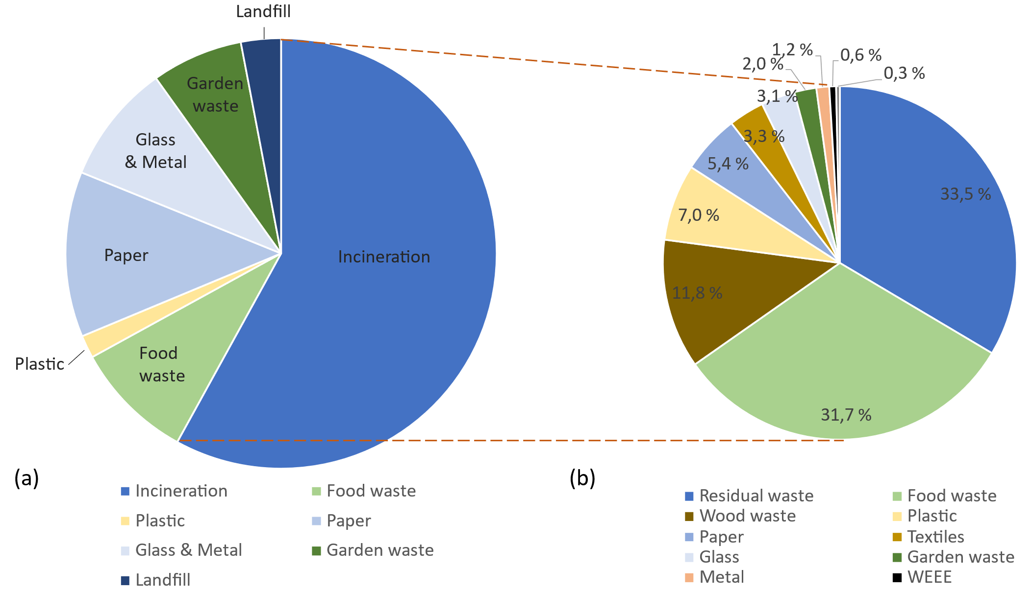
Efforts to reduce edible food waste as promoted by the United Nations' Sustainable Development Goals (SDG) would also contribute to decreasing the rate of unsorted food waste. The SDG target 12.3 aims at reducing food wastage by 50 % by 2030 (United Nations, 2015), and as a consequence of this effort, food wastage in Norway has been reduced by 9.5 % between 2015 and 2020 (GSSO, 2021). A further decrease in edible food waste will result in a higher SR for food waste. Paper waste is the second largest recyclable waste fraction (Figure 2b). Of the 38,000 t paper waste generated, 28,000 t were correctly sorted and sent to material recycling. Of these, approximately 4,000 t are rejected at the recycling facilities, resulting in a RR of 64 %. Paper waste can be classified into packaging paper waste (37 % of the paper waste) and non-packaging paper waste (63 % of the paper waste), which consists of reading materials and other paper items. Both SR and recycling efficiency are different for these two categories. Non-packaging waste has a SR of 85 %, while this is only 55 % for packaging waste. As for edible food waste, this could be due to paper food packaging being thrown in the mixed waste bin together with their expired content. This gives a RR of 54 % for paper packaging. It is therefore important to focus the efforts on increasing sorting of packaging waste to reach the EU targets of 75 % and 85 % RR by 2025 and 2030, respectively (European Union, 2018b). The SR for plastic is relatively low (Figure 2c): only 3,400 t out of the 12,800 t of generated plastic waste are correctly source sorted, resulting in a 27 % SR. Moreover, approximately 1,000 t of other waste is wrongly sorted together with plastic waste and needs to be removed before the plastic waste is sent to material recycling (Cansu and Becidan, 2022). Due to the relatively low recycling efficiency of plastic, the final plastic RR is only 15 %. Plastic waste consists mainly of plastic packaging and only 6 % of the total plastic waste is non-packaging waste. Metal and glass are sorted in a common container. Both have a relatively high SR, with 69 % of glass waste and 75 % of metal waste being correctly sorted (Figure 2d). The recycling efficiency is also high, giving a final RR of 68 % for glass and 61 % for metal. While approximately 99 % of the generated glass waste is glass packaging, metal packaging represents only 30 % of the generated metal waste. Metal packaging has a much lower SR than other metal waste, with only 23 % of metal packaging being correctly sorted. This gives a RR for metal packaging of only 17 %. This RR is very different from that reported at the national level by Grønt Punkt (2022b). This can be due to local conditions or by different reporting and categorisation practices. It should also be noted that metal waste extracted from bottom ashes after MSW incineration is not taken into account in this analysis. Aluminium beverage cans are not considered here either, as they are handled through a container-deposit scheme that ensures high collection rate and recycling.
Figure 1: MSW streams as separated at source to incineration, material recycling and landfill (a) and composition of the MSW sent to incineration (b).
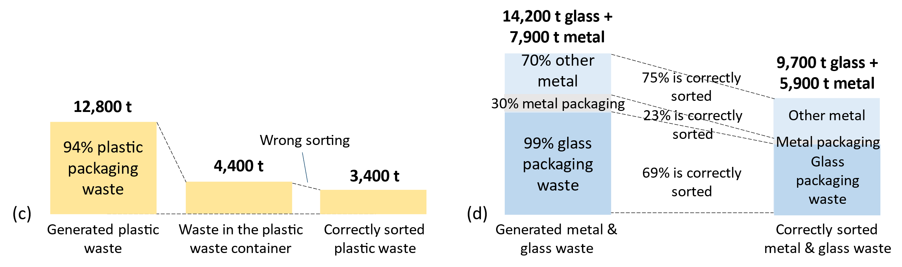
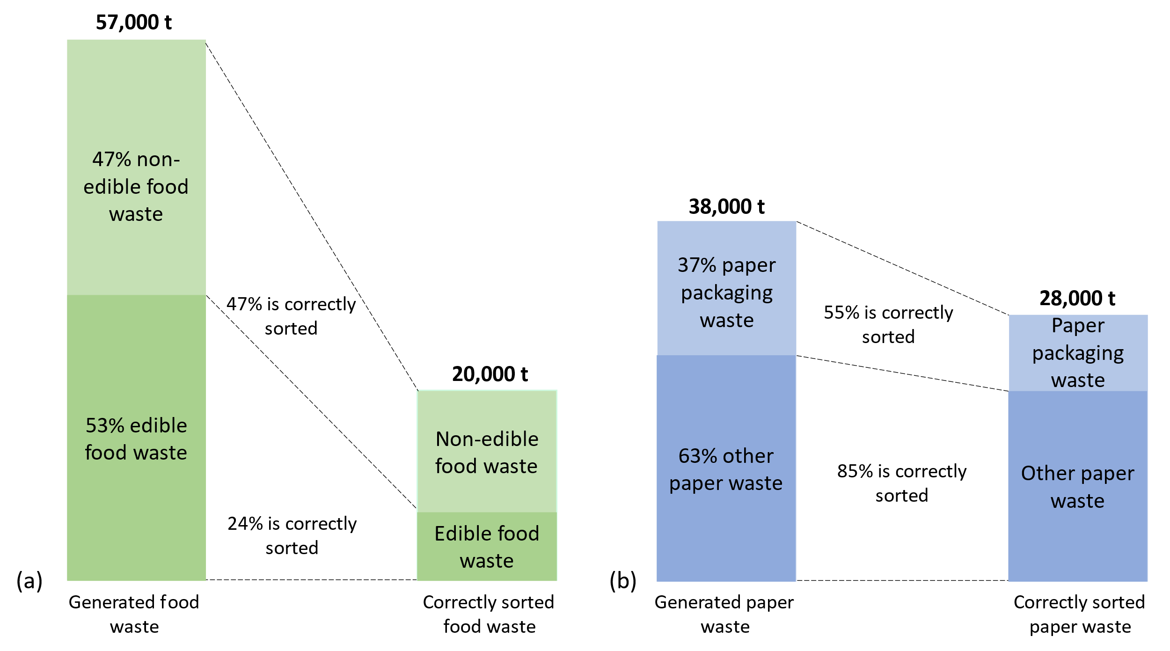
From the analysis above, it appears that the first measure to increase the overall RR of the different fractions is to increase their SR. Central sorting can help to increase SR of paper, metal and plastic. Plastic is the only considered fraction with a large room for improvement of the recycling efficiency. Introduction of chemical recycling could help increase recycling efficiency of this fraction. Applying the expected performance of a hypothetical central sorting plant (see Table 3), the new SR for several waste fractions were calculated. Table 4 shows that the introduction of central sorting helps increase the SR from 74 % to 81 % for paper, from 27 % to 60 % for plastic and from 75 % to 95 % for metal. Due to the relatively low source sorting, central sorting could help increase the plastic SR more than 2-fold. Chemical recycling alone does not have a large impact on the RR of plastic, due to the low SR. On the other hand, the combination of central sorting and chemical recycling helps almost triple the RR of plastic. The introduction of these two technologies helps narrow the gap between current RR and the ambitious recycling targets for 2025 and 2030. However, their establishment will require large investments that may increase waste treatment costs. An analysis of the consequences for introducing technologies will have to be carried out, including logistical and social aspects. Nonetheless, even with the introduction of these technologies, results show that a more extended citizen involvement and source sorting are necessary for the sorting and recycling EU targets to be achieved.
Figure 2: Generated and correctly sorted food waste (a), paper (b), plastic (c) and metal & glass waste (d).
Table 4: Summary of SR and RR for today's system and with central sorting and chemical recycling.
Waste fraction | Today |  | Central sorting |  | Chemical recycling |  | Central s.+Chem. recyc.
 | SR | RR | SR | RR | SR | RR | SR | RR
Food waste | 35 % | 35 % | 35 % | 35 % | 35 % | 35 % | 35 % | 35 %
Paper waste | 74 % | 64 % | 81 % | 70 % | 74 % | 64 % | 81 % | 70 %
Plastic waste | 27 % | 15 % | 60 % | 32 % | 27 % | 20 % | 60 % | 43 %
Metal waste | 75 % | 61 % | 95 % | 77 % | 75 % | 61 % | 95 % | 77 %
Glass waste | 69 % | 68 % | 69 % | 68 % | 69 % | 68 % | 69 % | 68 %
  - Conclusions
This study analyzed the results of MSW management system in a large Scandinavian city and studied the effect of introducing central sorting and chemical recycling of plastic on the sorting and recycling rate. Almost two thirds of the residual waste could be sent to recycling if correctly sorted. Only 35 % of food waste is correctly sorted, but the SR of inedible food waste is much higher (47 %) than that of edible food waste (24 %). In general, packaging waste fractions had lower SR than non-packaging waste. This might be correlated to the low SR of edible food waste, as expired food tends to be thrown together with its packaging as residual waste. The introduction of central sorting could help recover part of the recyclable waste not sorted at source, bringing the SR of paper from 74 % to 81 %, the SR of plastic from 27 % to 60 % and the SR of metal from 75 % to 95 %. Due to the relatively low initial SR of plastic, chemical recycling alone does not bring large improvements to its RR. However, as central sorting more than doubles SR of plastic, the combination of these two technologies almost triples the RR of plastic. Nonetheless, citizen involvement still needs to be improved if one is to achieve ambitious sorting and recycling targets.
Acknowledgments
This work is part of the CircWtE project co-funded by industry and public partners and the Research Council of Norway under the SIRKULÆRØKONOMI program (CircWtE - 319795). The authors thank the personnel at REG Oslo for providing data and valuable information on the waste management system.
References
Avfall Sverige, 2014, Correction factors for sample analysis for central sorted combustible waste, Malmo, Sweden.
European Union, 2018a, Directive (EU) 2018/850 of the European Parliament and of the Council of 30 May 2018 amending Directive 1999/31/EC on the landfill of waste, Brussels, Belgium.
European Union, 2018b, Directive (Eu) 2018/852 of the European Parliament and of the Council of 30 May 2018 amending Directive 94/62/EC on packaging and packaging waste, Brussels, Belgium.
European Union, 2020, A new Circular Economy Action Plan - For a cleaner and more competitive Europe, Brussels, Belgium.
Eurostat, 2022, Municipal waste by waste management operations, < https://ec.europa.eu/eurostat/
databrowser/view/ENV_WASMUN/default/table?lang=en>, accessed 07.02.2023.
Furberg A., Callewaert P., Lyng K.-A., 2022, Life cycle assessment of household plastic waste treatment in Norway, NORUS, Kråkerøy, Norway.
Grønt Punkt, 2022a, Facts and numbers, <https://www.grontpunkt.no/om-oss/fakta-og-tall/.> accessed 07.02.2023 (in Norwegian).
Grønt Punkt, 2022b, Metal packaging, < https://www.grontpunkt.no/gjenvinning/metallemballasje/.> accessed 07.02.2023 (in Norwegian).
GSSO (Norwegian Government Security and Service Organisation), 2021, Main report 2020: The industry agreement on reducing food waste, Oslo, Norway (in Norwegian).
Hertzenberg A, 2020, A comparative analysis of costs, capacity and efficiency at Norwegian established and planned sorting plants for household waste, Norwegian University of Life Sciences, As, Norway.
Jeswani H., Krüger C., Russ M., Horlacher M., Antony F., Hann S., Azapagic, A., 2021, Life cycle environmental impacts of chemical recycling via pyrolysis of mixed plastic waste in comparison with mechanical recycling and energy recovery, Science of the Total Environment, 769, 144483.
Meys R., Frick F., Westhues S., Sternberg A., Klankermayer J., Bardow A., 2020, Towards a circular economy for plastic packaging wastes – the environmental potential of chemical recycling, Resources, Conservation & Recycling, 162, 105010.
MCE (Ministry of Climate and Environment), 2022, Regulation on recycling and treatment of waste, Oslo, Norway (in Norwegian).
Raadal H. L., Modahl I. S., Lyng K.-A., 2010, Climate accounting for waste management. Phase I and II: Glass packaging, metal packaging, paper, cardboard, plastic packaging, wet organic waste, wood waste and residual waste from households, NORSUS, Kråkerøy, Norway (in Norwegian).
Rahimi A., Garcia J.M., 2017, Chemical recycling of waste plastics for new materials production, Nature Reviews Chemistry, 1, 46.
United Nations, 2015, Transforming Our World: The 2030 Agenda for Sustainable Development, sustainabledevelopment.un.org.

