CHEMICAL ENGINEERING TRANSACTIONS  VOL. , 2023 | A publication of
The Italian Association
of Chemical Engineering
Online at www.cetjournal.it

Guest Editors: Sauro Pierucci, Jiří Jaromír Klemeš
Copyright © 2023, AIDIC Servizi S.r.l.
ISBN 978-88-95608-98-3; ISSN 2283-9216

Simulation and Optimization of Vapor Absorption Refrigeration System Using DWSIM
Somchart Chantasiriwan
Faculty of Engineering, Thammasat School of Engineering, Thammasat University, Thailand
somchart@engr.tu.ac.th
DWSIM is an open-source chemical process simulator. For educational purpose, its capabilities are comparable to commercial simulators such as Aspen Plus, Aspen HYSYS, ChemCAD, ProSim, etc. The objective of this paper is to present a model of NH₃-H₂O vapor absorption refrigeration system in DWSIM. Simulation results of this model are compared with those of Aspen HYSYS. NH₃-H₂O vapor absorption refrigeration system consists of absorber, evaporator, pump, generator, rectifier, condenser, evaporator, and valves. It provides examples of common chemical engineering processes such as heat transfer, mass transfer, condensation, evaporation, throttling, gas-vapor separation, absorption, and desorption. Sensitivity and optimization analyses can be performed using the DWSIM model presented in this paper. Therefore, it is expected that this model will not only teach a student about chemical engineering in general and vapor absorption refrigeration in particular, but also enhance the student's skill in using DWSIM.
  - Introduction
Chemical process design and analysis is an important topic in chemical engineering education. Unless a process is very simple, the design or analysis of the process usually involves a system of nonlinear equations. Although it is possible to solve such a system of equations manually, the modern teaching method relies on computerized process simulator. Inspection of chemical engineering textbooks reveals that all of the widely recognized textbooks mention only commercial process simulators. A commercial process simulator requires a license fee, which may not be affordable to many universities in third-world countries. Free process simulator has an obvious advantage over commercial process simulator in terms of cost. Moreover, there are two more disadvantages of commercial process simulator. Firstly, there may be a restriction that commercial process simulator can be used only on campus, whereas there is no such restriction in free process simulator. Secondly, an engineering student may be faced with a different commercial process simulator in the workplace when he or she becomes an engineer, which means that he or she will have to learn how to use the new process simulator. Two well-known free chemical process simulators are COCO (https://www.cocosimulator.org/) and DWSIM (https://dwsim.org/). Advantages of DWSIM include its capability to model dynamic processes and more complicated processes. In addition, it is more user-friendly. DWSIM has been used as a research tool over the years. For example, Jonach et al. (2022) used DWSIM to model and simulate 3-phase separators in the oil and gas industry.
An important engineering system that is frequently discussed in chemical engineering textbooks is refrigeration system. There are a variety of refrigeration systems. Two basic industrial refrigeration systems are vapor compression refrigeration system and vapor absorption refrigeration system. Both systems have common components, which are evaporator, condenser, and throttle valve. The main difference between the two systems is the compression process. Instead of using a compressor in this process, vapor absorption refrigeration system uses a pump to increase the pressure of the refrigerant that exists in the liquid state due to the absorption of a gaseous refrigerant by an absorbent. As a result, vapor absorption refrigeration system requires less power input. However, it requires heat input to increase the temperature the refrigerant-absorbent mixture to the saturation temperature so that the refrigerant can be separated from the absorbent. Heat input may come from various sources including waste heat (Leong et al., 2017) and solar energy (Martínez-Rodriguez et al., 2022). Therefore, vapor absorption refrigeration system has generated much interest among researchers. From the viewpoint of chemical engineering education, vapor absorption refrigeration system is an interesting case study because it consists of heat and mass transfer, condensation, evaporation, throttling, gas-vapor separation, absorption, and desorption processes.
A model of a vapor absorption refrigeration system consists of mass and energy balance equations of all components, equations of states of NH₃ and H₂O, and correlations for overall heat transfer coefficients of all heat exchangers. Some of these equations are nonlinear. Therefore, the solution of the resulting system of equations has to be obtained using iterative computation. An analysis of such a system is considered to be too tedious to be performed manually. There have been publications on computerized procedures for such an analysis. Chua et al. (2002) developed a general thermodynamic framework for the modeling of an irreversible absorption chiller. Sathyabhama and Ashok Babu (2008) presented a model of ammonia-water absorption refrigeration system. Le Lostec et al. (2013) provided details for simulating each component of an ammonia-water absorption chiller. These researchers wrote computer programs to obtain simulation results. Other authors relied on commercial process simulators. Aspen Plus, Aspen HYSYS, and ChemCAD were used to simulate NH₃-H₂O vapor absorption refrigeration systems by, respectively, Darwish et al. (2008), Mehrpooya et al. (2018), and Wu et al. (2000). It is an aim of this paper to demonstrate that DWSIM can also be used to simulate such a system.
  - Vapor absorption refrigeration systems
Q_{gen}
6
7
2
Rectifier
Q_{cond}
Generator
Condenser
5
Q_{rec}

3
2
3
8
2

W_{p}

Q_{abs}
2
1
9
2
Absorber
Evaporator
4
2
10

Q_{evap}
Figure 1: Simplified NH₃-H₂O absorption refrigeration system.
Figure 1 shows the diagram of the simplified vapor absorption refrigeration system that uses ammonia as the refrigerant and water as the absorbent. Components of this system are absorber, generator, condenser, evaporator, pump, and valves. Low-pressure NH₃ vapor (state 10) enters the absorber, and mixes with low-pressure NH₃ solution (state 4). Absorber heat (Q_{abs}) must be transferred from the resulting NH₃ solution so that the outlet of the absorber is saturated liquid solution (state 1). The NH₃ solution pressure is increased by a pump, of which work input is W_{p}, before the high-pressure NH₃ solution (state 2) enters the generator. Heat input (Q_{gen}) to the generator causes partial vaporization of the NH₃ solution. The remaining NH₃ solution is mixed with liquid water coming from the rectifier (state 6) before the resulting NH₃ solution (state 3) goes to the throttle valve. Its pressure is reduced by the valve, and it becomes low-pressure NH₃ solution (state 4) that is returned to the absorber. Vapor from the generator (state 5) is a mixture of NH₃ vapor and water vapor. Since water vapor can cause the deterioration in the system performance, water is removed by reducing the temperature of the mixture in the rectifier. The heat removal (Q_{rec}) causes water vapor to condense, and increases the mass fraction of NH₃ in the remaining mixture. The high-pressure vapor from the rectifier (state 7) is sent to the condenser, whereas the liquid water (state 6) is returned to the generator. Heat output (Q_{cond}) at the condenser causes the complete condensation of the high-pressure vapor. The high-pressure liquid (state 8) becomes low-pressure saturated vapor (state 9) after the pressure is reduced by a throttle valve. The saturated vapor is heated in the evaporator due to heat input (Q_{evap}) so that the output of the evaporator is low-pressure vapor consisting mostly of NH₃ (state 10).
Coefficient of performance (COP) is defined as
(1)
Since W_{p} is much less than Q_{gen}, it may be omitted from Eq. (1) without causing a significant error.
The simplified NH₃-H₂O absorption refrigeration system yields a low value of COP. It can be seen from Figure 1 that there are heat outputs at rectifier and absorber. Some of the heat outputs may be used to raise the temperature of NH₃ solution before it enters generator, which reduces Q_{gen} and increases COP. Figure 2 shows the improved system known as the heat-integrated NH₃-H₂O absorption refrigeration system. There are two absorbers in this system: absorber A and absorber B. Heat outputs of rectifier and absorber A are used to increase the temperature of NH₃ solution from T₂ to T₁₂ and T₁₂ to T₁₃, respectively.
Q_{gen}
6
7
2
Rectifier
Q_{cond}
Generator
Condenser
5

8
2
12
2
3
3

1
2
13
Q_{abs-B}
9
W_{p}
2

Absorber B
Absorber A
Evaporator
11
10
4

Q_{evap}
Figure 2: Heat-integrated NH₃-H₂O absorption refrigeration system.
The performance of this system depends on the product of the overall heat transfer coefficient (U) and the heat transfer area (A) of each of the heat exchangers (rectifier and absorber A). Both products may be determined from the LMTD method.
(2)
(3)
where Q_{rec} and Q_{abs-A} are rates of heat transfer in rectifier and absorber A, and F_{rec} and F_{abs-A} are correction factors. If both heat exchangers are counter-flow heat exchangers, the correction factors equal one.
  - DWSIM models
The first step in constructing a DWSIM model of the simplified NH₃-H₂O absorption refrigeration system is selecting NH₃ and H₂O as the two materials in the model. Next, the Peng-Robinson model is selected as the thermodynamics of both materials. A flowsheet of the basic NH₃-H₂O absorption refrigeration system is constructed as shown in Figure 3. Absorber is represented by MIX-1 and CL-1. The output of MIX-1 is the mixture of saturated vapor and saturated liquid. The mixture becomes saturated liquid after leaving CL-1. PUMP-1 is used to increase the pressure of the liquid. Generator is represented V-1. The outputs of V-1 are saturated vapor and saturated liquid. Controller Block (C-1) is used to set the heat input (Qgen) to V-1 so that the mass flow rate of saturated vapor is a fixed value. The saturated vapor is sent to rectifier, which is represented by CL-2 and V-2. The saturated vapor is a mixture of NH₃ vapor and water vapor. It is cooled in CL-2, causing condensation of water vapor. Therefore, the vapor at the outlet of V-2 has a high concentration of NH₃. The vapor flows successively from V-2 to condenser (represented by CL-3), VALVE-1, and evaporator (represented by HT-1). The liquid from V-2 is a weak NH₃ solution. It is mixed with the liquid from V-1 in MIX-2. The output flows through VALVE-2. It should be noted that computations in DWSIM are done sequentially. As a consequence, there must be a tear stream between evaporator and absorber. The outlet of HT-1 is state 10’, and the inlet of MIX-1 is state 10. Another tear stream is between VALVE-2 and MIX-1. The outlet of VALVE-2 is state 4′ and the inlet of MIX-1 is state 4.
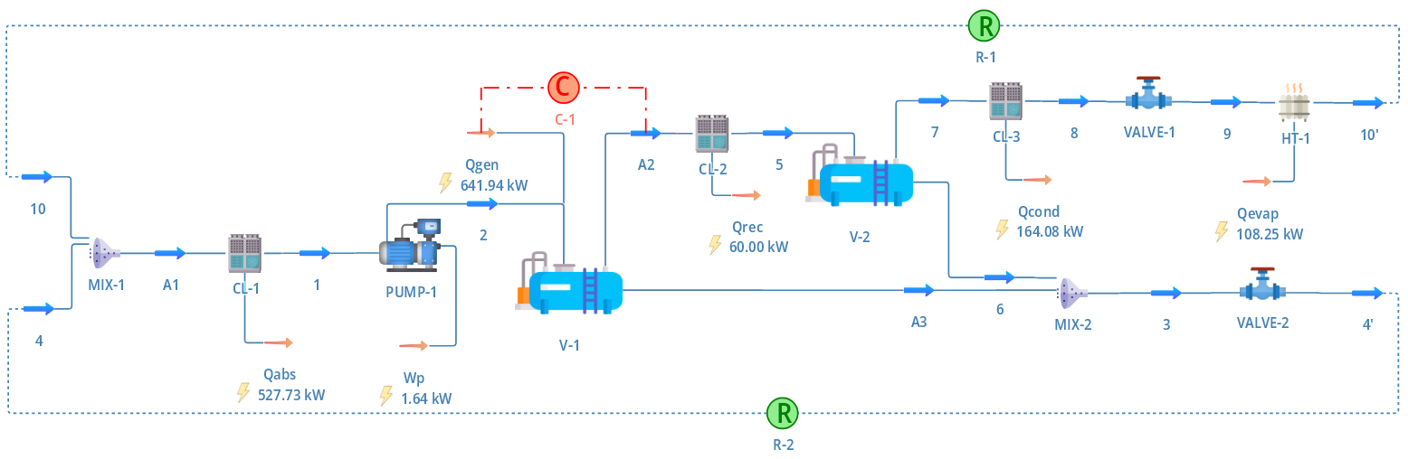
Figure 3: DWSIM flowsheet of simplified NH₃-H₂O absorption refrigeration system.
A general procedure for simulating the system requires the following specifications.
- Composition, pressure, temperature, and mass flow rates of states 4 and 10
- Outlet vapor fraction of CL-1 (set to 0)
- Pressure increase and efficiency of PUMP-1 (set to 100%)
- Mass flow rate of state A2 in C-1
- Heat output (Qrec) of CL-2
- Outlet vapor fraction of CL-3 (set to 0)
- Pressure drops of VALVE-1 and VALVE-2
- Outlet vapor fraction of HT-1 (set to 1)
States 10 and 4 should have the same (or almost the same) compositions, pressures, temperatures, and mass flow rates as states 10′ and 4′ so that R-1 and R-2 can be used to join states 10′ and 4′ with states 10 and 4.
Simulation may be performed for a set of input data. Results of mass flow rate (m), pressure (p), temperature (T), and mass fraction of NH₃ (x_{ammonia}) at each state are shown in Table 1. These results were obtained using DWSIM 8.3.4. Simulation was also performed using Aspen HYSYS V12. DWSIM and Aspen HYSYS require comparable effort, and their simulation times are equally fast. As can be seen from Table 1, results from both simulators mostly agree. However, there are noticeable differences in temperatures at states 1, 2, 4, and 9. Nevertheless, COP computed by DWSIM (0.168) is close to COP computed by Aspen HYSYS (0.179).
Table 1: Comparison of simulation results from DWSIM and Aspen HYSYS
 | DWSIM |  |  |  |  | Aspen HYSYS
 | m (kg/s) | p (kPa) | T (°C) | x_{ammonia} (%) |  | m (kg/s) | p (kPa) | T (°C) | x_{ammonia} (%)
1 | 0.986 | 240.2 | 32.43 | 35.69 |  | 0.986 | 240.2 | 27.88 | 37.03
2 | 0.986 | 1555 | 32.51 | 35.69 |  | 0.986 | 1555 | 27.93 | 37.03
3 | 0.861 | 1555 | 124.7 | 26.73 |  | 0.862 | 1555 | 124.4 | 27.94
4 | 0.861 | 240.2 | 74.72 | 26.73 |  | 0.862 | 240.2 | 70.09 | 27.94
5 | 0.150 | 1555 | 91.66 | 88.17 |  | 0.150 | 1555 | 91.51 | 88.51
6 | 0.025 | 1555 | 91.66 | 41.89 |  | 0.026 | 1555 | 91.51 | 43.48
7 | 0.125 | 1555 | 91.66 | 97.46 |  | 0.124 | 1555 | 91.51 | 97.48
8 | 0.125 | 1555 | 40.93 | 97.46 |  | 0.124 | 1555 | 41.29 | 97.48
9 | 0.125 | 240.2 | -13.71 | 97.46 |  | 0.124 | 240.2 | -17.28 | 97.48
10 | 0.125 | 240.2 | -10.00 | 97.46 |  | 0.124 | 240.2 | -10.00 | 97.48
W_{p} | 1.64 kW |  |  |  |  | 1.61 kW
Q_{gen} | 641.94 kW |  |  |  |  | 650.0 kW
Q_{rec} | 60.0 kW |  |  |  |  | 60.00 kW
Q_{cond} | 164.08 kW |  |  |  |  | 163.2 kW
Q_{evap} | 108.25 kW |  |  |  |  | 116.9 kW
Q_{abs} | 527.73 kW |  |  |  |  | 545.5 kW
Figure 4 shows DWSIM flowsheet of the heat-integrated NH₃-H₂O absorption refrigeration system. CL-2 is replaced with HX-1, and HX-2 is added between MIX-1 and CL-1. The addition of HX-1 and HX-2 results in two more tear streams. The first additional tear stream is between HX-1 and HX-2. The outlet of HX-1 is state 12′, and the inlet of HX-2 is state 12. The second tear stream is between HX-2 and V-1. The outlet of HX-2 is state 13′, and the inlet of V-1 is state 13. HX-1 and HX-2 require the specification of overall heat transfer coefficient and heat exchanger area. Simulation results are unchanged if the product of the two parameters does not change.

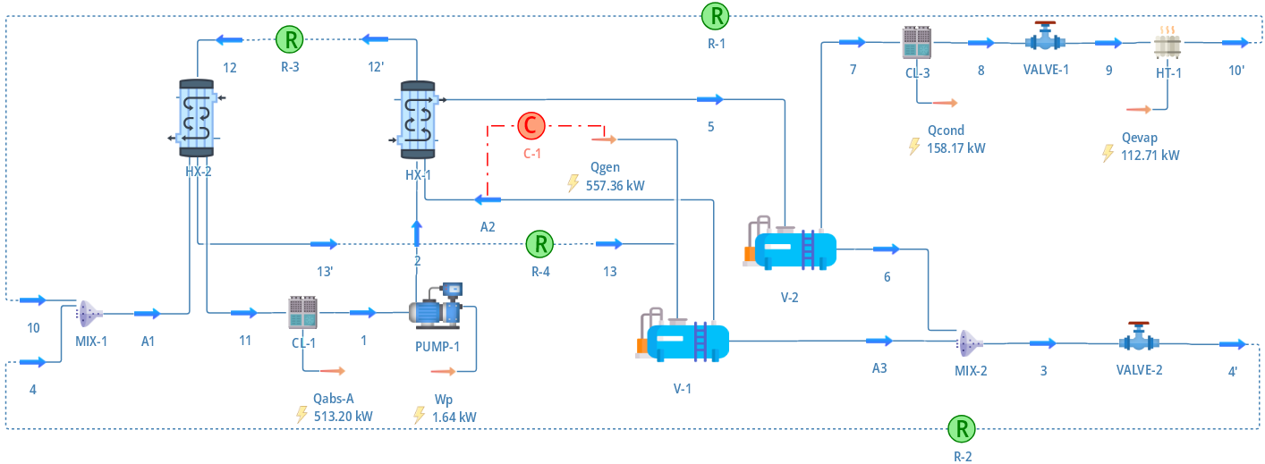
Figure 4: DWSIM flowsheet of heat-integrated NH₃-H₂O absorption refrigeration system.
  - System analysis
The performance of the heat-integrated NH₃-H₂O absorption refrigeration system depends on UA_{abs-A} and UA_{rec}. Figure 5 shows that COP increases monotonically with either parameter. However, the rate of increase decreases as each parameter increases. With UA_{rec} equal to 1 kW/K, COP approaches 0.234 as UA_{abs-A} increases to a very large value. With UA_{abs-A} equal to 1 kW/K, COP approaches 0.209 as UA_{rec} increases to a very large value. Furthermore, it can be seen from Figure 5 that COP is much more sensitive to UA_{abs-A} than UA_{rec}.

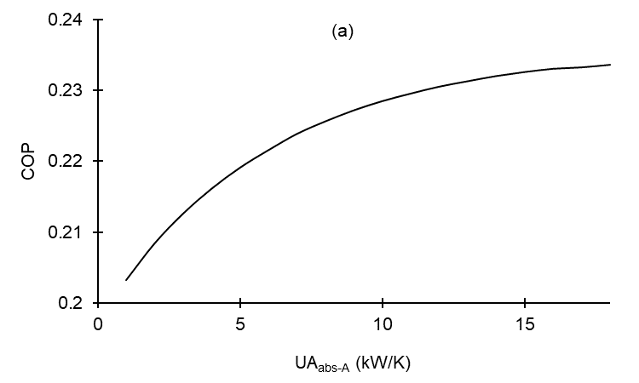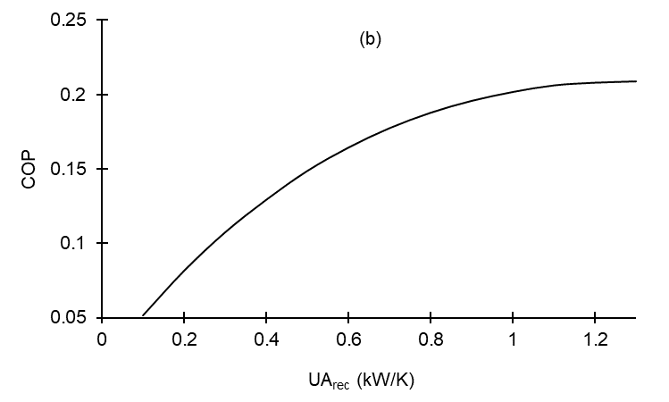
Figure 5: Variation of COP of the heat-integrated NH₃-H₂O absorption refrigeration system with (a) UA_{abs-A} (UA_{rec} equal to 1 kW/K) and (b) UA_{rec} (UA_{abs-A} equal to 1 kW/K).
The cost of a NH₃-H₂O absorption refrigeration system depends on surface areas of heat exchangers in the system. For the heat-integrated NH₃-H₂O absorption refrigeration system, there are other heat exchangers in addition to rectifier and absorber A. To simplify the analysis, it is assumed that the heat transfer areas of other heat exchangers are not significantly affected by changes in UA_{abs-A} and UA_{rec}. Furthermore, it is assumed that the overall heat transfer coefficients of both rectifier and absorber A are comparable. Therefore, the total cost of this system depends on the sum of UA_{abs-A} and UA_{rec}. Figure 6 shows the variation of COP with UA_{abs-A} under the condition that the sum of UA_{abs-A} and UA_{rec} is 10 kW/K. It can be seen that COP reaches the maximum value of 0.234 when UA_{abs-A} is 8.62 kW/K, and UA_{rec} is 1.38 kW/K.

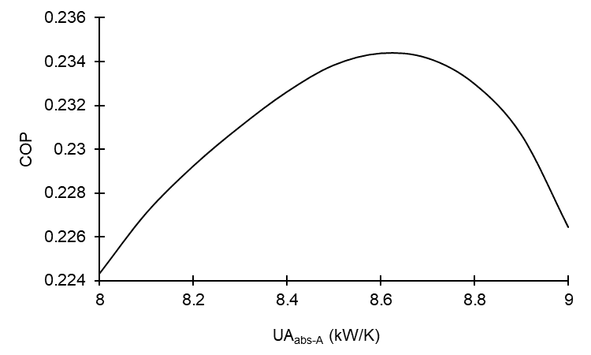
Figure 6: Variation of COP of the heat-integrated NH₃-H₂O absorption refrigeration system with UA_{abs-A} under the condition that the sum of UA_{abs-A} and UA_{rec} is 10 kW/K.
  - Conclusions
A DWSIM model of NH₃-H₂O vapor absorption refrigeration system is presented in this paper for education purpose. Detail of the model construction is provided, which should enable the reader to understand how DWSIM works, and help develop the reader’s skill in using DWSIM. Simulation results of DWSIM are shown to be comparable to those of Aspen HYSYS. It is also shown that the performance of the system can be improved through heat integration. Simple analyses of the system using the presented model are also demonstrated. It is shown that the system performance depends on heat transfer areas of two heat exchangers. Under the condition that the total area is fixed, there exists the optimum distribution of the total area between the two heat exchangers.
References
Chua H.T., Toh H.K., Ng K.C., 2002, Thermodynamic modeling of an ammonia–water absorption chiller, International Journal of Refrigeration, 25, 896-906.
Darwish N.A., Al-Hashimi S.H., Al-Mansoori A.S., 2008, Performance analysis and evaluation of a commercial absorption–refrigeration water–ammonia (ARWA) system, International Journal of Refrigeration, 31, 1214-1223.
Jonach T., Jordan C., Haddadi B., Harasek M., 2022, Modelling and simulation of 3-phase separators in the oil and gas industry with emphasis on water quality, Chemical Engineering Transactions, 94, 1009-1014.
Le Lostec B., Galanis N., Millette J., 2013, Simulation of an ammonia-,water absorption chiller, Renewable Energy, 60, 269-283.
Leong Y.T., Chan W.M., Ho Y.K., Isma A.I.M.I.A., Chew I.M.L., 2017, Discovering the potential of absorption refrigeration system through industrial symbiotic waste heat recovery network, Chemical Engineering Transactions, 61, 1633-1638.
Martínez-Rodriguez G., Baltazar J.-C., Fuentes-Silva A.L., 2022, Assessment of electric power and refrigeration production by using solar thermal energy for industrial applications, Chemical Engineering Transactions, 94, 313-318.
Mehrpooya M., Ghorbani B., Hosseini S.S., 2018, Thermodynamic and economic evaluation of a novel concentrated solar power system integrated with absorption refrigeration and desalination cycles, Energy Conversion and Management, 175, 337-356.
Sathyabhama A., Ashok Babu T.P., 2008, Thermodynamic simulation of ammonia-water absorption refrigeration system, Thermal Science, 12, 45-53.
Wu L.-C., Wu C.-C., Chang Y.-I., 2000, The advantage of using a distillation tower in an ammonia-water absorption cycle for refrigeration, Journal of the Chinese Institute of Chemical Engineers, 31, 193-197.

