CHEMICAL ENGINEERING TRANSACTIONS  VOL. , 2023 | A publication of
The Italian Association
of Chemical Engineering
Online at www.cetjournal.it

Guest Editors: Sauro Pierucci, Jiří Jaromír Klemeš
Copyright © 2023, AIDIC Servizi S.r.l.
ISBN 978-88-95608-98-3; ISSN 2283-9216

Dynamic and Prospective Model of the Quality of Lentic Water Resources due to Discharges of Urban Wastewater
Elea N. Inga-Rengifo, Felipa Muñoz Ccuro, Verónica Tello Mendívil, Eusterio H. Acosta Suasnabar, Carlos A. Castañeda-Olivera, Guido R. Suca-Apaza, Elmer Benites-Alfaro*
Universidad César Vallejo, Escuela Profesional de Ingeniería Ambiental, Lima, Perú
Corresponding author: ebenitesa@ucv.edu.pe.
Historically, populations have generally sought to settle around water sources such as rivers, lakes, and wetlands, among others. These populations and population growth also bring as a consequence a greater requirement of water for their activities; however, at the same time, wastewater also originates, which is discharged mainly into these same bodies of water, which over time generates a negative impact on flora and fauna. The objective of the research was to make a dynamic model with the Stella software to carry out a prospective study of the water quality around the physicochemical and microbiological parameters of the Patarcocha lagoon, before the dumping of residual water by the surrounding population. As a result of the model, in a period of 20 years from 2010 to 2030, the population of human settlements around the Patarcocha lagoon will grow (to 35 000), generating an increase in residual water discharge from 8.97 L/s to 9.9 L/s; This brings as a consequence that the parameters of the water of the lagoon in the same period vary such as: nitrate will increase up to 3.2 mg/L, the phosphorus will fluctuate between 78 mg/L to 81 mg/L, the dissolved oxygen will increase, the BOD₅ will increase (to 125 mg/L), the pH will increase (up to 7.5) and Temperature ( to 10.5 °C), this would cause alterations in the water quality of the lagoon. This research allows decision makers to assume management measures in order to protect water resources that are very important for life.
  - Introduction
Population growth generally occurs in places close to freshwater sources and this increase also goes along with the increase in solid waste generation and wastewater discharge (Vigiak et al., 2018) that generates concern for worsening what is called global "sanitation crisis" (Vörösmarty, 2010); freshwater sources are lakes and rivers that require continuous evaluation to determine the quality of water to be exploited. In this monitoring, the Biochemical Oxygen Demand (BOD), which represents the amount of oxygen that organisms use to consume oxidizable organic matter over time, is an important parameter because it is an indicator of contamination by organic matter (Wen et al., 20017), also dissolved oxygen (DO), temperature, pH, total coliforms, nitrites, sulfates, heavy metals, among the most important for the impacts on ecosystems (Bhateria, 2016).
Prospective studies help to have future scenarios based on past and current data, it has been used in various cases such as agronomy, energy, and environment; Thus, by analyzing information on the water quality status of surface water such as rivers and lakes, it is possible to project the probable conditions of this resource in the coming years, if the same current conditions are maintained; For example, Vigiak et al. (2019) made a prediction study of Chemical Oxygen Demand in freshwater from rivers in European countries, they called their model GREEN+ BOD (Grizzetti et al., 2012). To perform these projections, there are several software that facilitates dynamic simulations, Munar-Samboní et al, (2021), used Hec-RAS for modeling the incidence of the tidal regime and wastewater discharges on water quality in an urban estuary, Atencia and Verbel (2021) used EFDC Explorer for hydrodynamic modeling and water quality in the Sinu River in Cordova - Colombia, Dyudnev et al. (2021) modelled to improve energy processes in chemical plants using Aspen HYSYS.
Stella is a dynamic modeling software that through the creation of Forrester diagrams allows a clear understanding of the behaviour over time of a phenomenon, process, event, system, etc.; In this way, hypotheses can be tested to avoid unwanted consequences, economic losses, and errors, predict environmental impacts and other aspects. In short, it models events helping to understand their development over time through systemic thinking (isee Systems, 2023).
In this context, the objective of the research was to perform dynamic modeling to make a prospective study of the physicochemical and microbiological parameters of the Patarcocha lagoon in the town of Cerro de Pasco, using the Stella software; results that will serve to opt for management measures and/or recovery of this important surface water source in this town.
  - Methodology
To achieve the objective of the research, firstly, information was collected on the external factors that impact the water of the Patarcocha lagoon; secondly, a dynamic data processing software Stella v. 9.0.2 was used to prospectively simulate the level of contamination of the lagoon in the future.
    - Study site
In the investigation we handled data obtained from measurements and analysis of water in the Patarcocha lagoon, located in the region of Pasco, district of Chaupimarca, at an altitude of 4338 m.a.s.l., with south latitude of 10°41'10'' and west longitude of 76°15'10'', has an area of 2.13 km², 1400 m perimeter and a depth of 0.965 km. See Figure 1.

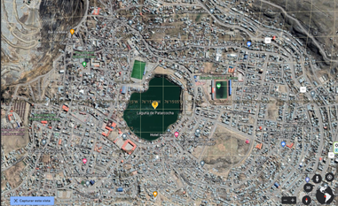  Surce: Google earth  Figure 1: Location of Patarcocha lagoon | Table 1: UTM coordinates of the sampling points of Patarcocha lagoon  Point UTM coordinates of location  East North  Punto 1 (P1) 363198.00 8818429.00  Punto 2 (P2) 363105.00 8818627.00  Punto 3 (P3) 362919.00 8818441.00  Punto 4 (P4) 363020.00 8818283.00
    - Collection of water samples and sampling points
Following the water sampling protocol of the National Water Authority (ANA, 2016), water samples were collected from the Patarcocha lagoon, at the points detailed in Table 1, these were chosen for presenting evidence of greater contamination. In addition to being accessible points.
    - Characterization of our water sources
They were carried out in the laboratory of the Universidad César Vallejo, following the methods indicated:
- Hydrogen potential (pH): APHA-AWWA-WEF (2005), method 4500 HB.
- Total Suspended Solids (TSS) (mg/L): APHA-AWWA-WEF (2012), method 2540 D
- Biochemical Oxygen Demand (BOD5) (mg/L): APHA-WWA-WEF (2012), method APHA 5210 B
- Dissolved Oxygen (DO) (mg/L): APHA-WWA-WEF (2012), method APHA 5210 B
- Total Phosphorus (mg/L): APHA-AWWA-WEF (2012), method APHA 5210 B
- Nitrates (mg/L): APHA-AWWA-WEF (2012), method APHA 5210 B
- Total Coliforms (NMPL: APHA-AWWA-WEF (2012), method APHA 5210 B
    - Data processing and analysis
Since the research is based on the prospective analysis of historical data related to external agents that have an impact on the environmental quality of Patarcocha lagoon water, the free software STELLA v.9.0.2 was used. Information collected from physicochemical and microbiological parameters from previous years (2010 to 2015) was used to find a model of the dynamic behavior of water quality until the year 2030. The information from 2016 was used as a comparison of the results of the model.
  - Results and discussion
    - External pressure factors of water quality in the Patarcocha Lagoon
3.1.1 Population
The population living adjacent to the Patarcocha lagoon is considered to be those who make use of the environmental service provided by this water source; therefore, it is related to population growth. According to the National Institute of Statistics and Informatics (INEI), the population of the Chaupimarca district in 2010 was 19380.83 habitants, with a population density of 072.52 inhabitants/km². Considering the annual growth rate, crude birth rate, crude death rate and net migration rate, Table 2 shows the population of this area, projected up to 2016, information that will serve to model the growth behaviour of the population that contributes to wastewater discharge to the lagoon.
 | Years
 | 2007 | 2010 | 2011 | 2012 | 2013 | 2014 | 2015 | 2016
Habitants (number) | 27873 | 19380.83 | 19477.74 | 19575.13 | 19673.00 | 19771.37 | 19870.22 | 19969.58
Table 2: Population growth in the area surrounding the Patarcocha lagoon

3.1.2. Wastewater discharge
The population's wastewater discharges into the Patarcocha lagoon are shown in Table 3. This information was obtained from the Pasco municipal authority, where the lagoon is located.
Table 3: The flow of wastewater discharged into Patarcocha lagoon
 | Years
 | 2010 | 2011 | 2012 | 2013 | 2014 | 2015 | 2016
discharged flow (L/s) | 8.97 | 9.02 | 9.06 | 9.11 | 9.15 | 9.19 | 9.25

3.1.3 Physicochemical parameters of Patarcocha lagoon water
The water quality of the Patarcocha lagoon is being impacted by solid waste and wastewater discharged into the lagoon by nearby residents. Therefore, by monitoring the physicochemical parameters of the lagoon's water resource in 2016, we were able to determine the water quality level. These results are shown in Table 4.
In this year, on average, it was found that TSS were within the environmental quality standards (ECA) of the Peruvian environmental regulations for water category 4 level E1 (D.S. 15-2015-MINAM), the same as pH and Nitrates; however, BOD5 and phosphates were above the level of the environmental quality standards -ECA (MINAM, 2017).
Table 4: Physicochemical parameters in 2016
Samples | P1 | P2 | P3 | P4 | Average | ECA
TSS (mg/L) | 18.87 | 26.40 | 19.60 | 20.00 | 21.22 | 25.00
pH | 6.30 | 6.20 | 7.60 | 7.20 | 6.83 | 6.5-8.5
BOD₅ (mg/L) | 80.00 | 86.70 | 76.70 | 63.30 | 76.68 | 5.00
N-NO₃ (mg/L) | 2.39 | 3.56 | 4.16 | 2.56 | 3.17 | 13.00
PO₄ | 37.96 | 16.67 | 23.71 | 32.71 | 27.76 | 0.35

Tables 5 and 6 present information on physicochemical parameters for the years 2010 and 2011 (Avelino, 2011) where it can be seen that TSS, BOD5 and phosphates were outside the ECA (Peruvian standard).

Table 5: Physicochemical parameters in 2011  Samples P1 P2 P3 P4 Average ECA  TSS (mg/L) 153.6 158.5 150.3 140.6 150.75 25.00  pH 5.8 5.3 5.7 5.1 5.48 6.5-9.0  BOD₅ (mg/L) 75.3 75.4 75.5 70.2 74.10 5  N-NO₃ (mg/L) 3.25 3.23 3.21 3.2 3.22 13  PO₄ 85.1 82.9 82.2 79.7 82.48 0.35  Fuente: Avelino, 2011 | Table 6: Physicochemical parameters in 2010  Samples P1 P2 P3 P4 Average ECA  TSS (mg/L) 150.2 149.6 144.2 135.8 144.95 25.00  pH 5.9 5.8 5.8 5.7 5.80 6.5-9.0  BOD₅ (mg/L) 65.3 65.4 65.5 60.2 64.10 5  N-NO₃ (mg/L) 2.25 2.23 2.21 2.2 2.22 13  PO₄ 75.1 65.4 65.5 59.4 66.35 0.35  Fuente: Avelino, 2011

3.1.4 Total Coliforms
The total coliforms of the water samples in 2016 from the four monitoring points are shown in Table 7, where it is established that all monitoring points presented high levels above the environmental quality standards for the water of category 4 type E1, corresponding to lagoons and lakes (R.S. 015-2015-MINAM).
Table 8 presents information on the same parameter for the years 2010 and 2011 collected from the scientific literature (Avelino, 2011).
Table 7: Total coliforms in water in 2016
Sample | P1 | P2 | P3 | P4 | Average | ECA (NMP)
Total coliforms (coliforms/100 mL) | 3600 | 4300.00 | 2500.00 | 1950.00 | 3087.50 | 1000.00

Table 8: Total coliforms in water for years 2010 and 2011
Sample | Año | P1 | P2 | P3 | P4 | Average | ECA
Total coliforms (coliforms/100 mL) | 2010 | 12000 | 10000 | 2300 | 1050 | 6337.50 | 1000
 | 2011 | 11000 | 11000 | 2100 | 2000 | 6525.00
Fuente: Avelino, 2011
    - Dynamic modeling of Patarcocha lagoon contamination
Using Stella software, and with the information collected, a Forrester causal diagram was developed to establish a connection through flows of the main elements affecting the water quality of the lagoon, such as the growth of the surrounding population, the flow of wastewater discharged, and the physicochemical and microbiological characteristics of this wastewater.
3.2.1 Population growth
Figure 2 shows the diagram of population growth, based on the fact that in 2010 the population was 19,831 inhabitants, considering also the net growth rate, net migration rate, net migration, births, deaths, birth rate (15.56 %) and death rate (5.54 %).
3.2.2 Wastewater
This is related to the population growth rate that contributes to the flow of wastewater discharged together with solid waste, with an error rate of 0.005, but at the same time it takes into account the flow of wastewater that leaves or is expelled, starting from an initial value of 8 L/s for the year 2010. The forrester plot is shown in Figure 3.
3.2.3 Total coliform parameter
For this parameter, it is essential to take into account the presence of nitrates, phosphates, BOD5 and temperature conditions. See Figure 4.

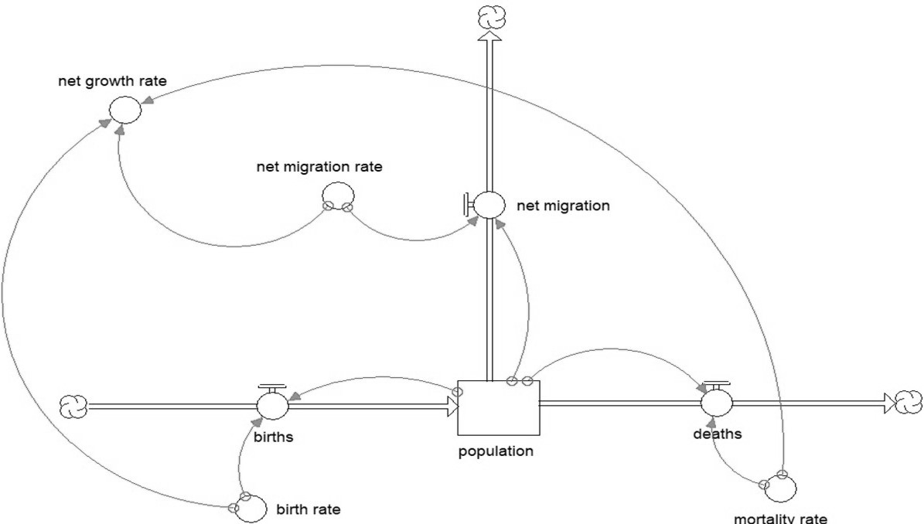 | 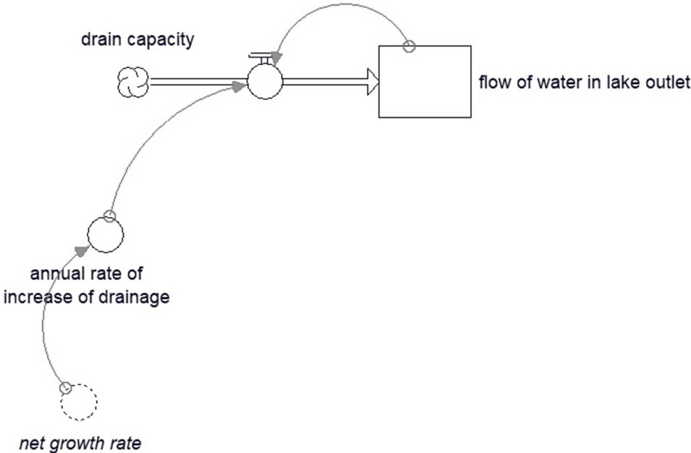 | 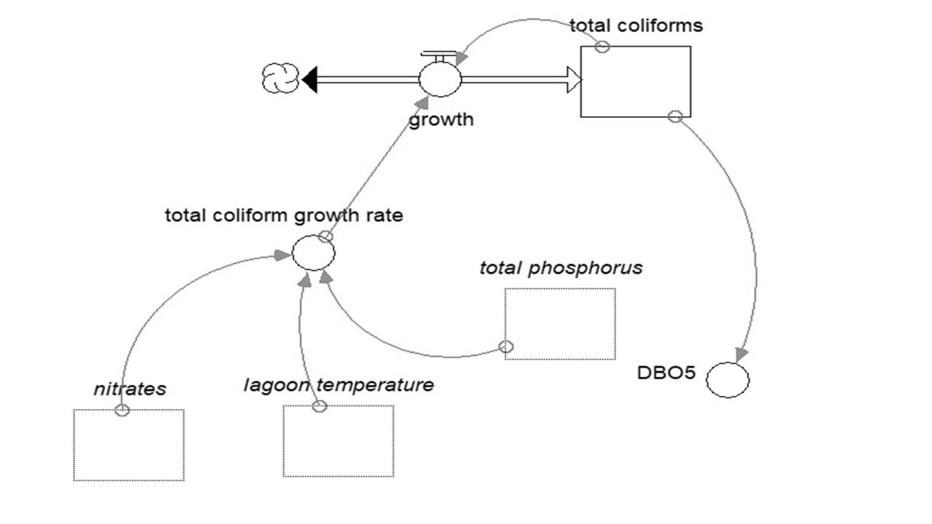
Figure 2: Forrester model for population growth | Figure 3: Forrester Model for Wastewater Discharge | Figure 4: Forrester Model for total coliforms

3.2.4 Physicochemical parameters
The pH will start with the value of 5.9 that it had in 2010, for nitrates it was 2.25 mg/L., in the dynamics intervene the temperature, annual precipitation, phosphates, dissolved oxygen and total coliforms mainly.

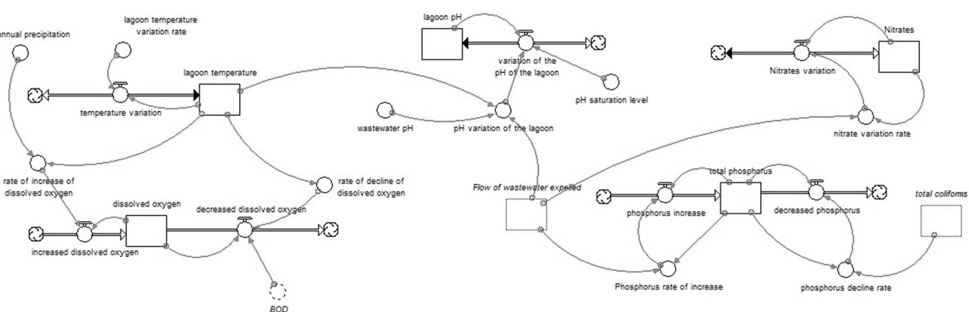
Figure 5: Forrester Model for Physicochemical parameters
    - Dynamic simulation of the model
After performing the dynamic simulations from 2010 to 2030, the final image is shown in Figure 6, corresponding to population and waste (6-a), lagoon drainage (6-b), phosphate and nitrate behavior (6-c), total coliforms (6-d), dissolved oxygen and BOD5 (6-e), pH (6-f) and temperature (6-g).

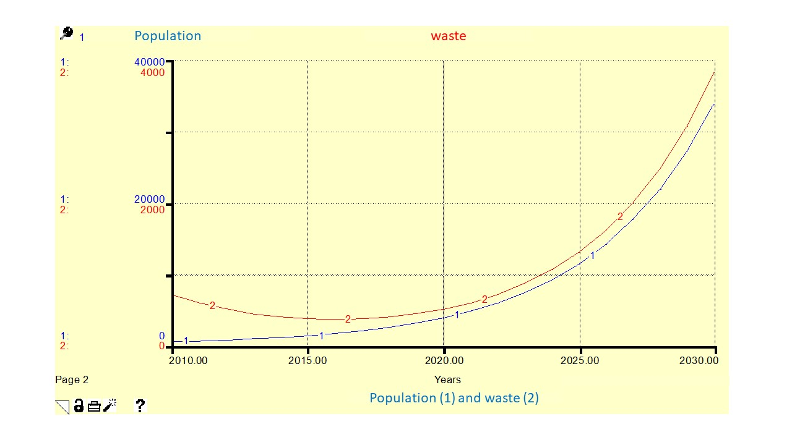  6-a | 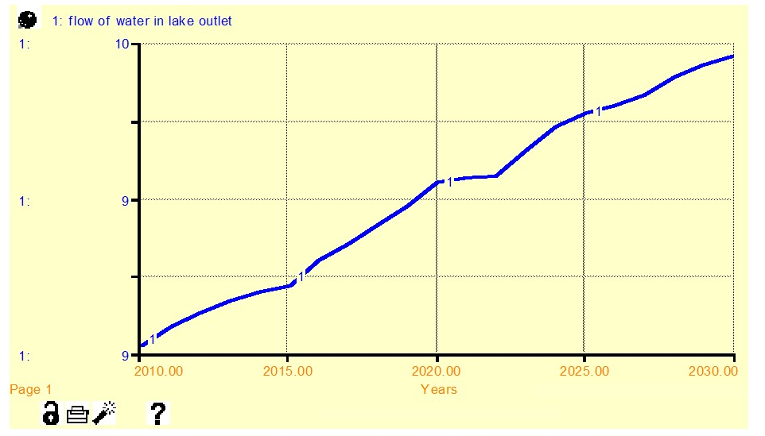6-b
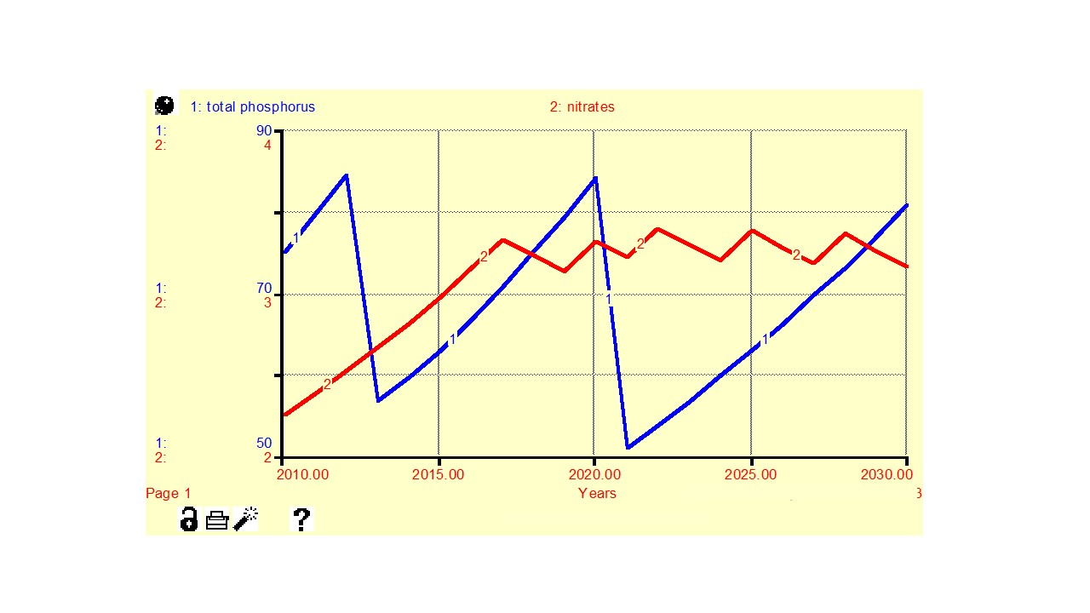  6-c | 6-d
6-e | 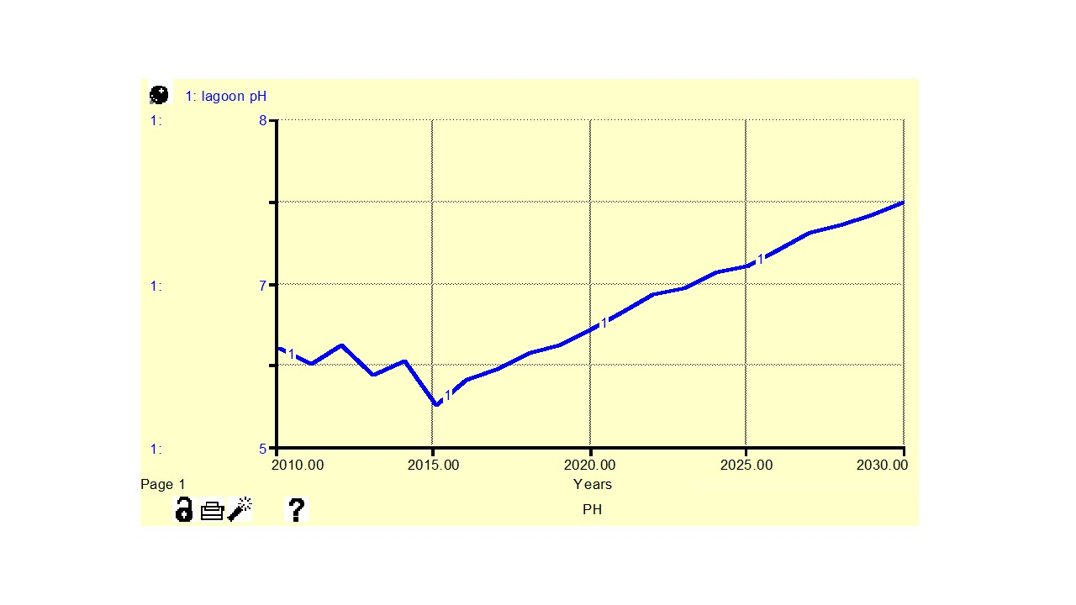  6-f
6-g | Note. To year 2030:  - The population will increase, reaching about 35,000 people.  - There will be about 9.9 L/s of wastewater flow from the lagoon.  - Nitrates will reach 3.2 mg/L and phosphates will reach 81 mg/L.  - Coliforms will have a downward trend.  - Dissolved oxygen could reach 11.7 mg/L and BOD₅ could reach 125 mg/L.  - pH would increase to 7.5  - Temperature would increase to approximately 10.5 °C.
Figure 6: Final representation of the simulation of physicochemical and microbiological parameters
The pH in the lagoon in 2030 would increase (Figure 6-f) probably due to the increased number of algae reproduced by increased nutrients that reach the lake along with organic waste and wastewater, algae consume CO2 that cause the pH to increase; however, inorganic waste also lowers the pH by the presence of acid rain. Another impact of a lot of aquatic flora is eutrophication, which can lower the temperature and increase the dissolved oxygen in the water (see Figure 6-e), as well as atmospheric pressure, dissolved salts and the depth of the lagoon. BOD5 increasing in future years’ organic pollution will increase (Wen et al., 2017) and reduce oxygen availability, degrading the lagoon ecosystem (Ferreira et al., 2017). In this scenario, the first thing to be done is to treat the wastewater before it is discharged into the lagoon using friendly methods such as hydrodynamic cavitation (Nieto, 2021), microorganisms (Mayorca, 2022), and others.
  - Conclusion

The prospective study indicates that the physicochemical and microbiological parameters of the waters of Patarcocha lagoon will undergo variations to 2030, such as an increase in BOD, temperature, nitrites, phosphates, pH, with a positive correlation with population growth and discharge of wastewater and waste into the lagoon. This situation and future scenario are worrisome, so urgent remediation and management measures must be taken to recover this slow source and save the ecosystems that exist there.
Acknowledgments
The authors would like to thank the Vice Rectorate for Research of the César Vallejo University, in its "Research UCV" program, for the support for the dissemination of this research.
References
ANA, 2016, R.J. N°010-2016-ANA, National Protocol for Monitoring the quality of surface water resources, <sinia.minam.gob.pe/normas/aprueban-protocolo-nacional-monitoreo-calidad-recursos-hidricos>, accessed 10.02.2023, (in Spanish)
Atencia M, Verbel M., 2021, Hydrodynamic and water quality modeling for Evaluate the assimilation capacity of discharges from the Sinú river (Sierra Chiquita-Universidad de Córdoba section), Thesis de grade, Universidad de Córdova , Colombia, (in Spanish)
Avelino C., 2011, Monitoring and diagnosis of eutrophication of the Patarcocha lagoon due to anthropogenic activities, en Cerro de Pasco, Thesis, Universidad Nacional del Callao.
Bhateria R., Jain D., 2016, Water quality assessment of lake water: a review. Sustainable Water Resources Management, 2, 161–173
Dyudnev V., Korotkii V., Novgorodtsev S., Boldyryev S., Di Pretoro A., Bragina J., Trusova M., Manenti F., 2021, Energy Analysis and Process Simulation for the Energy Efficiency Improvement of Existing Chemical Plants, Chemical Engineering Transactions, 86, 715-720.
Ferreira A.d.L., Sanches L.F., Cortes R.M.V., Pacheco F.A.L., 2017, Assessing anthropogenic impacts on riverine ecosystems using nested partial least squares regression, Science of The Total Environment, 583, 466-477.
Grizzetti B., Bouraoui F., Aloe A., 2012, Changes of nitrogen and phosphorus loads to European seas, Global Change Biology, 18(2), 769 – 782.
isee Systems, 2023, isee systems helps you find solutions to complex problems, <www.iseesystems.com/> accessed 10.04.2023.
Mayorca Clemente S., Castaneda-Olivera C.A., Benites Alfaro E.G., 2022, Microbial Biofilm as a Methodology for Treatment of Cyanide-contaminated Water, Chemical Engineering Transactions, 93, 151-156.
MINAM, 2017, D. S. 004-2017-MINAM, Aprueban Estándares de Calidad Ambiental (ECA) para Agua y establecen Disposiciones Complementarias, <sinia.minam.gob.pe/normas/aprueban-estandares-calidad-ambiental-eca-agua-establecen-disposiciones>, Accessed 16.02.2023.
Munar-Samboní A., Méndez-Pedroza N., Valbuena-Calderón O., 2021, Hydrodynamic and water quality modeling in an urban estuarine ecosystem with tidal incidence and sewage, Ciencia y Tecnología, 17(1), 302-320.
Nieto S., Benites Alfaro E.G., Gamarra C., Zambrano A., Valverde Flores J.W., Castaneda Olivera C., Ruiz-Vergaray M., 2021, Hydrodynamic Cavitation as a Clean Technology in Textile Industrial Wastewater Treatment, Chemical Engineering Transactions, 86, 277-282.
Vigiak O., Grizzetti B., Udias-Moinelo B., Zanni-Chiara M., Bouraoui F., Pistocchi A., 2019, Predicting biochemical oxygen demand in European freshwater bodies, Science of The Total Environment, 666, 1089-1105.
Vigiak O., Grizzetti B., Zanni M., Dorati C., Bouraoui F., Aloe A., Pistocchi A., 2018, Estimation of domestic and industrial waste emissions to European waters in the 2010s, Publications Office of the European Union, <op.europa.eu/en/publication-detail/-/publication/78376a1b-2054-11e9-8d04-01aa75ed71a1/language-en>, accessed 15.02.2023.
Vörösmarty J., McIntyre P.B., Gessner M.O., Dudgeon D., Prusevich A., Green P., Glidden S., Bunn S.E., Sullivan C.A., Reidy Liermann C., Davies P.M., Global threats to human water security and river biodiversity, Nature, 467 (2010), 555-561.
Wen Y., Schoups G., Van de Giesen N., 2017, Organic pollution of rivers: combined threats of urbanization, livestock farming and global climate change, Scientific Reports, 73289.

