CHEMICAL ENGINEERING TRANSACTIONS  VOL. ,2023 | A publication of
The Italian Association
of Chemical Engineering
Online at www.cetjournal.it

Guest Editor: Sauro Pierucci
Copyright © 2023, AIDIC Servizi S.r.l.
ISBN 978-88-95608-98-3; ISSN 2283-9216

Bio-Crude and Bio-Char production via hydrothermal carbonization of spontaneously grown Ricinus Communis
Fabio Codignole Luzª, Maurizio Volpeª, Christian Chiaruzzi^{b}, Antonio Piconeª, Antonio Messineo^{a*}
ªFaculty of Engineering and Architecture, University of Enna Kore, Cittadella Universitaria, 94100 Enna, Italy
*antonio.messineo@unikore.it
^{b}Horizonfarm Società Agricola, viale Franceco Scaduto 2/D, 90143, Palermo.

In this study, hydrothermal carbonization (HTC) of Ricinus Communis (RC) (seeds and husks) has been carried out at a temperature range of 120-250 °C, 1 h of residence time, and corresponding autogenous water pressures (2-40 bar) to investigate the production of energy-dense solid (hydrochar) and liquid (bio-crude) biofuels. RC, an oilseed and phyto-depurant plant, exhibits high resistance to drought and climatic variations, and abilities to adapt to polluted and low fertility environments. RC, although is originally from tropical Africa, is also widespread and spontaneously grown in the south of Italy and in particular in the Sicilian region. Dried hydrochars were extracted with acetone (7.5 ml/gr), leading to a bio-crude fraction and a solid residue. The results showed that the bio-crude mass yield increased with increasing HTC temperature up to 47.6% at 250 °C. The bio-crude showed no significant changes in higher heating value (HHV) which was of 35.3 MJ/kg on average. The hydrochar mass yield varied between 78 and 63% at 120 and 250 °C, respectively, and the corresponding acetone-extracted hydrochars showed HHVs of 19.47 and 23.72 MJ/kg. Hydrothermal carbonization proved to be an efficient thermochemical treatment for the production of valuable bio-char and energy-dense bio-crude.
  - Introduction
Dry thermochemical conversion processes such as pyrolysis and gasification are readily applicable to produce high-quality gaseous, liquid, and solid fuels (Messineo et al., 2012, Luz et al., 2015, Leme et al., 2018). However, these conversion technologies can only work with high efficiency when a dry feedstock is used (Kruse et al., 2013, Volpe et al., 2016,). In recent years, different conversion technologies have been developed to obtain valuable products from different kinds of biomass for fuel and chemical uses (Titirici et al., 2007, Olszewski et al., 2020; Jui-Chun et al., 2021, Picone et al., 2022).
HTC is a thermochemical treatment for high moisture content feedstock, carried out in a closed vessel in the presence of subcritical water (process temperature ranging typically between 180 and 260 °C) (Murillo, et al., 2015) that promotes the decomposition of biomass macro-components via hydrolysis, dehydration, aromatization, and decarboxylation reactions (Kruse et al., 2013, Heidari et al., 2018).
RC is an oilseed and phyto-depurant plant originally from tropical Africa, which shows considerable resistance to drought and climatic variations, even adapting to polluted and low-fertility soils. RC is also widespread abundantly in the South of Italy, more specifically in the Sicilian region.
The oil content in the seeds can vary between 37 e 60 wt% (Wang et al., 2010, Yeboah et al., 2020), depending on the genotype, environmental conditions, soil fertilization, and harvest period, among other factors. RC oil can be valorized in numerous applications such as in the chemical, pharmaceutical, aeronautical, food, and bioenergy fields (Vasco-Leal et al., 2018, Yeboah et al., 2020). Typically, RC oil is extracted by pressing, solvent extraction (e.g. using hexane), and supercritical carbon dioxide (Yeboah et al., 2020). Before extraction, castor seeds are cleaned and placed in de-hulling machines to remove husks. Plants such as RC, with high weather resistance, low need for soil fertilization and spontaneous growth could be a promising resource for integration in agri-photovoltaic systems. In this paper, HTC of RC was investigated to evaluate yields and physical-chemical properties of solid and liquid bio-fuels produced at different operating temperatures.

  - Materials and methods
    - Materials and sample preparation
HTC tests were carried using wild Ricinus Communis plants, harvested in Palermo (Sicily) between late spring and early summer. Castor seed is covered in the husk, representing 58% of the total mass (Figure 1). All material was crushed (seed and husk) without any kind of separation. Moisture content of RC was 4.9 ±0.5 wt%. Acetone, PA grade purchased from Sigma Aldrich, (7.5 ml/g) was used to wash hydrochar and extract oil.

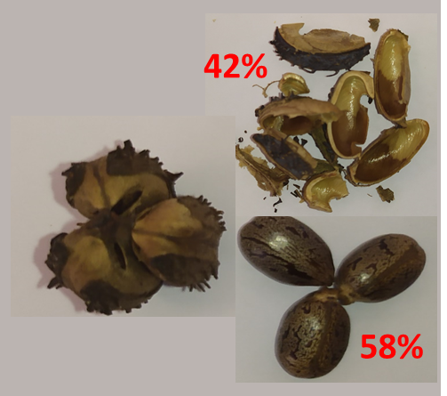
Figure 1: Mass fractions of seeds and husk contained in wild ricinus.
    - HTC reaction systems set up and experimental procedure
HTC reaction system used in this research consists of a stainless steel (AISI 316) batch reactor with an internal volume of 500 ml (Figure 2).

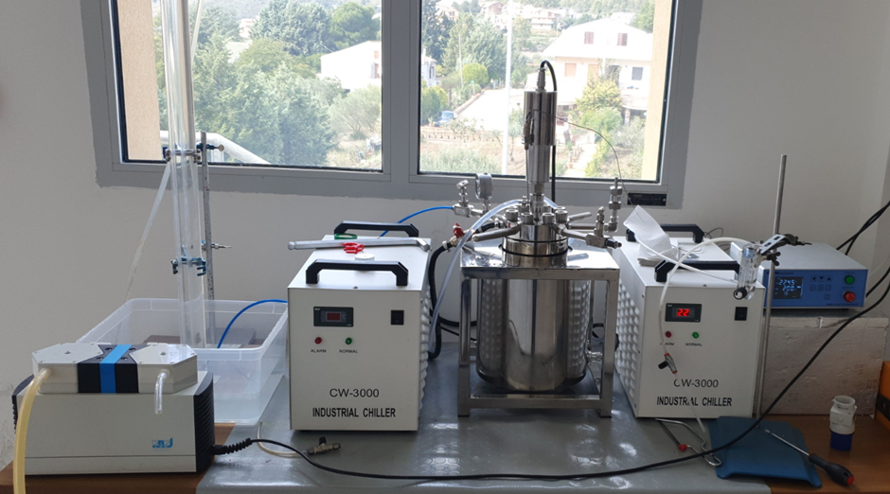
Figure 2: 500 ml HTC reaction system set up at University Kore of Enna.
The system set up and detailed features have been previously described by Volpe and co-workers (Volpe et al., 2021).
Experiments were carried out, in duplicate, at the five different temperatures of 120, 150, 180, 220 and 250 °C, keeping a fixed residence time of 1 h (the results were considered valid if Er% < 2.5). The RC and distilled water were accurately weighed (40.0 g of dry biomass and 300.0 g of distilled water) and loaded into the reactor to obtain a biomass to water ratio B/W of 12 wt%. The amount of biomass and water was chosen in order to fully submerge the feedstock and filling the 65-70% of the reactor internal volume. The reactor was then sealed and evacuated by flushing with pure nitrogen (Airliquide Alphagas 1, 5.0 purity). After purging, all the valves were closed and the reactor was heated up to the desired temperature, and kept at the prefixed residence time. The heating step lasted between 23 and 35 min (depending on the set temperature) and the pressure ranged from 2 to 40 bar. The residence time was measured starting from the time of reaching the desired temperature set point value. At the end of the run, the reactor was cooled down by flowing water at 25 °C, through a stainless steel coil inside the reactor, pumped by an external water chiller. When it reached a temperature of 30 °C, the outlet valve was opened to let the produced gases flow into a graduated cylinder, filled with water. Once the gas volume was measured, the reactor was opened and the hydrochar was separated from process water by vacuum filtration, then oven dried at 45 °C for 48 h. The hydrochar yield (MY) was determined according to Equation (1):
$$MYHC(\%)=\left(\frac{M_{HCdb}}{M_{RCdb}}\right)∙100$$ (1)

where M_{HCdb} represents the mass (on a dry basis) of the solid remaining after thermal treatment (HC stands for hydrochar), and MR_{Cdb} represents the mass (on a dry basis) of the raw RC sample. The mass of gaseous matter was evaluated applying the ideal gas law, assuming atmospheric pressure, temperature of 30 °C and CO₂ as the sole gaseous product (Hitzl et al., 2015), and similarly, the yield was defined as the mass of gas produced per unit mass of dry raw sample, liquid yield was calculated by difference. Hydrochars were stored in sealed vials, for subsequent analytical characterization and oil extraction.

    - Oil Extraction
After the drying period, the hydrochar was washed with acetone (7.5 ml/g). The hydrochar washing process was carried out using an orbital shaker at 400 rpm for 10 minutes. After washing, the mixture was separated using a vacuum filtration system, obtaining a liquid and a solid fractions, that were then oven dried at 35 °C overnight to remove acetone residues.
After drying, the oil fraction was weighted to determine its mass yield. The oil yield (MYoil) was determined according to Equation (2):

$MYOil \left(\%\right)=\left(\frac{M_{OILdb}}{M_{RCdb}}\right)∙100$ (2)

where M_{OILdb} represents the mass (on a dry basis, db) of the oil obtained after washing step and M_{RCdb} represents the starting RC mass (on a dry basis).
The hydrochar yield obtained after washing was calculated by difference, according to Equation (3):

$${MY}_{HCwash} \left(\%\right)=100-MYoil$$
(3)
    - Analytical Characterizations
All samples, including raw material, extracted oil and hydrochars before and after washing, were characterized in terms of proximate analysis and higher heating value (HHV). Proximate analysis was carried out by a LECO Thermogravimetric Analyser TGA 701. Moisture content (M), volatile matter (VM), and ashes (ASH) of solid samples were respectively determined by the following thermal programs: 5 °C/min ramp to 105 °C in air, held until constant weight (<±0.05%) (M); 16 °C/min ramp from 105 to 900 °C, hold time 7 min, in N₂ (VM); natural cooling down to 500 °C in N₂; 30 °C/min ramp in air to 800 °C and isothermal until constant weight (ASH). Fixed carbon (FC) was evaluated by difference.
HHV was evaluated according to the CEN/TS 14918 standard by means of a LECO AC500 calorimeter.
The energy densification ratio (EDR) and the energy yield (EY) of hydrochars and oil extracted were determined via Equations (4) and (5), respectively:

$EDR\left(\%\right)=\left(\frac{{HHV}_{HCdb}}{{HHV}_{RCdb}}\right)∙100$ (4)

$EY\left(\%\right)=MY∙EDR$ (5)

where HHV_{HCdb} and HHV_{RCdb} are the higher heating values of hydrochars or oil extracted and raw feedstock (on dry basis), respectively.
  - Results and Discussion
Distribution and mass yields of solid, liquid and gaseous products obtained from HTC conversion of RC are shown in Table 1. On one hand, as expected, hydrochar mass yield decreased at increasing HTC temperature, showing values between 99.98 and 75.91% at 120 and 250 °C, respectively. On the other hand, gas and liquid fractions showed a slight increase with temperature, with values from 0.0 to 10.54% for gas, and from 0.02 to 13.54% for liquid. As established in literature, liquid and gas yields were barely affected by HTC temperature (Volpe M. et al., 2021). The mass of extracted oil increased with temperature, which improves post-process oil extraction from the solid phase. This could be explained by the increasing feedstock structure degradation with conversion severity, making the solvent extraction more efficient.
The yield of extracted oil ranged from 22.30 to 36.50% after HTC, so it increases consistently compared to Ricinus Raw. The oil yield reported values are referred to the initial mass of seeds and husk. If only seed mass is considered, the oil yield rises up to 59% at 250 ºC, that is approximately the value of oil contained in castor seed according to (Wang et al., 2010, Yeboah et al., 2020).
This founding shows that HTC process can be effective in improving the efficiency of bio-crude extraction from RC using solvents.

Table 1: Mass yields (wt% on dry basis) and recovered fractions measured after HTC tests conducted in duplicate; average values showed (Er% ≤ 1.8).

Sample | MY_{HC} |  | Gas | Liquid* |  | MY_{Oil} | MY_{HCwash}
RC_Raw |  |  |  |  | 21.85 |  | 78.15
HC_RC_120 | 99.98 | 0.00 |  | 0.02 | 22.30 |  | 77.70
HC_RC_150 | 97.32 | 0.96 |  | 1.72 | 22.43 |  | 77.57
HC_RC_180 | 90.14 | 1.96 |  | 7.90 | 25.19 |  | 74.81
HC_RC_220 | 78.86 | 7.85 |  | 13.29 | 28.15 |  | 71.85
HC_RC_250 | 75.92 | 10.54 |  | 13.54 | 36.14 |  | 63.86
* by difference.

The yield of residual solid phase after oil extraction also decreased with increasing temperature. All HTC products (solid, aqueous liquid and gas) yield trends and the acetone extracted oil yield at the different temperatures are depicted in Figure 3.

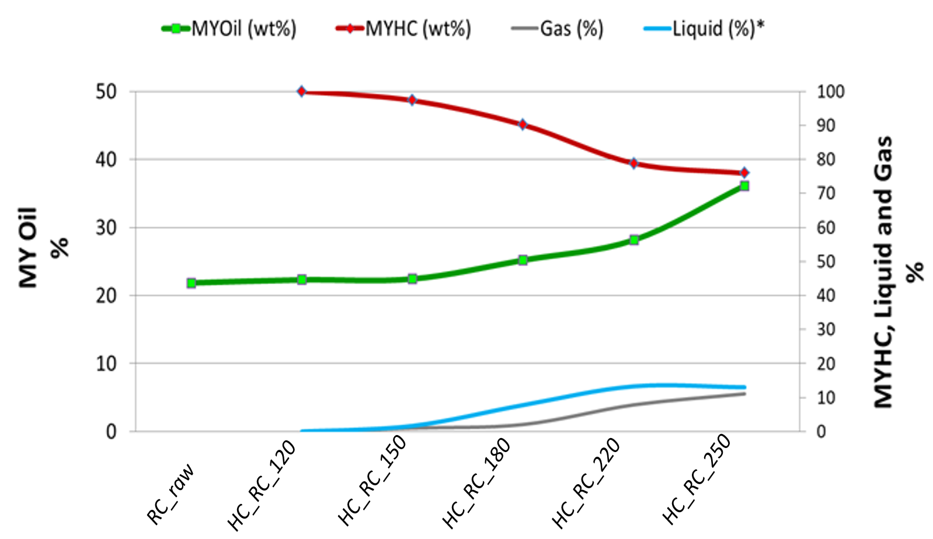

Figure 3: HTC products yield trends with operating temperature, (* evaluated by difference).

Proximate analysis results and energy properties of RC raw and HTC products are reported in Table 2. All hydrochar samples showed a considerable increase in fixed carbon (FC) and a decrease in the volatile matter (VM) content when compared to the corresponding values of raw material. The solid residues showed also a slight increase in ash content (ASH). Conversely, bio-crude samples showed a dramatic decrease in ASHs; VM content remained approximately unchanged at different conversion temperatures, (a moderate decrease was observed at 250 ºC); FC evidently increased with temperature. All Hydrochars samples showed a significant increase of HHVs, and thus EDR, than RC raw. In contrast, oil HHV kept constant at the value of approximately 35 MJ/kg with increasing temperature.

Table 2: Proximate analysis and energy properties of RC, extracted RC, hydrochars, extracted hydrochars and bio-oils. Proximate analysis performed in duplicate; average values showed (Er% ≤ 2.2%). HHVs average of two measurements, Er% ≤ 0.6.

Sample | Proximate Analysis wt% d.b. |  |  | Energy Properties
 | VM | ASH | FC | HHV (MJ/kg) | EDR (%) | EY (%)
RC_Raw | 79.11 | 3.43 | 17.47 | 23.63 | 100.00 | 100.00
HC_RC_120 | 82.05 | 3.47 | 14.48 | 23.63 | 100.00 | 99.99
HC_RC_150 | 78.36 | 3.52 | 18.13 | 23.88 | 101.10 | 98.35
HC_RC_180 | 78.37 | 4.13 | 17.51 | 24.61 | 104.14 | 93.87
HC_RC_220 | 74.51 | 4.48 | 21.01 | 25.87 | 109.48 | 86.34
HC_RC_250  RC_ Extr | 71.27 | 4.62 | 24.09 | 28.69 | 121.40 | 92.16
 | 74.98 | 4.22 | 20.81 | 19.47 | 100.00 | 78.15
HC_Extr_120 | 76.40 | 4.47 | 19.13 | 19.47 | 100.02 | 77.70
HC_ Extr _150 | 73.97 | 4.81 | 21.22 | 20.86 | 107.15 | 83.12
HC_ Extr _180 | 71.78 | 5.25 | 22.98 | 20.87 | 107.21 | 80.20
HC_ Extr _220 | 66.52 | 7.27 | 26.21 | 21.78 | 111.88 | 80.38
HC_ Extr _250  Oil_RC_Raw | 58.78 | 9.20 | 32.02 | 23.72 | 121.82 | 77.80
 | 99.940 | 0.006 | 0.054 | 35.47 | 100.00 | 21.85
Oil_RC_120 | 99.905 | 0.009 | 0.086 | 35.47 | 100.01 | 22.30
Oil_RC_150 | 99.870 | 0.012 | 0.118 | 35.63 | 100.46 | 22.53
Oil_RC_180 | 99.675 | 0.024 | 0.301 | 35.78 | 100.87 | 25.41
Oil_RC_220 | 98.485 | 0.120 | 1.395 | 35.69 | 100.61 | 28.32
Oil_RC_250 | 94.625 | 0.350 | 5.025 | 35.61 | 100.39 | 36.28
  - Conclusions
In this study, hydrothermal carbonization of Ricinus Communis (seeds and husks), collected in Palermo (Sicily), has been explored to investigate the potential of solid and liquid bio-fuels production. The obtained results showed that HTC process could, on the one hand, significantly promotes the recovery of energy dense oil fractions and, on the other hand, produce also a solid residue potentially usable as a bio-fuel. The extracted bio-crude showed no significant changes in HHV that was of 35.3 MJ/kg on average. The hydrochar mass yields varied between 78 and 63% at 120 and 250 °C, respectively, and the corresponding acetone extracted solid residues showed HHVs of 19.47 and 23.72 MJ/kg. HTC proved to be a promising thermochemical conversion treatment for the production of energy dense liquid and solid bio-fuels from spontaneous grown biomasses as wild ricinus.
Acknowledgments
The research was carried out in the framework of the Italian research program PRIN (Progetti di Ricerca di
Rilevante Interesse Nazionale) 2017 ”BIOmasses Circular Holistic Economy Approach to EneRgy equipments
(BIO_CHEAPER)” – Project code: 20175TXJER. Fabio Codignole Lùz, gratefully aknowledge Horizonfarm Company for financial support.

References
Heidari, M., Salaudeen, S., Dutta, A., Acharya, B., 2018. Effects of Process Water Recycling and Particle Sizes on Hydrothermal Carbonization of Biomass. Energy and Fuels. https://doi.org/10.1021/acs.energyfuels.8b02684
Hitzl, M., Corma, A., Pomares, F., Renz, M., 2015. The hydrothermal carbonization (HTC) plant as a decentral biorefinery for wet biomass. Catal. Today 257, 154–159. https://doi.org/10.1016/j.cattod.2014.09.024.
Jui-Chun, L., Dylan M., Volpe, M., Fiori, L., Selim, C., Goldfarb, J. L., 2021 Integrated Thermochemical Conversion Process for Upgrading Mixed Agricultural Waste to Nutrient-Enriched Soil Amendments and Biofuels, Bioresource Technology, 328, 124765, DOI:10.1016/j.biortech.2021.124765.

Kruse, A., Funke, A. & Titirici, M.-M. 2013. Hydrothermal conversion of biomass to fuels and energetic materials. Current opinion in chemical biology, 17, 515-521.
Leme, M. M. V., Venturini, O. J., Lora, E. E. S., Rocha, M. H., Luz, F. C., De Almeida, W., De Moura, D. C. & De Moura, L. F. 2018. Electricity generation from pyrolysis gas produced in charcoal manufacture: Technical and economic analysis. Journal of Cleaner Production, 194, 219-242.
Luz, F. C., Rocha, M. H., Lora, E. E. S., Venturini, O. J., Andrade, R. V., Leme, M. M. V. & Del Olmo, O. A. 2015. Techno-economic analysis of municipal solid waste gasification for electricity generation in Brazil. Energy Conversion and Management, 103, 321-337.
Messineo, A., Volpe, R., F. Asdrubali, F. 2012. Evaluation of net energy obtainable from combustion of stabilised olive mill by-products, Energies, 5 (5), 1384-1397. https://10.3390/en5051384
Álvarez-Murillo, A., Sabio, E., Ledesma, B., Rom, S., 2016. Generation of biofuel from hydrothermal carbonization of cellulose. Kinetics modelling. Energy 94, 600–608. https://doi.org/10.1016/j.energy.2015.11.02
Olszewski, M.P., Nicolae, S.A., Arauzo, P.J., Titirici, M.M., Kruse, A., 2020. Wet and dry? Influence of hydrothermal carbonization on the pyrolysis of spent grains. Journal of Cleaner Production 260, 121101. https://doi.org/10.1016/j.jclepro.2020.121101.
Picone, A., Volpe, M., Luz, F.C., Messineo, A., 2022. Hydrothermal Liquefaction of Agro-Waste Biomass : Design of a Novel Experimental Set Up and Preliminary Results. Chemical Engineering Transaction 92, 145–150. https://doi.org/10.3303/CET2292025.
Titirici, M.M., Thomas, A., Antonietti, M., 2007. Back in the black: Hydrothermal carbonization of plant material as an efficient chemical process to treat the CO2 problem? New Journal of Chemistry 31, 787–789. https://doi.org/10.1039/b616045.
Vasco-Leal, J. F., Mosquera-Artamonov, J. D., Hernandez-Rios, I., Mendez-Gallegos, S. J., Perea-Flores, M. J., Peña-Aguilar, J. M. & Rodriguez-Garcia, M. E. 2018. Physicochemical characteristics of seeds from wild and cultivated castor bean plants (Ricinus communis L.). Ingeniería e Investigación, 38, 24-30.
Volpe, M., Luz, F.C., Saha, N., Reza, M.T., Mosonik, M.C., Volpe, R., Messineo, A., 2021. Enhancement of energy and combustion properties of hydrochar via citric acid catalysed secondary char production. Biomass Convers. Biorefinery. https://doi.org/10.1007/s13399-021-01816-z.
Volpe, R., Messineo, S., Volpe, M., Messineo, A., 2016. Catalytic Effect of Char for Tar Cracking in Pyrolysis of Citrus Wastes, Design of a Novel Experimental Set Up and First Results Chemical Engineering Transaction 50, 181–186. https://doi.org/10.3303/CET1650031.
Wang, M., Morris, J., Pinnow, D., Davis, J., Raymer, P. & Pederson, G. 2010. A survey of the castor oil content, seed weight and seed-coat colour on the United States Department of Agriculture germplasm collection. Plant Genetic Resources, 8, 229-231.
Yeboah, A., Ying, S., Lu, J., Xie, Y., Amoanimaa-Dede, H., Boateng, K.G.A., Chen, M., Yin, X., 2021. Castor oil (Ricinus communis): A review on the chemical composition and physicochemical properties. Food Science Technology 41, 399–413. https://doi.org/10.1590/fst.19620.

