|  |  |
| --- | --- |
| cetlogo ***CHEMICAL ENGINEERING TRANSACTIONS***  ***VOL. , 2023*** | A publication of  aidiclogo_grande |
| The Italian Association  of Chemical Engineering  Online at www.cetjournal.it |
| Guest Editor: Sauro Pierucci  Copyright © 2023, AIDIC Servizi S.r.l. **ISBN** 978-88-95608-98-3; **ISSN** 2283-9216 | |

COMPARISON OF SODIUM LAURYL SULFATE AND SODIUM LAURYL ETHER SULFATE DETERGENTS FOR DECELLULARIZATION OF PORCINE LIVER FOR TISSUE ENGINEERING APPLICATIONS

Teodora Prebeg\*, Dinka Omerčić, Valentina Erceg, Gordana Matijašić

University of Zagreb, Faculty of Chemical Engineering and Technology, Marko Marulic Square 19, Zagreb, Croatia

\*tprebeg@fkit.hr

With the increasing incidence of liver disease and the shortage of donors, there is an ever-increasing need for an alternative to replace and repair damaged tissue. To address this problem, various biomaterials have been synthesized or isolated to provide a biocompatible and biomimetic scaffold. Decellularized native extracellular matrix (dECM) appeared to be a promising solution for regenerative purposes because it retains the naturally occurring components and structure important for cell survival and differentiation. Since any method of decellularization can damage extracellular matrix (ECM) components, it was important to choose a method that effectively removed the cells but also preserved the ECM components. To properly decellularize liver tissue, two different detergents were used, among other methods. Previous research has shown that sodium lauryl sulfate (SLS) can remove cells and DNA components, but can also destroy collagen and glycosaminoglycans. Therefore, a milder detergent, sodium lauryl ether sulfate (SLES), was used in addition to SLS. The aim of this study was to compare the decellularization performed with SLS and SLES detergents. Stereo and light microscopy showed that the natural architecture of the tissue was partially preserved depending on the detergent used and the exposure time. In addition, the number of protocol steps was compared so that the complexity of each protocol could be determined.

* 1. Introduction

Nowadays, the need for liver transplantation and reparation is increasing due to excessive drug use, cirrhosis, cancer and other diseases. Since there is a large gap between the number of donors and patients requiring liver transplantation, new approaches are needed to treat such health problems. (Moffat et al., 2022) Because the ECM occurs naturally and provides a suitable environment for cells, its structure, porosity, chemical, and biochemical components collectively provide a good potential scaffold for cell ceding and transplantation to a defective site in the patient. For the same reasons, the ECM is a model that should be mimicked by biomaterials (Goddard et al., 2016). One way to obtain dECM-based biomaterials is to decellularize natural tissues, as this can preserve the natural architecture and components of the ECM. Since decellularization aims to induce apoptosis of cells, it also simultaneously removes cells and DNA that could trigger an immunogenic response if left in the biomaterial once it is transplanted into the patient's body. (Nicolas et al., 2020)

There are a plethora of decellularization methods that have been developed in recent years, all of which have their advantages, but also their disadvantages. Essentially, decellularization methods can be divided into several groups: chemical, physical, biological, and combined. Chemical methods include the use of detergents (ionic, non-ionic, zwitterionic), solvents (alcohols, acetone, etc.), acids and bases, hypotonic and hypertonic solutions. The most commonly used physical methods are freeze-thaw cycles, high hydrostatic pressure, sonication, electroporation, immersion, and agitation. Biological methods include the use of enzymes: trypsin, nucleases such as ribonuclease and DNase, and proteases such as dispase, phospholipase, chondroitinase, etc. By combining some of these methods, they try to balance the destruction of ECM components destruction by limiting the exposure time of some decellularization methods (Gilpin and Yang, 2017).

The most commonly used and researched decellularization methods to date are those using detergents. Detergents are amphipathic molecules described by hydrophilic groups on one side ("head"), which can form hydrogen bonds with water molecules, and a lipophilic aliphatic chain ("tail") on the other. Detergents are also called surfactants because of their ability to reduce the surface tension of water. (Linke, 2009) Among other methods, detergents are most commonly used for decellularization because they can successfully disrupt the cell membrane and remove cellular components. This ability is based on the structural similarity between the molecule of a detergent and the phospholipids of biological membranes. The detergent molecules integrate into the phospholipid bilayer, thus breaking the bonds between the phospholipids, and then form micelles together with the detergent molecules. (Kalipatnapu and Chattopadhyay, 2005) This process triggers apoptosis of cells and is therefore used as a decellularization method. Some of the ionic detergents that have been used for decellularization are sodium lauryl sulfate (SLS), sodium deoxycholate (SDC), potassium laureate (PL), etc. (Moffat et al., 2022)

Sodium lauryl sulfate, also known as sodium dodecyl sulfate, is a commonly used surfactant in cleaning and personal care products such as shampoos and detergents. Its concentration in products varies from 0.1 to 50%, depending on the intended use, and can be synthetically or naturally derived. Previous toxicity reviews indicate that it is suitable for human use. (Bondi et al., 2015) Sodium lauryl ether sulfate, which resembles SLS, is used in personal care products and is obtained by ethoxylation of sodium lauryl sulfate. Despite its structural similarity to SLS shown in Figure 1, SLES is considered milder and less irritating, although it has almost the same properties. Nevertheless, the time of exposure to detergents should be limited and they should be thoroughly washed off (Barra Caracciolo et al., 2017).



Figure 1: Structure of detergents sodium lauryl sulfate (a) and sodium lauryl ether sulfate (b)

Keshvari et al., (2021) performed decellularization with both detergents and showed that ECM components were better preserved with SLES, but both were well accepted and vascularized in *in vivo* studies in rats. Similar results were provided by Yaghoubi et al., (2022) who demonstrated good preservation of tissue structure after decellularization with SLES, angiogenesis, and no graft rejection in *in vivo* studies in male Sprague-Dawley rats. Hassanpour et al., (2018) developed a decellularization protocol with SLES for human ovarian tissue. Tissue structure was well preserved, 3-(4, 5-dimethylthiazolyl-2)-2, 5-diphenyltetrazolium bromide (MTT) assay indicated cytocompatibility, and the seeded primary ovarian cells remained viable and bioactive and expressed higher hormone levels in rats with ceded grafts than control ones.

Previous research has shown that SLS is the most promising method of decellularization because it is accessible and successfully removes cells, but the main problem with its use is excessive damage to ECM components. (Kawasaki et al., 2015) The aim of this work was to overcome the above problem of SLS detergent. Therefore, a milder but structurally similar detergent, sodium lauryl ether sulfate (SLES), was used and the results were compared.

* 1. Materials and methods

Porcine liver was collected from the local butcher store and frozen at -20 ⁰C until later use. Later, the samples were cut into 1 mm thin pieces of about 1 cm2, then immersed in a 0.9 wt% NaCl solution and agitated with mechanical stirrer at 400 rpm. The solution was changed 4 times and left overnight on a magnetic stirrer at 150 rpm. As shown in Table 1, the samples were then divided into 4 groups and stirred in detergents SLS and SLES at concentration of 1 and 0.5 wt%with a magnetic stirrer at 150 rpm. The concentrations of the detergents were determined by previous studies which showed that concentrations less than 0.5 wt% required too many protocol steps to be effective. On the other hand, concentrations higher than 1 wt% were too aggressive for the ECM components.

Each group was divided into a subgroup ***a***and a subgroup ***b***. The solution was changed after 30 minutes for all ***a*** subgroups and after 60 minutes for all ***b*** subgroups. The treatment with the detergent was carried out until the samples were transparent. Then, all samples were washed thoroughly in distilled water, stirred in ethanol (96%) at 150 rpm for 30 minutes and then placed in PBS (phosphate buffer saline) for 24 hours. Finally, the samples were preserved by freezing at -20 ⁰C until later use.

Table 1: Parameters of protocol and sample names

|  |  |  |  |  |  |  |  |  |
| --- | --- | --- | --- | --- | --- | --- | --- | --- |
| Detergent | Concentration / wt% | Time in solution /min |  |  | Sample name |  |  |  |
| SLS | 1 | 30 |  |  | SLS 1***a*** |  |  |  |
|  | 60 |  |  | SLS 1***b*** |  |  |  |
| 0.5 | 30 |  |  | SLS 0.5***a*** |  |  |  |
|  | 60 |  |  | SLS 0.5***b*** |  |  |  |
| SLES | 1 | 30 |  |  | SLES 1***a*** |  |  |  |
|  | 60 |  |  | SLES 1***b*** |  |  |  |
| 0.5 | 30 |  |  | SLES 0.5***a*** |  |  |  |
|  | 60 |  |  | SLES 0.5***b*** |  |  |  |

All samples were subsequently characterized. The preservation of the natural structure was evaluated and compared by stereo and light microscopy. The total number of steps in each protocol required to make the samples transparent was also compared.

* + 1. Light microscopy

Measurements were performed using the Motic BA200 light microscope. All samples for microscopy were taken directly from the media after treatment with detergents and placed on a slide without further treatment steps.

* + 1. Stereomicroscopy

Stereomicroscopy was performed using Olympus SZX16 to determine the preservation of specific dense liver tissue at a larger scale. Samples were prepared in the same manner as for light microscopy.

* 1. Results

In Figure 2, the parameters of the protocol, such as the detergent used, its concentration and the change time, were compared. It is shown that sample SLS 1***b*** requires the least number of protocol steps to make the samples transparent. In addition, SLS samples required fewer protocol steps overall than SLES samples, which is consistent with previous research showing that SLS is generally a more aggressive detergent. It can be seen that concentration also plays an important role; as concentration decreases, the number of protocol steps increases. It is also interesting to note that the change in time has an effect on the number of protocol steps. It can be seen that when the changing period is longer (60 minutes), the number of steps decreases, but the total time required for decellularization is longer. Thus, the sample with the most protocol steps is SLES 0.5***a***, but the sample with the longest decellularization time is SLES 0.5***b***.

|  |
| --- |
| Figure 2: Comparison of the time of decellularization depending on the detergent, its concentration and the change times |

* + 1. Light microscopy

The micrographs obtained by light microscope can be found in Figure 3 A. Dense liver tissue and its microstructure can be seen in all images. In addition, all samples are thin, semi-transparent and light brown in color. Samples SLS 1***a*** and SLS 1***b*** have damaged structures and in thinner areas there is no tissue at all. There are also signs of tearing and threading of tissue. This could be the result of too harsh detergent treatment, but also from stress during mechanical stirring in decellularization protocol. Samples with lower SLS concentration (SLS 0.5***a*** and ***b***) also show signs of damage. There are missing pieces of tissue in thinner areas, but no threads or tears in the tissue. Samples decellularized with SLES show almost no damage in the tissue structure, all tissue pieces are visible and smooth with some small holes.

* + 1. Stereomicroscopy

The stereomicrographs are shown in Figure 3 B. The natural liver structure with some arteries and veins is preserved in all samples with milder signs of damage. The damage is visible in thinner tissue areas as absence of connective tissue. The difference between samples in subgroup ***a*** and ***b*** is more visible than between detergents or concentrations. It can be seen that the samples whose medium was changed every 60 minutes were more damaged and had more holes. This could be the result of partial digestion of the tissue caused by intercellular enzymes released after cell lysis in the decellularization media that were not washed away as quickly as in the subgroup ***b*** samples. (Klak et al., 2022) There is also a slight difference between detergents, with SLES samples showing a better preservation.

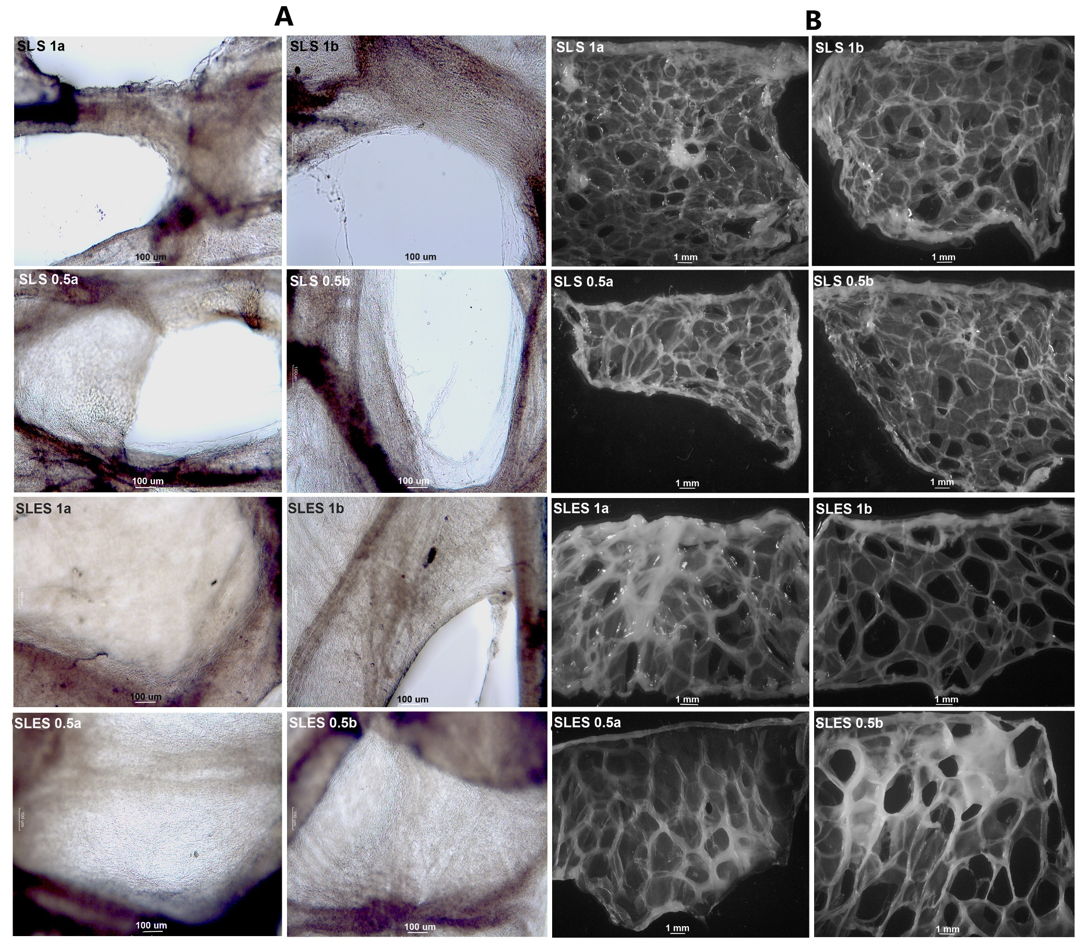

Figure 3: Light (A) and stereomicroscopy (B) of samples prepared with different decellularization protocols

* 1. Conclusion

A total of eight different decellularization protocols were performed, which differed in terms of detergents, concentration, and time of media change. Thus, eight different decellularized samples were obtained and characterized. Comparison of the number of steps shows that SLS is fastest to make samples transparent, where the increase in concentration decreases the number of media changes. Light microscopy indicates that SLS may be too aggressive for the tissue, while SLES shows better preservation of the tissue samples. Stereomicroscopy shows better preservation of natural tissue structure when the medium is changed after 30 minutes. Therefore, the SLES 1***a*** and 0.5***a*** samples show promising properties for future tissue engineering applications, but further studies should be performed to support this statement.

Future research directions

To investigate the matter further, the ECM components should be quantified and compared. In addition, a rheological study should be performed for the hydrogels obtained from all samples to determine a possible application in 3D printing. This research is ongoing.

References

Barra Caracciolo, A., Cardoni, M., Pescatore, T., Patrolecco, L., 2017. Environ. Pollut. 226, 94–103.

Bondi, C.A.M., Marks, J.L., Wroblewski, L.B., Raatikainen, H.S., Lenox, S.R., Gebhardt, K.E., 2015. Environ. Health Insights 9, 27–32.

Gilpin, A., Yang, Y., 2017. Biomed Res. Int. 2017, 1–13.

Goddard, E.T., Hill, R.C., Barrett, A., Betts, C., Guo, Q., Maller, O., Borges, V.F., Hansen, K.C., Schedin, P., 2016. Int. J. Biochem. Cell Biol. 81, 223–232.

Hassanpour, A., Talaei-Khozani, T., Kargar-Abarghouei, E., Razban, V., Vojdani, Z., 2018. Stem Cell Res. Ther. 9, 252–265.

Kalipatnapu, S., Chattopadhyay, A., 2005. IUBMB Life 57, 505–512.

Kawasaki, T., Kirita, Y., Kami, D., Kitani, T., Ozaki, C., Itakura, Y., Toyoda, M., Gojo, S., 2015. J. Biomed. Mater. Res. - Part A 103, 3364–3373.

Keshvari, M.A., Afshar, A., Daneshi, S., Khoradmehr, A., Baghban, M., Muhaddesi, M., Behrouzi, P., Miri, M.R., Azari, H., Nabipour, I., Shirazi, R., Mahmudpour, M., Tamadon, A., 2021. Cell Tissue Res. 386, 365–378.

Klak, M., Kosowska, K., Bryniarski, T., Łojszczyk, I., Dobrzański, T., Tymicki, G., Filip, A., Szczepankiewicz, A.A., Olkowski, R., Kosowska, A., Berman, A., Kamiński, A., Wszoła, M., 2022. Bioprinting 28, e00233.

Linke, D., 2009. Chapter 34 Detergents. An Overview, 1st ed, Methods in Enzymology. Elsevier Inc.

Moffat, D., Ye, K., Jin, S., 2022. J. Tissue Eng. 13, 1–29.

Nicolas, J., Magli, S., Rabbachin, L., Sampaolesi, S., Nicotra, F., Russo, L., 2020. Biomacromolecules 21, 1968–1994.

Poveda-Giraldo, J.A., Piedrahita-Rodríguez, S., Cardona-Alzate, C.A., 2021. Chem. Eng. Trans. 83, 397–402.

Yaghoubi, A., Azarpira, N., Karbalay-Doust, S., Daneshi, S., Vojdani, Z., Talaei-Khozani, T., 2022. Stem Cell Res. Ther. 13, 1–18.