CHEMICAL ENGINEERING TRANSACTIONS  VOL. , 2023 | A publication of
The Italian Association
of Chemical Engineering
Online at www.cetjournal.it

Guest Editor: Sauro Pierucci
Copyright © 2023, AIDIC Servizi S.r.l.
ISBN 978-88-95608-98-3; ISSN 2283-9216

Performance Evaluation of Wastewater Concentration Device: Analysis of Recovery Rate for Implementing SARS-CoV-2 Wastewater-Based Epidemiology
Brigita Dejusª*, Roberts Ozolsª, Martins Strodsª, Juris Laicansª, Anna Zajakina^{b}, Ance Roga^{b}, Davids Fridmanis^{b}, Talis Juhnaª
ªWater Research and Environmental Biotechnology Laboratorija, Riga Technical University, Kipsalas 6A, Riga, Latvia
^{b}Latvian Biomedical Research and Study Centre, Rautsupites 1, Riga, Latvia
*Corresponding author: brigita.dejus@rtu.lv (B. Dejus)
To successfully implement wastewater-based epidemiology (WBE), a rapid, cost-effective, and sensitive method of concentrating SARS-CoV-2 virus RNA in wastewater is necessary. This study aimed to design a wastewater concentration device with an ultrafiltration membrane system and evaluate its performance by comparing its recovery rate (%) of virus RNA to the polyethylene glycol precipitation method. The results showed that there was no significant difference (p > 0.05) between the two methods, with recovery rates ranging between 80 – 85 %. This suggests that an ultrafiltration membrane system is a viable option for targeting COVID-19 in wastewater, as it can save time, and energy and reduce costs, making it suitable for the implementation of WBE.
  - Introduction
The COVID-19 pandemic is affecting millions of people worldwide, making community surveillance and early disease outbreak monitoring crucial (Jia et al., 2021). As SARS-CoV-2 virus RNA is excreted into the sewer system via feces, saliva, swabs, and sputum of infected individuals, the COVID-19 outbreak can be described using the RNA load-shedding profile from the total amount of virus RNA in wastewater several times points after infection called as wastewater-based epidemiology (WBE) (Galani et al., 2022; Kitajima et al., 2020). Therefore, the WBE has been demonstrated as a useful, viable, and efficient method to track COVID-19 and potentially other infectious diseases (Daughton, 2020).

The detection of SARS-CoV-2 virus RNA in untreated municipal wastewater has already been reported in numerous studies from countries across the globe including the United States, Japan, Italy, and Latvia (Ahmed et al., 2021; Gudra et al., 2022; Haramoto et al., 2020; la Rosa et al., 2020). Previous studies have also shown that the concentration of viral RNA correlates with the community prevalence of SARS-CoV-2 (Weidhaas et al., 2021). However, one of the most challenging steps of WBE is the concentration step and detection of relatively low viral particle loadings in large volumes of wastewater (Lu et al., 2020; Polo et al., 2020). Thus, the development of a rapid, cost-effective, and sensitive method for concentrating RNA of the SARS-CoV-2 in wastewater is essential for virus quantification and successful implementation of WBE (LaTurner et al., 2021).

The wastewater concentration methods applied for SARS-CoV-2 RNA vary widely from electronegative filtration with bead beating (Ahmed et al., 2020), electronegative filtration with ultrafiltration (Westhaus et al., 2021), polyethylene glycol precipitation (PEG) (La Rosa et al., 2021), ultracentrifugation (Wurtzer et al., 2021) to direct extraction (Dimitrakopoulos et al., 2022). So far, the PEG precipitation method has been selected most often, however, this method is time-consuming, especially with large samples of wastewater (Zheng et al., 2022). Thus, there is a need for the WBE community to search for an optimal concentration method for virus RNA detection and quantification in wastewater (Kabdaşlı and Tünay, 2021). The main objective of this study was to design the wastewater concentration device with an ultrafiltration membrane system and compare the recovery rate of virus RNA with the PEG precipitation method. To achieve this objective, the main tasks of the study were to (i) design the wastewater concentration device and evaluate its performance by comparing the recovery rate of RNA; (ii) compare the recovery rates of RNA from the concentration device and precipitation method.
  - Material and methods
2.1 Wastewater sampling
Samples of untreated wastewater were taken from an entry tank after the screening unit at Daugavgriva WWTP in Riga (Latvia). The 6 L of the sample was collected in a PET tank and stored at 4 °C, afterward transported to the laboratory, and processed within 24 hours.
2.2 Design of wastewater concentration device
The wastewater concentration device design and schematic scheme of sampling are presented in Figure 1. Briefly, the wastewater concentration device consists of concentrate and permeates tanks, microfilter, feed gear pump (Iwaki, module MDG-R2BB), pressure gauge, flowmeters, and ultrafiltration membrane (Bergof hyperflux tubular module MO P22U (1M) I5LE). The surrogate-recombinant, replication-defective, and GFP gene-containing Semliki Forest virus (SFV) particles were constructed at Latvian Biomedical Research and Study Centre and used for the performance evaluation tests. For sample concentration, 150 μL of SFV particles were spiked into 5.2 L of wastewater. After wastewater spiking, the sample was stirred, and 200 mL of the sample was taken for further analysis. After that 5 L, the wastewater was pumped to a concentration tank with a peristaltic pump through a microfilter to purify the wastewater from macro particles and decrease the risk of ultrafiltration membrane fouling. After the microfiltration, the gear pump was started for the first circulation of 3 min and the wastewater was circulated in an ultrafiltration membrane and pipes. After ultrafiltration, a sample from the concentration tank for further analysis was taken. The wastewater concentration process with ultrafiltration was performed in crossflow mode and the process run until the device’s dead capacity. Samples from concentrate and permeate were taken for further analysis. After concentration, the cleaning with a sodium hypochlorite mixture for ultrafiltration membrane was done, according to the manufacturer’s instructions. After the cleaning process, the sample for further analysis was also collected.
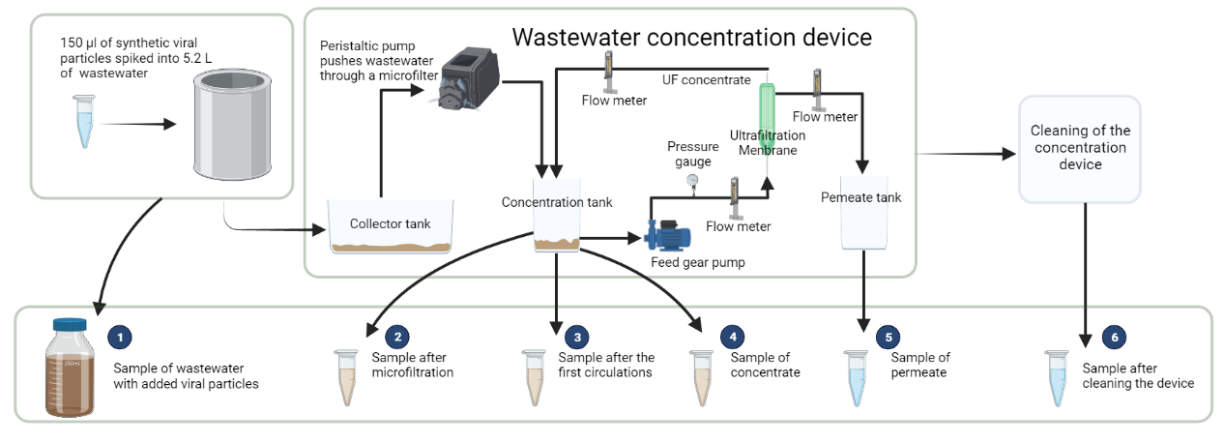
Figure 1. Design of wastewater concentration device and schematic scheme of experimental design and sampling (created by BioRender.com)
2.3 Performance evaluation of wastewater concentration device
During the performance evaluation, tests were done for investigating (1) the attachment of SFV to the microfilter surface (tests were carried out using deionized water instead of wastewater and spiked with SFV particles; the standard protocol of wastewater concentration was applied from 2.2 paragraph and samples were taken for recovery rate analysis); (2) the attachment of SFV to wastewater particles (tests were carried out using microfiltered wastewater instead of untreated wastewater and spiked with SFV particles; samples after microfiltration were not taken; the standard protocol of wastewater concentration device was carried out according to the 2.2 paragraph); (3) the impact of SFV negative charge attachment to wastewater macro-particles (SFV particles were sonicated for 30 sec to reduce viral particle attachment to each other; sonicated particles were added to microfilter treated wastewater; samples after microfiltration were not taken). The standard protocol of the wastewater concentration device was carried out in duplicate or triplicate for each test.
2.4 Wastewater concentration with PEG precipitation and RNA extraction
The wastewater sample (180 mL, 4 x 45 mL) was centrifuged at 8000 x g for 30 min at 4 °C to remove larger particles, such as bacterial cells and debris, and virus particles were precipitated using polyethylene glycol (PEG). Briefly, the supernatant was transferred to new tubes containing 8 % PEG 8000 (Sigma-Aldrich) and 0.5 M NaCl (PanReac AppliChem). The mixtures were incubated for 2 h at 4 °C with gentle agitation. The precipitated virus particles were recovered by centrifugation at 12,000 x g for 10 min at 4 °C and RNA was isolated with Tri reagent (Sigma-Aldrich) according to the manufacturer's instructions. Viral RNA was eluted in molecular-grade water. RNA samples were stored at – 80 °C. RNA concentration was estimated using the Qubit RNA HS Assay kit and Qubit 2.0 fluorometer (Thermo Fisher Scientific) according to the manufacturer's instructions.
2.5 Sample analysis with dd-PCR
Analyses of ddPCR were carried out on a single region of the surrogate, the recombinant SFV (rSVF) GFP gene. All assays were performed in 22 µL reaction mixtures using a One-Step RT-ddPCR Advanced Kit for probes (Bio-Rad, Hercules, CA, USA). The reaction mixture contained 5 μl of Supermix, 2 μl of reverse transcriptase, 1 μl of 300 mM dithiothreitol, 1.2 μM of each appropriate forward and reverse primers, and 0.3 μM of probe (Metabion, Planegg, Germany), 2 μl of extracted WW RNA. The following steps included droplet generation with a QX200 Droplet Generator (Bio-Rad), amplification in a T100 Thermal Cycler (Bio-Rad) (under the following conditions: ramp rate setting 1; 50 °C for 60 min; 95 °C for 10 min; 40 cycles of 94 °C for 30 s and 60 °C for 2 min; 98 °C for 10 min), at least 4 h equilibration and droplet stabilization at 4 °C and positive/negative droplet quantification in a QX200 Droplet Reader (Bio-Rad). Acquired data were analyzed using QuantaSoft software (Bio-Rad).
2.6 Performance evaluation of wastewater concentration device and precipitation method
A concentration comparison between ultrafiltration and precipitation was carried out, i.e., 5.2 L of untreated wastewater was spiked with SFV particles. A sample for precipitation of 180 mL of spiked wastewater was taken. The rest of the wastewater was concentrated following the standard protocol in section 2.2, except for only taking 4 ml of concentrated virus samples for RNA isolation with Tri reagent. The experimental comparison was carried out in triplicate. For recovery rate calculation, the Equation (1) and (2) were used:

$Copies per sample=\frac{Copies in taken sample∙Section Volume}{Taken sample volume}$ (1)

$Recovery effiecency \%=(\frac{Total RNA gene copies recovered}{Total RNA gene copies spiked})∙100$ (2)

All statistical analyses and graphs were completed in GraphPad Prism, version 9.3.1 (LaJolla, CA). The wastewater virus RNA concentrations were reported as gene copies in concentrated wastewater; t-tests were used to compare results after confirming that data were normally distributed.
  - Results and discussion
3.1 Performance evaluation for wastewater concentration device
As viruses, including SARS-CoV-2, are charged colloidal particles that can adsorb on surfaces, their adsorption interaction with solid particles is very important for their behavior in aquatic and soil environments and their elimination or concentration (Lahrich et al., 2021). Semliki Forest virus (SFV) has long been utilized as a model system for studying the molecular biology of RNA viruses. As such, it can serve as a useful control for investigating SARS-CoV-2, since both are enveloped, positive-sense, single-stranded RNA viruses (Atkins et al., 1999). Therefore, to gain a more comprehensive understanding of the performance of the concentration device and the recovery rate of the SARS-CoV-2 virus from wastewater, tests were conducted to assess the interaction between SFV and the microfilter surface, as well as any potential adsorption of SFV onto the wastewater's solid particles. For this purpose, the tests were conducted using (1) deionized water as a control matrix to assess SFV particle interaction with the concentration device; (2) filtered wastewater with the microfilter to investigate suspended particle effect on SFV particle recovery rate; and (3) wastewater filtered through the microfilter with SFV particles added and then sonicated to assess possible adsorption interaction and effect on recovery rate.

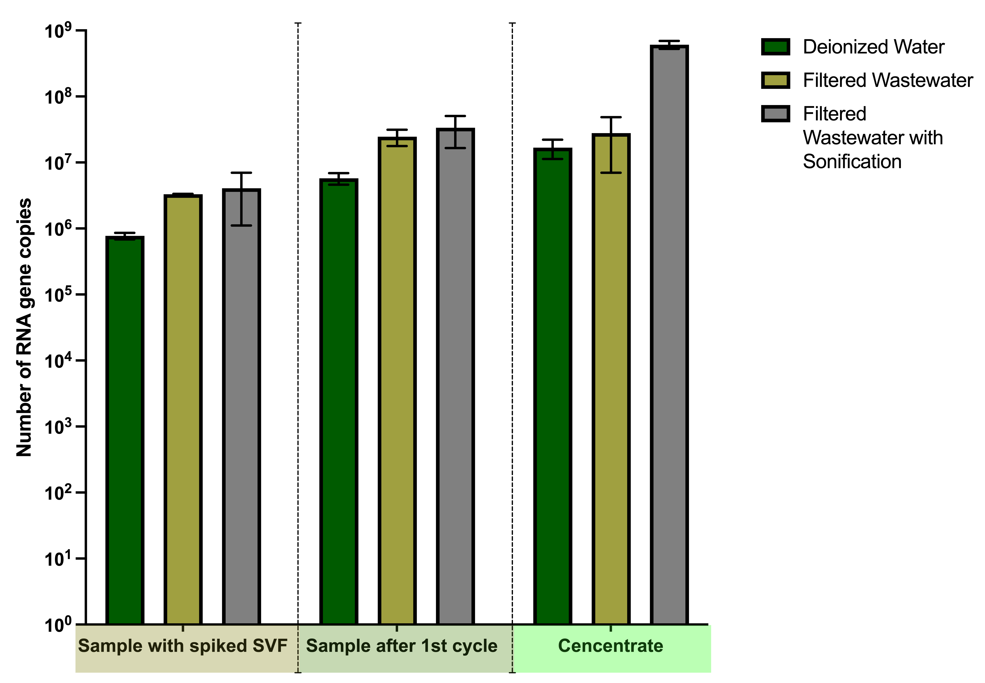
Figure 2. Effects of control matrix and adsorption interactions on SFV particle recovery rate (n=3)

The results of the tests, represented in Figure 2, revealed that there was no statistically significant difference (p > 0.05) in concentration performance when using deionized water as a matrix and that filtered wastewater or pre-treatment with sonication did not significantly (p > 0.05) alter the recovery rate. Although the SFV particle recovery rates were not significantly different among the samples analyzed (p > 0.05), the samples with pre-treatment with sonification demonstrated the relatively highest mean recovery rate (90 % compared to the control sample with synthesized SVF particles). This is likely caused by using the pre-treatment step by sonication. For example, Juel et al. (2021) have demonstrated that sonication treatment can increase the viral recovery rate by causing the desorption of viral particles from organic substances and the release of viral particles from host cells. The sonication step may partly solve a problem common to all ultrafiltration-based concentration methods, in which some part of the virus is lost with the pellet during centrifugation (Juel et al., 2021). Therefore, based on the results of the study, it can be concluded that pre-treatment with sonication can be a promising approach for increasing the recovery rate of RNA in untreated wastewater.
3.2 Comparison of recovery rate between wastewater concentration device and centrifugation method
The wastewater concentration device demonstrated a recovery rate ranging from 80 to 85 % in comparison to the control sample with synthesized SVF particles. The performance of the concentration device was then compared to the classical precipitation method, with the results presented in Figure 3. The results revealed no significant difference (p > 0.05) between concentration devices with ultrafiltration membrane and precipitation method. Both techniques exhibited a recovery rate between 80 – 85 % when compared to the positive control, i.e., the sample that presents a total number of added SVF particles to the sample before the concentration. Consequently, both methods demonstrate relatively good performance and can be employed to concentrate untreated wastewater for the analysis of the SARS-CoV-2 virus RNA.
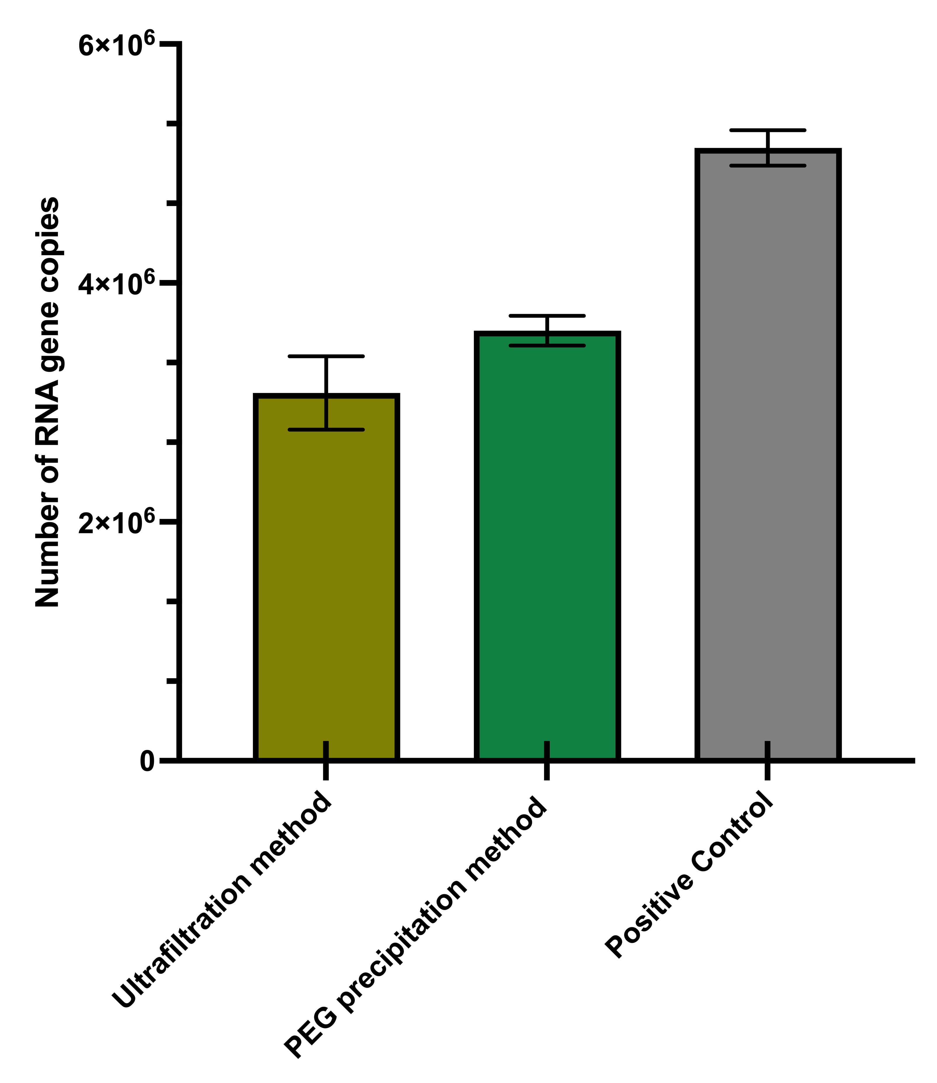
Figure 3. Number of RNA gene copies in concentrate from ultrafiltration and PEG precipitation methods compared with the total number of added SVF particles to the sample as a positive control (n=2)
The PEG precipitation method that includes centrifugation steps is time-consuming and energy-intensive (Zheng et al., 2022). For example, the most used centrifugation systems can concentrate 300 ml of wastewater per run and take up to 3 hours, whereas 5 up to 10 L is reported as the optimal volume for wastewater that needs to be concentrated for sample analysis (Corpuz et al., 2020). Consequently, the concentration device system designed by this study can save time and energy (e.g., 5 L concentration takes approx. 1 hour), reducing costs by enabling the concentration of wastewater with the same recovery rate compared to the centrifugation in a single run. Overall, both ultrafiltration membrane and precipitation techniques demonstrate a relatively high-performance recovery rate (%) and can be employed to concentrate untreated wastewater for the analysis of the COVID-19 virus. Additionally, the concentration device system designed by this study provides an efficient solution to save time and energy while reducing costs. Although ultrafiltration can be an effective method for viral concentration from wastewater samples, it can be affected by high turbidity which can clog the small pore size of filters (Zheng et al., 2022). Therefore, further research is necessary to ascertain the optimal concentration levels and limits for the device's operation.
  - Conclusions
The results of this study have demonstrated that both ultrafiltration membrane and PEG precipitation methods can be used to effectively concentrate untreated wastewater for the analysis of the viral RNA. Furthermore, ultrafiltration gave comparable results to the already well-established PEG method and provided an efficient solution to save time and energy while reducing costs. Further research is necessary to ascertain the optimal concentration levels and limits for the device's operation. Overall, the results of this study will be useful for the WBE community, as it is the first to design a wastewater concentration device with an ultrafiltration membrane system and compare the recovery rate of RNA with the classical precipitation method. This could lead to improved methods for the concentration of SARS-CoV-2 RNA in wastewater, which will enable faster, more accurate, and cost-effective tracking of the virus.
Acknowledgments
Project “Platform for the Covid-19 safe work environment” (ID. 1.1.1.1/21/A/011) is founded by European Regional Development Fund specific objective 1.1.1 «Improve research and innovation capacity and the ability of Latvian research institutions to attract external funding, by investing in human capital and infrastructure». The project is co-financed by REACT-EU funding for mitigating the consequences of the pandemic crisis.
References
Ahmed, W., Bertsch, P.M., Bivins, A., Bibby, K., Farkas, K., Gathercole, A., Haramoto, E., et al. (2020), “Comparison of virus concentration methods for the RT-qPCR-based recovery of murine hepatitis virus, a surrogate for SARS-CoV-2 from untreated wastewater”, Science of the Total Environment, Elsevier B.V., Vol. 739, doi: 10.1016/j.scitotenv.2020.139960.
Ahmed, W., Tscharke, B., Bertsch, P.M., Bibby, K., Bivins, A., Choi, P., Clarke, L., et al. (2021), “SARS-CoV-2 RNA monitoring in wastewater as a potential early warning system for COVID-19 transmission in the community: A temporal case study”, Science of the Total Environment, Elsevier B.V., Vol. 761, p. 144216, doi: 10.1016/j.scitotenv.2020.144216.
Atkins, G.J., Sheahan, B.J. and Liljestro, P. (1999), Printed in Great Britain The Molecular Pathogenesis of Semliki Forest Virus : A Model Virus Made Useful?, Journal of General Virology, Vol. 80.
Corpuz, M.V.A., Buonerba, A., Vigliotta, G., Zarra, T., Ballesteros, F., Campiglia, P., Belgiorno, V., et al. (2020), “Viruses in wastewater: occurrence, abundance and detection methods”, Science of the Total Environment, Elsevier B.V., Vol. 745, doi: 10.1016/j.scitotenv.2020.140910.
Daughton, C.G. (2020), “Wastewater surveillance for population-wide Covid-19: The present and future”, Science of the Total Environment, Elsevier B.V., doi: 10.1016/j.scitotenv.2020.139631.
Dimitrakopoulos, L., Kontou, A., Strati, A., Galani, A., Kostakis, M., Kapes, V., Lianidou, E., et al. (2022), “Evaluation of viral concentration and extraction methods for SARS-CoV-2 recovery from wastewater using droplet digital and quantitative RT-PCR”, Case Studies in Chemical and Environmental Engineering, Elsevier Ltd, Vol. 6, doi: 10.1016/j.cscee.2022.100224.
Galani, A., Aalizadeh, R., Kostakis, M., Markou, A., Alygizakis, N., Lytras, T., Adamopoulos, P.G., et al. (2022), “SARS-CoV-2 wastewater surveillance data can predict hospitalizations and ICU admissions”, Science of the Total Environment, Elsevier B.V., Vol. 804, doi: 10.1016/j.scitotenv.2021.150151.
Gudra, D., Dejus, S., Bartkevics, V., Roga, A., Kalnina, I., Strods, M., Rayan, A., et al. (2022), “Detection of SARS-CoV-2 RNA in wastewater and importance of population size assessment in smaller cities: An exploratory case study from two municipalities in Latvia”, Science of the Total Environment, Elsevier B.V., Vol. 823, doi: 10.1016/j.scitotenv.2022.153775.
Haramoto, E., Malla, B., Thakali, O. and Kitajima, M. (2020), “First environmental surveillance for the presence of SARS-CoV-2 RNA in wastewater and river water in Japan”, Science of the Total Environment, Elsevier B.V., Vol. 737, doi: 10.1016/j.scitotenv.2020.140405.
Jia, X., Varbanov, P.S., Klemeš, J.J. and Jia, X. (2021), “The Impact of COVID-19 on the Water Sector: A Review”, Chemical Engineering Transactions, Italian Association of Chemical Engineering - AIDIC, doi: 10.3303/CET2188011.
Juel, M.A.I., Stark, N., Nicolosi, B., Lontai, J., Lambirth, K., Schlueter, J., Gibas, C., et al. (2021), “Performance evaluation of virus concentration methods for implementing SARS-CoV-2 wastewater based epidemiology emphasizing quick data turnaround”, Science of the Total Environment, Elsevier B.V., Vol. 801, doi: 10.1016/j.scitotenv.2021.149656.
Kabdaşlı, I. and Tünay, O. (2021), “Concentration techniques tailored for the detection of SARS-CoV-2 genetic material in domestic wastewater and treatment plant sludge: A review”, Journal of Environmental Chemical Engineering, Elsevier Ltd, doi: 10.1016/j.jece.2021.106296.
Kitajima, M., Ahmed, W., Bibby, K., Carducci, A., Gerba, C.P., Hamilton, K.A., Haramoto, E., et al. (2020), “SARS-CoV-2 in wastewater: State of the knowledge and research needs”, Science of the Total Environment, The Authors, Vol. 739, p. 139076, doi: 10.1016/j.scitotenv.2020.139076.
Lahrich, S., Laghrib, F., Farahi, A., Bakasse, M., Saqrane, S. and el Mhammedi, M.A. (2021), “Review on the contamination of wastewater by COVID-19 virus: Impact and treatment”, Science of the Total Environment, Elsevier B.V., Vol. 751, doi: 10.1016/j.scitotenv.2020.142325.
LaTurner, Z.W., Zong, D.M., Kalvapalle, P., Gamas, K.R., Terwilliger, A., Crosby, T., Ali, P., et al. (2021), “Evaluating recovery, cost, and throughput of different concentration methods for SARS-CoV-2 wastewater-based epidemiology”, Water Research, Elsevier Ltd, Vol. 197, doi: 10.1016/j.watres.2021.117043.
Lu, D., Huang, Z., Luo, J., Zhang, X. and Sha, S. (2020), “Primary concentration – The critical step in implementing the wastewater based epidemiology for the COVID-19 pandemic: A mini-review”, Science of the Total Environment, Elsevier B.V., Vol. 747, doi: 10.1016/j.scitotenv.2020.141245.
Polo, D., Quintela-Baluja, M., Corbishley, A., Jones, D.L., Singer, A.C., Graham, D.W. and Romalde, J.L. (2020), “Making waves: Wastewater-based epidemiology for COVID-19 – approaches and challenges for surveillance and prediction”, Water Research, Elsevier Ltd, Vol. 186, doi: 10.1016/j.watres.2020.116404.
la Rosa, G., Iaconelli, M., Mancini, P., Bonanno Ferraro, G., Veneri, C., Bonadonna, L., Lucentini, L., et al. (2020), “First detection of SARS-CoV-2 in untreated wastewaters in Italy”, Science of the Total Environment, Elsevier B.V., Vol. 736, p. 139652, doi: 10.1016/j.scitotenv.2020.139652.
la Rosa, G., Mancini, P., Bonanno Ferraro, G., Veneri, C., Iaconelli, M., Bonadonna, L., Lucentini, L., et al. (2021), “SARS-CoV-2 has been circulating in northern Italy since December 2019: Evidence from environmental monitoring”, Science of the Total Environment, Elsevier B.V., Vol. 750 No. doi: 10.1016/j.scitotenv.2020.141711.
Weidhaas, J., Aanderud, Z.T., Roper, D.K., VanDerslice, J., Gaddis, E.B., Ostermiller, J., Hoffman, K., et al. (2021), “Correlation of SARS-CoV-2 RNA in wastewater with COVID-19 disease burden in sewersheds”, Science of the Total Environment, Elsevier B.V., Vol. 775, doi: 10.1016/j.scitotenv.2021.145790.
Westhaus, S., Weber, F.A., Schiwy, S., Linnemann, V., Brinkmann, M., Widera, M., Greve, C., et al. (2021), “Detection of SARS-CoV-2 in raw and treated wastewater in Germany – Suitability for COVID-19 surveillance and potential transmission risks”, Science of the Total Environment, Elsevier B.V., Vol. 751, doi: 10.1016/j.scitotenv.2020.141750.
Wurtzer, S., Waldman, P., Ferrier-Rembert, A., Frenois-Veyrat, G., Mouchel, J.M., Boni, M., Maday, Y., et al. (2021), “Several forms of SARS-CoV-2 RNA can be detected in wastewaters: Implication for wastewater-based epidemiology and risk assessment”, Water Research, Elsevier Ltd, Vol. 198, doi: 10.1016/j.watres.2021.117183.
Zheng, X., Deng, Y., Xu, X., Li, S., Zhang, Y., Ding, J., On, H.Y., et al. (2022), “Comparison of virus concentration methods and RNA extraction methods for SARS-CoV-2 wastewater surveillance”, Science of the Total Environment, Elsevier B.V., Vol. 824, doi: 10.1016/j.scitotenv.2022.153687.

