CHEMICAL ENGINEERING TRANSACTIONS  VOL. , 2023 | A publication of
The Italian Association
of Chemical Engineering
Online at www.cetjournal.it

Guest Editors: Sauro Pierucci, Jiří Jaromír Klemeš
Copyright © 2023, AIDIC Servizi S.r.l.
ISBN 978-88-95608-98-3; ISSN 2283-9216

Dynamic Modelling and Process Control System Development of a H₂S Scrubber Used in a Coke Oven Gas Purification Technology
Nikolett Radó-Fótyª*,Attila Egedyª, Lajos Nagyª, Iván Hegedűs^{b}
ªUniv. of Pannonia, Dep. Process Engineering, Egyetem St. 10., 8200 Veszprém, Hungary
^{b}ISD Kokszoló Kft., Vasmű Sq. 1-3., 2400 Dunaújváros, Hungary
rado-foty.nikolett@mk.uni-pannon.hu
Coke oven gas is a by-product of coke production. Cleaned coke oven gas can be a valuable energy source, ideal as a substitute for natural gas. However, to meet increasingly stringent environmental regulations and to protect combustion equipment, the high efficiency of the coke oven gas purification process must be ensured continuously, even for existing, less up-to-date plants. Process simulators built to support technologies can be a great help in this task. At the same time, they can be used to assist operations, understand general and specific process behaviour features, and examine development suggestions. The H₂S scrubber of an existing coke oven gas purification plant was investigated in this study. Previously, the steady-state model of the purification process was studied, and the impact of operating parameters was investigated. Then the dynamic model of the purification process was created in Aspen Hysys simulator software. Finally, the model was validated against laboratory analyses and daily operational plant data. Subsequently, the control structure of the purification process was studied. It was concluded that the control system used in the coke oven gas purification plant is rather elementary and is primarily designed to ensure the safe operation of the technology. However, a more complex advanced control structure is needed to continuously provide a constant gas composition, in which the dynamic model of the technology is a great support. In this study, two examples for improving the control structure of the process were presented using the dynamic model of the H₂S scrubber.
  - Introduction
One of the indispensable raw materials in the iron and steel industry is coke, produced by the high-temperature pyrolysis of special coal blends. During coke production, coke oven gas is formed from the volatile content of the coal blend. Coke oven gas contains many components, including valuable ones such as coal tar or benzene and pollutants like hydrogen sulphide or ammonia. Separating the valuable components is necessary because of economic considerations while removing impurities is environmentally crucial. After purification, coke oven gas is an ideal energy substitute due to its high heating value, which is about 75 % of the heating value of natural gas (Razzaq et al., 2013). The main part of the fuel consumption of integrated steel plants can be ensured by the continuously formed and properly purified by-product gases, such as blast furnace gas or coke oven gas. (Porzio et al., 2014). Thus, natural gas consumption can be reduced, making the whole iron and steel production more profitable, especially in the current energy crisis, and more environmentally sustainable (Garcia et al., 2021).
In order to use coke oven gas as a fuel, the concentration of impurities needs to meet environmental regulations and technological limits. For example, according to European Directives, the residual hydrogen sulphide concentration in the gas must be less than 1,000 mg/Nm³, when the most commonly used absorption technology is applied for the purification of coke oven gas (Commission Implementing Decision, 2012).
There is an increasing trend to improve existing plants with the help of flowsheet simulators, which aims to optimise and effectively manage the process. These simulators can find the optimal operating conditions, train the operating teams for different situations, like malfunctions or rare events, investigate different experiments without disturbing the real operation, or examine complex process control structures. However, creating a proper process simulator is a relatively complicated task, especially for multi-component systems like coke oven gas purification, where structural geometry is complex and several parallel and competitive chemical reactions occur (Mayer et al., 1999).
Only a few publications concerning on modelling of coke oven gas purification technology, and no studies on the development of the control system of these processes. Most of these studies focus on coke oven gas purification using absorption methods, while few articles investigate dry or wet oxidation methods. The absorption methods typically consist of one or more ammonia scrubbers and hydrogen sulphide scrubbers and use different washing liquids in a counter-current flow to the gas (Kohl and Nielsen, 1997). Different rigorous two-phase models were created for a theoretical description of the process (Thiele et al., 2007). For the validation of these models, pilot plant or industrial measurements were carried out. Some research groups built steady-state models in widely used process simulator programs and then performed analyses on different aspects. Carneiro et al. evaluated solutions that improve the removal of hydrogen sulphide with the developed process model. Two different configurations were created, and extra ammoniacal water was fed as a solvent. The last one had the biggest impact on the removal, and a 5 % increase in hydrogen sulphide absorption could be observed (Carneiro et al., 2020). Pan et al. modelled an integrated hydrogen sulphide, ammonia scrubber, and regeneration columns. With the help of the model, it was concluded that only hydrogen sulphide scrubbing efficiency improves by increasing the flow rate of strong ammoniacal water, while increasing the flow rate of weak ammoniacal water enhances the scrubbing efficiency of both impurities (Pan et al., 2023).
Steady-state simulations are ideal for determining optimal design parameters, performing sensitivity analysis and defining the operating conditions of the systems. However, real chemical plants are never in a truly steady-state condition. Different disturbances or fouling of equipment continuously disrupt the condition of a well-functioning process. Therefore, dynamic simulation is more appropriate for studying the transient behaviour of a real process. By establishing the detailed unit specification in the dynamic model, it can be verified that the unit functions as expected. Moreover, controller design can be optimised without negatively influencing the profitability or safety of the plant. It can be designed and tested various control strategies before selecting the one that is ideal for implementation. It can be examined the dynamic response to disturbances and revise the tuning of controllers (Aspen Technology, 2005).
In the field of dynamic behaviour and control of absorption, columns have been performed only a few studies, and those focused mainly on carbon dioxide absorption processes. Panahi et al. considered different control configurations, which used decentralised controllers and model predictive control, for an efficient carbon dioxide capturing process (Panahi and Skogestad, 2012). Heinze et al. investigated control strategies to improve the ramp rate of an acid gas absorber column (Heinze et al., 2017).
In this study, an H₂S scrubber of an existing coke oven plant was investigated. Based on the previous steady-state results, the dynamic model of the scrubber was created. Creating an appropriate simulation of the process is a rather challenging task due to the complexity of coke oven gas, the competing, parallel chemical reactions, the low number of operational measurements and the uniqueness of the physical structure of the equipment and packing. Furthermore, the actual process control structure is rather elementary and only aimed at ensuring safe operation. However, a proper control system can help provide constant gas composition even under varying operation conditions, which is important to maintain compliance with increasingly stringent environmental regulations. Therefore, two possible control structures were developed and evaluated, built on previous sensitivity analysis experience (Radó-Fóty et al., 2022).
    - Technology description
The studied H₂S scrubber is the first unit of a gas purification technology used in a Hungarian coke oven plant, but to understand the source of the streams, it is advisable to describe the whole process.
The complete technology consists of a gas purification section and a washing liquor regeneration section. The raw coke oven gas, produced in the coking chambers, is cooled and separated from coal tar and coal water before entering the process. There are three columns, an H₂S-, an NH₃- and a fine NH₃-scrubber, in a series arrangement, in which the gas is in counter-current with the washing liquids.
The saturated washing liquor leaving the columns is regenerated in the other section of the process. The regeneration section consists of a deacidification column and a stripping column. In the deacidification column, a significant part of the dissolved hydrogen sulphide compounds is removed, resulting in a high ammonia content liquid, the so-called deacidified water, as a bottom product. The vapours of this column are fed into the Closed Claus Plant, where catalytic conversion occurs. Part of the deacidified water is returned to the H₂S scrubber and part to the stripping column. In this column, all the impurities are stripped, and stripped water leaves at the bottom of the column. The head product of the stripping column is returned to the deacidified tower. The main part of the stripped water fed to the fine NH₃ scrubber, while the surplus led to the Wastewater Treatment Plant. In addition to the deacidified water and the stripped water, so-called coal water is also used in the gas cleaning section. Coal water is generated from the coal blend's moisture content charged into the coke oven chambers.
The most critical part of the purification process is the H₂S scrubber since keeping the hydrogen sulphide content of the coke oven gas below environmental regulations is the main challenge for the plant. Therefore, this study focuses primarily on this unit.
  - Process modelling
Previously, the steady-state model of the H₂S scrubber was investigated in Aspen Plus (Radó-Fóty et al., 2021). It was found that rate-based method is appropriate to describe the process. Based on the correlations and reactions described in the previous study, the column was modeled in Aspen Hysys, which could be convert into dynamic mode. Compared to the previous study, a more detailed model was developed. In the real scrubber, there is a so-called secondary cooler stage in the lower section of the column, where the exhausted coke oven gas is cooled by direct cooling water. Now, this stage has also been considered, so the H₂S scrubber was built using two separate columns as Figure 1 shows. At the bottom of both column section there is a liquid collector, which was implemented in the model with a single tank. The coke oven gas enters at the bottom of the secondary cooler tower and is then fed into the main column. In the secondary cooler column, similarly to the main column, special expanded packings are placed. The cooling water is fed in at the top of the column and flows into the tank at the bottom, where the liquid level is controlled by the LCV 143.2 control valve. The recooled coke oven gas then enters the bottom of the main column and gets in contact with the washing liquors. The washing liquid leaving the NH₃ scrubber enters at the top of the H₂S scrubber, while deacidified water is fed at the 4th stage. The washing liquids flow from the bottom of the column into the tank, which kept at constant level by the control valve LCV 144.
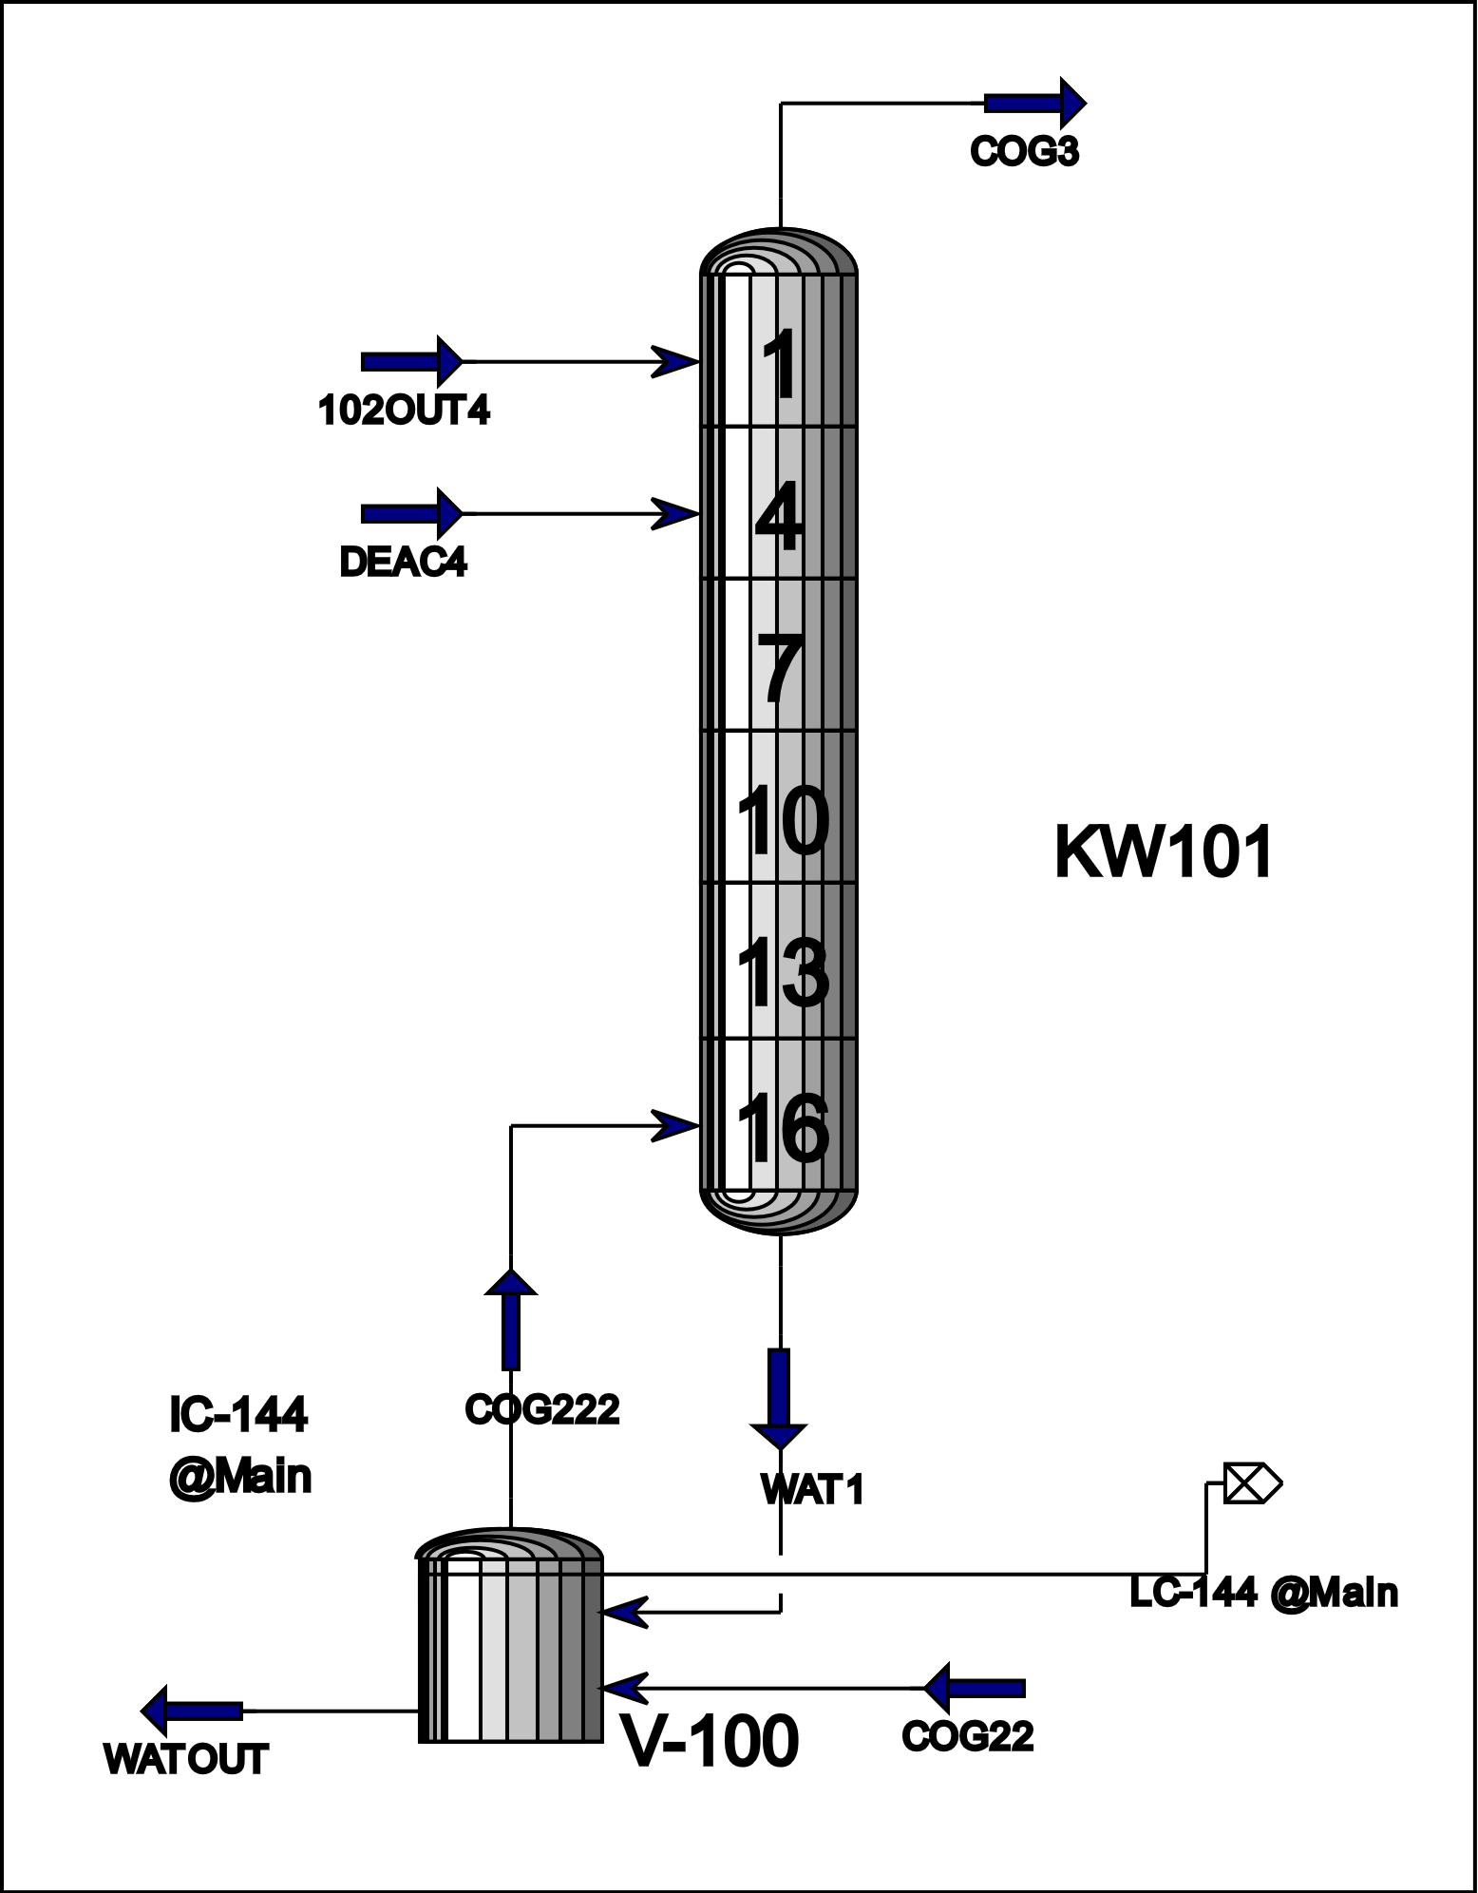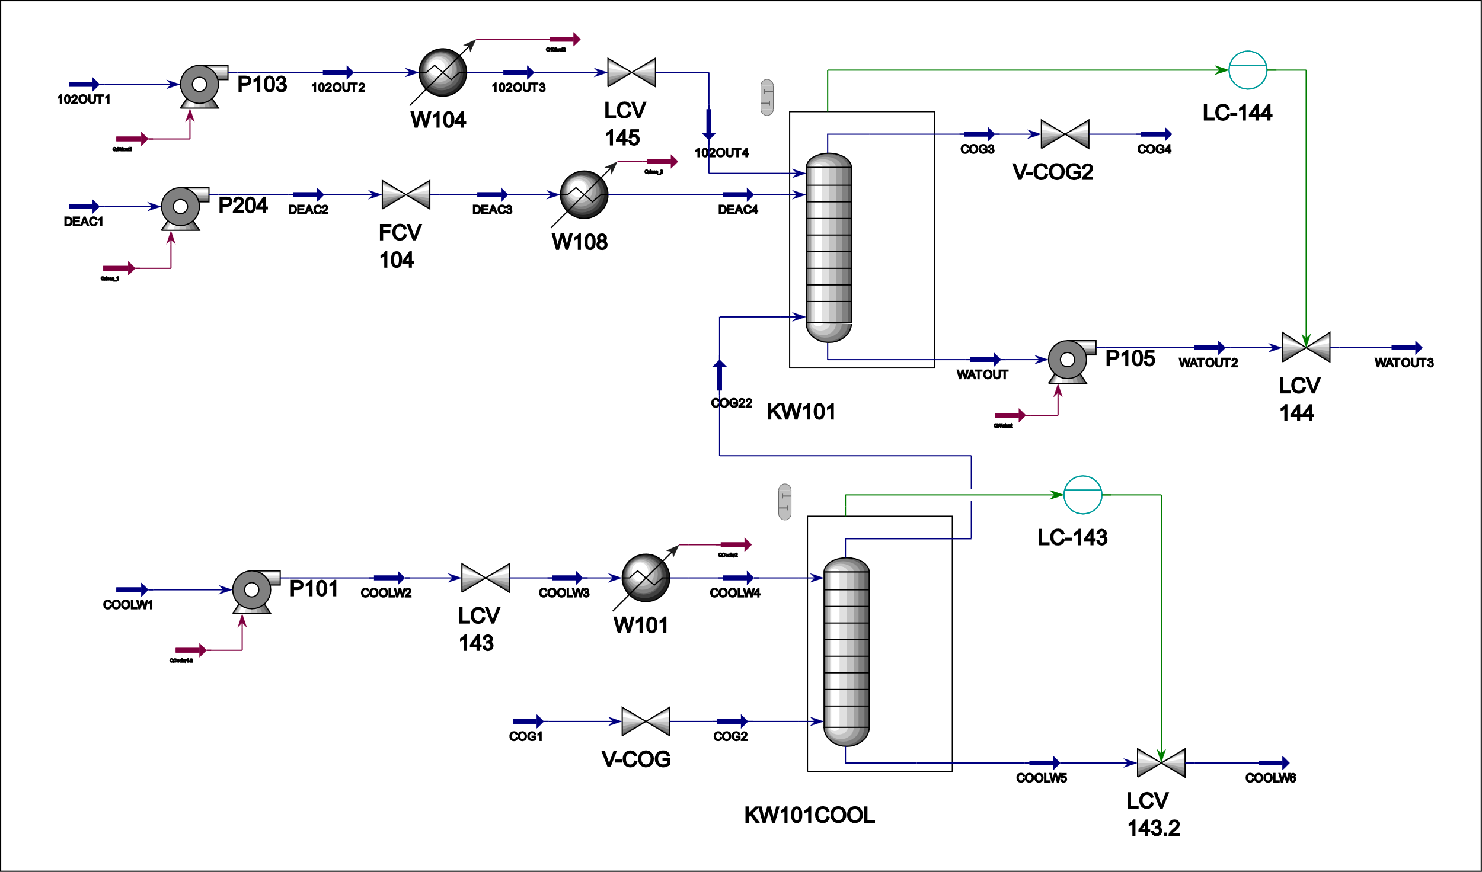
Figure 1: Model structure
The input parameters of the streams in Table 1 were used to build the model. The pumps for transporting the fluids and the heat exchangers for cooling them were sized according to the equipment used in the plant.
Table 1: Input parameters
 | COG | Cooling water | Washing liquid | Deacidified water
Temperature (°C) | 24 | 20 | 22 | 24
Pressure (bar) | 1.277 | 1.268 | 1.132 | 1.158
Flow rate (m³/h) | 46,190 | 11.4 | 42,6 | 62.0
 | Composition (V/V %)
H₂O | - | 93.84 | 99.00 | 95.78
H₂ | 60.74 | - | - | -
NH₃ | 0.33 | 2.00 | 0.55 | 3.80
H₂S | 0.39 | 0.35 | 0.17 | 0.07
CO₂ | 2.60 | 3.80 | 0.28 | 0.35
HCN | 0.02 | - | - | -
CO | 4.20 | - | - | -
CH₄ | 23.90 | - | - | -
C₂H₆ | 3.10 | - | - | -
N₂ | 4.72 | - | - | -
    - Process control development
The existing control structure of the gas purification technology is simple and consists of only two liquid-level controllers with a safety role. However, an advanced control structure can be a great help to ensure constant gas purification efficiency. Therefore, the validated dynamic model investigated two ratio control schemes, as shown in Figure 2.
In Case 1, the aim was to control the mass flow of cooling water entering the secondary cooler section based on the inlet coke oven gas temperature. When the coke oven gas temperature rises, the LCV 143 control valve opens, thus increasing the mass flow of cooling water. By this control scheme, the temperature of the coke oven gas entering the main section of the H₂S scrubber can be kept nearly constant.
Based on the previous sensitivity analysis, it was observed that the mass flow of deacidified water has the most significant effect on the efficiency of coke oven gas cleaning. Consequently, a ratio control scheme was developed in Case 2 that controls the mass flow of the deacidified water depending on the mass flow of the inlet coke oven gas through the FCV 104 control valve.
Case 1 | Case 2
Figure 2: Studied control structures
  - Results
Following the development of the dynamic model, the dynamics of the process were investigated by varying the amount of the inlet coke oven gas. Figure 3a shows the mass flow of NH₃ and H₂S in the outlet gas phase, while the changes in the mass flow of the coke oven gas are shown in Figure 3b. It can be observed that the mass flow of NH₃ increased with increasing the mass flow of inlet gas, but an inverse trend can be seen for H₂S. The difference from the expected behavior can be explained by the effect of the pH of the washing liquor, which favored the absorption of H₂S. The pH values of the outlet washing liquor are also shown in Figure 3b.
a) |  | b)
Figure 3: Studied control structures
    - Process control results
Figure 4 shows the results of Case 1 control scheme. The controlled process variable (PV1) was the mass flow of the cooling water, in the range of 5,000-15,000 kg/h. The referenced process variable (PV2) was the temperature of the inlet coke oven gas, in the range of 20-45 °C. It can be seen in Figure 4a that the cooling water mass flow increases immediately with increasing inlet coke oven gas temperature, and the referenced process value reaches the setpoint value quickly. While Figure 4b shows that as the inlet temperature increases, the temperature of the gas leaving the secondary cooler increases only slightly. Such a temperature rise does not lead to any problems in the absorption process, nor does it decrease the cleaning efficiency.
a) |  | b)
Figure 4: Results of Case1 control scheme
The results of Case 2 can be seen in Figure 5. The controlled process variable (PV1) was the mass flow of the deacidified water, in the range of 35,000-75,000 kg/h. The referenced process variable (PV2) was the mass flow of the inlet coke oven gas, in the range of 16,000-31,000 kg/h. Figure 5a shows that the value of the mass flow of the deacidified water reaches the setpoint value properly. The mass flow of H₂S in the outlet gas phase can be seen in Figure 5b. However, the mass flow of H₂S in the outlet gas stream has not been significantly reduced compared to what was expected based on the steady-state results.
a) |  | b)
Figure 5: Results of Case2 control scheme
  - Conclusions
As a continuation of our previous work, a dynamic model of the H₂S scrubber of a coke oven gas purification technology was developed. The model was extended with the secondary cooler section, the pumps, the washing liquor coolers and the control valves. Then the dynamic of the process was investigated by varying the amount of the inlet mass flow of the gas. This also revealed the complexity of the system, as the mass flow of H₂S in the outlet gas stream showed a different trend than expected.
Subsequently, the control structure of the process was studied and two different control schemes were developed. One of them controls the variation of the temperature of the inlet gas, while the other is based on the changes in the mass flow of the gas.
The temperature control resulted in an increase in the temperature of the coke oven gas leaving the secondary cooler of only 3 °C, even when the inlet gas temperature was raised from 24 °C to 40 °C. This indicates that this type of ratio control scheme is adequate to ensure the temperature of the coke oven gas required for the absorption process.
The control scheme that controls the mass flow of the deacidified water according to the changes in the mass flow of the gas, is not completely appropriate. The expectation was to increase the mass flow of the deacidified water with increasing gas feed, in order to reduce the amount of H₂S content in the outlet gas stream. However, due to the occurring parallel processes and the varying pH value of the washing liquor, a more complex control structure is required to control the amount of the H₂S in the outlet coke oven gas.
Acknowledgments
Prepared with the professional support of the Doctoral Student Scholarship Program of the Co-operative Doctoral Program of the Ministry of Innovation and Technology financed from the National Research, Development and Innovation Fund.
References
Aspen Technology, 2005, Dynamic Modeling, Aspen Technology Inc., 1-12.
Carneiro L. O., Vasconcelos S. F., Neto G. W. F., Brito R.P., Brito K. D., 2020, Improving H₂S Removal in the Coke Oven Gas Purification Process, Separation and Purification Technology 257, 117862.
European Commission, 2012, Commission Implementing Decision of 28 February 2012 establishing the best available techniques (BAT) conclusions under Directive 2010/75/EU of the European Parliament and of the Council on industrial emissions for iron and steel production, Official Journal of the European Union L70/85-88.
García S.G., Montequín V.T., Piloneta M.D., Lougedo S.T., 2021, Multi-Objective Optimisation of Steel off-Gas in Cogeneration Using the ε-Constraint Method: A Combined Coke Oven and Converter Gas Case Study, Energies 14, 1-21.
Heinze C., Higman C., Marasigan J., Epple B., 2017, Investigation of new control strategies for acid gas absorber columns to improve the response rates using dynamic process simulation, Fuel 203, 964-972.
Kohl A., Nielsen r., 1997, Gas Purification (5th ed.), Gulf Publishing Company, Houston, Texas, 279-326.
Mayer J., Schneider R., Kenig E., Górak A., Wozny G., 1999, Dynamic and Steady State Simulation of Coke Oven Gas Purification, Computers and Chemical Engineering Supplement, 843-846.
Pan H.J., Fang M.C., Ward J.D., Lee H.Y., Lin H.Y, Hsieh C.T., Lee C.L., Huang T.H., Hsieh Y.C., Lin S.C., Chou W.T., 2023, Modeling of an integrated H2S/NH3 scrubber and regeneration columns for coke oven gas purification, Journal of Cleaner Production 389, 1-11.
Panahi M., Skogestad S., 2012, Economically efficient operation of CO₂ capturing process. Part II. Design of control layer, Chemical Engineering and Processing 52, 112-124.
Porzio G.F, Colla V., Matarese N, Nastasi G., Brance T. A., Amato A., Fornai B., Vannucci M., Bergamasco M., 2014, Process Integration in Energy and Carbon Intensive Industries: An Example of Exploitation of Optimisation Techniques and Decision Support, Applied Thermal Engineering, 70, 1148-1155.
Radó-Fóty N., Egedy A., Nagy L., Hegedűs I., 2021, Comparison of Equilibrium-Stage and Rate-Based Models of a H₂S Scrubber for Purification of Coke Oven Gas, Chemical Engineering Transactions 88, 217-222.
Radó-Fóty N., Egedy A., Nagy L., Hegedűs I., 2022, Investigation and Optimisation of the Steady-State Model of a Coke Oven Gas Purification Process, Energies 15, 1-16.
Razzaq R., Li C., Zhang S., 2013, Coke Oven Gas: Availability, Properties, Purification, and Utilization in China, Fuel 113, 287-299.
Thiele R., Faber R., Repke J.-U-, Thielert H., Wozny G., 2007, Design of Industrial Reactive Absorption Process in Sour Gas Treatment Using Rigorous Modelling and Accurate Experimentation, Chemical Engineering Research and Design 85, 74-87.

