CHEMICAL ENGINEERING TRANSACTIONS  VOL. , 2023 | A publication of
The Italian Association
of Chemical Engineering
Online at www.cetjournal.it

Guest Editor: Sauro Pierucci
Copyright © 2023, AIDIC Servizi S.r.l.
ISBN 978-88-95608-98-3; ISSN 2283-9216

Fluidized Bed in Industry Scale: Comparing Eulerian Multiphase and Coarse-Grained CFD-DEM Simulation
Thomas Eppinger^{a,}*, Nico Jurtz^{b}, Ravindra Aglaveª, Matthias Kraume^{b}
ªSiemens Digital Industries Software, Nonnendammallee 104, Berlin, Germany
^{b}Technische Universität Berlin, Chair of Chemical & Process Engineering, Marchstraße 23, 10587 Berlin, Germany
thomas.eppinger@siemens.com
To predict and analyse fluidized bed reactors in large scale two different methods are compared with experimental results: the coarse-grained CFD-DEM approach and the kinetic theory of granular flow, EMP-KTGF. Both methods have proven to give accurate results in lab scale, where all the flow patterns can be resolve by the underlying mesh. For larger scales modifications have to be implemented. In this study it is shown that EMMS-based drag corrections improve the accuracy significantly for both modelling approaches. CFD-DEM, the computationally more expensive method, shows better agreement with experimental results than EMP-KTGF, but at a cost of substantially higher computation times.
  - Introduction
Fluidized particulate systems are widely used in the chemical and process industry. Common applications are heterogeneous catalysis, drying processes, polymerization, and coal combustion or gasification. Those applications are most often conducted in fluidized beds. This reactor type is characterized by physical phenomena acting on different length scales. The microscopic scale is determined by collisions between individual particles and between particles and the wall, as well as interactions between particles and the fluid phase. The microscale interactions significantly control energy, momentum, and mass transport and lead to local mesoscale phenomena like cluster and bubble formation and, in the case of non-spherical particles, a preferred particle orientation (Vollmari et al., 2016). On the macroscopic level, those phenomena significantly affect mixing characteristics and flow regime (Vollmari et al., 2016; Kruggel-Emden and Volmari, 2016).
Two well-established methods to describe the system on meso-scale level is the kinetic theory of granular flow in an Eulerian framework (KTGF or EMP-KTGF) and the coupling of computational fluid dynamics (CFD) with DEM (CFD-DEM). Since its introduction (Cundall and Strack, 1979), the Discrete Element Method (DEM) has proven to be a valuable method for the analyzing and understanding particulate flows. Supported by the continuously increasing computational power, CFD-DEM simulations have found their way into the chemical and process industry for various applications like solid suspension in mixing vessels, fluidized and spouted beds, granular transport and coating applications in rotary drums (Eppinger et al., 2017; Baran et al. 2015). The major shortcoming of DEM, however, is its computational cost that increases with the amount of particles involved, their material properties (stiffness) and size. This hinders the application of CFD-DEM simulation to large-scale systems of industrial size. To overcome this shortcoming a coarse grain (CG) model has been described [4]. Using straightforward scaling rules, a group of particles gets replaced by a representative coarse parcel. This effectively reduces the number of particles that need to be processed and subsequently shortens the computational time. On the other hand, it introduces a modeling error into the simulation. In a previous study different coarse graining models were investigated and the effect on different parameters were quantified. Additionally, bed expansion, pressure drop and their fluctuations for a fluidized bed and spouted bed were compared against results from a lab-scale experiment. To summarize, bed expansion and pressure drop are well predicted for all investigated CG methods but depending on the CG factor the dynamic of the system cannot be captured (Jurtz et al, 2020).
An alternative approach is the kinetic theory of granular flow based on the Eulerian multiphase model. The different phases are treated as interpenetrating continua, but additionally the intraphase interaction of the dispersed solid phase is considered by so-called subgrid models. One advantage of this modelling approach is that for each phase only one set of transport equations is solved, which means that the computational effort is independent of the number of particles. A validation of different KTGF-models and the influencing model parameters similar to the CFD-DEM study was recently presented (Eppinger et al., 2019).
In this work a fluidized bed in industry scale is investigated with both methods. The large scale of the system requires a relatively coarse mesh to keep the simulation time feasible. But a coarse mesh is not able to capture the heterogeneity of the solid distribution like cluster formation which leads to a substantial overprediction of the drag force. To compensated this, EMMS-based (Energy-Minimization Multi-Scale) drag correction models are proposed and used in this investigation.
In this work we are comparing coarse-grained CFD-DEM, EMP-KTGF and experimental results for an industrial scale fluidized bed in terms of certain modelling aspects, accuracy and runtime.

  - Methods
The focus of this investigation is to compare the two methods, CFD-DEM with coarse graining (CG) and EMP-KTGF, in terms of runtime as well as accuracy compared to experimental results. For the simulations Simcenter STAR-CCM+ by Siemens is used. The CFD-DEM simulation setup and the used models are described in detail in the open-access research article by Jurtz et al. (2020) and are not repeated here, except of the introduced EMMS-based drag correction.
The EMP-KTGF approach solves for each phase a set of transport equations for mass, momentum and turbulence for the gas phase. To capture the particle-particle interactions in the solid phase the granular pressure model is used. The model introduces the concept of the packing limit. In computational cells below this limit, particles are loosely packed and inter-particle collisions determine their motion; these collisions are handled as part of a granular temperature model. Above the packing limit, friction between particles dominates their motion and a frictional stress model is used. For the frictional stress the Modified-Johnson model is used in conjunction with the Ding-Gidaspow formulation for the radial distribution. For the granular temperature a transport equation is solved where the solid viscosity and the granular diffusion is calculated based on the formulation by Gidaspow. A detailed formulation can be found in the User Guide of Simcenter STAR-CCM+.
The drag forces between particles and the gas phase are calculated based on Gidaspow and the EMMS-based modified Gidaspow drag law proposed by Herbert and Reh (1999).
The drag force F_{d}
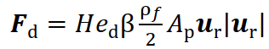
is calculated with the heterogeneity index He_{d}, drag coefficient β, density ρ_{f} of the gas phase, particle cross section A_{p} and the relative velocity between the gas and particle phase u_{r}.
The drag coefficient β is calculated as follows:
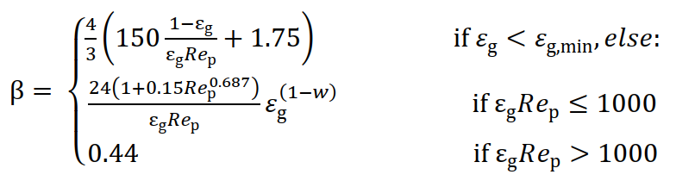
with the local void fraction ε_{g} and the particle Reynolds number Re_{p}
Finally, the heterogeneity index He_{d} is a function of the particle Reynolds number Re_{p}, the local void fraction ε_{g} and 3 fitting parameters a, b and c.
Table 1 shows the material properties of the Geldart group D particles, the gas phase and the boundary conditions of the system under investigation, while in figure 1 the investigated circulating fluidized bed unit is shown. The unit consists of a cylindrical riser, 11 ft. in height and with a diameter of 8 inch, followed by an elbow. A cyclone is installed to separate the heavy fractions from the fines. The larger particles fall through the standpipe and are circulated back to the riser.

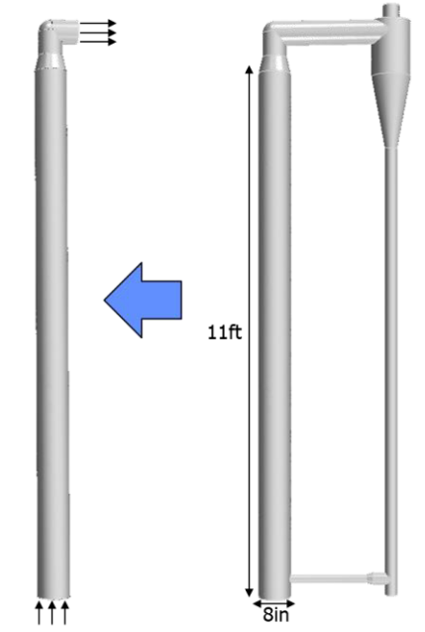  Figure 1: full and reduced CFB unit | Table 1: Material properties and boundary/initial condition  Property Value  Particle diameter dp 36.24 ym  Particle density 2500 kg/m3  Density Air 1.18 kg/m³  Dynamic viscosity Air 1.85*10⁻⁵ Pa∙s  Initial solid mass 29 kg  Number of DEM parcels 465616  DEM particles per parcel 1,000,000  Inlet velocity 0.229 m/s, 0.328 m/s, 0.615 m/s  Pressure outlet 1 bar
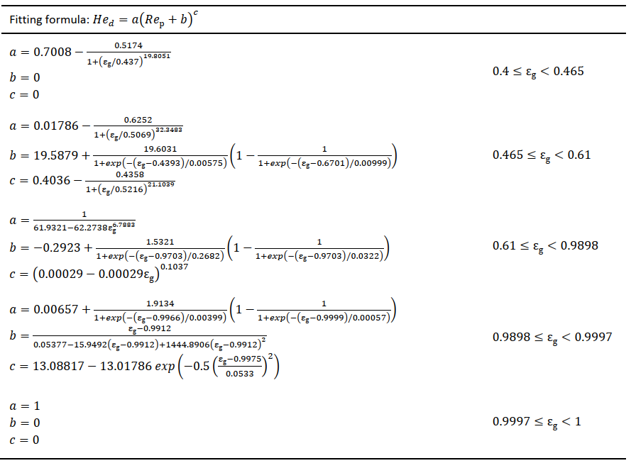

Experimental investigations have shown that for superficial inlet velocity up to v=0.615 m/s no particle entrainment was observed, so that in a first comparative study it was investigated if the full model can be reduced by excluding the cyclone and standpipe. While in the original model, the flow enters the domain through the bottom of the riser and leaves it through the top of the cyclone, in the reduced model, the flow leaves the reactor directly after the elbow. In this case, the outlet is impermeable for the particles. If particles are entrained, they will either accumulate close to the outlet or rebound and fall back in the riser. The comparison was conducted for the highest inlet velocity of 0.615 m/s with the DEM-CFD approach. The results are shown in Figure 2, where none of the metrics (time-averaged particle volume fraction distribution and pressure as well as the axial pressure gradient) are significantly affected by the model reduction. On the other hand, the simulation time is reduced by approximately 40%, so that the use of the reduced unit is justified.

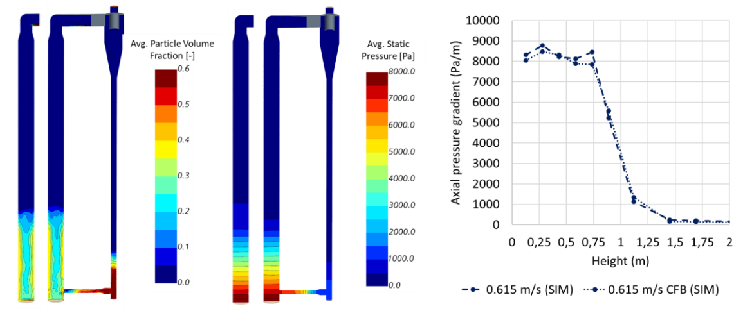
Figure 2: Comparison of the full and reduced unit in terms of time-averaged local particle volume fraction and pressure distribution as well as the axial pressure gradient.

  - Results
To estimate the effect and justify the use of the EMMS-based drag model, two CFD-DEM simulations were conducted for a superficial inlet velocity of u_{in}=0.229 m/s, one using the unaltered Gidaspow formulation and one using the EMMS-based drag correction. The results are shown in Figure 3. Without drag correction a massive entrainment of particles can be observed, which is far beyond what was observed in the experiments. When an EMMS-based drag correction is used, the drag force is significantly lower resulting in a significantly lower dense bed zone and no entrainment can be detected. As the particle dynamics are completely mis-predicted without drag correction, also other metrics like the average static pressure and solid phase fraction is described wrongly.

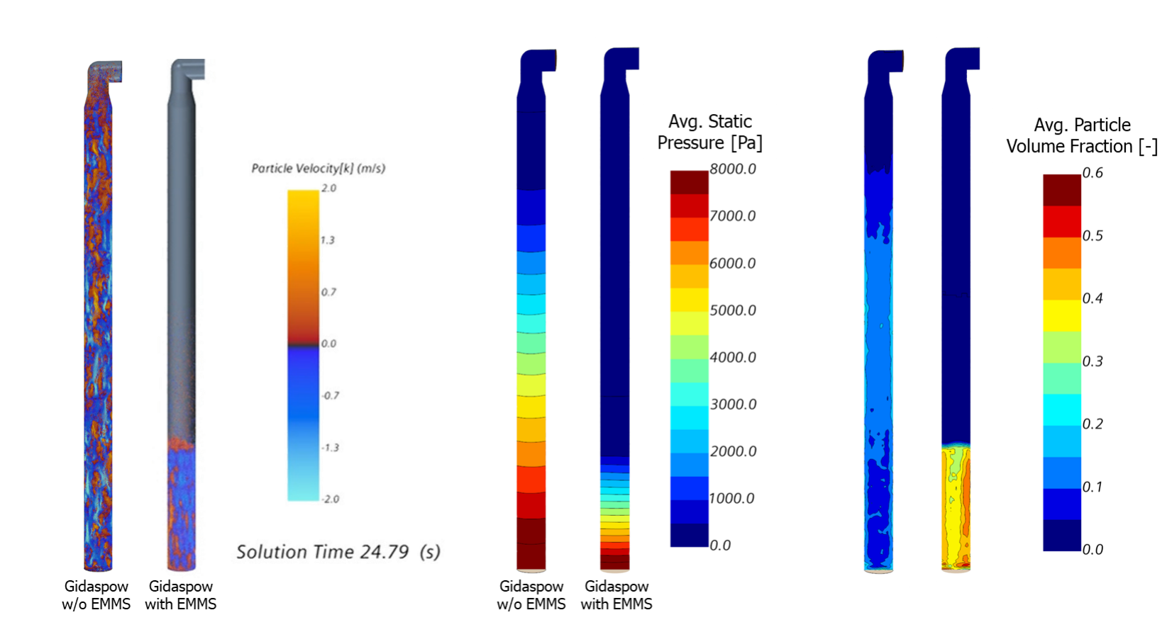
Figure 3: Comparison of the results for a simulation with and without EMMS-based drag correction
Similar results were found for EMP-KTGF simulation as shown Figure 4. Here the left image shows entrainment for the default Gidaspow drag law, while the time series starting from the second image illustrates the fluidization and bed expansion with EMMS-based drag correction in time intervals of dt = 0.4 s (2nd of 6th image) and dt=1s (7th to 10th image), respectively. The bed expansion is much lower than for the default Gidaspow drag law and comparable to the CFD-DEM results and particle entrainment is not observed.
In Figure 5 the static pressure over the height of the cylindrical riser unit is shown. Data were collected every 15 cm from the bottom. The numerical values are averaged over each corresponding cross section when a pseudo-steady state is reached after 25 seconds of simulated time. That was done experimentally and numerically for three cases with different inlet superficial velocities. For the sake of clarity only one of the experimental curves is plotted, because the deviation for the other two curves is negligible.
The plot indicates that all investigated cases show a similar value at the bottom for and since the pressure at the head is the same for all cases the total pressure drop is the same. Comparing the pressure profile for the two CFD-DEM cases with the lower inlet velocity and the experimental results an excellent agreement is found. The CFD-DEM case with the higher inlet velocity shows a similar slope for the pressure profile in the lower part of the riser but deviates at a height of around 0,75 m indicating that a portion of the particles are better fluidized, and the bed expansion is increased compared to the experiment.
Comparing the EMP-KTGF results with experimental results clearly show two differences. The slope in the dense bed zone is different leading to an increased bed expansion up to a bed height of approximately 1.3m compared to ~0.8-0.9 m in experiment. Similar to the CFD-DEM simulation the curves for the two lower inlet velocities are pretty close to each other, while for the higher inlet velocity a slightly different slope is found leading to similar effects as for the CFD-DEM case.
Regarding runtime, an EMP-KTGF simulation for 25s simulated time takes around 60 hours while a CFD-DEM simulation requires around 150 hours on comparable machines.
And finally, it should be noted that no further model tuning was conducted, and all simulation were run with default parameters. Especially for the EMP-KTGF cases further model tuning might improve the accuracy of the results. But this was not investigated is this study and is something for a follow-up investigation.

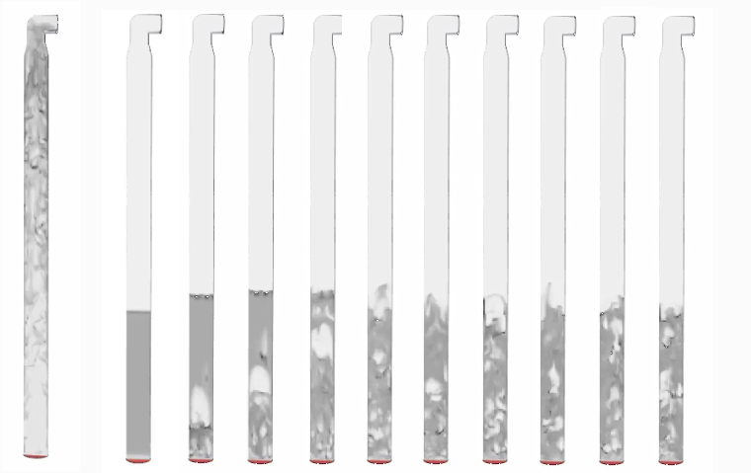
Figure 4: Comparison of the results without (left image) and with EMMS based drag model (2nd to 11th image) with EMP-KTGF. Series on the right shows the development of the fluidized bed for a time interval of dt=0.4 s and 1 s, respectively.

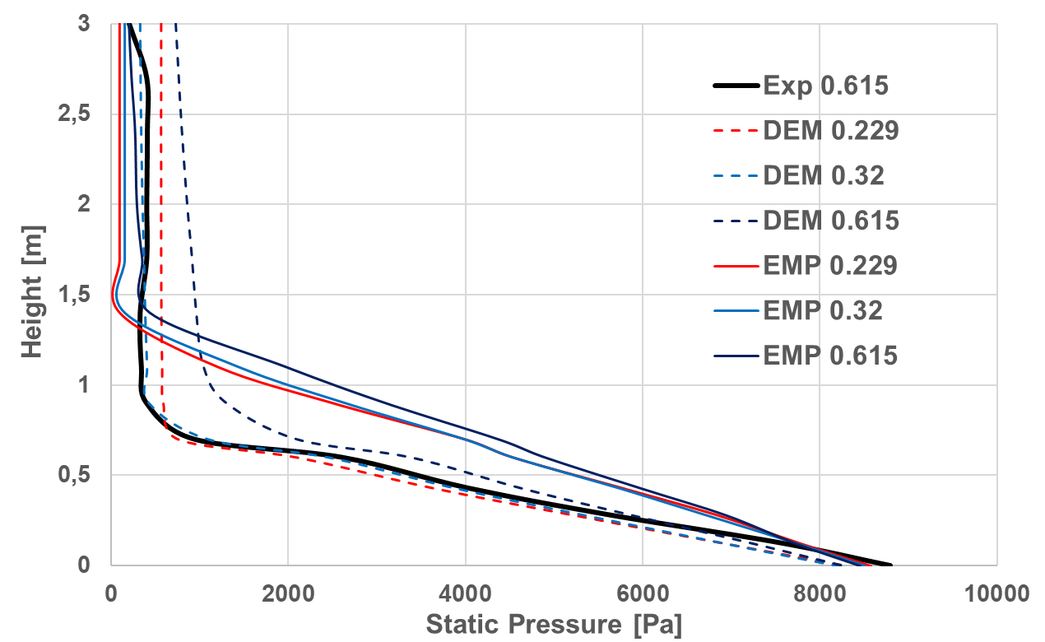
Figure 5: Static pressure profile over height of the cylindrical riser for different inlet velocities.
  - Conclusion
In this work we have compared experimental and numerical results of a fluidized bed of Geldart D particles in large scale. Findings are as follows:
- It is mandatory to use a drag correction model, because the required mesh resolution to resolve all flow patterns is prohibitive expensive and with larger cells meso-scale flow patterns like clustering get lost.
- In literature proposed EMMS-based drag correction models improve the simulation results significantly.
- CFD-DEM simulation results agree better with experimental results than EMP-KTGF results in terms of bed expansion and pressure distribution.
- Simulation time for EMP-KTGF is around 60% lower than for CFD-DEM simulation

References
Baran O., Aglave R., Tandon M., Karnik A., Lo S., 2015, Numerical Simulation of Dense Gas-Solid Fluidized Beds: Comparison Between Eulerian Multiphase and Discrete Element Methods, AIChE Annual Meeting, Salt Lake City, UT.
Cundall P.A., Strack O.D.L., 1979, A discrete numerical model for granular assemblies, Geotechnique, 29, 47
Eppinger T., Baran O., Aglave R., Lo S., 2017, Simulating Solid Suspension in Stirred Vessels with a Fully Coupled CFD-DEM Algorithm, AIChE Annual Meeting, Minneapolis
Eppinger T., Tourani C., Aglave R., 2019, Quantifying Effects of Coarse-Grain Model Parameter in CFD-DEM Simulations of Fluidized and Spouted Beds and Comparison Against Eulerian Multiphase Simulation Results, AIChE Spring Meeting, New Orleans
Herbert P., Reh L., 1999, ETH-CFB Measurement Database: General Description and Operations Manual, ETH Zurich, Zurich
[79] M. J. V. Gold Jurtz N., Kruggel-Emden H., Baran O., Aglave R., Cocco R., Kraume M., 2020, Impact of Contact Scaling and Drag Calculation on the Accuracy of Coarse-Grained Discrete Element Method, Chemical Engineering Technology, 43, 1959-1970.
Kruggel-Emden H., Vollmari K., 2016, Flow-regime transitions in fluidized beds of non-spherical particles, Particuology, 29,1–15.
Vollmari K., Jasevicius R., Kruggel-Emden H., 2016, Experimental and numerical study of fluidization and pressure drop of spherical and non-spherical particles in a model scale fluidized bed, Powder Technology, 291, 506–521.
Vollmari K., Oschmann T., Kruggel-Emden H., 2017, Mixing quality in mono-and bidisperse systems under the influence of particle shape: A numerical and experimental study, Powder Technology, 308, 101–113.

