CHEMICAL ENGINEERING TRANSACTIONS  VOL. , 2023 | A publication of
The Italian Association
of Chemical Engineering
Online at www.cetjournal.it

Guest Editor: Sauro Pierucci
Copyright © 2023, AIDIC Servizi S.r.l.
ISBN 978-88-95608-98-3; ISSN 2283-9216

Hydrothermal carbonization as a process to facilitate the disposal of bioplastics
Filippo Marchelli^{a,}*, Giulia Ischiaª, Marco Calvi^{b}, Luca Fioriª
ªDepartment of Civil, Environmental and Mechanical Engineering (DICAM), University of Trento, Via Mesiano 77, 38123 Trento, Italy
^{b}Certottica S.c.r.l. – Italian Institute of Certification of Optical Products, Villanova Industrial Area, 32013 Longarone, Italy
filippo.marchelli@unitn.it
Bioplastics are steadily replacing fossil-based plastics due to their renewable origin and biodegradability. However, their end-of-life can be problematic: they are often collected with the organic fraction of municipal solid waste (OFMSW) but can be not satisfactorily biodegradable in plants that treat it, leading to their rejection at the entrance. This work focuses on five different commercial bioplastics employed in the eyewear industry: two based on cellulose acetate, one on galalithe, one on corn starch and one on polyamide. The aim was to assess their treatability via hydrothermal carbonization (HTC), which was never reported in the literature for these materials. Under HTC at 180 and 220 °C for 1 h, four of the tested bioplastics show significant degrees of degradation, leading to the formation of different solid and liquid products, which were respectively characterised according to their elemental composition and pH. The interesting different behaviours may be ascribed to the different compositions and structures of the materials. HTC appears as a viable route to facilitate the degradation of these recalcitrant materials and may be followed by a material recovery or an energetic valorisation through anaerobic digestion or thermochemical pathways, depending on the purity of the waste stream.
  - Introduction
Bioplastic is an umbrella term employed for plastic materials that are either of biological origin or biodegradable, or both. Due to the increasing awareness regarding the environmental concerns posed by traditional fossil-based plastics, bioplastics are steadily becoming more abundant in different fields (Rosenboom et al., 2022). Most of these bioplastics are certified as biodegradable according to international standards. Thus, in principle bioplastic waste should be collected together with the OFMSW and treated via biological methods, such as anaerobic digestion or composting, which is their most studied disposal route (Gioia et al., 2021). In practice, this approach is often problematic: the standards employed to assess the biodegradability of these materials employ markedly harsher conditions and longer residence times than most of the plants that treat the OFMSW. Bioplastics often do not degrade satisfactorily in these plants (Battista et al., 2021), and sometimes are discarded at the entrance of the plants and destined for other disposal methods, such as incineration or landfilling. Other reported disposal methodologies for bioplastics include their mechanical or chemical recycling (Lamberti et al., 2020). This however requires advanced separation efficiency for valuable material recovery and may produce materials with less desirable properties (Lagazzo et al., 2019).
Hydrothermal carbonization (HTC) has been proved to be a possible path to facilitate the degradation of biogenic materials. HTC is an induced coalification process, which operates with a feedstock submerged in liquid water that is heated up to 180-250 °C, with a residence time of minutes to hours. In these conditions, water acts as a catalyst and facilitates the breakage of the biomass molecules, producing a carbon-rich solid (hydrochar), a liquid phase containing various organic components (liquor) and a gas that mainly consists of carbon dioxide (Lachos-Perez et al., 2022). The solid and liquid products of HTC may then be fed to anaerobic digestion, increasing the biogas yield (Ferrentino et al., 2020), or destined to other valorisation pathways, such as thermochemical conversion (Prifti et al., 2021), platform chemicals extraction (Gallifuoco et al., 2022) or production of adsorbent materials (Puccini et al., 2018). The HTC treatment of traditional plastics was first reported in 2015 (Poerschmann et al., 2015) and the literature features a few works on it, as recently reviewed by Mumtaz et al. (2023), but to the best of the authors’ knowledge, no work has ever reported on the HTC of bioplastics.
This work focuses on five different types of commercial bioplastics, all employed in the eyewear industry. The aim of the work is to assess whether HTC may be a suitable way to facilitate their degradation, producing materials that are more easily treatable with subsequent disposal technologies.
  - Materials and methods
This section summarises the employed materials and procedures. All the tests were performed in the laboratories of the Department of Civil, Environmental and Mechanical Engineering of the University of Trento.
    - Tested materials
This work focused on bioplastic materials that are employed in the eyewear industry, but which differ in their origin, polymeric structure and appearance. The tested materials are:
- M49 (CDA);
- Hempatica (CA);
- Lactite (LA);
- Organolite MBE102A (OL);
- Rilsan® Clear G (PA).
Table 1 summarises some properties of the materials (as provided by the producers), while Figure 1 shows their appearance.
Table 1: Properties of the tested bioplastics.
Material | Main polymer | Feedstock | Biodegradability | Melting temperature (°C) | Density  (kg/m³)
CDA | Cellulose diacetate | Wood pulp  and cotton fibre | Biodegradable according to ISO 14855 | Not stated | 1269
CA | Cellulose acetate | Hemp | Not stated | > 180 | 1270
LA | Galalithe | Milk casein | Biodegradable | > 225 | 1340
OL | Not specified | Corn starch | Compostable according to TUV | 175 | 1270
PA | Amorphous copolyamide | Bio-based | Not biodegradable | 80-200 | 600
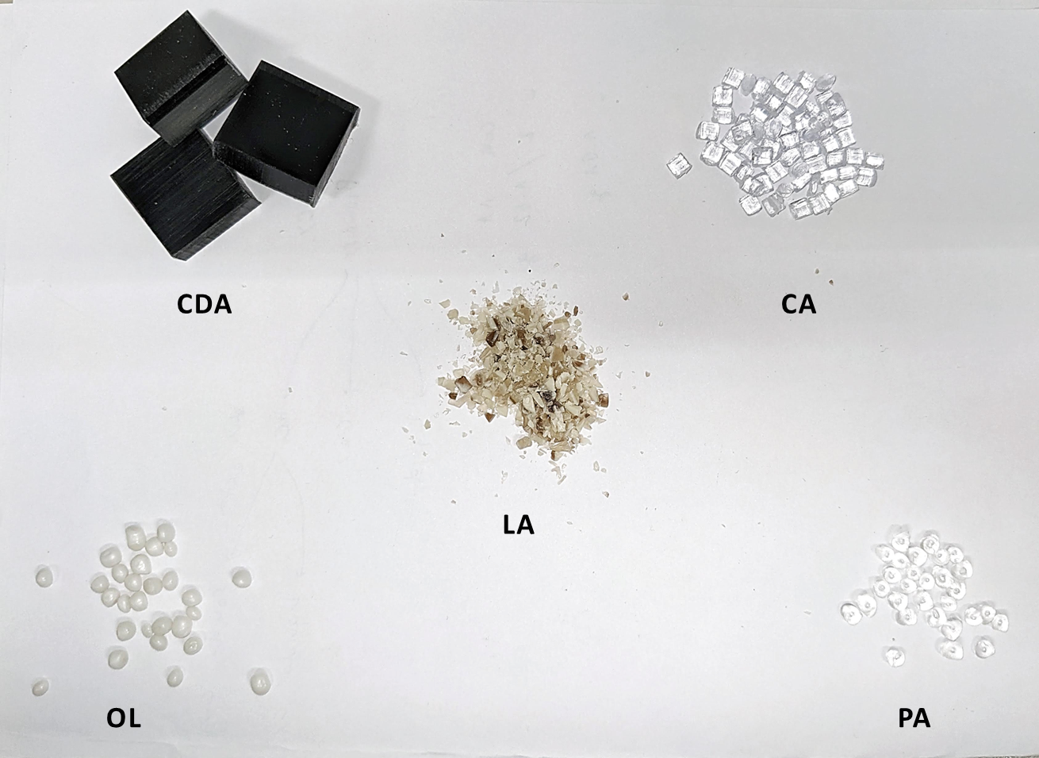
Figure 1: Appearance of the five employed bioplastics.
    - Experimental procedure
The bioplastics were subjected to HTC without any further pre-treatment. The HTC tests were performed in a 50 mL stainless steel reactor, already described in detail in previous publications (Fiori et al., 2014). Each experimental condition was tested at least twice.
In each test, the reactor was filled with about 3.50 g of the selected bioplastic and the amount of distilled water necessary to achieve a bioplastic to water mass ratio of 0.125. At the beginning, the reactor was sealed and purged with pure gaseous nitrogen to remove oxygen from the gas phase. Then, it was heated via an external electrical resistance and kept at the chosen temperature (180 or 220 °C) for a time of 1 h. After this time had passed, the reactor was swiftly cooled to ambient temperature by soaking it in liquid water. The volume of the producer gas was measured by letting it flow in a transparent cylindrical column filled with water and closed at the top. This value was employed to calculate the producer gas mass through the ideal gas equation, assuming it was entirely composed of CO₂. The slurry contained in the reactor was filtered through a 0.45 µm filter membrane with the aid of a vacuum pump. The reactor and the filter were dried in an oven at 105 °C overnight and then weighted to measure the mass of solid material produced in the HTC process. The mass yields of the gaseous and solid products (GY and SY) were calculated as the ratios between their masses and the initial mass of the bioplastic material, while the yield of the liquid product (LY) was calculated by difference.
Both the untreated bioplastics and the obtained solid products were analysed in terms of their ash content and elemental composition: the former was measured by keeping samples of them in a muffle at 550 °C overnight, while the latter was determined via a LECO 628 Elemental Analyser in accordance with ASTM D-5375 for carbon, hydrogen and nitrogen. The oxygen content was determined by difference with the amounts of C, H, N and ash, assuming that the presence of other elements in the volatile matter was negligible. The pH of the liquid phase was determined after filtration with a WTW pH 3310 pocket meter.
  - Results and discussion
    - Bioplastics composition
Table 2 summarises the elemental composition and ash content of the five bioplastic materials. The values highlight that CDA and CA have a very similar composition, which was expectable since both are based on cellulose acetate, although they are produced by different companies and possibly contain different plasticisers. Their composition is not largely dissimilar to that of OL, whose base polymer was not stated by the producers. However, OL features a significantly high ash content, which may signal the presence of inorganic additives in its formulation (Anugrahwidya et al., 2021). The only other polymer with a non-null ash content is LA, which also features a high nitrogen content, coherently with the fact that it is the only one obtained by proteins. Finally, PA also has a non-null nitrogen content and a significantly higher carbon content, as expectable due to its polyamidic structure.
Table 2: Elemental composition of the five bioplastic materials (mass fractions, with O calculated by difference).
Material | C (%) | H (%) | N (%) | O (%) | Ash (%)
CDA | 48.9 | 6.2 | 0.0 | 44.9 | 0.0
CA | 48.8 | 6.5 | 0.0 | 44.7 | 0.0
LA | 43.1 | 7.2 | 12.2 | 30.0 | 7.4
OL | 44.4 | 6.0 | 0.0 | 33.0 | 16.6
PA | 72.0 | 11.5 | 6.4 | 10.0 | 0.0

    - HTC tests
The assessment of the product yield allowed assessing the effectiveness of HTC on the five bioplastics in the chosen operative conditions. Figure 2 shows the obtained solid, liquid and gas yields. The data show that HTC can degrade all the tested bioplastics to some extent, except for the PA. A visual inspection of PA after the HTC tests proved that it indeed melts in the tested conditions, coherently with its melting temperature reported in Table 1, but then solidifies again in a single block without any significant mass loss towards the liquid or gas phases. For all the other bioplastics, the behaviour is instead quite similar: the solid yield is higher at 180 °C and the solid product has a similar appearance to the starting material, appearing solidified as a single block, whereas at 220 °C the liquid product is preponderant and the solid product results more granular and altered from its original appearance.
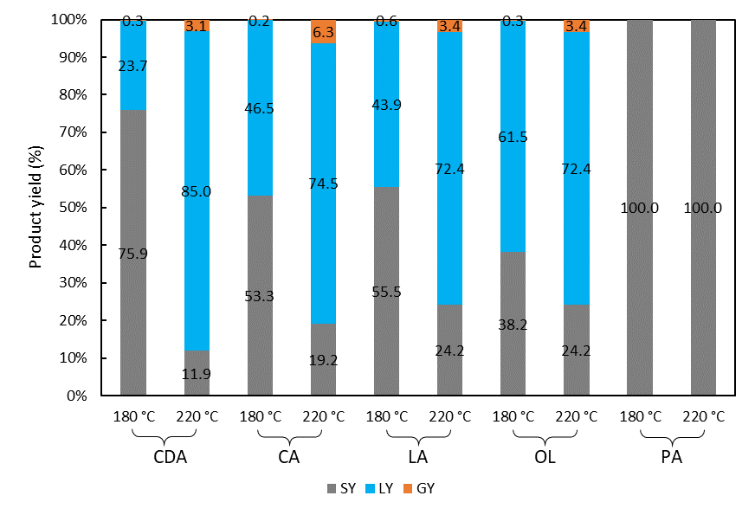
Figure 2: Yields of the solid, liquid and gas products after the HTC tests.
The results of the CHN analyses offer more insights into the fate of the elemental constituents of the bioplastics in the HTC process; Figure 3 shows elemental data for the raw bioplastics and the solid products of the tests, besides for PA which did not degrade during HTC.
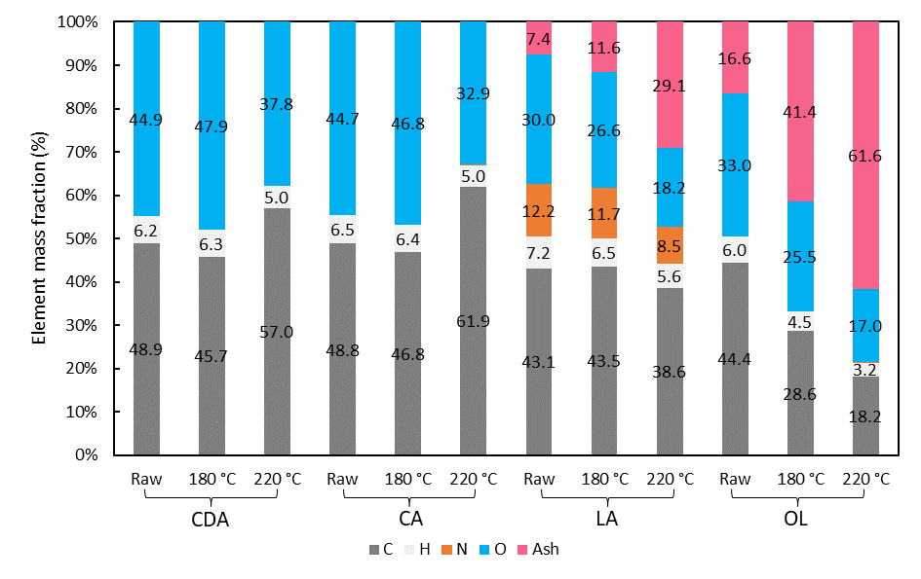
Figure 3: Elemental analysis of the raw bioplastics and HTC solid products.
For CDA and CA, the behaviour is quite similar, which may be due to the fact that both are based on cellulose acetate. The solid products obtained at 180 °C present a very similar composition to the starting material, whereas at 220 °C the solid becomes richer in carbon and poorer in hydrogen and oxygen. This was already observed for pure cellulose in previous works (Volpe et al., 2020), although cellulose acetate-based bioplastics seem to require a much lower temperature to reach comparable degradation degrees. Additives and plasticisers may play a role in determining this degradation pattern, but further research is necessary to confirm this.
The HTC of LA and OL is also comparable: the ash concentration increases due to its low-to-null solubility in the liquid phase, while the concentration of the other elements diminishes. For LA it is difficult to draw a comparison with the literature: there are only a few published works on the HTC of milk or milk products (Haj Yahia et al., 2019) and they report a higher carbon abundance in the solid, but the operating conditions and purpose are different. For OL a comparison with the literature is even more difficult due to the unknown nature of its constitutive polymer(s). However, published articles on the HTC of corn starch (Zhao et al., 2016) report an increase in the carbon content in the hydrochar, similar to other natural polymers and vegetal feedstocks. Quite interestingly, for OL increasing the HTC temperature from 180 to 220 °C causes a very minor increase of the O/C and H/C ratios, which instead noticeably decrease for the other bioplastics and for biomass in general, as well-known in the HTC literature. Such a behaviour may be due to the fact that for OL the major chemical reactions take place at 180 °C or below, and thus between 180 and 220 °C the solid only undergoes further mass transfers to the liquid and gas phases, increasing the ash concentration but not affecting substantially the element ratios.
Finally, Table 3 reports the pH of the liquid phase obtained after the HTC tests. The liquors obtained from CDA and CA are all markedly acid, which is probably caused by the release of the acetyl groups from the cellulose backbone, reported to be the first step in the degradation of cellulose acetate, regardless of the mechanism (Puls et al., 2011). The OL liquor is acid as well, although it is more difficult to hypothesise the reason since data on the polymer’s chemical structure are lacking. For LA, the liquor is acid at 180 °C but basic at 220 °C: this may be due to the thermal behaviour of galalithe or additives, which apparently release basic compounds when their degradation advances.
Table 3: pH of the liquid products of HTC.
HTC temperature (°C) | CDA | CA | LA | OL
180 | 2.63 | 2.40 | 5.70 | 2.62
220 | 2.10 | 2.63 | 8.15 | 2.56
Previous works have shown that the addition of acids may catalyse the HTC process (Lynam et al., 2011), thus some of the studied bioplastics may undergo autocatalytic behaviour. Moreover, the evolution of acid compounds may prove to be a valuable phenomenon when processing these bioplastics in a mixture, as the creation of an acid environment may facilitate the degradation of the most recalcitrant ones, such as PA (Hocker et al., 2014). Such an effect would be particularly favourable in practical applications and will be assessed in future works.
  - Conclusions
Five bio-based plastics from the eyewear industry were subjected to HTC at 180 and 220 °C for 1 h. Four of them, based on cellulose acetate, milk casein and corn starch, proved to markedly degrade at both temperatures, with a substantially higher degree of solubilisation at 220 °C. The fifth bioplastic, based on polyamide, showed no signs of degradation either at 180 °C or at 220 °C. An assessment of the properties of the solid and liquid products shows that the behaviour of the cellulose acetate-based bioplastics is rather similar, while the casein-based and starch-based bioplastics seem to behave more peculiarly, with phenomena that are usually not observed in the HTC of biomass materials. Overall, HTC seems a viable and interesting way to facilitate and accelerate the degradation of these materials and may be followed by a recovery of possible chemicals of interest or a valorisation through biological processes, aided by the increased solubilisation of the feedstock.
Acknowledgments
The authors are grateful to Fondazione Cariverona for the economic support to the Occhio al Bio! project, funded within the Ricerca&Sviluppo 2020 call. The publication was created with the co-financing of the European Union – FSE-REACT-EU, PON Research and Innovation 2014-2020 DM1062/2021.
The authors thank eyewear companies for providing bioplastic samples.

References
Anugrahwidya, R., Armynah, B., Tahir, D., 2021. Bioplastics Starch-Based with Additional Fiber and Nanoparticle: Characteristics and Biodegradation Performance: A Review. J. Polym. Environ. 29, 3459–3476. https://doi.org/10.1007/s10924-021-02152-z
Battista, F., Frison, N., Bolzonella, D., 2021. Can bioplastics be treated in conventional anaerobic digesters for food waste treatment? Environ. Technol. Innov. 22, 101393. https://doi.org/10.1016/J.ETI.2021.101393
Ferrentino, R., Merzari, F., Fiori, L., Andreottola, G., 2020. Coupling Hydrothermal Carbonization with Anaerobic Digestion for Sewage Sludge Treatment: Influence of HTC Liquor and Hydrochar on Biomethane Production. Energies 13, 6262. https://doi.org/10.3390/en13236262
Fiori, L., Basso, D., Castello, D., Baratieri, M., 2014. Hydrothermal carbonization of biomass: Design of a batch reactor and preliminary experimental results. Chem. Eng. Trans. 37, 55–60. https://doi.org/10.3303/CET1437010
Gallifuoco, A., Taglieri, L., Papa, A.A., Di Carlo, A., 2022. Advanced Biomass-to-Value Chains By Integrating Hydrothermal Carbonization into Complex Conversion Process Schemes. Chem. Eng. Trans. 92, 67–72. https://doi.org/10.3303/CET2292012
Gioia, C., Giacobazzi, G., Vannini, M., Totaro, G., Sisti, L., Colonna, M., Marchese, P., Celli, A., 2021. End of Life of Biodegradable Plastics: Composting versus Re/Upcycling. ChemSusChem 14, 4167–4175. https://doi.org/10.1002/cssc.202101226
Haj Yahia, S., Lee, K.K., Ayed, B., Hedin, N., Church, T.L., 2019. Activated Carbons from Hydrochars Prepared in Milk. Sci. Rep. 9, 16956. https://doi.org/10.1038/s41598-019-53361-5
Hocker, S., Rhudy, A.K., Ginsburg, G., Kranbuehl, D.E., 2014. Polyamide hydrolysis accelerated by small weak organic acids. Polymer (Guildf). 55, 5057–5064. https://doi.org/10.1016/j.polymer.2014.08.010
Lachos-Perez, D., César Torres-Mayanga, P., Abaide, E.R., Zabot, G.L., De Castilhos, F., 2022. Hydrothermal carbonization and Liquefaction: differences, progress, challenges, and opportunities. Bioresour. Technol. 343, 126084. https://doi.org/10.1016/J.BIORTECH.2021.126084
Lagazzo, A., Moliner, C., Bosio, B., Botter, R., Arato, E., 2019. Evaluation of the Mechanical and Thermal Properties Decay of PHBV/Sisal and PLA/Sisal Biocomposites at Different Recycle Steps. Polymers (Basel). 11, 1477. https://doi.org/10.3390/polym11091477
Lamberti, F.M., Román-Ramírez, L.A., Wood, J., 2020. Recycling of Bioplastics: Routes and Benefits. J. Polym. Environ. 28, 2551–2571. https://doi.org/10.1007/s10924-020-01795-8
Lynam, J.G., Coronella, C.J., Yan, W., Reza, M.T., Vasquez, V.R., 2011. Acetic acid and lithium chloride effects on hydrothermal carbonization of lignocellulosic biomass. Bioresour. Technol. 102, 6192–6199. https://doi.org/10.1016/j.biortech.2011.02.035
Mumtaz, H., Sobek, S., Werle, S., Sajdak, M., Muzyka, R., 2023. Hydrothermal treatment of plastic waste within a circular economy perspective. Sustain. Chem. Pharm. 32, 100991. https://doi.org/10.1016/J.SCP.2023.100991
Poerschmann, J., Weiner, B., Woszidlo, S., Koehler, R., Kopinke, F.-D., 2015. Hydrothermal carbonization of poly(vinyl chloride). Chemosphere 119, 682–689. https://doi.org/10.1016/j.chemosphere.2014.07.058
Prifti, K., Basso, D., Pavanetto, R., Manenti, F., 2021. Improving hydrothermal carbonization (HTC) processes by hydrochar gasification. Chem. Eng. Trans. 86, 925–930. https://doi.org/10.3303/CET2186155
Puccini, M., Stefanelli, E., Tasca, A.L., Vitolo, S., 2018. Pollutant removal from gaseous and aqueous phases using hydrochar-based activated carbon. Chem. Eng. Trans. 67, 637–642. https://doi.org/10.3303/CET1867107
Puls, J., Wilson, S.A., Hölter, D., 2011. Degradation of Cellulose Acetate-Based Materials: A Review. J. Polym. Environ. 19, 152–165. https://doi.org/10.1007/S10924-010-0258-0/FIGURES/11
Rosenboom, J.G., Langer, R., Traverso, G., 2022. Bioplastics for a circular economy. Nat. Rev. Mater. 7, 117–137. https://doi.org/10.1038/s41578-021-00407-8
Volpe, M., Messineo, A., Mäkelä, M., Barr, M.R., Volpe, R., Corrado, C., Fiori, L., 2020. Reactivity of cellulose during hydrothermal carbonization of lignocellulosic biomass. Fuel Process. Technol. 206, 106456. https://doi.org/10.1016/j.fuproc.2020.106456
Zhao, M., Li, B., Cai, J.-X., Liu, C., McAdam, K.G., Zhang, K., 2016. Thermal &amp; chemical analyses of hydrothermally derived carbon materials from corn starch. Fuel Process. Technol. 153, 43–49. https://doi.org/10.1016/j.fuproc.2016.08.002

