CHEMICAL ENGINEERING TRANSACTIONS  VOL., 2023 | A publication of
The Italian Association
of Chemical Engineering
Online at www.cetjournal.it

Guest Editor: Sauro Pierucci
Copyright © 2023, AIDIC Servizi S.r.l.
ISBN 978-88-95608-98-3; ISSN 2283-9216
Alternatives for Exothermicity Control of Vegetable Oils in Existing Hydrotreatment Plants to Produce Diesel and Jet Renewable
Claudia X. Ramirez^{a,}, Laura L. Garzón^{a,}*, Eduard A. Palomino^{b}, Juan E. Torresª.
ª Ecopetrol S.A., Centro de innovación y Tecnología de Ecopetrol-ICP, Kilómetro 7 via Piedecuesta, Piedecuesta, Santander, Colombia
^{b} Ecopetrol S.A., Gerencia Refinería de Barrancabermeja, Barrancabermeja, Santander, Colombia
*laura.garzon@ecopetrol.com.co.

Sustainable aviation fuel (SAF) and renewable diesel (HVO) production simulation models from Colombia palm oil and used cooking oil (UCO) were developed considering the design of an existing hydrotreating unit. Due to restrictions design of the reactor (not including liquid quench), the model was configurated, including a recycle stream of the products from the separation of the low-pressure zone toward the reactor to obtain the required system conversion. After having the product with the required conversion, two process options are selected for new feed; the first one is sent to the stripper column area where the HVO and/or SAF are obtained, removing the maximum amount of water in the stream and the CO₂ produced. A second option is to get HVO in the separation zone due to the low flow of non-condensable and products C₅- to the stripping column. This means it operates outside the hydraulics limit without presenting a significant change in the final products.

A conversion reaction model evaluation of the system is performed with the design conditions of the plant. The yield of HVO and SAF in the first case was 82% and 6%, respectively, while in the second case, the conversion of HVO was 32% and SAF 53%. The high number of recycles in both cases is due to the management of exothermicity in the reaction zone and the restriction of the total conversion of triglycerides of the current. For this reason, to achieve the maximum conversion and to operate within the allowable temperature difference of the process in both cases, it was proposed to recirculate 10 times the feed for case I and 14 times for case II.
1. Introduction
The production of biofuels is a line of research that has been developed in Colombia in recent years (Cuellar Sanchez, 2009; Tessarolo et al., 2014).In this way, the possibility of using an existing paraffinic oil hydrotreatment unit to produce HVO and SAF from Colombia palm oil or used cooking oil is studied, evaluating changes in the facilities of the unit, changes in operating conditions, in the behavior of the reactor (restrictive unit of the system due to the design conditions of unit, the temperature increment should not be higher 50°F), and the stripping unit columns.

The UCO is a type of feed that can be employed for producing HVO and SAF due to their properties and molecular similarity to palm oil; a basic comparison of features is presented in Table 1; Showing the molecular compatibility of UCO with palm oil. Another characteristic of this type of feed is the great volumes generated each year in Colombia (Rodríguez et al., 2022) and the world (Joshi et al., 2023).

Table 1. Characterization of palm oil and UCO
Triglycerides | Palm Oil (%Wt) | UCO (%Wt)
Triolein (OOO) | 0,39 | 0,47
Tripalmitin (PPP) | 0,46 | 0,28
Trilinolein ( LLL) | 0,10 | 0,2
Tristearin (SSS) | 0,05 | 0,04
In this study, a process evaluation was developed to have an a priori knowledge of the system behavior through the simulation model of the current hydrotreating unit considering the new green feed. With this, the strengths and weaknesses of adapting the existing paraffinic oil hydrotreating unit to co-process Colombian palm oil as feed to produce HVO and SAF are shown.
2. Steady-State Simulation Approach
The biofuel production model from palm oil was made in Aspen Hysys Version 12.1, the thermodynamic method used was Peng-Robinson-Stryjek-Vera (PRSV). The process begins with the feed preheating to 518°F with small delta temperature increments (less 50 °F, a restriction due to reactor design) to avoid temperature runaway in the reactor until 932 °F (maximum inlet temperature to the reactor in the last recycle), reactors operate adiabatically, is assumed that after each temperature increase the system reaches the steady state.

To produce HVO and/o SAF, the feed is initially mixed with H₂ and sent to a reaction zone of high pressure (see figure 3.); in this stage the reactor operates at 1685 psig of pressure. The reaction products are cooled and sent to high pressure separation section where to enter at approximately 212°F to a drum separator; the top products from the high-pressure separator flow to a second separator that operates at a low temperature where a H₂ rich gas is obtained, which is recycled to the process; the bottoms of high pressure separator are sent to the low-pressure separator at 60 psig and 223°F, the light components obtained in this stage of separation are separated in sour water and gas rich in propane.

The bottom from the low-pressure separator is the stream of recycle to the reactor proposed; this stream was recycled n-times, and the number of the recycles was directly proportional to the conversion of palm oil required, close to 100% (in each recycle was increased the temperature of the stream that feeds the reactor concerning the previous cycle), maintaining the operating conditions within the design conditions of the equipment used. After having the product with the required conversion, two process options are selected for new feed; the first one is sent to the stripper column area where the HVO and/or SAF are obtained, removing the maximum amount of water in the stream and the CO₂ produced. A second option is to get HVO in the separation zone due to the low flow of non-condensable and C₅- to the stripping column, which means that the column is being operated outside its hydraulics limit without presenting a more significant change in the final products.
Colombian palm oil employed in the model has the following fatty acid profile: The triglycerides from palm oil: 39.7% triolein (OOO), 42.8% tripalmitin (PPP), 10% trilinolein ( LLL), 4.8% tristearin (SSS). The feed in the simulation was represented with the four most abundant components with which there is information on the reaction kinetics as frequency factor and activation energy.

The reactions to produce alkanes from vegetable oils with hydrogen produce CO₂, propane, ethane, H₂O, light alkanes, and alkanes (Tirado et al., 2018; Tirado and Ancheyta, 2020). Hydrogenation, hydrodeoxygenation, and hydrodecarbonization reactions proposed by Vélez (Vélez-Manco, 2014) have been used for the case of HVO production (case I) and the first bed of case of production of HVO and SAF from palm oil (case II).
A set of reactions are incorporated for the development of case II, cracking, and isomerization. Twenty-two global reactions are included as follows, 17 reactions for cracking and 5 reactions for isomerization; in figure 1, the scheme of the cracking reactions of the system is shown, being of second order the cracking reactions from (1) to (2) and from (1) to (3), while the cracking reactions from (2) to (3) are first-order reactions(Gutiérrez-Antonio et al., 2016, 2020).
Hydrocarbons of C₅-C₁₇
(2)

Hydrocarbons of C₁-C₄
(3)

Hydrocarbons of C₁₅-C₁₈
(1)
Cracking
Cracking
Cracking

Figure1. Reaction scheme used in the cracking stage according to the number of carbons

In general, the scheme of reactions that occur for the hydrocarbons produced in the second bed (cracking) under high pressure and excess of hydrogen is:
${Hydrocarbon}_{Linear}+H_{2}→{Hydrocarbon}_{isomerized}+{Hydrocarbons}_{Cracked}$ (1)

A set of reactions and their respective kinetics were obtained for case I and II. This information allowed evaluation of the behavior of the reactor subject to the design conditions of the plant in each case. Table 2 shows the average of heats of reaction used in the present work; these values are based on lbmol of triglyceride or paraffin compound.

Table 2. Average heats of reaction per reaction group worked
Reaction | ∆H°RX [Btu/lbmol-H₂] /Average
Hydrogenation | -1.13x10⁵
Hydrodeoxygenation | -2.23x10⁵
Hydrodecarbonization | -8.03x10⁴
Cracking | -1.87x10⁴
Isomerization | -3.01x10³

The test temperature value was based on information from industry-known HVO and SAF production processes(Varga et al., 2018; Amin, 2019). It was observed that if the temperature at the entrance to the fixed bed reactor, adiabatic, is greater than 572 °F, the system presents a temperature runaway exceeding the design conditions, generating an operation hazard in the plant in both cases.
A
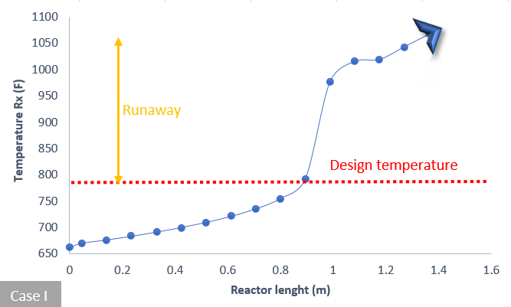

B
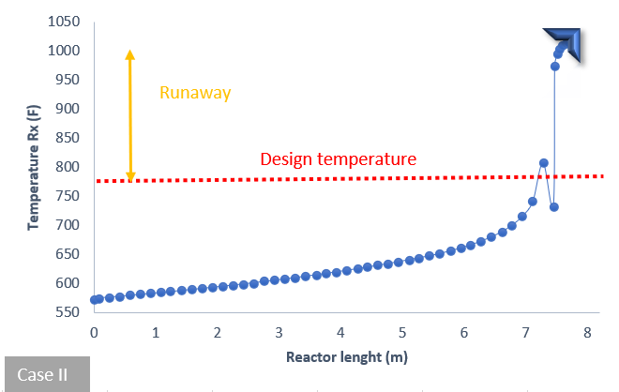
Figure 2. Runaway - Case I (A) if the reactor inlet temperature is 608 °F. Case II run (B) reactor inlet temperature 573 °F.
Due to the runaway in the reaction system for temperatures over 573°F, to achieve the maximum conversion and to operate within the allowable temperature difference of the process in both cases, was proposed to recirculate the feed several times until the required conversion is achieved. But to have a current suitable for recycling is necessary first to remove possible contaminants from the new feed. The product of the reaction zone is sent to a high-pressure drum at approximately 212°F. The top products from the high-pressure separator flow to a drum of the low-temperature separator, where an H₂ rich gas is separated; the liquid from the high-pressure separator is vaporized in the low-pressure separator at 60 psig and 223°F. The liquid from the low-pressure separator is the stream proposed to be recirculated to the reactor, a stream from which water and CO₂, products of the hydrotreating reactions have been removed. This stream must be heated each step to increase the conversion of the system without exceeding the reactor temperature delta (50 °F). Upon reaching the desired conversion, the current is sent to a vacuum stripping tower, where the last traces of contaminants are eliminated using stripping with superheated steam; in this case, it is sought to rectify the quality of products. The flowsheet of the process is shown in figure 3.
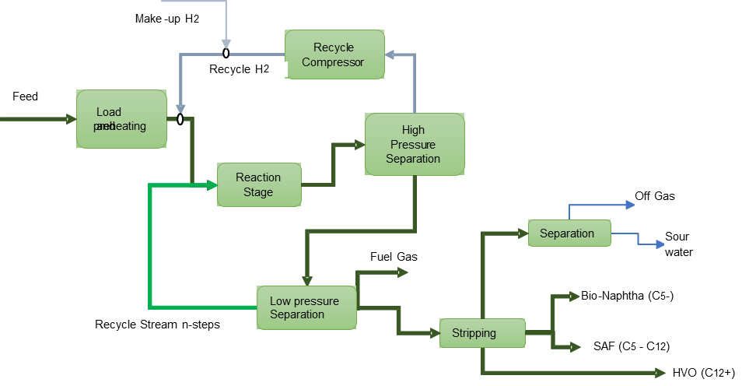

Figure 3. Block diagram of hydrotreating plant to produce HVO and SAF.

3. Results

In each recycle evaluated, a conversion of triglycerides is associated (figure 4) with the increase in reactor temperature (figure 5). Finally, the overall temperature profile of the reaction system is obtained by having a charge conversion greater than 99%. The graph of Handling exothermicity of the reaction system in case I shows how the feed stream has been treated. Was observed that it is necessary to recirculate the feed 10 times for case I, while it was found that it needed to be 14 times for case II; in both cases, it was the same process restriction, an almost 100% conversion of the original feed. It should be taken into account that the product stream leaving the reactor should not presents a temperature increase of more than 50°F; this stream is then sent to the high- and low-pressure separators, from where it is recirculated back to the process. The new feed to the reactor (product of the previous reaction cycle) is heated to a temperature higher than the temperature of the last conversion step but evaluating that the temperature delta allowed in the reactor is not exceeded, see figure 5. To make a test an industrial plant run, a possible next step in the evaluation, it should be considered that the restrictions on equipment design are the conditions that restrict the heating operation of the feed stream to the reactor. The maximum operating temperature allowed by design is 700°F in the reactor.

Figure 4. Conversion of triglycerides by recycles, Case I

Ideally, if the reactor temperature design constraints were not met, 10 recycles would be required to achieve system conversion (case I), but due to this constraint, only seven recycles of the feed are possible in both cases due to the exothermicity of the reactions hydrotreating and hydrocracking remaining remnants of PPP and SSS. The conversion behavior of palm oil for case I is presented in figure 4, where is observed the consumption of OOO, PPP, and LLL in all steps, while SSS in the first three steps presents an increase as an intermediate product and after the third recycle the consumption of the same is evident; the same behavior occurs in case II.

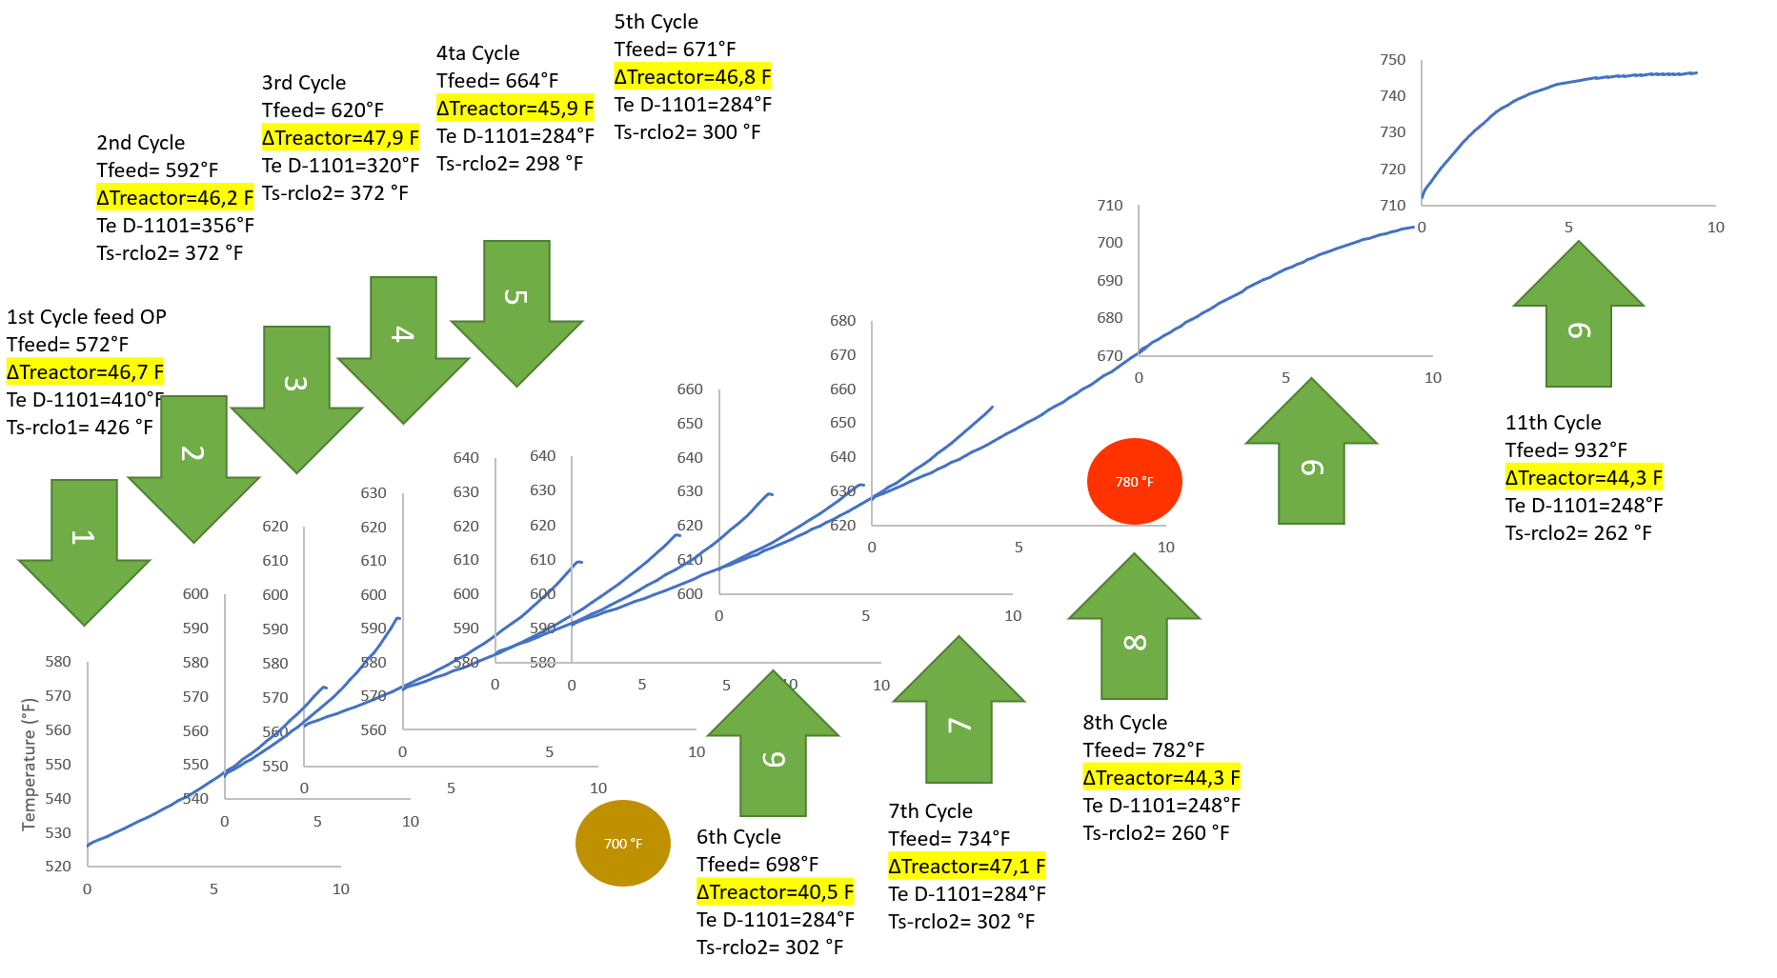
Figure 5. Handling exothermicity of the reaction system in case I.

The production of high-added value products also showed changes in each recycle. Consumption of feed per step is associated with increased HVO production in both cases. In case II specifically, although in the first recycles of the process, there is a greater flow of HVO, from recycling 7, a greater flow of SAF than the HVO begins to appear, which shows that the HVO fraction of each recycles also reacts along with palm oil. The behavior of the products is shown in figure 6.

Figure 6. Product flow, Case II.

4. Conclusions

Is possible to produce HVO and SAF in the existing hydrotreatment plant with palm oil as feed under a set of operating restrictions, mainly in reaction system when the exothermicity is controlled through to recycles of an intermediate product (converted and unconverted Palm Oil), increasing the temperature step by step until the total conversion of palm oil for each case. Unit capacity is limited in 500 BPD due to requiring exothermicity control. Used cooking oil showed similar behaviour to palm oil.

In case II (production of SAF and/or HVO from Colombian palm oil) concluded that require a greater number of recyclings,14 in total, compared to case I (production of only HVO), 10 cycles, to obtain the biofuel. A high number of recycles in both cases is due to the management of exothermicity in the reaction zone and the restriction of the total conversion of triglycerides of the current.

It should be noted that length reactor is the same for cases I and II, however configuration system catalytic in the bed was necessary changing and include 20% of bed with zeolite catalyst to promotes cracking reaction to increase SAF production of 5% to 50% in case I to case II. Was found that the cracking and isomerization reactions begin to have a significant conversion above 608°F in the system.
References
Amin, A. , 2019, ‘Review of diesel production from renewable resources: Catalysis, process kinetics and technologies’, Ain Shams Engineering Journal, 10(4), pp. 821–839. doi: 10.1016/j.asej.2019.08.001.
Cuellar Sanchez, M. , 2009, ‘Características del Biodiésel de palma y las mezclas’, Manual de Buenas Practicas de Manejo de Biodiesel y sus Mezclas., p. 29.
Gutiérrez-antonio, C. et al. , 2016, Energy integration of a hydrotreating process for the production of biojet fuel, 26th European Symposium on Computer Aided Process Engineering. Elsevier Masson SAS. doi: 10.1016/B978-0-444-63428-3.50026-6.
Gutiérrez-Antonio, C. et al. , 2020, ‘Chemical Engineering and Processing : Process Intensi fi cation Simultaneous energy integration and intensi fi cation of the hydrotreating process to produce biojet fuel from jatropha curcas’, Chemical Engineering & Processing: Process Intensification, 110(2016), pp. 134–145. doi: 10.1016/j.cep.2016.10.007.
Tessarolo, N. S. et al. , 2014, ‘Assessing the chemical composition of bio-oils using FT-ICR mass spectrometry and comprehensive two-dimensional gas chromatography with time-of-flight mass spectrometry’, Microchemical Journal, 117, pp. 68–76. doi: 10.1016/j.microc.2014.06.006.
Tirado, A. and Ancheyta, J. , 2020, ‘Scaling Up the Performance of a Reactor Model for Hydrotreating Vegetable Oil from Bench-Scale to Pilot-Scale Reactors’. doi: 10.1021/acs.iecr.0c04538.
Tirado, A., Ancheyta, J. and Trejo, F. , 2018, ‘Kinetic and Reactor Modeling of Catalytic Hydrotreatment of Vegetable Oils’, Energy & Fuels, 32, pp. 7245–7261. doi: 10.1021/acs.energyfuels.8b00947.
Varga, G. et al. , 2018, ‘Fuels from natural fatty acid esters’, Chemical Engineering Transactions, 70(August 2018), pp. 1591–1596. doi: 10.3303/CET1870266.
Vélez-Manco, J. F. , 2014, Conceptual Design of a Palm Oil Hydrotreatment Reactor for Commercial Diesel Production Conceptual Design of a Palm Oil Hydrotreatment Reactor for Commercial Diesel Production. Universidad Nacional de Colombia.

