CHEMICAL ENGINEERING TRANSACTIONS  VOL. , 2023 | A publication of
The Italian Association
of Chemical Engineering
Online at www.cetjournal.it

Guest Editor: Sauro Pierucci
Copyright © 2023, AIDIC Servizi S.r.l.
ISBN 978-88-95608-98-3; ISSN 2283-9216

Power-to-methanol process plant performances under uncertainty : economic and environmental criticalities
Alessandro Di Pretoro^{a,}*, Antonio Silvetti^{b}, Maria Cristina Annesini^{b}
ªLaboratoire de Génie Chimique, Université de Toulouse, CNRS/INP/UPS, Toulouse, France
^{b}Department of Chemical Engineering, Materials & Environment, University of Rome “La Sapienza”, Via Eudossiana 18, 00184 Roma, Italy
alessandro.dipretoro@ensiacet.fr
The main goal of the current chemical and energy industry is to define innovative solutions and methodologies to meet the UE target concerning CO₂ net zero emissions for 2050 or even negative in a long term perspective. In order to achieve this goal, during the last years the combined heat power and chemical (HPC) generation in chemical processes proved to be rather effective. However, although the use of renewables and bio-based materials allows to considerably reduce the processes environmental impact, their nature is characterized by uncertainties both in terms of availability and properties over the years seasons. In case these upstream deviations become relevant, the energy required to mitigate the disturbances should still be drawn by the electricity grid. In most of the countries, the electricity immitted in the grid is seldom obtained by renewable energy sources since it has the purpose to be stable and constantly available within a certain demand range. As a consequence, the process, whose initial purpose was to consume CO₂, is actually a positive emission system due to the energy consumption aimed at compensating perturbations. In the light of these premises, in this research work the analysis of a power-to-methanol process under uncertainty is carried out according to the flexibility indexes based methodology proposed by Di Pretoro et al. (2019). The system is composed by an electrolysis section aimed at the production of green hydrogen and a cogeneration power plant fed by biomasses that provides CO₂ for the methanol synthesis. Based on the characterization of the uncertainty related to the variable biomass nature over the year seasons and to renewable energy availability, this particular approach allows to quantify the system performances under of external perturbation in terms of costs and emissions for a given methanol demand. The obtained results provide a quantitative analysis of the power-to-methanol process behaviour and permits to synthesize the system flexibility by means of a single index and to correlate it with investment and operating costs as well as with the Greenhouse Warming Potential. This methodology enables then the decision maker to have more conscious expectations about the designed plant and could be used in further studies to adapt the system design to the expected deviation in order to have a more flexible process.
  - Introduction
Nowadays, one of the major issues of the European Union is carbon neutrality. For this purpose, a set of actions concerning transportation, energy, environment and industrial policies have been taken in order to reduce the equivalent CO₂ emissions by 55% (European Council, 2019). In order to enhance the energy transition, major modifications from multiple perspectives are required. A first approach is based on the captured CO₂ reuse as an exploitable raw material to produce higher added value molecules for the market. This strategy allows both to reduce emissions and to take advantage from a molecule that is usually considered as a waste product. A second option is to employ sustainable raw materials, such as biomasses, as feedstock for chemical processes that are usually fed by oil derived chemicals since they are a natural storage of carbon based molecules. Then, from the energy side, the use of renewables could have a considerable impact on the sustainability of both industrial processes and transportation emissions when dealing with E-fuels. Solar and wind power could be in fact exploited to provide the required duties in terms of heat and electricity to industrial processes and power plants that are conventionally fed by energy deriving from fossil fuels such as methane or oil combustion to provide thermal duties, for the steam generation in chemical plants or electricity to be sent to the power grid. In this perspective, the most sustainable E-fuel is hydrogen and electrolysis is the greenest way to produce it if renewables are used as source of electricity. The main inconvenient of this approach comes from the economic side since electrolysers have non-negligible costs and the sustainability of a process is of a comparable importance with respect to its profitability.
Nevertheless, even whether technologies are sufficiently developed to ensure affordable costs and emissions, there’s still one issue related to renewables concerning their difficulty to be stored. For this purpose, a new approach of the energy industry is based on the exploitation of chemicals as energy storage. As already mentioned, hydrogen is one of the most valuable ones. However, at standard conditions, hydrogen is a gas and, in order to have a relevant energy density, it needs to be compressed. Thus, more practical options have been identified in chemicals such as methanol, ethanol or dimethyl ether. Among them, methanol has seen particular attention as energy vector due both to its versatility as intermediate chemical and to its possible reconversion into a high value energy source as a fuel. Nowadays, the power-to-methanol plant layout, better described in Section 2, is one of the most interesting design choices to couple chemicals and energy according to the sustainability standards the EU and the worldwide industrial sector aim at. Anyways, being this configuration based on the exploitation of both biomasses and renewables, the design under nominal operating conditions is not sufficient to assess the actual performances. Due to variability of both raw materials and the energy source, uncertainty needs to be taken into account in terms of productivity, economic as well as sustainability performances. That is why, we present a flexibility analysis for a power-to-methanol simplified scheme case study to evaluate the impact of perturbations on the plant behaviour both from a qualitative and a quantitative point of view.
  - The “power-to-methanol” case study
The selected case study for this research is a power-to-methanol process plant whose simplified scheme is reported in Figure 1. In particular, the energy plant is fed by biomasses while the renewable energy section tha was taken into account in this work only concerns solar power. The case study plant is a 4MW power plant to design that would be located in Lazio and whose detailed properties in terms of process parameters and uncertain variables are better described in the following subsections.
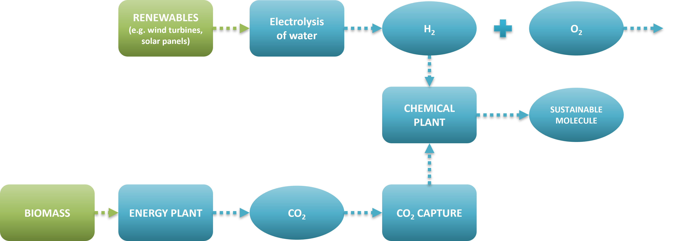
Figure 1: Power-to-methanol plant simplified scheme
    - Process variables
The plant design is performed with a two-step approach. The first phase is related to the energy section of the plant and both thermal and mass balances are performed via Matlab calculations according to the selected process parameters that, for this case study, are provided in Table 1. Then, the reaction section is simulated by means of Pro II process simulator over a wide range of temperature and pressure in order to detect the optimal reactor operating conditions in terms of conversion and the relative methanol productivity as well as the required process duties. In particular, after a preliminary thermodynamic analysis with the given feed hydrogen to carbon dioxide ratio, the selected temperature and pressure for this case study are 200 °C and 50 atm. At last, the net income concerning the net electricity power provided to the grid and the methanol productivity are calculated accounting for the specific cost values equal to 0.172 €/kWh (IEA, 2019) and 0.306 €/kg (Methanol Institute, 2022) respectively.
Table 1: Process and uncertain* parameters
Variable | Symbol | Value | Unit | Min value | Max value | Discretization
Biomass combustion heat* | H_{b} | 10 000 | kJ/kg | 7 000 | 13 000 | 150
Biomass specific emissions* | E_{b} | 1.83 | kg_{eq}/kg | 1.4 | 2.2 | 0.0183
Cogeneration efficiency | η_{e} | 40 | %
CO₂ capture efficiency* | η_{c} | 90 | % | 70 | 100 | 7.5
H₂/CO₂ ratio | r | 3 | /
Electrolysis energy consumption | E_{el} | 50 | kWh/kgH₂
Photovoltaic power* | P_{p} | 44 | MW | 26.4 | 61.6 | 0.44
Plant nominal power | P_{e} | 4 | MW

    - Uncertain variables
As concerns the uncertain parameters to be modified during the flexibility analysis, four of them have been selected as listed in Table 1 according to their variation range and discretization step.
In particular the biomass properties variability is related to its nature that depends both on the year seasons and on the specific feedstock selected for the cogeneration sections. The solar power as well can vary over the years seasons according to the values for Rome obtained thanks to the model UNI 8477/1. Finally, the CO₂ capture performances could vary due to inherent perturbation of the absorption section.
  - Methodology
In the next subsections both the power-to-methanol plant design and the flexibility analysis will be discussed in detail. In particular, the analysis is performed by coupling a Matlab code with the Pro II process simulation. The former software is used to generate the uncertain parameter discretization and to perform preliminary calculations required to provide the input data that are then exploited by the process simulator to calculate results over the uncertain domain.
    - Plant design and simulation
The plant design is performed in two phases with different degrees of accuracy. The first part is calculated via Matlab and exploits mass and energy balances. Given the power of the plant and the biomass specific heat, the feed flowrate is evaluated and, thus, the amount of CO₂ that is captured can be quantified. After that, the stoichiometric amount of hydrogen is assessed and the required electrolysis energy consumption is obtained as a consequence. All required model equations are listed here below:
$$F_{b}=\frac{P_{e}}{η_{e}⋅H_{b}}$$ | (1)
$$F_{CO_{2}}=η_{c}⋅F_{b}⋅E_{b}$$ | (2)
$$F_{H_{2}}=r⋅F_{CO_{2}}$$ | (3)
$$P_{el}=F_{H_{2}}⋅E_{el}$$ | (4)
Therefore, the obtained data for process feed are sent to the Pro II to simulate the reaction section. One aspect of critical importance for the process development is the maximum conversion (i.e the conversion at the equilibrium) achieved at the outlet of the reactor and, in this work, the Gibbs free energy minimization method (i.e. Gibbs reactor model in PROII) is used for the evaluation of equilibrium conditions. In particular, it is assumed that the components in the system are CO₂, H₂, methanol, water and CO; in this way also the methanol synthesis from CO and the reverse-water gas shift, which can occur in the reactor, are accounted for. After the reactor, a preliminary flash unit is used to recover and recycle part of the unreacted gases while the liquid phase is sent to a further purification section to obtain methanol at the required composition to meet the market standards. The output parameters of the simulation are the duty consumption and the methanol productivity that are sent back to Matlab in order to perform the economic part related to the flexibility assessment.
    - Uncertainty
As concerns the part of flexibility analysis, it has been performed by means of the flexibility index (F_{SG}) proposed by Swaney and Grossmann (1985). It is a deterministic index, i.e. it is based on the magnitude of the deviation considering all perturbations equally probable, and it is defined as the maximum fraction of the expected deviation that can be accommodated by the system. From a graphical point of view, it represents the minimum among the maximum fractions of the hyperrectangle sides' lengths that is bounded by the feasible zone as shown in Figure 2.
From a mathematical perspective, its formulation is given by:
$$F_{SG}=\max_{}{δ}$$ | (5)
$$s.t.\max_{θ∈T(δ)}{}\min_{z}{}\max_{j∈J}{f_{j}(d,z,θ)≤0}$$ | (6)
$$s.t.χ(d)=h\left(d,z,θ\right)=0$$ | (7)
$$δ≥0$$ | (8)
$$T\left(δ\right)=\{θ|θ^{N}-δ*∆θ^{-}≤θ≤θ^{N}+δ*∆θ^{+}\}$$ | (9)
where θ represents the uncertain parameters, d the design variables, z the control variables, f the feasibility region and δ the scale factor defining the hyperrectangle T.

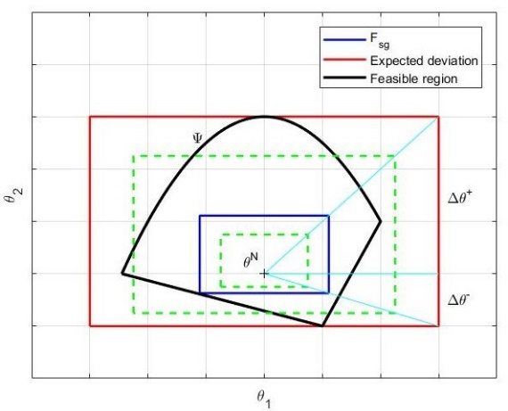
Figure 2: Swaney and Grossmann flexibility index
It is worth remarking that, in this research work, we solve the flexible design problem. This means that the process system costs, in this case operating expenses, are calculated on the basis of the perturbed process conditions and the value associated with the index is the most restrictive constraint that should be afforded to ensure the operation feasibility for any deviation of the region inscribed in the hyperrectangle characterized by a side size equal to F_{sg}. Once the flexibility analysis is carried out over the entire uncertain domain as reported in Table 2, the parameters corresponding to each value of the F_{SG} index can be exploited to calculate the corresponding income. According to the methodology proposed by Di Pretoro et al. (2019) an economic vs. flexibility plot can then be used to summarize the results as explained in the next section.
  - Results
The entire simulation was performed under nominal case conditions first. The most relevant values among the obtained results, that will be useful for the next step, are listed in Table 2.
Table 2: Results under nominal operating conditions
Variable | Value | Unit
Reactor conversion | 0.4 | /
Electrolysis Power | 40 426 | kW
Net Power Production | 7 574 | kW
Methanol Production | 4 312 | kg/h
Net Income | 39 802 | €/day
As explained in the previous sections, the flexibility analysis was performed for the four uncertain parameters. In order to allow the graphical representation of the results in the 3D space it was made twice by using two parameters at a time.
In particular, we made the choice to couple parameters related to energy, i.e. photovoltaic power and biomass heating value and those related to CO₂, namely specific emissions and capture efficiency.
First of all, a sensitivity analysis over the uncertain domain is carried out. In the first case, methanol production, and thus the associated income, doesn’t change since energy related variables don’t affect the plant power side.
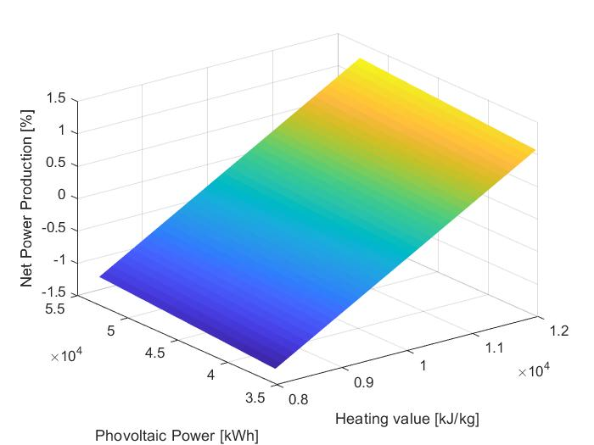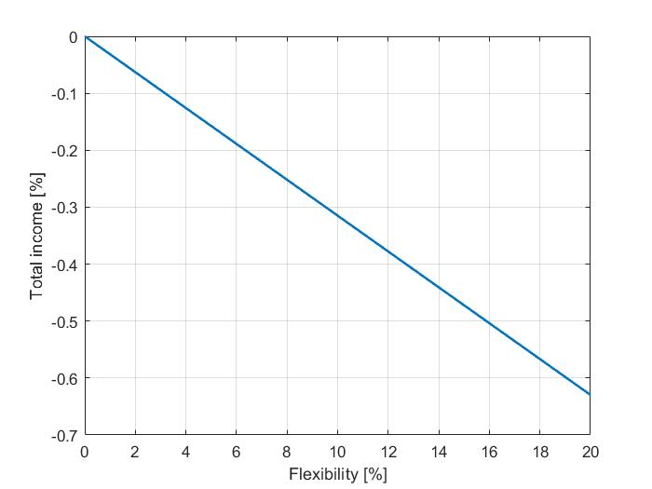
Figure 3: Results for case study 1 – Net Power Production (left) and Income vs F_{sg} (right)
As it can be noticed in Figure 3 (left) the produced power of the plant linearly increases with respect to the increase of the two variables as expected. Therefore, the units of the analysis are converted in terms of flexibility and economic indicators expressed as a percentage of deviation and as the total income values normalized with respect to the nominal ones. Since the flexibility index of Swaney and Grossmann accounts for the worst case scenario, the resulting trend corresponds to the diagonal line going from the center of Figure 3 (left) to the bottom corner. Beside the decreasing trend, an important value is the slope of the line corresponding to about 0.03% of the income losses for unit percent of F_{sg}.After that, the second part of the analysis is performed. In this case, biomass emissions and the amount of captured carbon dioxide affect both methanol and net power production. This is due to the fact that the system is designed to allow the conversion of all the captured CO₂ and, as a consequence, the energy for electrolysis is adapted to the stoichiometric hydrogen quantity to be produced. As we can see in Figure 4 (left) the amount of produced methanol increases with a slightly non-linear trend towards higher capture and emissions in the range of [-40 +60]%. As a consequence, the power consumption increases in the same direction, i.e. the net power production decreases when higher emissions and efficiency occur, but with a much higher variation with respect to the nominal operating conditions ([-300 +180]%).
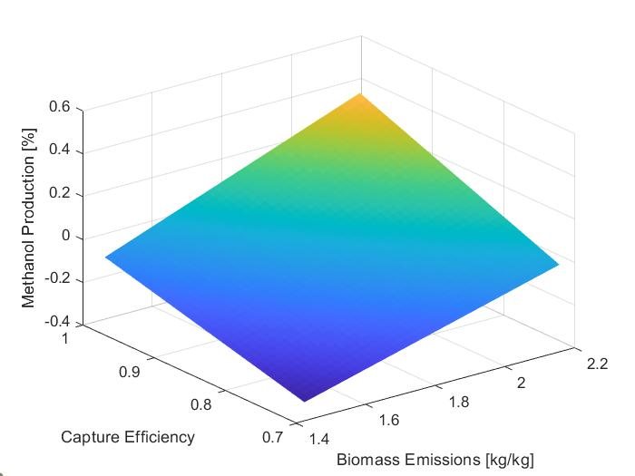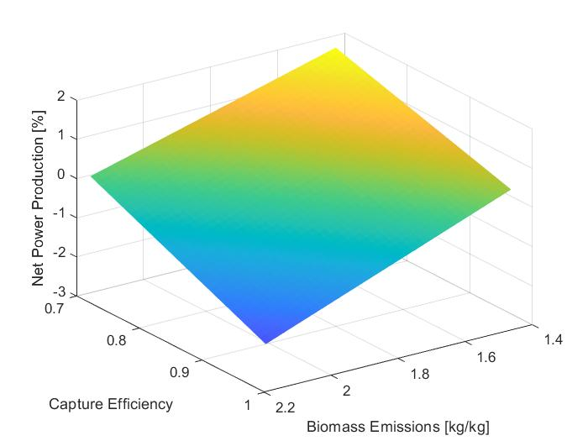
Figure 4: Results for case study 2 – Methanol production (left) and Net Power Production (right)
As a combination of these two effects, while for the previous case the trend of the income was similar to that of the power production, in this second case study it is given by a linear combination of methanol productivity and energy that can be immitted in the grid according to a coefficient equal to their specific cost.
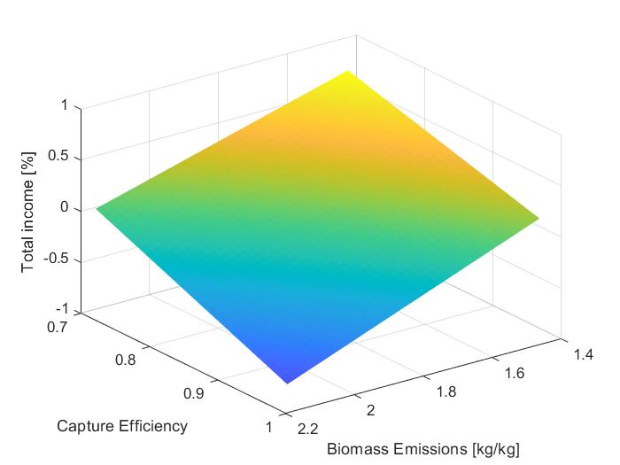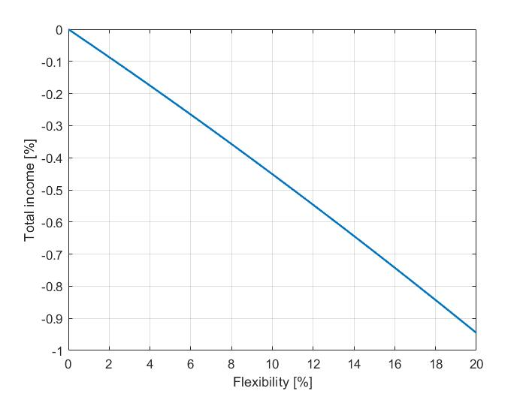
Figure 5: Results for case study 1
Figure 5 (left) shows, as a result of this combination, that the total income trend has different slope when going towards positive/positive or negative/negative deviation of the variable. Due to comparable values of the income related to methanol and that of the electricity, the variation range [-0.71 +77]% is a weighed compromise between the previous two plots and its slope is more mitigated than the Net Power Production one.
The behaviour of the income with respect to the F_{sg} index shows a little bit of convexity with respect to that of the previous case study with a similar slope due to the fact that the positive/negative diagonal is less affected by the competitive behaviour of the two uncertain parameters. However, the decrease is less relevant in this case but the difference is about 0.0475% every percent of F_{sg}.
  - Conclusions
The proposed approach based on deterministic flexibility indexes to study the performances of power-to-methanol process plants under uncertainty proved to be effective both from a qualitative and a quantitative point of view. The analysis was possible over the entire considered deviation range due to the prior feasibility evaluation of the process. The economic assessment was carried out with a sufficient accuracy degree to allow the estimation of profitable conditions in case of external perturbations and to quantify the actual gain and losses accordingly. Further developments of this work could be, for instance, the flexibility analysis involving on all four parameters at the same time or also the use of stochastic flexibility indexes based on the probabilistic characterization of the uncertain parameter deviations.
References
The commission of the European Parliament, the European Council, the Council, the European Economic and Social Committee and the Committee of the Regions, 2019. The European Green Deal <https://eur-lex.europa.eu/legal-content/EN/TXT/?uri=COM%3A2019%3A640%3AFIN> accessed 10.12.2022.
Di Pretoro A., Montastruc L., Manenti F., Joulia X., 2019. Flexibility analysis of a distillation column: Indexes comparison and economic assessment. Computers & Chemical Engineering 124, 93–108.
Fedeli M., Manenti F., 2022. Assessing process effectiveness with specific environmental and economic impact of heat, power & chemicals (HPC) option as future perspective in biogas. Cleaner Chemical Engineering 2, 100016, https://doi.org/10.1016/j.clce.2022.100016.
Gadalla M., Olujić, Ž. Jobson M., Smith R., 2006. Estimation and reduction of CO2 emissions from crude oil distillation units. Energy 31, 2398–2408.
IEA, 2019. Industry end-user electricity prices in selected OECD countries <https://www.iea.org/data-and-statistics/charts/industry-end-user-electricity-prices-in-selected-oecd-countries-2019>accessed 10.12.2022
Methanol Institute, 2022. Methanol price supply demand <https://www.methanol.org/methanol-price-supply-demand/> accessed 10.12.2022.
Swaney R. E., Grossmann I. E., 1985. An Index for Operational Flexibility in Chemical Process Design. Part I: Formulation and Theory, AIChE Journal, 31, 621–30.

