CHEMICAL ENGINEERING TRANSACTIONS  VOL. , 2023 | A publication of
The Italian Association
of Chemical Engineering
Online at www.cetjournal.it

Guest Editors: Sauro Pierucci, Jiří Jaromír Klemeš
Copyright © 2023, AIDIC Servizi S.r.l.
ISBN 978-88-95608-98-3; ISSN 2283-9216

Thermodynamic Validation of CESAR1 Model and Effect of Water Wash Configurations
Diego D. D. Pinto^{a,*}, Jeffrey A. Weinfeld ^{b}
ªHovyu B.V., 3118JW, Schiedam – The Netherlands
^{b}Optimized Gas Treating, Inc., 212 Cimarron Park Loop, Buda, TX 78610 – USA
*corresponding author: diego.pinto@hovyu.com
Validation of thermodynamic models used in process simulators is important to ensure that predictions are accurate and can be used with high degree of confidence. Vapor-liquid equilibrium is one of the important parameters to be validated when using process simulators to design, simulate and optimized CO₂ capture processes. In this work, the thermodynamic model implemented in ProTreat® of CESAR1, a blend of 1.5 M piperazine (PZ), and 3.0 M 2-amino-2-methyl-1-propanol (AMP) is validated against experimental data. Currently, literature data is available only at absorber/desorber conditions. New data under water wash conditions will soon be available (under the Sustainable OPEration of post-combustion Capture plants, SCOPE, project) when the ProTreat® model will be updated to take account of the new dataset. Nonetheless, the current model already shows good agreement with literature. Recent pilot validations have confirmed that the software is accurate to use for designing CO₂ capture plants. An evaluation of the water wash (WW) effect on the amine volatile emissions was also performed. Different WW configurations were tested for a generic post-combustion CO₂ capture process. It was observed that the double WW configuration was most suited for CESAR1 if volatile amine emissions were required to be below 1 ppmv. Water balance was also greatly impacted by WW configuration and operating conditions and should be considered when designing this step in the process.
  - Introduction
Amine-based chemical absorption is state-of-the-art for post-combustion CO₂ capture. An aqueous solution of 30 wt. % monoethanolamine (MEA) has been historically considered the benchmark solvent. MEA is the most widely studied solvent and a large amount of data is publicly available. However, one of the criticisms of MEA is its relatively high regeneration energy demand, around 3.7 MJ/kg_{CO2} (Knudsen et al., 2011). Since a large part of the process energy requirement is related to the heat of absorption (an intrinsic characteristic of the solvent), research has long been concentrated in developing solvents with low(er) energy requirements. Several solvents were developed including proprietary and open (as the CESAR1 – a blend of 1.5 M piperazine, PZ, and 3.0 M 2-amino-2-methyl-1-propanol, AMP), all of which were able to reduce energy requirement below 3 MJ/kg_{CO2}. Because of its lower energy demand, there is a new trend to consider CESAR1 the new benchmark solvent for post-combustion carbon capture (Feron et al., 2020).

Energy consumption is, however, not the only parameter deserving of attention in a CO₂ capture plant. The rate at which CO₂ reacts with the solvent, and the volatility of the solvent, for instance are two other important factors. The first will affect the size of the absorber, while the second will dictate the amine volatile emissions (aerosol emissions undergo a different mechanism, see for instance Majeed et al. (2017)) and affect the emissions mitigation strategy.

The regeneration section of the amine-based CO₂ capture plant, i.e., stripper and reboiler, operates at nearly equilibrium conditions. Thus, having a model that accurately represents the vapor-liquid equilibrium (VLE) of the solvent is important to correctly calculate the energy requirement of the process (and properly design the CO₂ capture plant). Moreover, volatile emissions will also be well represented when an accurate VLE model is used.

Process simulators are often used to design and optimize a carbon capture plants by focusing on the energy requirement and capture rate. Most of the models used in the process simulators were developed with available literature which were focused on the absorber/desorber operating ranges (e.g., high amine concentration). Under the Sustainable OPEration of post-combustion Capture plants (SCOPE) project (SCOPE, 2021), novel experimental data under water wash conditions (low amine concentrations) are being generated for both MEA and CESAR1 solvents to close the existing gap in literature data. The new data generated under the SCOPE project will be used to update the thermodynamic model of future versions of ProTreat®, which is the mass-transfer rate-based simulator developed by Optimized Gas Treating, Inc.

In this work, validation is performed of the CESAR1 equilibrium model used in v.8.0 of ProTreat®, which was developed using existing literature data. The proprietary ProTreat® thermodynamic model is based on the Deshmukh-Mather VLE model, and is tuned using interaction parameters fitted for the CESAR-1 system (Deshmukh & Mather, 1981). Since ProTreat® is an entirely rate-based model, the simulator accounts for the impact of physical properties, tower hydraulics, gas and liquid loads, and reaction rate for calculations across phase interfaces, rather than assuming equilibrium stages. In this case study, water wash (WW) designs of a CO₂ capture treating generic coal-fired power plant flue gas were studied to evaluate the effect on amine emissions.
  - VLE validation
The VLE calculations were performed by using a flash block in ProTreat®’s flowsheet. The CO₂ loading of the flash inlet stream was varied and the equilibrium vapor and liquid composition was calculated. Although the experiments covered a wide range of compositions and temperatures, in this work, only available literature data for the CESAR1 concentration (27 wt.% AMP + 13 wt.% PZ) was used in the validation. As mentioned, ProTreat® is undergoing a major update of its AMP/PZ thermodynamic model to include new experimental data, and validation of a wider range of data will be presented in the future.
    - Results
Figure 1 shows the calculated and experimental pressures for the AMP 27 wt.%/PZ 13 wt.% solution. Analysis shows some inconsistencies amongst the available experimental data. The measured CO₂ partial pressures from Yang et al. (2010) are generally lower than other sources. At 80 ˚C, however, the discrepancy is very pronounced. While Hartono et al. (2021) and Brúder et al. (2011) respectively measured the CO₂ partial pressures at 13.1 and 9.9 kPa for the corresponding loadings of 0.42 and 0.41, Yang et al. (2010) presented a measurement of 2.5 kPa for a loading of 0.42 (more than 300% deviation).

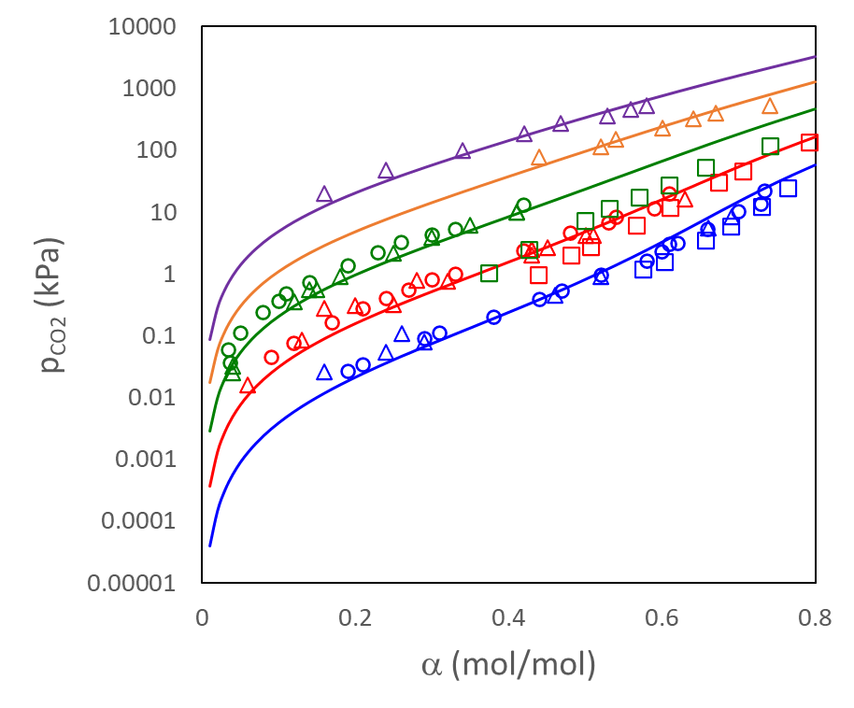  a | 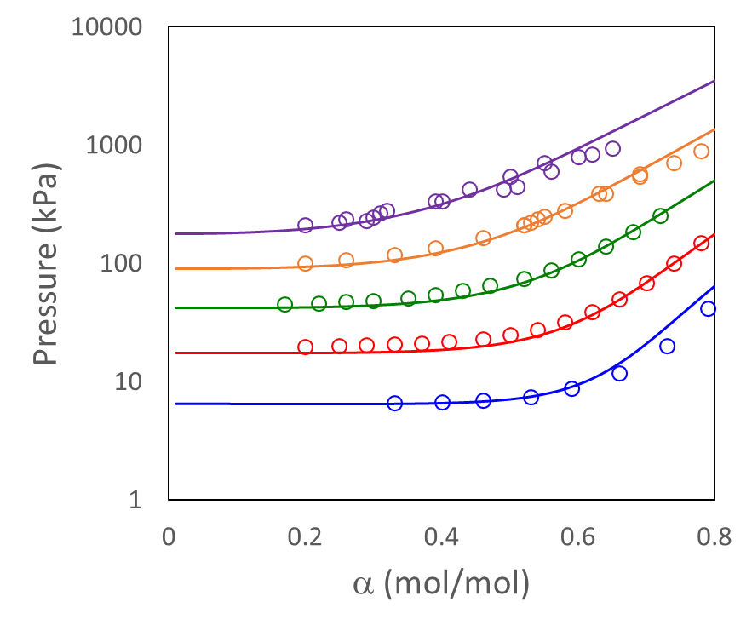  b
Figure 1: Experimental and calculated equilibrium pressures as function of the loading (α) for 27 wt.% AMP + 13 wt.% PZ aqueous solutions. (A) Partial pressure of CO₂, p_{CO2}; and (B) Total pressure, p_{total}. Temperatures: 40 ˚C (blue), 60 ˚C (red), 80 ˚C (green), 100 ˚C (orange), and 120 ˚C (purple). Experimental points: (o) Hartono et al. (2021), (Δ) Brúder et al. (2011), and (□) Yang et al. (2010).
As seen in Figure 1b, Hartono et al. (2021) presents the total pressure measurements at 80 ˚C. By subtracting the solvent partial pressure at zero loading, it is possible to estimate the CO₂ partial pressure from those measurements. In Figure 2, the comparison of the data and model at 80 ˚C is shown (where 40 ˚C was kept for perspective). The filled circles represent estimations from the total pressure data. It is seen that the estimated CO₂ partial pressure is in agreement with the other measurements, and also highlights the discrepancy of Yang et al. (2010) data. Although CO₂ partial pressure can be estimated from total pressure measurements, this data should be used cautiously. Measured data (rather than estimated), especially at low loading ranges, should always be preferred.

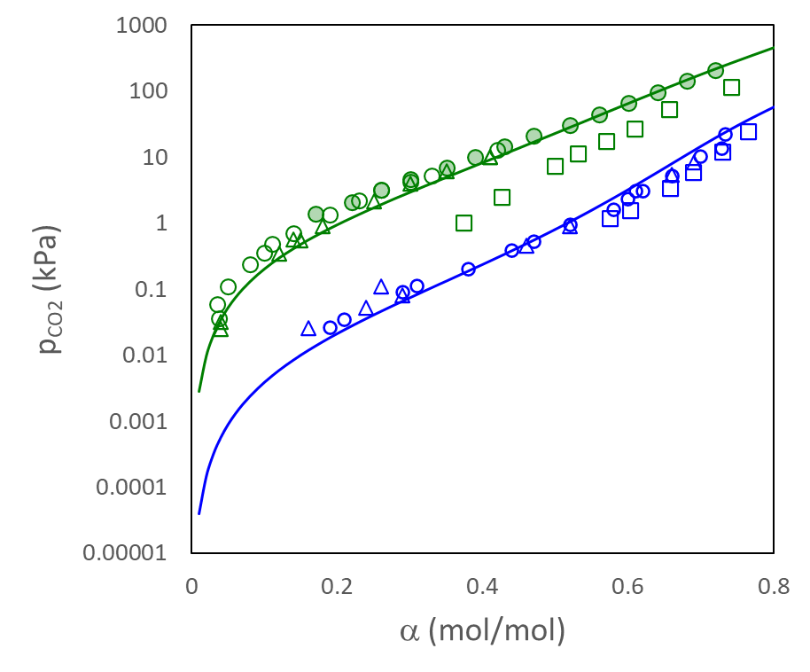
Figure 2: Partial pressure of CO₂ at: 40 ˚C (blue), 80 ˚C (green). Experimental points: (o) Hartono et al. (2021), (Δ) Brúder et al. (2011), and (□) Yang et al. (2010). Filled circles are estimated CO₂ partial pressure from total pressure measurements.
Despite that inconsistency, the model is in very good agreement with the experimental data for both the CO₂ partial pressure (Figure 1a) and the total pressure (Figure 1b). The accuracy is in an acceptable range to use the model to design, simulate and optimize CO₂ capture plants. Moreover, the same CESAR1 model was validated against pilot plant data and was able to accurately represent the experiments (Pinto et al., 2022)(Pinto et al., 2022). This confirmed that the model can be used with a great degree of confidence to represent a CO₂ capture process using CESAR1 solvent.
  - Water wash modeling
A generic flue gas with flow rate of 96.55 kNm³/h composed of 14.2 vol.% CO₂, 80.8 vol.% N₂ and 5 vol.% O₂ (all in dry basis) and saturated water was used to study the effect of water wash on the volatile emissions of CESAR1. The gas entering the absorber was assumed to be 40 ˚C and 1.050 bara. A complete process (absorption-desorption loop) was modelled in the ProTreat® process simulator (see Figure 3). The control block (CB) calculates the make-up and/or bleed (water and amines) to keep the solvent at the specified concentration. The water wash section was decoupled from the absorber for ease of visualization, but in principle it belongs to the same columns as the condensate entered at the top of the absorber. The process was optimized to capture 90% of the CO₂. The flue gas leaving the absorber (entering the WW section) was at about 63.5 ˚C and with concentration of around 1000 ppm of AMP and 45 ppm of PZ.

Single and double water wash configurations were tested (Figure 3 only shows the single WW configuration. A double WW configuration is composed of two WW sections in series with independent water loops). For the single water wash, the packing height was varied from 3 to 6 m, while the double water wash configuration was tested using two packings of 2 m each and two packings of 3 m each. In all columns, the packings were chosen as Mellapak 250X. The hydraulics were calculated by a Sulzer proprietary model while the Billet-Schultes (REF) model was used to calculate the mass transfer.

For the water wash loop(s), two cooling temperatures were tested: 35 and 40 ˚C. For the stripper condenser and lean cooler, the temperature was set to 40 ˚C. The objectives of the water wash in this case are twofold: (i) mitigate/eliminate the amine emissions, and (ii) close the water balance of the plant.
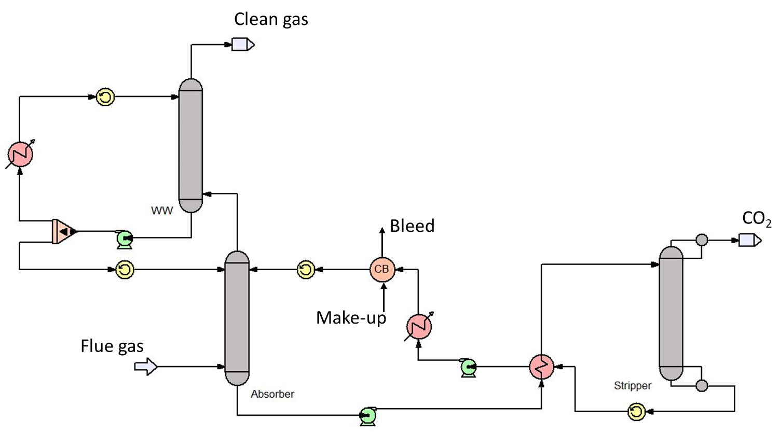
Figure 3: Flowsheet in ProTreat® of a generic CO₂ capture process (for single water wash).
    - Results
The water wash section(s) were designed to achieve around 40 ˚C in the flue gas leaving the column. Figure 4 shows the results for the varying packing heights and cooling temperatures. In general, it is seen that a single WW will lead to amine emissions higher than 6 ppmv (mainly AMP). The double WW configuration can eliminate amine volatile emissions at the expense of extra equipment (packing section, pump and heat exchanger) and higher (water) circulation flow.

When the cooling temperature of the WW loop is set to 35 ˚C (Figure 4a), the water make-up required to close the water balance is rather significant. Increasing the packing height would reduce the water requirement, but even at 6 m packing height, the water requirement would be considerable. This effect is due to the true rate-based model characteristics of the ProTreat® model. Rigorous mass-transfer calculations of chemical kinetics, diffusion coefficients, and transport properties around column hardware can reveal such effects that would not be represented in an equilibrium-based simulation. Therefore, increasing the contact area (packing height) will increase the mass transfer rate (if not in equilibrium), and in this case more water is transferred from the gas to the liquid phase.

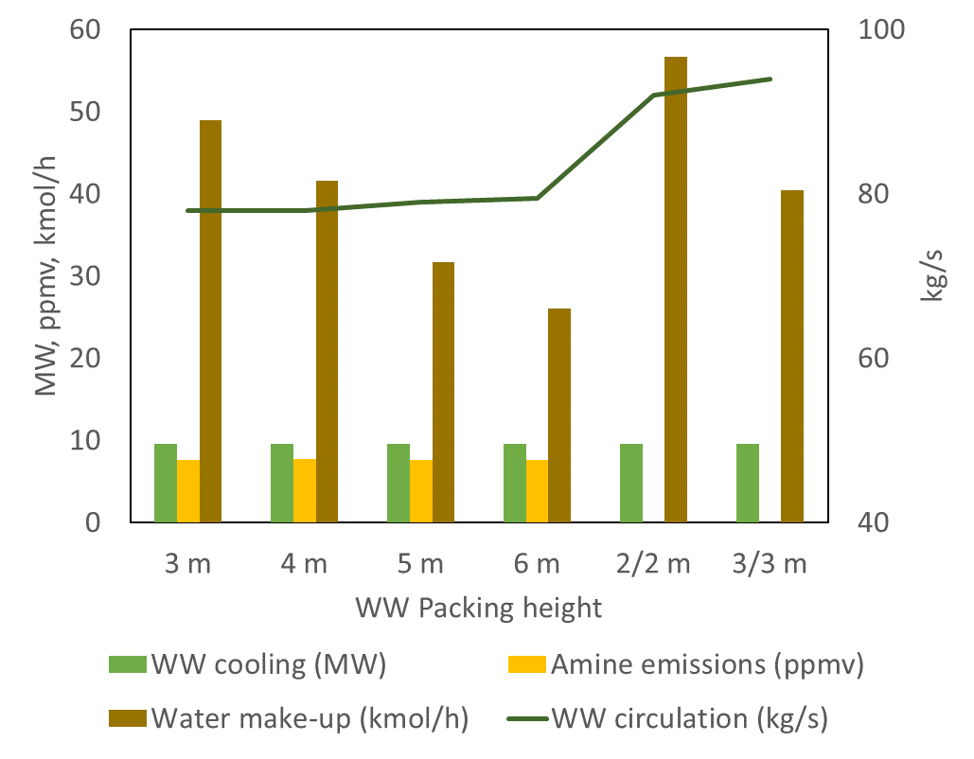  a | 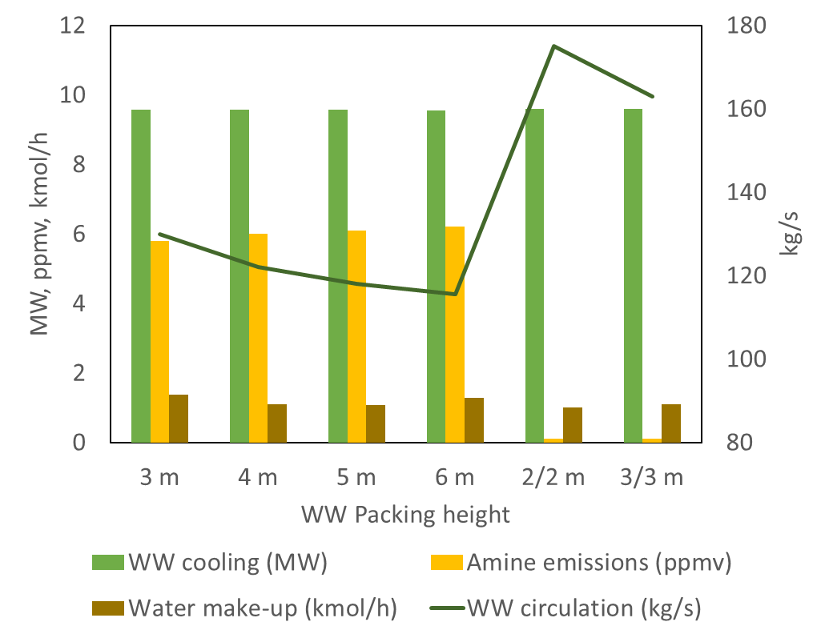  b
Figure 4: Results for the water wash operated at: (a) 35 ˚C and (b) 40 ˚C. Flue gas outlet temperature targeted at 40 ˚C. Water make-up and WW circulation flows are given in two different units to avoid scale compression.
The same trend is observed for the double WW configuration, as increasing from 2 x 2 m to 2 x 3 m decreases the water make-up. However, the total water circulation rate (in the WW loop) is increased. It is interesting to note that the water make-up for the double water wash section is higher than the equivalent total height of the single WW (2 x 2 m vs. 4 m, and 2 x 3 m vs. 6 m). The total cooling duty is rather constant for all cases (ca. 9.0 MW). This may be related to the fact that when using double water wash sections, the flows were not optimized, but tried to be evenly split. Reducing the flow at the bottom section will reduce the heat removed. Since the last section operates at the same targeted temperature, the circulation flow at the top part needs to increase to compensate for the low temperature difference.

When the WW loop cooling temperature is set to 40 ˚C (Figure 4b), the water balance can be nearly closed. For single WW sections, volatile emissions are still around 6 ppmv (as observed in the 35 ˚C). The cooling requirements are also constant for the variations tested, and slightly higher than for the 35 ˚C cases (9.5 MW). As observed in the 35 ˚C cases, the double WW requires more circulation rate than single WW. In this case, however, increasing the total packing height (2 x 2 m to 2 x 3 m) decreases circulation rate.

In the single WW configuration, to further decrease the amine volatile emissions, the water circulation rate needs to be increased. This will affect the outlet gas temperature and the water condensation rate. If the cooling temperature is set to 35 ˚C, the outlet temperature easily drops below 40 ˚C causing extra condensation of water. The amine volatile emissions could be reduced to around 4 ppmv by increasing the circulation flow rate (outlet gas temperature at around 36 ˚C). However, since the flue gas enters the absorber saturated at 40 ˚C, reducing the outlet gas temperature will increase the rate of condensation to an extent that a water bleed is necessary. Increasing the packing height, as seen in the other cases, will increase the bleed requirements even further. In the studied example, this value can be as high as 63 kmol/h (1.1 ton/h). As for the previous cases, the water circulation flow rate also decreases when the packing height is increased. However, the decrease is marginal when increasing the packing from 5 m to 6 m.

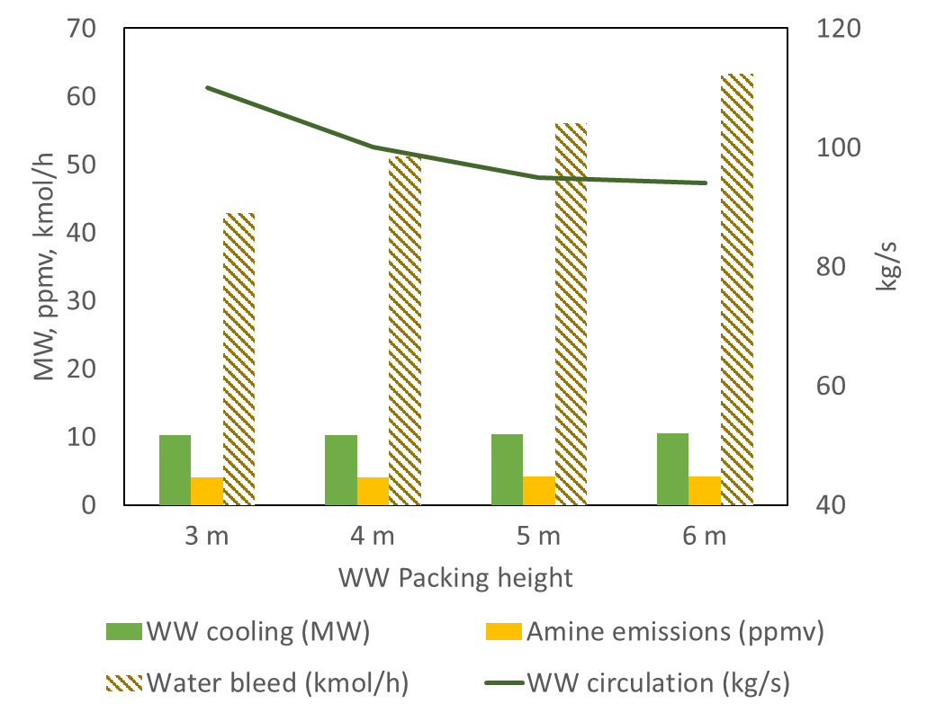
Figure 5: Results for the water wash operated at 35 ˚C targeting 4 ppmv amine volatile emissions.
If the cooling temperature is set at 40 ˚C in the WW loop, the required increase in the water circulation rate to reduce the emissions would flood the WW column making it unfeasible to operate.
  - Conclusions and Future Work
ProTreat® is currently undergoing an improvement of the model parameters to include new data generated under water wash conditions and recent data published in literature. The refitted model will be available in future releases of ProTreat®. In this study, the validation of the thermodynamic model of CESAR1 currently implemented in v8.0 of ProTreat® is presented. The current model (v8.0) can represent the data with good accuracy. For this work, only the concentrations of AMP and PZ composing the so-called CESAR1 solvent (aqueous solution of 3.0 M AMP and 1.5 M PZ) were investigated. Plenty of data at different amine concentrations are available and will be used in the parameter refitting. The deviation will be presented using a comprehensive range of pressure, temperature and compositions. One set of data, however, was found to disagree with other measured data. This is also reflected in the calculated deviation (124%) for that source. Nevertheless, the model is in good agreement with the other two data sources with calculated deviations of 23.8% and 30.8%. These deviations are expected to decrease once the refitting of the parameters is completed.

In the CO₂ capture process, controlling the amine emissions is important not only from the process economic, but also from an HSE, perspective. One of the strategies to eliminate/mitigate amine volatile emissions is the implementation of water-wash sections. In this work, several water-wash configurations were investigated. Double water wash virtually eliminated amine volatile emissions. However, the water circulation rate increased compared to single water wash. Under the single water wash configuration, operating the cooling loop temperature at the same temperature as the absorber inlet gas proved to be beneficial for the water balance. Decreasing the cooling loop temperature will affect the water balance requiring a make-up or bleed depending on the chosen target. Nevertheless, single water wash sections were not able to reduce AMP volatile emissions to below 4 ppm.

Regulations for amine emissions are country specific and are expected to become stricter. According to Khakharia et al. (2013), 4.3 ppmv is an upper limit for amine aemissions. Therefore, having a process configuration that can reduce emissions to below 4 ppmv is important. Indeed, it’s important that any arbitrarily imposed limit be achievable via process configuration, or other means. Thus, the utility of a water wash must be maintained wherever possible. Under the SCOPE project, amine emissions mitigation strategies are being investigated and results will be crucial to safely design and operate CO₂ capture plants.
Acknowledgements
This project is funded through the ACT programme (Accelerating CCS Technologies), ACT 3 Project No 327341. Financial contributions made by the Research Council of Norway (RCN), Rijksdienst voor Ondernemend Nederland (RVO), Department for Business, Energy & Industrial Strategy UK (BEIS), Forschungszentrum Jülich GmbH, Projektträger Jülich (FZJ/PtJ) Germany, Department of Energy (DoE) USA and Department of Science and Technology (DST) India are gratefully acknowledged.
References
Brúder, P., Grimstvedt, A., Mejdell, T., & Svendsen, H. F. (2011). CO2 capture into aqueous solutions of piperazine activated 2-amino-2-methyl-1-propanol. Chemical Engineering Science, 66(23), 6193–6198.
Deshmukh, R. D., & Mather, A. E. (1981). A mathematical model for equilibrium solubility of hydrogen sulfide and carbon dioxide in aqueous alkanolamine solutions. Chemical Engineering Science, 36(2), 355–362.
Feron, P. H. M., Cousins, A., Jiang, K., Zhai, R., & Garcia, M. (2020). An update of the benchmark post-combustion CO2-capture technology. Fuel, 273, 117776.
Hartono, A., Ahmad, R., Svendsen, H. F., & Knuutila, H. K. (2021). New solubility and heat of absorption data for CO2 in blends of 2-amino-2-methyl-1-propanol (AMP) and Piperazine (PZ) and a new eNRTL model representation. Fluid Phase Equilibria, 550, 113235.
Khakharia, P., Brachert, L., Mertens, J., Huizinga, A., Schallert, B., Schaber, K., Vlugt, T. J. H., & Goetheer, E. (2013). Investigation of aerosol based emission of MEA due to sulphuric acid aerosol and soot in a Post Combustion CO2 Capture process. International Journal of Greenhouse Gas Control, 19, 138–144.
Knudsen, J. N., Andersen, J., Jensen, J. N., & Biede, O. (2011). Evaluation of process upgrades and novel solvents for the post combustion CO2 capture process in pilot-scale. Energy Procedia, 4, 1558–1565.
Majeed, H., Knuutila, H. K., Hillestad, M., & Svendsen, H. F. (2017). Characterization and modelling of aerosol droplet in absorption columns. International Journal of Greenhouse Gas Control, 58, 114–126.
Pinto, D. D. D., Monteiro, J. G. M.-S., Skylogianni, E., Moser, P., & Wiechers, G. (2022). Validation of process simulator with new plant data for MEA and CESAR1. Proceedings of the 16th Greenhouse Gas Control Technologies Conference (GHGT-16) 23-24 Oct 2022.
SCOPE. (2021). SCOPE. https://www.scope-act.org/
Yang, Z.-Y., Soriano, A. N., Caparanga, A. R., & Li, M.-H. (2010). Equilibrium solubility of carbon dioxide in (2-amino-2-methyl-1-propanol+piperazine+water). The Journal of Chemical Thermodynamics, 42(5), 659–665.

