CHEMICAL ENGINEERING TRANSACTIONS  VOL. , 2023 | A publication of
The Italian Association
of Chemical Engineering
Online at www.cetjournal.it

Guest Editor: Sauro Pierucci
Copyright © 2023, AIDIC Servizi S.r.l.
ISBN 978-88-95608-98-3; ISSN 2283-9216

The Effect of 3D Printing Process Parameters on Nylon Based Composite Filaments: Experimental and Modelling Study
András Kámánª, László Baloghª, Miklós Jakab^{b}, Armand Meszlényiª, Bálint Levente Tarcsayª, Attila Egedyª
ªDepartment of Process Engineering, University of Pannonia, 10 Egyetem str., 8200 Veszprém, Hungary
^{b}Department of Materials Engineering, University of Pannonia, 10 Egyetem str., 8200 Veszprém, Hungary
kaman.andras@mk.uni-pannon.hu

In recent years the topic of additive manufacturing has become quite popular in industrial applications and scientific studies. However, the rapid development in this field, especially the slicer and machine software, makes research difficult because these can become obsolete due to software improvements. Another impeding aspect is the lack of knowledge and interest in the field of 3D printing or additive manufacturing process and materials; primarily, 3D printing is seen as a tool to achieve some results by researchers. Due to these facts, most studies do not discuss 3D printing parameters properly, making reproducing results almost impossible.
This paper discusses three 3D printing parameters that affect the properties of final products made by different chopped fibre filled- and generic nylon filaments; these parameters are the printing temperature, nozzle diameter, layer height, infill orientation and wall line count (or perimeter count). The family of nylon filaments is mainly used for functional 3D printing, especially in replacing aluminium and steel parts, thanks to their mechanical and thermal properties. Furthermore, a polynomial function was fitted to the measured data points, which made it possible to calculate the tensile strength and ductility of the 3D-printed samples based on their printing parameters.
  - Introduction
Plastic Fused Deposit Modelling (FDM) 3D printing is the most widely used method to fabricate objects using thermoplastics. Its cost-effectiveness and adaptability to different tasks made it the go-to choice for industrial and household 3D printing, and its ease of compositing these materials made their usage for technical applications a perfect choice. Chopped fibre and particle-composited 3D printing materials are by far the most used, and they require no modification to the 3D printer to be used, so that they can be easily used in hobby printers as well. In recent years the Continuous Fibre Fabrication (CFF) 3D printing field has become increasingly popular due to its enhanced mechanical properties (Kabir, Mathur, & Seyam, 2020). However, CFF 3D printing is still very limited in applications, mainly because of the increased cost of the printer itself, which often comes with their proprietary materials and software, further raising expenses. Another factor is the printer adjustability in firmware and printing process settings; because these machines are industrial or semi-industrial, their usage for research is very limited or non-existent. Between the different 3D printing technologies (SLA, SLS, DLP, FDM, etc.), the FDM printing process has by far the most adjustable parameters (Mostafaei & Amir, 2021), and their effect on the final mechanical properties are significant (Fernandez-Vicente, & Miguel, 2016). Usually, the most impactful parameters are the nozzle diameter, layer height, printing temperature, orientation of the object and the infill, etc. Unfortunately, the mechanical properties are worse in 3D printed objects than in objects manufactured using traditional technologies; composite materials are used for technical applications to compensate for this detrimental aspect of 3D printing (Sanatgar et al., 2017).
One of the most widely used technical 3D printing materials is nylon based. It can be printed with low-end 3D printers, is non-toxic, and does not require an enclosure like ABS. Also, they are not much more expensive than the standard materials used, unlike other technical printing materials. The most common fibre type used in these nylon filaments is chopped carbon fibre, usually around 15-20 wt.%.
The impact process parameters have on parts made by additive manufacturing started to be studied in recent years due to the rising demand for better performance, particularly in mechanical properties. Studies have ranged from the most basic materials and methods to advanced and specialised materials and methods (Pepelnjak et al., 2023). The most studied composite 3D printing material is carbon fibre-reinforced nylon due to its mechanical properties and widespread use (Tutar, 2023). However, most of the studies conducted in this field are quite lacking in both features used during the manufacturing process. The investigated parameters usually only include the most basic infill types and wall line count. In this study the inquiry was made to determine the different characteristics and properties the materials can achieve with the adjustment of three of the most impact parameters.
  - Materials and method
The 3D printed samples were printed on a Rat Rig V-Core 3, a modular CoreXY FDM 3D printer that uses Klipper firmware and features quality mechanical parts. LDO Orbiter 1.5 genuine extruder and Slice Engineering Mosquito hotend were used for precise plastic deposition. Klipper firmware has advanced features which significantly enhance 3D printed objects quality; these were pressure advance and skew correction. Before printing the samples, the advanced features and basic settings were calibrated. The G-code for each sample was generated in the SuperSlicer software. Due to the number of parameters that can be adjusted, this paper only mentions the main ones. During printing, the cooling was disabled for better bonding between layers, and because of this, the printing speed had to be reduced as well; it was 40 mm/s as default. Also, due to the usage of larger diameter nozzles, the maximum volumetric speed was 12 mm³/s. In this study, nylon 6/6 polymer-based filaments of 1.75 mm diameter were used exclusively. They were manufactured by Shenzhen Esun Industrial Co., Ltd., which has a reputation for its affordable and quality 3D printing filaments. Due to the hydrophilic nature of nylon filaments, the used nylon filaments were dried at 70°C for 24 hours before printing and under constant drying while the printing took place. The tests were conducted on an INSTRON 3400 series universal testing machine (250 kN). Specimens were ASTM D638 type V due to their smaller size. The investigation of different characteristics during tensile strength measurements was done by FEI/Thermofischer Apreo S; Philips XL 30 ESEM scanning electron microscopy (SEM) and Nikon XT H 225 ST X-ray computed tomography (CT). The original five parameters were the temperature, nozzle diameter, layer height, infill orientation and wall line count. However, using a wall made the 3D-printed samples less homogenous and the evaluation of the parameters more troublesome, so it was left out. Another change to the five parameters was incorporating the layer height and nozzle diameter into a single virtual parameter named the printing line cross-section area (P.L.C.S.A.), a theoretical area gained by multiplying the layer height by the nozzle diameter. The final three parameters chosen were the printing line cross-section area (mm²), printing temperature (°C) and the infill orientation (°) and and after printing the tensile strength (MPa) and Young modulus (MPa) of the samples were measured, which are two of the most important properties when plastics are involved.
The inputs of the model were the printed line cross section area, the temperature and the infill orientation and their products of each other, the real values of the three starter parameter were 0.04 – 0.4 mm², 240 – 260 °C and 0° – 45° respetively. Standardization was necessary and their coded value were between [-1, 1].
  - Results
During the tensile strength testing, different behaviours in elasticity were observed between the composite-free and carbon fibre-filled nylon samples. The carbon fibre-filled nylon samples broke much more rigidly compared to the composite-free nylon, and their layers and lines were not deformed significantly, as seen in Figure 1 A-B; the composite-free nylon, on the other hand, broke after an elastic elongation, during which the layers and lines merged into one another (Figure 1 C-F) explaining the increasing tensile strength during this elongation phase as seen on Figure 4. The orientation of carbon fibres inside individual extrusion layers can be seen in Figure 1 B; they have oriented in the same direction as the extruded lines, so their orientation can be adjusted with printing directions. The porosity of the samples was between 0.2 – 3 vol% (Figure 2 A-B), and their porosity systems were entirely dependent on the printing line cross-section area and infill orientation parameters.
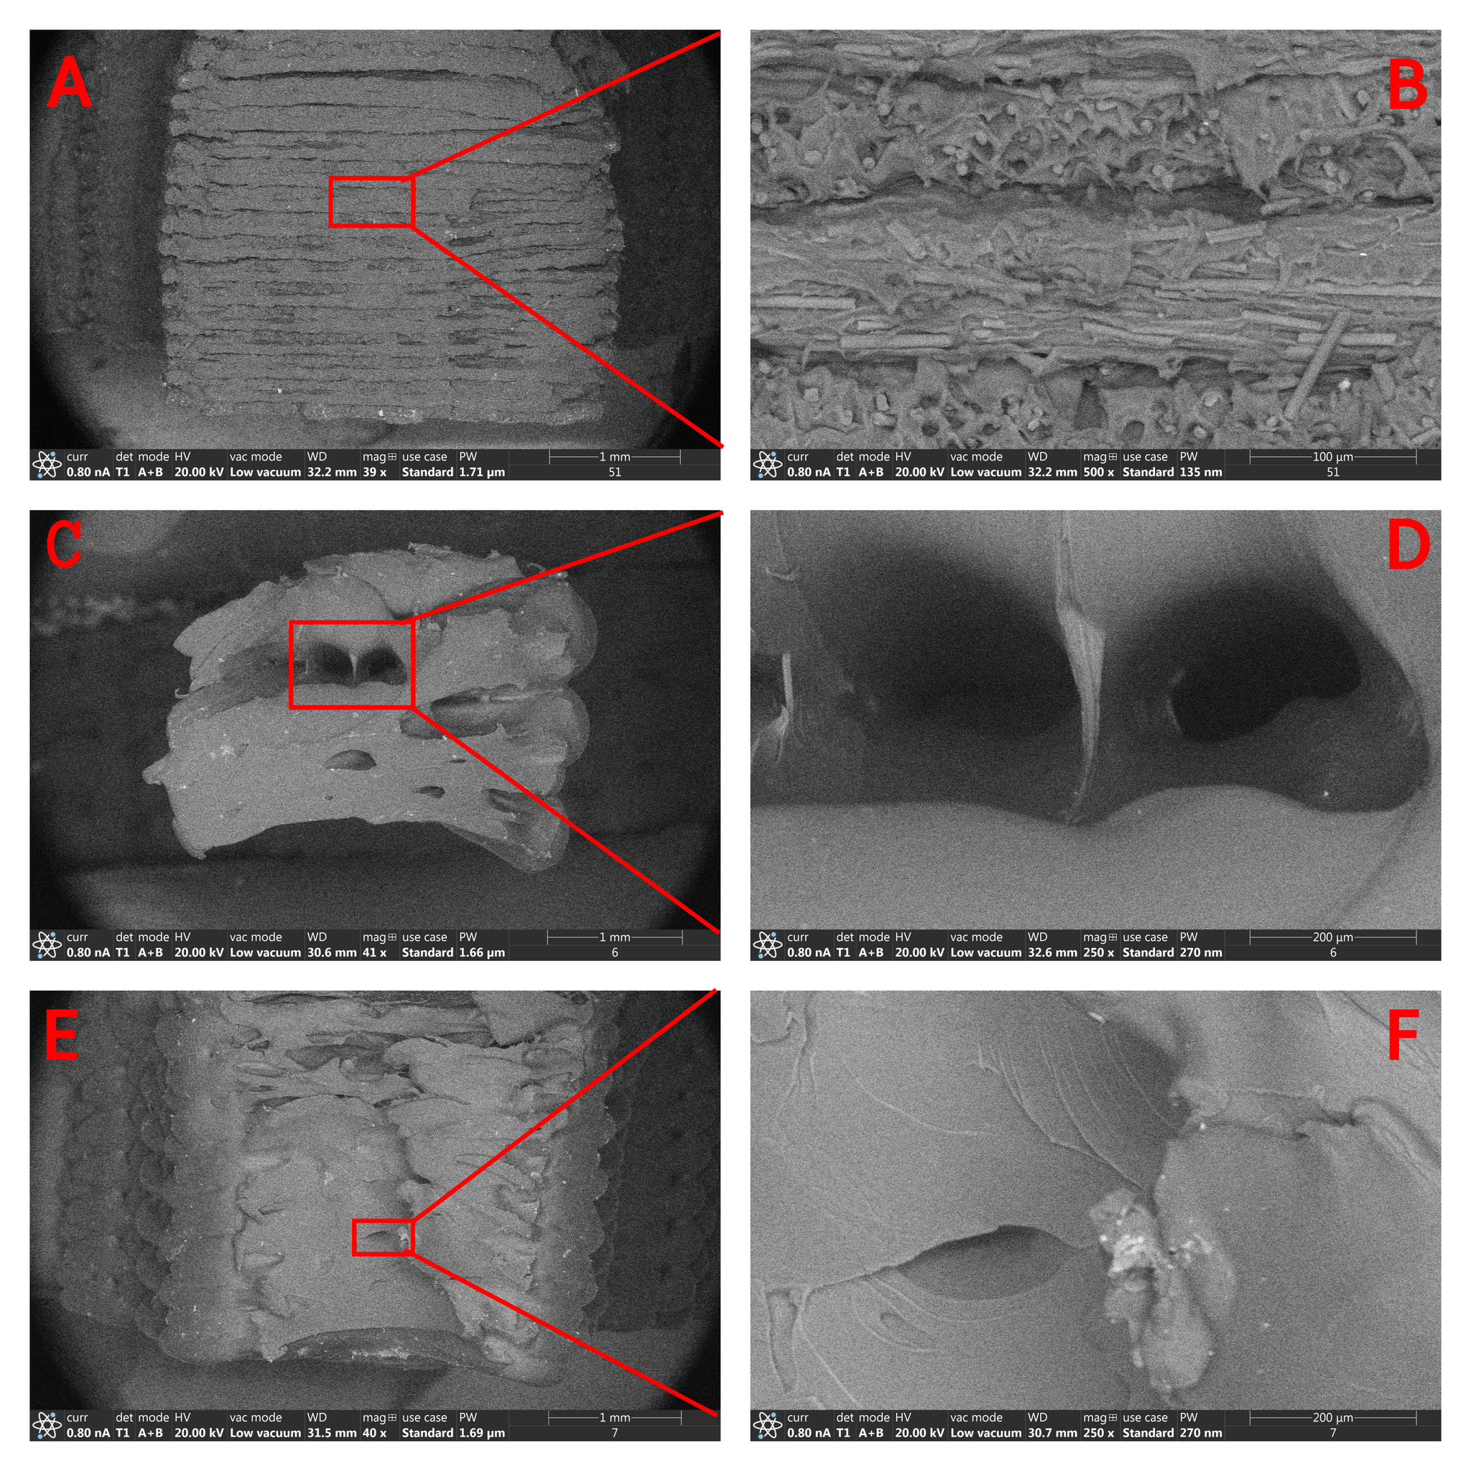
Figure 1: A: SEM image of the cross-section of a carbon fibre-filled nylon specimen with 0° infill orientation tensile strength specimen after breakage, B: zoomed image of figure 1A the orientation of carbon fibres and printing lines, C: SEM image of the cross-section of a composite free nylon specimen with 0° infill orientation tensile strength specimen after breakage, D: the zoomed image of figure 1C formed cavity after the breakage, E: SEM image of the cross-section of a composite free nylon specimen with 45° infill orientation tensile strength specimen after breakage, F: zoomed image of figure 1E

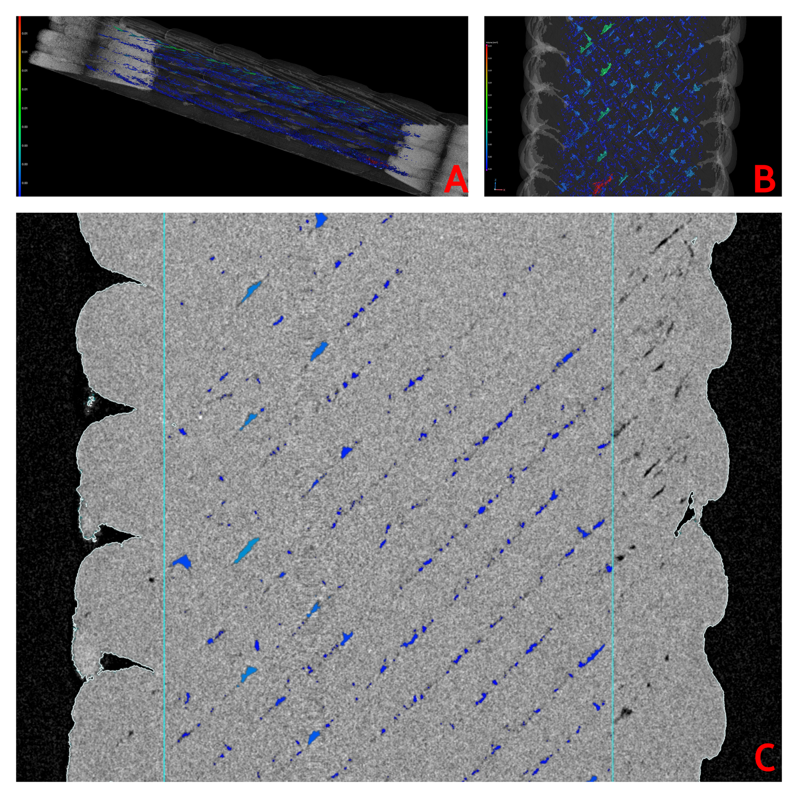
Figure 2: A: The porosity system of carbon fibre-filled nylon sample before breakage, B: The 45° orientation of porosity system of carbon fibre-filled nylon sample before breakage, C: The porosity system layout in a cross-section
The three main parameters' effects on tensile strength and Young modulus, as seen in Figure 3 A-D, were quite significant. The tensile strength varied between ~46–80 MPa and the Young modulus between ~2500-3100 MPa in composite-free nylon samples, and in carbon fibre-filled nylon samples, the tensile strength was between ~55-81 MPa and the Young modulus between ~3500-5600 MPa respectively. Furthermore, the three parameters affected the composited and composite-free samples differently. The printed line cross-section area had a much more significant effect on the composite-free nylon samples than on the carbon fibre-filled ones regarding tensile strength. However, the opposite was true regarding the Young modulus. The temperature had almost the same impact on the two studied mechanical properties as the printed line cross-section area. One glaring exception was the tensile strength of the composite-free nylon samples, whose impact was much less than the other two parameters. The infill orientation was by far the most impactful in both tensile strength and young modulus of carbon-filled nylon samples, which is not surprising considering that the infill orientation dictates the orientation of fibres in printed samples, as discussed earlier. However, its impact was not insignificant in the case of the composite-free nylon samples; it was much less prevalent (Figure 4). The Ridge traces show which parameters should be excluded in further prediction studies, for example when composite free nylon is used the orientation of infill can be excluded in further study, while in the study of its tensile strength the temperature can be excluded.
The fitted models R² were 0.76 at the Tensile strength of carbon fiber filled nylon samples and 0.91 at their Young modulus (Figure 5). In the instance of composite free nylon samples the fitted model could produce a R² of 0.84 at tensile strength and 0.41 at Young modulus. The fitted models R² were all more than satisfactory except for the one obtained from the composite free Young modulus, which can be explained by the vast difference between elastic behaviours of individual samples (Figure 4). The fitment of measured Young modulus values against predicted Young modulus values can be best observed in Figure 5.
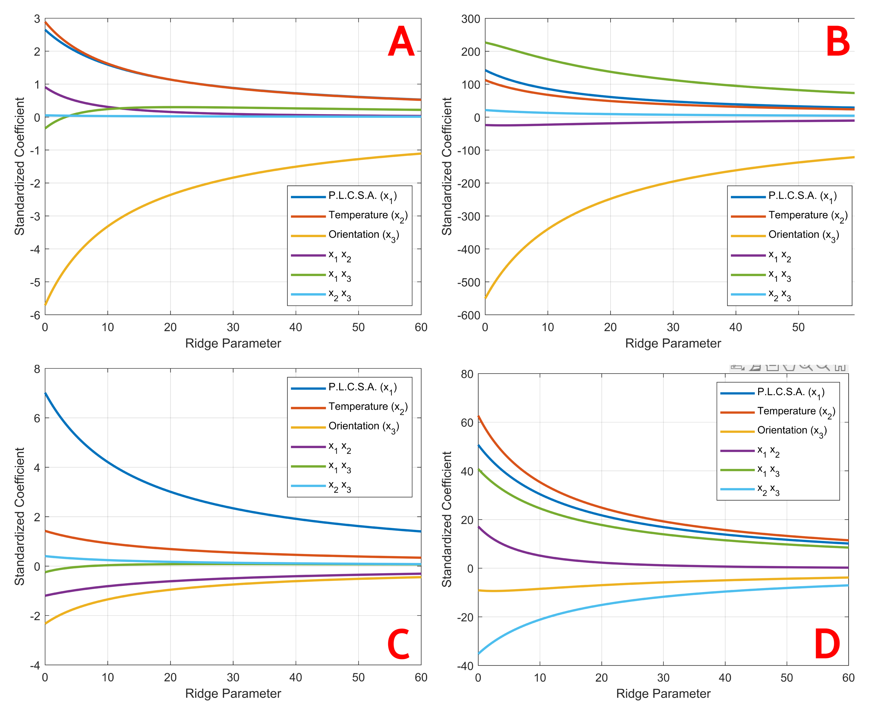
Figure 3: Ridge Trace for Ridge Regression of A: tensile strength of carbon fibre-filled nylon samples, B: Young modulus of carbon fibre-filled nylon samples, C: tensile strength of composite free nylon samples, D: Young modulus of composite free nylon samples
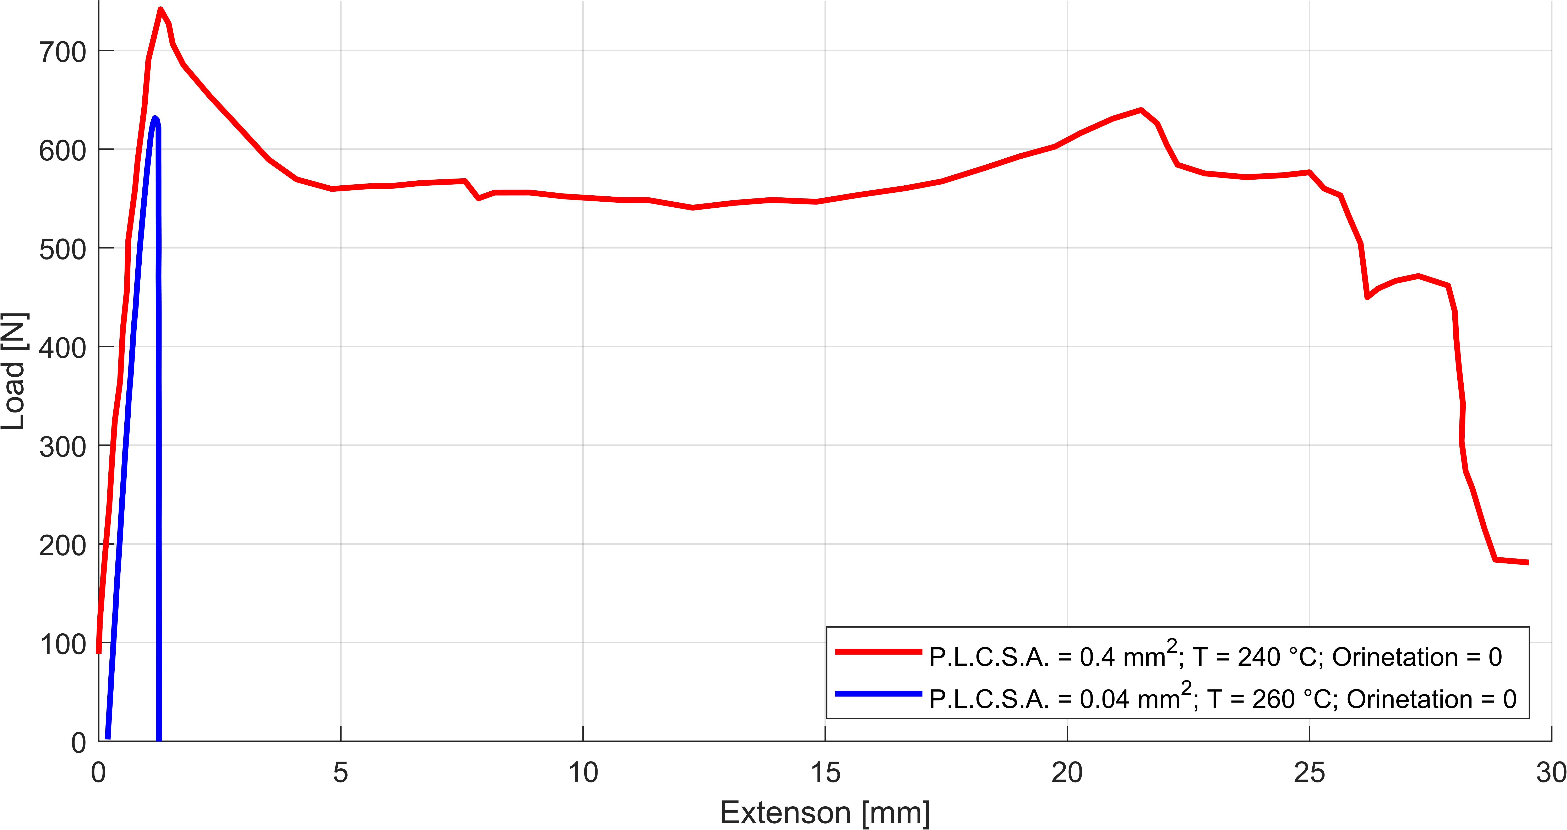
Figure 4: An example of the difference between elastic behaviour during tensile testing in individual composite free nylon samples
The regression method used for predicting the tensile strength and Young modulus based on the three parameters in both carbon fibre-filled and composite-free nylon materials were the following:
$$\begin{matrix}{\hat{\text{β}}}_{\text{R}}\text{=}{\left({\text{X}}^{\text{T}}\text{X}\text{+λ}\text{I}\right)}^{\text{-1}}{\text{X}}^{\text{T}}\text{y} & \text{λ>0}\end{matrix}$$ | (1)
This regression was made in MATLAB environment with the built-in Ridge function.

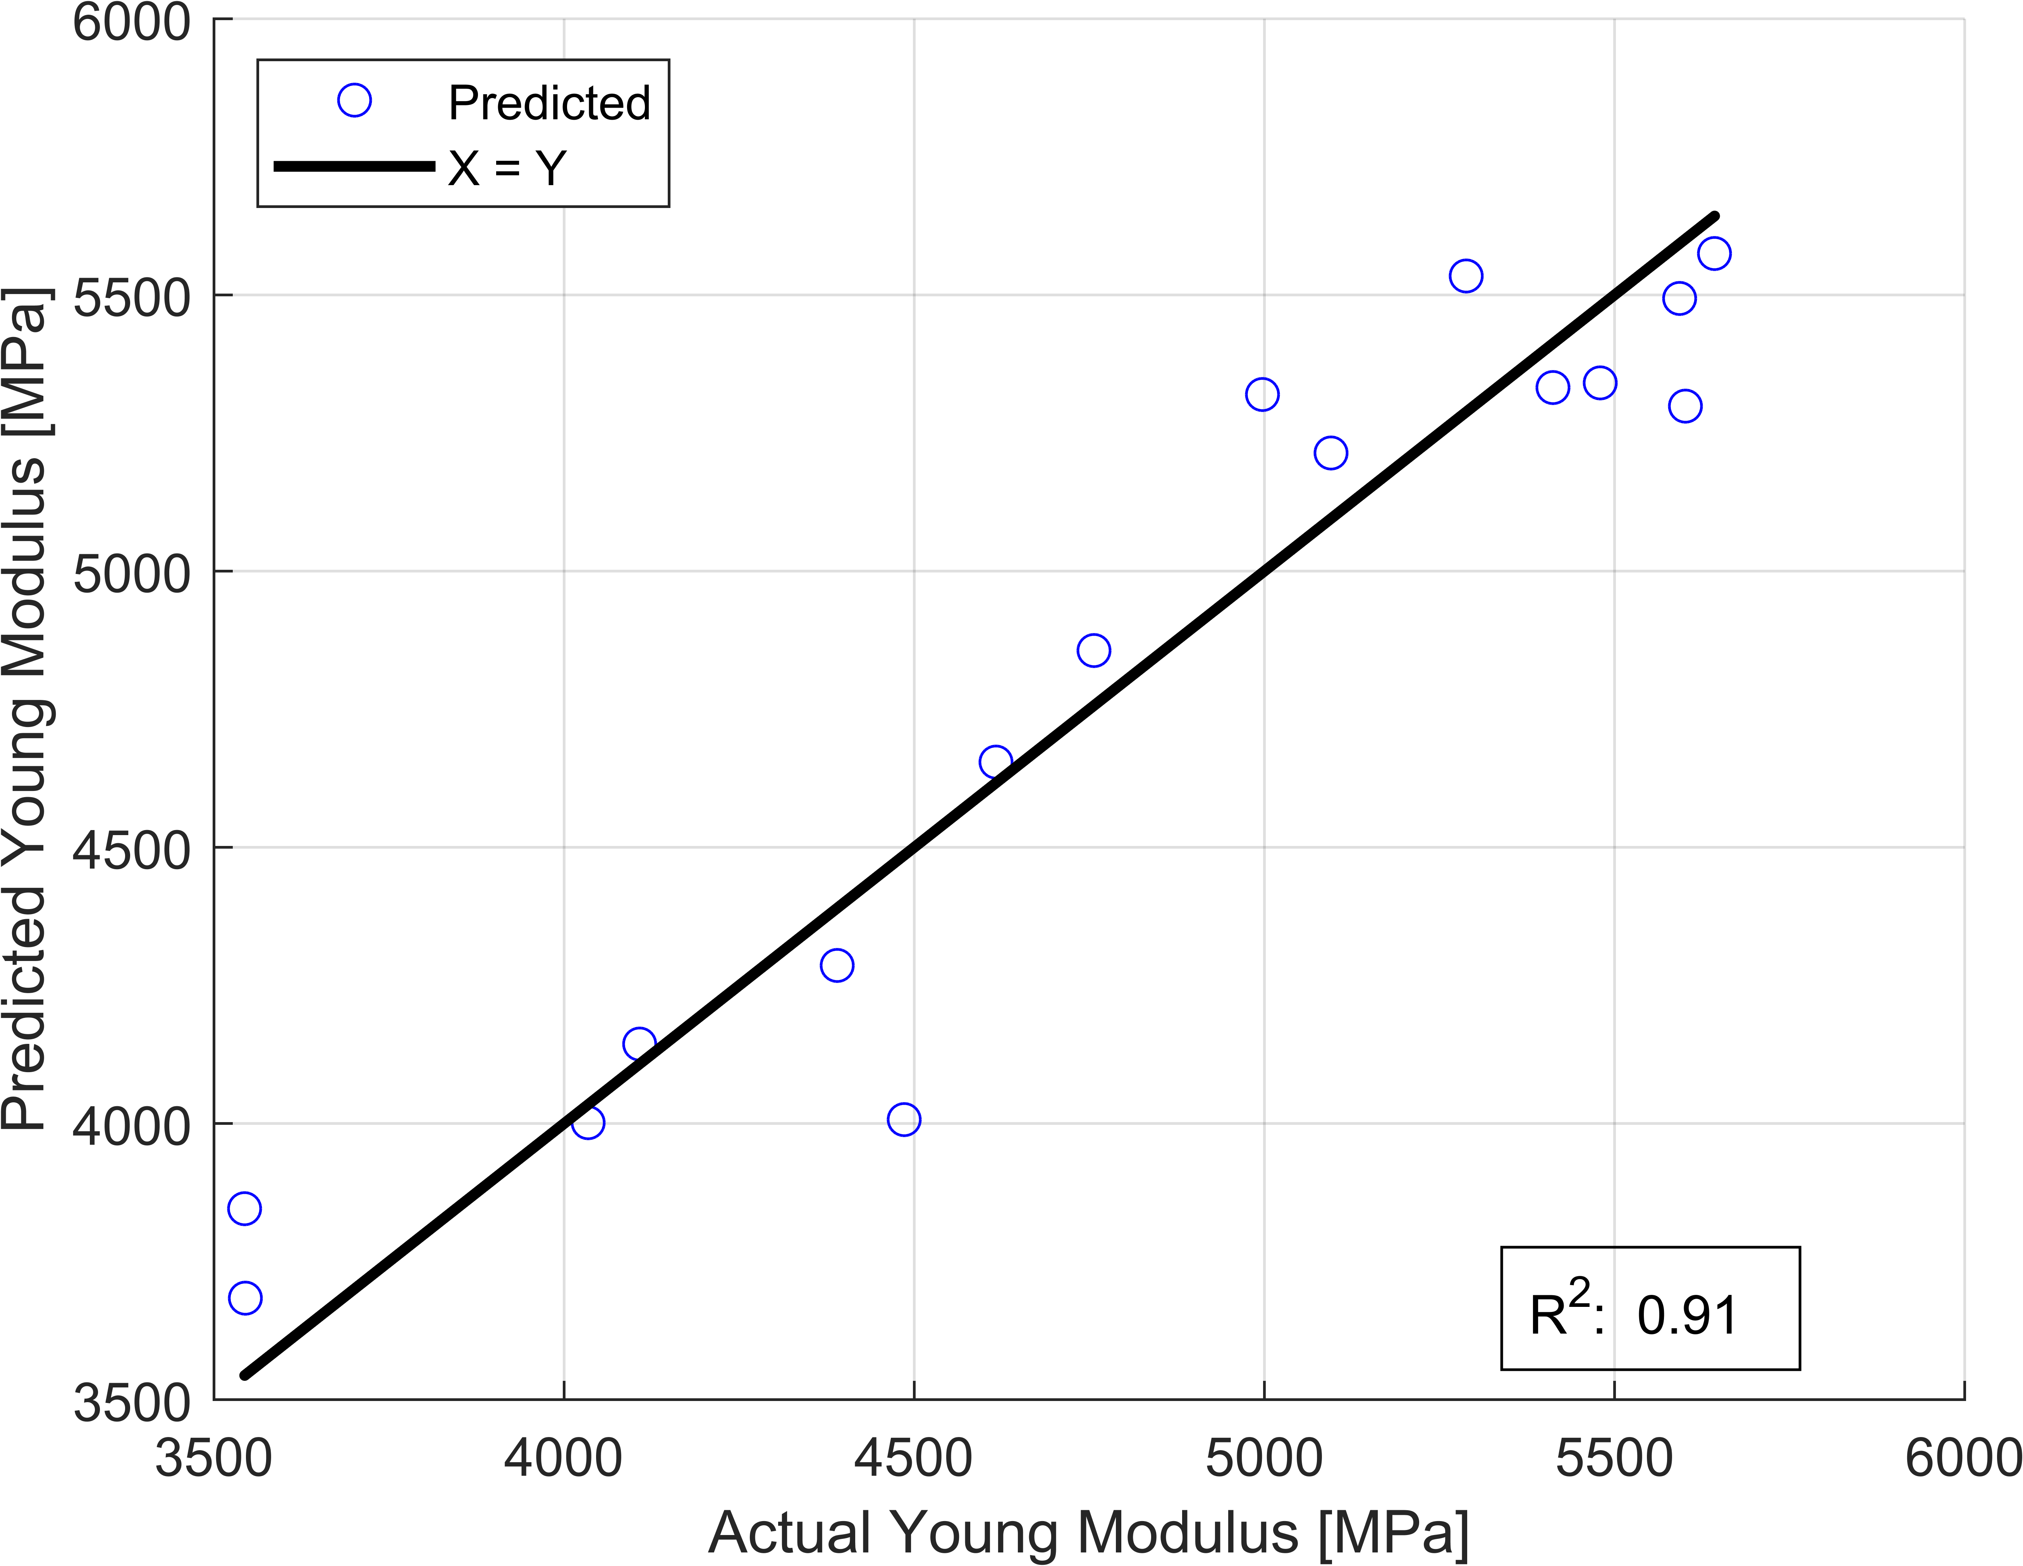
Figure 5: the performance of the regression at λ = 0 in the case of young modulus of carbon fibre-filled nylon samples
  - Conclusion
This paper determined the effects of printed line cross-section area, temperature and infill orientation on tensile strength and young modulus of both carbon fibre composited- and composite-free nylon 6/6 3D printed samples. Furthermore, the Ridge regression can be used in further studies to predict the end products mechanical properties based on the printing parameters. The different elastic behaviour during tensile testing between these two materials was confirmed with electron microscopy. In the case of carbon fibre reinforced nylon samples the infill orientation was by far the most impactful parameter on both tensile strength and young modulus, while temperature and printed line cross section area had a very similar impact. The composite free nylon material behaved differently, printed line cross section area had the most significant impact on its tensile strength and temperature an almost insignificant impact, on its young modulus both temperature and printed line cross section area had a similar impact and infill orientation a negligible one.
With the results obtained, the properties of final products can be modified with the adjustment of parameters, which calculates properties more predictably during the designing of parts and in the long run, it can help optimise the parameters along desired characteristics and properties.

Nomenclature
X – variables
I – identity matrix
${\hat{β}}_{R}$ – fitted parameters
y – predicted outcome
λ - ridge parameter

References
Fernandez-Vicente, M., Calle, W., Ferrandiz, S., & Conejero, A. (2016). Effect of infill parameters on tensile mechanical behavior in desktop 3D printing. 3D printing and additive manufacturing, 3(3), 183-192.
Mostafaei, A., Elliott, A. M., Barnes, J. E., Li, F., Tan, W., Cramer, C. L., & Chmielus, M. (2021). Binder jet 3D printing—Process parameters, materials, properties, modeling, and challenges. Progress in Materials Science, 119, 100707.
Pepelnjak, T.; Stojšić, J.; Sevšek, L.; Movrin, D.; Milutinović, M. (2023 )Influence of Process Parameters on the Characteristics of Additively Manufactured Parts Made from Advanced Biopolymers. Polymers, 15, 716
Sanatgar, R. H., Campagne, C., & Nierstrasz, V. (2017). Investigation of the adhesion properties of direct 3D printing of polymers and nanocomposites on textiles: Effect of FDM printing process parameters. Applied Surface Science, 403, 551-563
Tutar, M. (2023) A Comparative Evaluation of the Effects of Manufacturing Parameters on Mechanical Properties of Additively Manufactured PA and CF-Reinforced PA Materials. Polymers, 15, 38

