CHEMICAL ENGINEERING TRANSACTIONS  VOL. XX, 2023 | A publication of
The Italian Association
of Chemical Engineering
Online at www.cetjournal.it

Guest Editors: Rubens Maciel Filho, Eliseo Ranzi, Leonardo Tognotti
Copyright © 2022, AIDIC Servizi S.r.l.
ISBN 978-88-95608-90-7; ISSN 2283-9216

Dairy Wastewater to Promote Mixotrophic and Heterotrophic Metabolism in Chlorella vulgaris:
Effect on Growth and FAME Profile

Tea Miottiª, Francesco Sansoneª, Veronica Lolli^{b}, Alessandro Concas^{c,d}, Giovanni Antonio Lutzu^{e}*
ªDipartimento di Chimica, Scienze della Vita e della Sostenibilità Ambientale, Università di Parma, Parco Area delle Scienze 11/A, 43124 Parma (PR), Italia
^{b}Dipartimento di Scienze degli Alimenti e del Farmaco, Università di Parma, Parco Area delle Scienze 27/A, 43124 Parma (PR), Italia
^{c}Dipartimento di Ingegneria Meccanica, Chimica e dei Materiali, Università di Cagliari, Piazza d’Armi, 09123 Cagliari (CA), Italia
^{d}Centro Interdipartimentale di Ingegneria e Scienze Ambientali, via San Giorgio 12, 09123 Cagliari (CA), Italia
^{e}Teregroup Srl, via David Livingstone 37, 41123 Modena, (MO), Italia
*gianni.lutzu@teregroup.net
The increase of greenhouse gases into the atmosphere represents today one of the most global concern. The inevitable depletion of fossil fuels and the adverse climate changes push the scientific community to seek renewable and sustainable sources of fuel. In this scenario microalgae can be potentially exploited as renewable and environmentally friendly fuel resources. Wastewaters (WW) can be used as culture media reducing the costs associated to their cultivation. Hence, the goal of this study was to examine the effect of an organic rich WW on Chlorella vulgaris growth and fatty acid methyl esters (FAME) profile. This strain shows high biomass productivity thriving in a wide range of WWs and is able to shift its metabolism from autotrophic to hetero/mixotrophic one. Glycerol can be used to convey metabolism towards lipids production. Therefore, C. vulgaris was cultivated in dairy waste (DWW) with different concentrations of glycerol under both metabolisms. When C. vulgaris was cultivated under mixotrophy attained a high biomass yield compared to heterotrophy. The highest biomass yield (1.72 g L⁻¹) was obtained with 10 mL of glycerol in DWW compared to the control (1.08 g L⁻¹). When a two-phase metabolism was adopted, that is the first ten days under mixotrophy followed by the last five days in heterotrophy (MHD), the biomass was almost doubled with 2 mL of glycerol in DWW. FAME profile reveled that compared to the control the highest saturated fatty acids (SFA), monounsaturated fatty acids (MUFA), and polyunsaturated fatty acids (PUFA) content were obtained under heterotrophy with 10 mL of glycerol, under MHD with 2 mL and with 4 mL of glycerol (46.73%wt, 41.79%wt, and 30.34%wt, respectively). A preliminary analysis on the saturated and unsaturated components of the FAME suggests that lipids extracted from C. vulgaris biomass cultivated mixotrophically and heterorophically in DWW could represents a feedstock to be exploited for biodiesel production.
  - Introduction
The increase of anthropogenic carbon dioxide (CO₂) emissions in the atmosphere and the depletion of the fossil fuels reservoirs represent a challenge for the scientific community and governments. Therefore, there is an urgent call at global level to seek renewable and sustainable sources of fuel (Zhao et al, 2022). In this scenario the exploitation of environmentally friendly resources is emphasized. To this aim, microalgae show high productivities in terms of biomass and lipid content making them suitable for biofuels production (Concas et al., 2021a).
Wastewaters (WWs) typically contain large amounts of nutrients, such as carbon (C), nitrogen (N), phosphorus (P) and trace elements to sustain algal growth. It is well demonstrated the ability of microalgae to combine their growth with the biological WW treatment (Lutzu et al., 2020a; Concas et al., 2021b). The presence inside a WW of inorganic and organic C makes some algae strains able to modulate their metabolism from autotrophic into a mixotrophic one depending on the carbon sources available. The use of food industry WWs, such as dairy, brewery and molasses sugarcane as a nutrient medium for microalgae cultivation is well established (Miotti et al., 2022). In addition, exogenous organic C sources added to a heterotrophic/mixotrophic cultivation of microalgae pushes metabolic apparatus of cells towards an enhanced lipid production (Whangchai et al., 2021; Yun et al., 2021). In this light, glycerol (a by-product of biodiesel industry) can be seen as a metabolic stress inducer to push production of lipids (Xue et al., 2017).
The microalga Chlorella vulgaris can accumulate lipids and produce biodiesel under suitable stress conditions (Ratomski and Hawrot-Paw, 2021; Korozi et al., 2021). This strain is also able to shift its exclusively photoautotrophic or heterotrophic metabolism into a mixotrophic one, leading to an increase in biomass production. The influence of heterotrophy and mixotrophy on lipid content and FAME composition is well documented for many Chlorella strains (Rahimi et al., 2021; Vitali et al., 2022). DWW is particularly rich in sugars (high BOD and COD values varying from 0.1 to 100 g L⁻¹) which can enhance biomass productivity by microalgae once available in the culture medium (Slavov, 2017). Hence, by considering the potential use of DWWs as media for microalgae cultivation, the effect of different concentration of glycerol as additional organic sources able to stress lipid metabolism on C. vulgaris biomass accumulation and lipid production is reported in this study. A close analysis of FAMEs profile is also assessed based on the addition of glycerol under heterotrophy, mixotrophy and a two-phase mixo-heterotrophic metabolism.

2. Material and Methods
2.1 Experimental setup

Chlorella vulgaris metabolic behaviour was monitored for 17 days under heterotrophy (HD) and mixotrophy (MD) condition using dairy WW (DWW) as culture medium and Doucha medium as control (CTRL), respectively. A two-phase metabolic condition (MHD) was obtained cultivating Chlorella for the first 12 days in mixotrophy and the last 5 days in heterotrophy. For each of the three metabolic conditions (HD, MD and MHD) three replicates were run with four different concentrations of glycerol: 0 mL, 2 mL, 4 mL, and 10 mL.

2.2 Inoculum and wastewater preparation
The strain used in this study, C. vulgaris SAG 211-12, was obtained from the culture collection of algae at the University of Gottingen, Germany (SAG, 2021). Detailed chemical composition of the culture maintenance media is available on the SAG official website. The strain was maintained in 150 mL glass tubes containing the growth medium recommended by SAG at room temperature. Two 32 W white fluorescent tubes continuously provided a photosynthetic photon flux density (PPFD) of 50 µmol m⁻² s⁻¹. During HD PBRs were wrapped up by aluminium foils to prevent light penetration. Inoculum was cultured for about one week once it reached the end of exponential growth phase. DWW was collected from a brewery facility located in Cremona, Italy. An average range of the main chemical-physical parameters for this effluent is shown in Table 1. Once collected DWW was stored at 4 ºC before its use. Later it was filtered using glass filter microfiber disks (GF/CTM 47 mm diameter, Whatman, Incofar Srl, Modena, MO, Italy), deprived of solid materials and then sterilized at 121 ºC and 0.1 MPa for 20 min before microalgae cultivation.
2.3 Culture medium and algae cultivation
1 L glass flasks, referred as PBRs, were used for algae cultivation. PBRs were covered with a cotton cup for air diffusion (0.03% CO₂ v v⁻¹) and daily shaken manually at room temperature. They were illuminated with a photoperiod of 12 h light/12 h dark by white fluorescent lamps providing a light intensity of 85 µmol m⁻² s⁻¹. The initial working volume of the PBRs and cell concentration were 500 mL and 0.1 g L⁻¹, respectively. The culture medium used as control was a modified Doucha whose composition was obtained by adding to 1 L of distilled water 10 mL of five stock solutions, NaNO₃ (38.92_{g} 250_{mL}⁻¹ H₂O), KH₂PO₄ (2.96_{g} 250_{mL}⁻¹ H₂O), MgSO₄$∙$7H₂O (2.55_{g} 250_{mL}⁻¹ H₂O), CaCl₂$∙$6H₂O (2.17_{g} 250_{mL}⁻¹ H₂O), EDTA-FeNa (0.5_{g} 250_{mL}⁻¹ H₂O), 1 mL of microelements solutions I and II, and 0.5 mL of NaOH 1 M. Microelements solution I was prepared in the following manner (mg L⁻¹): H₃BO₃ 415, MnCl₄$∙$4H₂O 1650, ZnSO₄$∙$7H₂O 1350, CoSO₄$∙$7H₂O 300, and CuSO₄$∙$5H₂O. For solution II (mg L⁻¹): (NH₄)₆Mo₇O₂₄$∙$4H₂O 85 and NH₄VO₃ 7. After two weeks of cell growth, the cultures were centrifuged at 9722 g for 10 min. The liquid phase was separated from the pellet and the latter used for fatty acids methyl esters (FAME) analysis.
2.4 Characterization of microalgae growth pattern
Microalgae growth in the culture was monitored by measuring the optical density (OD) at 680 nm. The detailed procedure adopted for monitoring algal growth was reported in Lutzu et al. (2020b). The cell concentration (dry weight V⁻¹) X_{dw} (g L⁻¹), specific growth rate (μ), and doubling time (t_{d}) calculations were performed according to Zhou and Dunford (2017). The average biomass productivity (∆X) was expressed as:
(1)
where $t_{0}$ represent initial time of the cultivation period. The pH of the cultures was recorded using a pH-meter (HI 2210, Hanna Instruments, Woonsocket, RI, USA).

2.5 FAMEs determination
FAMEs were prepared according to a modified protocol reported by Lage and Gentili (2018). Briefly, a toluene solution and a 1% H₂SO₄ solution in anhydrous methanol were used to re-suspend freeze-dried cells to improve the methylation of non-polar lipids and their trans-methylation, respectively. A tricosanoic acid methyl ester (TAME) (CH₃(CH₂)₂₁COOCH₃) in hexane was added as an internal standard. The FAMEs were then extracted with an extractive solution (5 mL aqueous 5% NaCl + 7 mL hexane) and after separation the organic phase was analyzed by a 7820A Gas Chromatopraph (Agilent Technologies, Palo Alto, CA, USA) coupled to a 5977B Mass Spectrometer (Agilent Technologies Palo Alto, CA, USA). The GC-MS system (split mode 20:1, split flow 19.6 mL min⁻¹) was equipped with a low polarity Supelco SLB-5 GC capillary column (30 m x 0.25 mm x 0.25 µm). Helium was used as carrier gas. The injector and detector temperatures were set at 280 and 230 °C, respectively. The chromatogram was recorded in the scan mode (40-500 m z⁻¹) with a programmed temperature from 60 to 280 °C. The identification and quantification of individual FAMEs were performed by using a standard reference solution obtained by mixing Supelco 37 Component FAME Mix® (Sigma Aldrich, Saint Louis, MO, USA), TAME internal standard solution and hexane. The content of FAMEs was calculated by manually integrating their peak areas with respect to the internal standard TAME, after calculation of the response factor (RF) using the standard reference solution. Finally, fatty acid (FA) levels were expressed as g 100 g⁻¹ total FAs.
2.6 Data Analysis
All the experiments with algae and analytical tests were carried out in triplicate, with mean values for them. MataboAnalyst 5.0, tuned by the McGills University (Montreal, Canada), was used for the statistical analyses of the data. The regression equations correlating dry biomass concentration to OD and to µ were calculated using Microsoft Office Excel program (Excel 2016 Ink, Microsoft, USA).
  - Results and Discussion
    - C. vulgaris growth in dairy wastewater supplemented with glycerol
DWWs are characterized by huge amount of organic matter as demonstrated by the high BOD and COD values reported in Table 1. On the other hands, these effluents are poor in N and P.
Table 1: Range of main physical-chemical parameters reported for dairy wastewaters
BOD₅ (g L⁻¹) COD (g L⁻¹) | TSS (g L⁻¹) | TN (g TN (g L⁻¹) |  | TP (g L⁻¹) pH Ref.
0.24-5.90 0.50-10.40 | 0.06-5.80 | 0.01-0.66 | 0-0.060 4.0-11.0 Slavov, 2017
0.087 0.215 | 0.147 | 0.091 | 0.014 7.95 Licata et al., 2021
1.3-1.6 2.50-3.0 | 72-80 | - | - 7.2-7.5 Demirel et al., 2005
Note: BOD = Biological Oxygen Demand, COD = Chemical Oxygen Demand, TSS = Total Suspended Solids, TN = Total Nitrogen, TP = Total Phosphorous.
To verify the effect of three trophic conditions such as MD, HD and MHD on C. vulgaris biomass production a series of growth experiments were carried out using DWW as culture medium and a regular Doucha medium as control (CTRL). For each trophic condition four glycerol concentrations (0, 2, 4 and 10 mL) were tested. As it can be seen in Table 2, MD with all the three glycerol amount tested greatly increased the biomass concentration (1.57, 1.62, 1.72 g L⁻¹, respectively) compared to the control (1.08 g L⁻¹), while under MHD mode only the addition of 2 mL of glycerol increased the biomass compared to CTRL, being the other three concentrations statistically not significant. On the other hand, under HD the biomass accumulation was considerably reduced. The glycerol supplementation stimulated C. vulgaris growth under MD while under HD and MHD its effect was negligible. Also the µ in HD conditions were lower compared to those in MD conditions. It has been also reported that algal µ can be significantly improved by nutrient supplementation (Lutzu et al., 2020b). In our study µ was lowered in CTRL, while when the dairy medium was amended with glycerol µ increased. These results are in agreement with previous works showing that mixotrophy significantly increases Chlorella sp. biomass concentration and productivity in batch systems, compared to autotrophy and heterotrophy (Miotti et al., 2022, Vitali et al., 2022). A possible explanation could be the fact that mixotrophic cultures are characterized by an accelerated anabolism due to adenosine triphosphate formed both in photochemical reactions during the photosynthesis and in mixotrophic reactions.
Table 2: Growth characteristics of C. vulgaris cultivated with dairy wastewater under different metabolic conditions
Growth medium | µ (day⁻¹) | t_{d} (day) | X_{max} (g L⁻¹) ∆X (mg L⁻¹ day⁻¹)
CTRL | 0.119 ± 0.013 | 5.81 ± 0.34 | 1.08 ± 0.06 82 ± 0.004
MD0 | 0.362 ± 0.063 | 1.91 ± 0.34 | 1.13 ± 0.05 63 ± 0.003
MD2 | 0.446 ± 0.015 | 1.55 ± 0.05 | 1.57 ± 0.13 92 ± 0.007
MD4 | 0.318 ± 0.030 | 2.18 ± 0.21 | 1.66 ± 0.84 97 ± 0.005
MD10 | 0.391 ± 0.025 | 1.77 ± 0.13 | 1.72 ± 0.05 101 ± 0.003
HD0 | 0.048 ± 0.001 | 8.72 ± 1.18 | 0.40 ± 0.01 31 ± 0.007
HD2 | 0.133 ± 0.015 | 5.21 ± 0.73 | 0.69 ± 0.02 42 ± 0.001
HD4 | 0.132 ± 0.009 | 5.25 ± 0.37 | 0.58 ± 0.01 42 ± 0.001
HD10 | 0.126 ± 0.003 | 5.50 ± 0.12 | 0.62 ± 0.01 41 ± 0.010
MHD0 | 0.365 ± 0.027 | 1.90 ± 0.14 | 0.94 ± 0.05 44 ± 0.002
MHD2 | 0.387 ± 0.030 | 1.80 ± 0.15 | 1.19 ± 0.05 61 ± 0.002
MHD4 | 0.443 ± 0.045 | 1.57 ± 0.16 | 0.96 ± 0.03 61 ± 0.002
MHD10 | 0.363 ± 0.045 | 1.99 ± 0.16 | 0.88 ± 0.03 67 ± 0.002
Note: µ: specific growth rate, t_{d}: doubling time, X_{max}: maximum biomass concentration, ∆X: average biomass productivity.
CTRL: Doucha medium, MD: mixotrophy in DWW, HD: heterotrophy in DWW, MHD: mixo-hetrotrophy in DWW. 0 mL, 2 mL,
4 mL, and 10 mL represent the amount of glycerol added to the media
Many studies reported that C. vulgaris growth is directly influenced by the N:P ratio found in the culture medium, being P the limiting factor for its growth. The optimum N/P ratio for C. vulgaris’s growth is set as 16:1 (Wu et al. 2014). In our growth test, N/P ratios of DWW both under MD and HD are far away from this optimum, while only the control is close with a N/P ratio of 13:1. Organic sources can be used by microalgae to shift their metabolism from autotrophy to mixothophy. This can explain why C. vulgaris, when cultivated in DWW, attained a better biomass concentration compared to CTRL where there are not at all organic compounds. On the other hand, the scarcity of N and P, typical of wastes rich in organic matter (Table 1), leads to an imbalance between the ratios C:N:P with respect to the optimal values for algae. This would lead to an excessive intracellular storage of C in the form of neutral lipids such as triacylglycerols rather than as proteins which would require N.
3.2 FAME profile of C. vulgaris under mixotrophy and heterotrophy mode
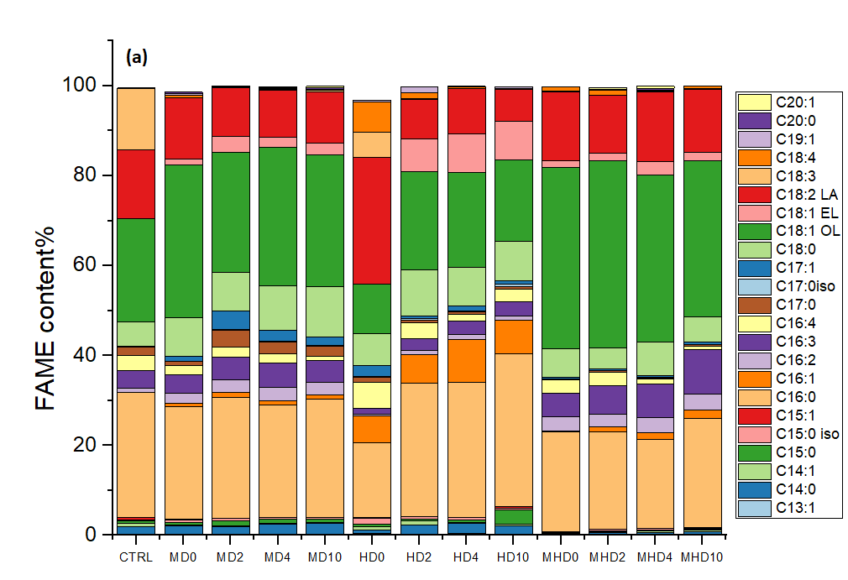
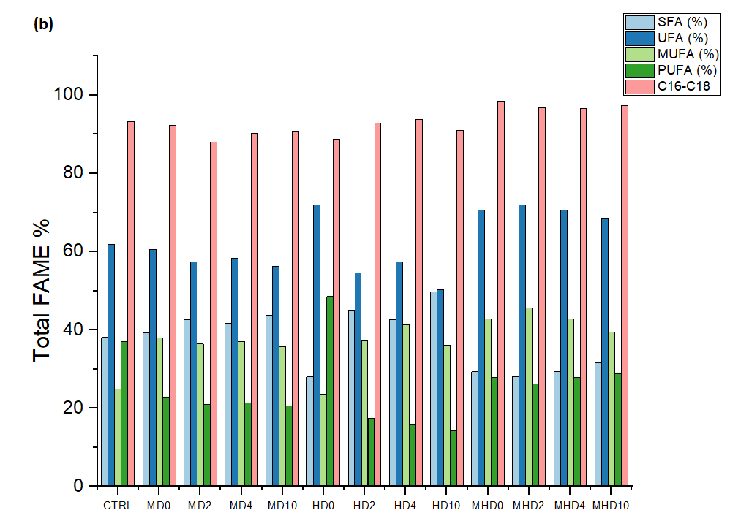
The composition of FAs in terms of length and branching of the carbon chain, and degree of unsaturation is a fundamental prerequisite for considering microalgal biomass as a feedstock for biodiesel production. Therefore, the FAME profile of C. vulgaris, obtained after the esterification of FAs, is reported in Figure 1. FAME obtained in MHD and in CTRL exhibithed higher percentages of long-chain compounds C16-C18 (97-99%wt and 96%wt, respectively) compared to those obtained under MD (90-92.5%wt) and HD (89-93%wt) (Fig 1b). The most represented FAs in MD were oleic (C18:1) > palmitic (C16:0) > linoleic (C18:2) > stearic (C18:0), in HD were C16:0 > C18:1 > C18:0 > C18:2, and in MHD were C18:1 > C16:0 > C18:2 > the ω-3 palmitolinolenic C16:3 FA (Fig. 1a). By considering the addition of glycerol on the three trophic systems it can be seen that in MD there were not statistically significant differences in the range 0-10 mL of glycerol except for 2 mL of glycerol that produced a % reduction of C18:1. In HD the addition of glycerol doubled the % of C16:0 while reduced to 1/3 that of C18:2. On the other hand, the presence of glycerol in MHD did not produce significant changes in the % of FAs. Interestingly, compared to CTRL the addition of glycerol almost halved the % of C18:1 in MD, increased considerablty the % of palmitoleic (C16:1) and C18:0 FAs and reduced that of C16:3 in HD, while in MHD increased hexadecadienoic (C16:2) and C18:1 FAs and decreased the % of myristoleic (C14:1), C16:0, palmitidonic (C16:4), and C18:2 FAs. In terms of degree of saturation and unsaturation (Fig 1b) the addition of glycerol produced an increase of unsaturated fatty acids (UFA) in MHD (68.90-70.38%) and a decrease in MD (54.57-61.36%wt) and HD (53.27-58.36%wt), while conversely the saturated fatty acids (SFA) decreased in MHD (29.62-30.60%wt) and increased in MD (38.64-45.43%wt) and HD (41.64-46.73%wt), compared to CTRL (62.33%wt of UFA and 37.67%wt of SFA). The most represented UFA were obtained in HD without glycerol (73.36%wt), while the highest % of SFA, monunsaturated fatty acids (MUFA) and polyunsaturated fatty acids (PUFA) were obtained in HD with 10 mL of glycerol (46.73%wt), in MHD wihout glycerol, and in HD without glycerol, respectively. When C. vulgaris was cultivated in MD and HD the UFA/SFA ratio was < 2 and > 2 in MHD. The highest UFA/SFA ratio (2.75) was obtained when C. vulgaris was cultivated in HD without the addition of glycerol, compared to CTRL (1.65). UFA/SFA ratio describes how SFA and UFA are distributed inside the cells. This ratio is strictly linked to the nutritional requirements of microalgae, therefore to the culture medium. Microalgal metabolism can be modulated depending on the conditions in which microalgae are grown. In particular, lipid composition in algal membrane and cytoplasm can be rearranged in terms of SFA and UFA. For example, a redistribution, which lead to an increased SFA portion, can be obtained by increasing the synthesis of neutral triglycerides at the expense of polar membrane lipids (rich in UFA) which can be partially degraded (Xin et al., 2018). This rearrangement of FAMEs can be enhanced under condition of nutrients starvation, such as those that can be found when C. vulgaris is grown in DWW. One of the FAs suitable for making biodiesel is C16:0. The content of this FA remained high in HD whit the addition of glycerol while decreased in MD and MHM (Fig 1a) suggesting that the accumulation of this specific FA could be influenced by the reduced availability of macronutrients (such as N and P) in organic media compared to CTRL. The high degree of unsaturation, % of C16-18 FAs and C16:0 suggests that a biodiesel obtainable by C. vulgaris cultivated in DWW with the addition of glycerol could be suitable for biodiesel production. Experiments are on the way to support this hypothesis by a close analysis of physical-chemical properties of lipids.

Figure 1. Fatty acids methyl ester profile (a) and total fatty acids (b) of C. vulgaris when cultivated under three different trophic conditions in the presence of glycerol

Conclusions
DWW, as organic source of waste, has been investigated to improve biomass production and FAME profile by C. vulgaris with the addition of glycerol under three different trophic modes. The results demonstrated that DWW could represent a costless resource of organic nutrients able to trigger the microalgal growth and biomass production is enhanced as the content of glycerol is increased under mixotrophy. As far as the FAME profile is concerned, C. vulgaris was able to modify its internal metabolism to achieve an improvement in terms of unsaturation based on trophic condition used. In particular, the addition of glycerol under MHD condition reduced the saturation of FAs by increasing the unsaturation level, providing also higher MUFA and PUFA compared to CTRL. The final microalgae biomass makes DWW a viable option as priceless media for the cultivation of C. vulgaris. By considering also the FAME profile mainly in terms of unsaturation level, microalgal biomass obtained cultivating this strain mixotrophycally could potentially represent a feedstock for biodiesel production.

References
Demirel B., Yenigün O., Onay T.T. 2005, Anaerobic treatment of dairy wastewater: A review. Process Biochemistry, 40, 2583-2595.
Concas A., Steriti A., Pisu M., Cao G., 2021a, Experimental and theoretical investigation of the effects of iron on growth and lipid synthesis of microalgae in view of their use to produce biofuels. Journal of Environmental Chemical Engineering, 9, 105349
Concas A., Lutzu G.A., Dunford N.T. 2021b, Experiments and modeling of Komvophoron sp. growth in hydraulic fracturing wastewater. Chemical Engineering Journal, 426: 131299.
Korozi E, Tsagou V, Kefalogianni I, Markou G, Antonopoulos D, Chakalis L., Kotzamanis Y., Chatzipavlidis I., 2022, Continuous culture of Auxenochlorella protothecoides on biodiesel derived glycerol under mixotrophic and heterotrophic conditions: growth parameters and biochemical composition. Microorganisms, 10:541.
Licata M., Ruggeri R., Iacuzzi N., Virga G., Faruggia D., Rossini F. Tuttolomondo, T. 2021, Treatment of combined dairy and domestic wastewater with constructed wetland system in Sicily (Italy). Pollutant removal efficiency and effect of vegetation. Water, 13, 1086
Lage S., Gentili F.G., 2018, Quantification and characterization of fatty acid methyl esters in microalgae: Comparison of pretreatment and purification methods. Bioresource Technology, 257:121-128
Lutzu G.A., Ciurli A., Chiellini C., Di Caprio F., Concas A., Dunford N.T., 2020a, Latest developments in wastewater treatment and biopolymer production by microalgae, Journal of Environmental Chemical Engineering, 9(1), 104926.
Lutzu G.A., Marin M.A., Concas A., Dunford N.T., 2020b, Growing Picochlorum oklahomensis in hydraulic fracturing wastewater supplemented with animal wastewater. Water Air & Soil Pollution, 231, 457.
MetaboAnalyst 5.0. https://www.metaboanalyst.ca/MetaboAnalyst/home.xhtml. Accessed on 29 September 2022
Miotti T., Pivetti L., Lolli V., Sansone F., Concas A., Lutzu G.A., 2022, On the use of agro-industrial wastewaters to promote mixotrophic metabolism in Chlorella vulgaris. Effect on FAME profile and biodiesel properties. Chemical Engineering Transactions, 92, 55-60.
SAG, The Culture Collection of Algae at the University of Göttingen, Germany. https://sagdb.uni-goettingen.de/. Accessed on 04.04.2021.
Slavov A.K. 2017, General characteristics and treatment possibilities of dairy wastewater – A review. Food Technology and Biotechnology, 55(1), 14-28.
Rahimi M, Jazini M, 2021, Mixotrophic cultivation of Chromochloris zofingiensis on glycerol, acetate, and vinasse. Journal of Applied Phycology 33:3579–3590
Ratomski P., Hawrot-Paw M., 2021, Influence of nutrient-stress conditions on Chlorella vulgaris biomass production and lipid content. Catalysts, 11, 573.
Vitali L., Lolli V., Sansone F., Concas A., Lutzu G.A., 2022, Effect of mixotrophy on lipid content and fatty acids methyl esters profile by Chromochloris zofingiensis grown in media containing sugarcane molasses. BioEnergy Research, https://doi.org/10.1007/s12155-022-10534-x.
Whangchai K, Mathimani T, Sekar M, Shanmugam S, Brindhadevi K, Van Hung T et al, 2021, Synergistic supplementation of organic carbon substrates for upgrading neutral lipids and fatty acids contents in microalga. Journal of Environmental Chemical Engineering, 9:105482
Wu J.S., Jia R.B., Li B., Liu C.C., 2014, Study on the correlation of N, P nutrients and Chlorella growth. Applied Mechanics and Materials, 641-642, 1183-1186.
Xin Y., Shen C., She Y., Chen H., Wang C., Wei L., et al., 2018, Biosynthesis of triacylglycerol molecules with a tailored PUFA profile in industrial microalgae. Molecular Plant, 12, doi:10.1016/j.molp.2018.12.007.
Xue L-L., Chen H-H, Jiang J-G., 2017, Implications of glycerol metabolism for lipid production. Progress in Lipids Research, 68, 12-25.
Yun H-S., Kim Y-S., Yoon H-S. 2021, Effect of different cultivation modes (photoautotrophic, mixotrophic, heterotrophic) on the growth of Chlorella sp. and biocompositions. Frontiers in Bioenergy and Biotechnology, 9, 774143.
Zhao J, Patwary A.K., Qayyum A., Alharthi M., Bashir F., Mohsin M., Hanif I., Abbas Q., 2022, The determinants of renewable energy sources for the fueling of green and sustainable economy. Energy, 228 (Part C), 122029.
Zhou N., Dunford N.T., 2017, Characterization of green microalgae and cyanobacteria isolated from Great Salt Plains. Transaction of the ASABE, 60(2), 283-290.

