|  |  |
| --- | --- |
| cetlogo ***CHEMICAL ENGINEERING TRANSACTIONS***  ***VOL. , 2023*** | A publication of  aidiclogo_grande |
| The Italian Association  of Chemical Engineering  Online at www.cetjournal.it |
| Guest Editors: Sauro Pierucci, Jiří Jaromír Klemeš  Copyright © 2023, AIDIC Servizi S.r.l. **ISBN** 978-88-95608-98-3; **ISSN** 2283-9216 | |

Hydrothermal liquefaction of waste biomass model compounds: a study to unravel the complexity of interactions in biocrude production from mixtures of cellulose-albumin-lipids

Alessandro Amadei\*, Paolo De Filippis, Martina Damizia, Maria Paola Bracciale, Benedetta de Caprariis

Department of Chemical Engineering, Sapienza University of Rome, via Eudossiana, 18.

alessandro.amadei@uniroma1.it

Hydrothermal liquefaction is a promising technology for liquid biofuel production from a wide range of organic wastes. Waste biogenic feedstocks with a high moisture content are particularly suitable for this purpose due to the possibility to feed wet materials and to obtain high liquid yields in hydrothermal liquefaction (HTL). Although, yields and quality of the obtained liquid products are usually strongly dependent on the composition of the feedstocks, and due to their variability, it is often difficult to have reliable predictions. However, biogenic waste can be easily schematize based on their content of organic macro-components, mainly polysaccharides, proteins, and lipids. This work tries to summarize the effect of the variation of feedstock’s composition on yields and the quality of HTL products, with a particular focus on binary interactions between the macro-components. Cellulose, egg albumin and sunflower oil are used as model compounds to represent polysaccharides, proteins, and lipids, respectively. HTL tests are carried out in micro autoclaves of 10 mL using these model compounds alone and in binary and ternary mixtures as feedstocks, at 330°C and 10 minutes of retention time. Results showed that the biocrude yields did not follow the behaviour predicted by the linear combination of the three compounds but an increase of biocrude production and a reduction of solid residue is obtained for the mixtures. GC-MS results showed the presence of compounds related to Maillard reactions and amides formation. Some general reaction pathways were summarized to explain these results. The comprehension of these interactions can guide the future research to obtain a prediction model for biofuel production through a HTL process.

* 1. Introduction

The world population has recently exceeded the number of 8 billion individuals, and this number is destined to increase in the coming decades. This growth is inevitably linked to an increase in the demand of resources and energy, as well as a general increase of waste production. These aspects are incompatible with a limited availability of resources, in addition to the increasingly challenging problem of waste disposal.

In this context, hydrothermal liquefaction appears to be a promising technology to recover energy from organic waste materials through the production of a high-quality liquid biofuel. The process takes place at medium temperature and high pressure in presence of water as solvent near its critical state (Tc = 374.1 °C and Pc = 22.064 MPa); the products are a biocrude (BC), the desired product and the precursor of liquid biofuel, and several by-products such as a gaseous phase (GP), an aqueous phase (AP) rich in soluble organics, and a solid residue (SR), that is composed of biochar and inorganics (ashes).

Several mechanisms are involved in a complex network of competing reactions, that can be schematized as hydrolysis, repolymerization and cracking. Water plays many roles in the process: reagent, solvent, due to the decreasing of its dielectric constant and viscosity, and acid/base catalyst, due to the increasing of its ionic dissociation product near its critical state.

Overall, HTL achieves to obtain a superior quality biocrude, in terms of water and heteroatom content and heating value, compared with other liquefaction technologies such as pyrolysis (de Caprariis et al., 2017).

Furthermore, the presence of water in the reaction environment allows to avoid the feedstock drying step, that can account on more than 75% of the total energy consumption (Hao et al., 2021) and that is needed for other energy recovery processes as pyrolysis and gasification (de Caprariis et al., 2020). This can be a great advantage when the feed has a high moisture content, as in the case of sewage sludge and of the organic fraction of municipal solid waste.

However, the chemistry behind hydrothermal liquefaction is still not completely understood, due to the high complexity of the products and the mechanisms involved, to the variability of the starting feedstock and to the dependance of the process on the operative conditions. Several studies tried to schematize reaction networks explaining the main mechanisms involved in HTL, including interactions between macro components as polysaccharides, proteins and lipids under reaction conditions. Gai et al. (2015) proposed a network of reaction pathways based on general mechanisms observed in HTL of low-lipid microalgae, starting from their content of polysaccharides, proteins and lipids. The reaction scheme they obtained is quite complete, and it would be interesting to compare it with a study based on a more general feedstock. Hietala and Savage (2021) managed to obtain a solid kinetic model that predicts biocrude and solid residue yields and their carbon and nitrogen balances for HTL of microalgae, basing on literature data. They included in their model polysaccharides and proteins interactions in Maillard reactions, but they didn’t mention lipids and proteins interactions in amidation reactions. Other studies proposed more detailed reaction pathways to explain the formation of some representative products of polysaccharides degradation (Chacon-Parra et al., 2022) and Maillard reactions (Fan et al., 2018).

In this work cellulose, albumin and sunflower oil are used in HTL experiments as model compounds to represent polysaccharides, proteins and lipids respectively, that are the main organic macro-components involved in the mechanisms of HTL of biomasses. Mass balances and composition analyses of the obtained products are carried out to investigate their variability as the feedstock composition varies.

This work aims to unravel the interaction between the main macro-components of organic wastes summarizing some general reaction pathways proposed in literature.

* 1. Material and methods

The experiments are carried out using the model compounds alone, their binary and their ternary mixtures as feedstocks for HTL batch reactions.

* + 1. Materials

The model compounds used in this study are cellulose, egg albumin and sunflower oil. Cellulose was purchased from Sigma-Aldrich (CAS 9005-34-6), egg albumin was purchased from Dal Cin Gildo spa and edible sunflower oil was used as lipid model compound. Acetone (CAS 67-64-1), purchased from VWR Chemicals, was used as solvent for the biocrude extraction from the reactor.

* + 1. Mixtures preparation

The dry feedstocks consist of the three single model compounds, their three binary mixtures, each containing equal masses of each compound, and, finally, their ternary mixtures, respecting the mass ratios of some interesting organic wastes to be used in HTL: a secondary sludge from wastewater treatment and two food waste mixtures. The mixtures compositions used for the experimentation on dry basis are summarized in Table 1.

Table 1: Mixtures compositions (dry basis)

|  |  |  |  |  |
| --- | --- | --- | --- | --- |
| Mixtures | Polysaccharides % | Proteins % | Lipids % | Reference |
| Cellulose (C) | 100 | - | - | - |
| Albumin (A) | - | 100 | - | - |
| Sunflower Oil (O) | - | - | 100 | - |
| Cellulose – Albumin (CA) | 50 | 50 | - | - |
| Albumin – S. Oil (AO) | - | 50 | 50 | - |
| Cellulose – S. Oil (CO) | 50 | - | 50 | - |
| Secondary Sludge (SS) | 48 | 44 | 8 | Fan et al. (2022) |
| Food Waste A (FWA) | 49 | 18 | 33 | Alibardi, Cossu (2015) |
| Food Waste B (FWB) | 60 | 18 | 22 | Maag et al. (2018) |

* + 1. Hydrothermal liquefaction set-up

HTL reactions are carried out in cylindrical micro autoclaves with an internal volume of 10 mL, made of stainless steel. The maximum temperature they can withstand is 330°C. The micro autoclaves are filled with 6 g of slurry obtained from the mixing of 1 g of dry feedstock and 5 g of deionized water (the ratio between dry feedstock and water is 1:5) and are purged with nitrogen to remove the oxygen before the reaction. The reactor is not pressurized initially, the final pressure is autogenerated and defined by the water liquid-vapor equilibrium and the gas and vapor produced during the reaction. The reactors are heated in a sand fluidized bath that was preheated to the setting temperature, so that the autoclave reached reaction temperature in about 3 min, with average heating ramp of 110 °C/min. The mixing of the reactant slurry was performed by fixing the autoclaves onto the shaft of a mechanical stirrer immersed and rotating inside the fluidized bed. The reaction was carried out at 330 °C for 10 minutes or retention time, including the heating time. After reaction, the autoclave was quenched with cold water.

* + 1. Separation of the products

Once the autoclave was cooled down, it was opened and left in vertical position for 10 minutes to allow the evolution of gaseous products. Then, the water phase was separated by filtration, emptying the content of the autoclave in a beaker, the oil phase remains adsorbed on the solid residue and on the reactor wall. To measure the organic content of the water phase, part of it is evaporated at ambient temperature on a watch glass overnight. The biocrude is extracted with acetone that is recirculated inside the reactor with a peristaltic pump for 10 minutes. Then, acetone is removed from the extract using a rotary evaporator working at 60 °C and 556 mbar. The acetone insoluble residue is dried in oven at 60 °C for a night and then mechanically removed from the autoclave wall.

* + 1. Product characterization

Biocrude samples were diluted in acetone with a mass ratio of 1:5 and its composition was analyzed using GC-MS. A model 6850 gas chromatograph was used, coupled with an Agilent 5973 Network Mass Selective Detector.

* 1. Results and discussion

The masses of the product phases are measured gravimetrically and the compositions of the biocrude and the aqueous phase are investigated with GC-MS analysis.

* + 1. Product phases yields

The dry based mass yields of the HTL product phases are reported in Figure 1. For the HTL of the single model compounds, as reported in Figure 1a, the results show a biocrude production that is ordered as sunflower oil > albumin > cellulose. Cellulose is the only compound producing a solid residue, consisting in biochar, as the starting biomass is ash free. Albumin is the compound that produces more water-soluble organics, followed by cellulose and sunflower oil respectively. Finally, cellulose is the compound that gives more gaseous products, followed by albumin and sunflower oil. Similarly, in Figure 1b and in Figure 1c the product phases yields from the HTL of the binary mixtures and the ternary mixtures are presented.

From Figure 1, where the results of binary and ternary mixture are presented, it is clear that the yields of the product phases are an intermediate value with respect to the pure components. However, in Figure 2 the biocrude yields of the single compounds and their binary mixtures are compared and it appears evident that the yields do not follow the value coming from the linear combination between the binary mixture yield results. The biocrude yields of the mixture 50-50 appear to be always higher than the value obtained from the linear combination of pure compounds results. These results suggest the presence of interactions between the model compounds when mixed together, leading to an increase of biocrude yield and as a consequence a decrease of solid residue production. Fan et al. (2022) report for secondary sludge a biocrude yield of 40.2% that is similar to the biocrude yield obtained from the SS model mixture reported in Figure 1c, with a similar reaction set-up in batch autoclave of 10 mL of volume, at 350 °C for 10 min. Maag et al. (2018) report for the food waste, that is modelled as the FWB ternary mixture, lower biocrude yields compared with those reported in Figure 1c. This result could be due to the completely different reaction set-up (HTL carried out in batch autoclave of 300 mL at 300 °C for 50 min of heating and 1 hour of retention in isothermal conditions), compared to that reported in this study.

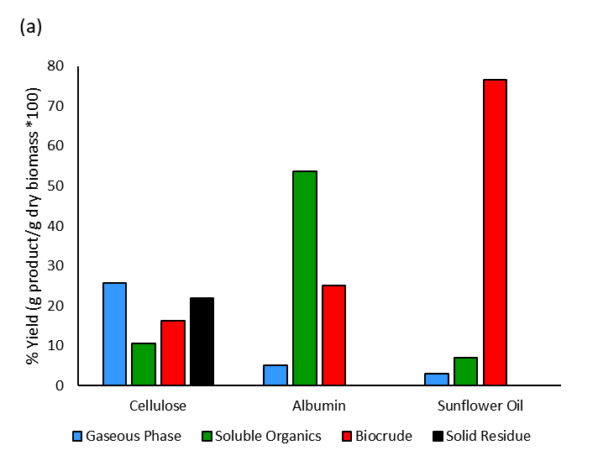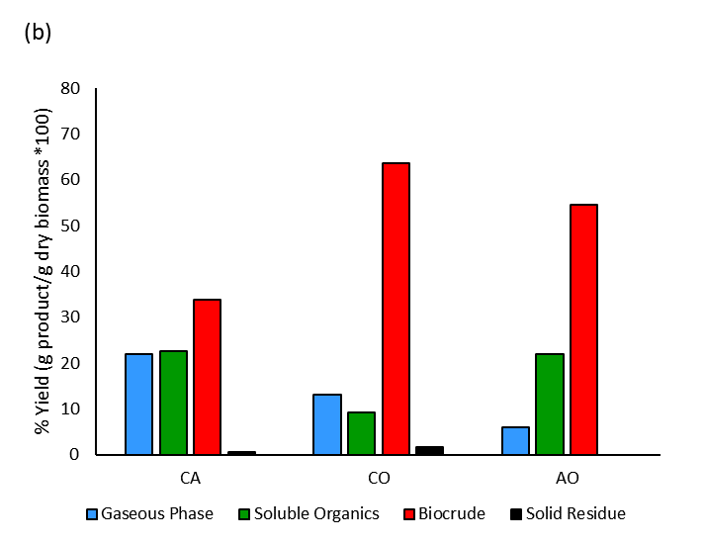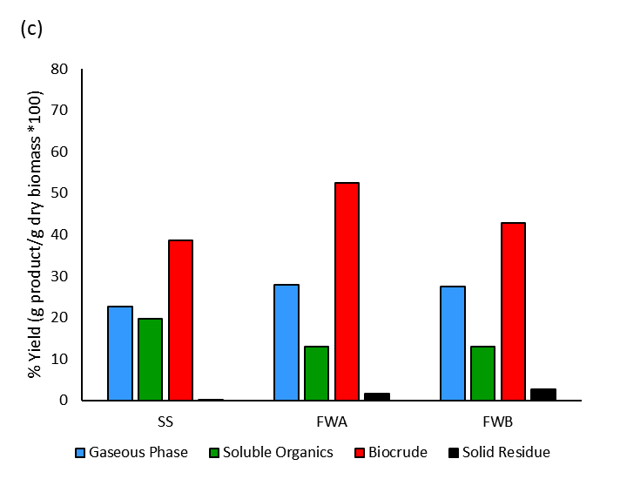

Figure 1: Product yields obtained from the HTL of: (a), the single model compounds; (b), binary mixtures; (c), ternary mixtures. CA = Cellulose – Albumin, CO = Cellulose – S. Oil, AO = Albumin – S. Oil, SS = Secondary Sewage Sludge, FWA = Food Waste A, FWB = Food Waste B.

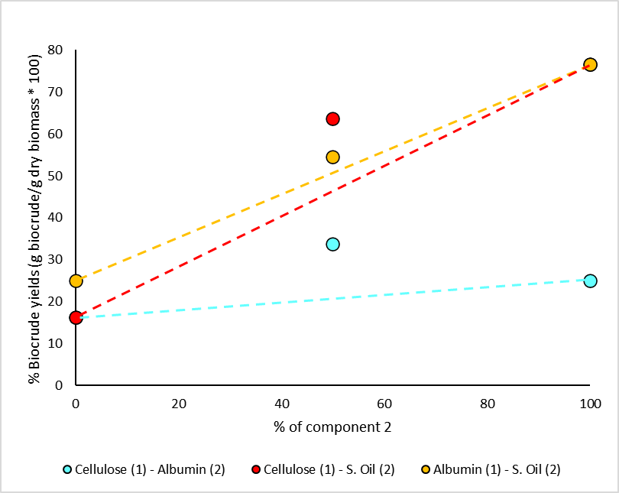

Figure 2: Biocrude yields from the HTL of the binary mixtures. The dashed line represents the linear combination of the biocrude yields of the single model compounds. The red point overlaps the blue point for pure cellulose and the yellow point overlaps the red point for pure sunflower oil.

* + 1. GC-MS analysis of biocrude and aqueous phase

The molecules detected by the gas chromatograph are grouped into classes of compounds based on their chemical nature. The selected classes of compounds are listed as follows: Acids, Fatty Acids, Aldehydes/Ketones, Amides, Amines, Nitrogen containing Heterocycles, DKPs (diketopiperazines), Oxygen containing Heterocycles and Alcohols/Phenols. The percentage areas obtained from the integration of the chromatograms of the biocrude and the aqueous phase of all the mixtures are reported in Figure 3 for each class of compounds. As shown in Figure 3a, the cellulose main products are acids, aldehydes, ketones, alcohol, phenols and oxygenated heterocycles. Albumin produces various compounds as ketones, alcohols, nitrogen containing heterocycles, DKPs, amines and amides. Finally, sunflower oil’s HTL products are fatty acids and alcohol (glycerin). The compositions of the products of the binary mixtures are presented in Figure 3b. Results show an increase of nitrogen containing heterocycles and DKPs for the Cellulose – Albumin mixture, a moderate increase of aldehydes and ketones for Cellulose - S. Oil and a marked increase of amides for the Albumin – S. Oil mixture. At the same time there is a decrease of oxygen containing heterocycles in Cellulose – Albumin mixture and a decrease of amines in Albumin – S. Oil mixture. Figure 3c shows similar results for the ternary mixtures, with the only notable difference for the simulated food wastes, in which a large increase in the content of aldehydes and ketones in the biocrudes is obtained.

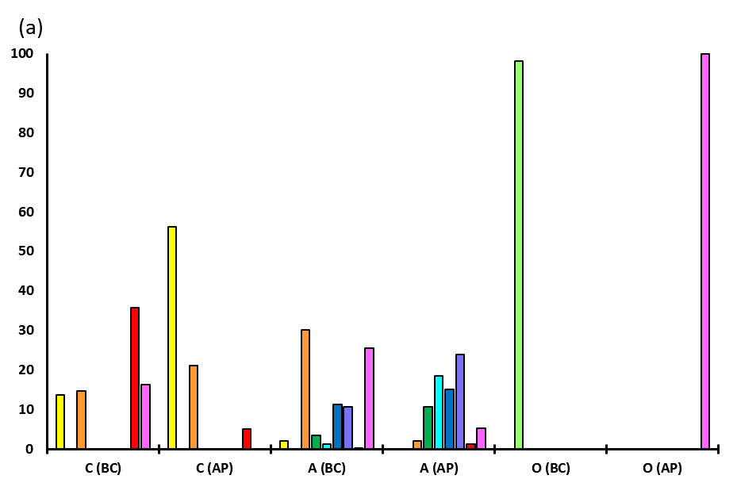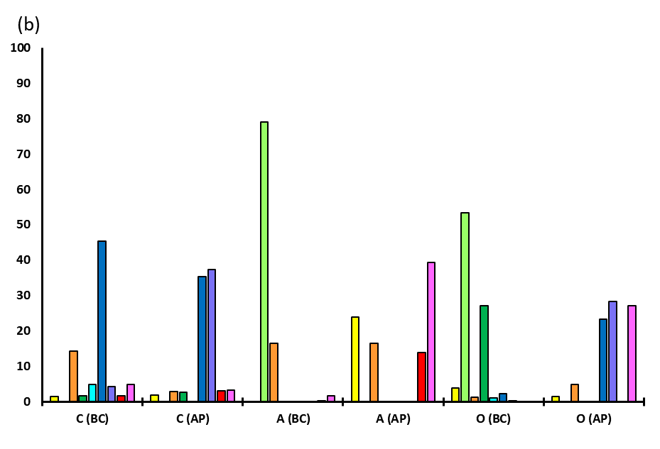

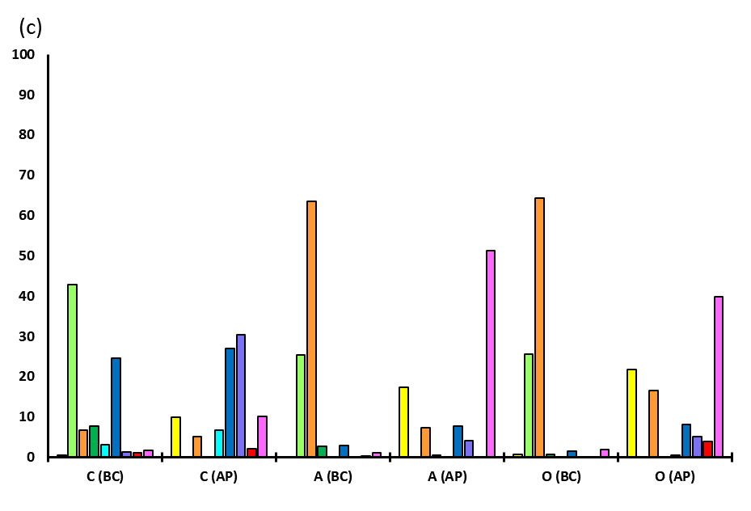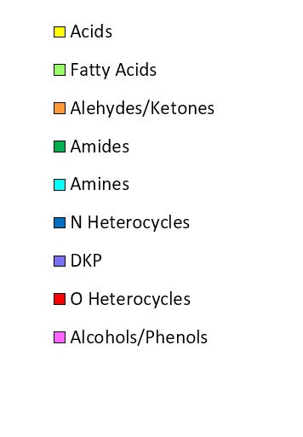

Figure 3: Histograms of the percent area of the main groups of compounds identified with GC-MS analyses in the Biocrude (BC) and in the Aqueous Phase (AP) obtained from the HTL of the single model compounds (a), their binary mixtures (b) and their ternary mixtures (c). CA = Cellulose – Albumin, CO = Cellulose – S. Oil, AO = Albumin – S. Oil, SS = Secondary Sewage Sludge, FWA = Food Waste A, FWB = Food Waste B.

* + 1. Proposed reaction pathways

The first reaction step for each component consists in the hydrolysis, which decomposes polysaccharides into sugars, proteins into amino acids and triglycerides into fatty acids and glycerin. These monomers undergo several transformation mechanisms, individually and through binary interactions with each other. Cellulose’s main hydrolysis product is glucose, that isomerizes to fructose. Fructose can decompose to oxygen containing heterocycle compounds with furanose structures, as 5-hydroxymethylfurfural (5-HMF) and other furan derivatives and can undergo to ring opening reactions to form levulinic acid and 2,5-hexanedione, and other smaller aldehydes and ketones. Acetic and formic acid are byproducts of these reactions. Phenolic compounds can be produced too. Furanose heterocycles and levulinic acid appears to be the main precursors for char production (Chacón-Parra et al., 2022). Amino acids can undergo deamination and decarboxylation reactions, forming respectively acids and amines, that enrich the aqueous phase. They can also dimerize to form DKPs, that are mainly present in the aqueous phase. Fatty acids can undergo decarboxylation to form long chain hydrocarbons, decarbonylation to form alcohols and can lose the hydroxyl group to form aldehydes. Oxygenated heterocycles from polysaccharides degradation can react with amino acids, or with the ammonia produced by amino acids deamination, to form nitrogen containing heterocycles as pyridines, pyrazines, pyrroles and others, that enrich the biocrude phase (Fan et al., 2018). These mechanisms are referable to Maillard reactions. The furanose compounds consumption to produce Maillard type products reduces their concentration in the reaction environment, hindering the char formation and lowering the solid residue yield, as shown in the results of Figure 1b where the reduction of char with respect to pure cellulose is shown. Fatty acids can react with amino acids or amines to produce long chained amides or can react with produced alcohols to form esters. Some of these products can also undergo polymerization, cyclization, and aromatization to form more complex structures, that enrich the biocrude and the solid residue.

* 1. Conclusions

Hydrothermal liquefaction appears to be one of the most promising technologies to produce liquid biofuel from organic feedstocks. High moisture waste biomasses are particularly interesting for this process, and due to their provenance, they can be schematized as mixtures of three main macro components: polysaccharides, proteins and lipids. In this work Cellulose, Albumin and Sunflower Oil were used, alone and in mixtures, as model compounds for these macro components respectively. Results showed the presence of binary interactions between these compounds, that increased biocrude yields and lowered solid residue yields. Some general reaction pathways were summarized to schematize these interactions. The results of GC-MS analysis showed clear signs of binary interactions, due to the Maillard reactions between polysaccharides and proteins, that lower the concentration of oxygen containing heterocycle compounds and produce nitrogen containing heterocycle compounds, and due to amidation between proteins and lipids, that lowers the concentration of amines and produces oil soluble amides. A better comprehension of these interactions during HTL of biomasses could help to predict the yields and the qualities of the biocrudes obtained from different feedstocks, with the aim to prepare blends of them that can optimize the process and simplify the subsequent up-grading steps, in order to obtain a high quality biofuel with lower costs of production.

References

Alibardi L., Cossu R., 2015, Composition variability of the organic fraction of municipal solid waste and effects on hydrogen and methane production potentials, Waste Management, 36, 147-155.

Chacòn-Parra A., Lewis D., Glasius M., van Eyk P., 2022, A multi-component reaction kinetics model for the hydrothermal liquefaction of carbohydrates and co-liquefaction to produce 5-ethoxymethyl furfural, Fuel, 331, 122499.

de Caprariis B., Bracciale M. P., Bavasso I., Chen G., Damizia M., Genova V., Marra F., Paglia L., Pulci G., Scarsella M., Tai L., De Filippis P., 2020, Unsupported Ni metal catalyst in hydrothermal liquefaction of oak wood: Effect of catalyst surface modification, Science of The Total Environment, 709, 136215.

de Caprariis B. Damizia M., Tai L., De Filippis P., 2022, Hydrothermal Liquefaction of Biomass using Waste Material as Catalyst: Effect on the Bio-crude Yield and Quality, Chemical Engineering Transactions, vol. 92, 607-612.

de Caprariis B., De Filippis P., Petrullo A., Scarsella M., 2017, hydrothermal liquefaction of biomass: Influence of temperature and biomass composition on the bio-oil production, Fuel, 208, 618-625.

Fan Y., Hornung U., Dahmen N., Kruse A., 2018, Hydrothermal liquefaction of protein-containing biomass: study of model compounds for Maillard reactions, Biomass Conversion and Biorefinery, 8, 909-923.

Fan Y., Hornung U., Dahmen N., 2022, Hydrothermal liquefaction of sewage sludge for biofuel application: A review on fundamentals, current challenges and strategies, Biomass and Bioenergy, 165, 106570.

Gai C., Zhang Y., Chen W., Zhang P., Dong Y., 2015, An investigation of reaction pathways of hydrothermal liquefaction using Chlorella pyrenoidosa and Spirulina platensis, Energy Conversion and Management, 96, 330-339.

Hao B., Xu D., Jiang G., Sabri T. A., Jing Z., Guo Y., 2021, Chemical reactions in the hydrothermal liquefaction of biomass and in the catalytic hydrogenation upgrading of biocrude, Green Chem., 23, 1562-1583.

Hietala D.C., Savage P.E., 2021, A molecular, elemental, and multiphase kinetic model for the hydrothermal liquefaction of microalgae, Chemical Engineering Journal, 407, 127007.

Maag A. R., Paulsen A. D., Amundsen T. J., Yelvington P. E., Tompsett G. A., Timko M. T., 2018, Catalytic Hydrothermal Liquefaction of Food Waste Using CeZrOx, Energies, 11, 564.