CHEMICAL ENGINEERING TRANSACTIONS  VOL. , 2023 | A publication of
The Italian Association
of Chemical Engineering
Online at www.cetjournal.it

Guest Editors: Sauro Pierucci, Jiří Jaromír Klemeš
Copyright © 2023, AIDIC Servizi S.r.l.
ISBN 978-88-95608-98-3; ISSN 2283-9216

Particle size segregation during the discharge of binary mixtures and the role of void saturation
Silvia Volpato*, Andrea C. Santomaso
APTLab-Advanced ParticleTechnology Laboratory, Department of Industrial Engineering, University of Padova, Italy
s.volpato@aptlab.it

Particles differing in size, under external mechanical activation, typically segregate rather than mix. This phenomenon, known as particle size segregation, is spontaneous and unavoidable in practice. In this work, we present an experimental investigation aiming at better understanding the segregation mechanisms occurring in industrial devices related to the storage of particulate materials. Even if storage in closed vessels is often considered a static operation, loading and unloading steps are always present and they must be considered as inherent part of the whole storage operation. These steps are clearly dynamic in nature. This work concentrates on the discharge step in which the particulate material is strongly sheared, especially close to the outlet of the storage bin giving high chances of segregation to the material. Segregation in dense sheared flows under gravity occurs mainly through the percolation of smaller particles in the voids existing between larger ones. The level of saturation of voids by small particles can strongly impact the segregation rate. It appears therefore that the relative amount of fines with respect to large particles, the level of bed dilatancy induced by shear, the interparticle friction are all variables that can affect fine particles mobility and therefore the extent of segregation. For these reasons, we carried out experiments on small-scale vessels discharging in a funnel flow regime. Binary mixtures at different fine compositions and particle size ratios have been considered. Furthermore, we carried out experiments to a better knowledge of the mixtures voidage. The correlations found in the literature fail to predict the critical fine concentration at which fine particle segregation stops. An Alternative correlation has been therefore proposed based on a micromechanical analysis of particles filling.
  - Introduction
Mixtures of particles of differing sizes during handling and processing operations typically segregate rather than mix (Tirapelle, 2021). This phenomenon, which is unavoidable in practice, represents an unending source of frustration for the bulk chemical, pharmaceutical, agricultural and food industries (Duran, 2012). Because of segregation, the quality of products degrades leading to an increase in production costs and waste (Gray and Ancey, 2015). Thus, a better understanding of segregation in granular materials is of great importance both from a fundamental physics point of view as well as for economic reasons (Duran, 2012). One of the most frequent and important mechanisms of segregation is interparticle percolation (Williams, 1976): when a granular mass contains particles of sufficiently different sizes, the finer ones tend to fall downwards through the voids between coarser particles, under the action of gravity. This sifting action can be spontaneous, but it is enhanced by the local rearrangement of the particle bed due, for example, to shear or vibrations occurring during mixing, pouring, or transport (Savage and Lun, 1988). Consequently, knowledge of the voidage of mixtures of particles is also important for predicting the packing and handling properties of granular materials (Finkers and Hoffmann, 1988). For this reason, in this work, the role of porosity of binary mixtures of granular material was investigated through the measure of the bulk density varying the size ratio of particles and the content of fine inside the mixture. There are literature studies on packing and on voids distribution in beds of binary and static mixtures (Finkers and Hoffmann, 1988; Yu and Standish, 1988). Further studies have been done to connect bed microstructure with granular mixture flowing behavior during gravity discharge (Arteaga and Tuzun, 1990; Fung and Kwan, 2014). Arteaga and Tuzun (1990), in particular, proposed a correlation, based on a simple geometrical model, to find limiting values of fine fractions above which segregation does not occur. In this work, we proposed a new correlation based on volume occupation by fines of voids created by large particles. In fact, the trend of bulk density made it possible to formulate a theory about the voids saturation that can affect the mobility of fine particles and therefore the extent of segregation. Furthermore, the segregation of the binary mixture of equal density granules differing in size was evaluated by examining the fine mass fraction during gravity unloading from a silo working in funnel flow regime to find a possible connection between the voids saturation and the reduction of the segregation extent.
2. Materials and methods
2.1 Silo unloading
The materials used in the experiments were a mixture of grains of pasta and couscous with irregular shapes and material density equal to 1348 kg/m³. The mixture of the two components (pasta and couscous) has allowed a broad particle size distribution ranging from 0.850 mm and 4 mm. The raw material was hence subdivided into 6 classes: A=0.850-1 mm, B=1-1.41 mm, C=1.41-2 mm, D=2-2.83 mm, E=2.83-3.36 mm, F=3.36-4 mm. To determine the binary mixtures used in the experiments, two classes were chosen to form the groups of material called fines and coarse. For the first set of experiments the fine group was composed of particles with sieve diameters between 1.4 and 2 mm (d_{f,1}=1.7 mm) and the coarse group was composed of particles with sieve diameters between 3.36 and 4 mm (d_{c}=3.68 mm). For the second set of experiments, the coarse group remained equal to that used in experiment 1, while the fine group was composed of particles with dimensions between 1 and 1.4 mm (d_{f,2}=1.2 mm). Hence, in the first experiment the particle diameter ratio (DR=d_{c}/d_{f,1}) was equal to 2.16; in the second is equal to 3. For the two sets of experiments, four different initial fractions were investigated: 10:90, 30:70, 50:50 and 65:35 by weight of fine and coarse grains.
A pilot silo was used in the experiments. The inclination with respect to wall steepness does not guarantee the funnel flow (but mass flow); for this reason, the walls of the hopper were covered with sandpaper (P400). In fact, according to Jenike’s theory (Schulze, 2021), by increasing the hopper wall friction angle, it is possible to convert a mass flow into a funnel flow.
A silo that discharges in funnel flow was chosen because it provides a greater extent of segregation. In fact, in funnel flow, there is more retention of fine particles in the bed inside the stagnant zones near the lateral walls on either side of the central flow region. This leads to an excess of fines discharged when the materials in the stagnant zones begin to be eroded, in the final stage of discharge.
The silo was filled with the same amount of mixture for all the experiments. The initial state of the mixture inside the silo was homogeneous. Great care was taken to fill the silo in order to ensure the random state of the mixture. Small quantities of mixed material were inserted in the silo with the aid of a short pipe, that slowly added the new materials to the free surface. After the filling, the silo was closed with a magnetic cap; then it was vertically placed on a trolley with the discharge outlet facing downward. A graded strip of paper was extended on the floor of the laboratory and fixed with adhesive tape. A second magnet was fixed on the floor at the beginning of the paper strip. When the trolley with the silo passed over the magnet on the floor, the closing cap was automatically detached from the silo outlet allowing the powder mixture to be discharged by gravity. The distance between the silo outlet and the floor was kept constant at 5 cm during the discharge; the speed, at which the silo moved, ensured the free discharge by gravity, well described by the Beverloo equation (Arteaga and Tuzun, 1990). All the discharged material was collected at a regular sampling distance (100 mm) to obtain the weight fraction of fine and coarse particles.
The procedure of discharge and sampling is sketched in Figure 1.
2.2 Bulk density
Average static densities of the mixtures $ρ_{b,m}$were calculated by weighting the mixture in the container with known geometrical volume. The filling of the container was done using a silo that worked in a mass flow regime. The ratio between the mass of the material inside the container after the filling and the volume of the container resulted in the mixture bulk density. The measure was done for the two different size ratios (DR=2.16 and DR=3) and mass fraction of fine between 0 and 100%.
3. Experimental results
3.1 Size segregation during silo unloading
The segregation of fine particles during the discharge under funnel-flow conditions was monitored by measuring the mass fraction of fine and coarse particles present in the discharged samples, collected at regular intervals, as reported in Figure 2. The x-axis of these plots reports the fine mass fraction $ϕ_{F}$ normalized by the average mass fraction of the initial filling $ϕ_{F,0}$. A value greater than 1 indicates segregation of fine material inside the mixture due to percolation of the fine within the hopper. A value lower than 1 suggests the retention of fine materials inside the hopper. A value equal to 1 indicates that no segregation occurs inside the mixture. The y-axis instead reports the cumulative overall mass discharged normalized by the initial total mass loaded into the silo.
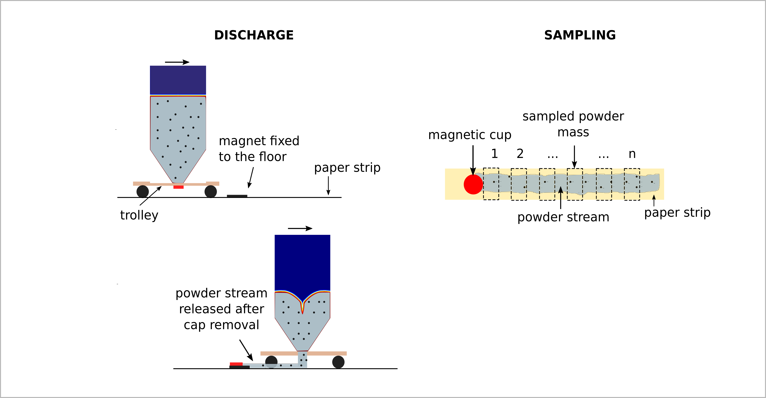
Figure 1: Scheme of silo unloading and sampling procedures.
The normalized fines mass fraction shows for every DR and every $ϕ_{F,0}$ three regions: an initial region where the mass fraction is always greater than 1, an intermediate region where the normalized fines mass fraction is lower than 1 (which indicates retention of fines inside the bulk material remained in the silo) and a final short zone where the normalized fines mass fraction comes back greater than 1.
For DR=2.16 the extent of segregation is greatest for $ϕ_{F,0}$=0.1. For $ϕ_{F,0}$=0.3, 0.5, 0.65 the intermediate and the final stages show a similar behavior, while the extent of segregation is similar in the initial stage for $ϕ_{F,0}$=0.5, 0.65. However the extent of segregation is very close to 1 for $ϕ_{F,0}$> 0.3.
Using a greater diameter ratio, DR=3, which means more difference between the size of fine and the coarse particles that compose the binary mixture, it is possible to appreciate a larger discrepancy in the extent of segregation varying $ϕ_{F,0}$. In this case the normalized fines mass fraction is near to 1 for $ϕ_{F,0}$>0.5.
Hence, observing these data set, we can assert that the fines segregation tends to stop at lower values of $ϕ_{F,0}$ for DR=2.16 respect to the case DR=3.
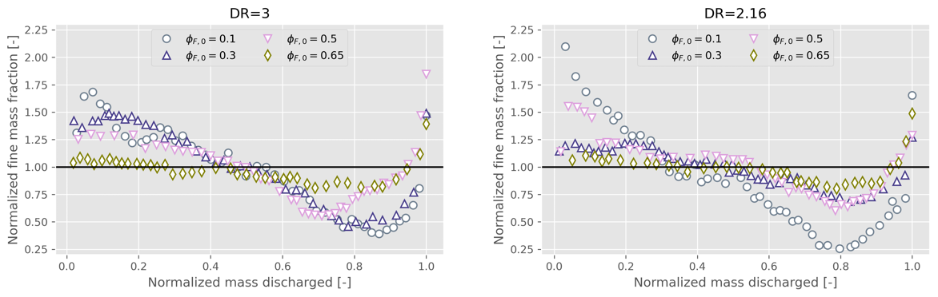Figure 2: Normalized fines mass fraction during discharge of a binary mixture from a funnel flow silo at different initial fines mass fraction and two different sizes ratios: DR=3 (left) and DR=2.16 (right).
3.2 Bulk density and porosity
To explain the segregation phenomenon during the gravity unloading of a binary mixture, its microstructure was investigated. The porosity of the binary mixture plays a fundamental role in the segregation; in fact fines percolation depends on the ability of smaller particles to fill the interstitial space between the particles and on voids propagation (Volpato et al., 2020). The porosity is strictly connected to bulk density; in fact if the bulk density increases the porosity decreases. Hence, to evaluate the porosity of the binary mixture at varying fines mass fractions, the static bulk density was measured for the two binary mixtures with DR=2.16 and DR=3 and content of fines between 0 and 100 % in weight. The curves of bulk density, as it is possible to see in Figure 3, show two different maximum points: for DR=2.16 the bulk density is maximum when the fines fraction is equal to 30 %; for DR=3 the bulk density is maximum when the fines fraction is equal to 40 %.

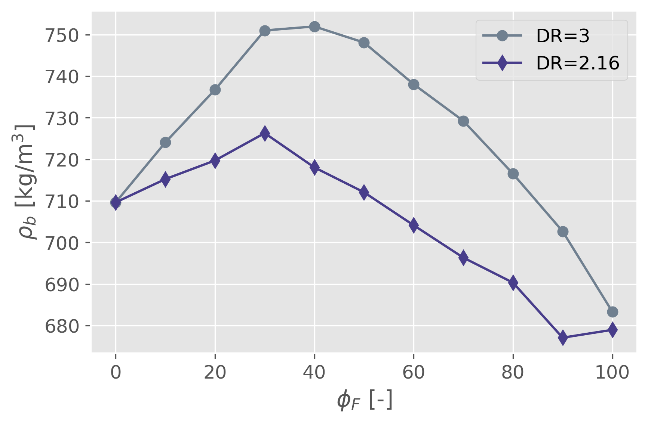
Figure 3: Bulk densities of the two mixtures (DR=3 and DR=2.16) with different content of fine materials (0-100 %).
The maximum values of the bulk densities bound two regimes (Arteaga and Tuzun, 1990): a coarse continuous phase and a fine continuous phase. The coarse continuous phase occurs when it is the matrix of coarse particles that determines the interparticle voids available for the fine particles. When the maximum bulk density is reached, the fine content is just enough to fill the voids between the coarse particles. Furthermore, there are no fine particles separating the coarse particles and the coarse particles touch each other; hence they can slide against each other when flowing, leading to relatively large dilatation of the bed. In the fine continuous phase, instead, the fines content is more than enough to fill the voids between the coarse particles (over saturation of the coarse matrix voids) and there is an excess of fine particles (that needs to fill the voids). In this phase, the large particles are no longer packed against each other but between them, there are one or more layers of fine particles which increase in thickness as the concentration of fines increases. In this case, also the bed dilatation is small, limiting both the void propagation and the percolation of fine particles.
So, as suggested by Figure 4 we can observe three stages of saturation of the coarse matrix as the content of fines increases: (a) a state of under saturation of the coarse matrix in which the percolation of fines can still be described by the mechanism of filling voids as done by Volpato (2020) for a binary mixture where fine particles are infinitely diluted; (b) a state of complete saturation of the voids and (3) a state of over saturation of coarse matrix voids, in which the voidage of coarse particles no longer plays a decisive role in the fines segregation.
In light of these observations, the fines fraction at which the maximum packing density is achieved should represent the limit value above which the segregation of fine is greatly reduced.
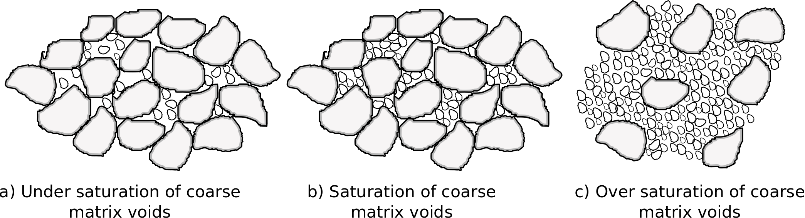
Figure 4: Stage of voids saturation in a binary mixture.
The maximum packing of bulk density, as said previously, is reached when the volume of the void is saturated by a certain volume of small particles.
In a bed of large particles the volume of interstitial space per particles is (Finkers and Hoffmann, 1988):

$V_{v,c}=\frac{ϵ_{L}}{1-ϵ_{L}}\frac{π}{6}d_{c}^{3}$ (1)

where $ϵ_{L}$is the porosity of bed constitute of coarse particles.
Dividing this value for the average volume of one fine particles and its associated void space:

$V_{F+V}=\frac{π}{6}d_{F}^{3}\left(1-ϵ_{F}\right)$, (2)

we obtain the number of fine particles that saturates the voids of one coarse particle.
This number ratio, (N_{F}/N_{C})_{sat} represents the value at which the maximum packing density occurs and it is equal to 4 for DR=2.16 and equal to 13 for DR=3 as reported in Table 1. The number of fine particles necessary to saturate the coarse matrix (that is the same for the case DR=3 and DR=2.16) is obviously greater for DR=3 since the diameter of fine particles is smaller than the fine diameter for the case with DR=2.16.
In Figure 5 the bulk density is represented in terms of number of fines N_{F} divided by the number of coarse particles N_{C} to verify if the maximum packed density occurs at the values indicated above. As it also possible to read in Table 1 the ratios calculated theoretically (with Eq(1) and Eq(2)) are very close to the ratio at which the maximum packed density occurs.

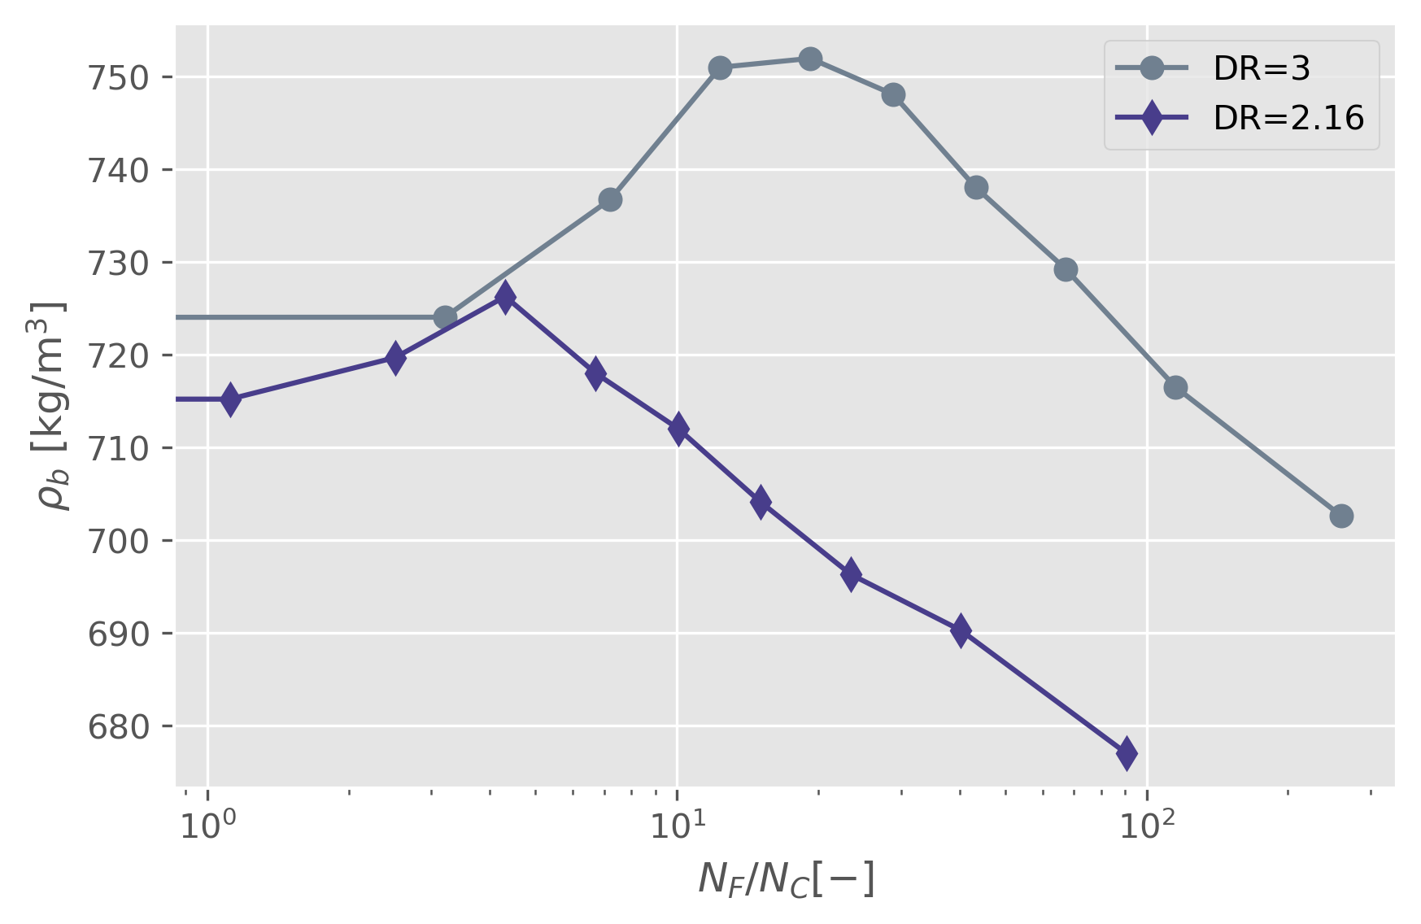
Figure 5: Bulk density of the two mixtures (DR=3 and DR=2.16) with different content of fine materials (0-100 %) at different N_{F}/N_{C}
Table 1: Values of the maximum bulk density and values of $ϕ_{F}$, ${\left({N_{F}}/{N_{C}}\right)}_{max}$, ${\left({N_{F}}/{N_{C}}\right)}_{sat}$ at which the maximum bulk density occurs.
DR [-] | $ρ_{b,max}$ [kg/m³] | $ϕ_{F}$ [%] | ${\left({N_{F}}/{N_{C}}\right)}_{max}$ [-] | ${\left({N_{F}}/{N_{C}}\right)}_{sat}$ [-]
3 | 752 | 40 | 19 | 13
2.16 | 726 | 30 | 4 | 4

3.3 Fines segregation and voids saturation
Ultimately, an overall segregation index (SI) was calculated for data set reported in Figure 2.
The segregation index is based on the standard deviation of the normalized fine mass fractions over the entire discharge process:
$SI=\sqrt{\frac{1}{n}\sum_{i=1}^{n}{{\left[{\left(\frac{ϕ_{F}}{ϕ_{F,0}}\right)}_{i}-1\right]}^{2}}}$ (3)
where n is the number of the samples.
When SI is equal to 0 indicates a complete uniform composition equal to the initial one; an increasing of SI, instead, indicates an increasing extent of segregation. Table 2 reports the values of SI. For DR=2.16 the overall extent of segregation is lower for DR=2.16 respect to DR=3. However, for $ϕ_{F,0}$ =30% and DR=2.16 the SI does not very close to zero, which means that the fines segregation still occurs. In both tases, anyway, for $ϕ_{F,0}$=65 % the SI is equal to 0.1, hence very close to zero. In this case we can consider that overall segregation of fines is practically null.
In light of these observations, the achievement of the maximum packing density in the mixture is not the unique condition to stop the fines segregation that continues to occur even when the oversaturation of the coarse voids state verifies.
Table 2: Segregation index (SI) for DR= 3 and 2.16 and initial fine mass fraction of 10, 30, 50, 65 %.
DR [-] | $ϕ_{F,0}$=10 % | $ϕ_{F,0}$=30 % | $ϕ_{F,0}$=50 % | $ϕ_{F,0}$=65 %
3 | 0.78 | 0.37 | 0.33 | 0.16
2.16 | 0.54 | 0.39 | 0.27 | 0.16
4. Conclusions
The voidage of a mixture is important to understand the mechanism of fine particle segregation. How the fine particles fill the void and how this occupation modifies the flow of the binary mixture is of crucial importance to better understand the fines segregation mechanism.
In this work, the maximum packed density achieved by the mixture at a certain value of fines content was connected with the state of saturation of the interparticle voids in a matrix composed only by coarse particles. Three states of saturation were identified in the mixture: an initial state, before the maximum packing density, in which the voidage of the coarse matrix is not completely filled by the small particles; the coarse particles are in contact with each other and the fine particles fill the voids. A consecutive state of complete saturation depends on the diameter ratio and the content of fine characterized by the maximum packed density of the mixture and a final state, is characterized by a decrease of the bulk density. In this state, the coarse particles are no longer in contact with each other, but they are spaced by different layers of fine particles.
We verify, hence, that fines segregation, during funnel flow silo unloading, occurs with greater extent in the under saturated state and completely saturated states, and continues with less intensity also in the over-saturation state. Further investigations will be done to understand to what extent the fines segregation continues in the over-saturation state and what is mechanisms drive the fines segregation in this state.

References
Artega P., Tüzün U., 1990, Flow of binary mixtures of equal-density granules in hoppers—size segregation, flowing density and discharge rates, Chemical engineering science, 45, 205-223.
Duran J., 2012, Sands, powders, and grains: an introduction to the physics of granular materials, Springer Science & Business Media.
Finkers H. J., Hoffmann A. C., 1998, Structural ratio for predicting the voidage of binary particle mixtures, AIChE journal, 44.2, 495-498.
Fung W. W. S., Kwan A. K. H, 2014, Effect of particle interlock on flow of aggregate through opening, Powder technology,253, 198-206.
Gray J. M. N. T., Ancey C., 2015, Particle-size and -density segregation in granular free-surface flows, Journal of Fluid Mechanics, 779, 622–668.
Savage, S. B., Lun, C. K. K.,1988, Particle size segregation in inclined chute flow of dry cohesionless granular solids, Journal of fluid mechanics, 189, 311-335.
Schulze D., 2021, Powders and bulk solids, Springer International Publishing.
Tirapelle M., Troncon L., Volpato S., Santomaso A. C. 2021, Size Segregation of Ternary Mixtures in Inclined Chute Flows: an Experimental Study. Chemical Engineering Transactions, 86, 823-828.
Volpato S., Tirapelle M., Santomaso A. C. 2020. Modeling and experimental investigation of shear-induced particle percolation in diluted binary mixtures, Physical Review E,102(1), 012902.
Williams J. C., 1976, The segregation of particulate materials. A review, Powder technology, 15(2), 245-251.
Yu A. B., Standish N., 1998, An analytical—parametric theory of the random packing of particles, Powder technology, 55(3), 171-186.

