CHEMICAL ENGINEERING TRANSACTIONS  VOL. , 2023 | A publication of
The Italian Association
of Chemical Engineering
Online at www.cetjournal.it

Guest Editor: Sauro Pierucci
Copyright © 2023, AIDIC Servizi S.r.l.
ISBN 978-88-95608-98-3; ISSN 2283-9216

Investigating the Ability of Experimental Agro-Ecological Systems to Restore Fertility
Marzhan Anuarbekovna Sadenova*, Nail Alikuly Beisekenov, Yerbolat Tleubekovich Ualiyev, Natalya Anatolyevna Kulenova
Priority Department Centre «Veritas» D. Serikbayev East Kazakhstan technical university, 19 Serikbayev str. 070000, Ust-Kamenogorsk, Kazakhstan
MSadenova@edu.ektu.kz
Under conditions of changing climate, unsustainable use of agricultural land and increasing anthropogenic pressure on the environment, the natural bioproductivity of the soil is being lost. The integration of geographic information systems (GIS) and remote sensing has been shown to promote precision farming technology and sustainable land use practices. In this study, based on the Revised Universal Soil Loss Equation (RUSLE) method, a digital elevation model of an experimental site in eastern Kazakhstan was developed. It was found that one of the main causes of erosion is critically low content of humus in the soil in the range of 0.82-1.66 %, so the use of spatial modelling methods can help determine the best management practices to reduce and prevent soil erosion and improve its quality by increasing the content of humus in the soil. Calculations of actual soil losses after gully formation, which amount to about 185 ha of land, have been made; a predictive model of the relief of the study area and increase of humus content to 3.5-5% with the proposed fertility restoration measures has been developed to prevent further soil erosion, preserve and restore fertility.
1. Introduction
The problem of soil degradation as a result of agricultural production intensification has taken on a global scale. It is known that more than a third (about 2$×$10⁶ ha) of the world's agricultural soils are degraded, having lost their former fertility and eroded (Pimentel et al., 2013). Since the end of the last century, a new term has emerged: conservation agriculture, regenerative farming, a system sharpened to preserve soil fertility in a sustainable manner. Under conditions of changing climate, irrational use and increased anthropogenic load on arid lands active degradation processes take place. Irreversible changes of ecosystems, loss of natural bioproductivity of soil, loss of species diversity of vegetation are observed. Regular monitoring by experts helps to timely identify problematic desertification hotspots, and then to develop and implement measures for preservation and restoration of arid zones. The development of GIS has made it possible to combine spatial positioning with different information, visualising it with maps and 3D scenes. Maps are used as geographical containers to incorporate data layers and analytics. GIS reveals a deeper understanding of data, patterns, relationships and provides a more intuitive representation of data (Lytos et al., 2020).
Climate change affects several aspects of agricultural production systems, such as changes in flowering phenology, water availability, soil fertility and erosion, increased pathogen distribution and host susceptibility (Rosenzweig et al., 1995). The use of a GIS system constitutes a special category of software that organises, analyses, processes and visualises field data in the form of digital maps. Radoglou et al. (2020) developed a unique modelling approach for rapid assessment of large-scale water erosion on a regional scale, using the example of the Loess Plateau in China. They created a mathematical model linking sediment output and selected variables based on remotely sensed (RS) data through an overlay in a GIS. In the final step, they trained the mathematical model by calculating predictor relationships using multiple regression analysis (MRA). Michalopoulou et al. (2022) analysed and studied the relationships between the Digital Elevation Model (DEM) and the topographic coefficient (LS), which is one of the most important parameters of the RUSLE model, to estimate the annual soil erosion rates. It is shown that the construction of a digital elevation model (DEM) is necessary to assess soil susceptibility to erosion. It has been established by the above authors that the evaluation of primary topographic data and different approaches to the calculation of LS coefficient are of particular importance, especially in areas with a diverse landscape.
This paper presents the results of a study to calculate soil loss of an experimental polygon, develop measures to restore soil fertility and prevent future erosion based on a combination of Earth remote sensing (ERS) technology and mathematical modelling techniques.
2. Object and methodology of research
The experimental site is located in eastern Kazakhstan at 50°20'06.3 "N and 81°37'48.7 "E and covers an area of 240 km². The study area is characterised by steep topography due to the proximity of the Irtysh River and the presence of the Shulba reservoir. Approximately 300 mm of precipitation falls each year in the area. The wettest months are from May to September. Due to high precipitation and steep slopes, large amounts of soil are subject to erosion and transported to low-lying valleys and various water bodies. The study area is shown in Figure 1.
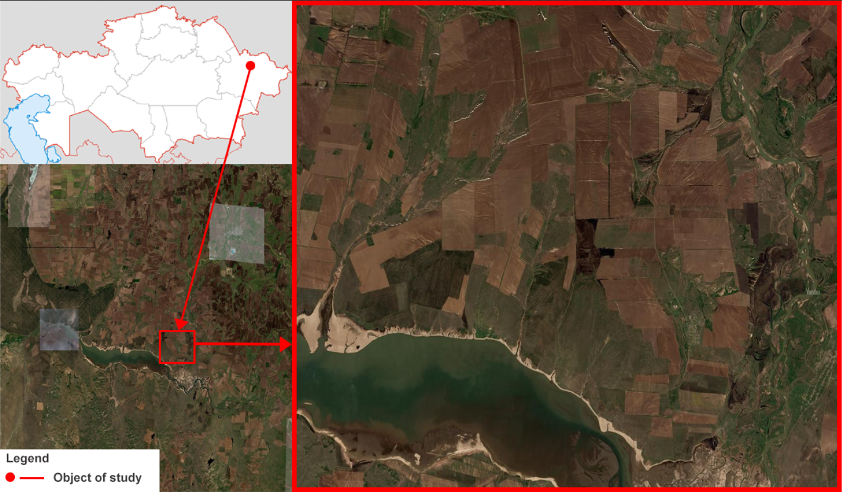
Figure 1: Experimental Range (image taken by Sentinel-2 L2A: 18.08.2022)
The SAGA GIS software was used to process the space images of the experimental polygon acquired from the spaceborne radiometer (ASTER) V3 (Conrad et al., 2015). The calculation of the S-factor in this study is based on the RUSLE model, RUSLE is an empirically based modelling approach that predicts the long-term average annual rate of soil erosion on slopes using five factors. It estimates soil loss under similar topography and meteorological conditions as described by Thapa (2020) presented in Eq (1):
$$\left\{\begin{aligned} S=10.8*sinθ+0.03, steepness<9\% \\ S=16.8*sinθ-0.50,steepness≥9\%\end{aligned}\right.$$ | (1)
where θ is the slope angle, expressed in radians.
The approach of Desmet and Govers (1996) presented in Eq (2-6) was used to calculate the LS coefficient:
$$L_{i,j}=\frac{{(A_{i,j-in}+D^{2})}^{m+1}+A_{i,j-in}^{m+1}}{D^{m+2}*x_{i,j}^{m}*{(22.13)}^{m}}$$ | (2)
$$x_{i,j}={sinα}_{i,j}+{cosα}_{i,j}$$ | (3)
$$m=\frac{β}{β+1}$$ | (4)
$$β=\frac{(\frac{sinθ}{0.0896})}{\left[0.56+3*{sinθ}^{0.8}\right]}$$ | (5)

where Ai,j-in - input area to grid cell with coordinates (i, j) (m²); D - grid cell size (m); αi,j - aspect direction for grid cell with coordinates (i, j).
to calculate the maximum absolute error, the mean value of products that can be approximated by the product of the means presented in Eq (6) is used (based on Li et al. (2016)):
$$\frac{\sum_{i=1}^{n}{{Rm}_{i}{Km}_{i}{LS}_{i}C_{i}P_{i}}}{n}≈\frac{\sum_{i=1}^{n}{{Rm}_{i}}}{n}\frac{\sum_{i=1}^{n}{{Km}_{i}}}{n}\frac{\sum_{i=1}^{n}{{LS}_{i}}}{n}\frac{\sum_{i=1}^{n}{C_{i}}}{n}\frac{\sum_{i=1}^{n}{P_{i}}}{n}$$ | (6)
3. Results and discussion
Predicting soil erosion is an important step in erosion prevention because it makes it possible to identify areas at high erosion risk and to implement appropriate management strategies. By predicting soil erosion, it is possible to take proactive measures to prevent erosion rather than waiting until damage has already occurred. In order to prevent soil erosion, it was decided to develop a predictive elevation model based on DEM and remote sensing data. In the first phase of the study, DEM, namely the digital elevation map of the Advanced Spaceborne Thermal Emission and Reflection Radiometer (ASTER) V3, released in 2019, with a horizontal resolution of 30 m, was used to calculate LS coefficients for the rugged terrain of the pilot area (Chen and Nguyen, 2022). The NASA Advanced Spaceborne Thermal Emission and Reflection Radiometer (ASTER) Version 3 global digital elevation model is available for download from The Land Processes Distributed Active Archive Center (LP DAAC) and includes land surfaces between 83° north latitude and 83° south latitude. Figure 2 shows a digital elevation map of the study area.
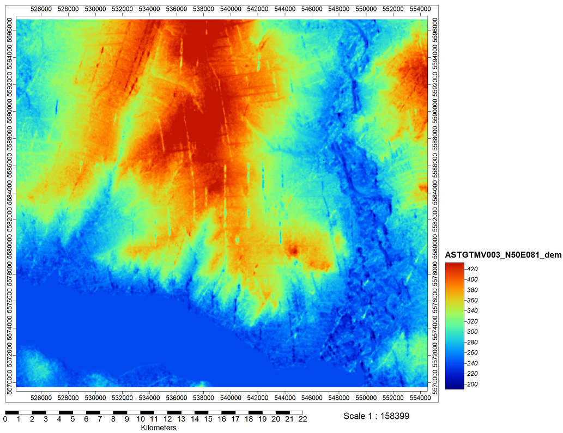
Figure 2: Digital elevation model of the study area: ASTER V3 (30 m)
In hilly terrain, the slope angle has a major effect on the rate of soil erosion. Shear stresses on soil particles increase as the overland flow velocity increases as the slope steepens. As the slope lengthens, overland flow and velocity increase, causing the erosive forces acting on the soil surface to increase. As topography determines the rate of surface runoff, it has a significant effect on soil erosion. Moving from slope to catchment, the LS coefficient is no longer based on a single slope profile with a uniform gradient and must be modified. In (Hrabalíková and Janeček, 2017) a hill was divided into several segments, which were assumed to be homogeneous in terms of slope gradient and soil properties. Panagos et al. (2021) proposed an LS equation for modelling complex topography. An improved algorithm based on the work of Kabzhanova et al. (2022) was developed to calculate the LS coefficient, taking into account the FCOVER layer properties of Sentinel-2 L2A satellite images based on the Desmet and Govers equation and LS coefficient field modules presented in SAGA (System for Automated Geoscientific Analyses) GIS, which integrates a multiple flow algorithm. Data from Sentinel-2 L2A and other satellites with description of their characteristics are promptly received and processed 2-3 times a day at the East Kazakhstan Technical University (EKTU) named after D. Serikbayev, located in Ust-Kamenogorsk (Beisekenov et al., 2021). The result of the LS coefficient calculation is presented in Figure 3a. Also a depression (valley) depth map has been plotted in Figure 3b.
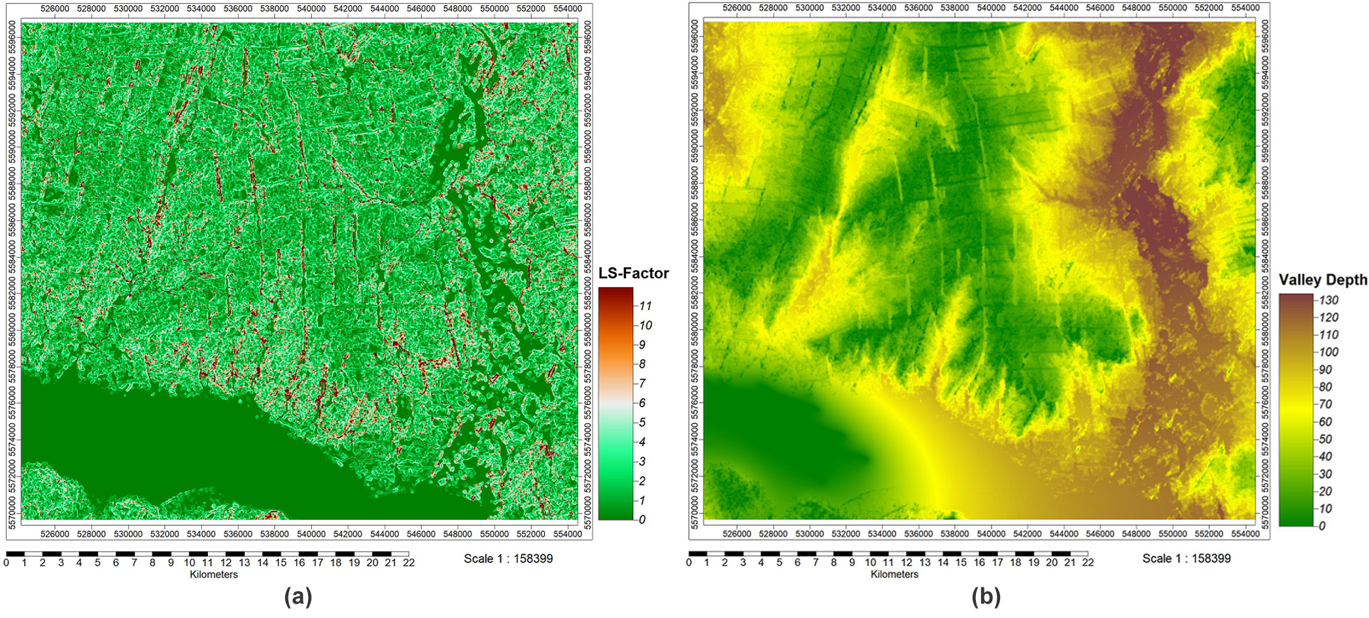
Figure 3: Maps based on the developed algorithm and DEM derived from ASTER V3 (30 m): a) LS factor; b) Valley Depth;
Based on Map 3a, a histogram of the LS factor of the study polygon was plotted in Figure 4a. It is shown that the DEM ASTER histogram has a fairly high peak between 0 and 1. The presence of red-burgundy colour in the histograms indicates the susceptibility of the soil to erosion.
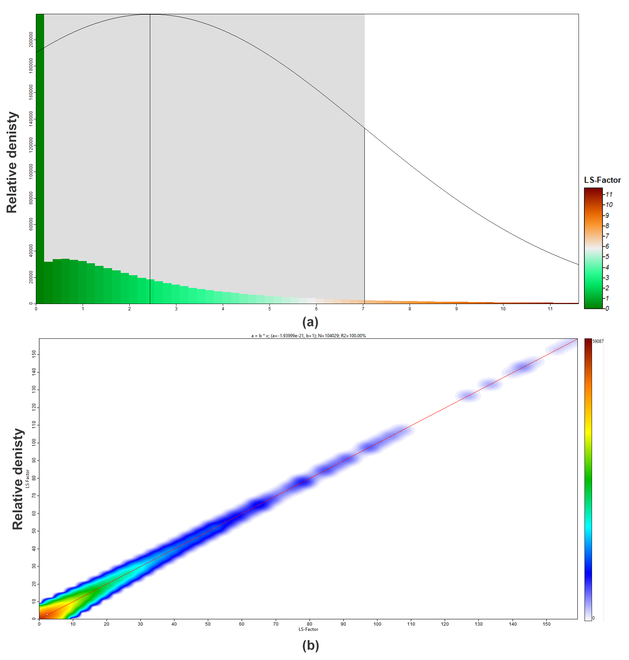
Figure 4: LS factor distributions: a) histogram; b) cumulative curve
Looking at the distribution of the cumulative density of the LS factor (Figure 4b), it can be seen that the curve at LS has one peak, with a smooth concentration of points, with a calculated value of potential soil erosion up to 10 t ha⁻¹, and actual soil loss subsequently due to gully formation, which is about 185 ha of land, suggesting average risk of soil exposure to future erosion. The LS factor quantifies the effect of topography on soil erosion and also has the greatest impact on the loss of fertile soil.
This study has generated the following recommendations:
- Using RUSLE models, researchers can compare soil erosion analyses over different historical periods;
- to determine the average rate of soil erosion in certain polygons, it is recommended to use the average of the products of five erosion factors (precipitation erosion factor Rm, soil erodibility factor Km, topographic factor LS, cover management factor C and support practice factor P);
- to calculate the maximum absolute error (10.6% to 28.4%, depending on DEM and catchment), it is recommended to use the mean value of the products, which can be approximated by the product of the means given in Eq (6).
- as an approximation, it is possible to analyse specific erosion factors separately and compare them across areas and countries to determine their proportional impact on overall soil loss in different parts of the world.
In order to develop measures to restore soil fertility and prevent future erosion, a model has been developed based on the overlay of ERS material on the DEM, which provides additional options for interpreting the DEM and predicting soil erosion over the next decades (Figure 5).
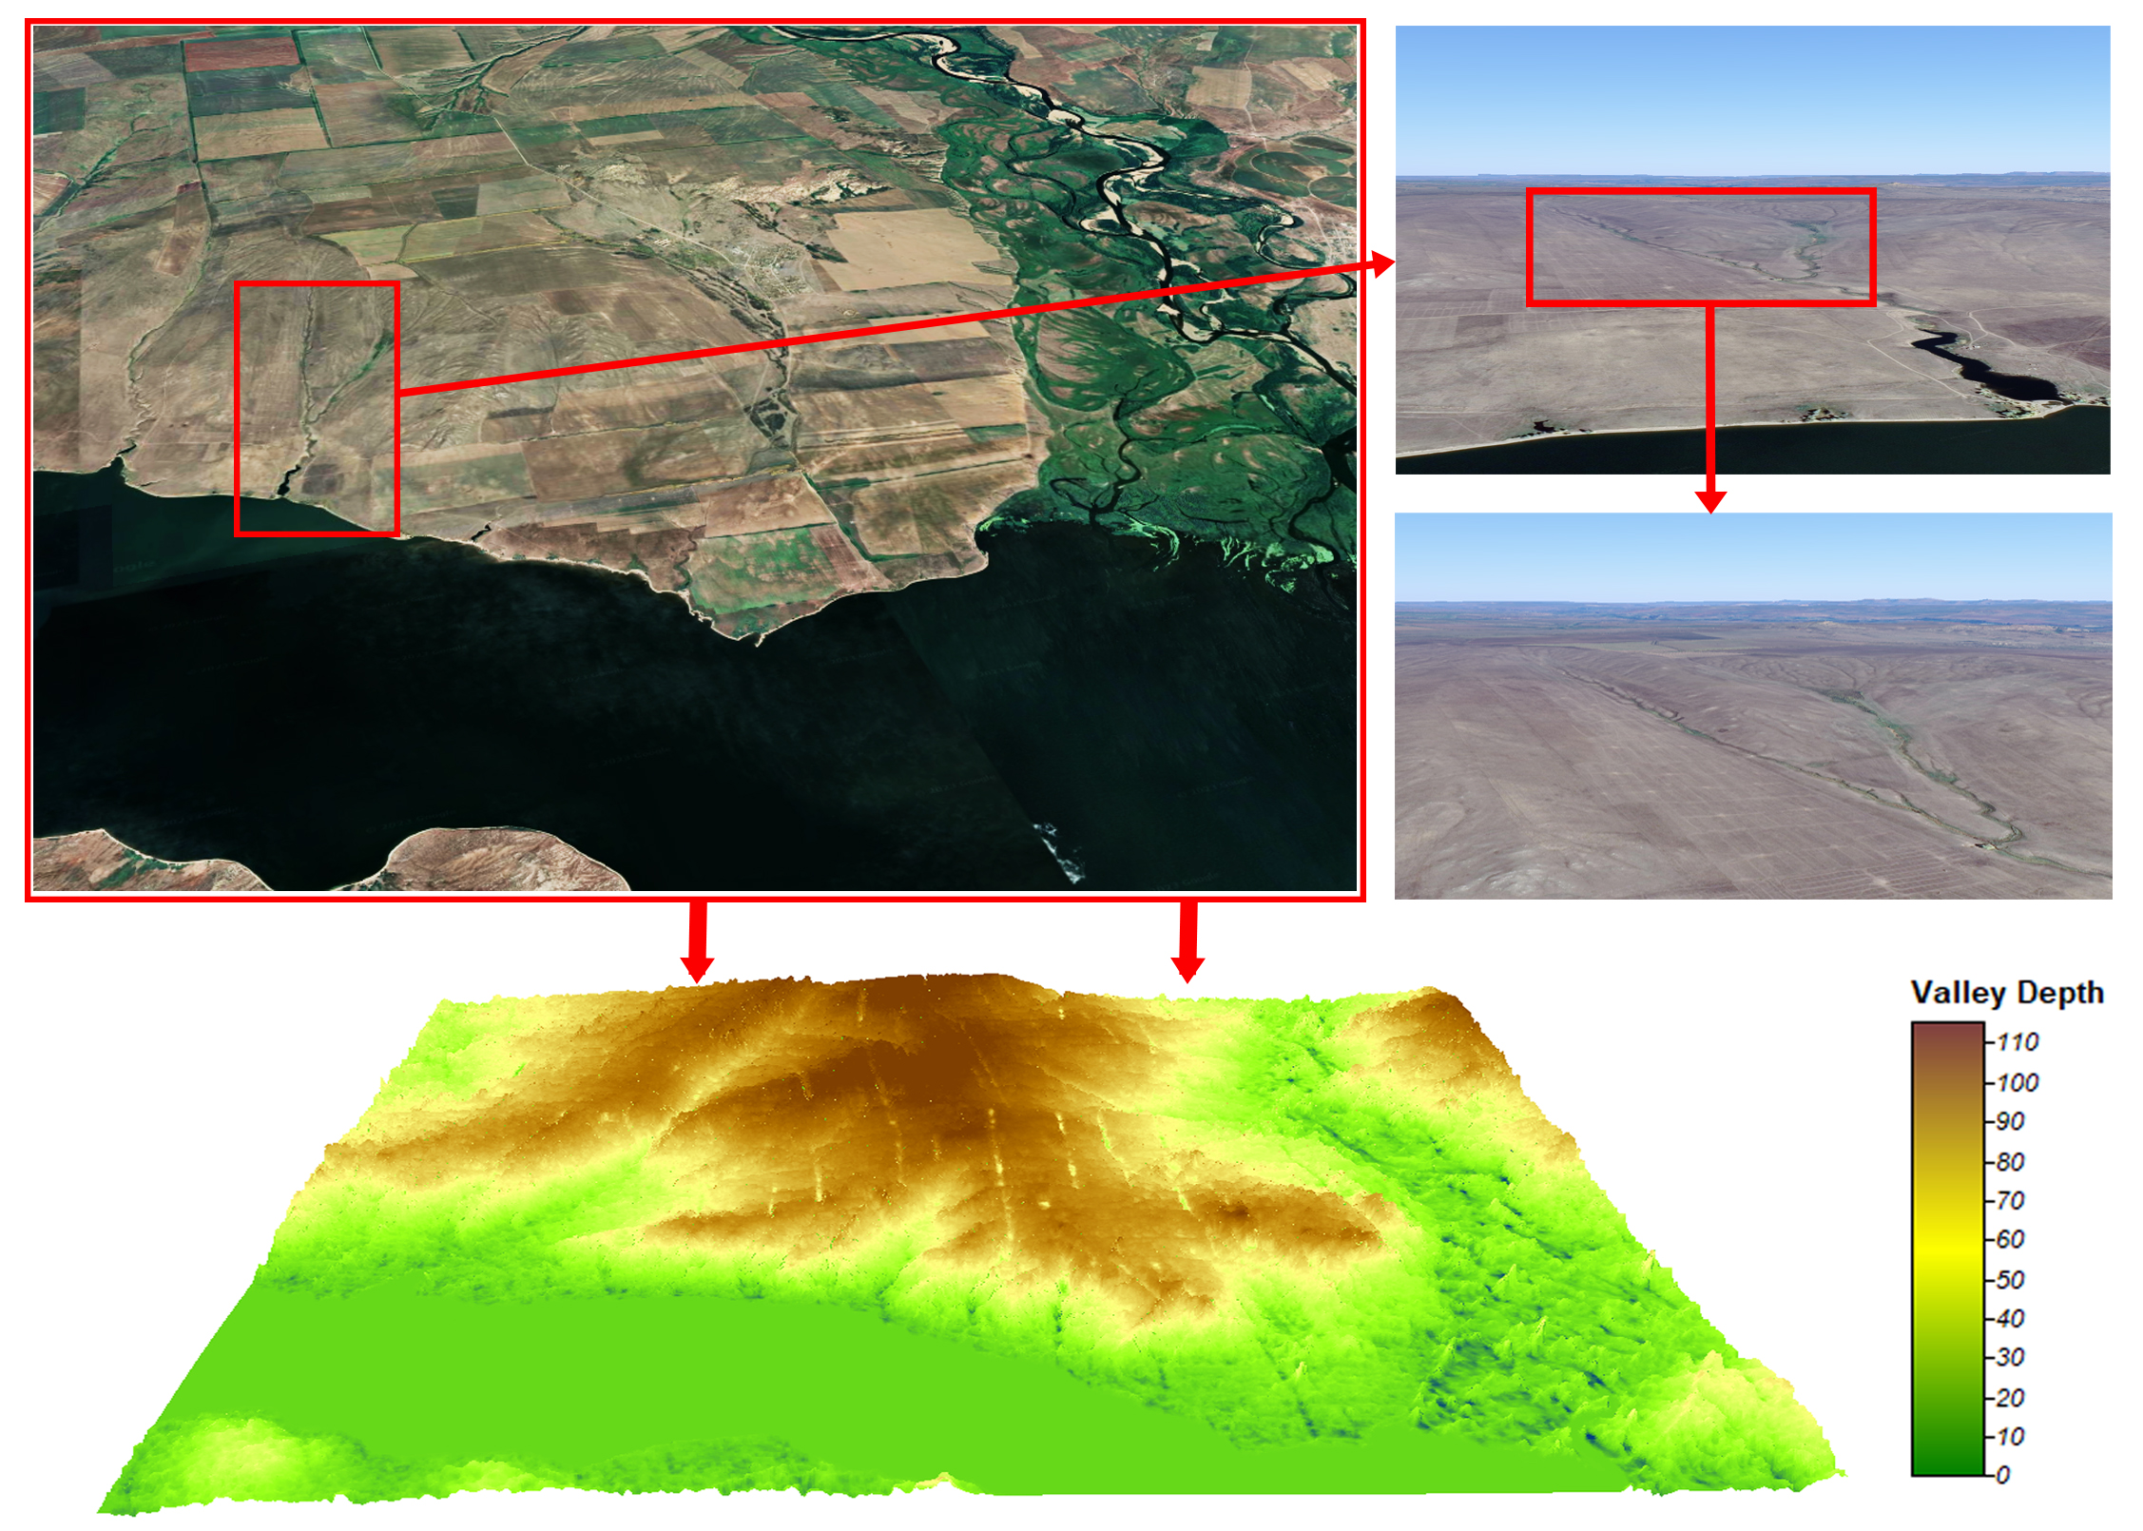
Figure 5: 3D model of predicted elevation map (DEM) of the study area with Sentinel-2 L2A image overlay (18.08.2022)
This 3D model shows the formed gullies. It is shown that these gullies correlate well with the linear elements of the Valley Depth option maps presented in Figure 3b above.
It is known that one of the most important components of healthy soil is humus. According to the agrochemical analysis for 2022, the humus content in the experimental plot varies between 0.82-1.66%, which is a critically high deviation from the norm. Following the example of the authors (Schoonover et al., 2015), measures are proposed to control gully erosion by increasing the organic matter content of the soil. The required predicted increase of organic matter is 3.5-5% for chestnut type soils. The recommended method of covering the soil with a layer of organic material is mulching. Given the topography of the study area, terraced sideratum sowing should be applied to prevent erosion on steep slopes. Another recommended technique is contour farming, which involves planting crops or vegetation along the contours of the slope rather than up and down the slope. This helps to slow the flow of water, reducing its erosive force and preventing further expansion and growth of gullies.
  - Conclusion
Based on the analysis of relationships between DEM and topographic coefficient LS of the RUSLE model, the current state of soil erosion of the experimental polygon was assessed in this paper. It was found that one of the main causes of erosion is critically low content of humus in the soil in the range of 0.82-1.66%, also calculations of actual soil losses after gully formation, which is about 185 ha of land were performed. In order to prevent further soil erosion, conservation and restoration of fertility a predictive model of the study site relief and increase of humus content up to 3.5-5% has been developed. Soil erosion prediction is shown to be an important step in soil erosion prevention by identifying areas at high erosion risk and implementing appropriate management strategies. Thus, by combining GIS, remote sensing technology and mathematical modelling, a new approach to obtain valuable information for monitoring and analysing soil erosion in agricultural landscapes has been developed. The results of this study demonstrate the effectiveness of spatial modelling techniques in identifying soil erosion and adopting necessary measures to improve soil quality and fertility. Further research is needed to explore the potential of these techniques to improve soil health and productivity in agricultural landscapes.
Acknowledgements
This research has been supported by the Project BR10865102 "Development of technologies for remote sensing of the earth (RSE) to improve agricultural management", funded by the Ministry of Agriculture of the Republic of Kazakhstan.
References
Beisekenov N.A., Sadenova M.A., Varbanov P.S., 2021. Mathematical Optimization as A Tool for the Development of "Smart" Agriculture in Kazakhstan. Chemical Engineering Transactions, 88, 1219-1224.
Chen W., Nguyen K.A., 2022. The New Island-Wide LS Factors of Taiwan, with Comparison with EU Nations. Sustainability, 14(5), 3059.
Conrad O., Bechtel B., Bock M., Dietrich H., Fischer E., Gerlitz L., Wehberg J., Wichmann V., Böhner J., 2015, System for automated geoscientific analyses (SAGA) v. 2.1. 4. Geoscientific Model Development, 8(7), pp.1991-2007.
Desmet P. J.J., Govers G., 1996. A GIS procedure for automatically calculating the USLE LS factor on topographically complex landscape units. Journal of soil and water conservation, 51(5), 427-433.
Hrabalíková M., Janeček M., 2017. Comparison of different approaches to LS factor calculations based on a measured soil loss under simulated rainfall. Soil and Water Research, 12(2), 69-77.
Kabzhanova G.R., Sadenova M.A., Beisekenov N.A., Bissembayev A.T., 2022. Efficiency of Using Earth Remote Sensing Data for The Rational Use of Agricultural Land. Chemical Engineering Transactions, 94, 1237-1242.
Li J.Y., Yang K.J., Chen W., 2016. Approximation equation of erosion calculation in GIS. In Proceedings of the 37th Asian Conference on Remote Sensing, ACRS, Colombo, Sri Lanka. p. 17-21.
Lytos A., Lagkas T., Sarigiannidis P., Zervakis M. Livanos G., 2020. Towards smart farming: Systems, frameworks and exploitation of multiple sources. Computer Networks, 172, p.107147.
Michalopoulou M., Depountis N., Nikolakopoulos K., Boumpoulis V., 2022. The Significance of Digital Elevation Models in the Calculation of LS Factor and Soil Erosion. Land, 11(9), 1592.
Panagos P., Ballabio C., Himics M., Scarpa S., Matthews F., Bogonos M., Borrelli P., 2021. Projections of soil loss by water erosion in Europe by 2050. Environmental Science & Policy, 124, 380-392.
Pimentel D., Burgess M., 2013. Soil erosion threatens food production. Agriculture, 3(3), pp.443-463.
Radoglou-Grammatikis P., Sarigiannidis P., Lagkas T., Moscholios I., 2020. A compilation of UAV applications for precision agriculture. Computer Networks, 172, p.107148
Rosenzweig C. Hillel D., 1995. Potential impacts of climate change on agriculture and food supply. Consequences, 1(2), p.23-32.
Schoonover J.E., Crim J.F., 2015. An introduction to soil concepts and the role of soils in watershed management. Journal of Contemporary Water Research & Education, 154(1), 21-47.
Thapa P., 2020. Spatial estimation of soil erosion using RUSLE modeling: a case study of Dolakha district, Nepal. Environmental Systems Research, 9, 1-10.

