CHEMICAL ENGINEERING TRANSACTIONS  VOL. , 2023 | A publication of
The Italian Association
of Chemical Engineering
Online at www.cetjournal.it

Guest Editor: Sauro Pierucci
Copyright © 2023, AIDIC Servizi S.r.l.
ISBN 978-88-95608-98-3; ISSN 2283-9216

Study of Unmanned Aerial Vehicle Sensors for Practical Remote Application of Earth Sensing in Agriculture
Marzhan Anuarbekovna Sadenova, Nail Alikuly Beisekenov*, Turezhan Baurzhanuly Anuarbekov, Azamat Kaisarovich Kapasov, Natalya Anatolyevna Kulenova
Priority Department Centre «Veritas» D. Serikbayev East Kazakhstan technical university, 19 Serikbayev str. 070000, Ust-Kamenogorsk, Kazakhstan
BNail@ektu.kz
Estimating the spectral response of vegetation using unmanned aerial vehicle sensors for non-destructive remote sensing represents a key element for monitoring crop growth and development. Given the extensive presence of commercial unmanned aerial vehicle (UAV) based solutions on the market, there is a need for clear information on the performance of these products to guide the end user in their selection and use for precision agriculture applications. The aim of this paper is to compare and evaluate the effectiveness of supporting the practical application of remote sensing methods using DJI P4M and senseFly eBee X UAVs in the production of the crop barley. The features of these commercial UAVs and the results of their application are described. The NDVI indices were calculated when processing survey data from both unmanned aerial vehicles. Based on the results, the r-Pearson correlation of the two UAVs was calculated to be between 0.78 and 0.80. Also, the block diagram showing the processing of the results of barley crop survey by means of two UAVs under study was developed. As a result of the comparative analysis of the two UAVs, senseFly eBee X proved to be the best in most indicators.
  - Introduction
Knowledge of spatial and temporal changes in crop growth is important for crop management and sustainable crop production for a country's food security. The combination of crop growth models and remote sensing data is a useful method for monitoring crop growth status and estimating yields (Jin et al., 2016).
The spectral response of the canopy to solar radiation refers to how plants absorb and reflect different wavelengths of light from the sun. Sunlight is composed of different wavelengths, which together make up the electromagnetic spectrum. Different types of plants have different spectral responses, meaning they absorb and reflect light differently depending on the wavelengths. The spectral response of the canopy to solar radiation, analysed by calculating a wide range of vegetation indices (VI), is the basis for the application of remote sensing in agriculture. Both structural aspects and biochemical composition, physiological processes and foliar symptoms affect how vegetation reflects light in different regions of the electromagnetic spectrum (Giovos et al., 2021). Therefore, spectral analysis provides important information about the vegetative state and needs of crops, but the optimal acquisition of spectral data must take into account the characteristics of each crop, since there are structures and characteristics that affect the spectral response (Tardaguila et al., 2021).
Given the various remote sensing platforms available, the best solution to optimally meet these needs is the use of unmanned aerial vehicles (UAV), which have become widespread in the last decade for a wide range of scientific research and applications in crop production (Matese et al., 2021). These platforms make it possible to accurately determine the variability in the field, providing a characterisation of the characteristics of plant growth and development and spatial resolution. UAVs can be an important technology for extracting useful information about the earth's surface in a short period of time, such as digital surface models (DSM) and other information. Final products are highly dependent on the choice of values for various parameters for flight planning and data processing (Liu et al., 2022). The data received by UAV sensors can be spectral, spatial and temporal. Choosing the right sensor and data depends on the nature of the application. For example, thermal data is suitable for determining the state of water, and spectral information is a good option for identifying possible plant diseases (Radoglou et al., 2020).
Various sources of information describe types of sensors such as thermal imaging, multispectral and hyper spectral cameras. There are many UAVs designed for agriculture using various types of remote sensing technologies. Drones are capable of obtaining high-resolution images, which, after processing with specialized software, are used for preliminary analysis of the crop. Drones are equipped with several types of built-in sensors, making them full-fledged mobile measurement platforms. They are able to work in different environments and conditions, with different levels of autonomy, individually or in cooperation with other unmanned vehicles of the same or another type.
High-precision topographic surveying with minimal cost and effort has always been one of the growing areas of scientific interest. Image-based remote sensing solutions using unmanned aerial systems (UAS) and structures from motion (SfM) with multiview stereophotogrammetry (MVS) is the latest automation and advancement in geodetic engineering. Modern developments have led to the widespread use of UAS in various fields of knowledge, however, the question of assessing the accuracy of survey results based on UAS remains. Evaluating accuracy and testing products for their applicability and effectiveness in solving a real problem is a prerequisite for any new technology. Individual UAVs have weight, size, and power consumption restrictions for both themselves and the sensors they carry (Doering et al., 2014).
The UAV-based remote sensing system must have characteristics such as cost-effectiveness, quick fabrication, ease of operation by local personnel, and good geometric accuracy (sub-metre). The authors (Rokhmana et al., 2015) point out that the basic data are orthophotos and digital elevation model (DEM). The average geometric accuracy can be up to 3 pixels or equivalent to sub-metre accuracy, and the production time can reach more than 500 ha per day. The orthophoto image can provide visual interpretation such as individual tree structure, plant density and area of the plot boundary, while the DEM can estimate information on tree height and ground topography with an accuracy of 3-6 pixels or 0.5-2.5 m. The work (Iost Filho et al., 2020) focuses on the use of small drones to obtain. Application of UAVs in agricultural monitoring and crop management:
1. Plant coverage, plant height and indices: RGB camera, spatial resolution - (1280×720); (1920×1080); (2048×1152); (3840×2160); (4000×3000); (4000×3000); (4056×2282); (4160×2340); (4608×3456); (5344×4016); (5472 × 3648);
2. Vegetative indices; physiological state of the plant: Multispectral camera, spatial resolution - (1080×720); (1248×950); (1280×960); (2064 × 1544). Weight 30-420g. Frame rate from 1 to 30 frames per second;
Plant surface temperature, crop water stress index: Thermal camera, Spatial resolution (336×256); (640×512); (1920×1080). Weight 92-370 g. Spectral range 7.5- 14 μm. Operating temperature range (°C) -40 to 55.
Thermal sensors detect infra-red (IR) electromagnetic energy emitted by a target and convert it into an image. They are used in agriculture because of their ability to provide measurements related to plant surface temperature and water stress index. RGB cameras can provide better spatial resolution than other types of sensors, however, in the field of agriculture, multispectral cameras have more advantages over RGB cameras in terms of extrapolated information, such as the ability to detect the invisible physiological state of a plant. He hyperspectral cameras are not usually used in agriculture as they require integration with a large number of other devices, including battery, frame grabber and storage device, to work properly on UAV platforms and are heavy and large. However, hyperspectral sensors are increasingly being miniaturised, which will increase the number of applications that can benefit from their use. Fluctuating ambient air conditions and the presence of various objects emitting or reflecting thermal infrared radiation can reduce the reliability of thermal camera measurements, requiring periodic calibration. Light detection and ranging (LiDAR) sensors measure the distance to a single target point by illuminating it and analysing the reflected light. This type of sensor is capable of providing a wide field of view (FOV), i.e., the angle covered by the sensor, and high accuracy. However, size and weight can be a challenge in terms of UAV payload requirements.
For UAVs flying at low altitudes, static and dynamic obstacles can pose a serious problem that also compromises the integrity of the aircraft. These considerations are true for all types of applications using UAVs. Some sensors that can help UAVs gain information about obstacles and the environment are reported along with their detection range. In agriculture, conventional RGB cameras are most commonly used because they allow for easy assessment of the physical condition of plants. These cameras are the most appropriate devices to answer the question of whether a plant is present, how many pieces are present, what damage is caused by wildlife, but it is also possible to achieve much more promising and accurate solutions to investigate the crop from a physiological point of view. Thus, analysis of the spectral response of vegetation using optical sensors for non-destructive remote monitoring represents a key element of crop monitoring. Given the extensive presence of commercial drone-based solutions on the market, the aim of this paper is to investigate and generate information on the performance of these products in order to guide the end user in their selection and use for precision agriculture applications.
  - Methodology of the experiment
The study of the configuration of sensors of unmanned aerial vehicles and GIS support to assess the prospects for the practical application of remote sensing technology in agriculture was carried out on the example of spring barley crops at an experimental site located in the northeast of Kazakhstan (Figure 1a). The experimental part of the work was carried out using a DJI Phantom 4 Pro Multispectral multicopter (manufactured by DJI, China) (Figure 1b) and a senseFly eBee X UAV (manufactured by senseFly, Switzerland) (Figure 1c).
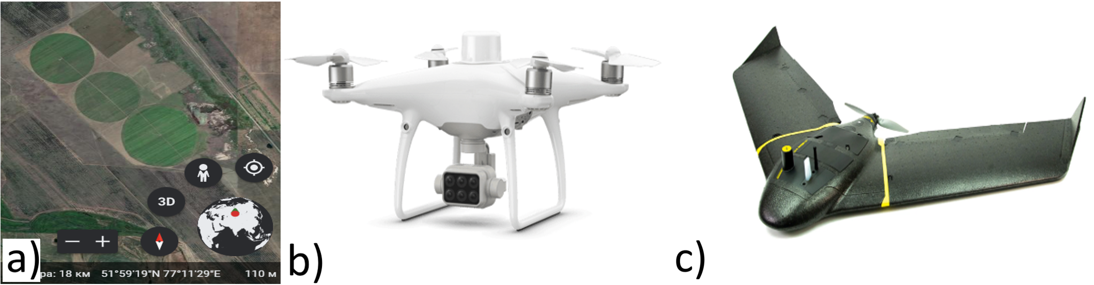
Figure 1: Experimental field and UAVs used in this study a) DJI P4M UAV; b) senseFly eBee X
The appearance of the used UAVs is shown in Figure 1b-c. To process the obtained images, the licensed software Pix4DMapper 4.4.12 was used according to the methodology described by (Sun et al., 2020). To prepare the flight task, senseFly eMotion flight planning software version 3.11.0 was used to create a horizontal and 3D mission block. The ground sampling distance (GSD) was set to 2.0 cm for the senseFly S.O.D.A 3D and 2.5 cm for the for Aeria X, a compact photogrammetric camera for drones, resulting in an altitude (AED) of 88 and 118 metres respectively. For optimum flight performance, the lateral overlap was set to 60% and the longitudinal overlap ranged from 60% for the Aeria X to 85% for the senseFly S.O.D.A. 3D, with the tilt angle set to 30 degrees by default. All flights were offline, and images were geotagged to absolute accuracy using the PPK workflow in eMotion Flight Data Manager (FDM).
  - Results and discussion
Unmanned aerial vehicles occupy a special place in the implementation of precision farming (Sadenova et al., 2021a). The technical capabilities of the use of UAVs in Kazakhstan are not fully used. These devices are changing the way we collect field data for analysis and decision making. Many commercial drones come with different types of camera sensors, for example the DJI Phantom 4 Multispectral comes with a multispectral camera. These types of cameras are very useful for collecting crop health data. Using multispectral imaging, agronomists can create different types of vegetation index maps that allow them to analyse plant and soil conditions. Frequent analysis of the data using multispectral maps will help identify any crop health issues before any visible disturbances appear. Early identification of crop growth problems will allow you to quickly draw up a plan of action and mitigate the problem before it worsens.
The use of UAVs, in remote sensing, vegetation monitoring, vegetation index mapping, etc., is increasingly being emphasised in precision agriculture. UAVs have many advantages, such as high spatial resolution, fast information acquisition, convenient and easy operation, high performance, no cloud interference, and low cost. Currently, different types of multispectral cameras are used to obtain surface reflectance values or digital numbers. The reflection coefficient values can be used to calculate the vegetation index NDVI. The accuracy of spectral data and NDVI obtained from these cameras has important applications. In this paper, the capability of surveying agricultural fields with Parrot Sequoia+ and DJI Phantom 4 Multispectral cameras was analysed using different combinations of correlation coefficients and accuracy. The following aspects were selected; Spectral values; Vegetation indices; Area of coverage (coverage). According to the survey data for coverage, the SenseFly eBee X can do 10 times as much shooting as the DJI Phantom 4 Multispectral, with the same accuracy performance in the same time span. The SenseFly eBee X has four times the flight speed and also the flight time on one battery is three times that of the DJI Phantom 4 Multispectral. The size of the sensor affects the amount of light that reaches the image. Larger cameras mean better light sensitivity. Full frame mode provides a wider field of view in every shot. When more images and high overlap are required, this difference adds up. With both the DJI Phantom 4 Multispectral and SenseFly eBee X Parrot Sequoia+, agricultural field survey data can be processed using software such as Pix4D, DJI Terra, Agisoft MetaShape, Propeller, etc. Using UAV data images were collected at different resolutions. Average spectral NDVI values were compared on two polygons, on polygon 1 (Figure 2Ⅰ) practicing rain-fed agriculture, on polygon 2 (Figure 2Ⅱ) practicing irrigated agriculture, using the example of an agricultural crop: barley of peasant farm "Mayak" in Pavlodar region. The results for polygon 1 show that the NDVI of multispectral camera DJI Phantom 4 equal: 0.25, and Sequoia+ NDVI index results are: 0.2, indicating a high band-to-band correlation (P2 correlation coefficient is 0.80. Sequoia+ and DJI Phantom 4 Multispectral cameras have high correlation; NDVI has the highest P2 correlation among them at 0.78. This shows that the performance of different cameras can be evaluated by spectral values as well as by the accuracy of vegetation indices (Figure 2).
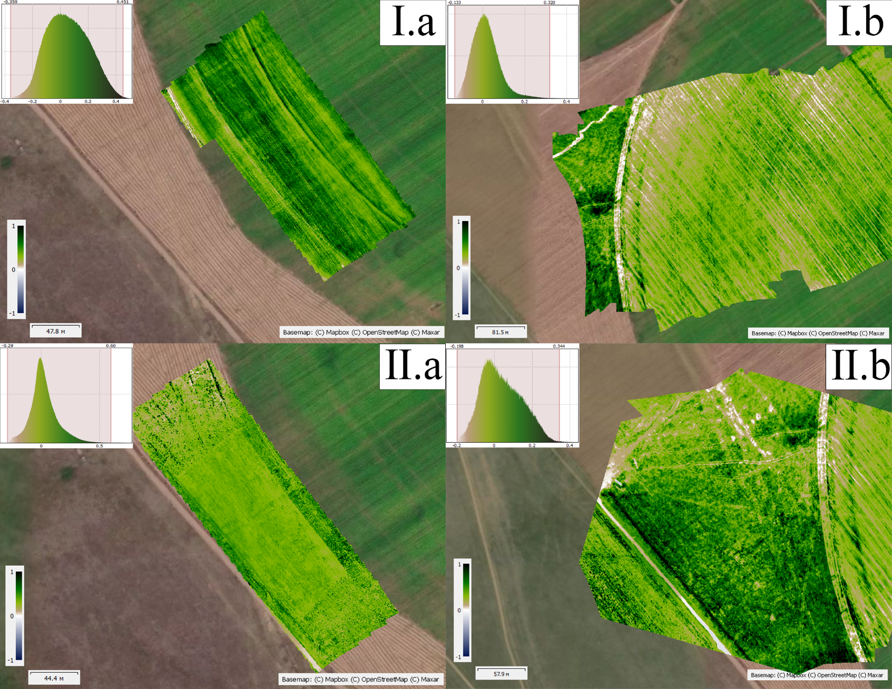
Figure 2: Processed NDVI index of experimental sites 1-2 (Ⅰ - irrigated agriculture; Ⅱ - rainfed agriculture) based on two UAVs: a) DJI P4; b) SenseFly eBee X Parrot Sequoia+ (UAV survey was conducted: 20.06.2022)
Different UAV multispectral cameras can have the same performance even if they have different spectral value functions. The results obtained can be used as a basis for analysing the compatibility of different sensors when analysing changes in vegetation growth on farms. The difference in the results shown above is justified by differences in the technical features of each UAV.
The DJI Phantom 4 Multispectral UAV used in this work comes with 5 camera sensors that capture image data invisible to the human eye. It features an optional RGB sensor and RTK GPS correction technology for centimeter accuracy. The DJI Phantom 4 Multispectral is DJI's corporate drone with accurate vegetation data built for agriculture. Data collection is easier and more efficient than ever with built-in image stabilization and a set of 5 2MP multispectral cameras with global shutter (blue, green, red, red edge and near infrared) and an RGB (visible spectrum) camera, all mounted on a 3-axis stabilized gimbal. DJI has created the P4 Multispectral platform with enhanced performance standards: only 27 minutes of flight time with a transmission range of 7 km. Image collection in agriculture is even easier and more efficient. A multispectral phantom with 5 multispectral sensors and a RGB camera on a stabilised suspension provides precise data on the condition of crops. It was of interest to compare the performance with another product in this class, the DJI Phantom 5 Multispectral. Combined with post-processing data, this information helps deliver the most accurate NDVI results. The P4 Multispectral built-in sunlight spectral sensor on top of the quadcopter works in conjunction with the suspension camera to achieve the most accurate NDVI results. The sensor captures sunlight to improve accuracy and ensure consistency of processed data at different times of day. When projects scale up, quadcopters lose their performance. Indeed, due to their low flight efficiency, they take between 5 and 14 times longer than fixed-wing UAV to map the same area.
Another UAV used for comparison in this study is the SenseFly eBee X. This is a lightweight, fixed-wing drone that is manually launched and can be captured by a number of cameras, making it suitable for data collection for various industries. Flight time is 60 minutes, but can be extended to 90 minutes with a heavy-duty battery. However, a clear disadvantage is the landing of the drone which complicates day-to-day use, potentially shortening the life of the drone. Landing can cause damage and an unpredictable landing area. This fact means that it is necessary to plan for 100 m2 to ensure that the drone lands safely. Another disadvantage is the smaller camera sensor and lower pixel density, which limits real resolution and GSD to 1.8cm (0.7in) / pixel. Absolute horizontal accuracy is ensured up to 3 cm. The main characteristics are shown in Table 1.
Table 1: Advantages and disadvantages of senseFly eBee X and DJI Phantom 4 Pro Multispectral UAVs
Types of UAV | SenseFly eBee X | Phantom 4 Multispectral
Availability of sensors | Depending on the needs, 7 different cameras are available (different applications and spectra). It is also possible to use with an RTK station. | Only available with high-resolution or multispectral camera (in 5 spectra). Also available as an option for use with an RTK station.
Weight | Approx. 1600 grams (weight may vary, due to the amount of optional equipment). | 1487 grams (additional equipment or sensors cannot be fitted)
Software | eMotion | DJI GS Pro
Sensor specifications | senseFly S.O.D.A. 3D, senseFly Duet T, Parrot Sequoia+, senseFly S.O.D.A., senseFly S.O.D.A. Corridor  Cameras: senseFly SODA 20 MP 1" sensor comes with the following options: Parrot Sequoia+multispectral and RGB; MicaSense RedEdge MX/5.5mm multispectral; SenseFly Aeria X 24 MP APS-C sensor; senseFly Duet T in thermal and visible spectrum; Corridor SenseFly S.O.D.A. The ISO range specified for the SODA is 125 to 6400 and for the Aeria X it is 100 to 6400. | Sensors: Six 1/2.9-inch CMOS sensors, including an RGB sensor for visible light and five monochromatic sensors for multispectral imagery. Each sensor: Effective pixels of 2.08 MP (2.12 MP total)  Filters: Blue (B): 450 nm ± 16 nm, green (G): 560 nm ± 16 nm, red (R): 650 nm ± 16 nm, red edge (RE): 730 nm ± 16 nm, near infrared (NIR): 840 nm ± 26 nm  Lens: FOV (field of view): 62,7  Focal length: 5.74 mm (35 mm format equivalent: 40 mm), autofocus set to ∞  Aperture: f/2.2  ISO sensor range: RGB 200 to 800

On the basis of the data obtained, a block diagram demonstrating the processing of barley crops surveyed by the surveyed drones was developed. Orthophotomaps and other data extraction were performed systematically in a certain sequence to obtain data from the UAV. A normalized relative vegetation index (NDVI) was used to verify the detection performance of different land cover types. A comparative analysis of the two indices was performed and orthophotos taken by DJI P4M and senseFly eBee X UAVs from 14 May to 20 September 2022 were analysed (Sadenova et al., 2021b). Figure 3 shows the developed methodology for the processing and evaluation of the two UAVs.
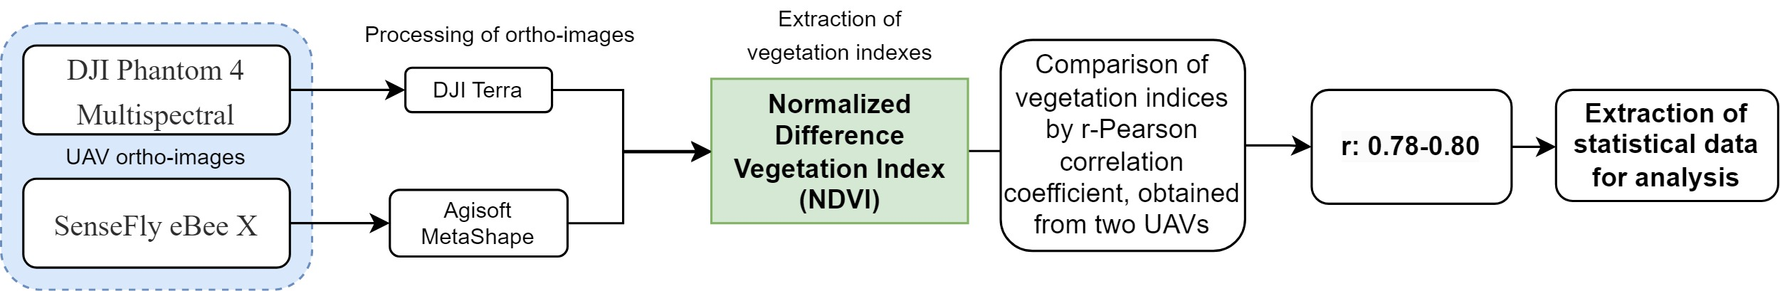
Figure 3: Block diagram demonstrating orthophoto processing and data extraction
  - Conclusions
The benefits of drones for agriculture are enormous, and as technology improves, they will become more widely used and play a huge role in agricultural tasks. There are many drones suitable for use in agriculture, from taking highly detailed geo-referenced images for maps to intelligent crop spraying. UAVs play a huge role in precision farming and help in the development of sustainable agricultural practices. A comparison between a senseFly eBee X UAV and a Phantom 4 Multispectral quadcopter showed that both aircraft can acquire raw data (photos) with almost the same accuracy without using RTK. In case an RTK station is used, the accuracy can be increased. The design features of these UAVs result in a variety of applications. The advantage of the senseFly eBee X UAV is its proprietary eMotion software, which enables it to fully exploit its capabilities. At the same time, the data obtained with the Phantom 4 Multispectral depends on the functionality of the software used for processing. The large coverage area of the senseFly UAV, the eBee X can cover up to 500 hectares in a single flight, while the DJI P4M can cover up to 32 hectares in a single flight. This larger coverage area allows the eBee X to be more effective for large-scale mapping and surveying projects. As a result of our comparison, the senseFly UAV has more advantages, for this reason it is the best solution compared to the DJI P4M.
Acknowledgments
This research has been supported by the Project IRN BR10965186 “Development and implementation of geoinformation support for "Smart" agriculture to improve the management of the agro-industrial complex”, funded by the Science Committee of The Ministry of Education and Science of the Republic of Kazakhstan.
References
Doering D., Benenmann A., Lerm R., de Freitas E.P., Muller I., Winter J.M, Pereira C.E., 2014, Design and optimization of a heterogeneous platform for multiple UAV use in precision agriculture applications. IFAC Proceedings Volumes, 47(3), pp.12272-12277.
Giovos R., Tassopoulos D., Kalivas D., Lougkos, N., Priovolou, A., 2021, Remote sensing vegetation indices in viticulture: A critical review. Agriculture, 11(5), p.457.
Iost Filho F.H., Heldens W.B., Kong Z., de Lange E.S., 2020, Drones: innovative technology for use in precision pest management. Journal of economic entomology, 113(1), pp.1-25.
Jin X., Kumar L., Li Z., Xu X., Yang G., Wang, J., 2016, Estimation of winter wheat biomass and yield by combining the aquacrop model and field hyperspectral data. Remote Sensing, 8(12), p.972.
Liu X., Lian X., Yang W., Wang F., Han Y., Zhang Y., 2022, Accuracy assessment of a UAV direct georeferencing method and impact of the configuration of ground control points. Drones, 6(2), p.30.
Matese A., Berton A., Di Gennaro S.F., Gatti M., Squeri C., Poni S., 2021, Testing performance of UAV-based hyperspectral imagery in viticulture. In Precision agriculture’21 (pp. 322-337). Wageningen Academic Publishers.
Radoglou-Grammatikis P., Sarigiannidis P., Lagkas T., Moscholios, I., 2020, A compilation of UAV applications for precision agriculture. Computer Networks, 172, p.107148.
Rokhmana C.A., 2015, The potential of UAV-based remote sensing for supporting precision agriculture in Indonesia. Procedia Environmental Sciences, 24, pp.245-253.
Sadenova M.A., Beisekenov N.A., Rakhymberdina M.Y., Varbanov P.S., Klemeš J.J., 2021a, Mathematical Modelling in Crop Production to Predict Crop Yields. Chemical Engineering Transactions, 88, 1225-1230.
Sadenova M.A., Beisekenov N.A., Apshikur B., Khrapov S.S., Kapasov A.K., Mamysheva A.M., Klemeš J.J., 2022b, Modelling of Alfalfa Yield Forecasting Based on Earth Remote Sensing (ERS) Data and Remote Sensing Methods. Chemical Engineering Transactions, 94, 697-702.
Sun G., Wang X., Yang H., Zhang X., 2020, A canopy information measurement method for modern standardized apple orchards based on UAV multimodal information. Sensors, 20(10), p.2985.
Tardaguila J., Stoll M., Gutiérrez S., Proffitt T., Diago M.P., 2021, Smart applications and digital technologies in viticulture: A review. Smart Agricultural Technology, 1, p.100005.

