CHEMICAL ENGINEERING TRANSACTIONS  VOL. , 2023 | A publication of
The Italian Association
of Chemical Engineering
Online at www.cetjournal.it

Guest Editor: Sauro Pierucci
Copyright © 2023, AIDIC Servizi S.r.l.
ISBN 978-88-95608-98-3; ISSN 2283-9216

POTENTIAL APPLICATION OF RENEWABLE EUTECTIC MIXTURES AS PHASE CHANGE MATERIALS FOR THERMAL ENERGY STORAGE
Víctor Alexis Lizcano-Gonzálezª, Viatcheslav Kafarovª*, Khamid Mahkamov^{b}, María Paula Carvajal Arciniegasª, and Nelcy Daniela Socha Rojasª
ª Department of Chemical Engineering, Carrera 27 Calle 9, Universidad Industrial de Santander, Bucaramanga, Colombia
^{b} Department of Mechanical and Construction Engineering, Sutherland Building Newcastle-upon-Tyne NE1 8ST, Northumbria University, United Kingdom
*Corresponding author. E-mail address: kafarov@uis.edu.co (V. Kafarov).

Many energies management and storage technologies use phase change materials (PCM) to increase process efficiency. Technologies such as solar thermal energy storage, passive temperature management in buildings, even the development of high-performance sportswear employ various types of PCM. Phase change materials can be classified according to the working temperature, their nature or the phase transition, highlighting the use of materials of renewable origin. There are different methodologies to modify the properties of PCM, among which the preparation of eutectic mixtures stands out. This is a technique that allows obtaining PCM with a lower melting temperature than that of the initial components. Considering the above, this work presents the thermal characterization of mixtures of palm stearin, hydrogenated palm stearin, beeswax, and paraffin wax in order to evaluate the heat storage potential of the resulting products. Mixing ratios of 80:20, 65:35, 50:50, 35:65 and 20:80 were evaluated. Melting and crystallisation temperatures and enthalpies and their solid and liquid heat capacities were measured by differential scanning calorimetry. The thermal stability of the mixtures was also determined by thermogravimetric analysis. From the results obtained, the PCM obtained by mixing beeswax and hydrogenated palm stearin, which presents its eutectic melting point for the mixture ratio of 50:50 with a temperature of 56 °C and an enthalpy of fusion of 264 kJ/kg, stands out.
  - Introduction
Population growth has a significant impact on global energy consumption. Most of its production is obtained from fossil resources such as coal, natural gas, oil, and its derivatives, which have a negative impact on the environment (Pasquevich, 2016). The use of renewable resources allows supplying part of the energy demand, taking advantage of various sources such as solar, wind, hydro, geothermal, among others.
The use of solar energy includes photovoltaic solar energy and solar thermal energy, the latter being commonly used for hot water supply and space heating (Agencia Valenciana de la Energía , 2008). Solar thermal systems (TES) capture solar radiation and transfer it in the form of heat to a fluid for further use. Many of the TES also employ a heat storage system, which can be either sensible heat or latent heat (Sakhaei & Valipour, 2021). For latent heat storage, the use of phase change materials (PCM) is required, which must have some characteristics such as melting temperature suitable for the application, chemical stability, high thermal conductivity, among others (Lui, et al., 2021). This characteristic can be enhancing by using mixtures of different materials, known as eutectic mixtures.
Eutectic mixtures are obtained by heating two or more solids in an established proportion that undergo a solid-liquid phase change at a given temperature (Alonso et al., 2018). The components of the mixture influence its eutectic point. Some studies conclude that this point occurs in 50:50 ratios such as Polyethylene Glycol 6000 (PEG600)/Myristic Acid (MA) (Ansu, et al., 2021) while for others this point lies with the majority of one of the components such as Stearic Acid (SA)/Hexanamide (HA) mixture (Ma, et al., 2019). Among the main applications are solar thermal energy storage, sustainable alternative to conventional solvents in organic chemistry, water heating in homes, residential units, hotels, swimming pools, domestic heating, among others (Chwieduk, 2016).
  - Materials and Methods

Four materials were selected: hydrogenated palm stearin (HPS), beeswax (BW), palm stearin (PS) and paraffin wax (PW). Two mixtures were made for each type of stearin, the first with beeswax completely agro-industrial and the second with paraffin wax. The combinations made were: palm stearin (PS)/beeswax (BW), hydrogenated palm stearin (HPS)/beeswax (BW), palm stearin (PS)/paraffin (PW) and hydrogenated palm stearin (HPS)/paraffin (PW).
Five mixing ratios were prepared for each binary mixture: 20:80, 35:65, 50:50, 65:35 and 80:20. Palm stearin (PS) and hydrogenated palm stearin (HPS) were studied as the main materials, due to its composition, low cost and physicochemical characteristics. Palm stearin has been reported to be a promising raw material for obtaining phase change materials (Lizcano González, et al., 2022). Figure 1 shows pictures of the raw materials employed while Table 1 summarises the mixing ratios chosen.

1.a  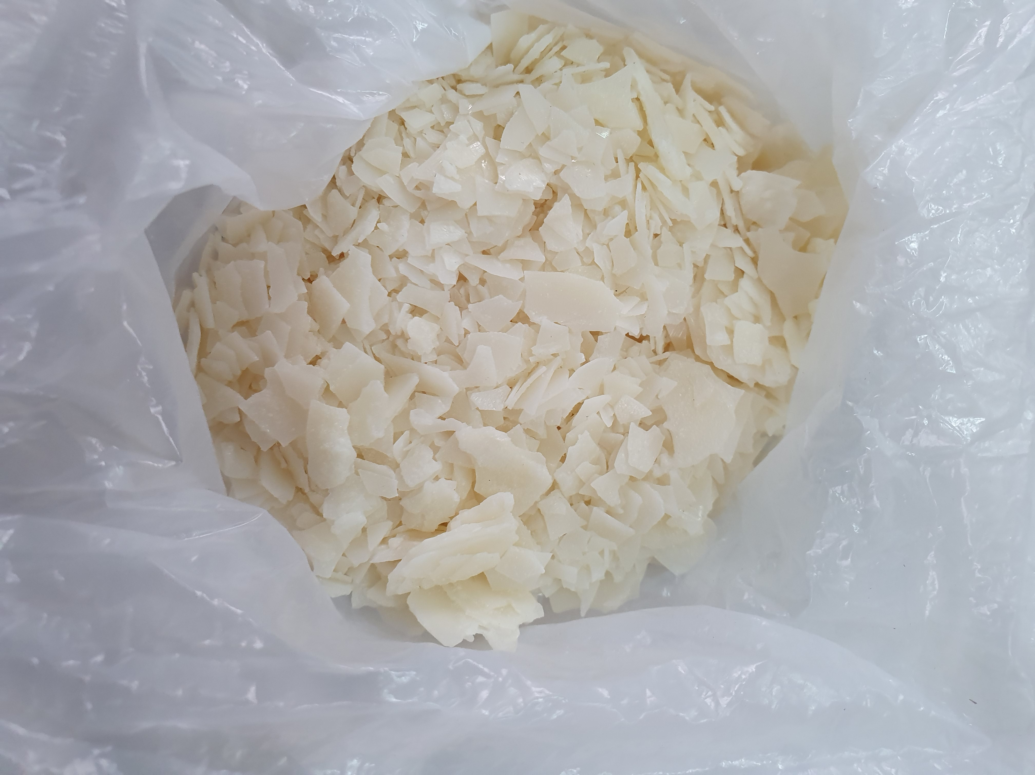 | 1.b  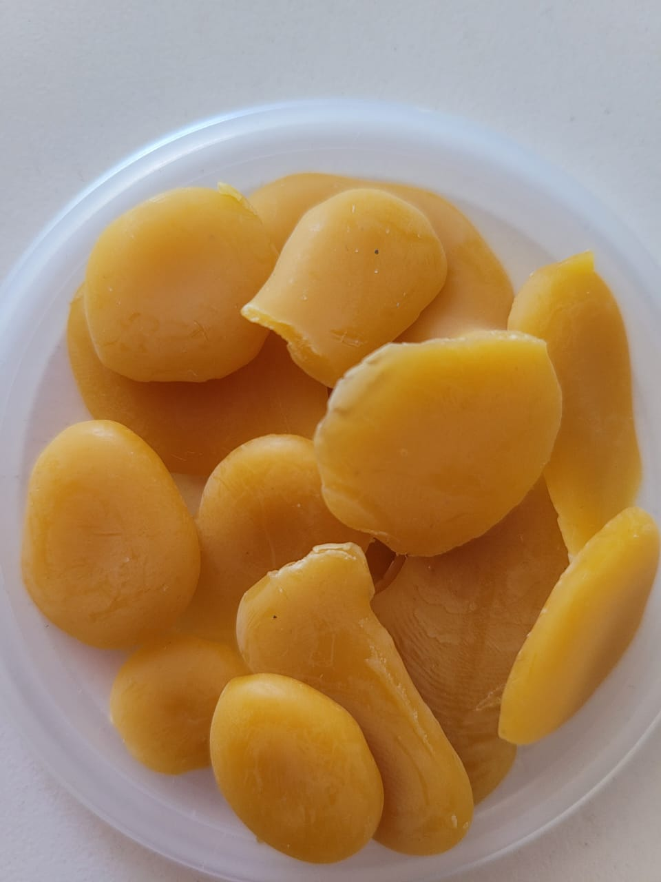
1.c  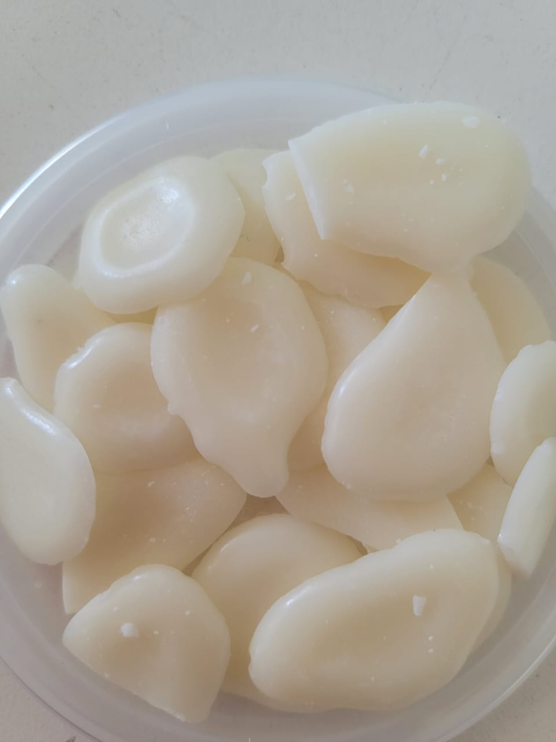 | 1.d  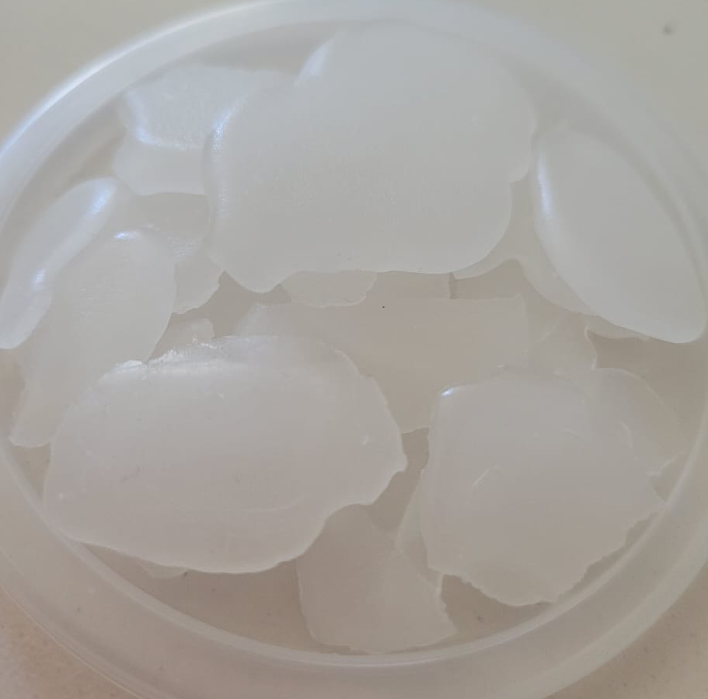
Figure 1.a Hydrogenated Palm Stearin. 1.b. Beeswax. 1.c. Palm Stearin. 1.d. Paraffin Wax.

The respective mixtures were made in the proportions named above, for a total of 2 grams per mixture and were transferred to a test tube to be subjected to 50 melting cycles. During the melting cycles, samples were heating and cooled in a temperature range between 283 K and 373 K. Finally, the melted sample was deposited in an Eppendorf tube. To achieve a more homogeneous mixture, the Eppendorf tubes were taken to the oven again for melting and stirring.
The thermal characterization of the blends was performed to measure enthalpy of fusion and crystallization based on (ASTM E793-06, 2018) and heat capacity by (ASTM E1269-11, 2018). The eutectic mixtures were subjected to 50 melting/crystallization cycles and characterized, using Differential Scanning Calorimetry (DSC) and Thermogravimetric Analysis (TGA).

Table 1. Proportions of eutectic mixtures
Components of the mixture | 20:80 | 35:65 | 50:50 | 65:35 | 80:20
Palm Stearin/Paraffin | PS/PW (1) | PS/PW (2) | PS/PW (3) | PS/PW (4) | PS/PW (5)
Palm Stearin/Beeswax | PS/BW (1) | PS/BW (2) | PS/BW (3) | PS/BW (4) | PS/BW (5)
Hydrogenated Palm Stearin/Paraffin | HPS/PW (1) | HPS/PW (2) | HPS/PW (3) | HPS/PW (4) | HPS/PW (5)
Hydrogenated Palm Stearin/Beeswax | HPS/BW (1) | HPS/BW (2) | HPS/BW (3) | HPS/BW (4) | HPS/BW (5)
Note: Eutectic mixture ratio (% by weight).

The energy stored and released from a material depends on the heat capacity and the enthalpy of fusion and crystallization of the sample under study, therefore, the energy stored by a body between two temperatures (T_{o}) and (T₃) during the heating process is expressed by equation 1 (Esteban Saiz, 1991), where the first and third expressions represent the sensible heat of the sample and the second expression the latent heat. Equation 2 express the energy release during the cooling process

$$E_{s}=\int_{T_{0}}^{T_{1}}{m*C_{psolid} dT +m*H_{f}+\int_{T_{2}}^{T_{3}}{m*C_{pliquid} dT (1)}}$$

$$E_{r}=\int_{T_{0}}^{T_{1}}{m*C_{psolid} dT +m*H_{c}+\int_{T_{2}}^{T_{3}}{m*C_{pliquid} dT (2)}}$$

Where:

m: mass of the sample (kg).
$C_{psolid}$: heat capacity in solid state (kJ/kg·K).
$C_{pliquid}$: heat capacity in liquid state (kJ/kg·K).
$H_{f}$: enthalpy of fusion for the calculation of stored energy (kJ/kg).
$H_{c}$: enthalpy of crystallization for calculation of energy released (kJ/kg).
$E_{s}$: energy stored (kJ).
$E_{r}$: energy released (kJ).

Finally, the amount of energy stored and released was calculated based on a working temperature range from 303.15 K to 358.15 K, considering that this range is reported as adequate in most organic PCM studies, for heating and domestic hot water applications such as solar thermal systems (Xiao et al., 2020)
  - Results and discussion

    - Eutectic graphs

The effects of mixing ratios on the temperature and enthalpy of fusion of binary eutectic mixtures are shown in Figure 2 for SP/BW and SP/PW and in Figure 3 for HSP/BW and HSP/PW.
The melting temperatures of the SP/BW and SP/PW eutectic mixtures do not exceed the melting temperature of the pure substances. The eutectic mixture ratio that obtains the lowest melting temperature is that of 20% SP and 80% BW with a value of 317.70 K. In addition, it can be evidenced that the highest enthalpy belongs to the binary eutectic mixture 20% SP and 80% PW. The highest enthalpy of fusion of the binary eutectic mixtures HSP/BW and HSP/PW, is observed at the mixing ratio 20:80 with a value of 257.103 kJ/kg and 275.59 kJ/kg, respectively. Furthermore, the melting temperatures again remain within the temperature range of pure substances.

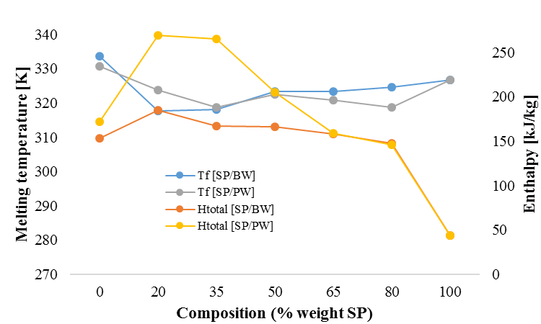
Figure 2. Composition-melting temperature-enthalpy diagram for the SP/BW and SP/PW binary system.

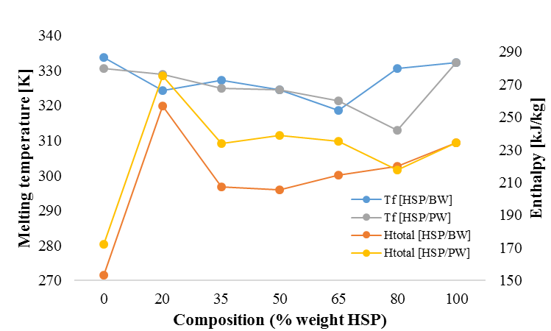
Figure 3. Composition-melting temperature-enthalpy diagram for the HSP/BW and HSP/PW binary system

Based on the data reported above, it is concluded that all mixtures are promising for use as phase change material. However, the mixtures where the proportion of SP and HPS is 20% and 80% corresponds to the other material, BW or PW, stand out.

    - Thermal properties.

The thermal properties of the best performing blends for use as phase change materials in solar thermal applications are presented below.
After characterization of the previously mentioned blends, better thermal properties and congruent energy values were obtained for their use as phase change materials, in the ratio 20:80 for each type of blend: (SP/PW 1), (SP/BW 1), (HSP/PW 1) and (HSP/BW 1).

The temperature data shown were obtained by Differential Scanning Calorimetry (DSC - HCH) analysis, where the highest melting and crystallization temperature of the most representative peak was reported. Table 2 shows thermal properties such as temperatures and enthalpies of fusion and crystallization and the solid and liquid heat capacities of the four mixtures with the best characteristics.

Table 2. Thermal properties of samples
Sample | Tm [K] | Tc [K] | Hf [kJ/kg] | Hc [kJ/kg] | Cpsolid [kJ/kg·K] | Cpliquid [kJ/kg·K]
HSP/BW-1 | 324.3 | 331.28 | 257.103 | 198.92 | 0.620* | 0.723***
SP/BW-1 | 317.7 | 331.61 | 184.60 | 170.28 | 0.639** | 0.678***
HSP/PW-1 | 328.9 | 324.96 | 275.59 | 186.32 | 0.631** | 0.667***
SP/PW-1 | 324.4 | 323.76 | 265.16 | 181.19 | 0.622* | 0.662***
Note: *Calculated at 300 K. ** Calculated at 290 K. *** Calculated heat capacity 360 K

It is observed that the difference between the melting temperatures of the mixture made with hydrogenated palm stearin and palm stearin is not significant and therefore the completely agro-industrial mixture is a valid option as a eutectic mixture.

    - Thermal stability study by thermogravimetric analysis (TGA)

Figure 4 shows the thermogravimetric TG curves for the PS/BW-1, HSP/BW-1, PS/PW-1, and HSP/PW-1 samples.

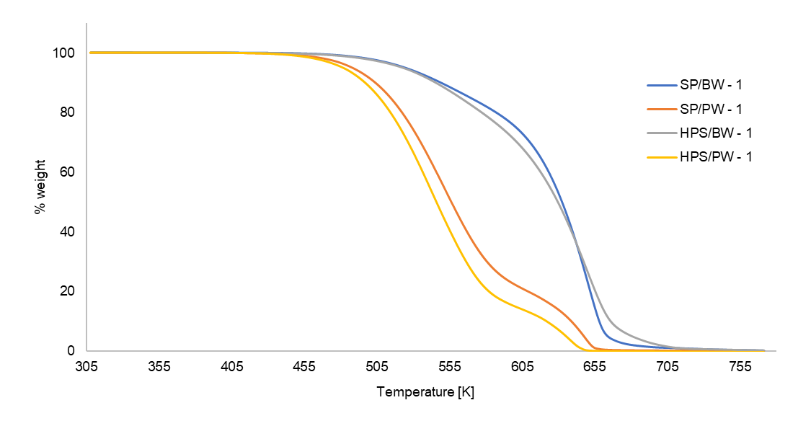
Figure 4. Thermogravimetric curves of eutectic mixtures
As shown in Figure 4, it is observed that there is no thermal degradation before 446.15 K, which indicates that the eutectic mixtures begin to evaporate slowly from that temperature. In addition, as shown in Figure 4, the SP/BW-1 mixture shows a trend of greater thermal stability. Although all blends have adequate thermal stability for the application, it is noted that the PS/BW and HPS/BW blends have significantly higher stability than those using paraffin wax.

    - Energy stored in and released from samples.
Table 3 reports the values obtained from the calculation of stored and released energy for each sample.

It is observed that the energy stored and released is greater when palm stearin and hydrogenated palm stearin are in lower proportion (20:80). Likewise, it is evident that with HPS the energy is greater than with PS.
Table 3. Theoretical energy stored and released from 1 kg of the samples.
Sample | E_{s} [kJ/kg] | E_{r} [kJ/kg]
HPS/BW-1 | 277.52 | 216.24
PS/BW-1 | 197.83 | 186.91
HPS/PW-1 | 292.42 | 205.85
PS/PW-1 | 282.13 | 201.39

  - Conclusion
The study characterized four types of eutectic blends of SP/BW, HSP/BW, SP/PW, and HSP/PW as potential PCMs for thermal energy storage applications. It can be concluded from the DSC analysis that the eutectic blends are promising PCMs for thermal storage.
The thermogravimetric analysis showed that the four types of eutectic mixtures performed presented thermal stability, since there was no degradation before the maximum working temperature of 373.15°C.
The binary mixture consisting of a molar ratio of 20% HSP and 80% BW was found to be a suitable PCM for thermal energy storage, particularly due to: 1) Suitable melting temperatures that are within the temperature range (T_{o}= 315.3 K, T_{f} = 340.19 K). 2) The individual PCMs used to prepare the eutectic mixture (HSP and BW) are PCMs that are commercially available for thermal energy storage applications. Due to this, it was determined that, a total replacement using agro-industrial materials by eutectic blends, reports promising results for their use as PCMs. However, the characteristics obtained in the HSP/PW-1 mixture show that using a partial substitution of kerosene also provides appropriate results for its use as PCM.
Finally, the effective utilization of these eutectic mixtures depends on the development of a modern, efficient and economical thermal energy storage system, designed according to the appropriate climatic conditions and making this project environmentally viable.

Acknowledgments

The authors would like to thank The Royal Society for funding this research through the Enabling Harvesting of Solar Energy for Remote Applications in the Andes Region project (ICA\R1\19120). Special thanks to the School of Chemical Engineering of the Universidad Industrial de Santander for providing access to the materials and equipment necessary for the characterization of the samples.

References
Agencia Valenciana de la Energía . (2008). Guía práctica de energía solar térmica . Valencia .
Alonso , D., Baeza, A., Chinchilla, R., Gómez, C., Guillena , G., Marset , X., . . . Saavedra , B. (2018). Mezclas eutécticas como alternativa sostenible a los disolventes convencionales en Química Orgánica. Real Sociedad Española de Química, 79-87.
Ansu, A., Sharma, R., & Singh, P. (2021). Development and Testing of Binary Organic Eutectic Mixture for Thermal Energy Storage. Lecture Notes in Mechanical Engineering, 787 - 794.
Chwieduk, D. (2016). Active solar space heating. Advances in Solar Heating and Cooling, 151-202.
Esteban Saiz, J. (1991). Análisis sobre el almacenamiento térmico en la edificación . Informes de la construcción .
Lizcano González, V., Viatcheslav V., K., & Khamid , M. (2022). Production of Fatty Esters from Palm Oil By-Products for use Phase Change Materials. Chemical Engineering Transactions.
Lui, Y., Zheng , J., Deng, Y., Wu, F., & Wang, H. (2021). Effect of functional modification of porous medium on phase change behavior and heat storage characteristics of form-stable composite phase change materials: A critical review. Storage, Journal of Energy.
Ma, G., Zhang, Y., Jing, Y., Jia, Y., & Sun, J. (2019). A novel low-temperature phase change material based on stearic acid and hexanamide eutectic mixture for thermal energy storage. Chemical Physics Letters, 166 - 171.
Pasquevich, D. M. (2016). La creciente demanda mundial de energía frente a los riesgos ambientales . Buenos Aires: Asociación Argentina para el Progreso de las Ciencias .
Sakhaei, S., & Valipour, M. (2021). Thermal behavior of a flat plate solar collector with simultaneous use of helically heat collecting tubes and phase change materials. Sustainable Energy Technologies and Assessments.
Xiao , Q., Cao, J., Zhang, Y., Li Li, Xu, T., & Yuan , W. (2020). The application of solar-to-thermal conversion phase change material in novel solar water heating system. Solar Energy, 484 - 490.

