CHEMICAL ENGINEERING TRANSACTIONS  VOL. , 2023 | A publication of
The Italian Association
of Chemical Engineering
Online at www.cetjournal.it

Guest Editors: Sauro Pierucci, Jiří Jaromír Klemeš

Copyright © 2023, AIDIC Servizi S.r.l.
ISBN 978-88-95608-98-3; ISSN 2283-9216

BIO-CRUDE PRODUCTION BY HYDROTHERMAL LIQUEFACTION OF AN INVASIVE MARINE ALGAE (SARGASSUM POLYCERATIUM)
Antonio Crespo^{a,b}, José M. Abelleira-Pereiraª, Juan J. Mascarell^{a*}, Belén García-Jarana, Jezabel Sánchez-Onetoª, Juan R. Portelaª, Enrique Martínez-de la Ossaª, Esteban Duran^{b}.
ªDepartment of Chemical Engineering and Food Technology, University of Cádiz, International Excellence Agrifood Campus (CeiA3). Spain
^{b}Chemical Engineering School, University of Costa Rica. Costa Rica
jotero.litio@gmail.com
The development of technologies to produce fuels from non-fossil sources is of great importance. One of the alternatives is the use of organic biomass feedstock. Hydrothermal liquefaction (HTL) is a technology that enables the transformation of organic matter into bio-crude by means of a reaction in aqueous medium and at high temperature and pressure conditions, although below the critical point of water. Among the different types of organic matter that can be used, marine macroalgae are a very promising feedstock as they are found in abundance within the oceans; in particular, some populations of invasive species cause environmental problems due to their excessive growth beyond their original niche. In fact, large uncontrolled proliferations of algae of the genus Sargassum are found on the coasts of many countries, causing a significant imbalance that affects both the native ecosystems and the tourism sector, which is of great economic importance in the affected areas.
Although there are many variables that influence the process, the objective of this study is to carry out preliminary HTL tests of the mentioned macroalgae specie, without being subjected to previous pre-treatment. In the experimental design, operating variables were temperature, reaction time and initial loading of algal biomass. The objective was to find the highest yield and calorific value of bio-crude produced from this raw material. MODDE® Pro 13 was the software employed for both experimental design and results processing.
All experiments were carried out in a 300 mL volume PARR stirred high pressure reactor. 150 mL of deionized water were used as reaction medium and an inert nitrogen atmosphere was applied. Bio-crude extractions were performed over the solids obtained in the reaction using dichloromethane as solvent. Among the experiments performed, the yields and high heating values (HHV) were compared at different reaction times at a temperature of 300°C and 95 bar pressure, in a time range from 0 to 60 minutes with an initial biomass load of 15 g (10% w/v). The best result obtained was a crude yield of 10.25% and a crude HHV of 9,240 kcal/kg for the 60 minutes HTL test.
1. Introduction
Due to the current and future environmental situation, a transition from the consumption of fossil fuels to another type of energy source must be made. This transition can be through the substitution of fossil fuels by biofuels, made from agricultural waste or seaweed. The Sargassum algae genus generates environmental problems in many countries, mainly because of its great capacity to spread along the coasts of the world (Pérez-López et al., 2014). It is found mostly in tropical and subtropical waters and generates serious environmental issues, since it reaches the beaches in seaweeds washed ashore (seaweed deposited in the beaches by sea water), becoming a source of pollution to the beaches and near shore waters (Devault et al., 2021). In fact, large uncontrolled proliferations of algae of the genus Sargassum are found on the South Atlantic coast of Costa Rica, causing a significant imbalance that affects both the native ecosystems and the tourism sector, which is of great economic importance in the affected areas (Thabard et al., 2011).
Several solutions are being found related to the use of this type of algae raw material in some other process. Thus, in many coastal areas of the Caribbean, these algae of the genus Sargassum have been used as animal feed (Rajauria, 2015). Algae have been found to provide bioactive compounds that promote the growth and development of livestock. Another alternative is the use in agriculture, obtaining as a result of the pyrolysis of the algae a biochar that can improve soil fertility. Some research has succeeded in producing bioplastics from alginates extracted from Sargassum siliquosum (Lim et al., 2018). Cosmetic products have also been obtained with skin protective properties (Jesumani et al., 2019).
Nevertheless, there is no doubt that the production of energy from algae is one of the most promising options. One of the main advantages of using algae as an energy source is the fact that they are considered third-generation biofuels, which means that their cultivation does not compete with crops dedicated to human food (Ghadiryanfar et al., 2016). HTL (Hydrothermal Liquefaction) is the most promising technology for producing biofuels from wet biomass (Biswas et al., 2018). HTL process is an important thermochemical conversion process used to convert biomass into valuable products or bio-crude. The process typically takes place between temperatures of 250-375°C and pressures of 4-22 MPa (Tekin, Karagöz and Bektaş, 2014) This thermochemical process takes place through a three major stages mechanisms which biomass undergoes depolymerization followed by decomposition of monomers to conclude in repolymerization resulting in the formation of bio-crude (Gollakota, Kishore and Gu, 2018).
Some species of Sargassum algae have been studied for bio-crude production from HTL process. In a study, (Biswas et al., 2020) obtained a maximum bio-crude yield of 33% under 280°C, 15 min and using CaO/ZrO₂ as catalyst from the algae Sargassum tenerrimum. Li et al., 2012 obtained a bio-crude yield of 32.1% at reaction conditions of 340°C, 15 minutes and with a loading of 10% (w/v) using Sargassum patens as feedstock. Also at 340ºC, He et al. (He et al., 2020) obtained their best bio-crude yield of 9.49% using algae of the genus Sargassum sp. At intermediate conditions, Wang et al., 2021 obtained the highest yield (35,25%) at temperatures of 300°C, reaction times of 60 min and algal biomass loading of 10% (w/v).
Table 1 includes a comparison of the yield results and HHV values obtained in various studies using algae as raw material in HTL for bio-crude production.
Table 1: Comparison of bio-crude yield (% w/v) and HHV (High Heating Value (MJ/kg)) of those bio-crudes in different reaction conditions according to the literature. 1 Dry biomass with ash. 2 Dry biomass without ash.
Algae | Reaction conditions | Yield | HHV (MJ/kg) | Ref.
Eteromorpha clathrata | Two step 200°C + 300°C, 60 min,  feed 40/4 (mL/g) | 35.2¹ | ─ | (Wang et al., 2021)
Sargassum sp. | 340°C, 30 min,  feed 9 g algae/51 g water | 9.5¹ | 35.2 | (He et al., 2020)
Sargassum tenerrimum | 280°C, 15 min | 33.0¹ | 27.9 | (Biswas et al., 2020)
Amphiroa fragilissima | 320°C, 60 min, feed 10 g/200mL | 28.9¹ | 17.3 | (Arun et al., 2020)
Ulva prolifera | 290°C, 10 min, | 26.7¹ | 33.6 | (Yan et al., 2019)
Sargassum sp. | 350°C, 35 min, feed 1:10 | 7.2¹ | ─ | (Rahbari et al., 2019)
Sargassum tenerrimum | 280°C, 15 min, feed 1:6 | 16.7¹ | 11.9 | (Biswas et al., 2018,b)
Sargassum sp. | 350°C, 15 min | 22.2² | ─ | (Díaz-Vázquez et al., 2015)
Laminarisea saccharina | 350°C, 15 min, feed 1:10 | 79.0² | 34.6 | (Bach et al., 2014)
Sargassum patens | 340°C, 15 min, feed 15 g/150ml | 32.1² | 27.1 | (Li et al., 2012)
Eteromorpha prolifera | 300°C, 30 min | 23.0¹ | 30.0 | (Zhou et al., 2010)

HTL of Sargassum polyceratium has been carried out in this study. Experiments were carried out at different conditions to assess the optimum bio-crude production, evaluated in terms of yield, HHV, TGA and ultimate analysis.
2. Material and methods.
Samples of Sargassum polyceratium were collected at Cahuita beach, in the southern Caribbean of Costa Rica. It is a brown seaweed, very common in the Caribbean Sea.
  - Reaction conditions
The collected seaweed was superficially washed with common water to remove salt and sand from the beach. Then, it was dried in oven at 60ºC for 24 hours. Once all moisture was removed, it was crushed to a particle size between 1-3 mm. The reaction took place in a 300 ml PARR high pressure reactor, with a 1.2 kW heating mantle controlled with a 4848 Reactor Controller. The algae was introduced into the high pressure reactor and a solid loading of 10% (w/v) was adjusted using 150 ml of deionized water. HTL conditions were, reaction times of 5, 15, 30 and 60 min and a constant temperature of 300ºC reaching 120 bar of pressure and at a 250 rpm of stirring speed. Once an experiment was concluded the heating blanket was removed from the reactor and cooling was started with water through a coil that passes inside the reactor. After cooled to room temperature, the reactor was depressurized and opened and the product was removed from the reactor. Three products were obtained from the reaction: a gas phase, a liquid phase and a solid phase. To obtain the bio-crude, the solid and liquid phases were first filtered to separate them, using vacuum filtration. Once both phases were separated, the extraction of the bio-crude from the solid phase was carried out using dichloromethane as solvent. Dichloromethane was dripped through the solid phase until it became transparent. Also, the reactor vessel was washed with dichloromethane. Finally, to obtain the bio-crude, this mixture was taken to a rotary evaporator during 30 min at 40°C to separate the solvent from bio-crude. The bio-crude yield was calculated from gravimetric analysis using the following equation:
$$Biocrude yield \%=\frac{Weight of biocrude obtained}{Dry seaweed weight}×100$$

  - Analytical methods.
Calorimetric analysis of the bio-crude was carried out in a PARR 6772 Calorimeter. For this analysis approximately 0.25 g of the bio-crude sample was introduced and burned in a high pressure oxygen atmosphere; the energy released by the combustion is absorbed inside the calorimeter, recording the temperature variation and its high heating value. Thermogravimetric analysis of the crude oil was carried out in a TA INSTRUMENTS SDT650 equipment, in which certain quantity (few milligrams) of the bio-crude sample was introduced and the curve was obtained by means of the Trios V5.1.0.46403 software. Finally, ultimate analyses of both macroalgae and bio-crude obtained by HTL were carried out in a FLASH SMART THERMOSCIENTIFIC equipment where the proportion of CHNSO of the samples was obtained.
- Results and discussions.

  - Seaweed characterization
Ultimate analysis of the seaweed collected was carried out in triplicated to determine the elemental chemical composition of the raw material used in this study. Table 2 shows results obtained in both ultimate analysis and HHV from calorimetric analysis.
Table 2. Ultimate analysis and calorimetric analysis of Sargassum polyceratium. CHNOS (% weight) composition.
Seaweed | C (%) | H (%) | N (%) | O (%) | S (%) | HHV (kcal/kg)
S. polyceratium | 32.6 ± 1.2 | 4.90 ± 0.08 | 1.34 ± 0.08 | 33.2 ± 1.0 | 1.47 ± 0.07 | 3,020

  - Yields obtained.
The effect of reaction time has been studied in this research. For this purpose, different experiments have been carried out at the same load of the algae biomass (10% w/v), temperature (300°C) and reaction times of 5, 15, 30 and 60 minutes. The bio-crude yield obtained in the different HTL experiments are shown in Figure 1. Three replicas of the conditions of the experiments carried out at 300ºC and 30 min were made, obtaining the following values for biocrude yield: 8.48%, 6.83%, 7.34%. The mean value with 95% confidence level is 7.55 (± 0.68 %), which is the one included in the Figure 1. It can be considered that the variability between yield values of the replicates is small, taking into account the multitude of operational steps necessary from the time the biomass is introduced into the reactor until the biocrude yield is calculated. These experimental errors justify the apparent drop in performance at 30 min. Therefore, the biocrude yield obtained follows in general an increasing trend with increasing reaction time in the studied range and for the temperature selected. The best value is obtained at 300ºC, an initial 10% w/v load and 60 min of reaction time, obtaining a bio-crude yield of 10.25%.

Figure 1. Bio-crude yield obtained by HTL from Sargassum polyceratium with a 10% w/v initial load of seaweed, 300ºC, 120 bar and different reaction times
This trend is highly dependent on the type of biomass used. Some studies confirm that increasing the reaction time impairs the bio-crude production yield as new decomposition reactions occur (Yin and Tan, 2012).
HHV for the bio-crude obtained was determined by calorimetric analysis, which gives a first idea of the quality of the bio-crude produced. The results obtained are shown in Table 3.
Table 3. HHV obtained from HTL of Sargassum polyceratium at different reaction times
HTL Experiment | Seaweed load (% w/v) | Time (min) | Temperature (°C) | HHV (kcal/kg)
5min | 10 | 5 | 300 | 7,824
15min | 10 | 15 | 300 | 7,999
30min | 10 | 30 | 300 | 8,271
60min | 10 | 60 | 300 | 9,240

As can be seen, in the range studied, HHV is proportional to reaction time. The best HHV for the bio-crude correspond with the highest reaction time (60 min), getting a HHV three times higher than the HHV corresponding to the dried seaweed.
  - Bio-crude characterization.
In addition to the HHV analysis, further analyses were carried out to characterize the crude oil with the highest HHV obtained, which is the case of a reaction time of 60 minutes). At first, ultimate analysis of the bio-crude was carried out. Results are shown in Table 4.

Table 4.Ultimate analysis obtained for the best result obtained in terms of bio-crude yield and HHV (HTL 60 min).
C (%) | H (%) | N (%) | O (%) | S (%)
73.3 ± 0.7 | 10.6 ± 0.3 | < 25 mg/kg | 11.0 ± 0.8 | < 25 mg/kg

From the ultimate analysis of both S. polyceratium and bio-crude obtained from that algae biomass by HTL, it is possible to obtain the corresponding H/C and O/C atomic ratio, to be represented in a Van Krevelen diagram, useful to compare the raw biomass and the bio-crude obtained with other typical fuels. Thus, an adapted Van Krevelen diagram has been built in order to locate both the S. polyceratium algae and the bio-crude obtained and compare them with different products shown in the original diagram. In Figure 2, the two red dots correspond to both the algae and the bio-crude obtained. It can be observed that the bio-crude obtained is practically in the range of the oil, with a slightly higher O/C ratio, and, as mentioned above, it would be within the bio-crude conversion path, so it can be concluded that it is a good result regarding bio-crude´s quality.
The Thermogravimetric analysis (TGA) of the bio-crude from experiment with a reaction time of 60 min is shown in Figure 3. As can be seen, different zones can be observed. The first one between 50 and 150°C, where dehydration occurs, and water and more volatile compounds are eliminated. In this case, there is a slight loss of weight corresponding to these compounds, approximately 5%. A second zone, delimited between 150-500°C where a constant decomposition takes place, and the sample loses its mass almost completely; more than 80% of its mass in our case. In this temperature range the decomposition of aliphatic chains and main components of the bio-crude occurs. The last stage occurs at 500°C and above, where the decomposition of long aliphatic chains and final aromatic compounds takes place. In this last stage there is a very slight weight loss of less than 5%, so it can be deduced that the crude is mostly made up of short aliphatic chains.

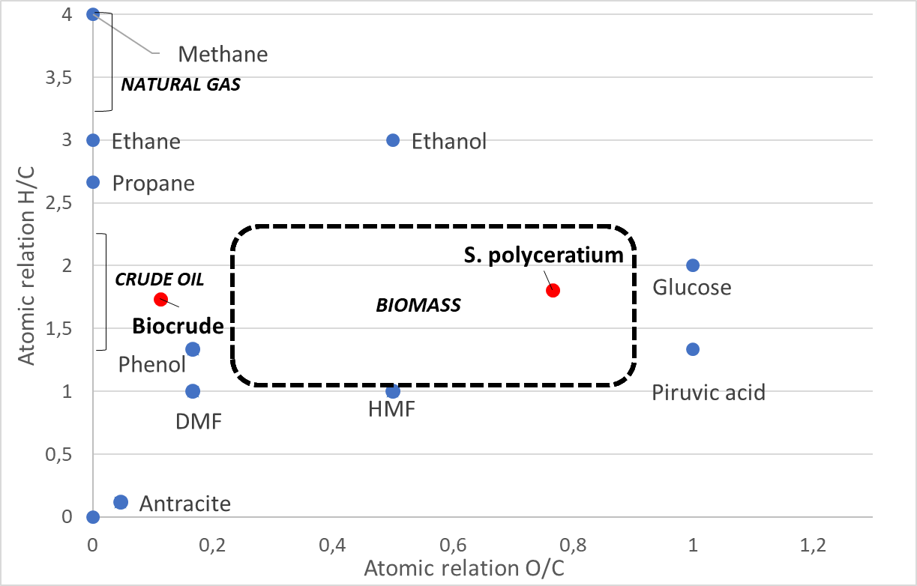
Figure 2. Van Krevelen diagram locating S. polyceratium and biocrude from HTL 60 min experiment.

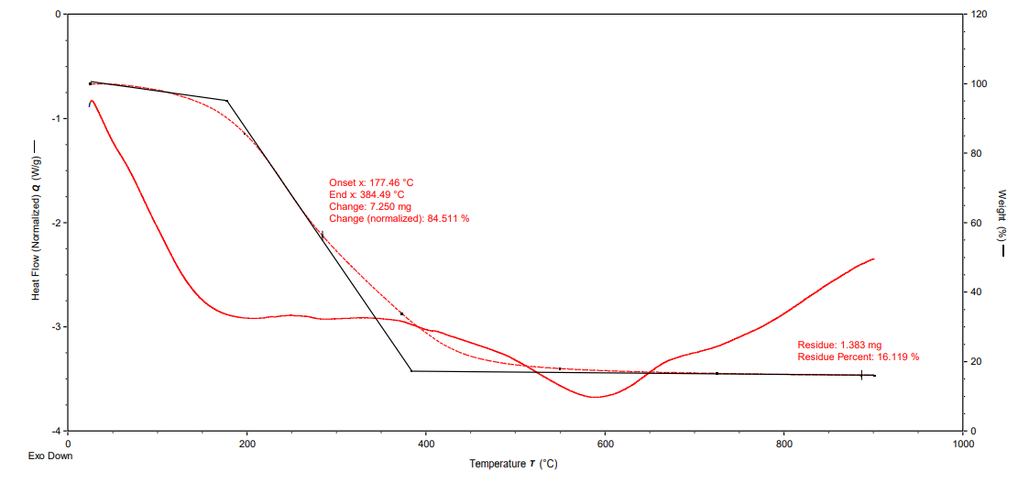
Figure 3. TGA curve obtained from the best yielding biocrude and HHV obtained.
- Conclusions
HTL is a feasible process for obtaining bio-crude from macroalgae as another type of biomass, and may be a solution to the increasingly widespread problem of algal blooms and accumulations of large quantities of algae on beaches and in the open sea. The maximum bio-crude yield value obtained was 10.25% for the HTL experiment with an initial load of 10% w/v, 300°C and 60 minutes, which is the maximum reaction time studied. Also at that conditions, the maximum HHV of 9240.3 kcal/kg was obtained. Ultimate analysis of bio-crude allow its representation into the Van Krevelen diagram. Based on this diagram, also for Sargassum polyceratium, a typical low lipid algae, it is possible to obtain a bio-crude with positive atomic relation H/C and O/C, reaching characteristics similar to those of a real crude oil.
It would be interesting to collect algae at different times of the year to see how the change on composition of macroalgae affect the HTL process efficiency.
Acknowledgments
Authors are grateful to 2014-2020 ERDF Operational Program and by the Department of Economy, Knowledge, Business and University of the Regional Government of Andalusia (Project reference: FEDER-UCA18-108297), AUIP Academic Mobility Scholarship Program and Foundation Cátedra CEPSA. Thanks to SARTORIOUS-UMETRICS for the outstanding attention regarding the software MODDE® Pro 13. We also would like to acknowledge University of Costa Rica for the possibility of carrying out the scientific stay of Antonio Crespo, and to Dr. Cindy Fernández García at the School of Biology of the UCR for her collaboration.
References
Arun, J., Gopinath, K.P., SundarRajan, P., Malolan, R. and AjaySrinivaasan, P. (2020). Hydrothermal liquefaction and pyrolysis of Amphiroa fragilissima biomass: Comparative study on oxygen content and storage stability parameters of bio-oil. Bioresource Technology Reports, 11, p. 100465. doi: https://doi.org/10.1016/j.biteb.2020.100465.
Bach, Q. V., Sillero, M.V., Tran, K.Q. and Skjermo, J. (2014). Fast hydrothermal liquefaction of a Norwegian macro-alga: Screening tests. Algal Research, 6, pp. 271–276. doi: https://doi.org/10.1016/j.algal.2014.05.009.
Biswas, B. Fernandes, A. C., Kumar, J., Muraleedharan, U. D. and Bhaskar, T. (2018). Valorization of Sargassum tenerrimum: Value addition using hydrothermal liquefaction. Fuel, 222, pp. 394–401. doi: https://doi.org/10.1016/j.fuel.2018.02.153.
Biswas, B., Kumar, A., Fernandes, A. C., Saini, K., Negi, S., Muraleedharan, U. D. and Bhaskar, T. (2020). Solid base catalytic hydrothermal liquefaction of macroalgae: Effects of process parameter on product yield and characterization. Bioresource Technology, 307, p. 123232. doi: https://doi.org/10.1016/j.biortech.2020.123232.
Devault, D., Pierre, R., Marfaing, H., Dolique, F. and Lopez, P. (2021). Sargassum contamination and consequences for downstream uses : a review. To cite this version : HAL Id : hal-03032938 Sargassum contamination and consequences for downstream uses : a review.
Díaz-Vázquez, L. M., Rojas-Pérez, A., Fuentes-Caraballo, M., Robles, I., Jena, U. and Das, K.C. (2015). Demineralization of Sargassum spp. macroalgae biomass: Selective hydrothermal liquefaction process for bio-oil production. Frontiers in Energy Research, 3, pp. 1–11. doi: https://doi.org/10.3389/fenrg.2015.00006.
Ghadiryanfar, M., Rosentrater, K., Keyhani, A. and Omid, M. (2016). A review of macroalgae production, with potential applications in biofuels and bioenergy. Renewable and Sustainable Energy Reviews, 54, pp. 473–481. doi: https://doi.org/10.1016/j.rser.2015.10.022.
Gollakota, A. R. K., Kishore, N. and Gu, S. (2018). A review on hydrothermal liquefaction of biomass. Renewable and Sustainable Energy Reviews, 81, pp. 1378–1392. doi: https://doi.org/10.1016/j.rser.2017.05.178.
He, S., Zhao, M., Wang, J., Cheng, Z., Yan, B. and Chen, G. (2020). Hydrothermal liquefaction of low-lipid algae Nannochloropsis sp. and Sargassum sp.: Effect of feedstock composition and temperature. Science of the Total Environment, 712, p. 135677. doi: https://doi.org/10.1016/j.scitotenv.2019.135677.
Jesumani, V., Du, Hong., Aslam, M., Pei, P. and Huang, N. (2019). Potential use of seaweed bioactive compounds in skincare - a review. Marine Drugs, 17(12), pp. 1–19. doi: https://doi.org/10.3390/md17120688.
Li, D., Chen, L., Xu, D., Zhang, X., Ye, N., Chen, F. and Chen, S. (2012). Preparation and characteristics of bio-oil from the marine brown alga Sargassum patens C. Agardh. Bioresource Technology, 104, pp. 737–742. doi: https://doi.org/10.1016/j.biortech.2011.11.011.
Lim, J. Y., Hii, S.L., Chee, S.Y. and Wong, C.L. (2018). Sargassum siliquosum J. Agardh extract as potential material for synthesis of bioplastic film. Journal of Applied Phycology, 30(6), pp. 3285–3297. doi: https://doi.org/10.1007/s10811-018-1603-2.
Pérez-López, P., Balboa, E., González-García, S., Domínguez, H., Feijoo, G. and Moreria, M.T. (2014). Comparative environmental assessment of valorization strategies of the invasive macroalgae Sargassum muticum. Bioresource Technology, 161, pp. 137–148. doi: https://doi.org/10.1016/j.biortech.2014.03.013.
Rahbari, H., Akram, A., Pazoki, M. and Aghbashlo, M. (2019). Bio-Oil Production from Sargassum Macroalgae: A Green and Healthy Source of Energy. Jundishapur Journal of Health Sciences, In Press(In Press). doi: https://doi.org/10.5812/jjhs.84301.
Rajauria, G. (2015). Seaweeds: A sustainable feed source for livestock and aquaculture, Seaweed Sustainability: Food and Non-Food Applications. Elsevier Inc. doi: https://doi.org/10.1016/B978-0-12-418697-2.00015-5.
Tekin, K., Karagöz, S. and Bektaş, S. (2014). A review of hydrothermal biomass processing. Renewable and Sustainable Energy Reviews, 40, pp. 673–687. doi: https://doi.org/10.1016/j.rser.2014.07.216.
Thabard, M., Gros, O., Hellio, C. and Maréchal, J.P. (2011). Sargassum polyceratium (Phaeophyceae, Fucaceae) surface molecule activity towards fouling organisms and embryonic development of benthic species. Botanica Marina, 54(2), pp. 147–157. doi: https://doi.org/10.1515/BOT.2011.014.
Wang, S., Zhao, S., Cheng, X., Qian, L., Barati, B., Gong, X., Cao, B. and Yuan, C. (2021). Study on two-step hydrothermal liquefaction of macroalgae for improving bio-oil. Bioresource Technology, 319, p. 124176. doi: https://doi-org/10.1016/j.biortech.2020.124176.
Yan, L., Wang, Y., Li, J., Zhang, Y. Ma, L., Fu, F., Chen, B. and Liu, H. (2019). Hydrothermal liquefaction of Ulva prolifera macroalgae and the influence of base catalysts on products. Bioresource Technology, 292, p. 121286. doi: https://doi.org/10.1016/j.biortech.2019.03.125.
Yin, S. and Tan, Z. (2012). Hydrothermal liquefaction of cellulose to bio-oil under acidic, neutral and alkaline conditions. Applied Energy, 92, pp. 234–239. doi: https://doi.org/10.1016/j.apenergy.2011.10.041.
Zhou, D., Zhang, L., Zhang, S., Fu, H. and Chen, J. (2010). Hydrothermal liquefaction of macroalgae enteromorpha prolifera to bio-oil. Energy and Fuels, 24(7), pp. 4054–4061. doi: https://doi.org/10.1021/ef100151h.

