CHEMICAL ENGINEERING TRANSACTIONS  VOL. , 2023 | A publication of
The Italian Association
of Chemical Engineering
Online at www.cetjournal.it

Guest Editors: Sauro Pierucci, Jiří Jaromír Klemeš
Copyright © 2023, AIDIC Servizi S.r.l.
ISBN 978-88-95608-98-3; ISSN 2283-9216

Simulation on hydrothermal liquefaction of Pinewood to produce bio-crude in a zero-waste process scheme
Seyedmohammad Mousavi*, Benedetta de Caprariis, Martina Damizia, M. Paola Bracciale, Paolo De Filippis
Department of Chemical Engineering Materials Environment, SAPIENZA University of Rome, Via Eudossiana 18, 00184 Rome, Italy
seyedmohammad.mousavi@uniroma1.it
Hydrothermal liquefaction (HTL) is one of the advanced biomass conversion technologies to produce bio-crude from wet lignocellulosic feedstocks. Hydrochar and water phase containing organics are always generated as by-products and their efficient re-use could be fundamental to decrease the whole energy consumption. Hydrogen producers like Fe are often added to the HTL reactor to maximize the bio-crude yields and quality. Furthermore, Fe can be easily recovered from the biochar at the end of the reaction and re-used, after a reduction treatment. In this work, the feasibility to produce bio-crude through HTL of pinewood in a continuous zero-waste process scheme is evaluated in an Aspen Plus® simulation. The zero- waste configuration was carried out using the water phase containing organics instead of distillate water in the HTL reactor and the hydrochar as renewable reductant of iron oxides. Experimental data were used to model the HTL (R_{yield}) while the iron oxide reduction and the combustion of the side streams were simulated in the Gibbs reactor (R_{gibbs}). Red mud, a waste stream of the Bayern process for aluminium production, containing 50 wt % of hematite (Fe₂O₃), was selected as low-cost iron source. The iron oxides reduction with hydrochar was performed at different temperature (400-1200 °C) to determine the optimal value (complete conversion to Fe). Based on the simulation results, hydrochar allows the complete red mud reduction at 780 °C but the separation of the carbon excess before Fe recirculation must be considered. The proposed continuous zero-waste HTL plant consumed a total energy of 5080 J s⁻¹, mostly of it related to the HTL (4945 J s⁻¹) and iron oxide reduction (640.2 J s⁻¹). However, the combustion of both off gases and hydrochar excess can approximately provide the heat needed to plant (-5012 J s⁻¹). Finally, the results demonstrated that the proposed HTL scheme might be a zero-waste process in terms of both mass and energy flows.
  - Introduction
Increasing demands for global energy, shortage of conventional resources, and climate change issues lead to exploring alternative sources of energy that are more renewable and sustainable. Lignocellulosic biomass is considered one of the most abundant carbon sources with low CO₂ emissions (Akhtar and Amin, 2011). Among them, pinewood coming from forestry waste can be converted into gas and liquid fuels through several biochemical and thermochemical processes. Hydrothermal liquefaction (HTL) is a promising thermochemical technique for the lignocellulosic biomass conversion into a valuable liquid product (bio-crude), occurring in the presence of water at operative conditions near its critical point (250-374 °C, 5-22 MPa) (de Caprariis et al., 2022). The presence of water in the reaction environment eliminates the preliminary energy-intensive drying unit, always present in the other thermochemical processes (pyrolysis and gasification). During HTL, the biomass decomposition causes breaking down of the biomass macromolecules through decarboxylation, depolymerization, and bond-breaking reactions, producing gases (mainly CO₂ with traces of CH₄, CO and H₂), a liquid bio-crude, a water phase containing soluble organics and a solid residue (char) (Tungal and Shende, 2014).
Recently, the recirculation of aqueous phase in the HTL, used instead of distillate water, is attracting increasing interest since it both improves the yield of bio-crude and decreases the cost of HTL wastewater treatment. In fact, a considerable amount of the carbon present in the feedstock is dispersed in the water phase which leads to energy loss; according to the economic analysis performed by Ranganathan P. and Sivaraman S. (2019), the wastewater treatments account for the 90 % of the total cost in HTL. The positive influence of water phase recycle in the process efficiency is discussed in the work of Leng et al. (2020) that reviewed the effect of hydrothermal parameters such as temperature, residence time and catalyst on aqueous phase recirculation performances. In another work, Ramos-Tercero et al. (2015) investigated the effect of consecutive water phase recycling in HTL process of a low lipid microalgae (C. vulgaris). Based on their results, the maximum bio-crude yield and energy recovery (42.2 wt % and 68 %, respectively) were achieved after seven consecutive water phase recirculation.
The presence of hydrogen during the bio-crude formation is demonstrated to be another important parameter to rise the bio-crude yields, avoiding the re-polymerization of the formed fragments into char and generating a more stable oil phase. The addition of Zero valent metals (ZVM) able to react with water in HTL conditions producing active hydrogen during the bio-crude formation (Tai et al., 2021), is widely studied thanks to their excellent redox properties and high reusability. The metal oxide, in fact, can be easily recovered and re-used in a subsequent test, after the reduction treatment, needed to restore the zero valent metal. Iron (Fe) is one of the most studied metals due to its wide availability, low cost, excellent redox properties, and environmentally friendly nature (Fruehan,1977). The use of a solid waste stream having high Fe concentration is one the most studied topic aimed at enhancing the total process sustainability.
Red mud is a waste stream of aluminum industry (Bayern process) and mainly consists of Fe₂O₃ (hematite), Al₂O₃ (alumina), SiO₂, and low amounts of Na₂O, TiO₂, CaO, and MgO. The amount of hematite (Fe₂O₃) in red mud is approximately of 30-50 % and therefore it could be a promising source of zero valent Fe after a reduction process (Agrawal et al., 2018). The activity of the reduced red mud on HTL of oakwood is already evaluated by the authors in an experimental work and an enhanced bio-crude yields with better quality was achieved with red mud at each tested conditions (270-330 °C, 0.1 g of reduced red mud added) (de Caprariis et al., 2022).
Aspen Plus® software as a process simulator widely used to model plant at industrial scale and evaluate the feasibility of the HTL plant and its energy efficiency: Hansen et al. (2019) worked on a conceptual HTL flow sheet to evaluate the influences of operation conditions (biomass moisture content, pressure, and temperature) on bio-crude yield and energy recovery; Pedersen et al. (2018) assessed gasoline production through hydrothermal liquefaction of aspen wood in terms of economic viability and energy efficiency showing that HTL could be highly cost competitive against fossil fuel processes; Tzanetis et al. (2017) report a simulation study on bio-jet fuel production through HTL or catalytic pyrolysis, stating that HTL allows higher yields and energy efficiencies than catalytic pyrolysis.
In this work, a simulation study on the bio-crude production through HTL of pinewood in a zero- waste process scheme is proposed by Aspen Plus V10. Experimental data of pinewood HTL according to methodology of (Tai et al., 2021) performed at 330 °C and 10 minutes of reaction time with red mud and recycling the water phase, were used to model the HTL reactor (Yield Reactor) while a thermodynamic analysis was performed in the other plant reactors (Gibbs Reactors). To realize the continuous zero-waste scheme, the water phase is recycled, the hydrochar is used as renewable reductant of red mud and the gaseous phase is burned to provide the heat needed to the process scheme. The red mud reduction with hydrochar was studied varying the temperature form 400-1200 ֯C to individuate the optimal value. An energy analysis was also performed to evaluate the heat needed to the proposed scheme.
  - Modeling of process
The flow sheet for the continuous zero-waste HTL of pinewood plant was simulated by Aspen Plus®. The initial mass flow rate, moisture content, inlet temperature and pressure of pinewood were fixed to 1 kg hr⁻¹, 11.7 %, 25 ֯C, and 1 bar, respectively. Fe₂O₃ and Al₂O₃ were selected as representative compounds of red mud (0.1 kg hr⁻¹, 50 wt % of Fe₂O₃ and 50 wt % of Al₂O₃) while char was considered composed by atomic carbon. The bio-crude and organic compounds in the water phase were represented as a mixture of acids (acetic acid, levulinic acid and propanoic acid), phenolic groups (Phenol-2-methoxy, 4-Ethyl-2-methoxyphenol), cyclopentanone, alcohol (3-pentene-2-ol), and other aromatics (Vanillin, Benzeneacetic acid, 4-hydroxy-3-methoxy-) components extracted from GC-MS data of the bio-crude and of the water phase obtained in the experimental tests. Soave-Redlich-Kwong (SRK) equation was selected to define the thermodynamic properties. For non-conventional components (pinewood) HCOALGEN and DCOALGEN models were applied to calculate the enthalpy and density through its ULTANAL and PROXANAL analyses, summarized in Table 1. The mass ratio of the organic compounds in the recycled aqueous phase was referred to the experimental water phase composition, obtained in HTL test with distilled water.
Other assumptions considered in the process were the following:

1. Process was steady state.
2. Pressure and temperature were uniform inside the HTL reactor.
3. All gases were ideal.
4. Al₂O₃ is considered inert in the iron redox reaction.

Table 1: Results for pinewood analyses
Proximate Analysis |  | Ultimate Analysis
Moisture (%)  FC¹ (%)  VM² (%)  ASH (%) | 11.7  11.8  74.5  2.0 | C (%)  H (%)  O (%)  N (%) | 50.0  5.6  44.0  0.4
¹ Fixed carbon
^{2.}Volatile matter
2.1. Process Flow Sheet
Figure 1 indicates the Aspen Plus® flowsheet of the zero-waste HTL scheme using pinewood as feedstock. The scheme is composed by 4 fundamental steps: HTL reactor (HTL-RCTR), products separation, iron oxides reduction (RED-RCTR) by hydrochar, and water phase recycle.

Figure 1: Flowsheet of the continuous HTL process with water phase and reduced red mud recirculation
In Figure 1, Pinewood [PINE] and recycled water phase [WP-REC] (H2O containing hydrophilic organic compounds) together with reduced red mud [RM-REC] are blended in a mixer [MIX-1]. Afterward, the mixed stream [FEED] is pressurized to 20 bar via a pump [PUMP-1] and entered into a Yield Reactor [HTL-RCTR] to produce bio-crude, water phase, solid and gaseous products (9.3 wt %, 84.9 wt %, 2.2 wt %, and 3.5 wt %, respectively). The HTL reactor works at constant pressure and temperature of 20 bar and 330 ֯C, respectively. The solid phase is separated from the other products in a separator [SEP-1] functioning at 330 ֯C and 20 bar. The mixture of gaseous and liquid products (bio-crude and water phase contained organics) is cooled down to ambient temperature (25 ֯C) by a cooler [CLR-1]. Next, depressurizing of the products (1 bar) at the exiting of the cooler [CLR-1] is performed by a valve [VLV-1]. The mainstream passes through 2nd separator [SEP-2] for the separation of the bio-crude [OIL-P], water phase [WP-1], and gas phase [GAS]. Since the concentration of organic soluble compounds is increased in the water phase stream after the HTL reaction (the results are available in the following section), the stream should be diluted by pure water [H20] to meet the concentration of the recycled water phase at the beginning of the process. Then, since the mass flow rate of the water-stream after dilution is higher than the required amount (5 kg hr⁻¹), the split block [SPL1] adjusts the mass flow rate for the solvent [WP-REC] of the process during the recycle loop. The solid phase composed by carbon, Fe₃O₄, and Al₂O₃ enters to the reduction reactor [RED-RCTR]. R_{gibbs} reactor block is selected to model this unit. reactor operates based on the Gibbs free energy minimization principle in Aspen Plus® so that thermodynamic equilibrium compositions of reduction reactor products are quantified. The analysis is conducted in the temperature range of (400-1200 ֯C) to determine the optimum temperature. Then, the exhausted gases (mainly CO and CO₂) [GP-O & GAS] of the HTL and of the iron oxides reduction reactors and the excess of hydrochar [C] at the end of iron oxide reduction enter the combustion chamber [CHMBR] (R_{gibbs} reactor) in the presence of air (Air to fuels mass ratio: 3.2) to be burnt and supply heat for the process. Finally, the RRM composed by Fe and Al₂O₃ [RM-REC] is returned to the process.
  - Results and discussion
Mass balance
Table 2 highlights the mass balance among the HTL feed, products, recycled by-products, solid, and water phases. Mass flow input of the HTL plant contained 1 kg hr⁻¹ pinewood, 0.1 kg hr⁻¹ of reduced red mud and 5 kg hr⁻¹ water phase (4.73 kg hr⁻¹ pure water plus 0.27 kg hr⁻¹ organic soluble compounds). HTL reaction resulted following mass flow rates for the products according to the experimental results at the same operative conditions: 0.57 kg hr⁻¹ oil phase, 0.216 kg hr⁻¹ gaseous products, 5.18 kg hr⁻¹ water phase containing 0.45 kg hr⁻¹ organics mixture solved in 4.73 kg hr⁻¹ pure water and 0.134 kg hr⁻¹ hydrochar. Also, the makeup and purge streams for diluting the recycled water phase were calculated by Design Spec tool at around 3.01 kg hr⁻¹ and 3.18 kg hr⁻¹, respectively.
Table 2: Flow rate of streams in the flowsheet
Components | Name of Stream in FS¹ | Mass flow (kg hr⁻¹)
HTL Feed
Pinewood | PINE | 1.000
Recycle Water Phase  Recycle RRM² | WP-REC  RM-REC | 4.730 W³ + 0.270 O⁴  0.100
HTL Products
Oil | OIL-P | 0.570
Water Phase | WP-1 | 4.730 W + 0.450 O
Gas | GAS | 0.216
Solid | HCHAR | 0.134
Other Input & Output streams
Make up of WP | H20 | 3.010
Purge | WP-O | 3.180
Gaseous Products | GP-O | 0.032
Carbon (excess of hydrochar) | C | 0.002
¹ Flowsheet
² Reduced red mud
³ Water
⁴ Organics soluble in water phase

Optimal operative conditions for iron oxides reduction with hydrochar.
Figures 2a and 2b report the mass flow rates of the main species detected in the solid and in the gaseous streams (Fe₃O₄, FeO, Fe, C, CO, and CO₂) while figure 2c shows the heat duty variation during the iron oxide reduction as a function of temperature (Block RED-RCTR, temperature range 400-1200 ֯C). The inlet stream (HCHAR) is composed by a mixture of carbon, Fe₃O₄ and Al₂O₃ (61 %, 15 % and 21 % in mole percentage, respectively). The trends in Figure 2a shows that from 520 ֯C, the reduction reaction of Fe₃O₄ by solid carbon is started, producing FeO, CO and CO₂ according to Equations 1 and 2. The results in Figure 2c also depicts that the occurring of the reaction since the heat duty of the reactor increases sharply from about 7.1 J s⁻¹ to over 15.9 J s⁻¹. At 520 °C, as it is shown in Figure 2a, the mass flow rates of Fe₃O₄ and carbon (C) in the RM-RED stream decrease. In this point, the whole Fe₃O₄ is converted into FeO while carbon is still present in the solid stream (0.0126 kg hr⁻¹). Carbon (C) participates in two main reactions: the reduction of Fe₃O₄ to FeO (Equations 1 and 2) and the reverse-Boudouard reaction (Equation 5). Looking at the carbon profile in Figure 2a in the temperature region 520-780 ֯C shows only Boudouard reaction is occurring since no formation of Fe is detected. The conversion of carbon into CO is confirmed in Figure 2b where the profile of CO and CO₂ in the range of temperature examined is reported: from 520 °C, the concentration of CO₂ starts to decrease and over 1000 °C, the gaseous stream is composed by mainly CO [mole fraction of CO > 99.3 %]. The complete reduction to Fe, fundamental to guarantee the production of high H₂ amount, is obtained at 780 °C where the heat duty reaches approximately 63 J s⁻¹ as shown in the Figure 2c.
$$C\left(s\right)+{Fe}_{3}O_{4}\left(s\right)↔3FeO\left(s\right)+CO(g)$$ | (1)
$$C\left(s\right)+2{Fe}_{3}O_{4}\left(s\right)↔6FeO\left(s\right)+CO_{2}(g)$$ | (2)
$$C\left(s\right)+FeO\left(s\right)↔Fe\left(s\right)+CO(g)$$ | (3)
$$C\left(s\right)+2FeO\left(s\right)↔2Fe\left(s\right)+CO_{2}(g)$$ | (4)
$$C\left(s\right)+{CO}_{2}\left(g\right)↔2CO(g)$$ | (5)

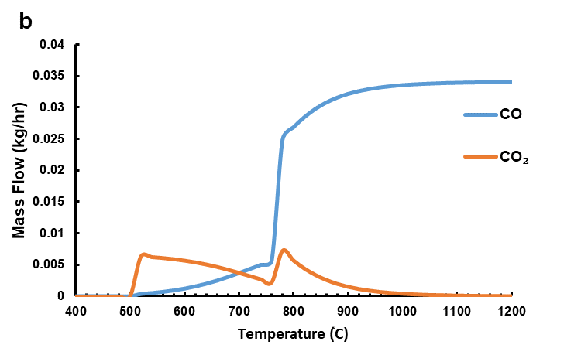
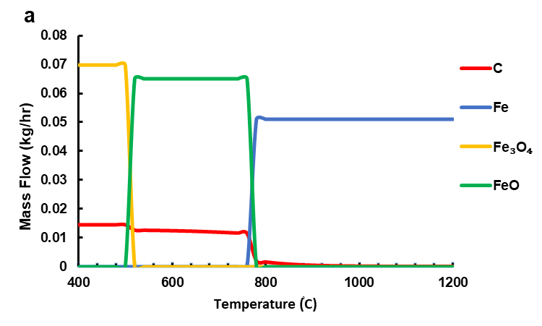

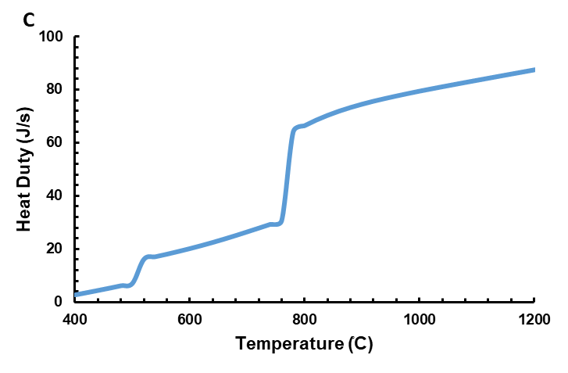

Figure 2: Mass flow rate of available components and heat duty of as a function of temperature (400-1200°C). a) RM-REC stream (recycled RRM) b) GP-O stream (gases produced during reduction) c) heat duty of reduction reactor

Energy balance
Table 3 summarizes the heat duty (J s⁻¹) of the main equipment in the simulated process. It can be noted that among the equipment for energy consumption, the energy required for the HTL reaction is 4945 J s⁻¹ as the most energy consumer unit. Also, the required heat duty for the complete reduction of iron oxides is approximately 64.0 J s⁻¹. The other energy consumer units in the system are separators. Among them, separator of oil, water, and gas phases [SEP-2] requires heat duty of 61.1 J s⁻¹. However, separator unit where hydrochar is split up from the main products [SEP-1] and the unit for purifying the reduced red mud stream from excess of hydrochar [SEP-3] do not need significant amount of energy therefore are not reported in the list. Moreover, the pump [PUMP-1] used for the pressurizing and entering the feed to HTL reactor consumes 9.4 J s⁻¹ of power. The total energy which should be supplied in this process is determined about 5079 J s⁻¹. On the other hand, the Table 3 also shows the equipment which could recover the heat needed. The majority of the required heat can be compensated by Cooling unit that it retrieves 4334 J s⁻¹ of heat duty after cooling down the liquid and gas products of the HTL reactor. As well as this, the combustion unit can release around 678 J s⁻¹ heat after burning the exhausted gaseous products (mainly CO, CO₂) and excess carbon exited from HTL and reduction reactors. The total energy recovery of the process is obtained 5012 J s⁻¹ accordingly, the energy balance demonstrates that the 98.6 % total heat needed by energy consumers equipment could be retrieved by recovery ones.

Table 3: Calculated heat duty of equipment in HTL process
Equipment for heat consumption |  |  | Equipment for heat recovery
Equipment | Name in FS | Heat duty (J s⁻¹) | Equipment | Name in FS | Heat duty (J s⁻¹)
R_{yield} Reactor | HTL-Reactor | 4945 | Cooler | CLR-1 | -4334
R_{gibbs} Reactor  Separator | RED-RCTR  SEP-2 | 64.0  61.1 | R_{gibbs} Reactor | CHMBR | -678
Pump | PUMP-1 | 9.4
Total |  | 5080 | Total |  | -5012
  - Conclusion
In this paper, the simulation of HTL of Pinewood has been developed using Aspen Plus® to evaluate the feasibility of the production of a high-quality bio-crude in a zero-waste process scheme. Based on the results, the feasibility to use the hydrochar as iron oxides reductant is confirmed, the optimum temperature for the complete conversion of oxidized iron (Fe₃O₄) to Fe were estimated thermodynamically at 780 ֯C. The presented continuous zero-waste HTL technique needed a total energy of 5080 J s⁻¹ which involved 4945 J s⁻¹ for HTL reactor, and 64 J s⁻¹ iron oxide reduction. Approximately 98.6 % of the required heat can be supplied by combustion of both off gases and excess of hydrochar, suggesting that this configuration appears promising also as a zero-energy system.
References
Agrawal, S., Rayapudi, V., Dhawan, N., 2018, Extraction of Iron values from Red mud. Mater. Today Proc. 5, 17064–17072.
Akhtar, J., Amin, N. A. S., 2011, A review on process conditions for optimum bio-oil yield in hydrothermal liquefaction of biomass. Renew. Sustain. Energy Rev. 15, 1615–1624.
De Caprariis, B., Damizia, M., Tai, L., De Filippis, P., 2022, Hydrothermal Liquefaction of Biomass Using Waste Material as Catalyst: Effect on the Bio-Crude Yield and Quality. Chemical Engineering Transactions 92(January):607–612.
Fruehan, R., 1977, The Rate of Reduction of Iron Oxides by Carbon. Metallurgical Transactions B 8(1):279–86.
Hansen, N. H., Pedersen, T. H., Rosendahl, L. A., 2011, Techno-economic analysis of a novel hydrothermal liquefaction implementation with electrofuels for high carbon efficiency. Biofuels, Bioprod. Biorefining 13, 660–672.
Leng, S., Leng, L., Chen, L., Chen, J., Chen, J., Zhou, W., 2020, The effect of aqueous phase recirculation on hydrothermal liquefaction/carbonization of biomass: A review. Bioresour. Technol. 318, 1240811q.
Pedersen, T. H., Hansen, N. H., Pérez, O. M., Cabezas, D. E. V., Rosendahl, L. A., 2018, Renewable hydrocarbon fuels from hydrothermal liquefaction: A techno-economic analysis. Biofuels, Bioprod. Biorefining 12, 213–223.
Ramos-Tercero, E. A., Alberto B., Brilman, D. W. F., 2015. Process Water Recycle in Hydrothermal Liquefaction of Microalgae to Enhance Bio-Oil Yield. Energy and Fuels 29(4):2422–2430.
Ranganathan, P., Sivaraman S., 2019, Techno-Economic Analysis of Microalgae-Based Liquid Fuels Production from Wastewater via Hydrothermal Liquefaction and Hydro processing. Bioresource Technology 284(March):256–265.
Tai, L., de Caprariis, B., Scarsella, M., De Filippis, P., Marra, F., 2021, Improved Quality Bio-Crude from Hydrothermal Liquefaction of Oak Wood Assisted by Zero-Valent Metals. Energy and Fuels 35, 10023–10034.
Tungal, R., Shende, R. V., 2014, Hydrothermal liquefaction of pinewood (Pinus ponderosa) for H2, bio-crude and bio-oil generation. Appl. Energy 134, 401–412.
Tzanetis, K. F., Posada, J. A., Ramirez, A., 2017, Analysis of biomass hydrothermal liquefaction and bio-crude-oil upgrading for renewable jet fuel production: The impact of reaction conditions on production costs and GHG emissions performance. Renew. Energy 113, 1388–1398.

The brackets in this section represent the name of streams and blocks in Aspen Plus flowsheet.

