CHEMICAL ENGINEERING TRANSACTIONS  VOL. , 2023 | A publication of
The Italian Association
of Chemical Engineering
Online at www.cetjournal.it

Guest Editor: Sauro Pierucci
Copyright © 2023, AIDIC Servizi S.r.l.
ISBN 978-88-95608-98-3; ISSN 2283-9216

Circular Economy: Use of Fruit Waste to obtain Bioplastics
Victoria N. Jara Ramirez, Zaira I. Ocaña Gonzales, Danny Lizarzaburu-Aguinaga, Felipa Muñoz Ccuro, Eduardo R. Espinoza Farfan, Elmer Benites-Alfaro*
Universidad César Vallejo, Av. Alfredo Mendiola 6332, Lima 15314, Perú
*ebenitesa@ucv.edu.pe
The inappropriate and limited management of organic waste causes it to be disposed of in streets or landfills, negatively impacting the various ecosystems due to leachate, the appearance of vectors, and the emission of greenhouse gases. Taking advantage of this waste under the concept of circular economy is a viable alternative, one way to do it is by transforming it into compost for agricultural activity. This research seeks to propose a new use of organic waste with favorable characteristics to obtain biomaterials. The elaboration of bioplastic from pectin extracted from the peels of citrus fruits and apples was tested. Through aqueous extraction, the pectin was obtained to later transform it into a bioplastic with the addition of citric acid, glycerol, carboxymethylcellulose, and water. They were experimented with using three doses, being the best dose to produce the bioplastic with the best properties when using 1 % citric acid, 7 % glycerol, 0.39 % carboxymethylcellulose and 2 % pectin, a bioplastic that presented elongation and tensile values of 7.3575. N/ cm² and 62.22 %, percentage of water absorption of 94.26 %, 100 % biodegradability (in the soil) in 21 days, as well as 100 % degradation in water in 14 days and 28.39 % degradation in the open air in 28 days. Obtaining these biomaterials is a way to take advantage of citrus waste and other fruits with environmental sustainability advantages and within the concept of circular economy, which would avoid the use of plastics based on polluting chemical products.
  - Introduction
Population growth has had a considerable increase in the last decade, causing a high demand for fruits and vegetables, which in turn has generated an increase in organic waste (Magama, Chiyanzu and Mulopo, 2022). Of the 1,300 million tons of food that are wasted in the world during its production and commercialization (Selva, Adithya and VishalI, 2022), 20 % is valued and 50 % becomes organic waste (Wan, et al, 2022).
Organic waste, for the most part, usually presents inappropriate management, or it is very limited, so it ends up being discarded in streets and landfills, reaching various ecosystems (Lee, et al, 2022). This is how these residues generate air pollution, unpleasant odors, contamination of soil and bodies of water, degradation of landscapes, and reproduction of insects and rodents (Babu, Prieto and Rene, 2021). Therefore, consider the application of the circular economy model through valuation approaches with the objective that it is not only reducing the generation of food waste (Papargyropoulou, et al, 2014). and investigating alternatives for eco-friendly and eco-efficient recovery processes (Fazzino, 2021), is of the utmost importance. The use of organic waste to obtain products has been investigated in recent years, such as obtaining bioplastic from Manihot esculenta (cassava) and Ficus benjamina (Olivares, et al. 2021), obtaining paper from Ananas commusus (Velásquez, et al., 2021), elaboration of kitchenware from Carya illinoinensis (Campos et al., 2021), roofs from pile crown residues and sugarcane bagasse (Morales, et al., 2022), elaboration of sorbets from Mangnífera indica and Vitis vinifera (Gallardo, et al., 2022), among others.
This scientific document reports the evaluation of the physical-mechanical properties and biodegradability of a biomaterial from pectin, which is composed of up to 70% galacturonic acid in the plant and is found in various citrus fruits providing mechanical resistance. to the cell wall, proving to be an element with potential use for the production of bioplastics (Gurram et al., 2018). In addition, for (Ministerio del Ambiente, 2022) in the last year the Ate district processed 570.85 tons of organic waste (such as citrus peels, apples, and others) in its recovery plant, evidencing the ability to process the biomaterial if the scale is increased.
  - Materials and methods
2.1 Raw material
Citrus and apple peels were collected from the Ceres market, in the district of Ate, for 7 days, obtaining a total of 14 kg and 9.90 kg of each type; then they were subjected to a pre-treatment before extracting the pectin, which consisted of performing two items of washing with shaking at 115 rpm for 20 min at 35 °C, cutting, drying at 40 °C for 16 hours and grinding.
2.2. Pectin extraction
This process was carried out using the aqueous extraction method (Passandide et al. 2017). Distilled water was added to the biomass obtained from citrus and apple peels in a 40:1 ratio and was subjected to a stirring process at 90 ºC for 180 min (Figure 1). Following the filtration process, the aqueous part was separated. To the solution obtained, alcohol was added in a ratio of 1.5:1 to precipitate the pectin. It was then centrifuged to separate the pectin from the alcohol. To obtain dry pectin, it was baked for 12 hours at 50 ºC. The dry pectin was characterized by determining its production yield, ash content, and moisture content by gravimetric method.

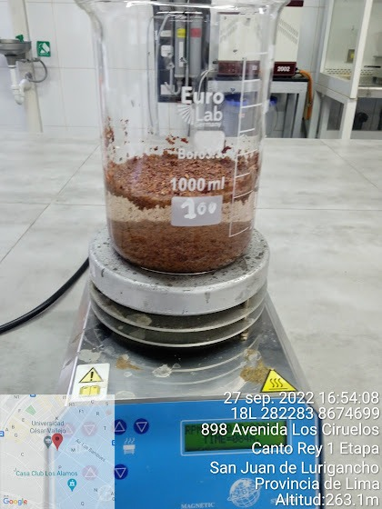  Figure 1: Pectin extraction | 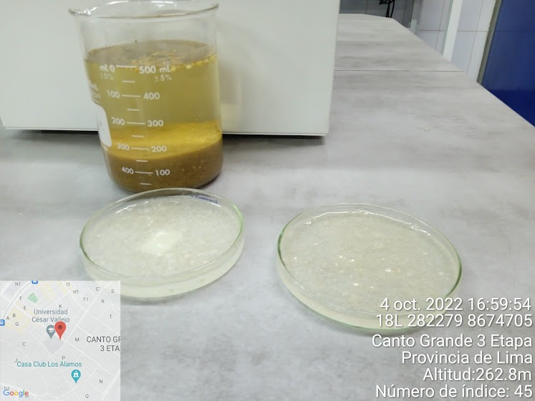  Figure 2: Bioplastic obtained
2.2 Bioplastic production
With citrus peel and apple pectin in a 1:1 ratio, 3 bioplastic samples were made with 3 replicates for each sample. The method used was the casting method (Bátori, 2017) under constant temperature conditions (95 ºC) and pH of acidified distilled water (3.5). The procedure began with the change of the pH of the distilled water to 3.5 by adding 2N HCL, followed by stirring at 250 rmp and 90 ºC for 40 min, adding citric acid, glycerol, carboxymethylcellulose and pectin in different doses (See Table 1). This homogenized mixture results in bioplastic. Example for bioplastic BP2, 1g of citric acid + 7g of glycerol + 0.39g of carboxymethylcellulose + 100 ml of water + 2 g of pectin were used, to obtain 100 g of bioplastic + water vapor. The bioplastic was put in Petri dishes and dried (see Figure 2).
Table 1: Amount of pectin and additives for bioplastic samples
Bioplastic | Sample | The citric acid (g) | Glycerol (ml) | Carboxymethylcellulose (g) | Distilled water (ml) | Pectin (g)
BP1 | BP1-M1 | 6 | 11 | 0.39 | 75 | 8
 | BP1-M2 | 6 | 11 | 0.39 | 75 | 8
 | BP1-M3 | 6 | 11 | 0.39 | 75 | 8
BP2 | BP2-M4 | 1 | 7 | 0.39 | 100 | 2
 | BP2-M5 | 1 | 7 | 0.39 | 100 | 2
 | BP2-M6 | 1 | 7 | 0.39 | 100 | 2
BP3 | BP3-M7 | 3 | 2 | 0.39 | 100 | 25
 | BP3-M8 | 3 | 2 | 0.39 | 100 | 25
 | BP3-M9 | 3 | 2 | 0.39 | 100 | 25
BP1: Bioplastic 1; BP2: Bioplastic 2; BP3: Bioplastic 3; M1: Sample 1; …M9: Sample 9.

2.3 Characterization of the bioplastic
Finally, the bioplastic was characterized, evaluating the biodegradation (See figure 3) in soil, aqueous, and open air. Regarding the soil environment, it was collected from a natural area, screened at 2 mm to eliminate any impurity (vegetable or inert matter), with a water retention capacity between 40% and 60%, pH between 6-8 and organic matter content. with a C:N ratio of 40:1 (ISO 17556 method), concerning the aqueous medium and the outdoors, the mass loss method was applied. The tensile and elongation test of the material was also carried out, for which bioplastic strips 15 cm long and 2.50 cm wide were cut, various weights were applied, and time was measured.
The water absorption capacity was evaluated, following the procedure based on the ASTM D570-98 standard (immersion in distilled water), which consists of subjecting the samples in beakers with distilled water to a temperature of 21.5 ºC simultaneously, during intervals After 1, 3, 5, 10, 15, 20, 25, 30, and 60 minutes, remove any water from the surface and weigh the samples.

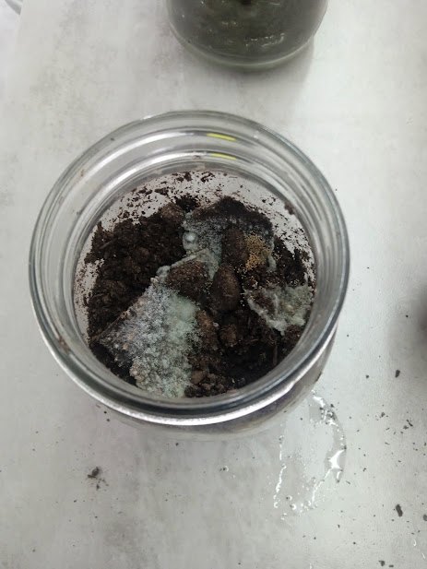
Figure 3: Biodegradation process in soil
3. Results and discussion
3.1 Traction and elongation of the bioplastic
The values obtained for traction force show that sample 1 supported a maximum force of 2.4525 N/cm² in an average time of 7.3 s; sample 2 reached its breaking point when 7.3575 N/cm² was applied in an average time of 20.35 s, and sample 3 tolerated a maximum force of 4.9050 N/cm² in 19.37 s. See Table 2.
The percentage of elongation obtained from the samples has a minimum value of 60% from sample 2 (BP2-M5 / BP2-M6), and a maximum value of 106.67 % from sample 1 repetition 1 (BP1-M1) and sample 3 (BP1-M9) (see Table 2).
The difference between the tensile force and elongation values of the 3 samples is caused by the amount of glycerol added in each sample, this is because glycerol allows the increase in elongation but decreases its tensile force, as mentioned. Giosafatto et al (2014), indicate the elongation and traction values are due to the amount of glycerol used in the production of bioplastic since it causes the structure of the material to become flexible; Gustafsson et al (2019), also mention that if the elongation values increase, the tensile strength decreases.

Table 2: Values obtained from the tensile test
Bioplastic | Repetitions | Elongation |  |  | Tractive force (N/cm²) | Time  (s)
 |  | L_{i} (cm) | L_{f} (cm) | E (%)
BP1 | BP1-M1 | 15 | 31 | 106.67 | 2.4525 | 7.3
 | BP1-M2 | 15 | 30 | 100.00 | 2.4525
 | BP1-M3 | 15 | 28 | 86.67 | 2.4525
BP2 | BP2-M4 | 15 | 25 | 66.67 | 7.3575 | 20.35
 | BP2-M5 | 15 | 24 | 60.00 | 7.3575
 | BP2-M6 | 15 | 24 | 60.00 | 7.3575
BP3 | BP3-M7 | 15 | 31 | 80.00 | 4.9050 | 19.37
 | BP3-M8 | 15 | 30 | 93.33 | 4.9050
 | BP3-M9 | 15 | 28 | 106.67 | 4.9050

Li=Initial length; Lf=final length
3.2 Bioplastic water absorption
The final values obtained in water absorption indicate that sample 3 has a value of 85.48 %, sample 2 reaches a value of 94.26 %, and sample 1 exceeds 100 %. (See Table 3), which is due to the dose of glycerol applied in each sample, since glycerol contains a hydrophilic part. Arrieta, Durango and Arizal (2018), mention that a determining factor in the absorption capacity of water or aqueous solutions of a biomaterial is the absence or presence of the plasticizer. This is because, when in contact with the pectin, it causes holes in its structure and collaborates with the wetting of the bioplastic, that is, the structure becomes porous and capable of absorbing humidity from the environment. This is how, in their experimentation, they obtained results with great differences according to the presence of glycerol (plasticizer). In samples without glycerol, the values obtained vary between 9.14 % and 13.99 and 9.14 %, and in samples with glycerol (dose between 3g and 5g) between 43.29 % and 48.66 %, attributing said results to the presence of the plasticizer; what is verified in the investigation that realizes.
Table 3: Percentage of absorption of bioplastic samples
Bioplastic | W_{i} (g) | W_{f} (g) | Absorption percentage (%)
BP1 | 3.78 | 9.39 | 148.41
BP2 | 3.31 | 6.43 | 94.26
BP3 | 7.85 | 14.56 | 85.48

Wi= initial weight; Wf=final weight

3.3 Biodegradability and bioplastic degradation

Biodegradation in Soil
The results obtained for the biodegradability at 28 days in soil medium (pH 6-8 and C:N ratio of 40:1, organic matter 10%, humidity 30%, electrical conductivity 2.2 ds/m) for the samples were: BP1 present an average of 97.10 %, the BP3 sample an average of 90.12 %; and the sample BP2 100 %, being the sample with the highest percentage of biodegradability obtained between 14 and 21 days, these results are shown in Figure 4. Other investigations also obtained similar values, such as the one carried out by Günkaya and Banar (2016), who elaborated bioplastics achieving biodegradability values of 70% in 9 days, reaching 78.4% in 15 days, attributing it to the Ph and organic matter present in the soil since this allows and helps microorganisms to quickly produce enzymes. To degrade biofilms. Espinoza et al, 2022 mention that soils that have organic matter in their composition can be more easily biodegraded even by larvae compared to those that do not contain it.

Figure 4: Biodegradability of bioplastic in soil | Figure 5: Bioplastic degradation in aqueous medium
Bioplastics have an advantage over traditional plastics, they degrade easily and in less time by living organisms, giving as products carbon dioxide, water, and biomass in aerobic and anaerobic conditions, not requiring systems to reduce or eliminate negative impacts on the environment. (Moeini et al, 2021).

Biodegradation in aqueous medium
The results obtained for degradation in aqueous medium present minimum values of the BP1 sample with a percentage of 7.19 % and the BP3 sample with 10.94 % after 7 days of testing, achieving complete degradability in 28 days. While the BP2 sample obtains a maximum value of 96 % in 7 days and completes its degradation in 14 days (see Figure 5), this happens due to the pectin content in its composition. Chinaglia, Tosin and Degli-innocenti (2018), explain that pectin is a great source of carbon, which contributes to the growth of microorganisms, which produce enzymes such as pectinase that bind to pectin, initiating biodegradation. In addition, being in aerobic conditions, they are quickly converted into biomass and then into CO₂. However, they also mention that molecular biodegradability must be considered, that is, that biodegradation is affected by the size of the particles.

Degradation of bioplastic outdoors
The outdoor samples presented degradation values in a range of 1.82 % in 7 days and 24.45 % in 28 days in the BP1 sample; the BP2 sample in 7 days presents an average of 5.17 % and 28.39 % in 28 days; and, the BP3 sample is in a range of 3.48 % and 25.76 % in the time of 7 and 28 days respectively (See Figure 6). As can be seen, the results obtained from the 3 samples do not present a considerable difference, on the other hand, they were not able to degrade completely, due to the climate and the environmental factor. Almirón et al (2021), mention that bioplastics subjected to the weather for 4 months obtain values ranging from 7 % to 13 %, which are determined by environmental conditions, such as the climate and temperature of the area.

Figure 6: Degradation of the bioplastic in the open air
Statistical analysis of biodegradability results.
First, the normality test was carried out for the percentages of biodegradability through the Shapiro-Wilk test, confirming the normality of the samples, we proceeded to analyze the relationship of biodegradability with the amount of pectin in each sample through the test. of ANOVA (see Table 4) observing values less than 0.05 in the soil and water medium for 7 and 14 days, demonstrating the significant differences in biodegradability, for 21 and 28 days there is no significant difference, this is because at these times the % approaches 100% biodegradability. In the interperiee the samples do not have significant differences, with these results the test of homogeneity of variances (Levene's statistic) was subsequently applied, finding similar results, therefore the hypothesis that the bioplastic obtained from citrus peel pectin is accepted and apple biodegrades with a percentage greater than 50.
Table 4: ANOVA test for biodegradability
Biodegradability | Day
 | 7 |  | 14 |  | 21 |  | 28
 | F | Sig | F | Sig | F | Sig | F | Sig
% biodegradability in soil | 37.7 | .000 | 28.6 | .001 | 2.7 | .143 | .563 | .597
% biodegradability in water | 294.7 | .000 | 7.7 | .043 | 28.5 | .001 | - | -
% biodegradability outdoors | 5.8 | .390 | 3.6 | .095 | .240 | .794 | .372 | .704

4. Conclusions
Citrus and apple peels could be used to manufacture biomaterials, from the pectin they contain, as long as the tests and studies are expanded. The bioplastic obtained presents mechanical physical characteristics similar to synthetic bioplastics such as water absorption in a range of 85.48% to 148.41%, elongation of 60% and 106.67%, tensile strength, 2,425 N/cm2 at 4.9525 N/cm2 and in general complies with the regulated percentage of biodegradability, even reaching 94% - 100% in a period of 21 to 28 days. Therefore, the production of bioplastics is a way to eliminate and recycle waste after its useful life or use of organic products, at the same time, it is a way to reduce the pressure of negative impacts on the environment.
Acknowledgments
The authors would like to thank "Investiga UCV" of the Universidad César Vallejo for financial support for the publication of this research.
Referencias
Almirón J., Barrionuevo Y., Chávez B., Mamani J., Ortiz Y., Tupayachy D., 2021, Evaluation of the physical-chemical degradation of biodegradable plastics sold in supermarkets. Prospective and trends in technology and skills for sustainable social development. Leveraging emerging technologies to build the future, Actas de la 19ª Conferencia Internacional Múltiple de Ingeniería, Educación y Tecnología de LACCEI, (in Spanish).
Arrieta A., Durango L., Arizal E., 2018, Study of absorbing properties of a biopolymer based on cassava starch (Manihot esculenta Crantz), Revista Espacios, 39(53), 15.
Babu R., Prieto P., Rene E., 2021, Strategies for resource recovery from the organic fraction of municipal solid waste. Case Studies, Chemical and Environmental Engineering, 3.
Bátori V., 2017, Jabbari M., Åkesson D., Lennartsson P.R., Taherzadeh M., Zamani A., Production of Pectin-Cellulose Biofilms: A New Approach for Citrus Waste Recycling, International Journal of Polymer Science, 2017(9732329) 9.
Campos K., Castro Y., Castañeda C., Valverde J., Benites E., 2021, Carya illinoinensis shell for made biodegradable food-safe packaging, Congreso Internacional de Innovación y Tendencias en Ingeniería (CONIITI), Bogotá, Colombia, IEEE Xplore, Proceeding, pp. 1 -4.
Chinaglia S., Tosin M. y Degli-innocenti F., 2018. Biodegradation rate of biodegradable plastics at molecular level, Polymer Degradation and Stability,147.
Espinoza Pinchi J., Ordonez Galvez J., Castaneda-Olivera C.A., Benites Alfaro E.G., 2022, Environmental Biotechnology: Biodegradation of Microplastics with Larvae of Tenebrio Molitor and Galleria Mellonella, Chemical Engineering Transactions, 93, 187-192.
Fazzino F., Folino A., Mauriello A., Pedulla A., Calabro P.S., 2021, Biofuel production from fruit and vegetable market waste and mature landfill leachate by an active filter-anaerobic digestion integrated system, Energy Conversion and Management, 12, 100130
Gallardo Bravo C.V., Velasquez Ruiz X.A., Jave Nakayo J., Tello Mendivil V., Castaneda-Olivera C.A., Benites Alfaro E., 2022, Biomes of Mangifera Indica and Vitis Vinifera for the Production of Biodegradable Sorbets, Chemical Engineering Transactions, 92, 523-528
Giosafatto V., Di Pierro P., Gunning P, Mackie A., Porta R., Mariniello L., 2014, Characterization of Citrus pectin edible films containing transglutaminase-modified phaseolin, Carbohydrate Polymers, 106, 200-208.
Günkaya Z. y Banar M., 2016, An environmental comparison of biocomposite film based on orange peel-derived pectin jelly-corn starch and LDPE film: LCA and biodegradability, The International Journal of Life Cycle Assessment, 21, 465–475.
Gurram R., Souza Filho P. F., Taherzadeh M. J., and Zamani A., 2018, A Solvent-Free Approach for Production of Films from Pectin and Fungal Biomass. Journal of Polymers and the Environment, 26(11), 4282–4292. doi.org/10.1007/s10924-018-1300-x
Gustafsson J. Landberg M, Bátori V., Akesson D., Taherzadeh M., Zamani A., 2019, Development of Bio-Based Films and 3D Objects from Apple Pomace, Polymers, 11(2).
Lee T., Tsai I., Liu Y., Chen Ch., 2022, Upcycling fruit peel waste into a green reductant to reduce graphene oxide for fabricating an electrochemical sensing platform for sulfamethoxazole determination in aquatic environments, Science of The Total Environment, 812,152273.
Magama P., Chiyanzu I., Mulopo J., 2022, A systematic review of sustainable fruit and vegetable waste recycling alternatives and possibilities for anaerobic biorefinery, Bioresource Technology Reports, 18.
Ministry of the Environment, 2022, Recovery Plant Report - ATE. SIGERSOL. <sistemas.minam.gob.pe/SigersolMunicipal/#/accesoLibre/valorizacion>.
Moeini A., Germann N., Malinconico M., Santagata G., 2021, Formulation of secondary compounds as additives of biopolymer-based food packaging: A review, Trends in Food Science & Technology,
Morales Avila J.Y., Castaneda-Olivera C.A., Ordonez Galvan J.J., Benites Alfaro E., 2022, Production of Ecological Roofing Calamines from Pineapple Bud and Sugarcane Bagasse Residues, Chemical Engineering Transactions, 92, 751-756.
Olivares C., Castaneda Olivera C., Valverde J., Benites Alfaro E., Valverde Y., 2021, Bioplastic Made from Manihot Esculenta (cassava) and Ficus Benjamina as an Ecological Alternative for Food Products, Chemical Engineering Transactions, 87, 67- 72.
Pasandide B. et al, 2017, Optimization of aqueous pectin extraction from Citrus medica peel, Carbohydrate Polymers, 178
Selva G., Adithya S., Vishali S., 2022, Utilization of fruit and vegetable waste to produce value-added products Conventional utilization and emerging opportunities-A review, Chemosphere, 287(3).
Velásquez D., Castañeda C., López R., Jave J-. Benites E., 2021, The Ecological Paper Obtained from Ananas Comusus Waste As An Alternative For Use In A Circular Econom, 2021, Proceedings of the 19th LACCEI International Multi-Conference for Engineering, Education and Technology, 114, 342-354
Wan W. et al., 2022, Progress in valorization of agriculture, aquaculture and shellfish biomass into biochemicals and biomaterials towards sustainable bioeconomy, Chemosphere, 291.

