CHEMICAL ENGINEERING TRANSACTIONS  VOL. , 2023 | A publication of
The Italian Association
of Chemical Engineering
Online at www.cetjournal.it

Guest Editor: Sauro Pierucci
Copyright © 2023, AIDIC Servizi S.r.l.
ISBN 978-88-95608-98-3; ISSN 2283-9216

Optimization of Gelatin-Based Bioplastic’s Tensile Strength from Janitor Fish Skin and Bones Using Response Surface Methodology
Ma. Monica E. Ornelas, Jennifer Camille B. Pahila, Jay Carlo S. Aguilar*
College of Engineering Education, Chemical Engineering Department, University of Mindanao, Matina, Davao City, 8000 Philippines
jaguilar@umindanao.edu.ph
Plastics can be found everywhere in our world today, which are petroleum-based polymers that do not degrade naturally causing pollution and irreversible environmental damage. One of the environmentally friendly alternatives developed are bioplastics, which are biodegradable and various raw materials have been used to create such. In this study, gelatin was extracted from janitor fish (skin and bones) which are abundant, invasive species in the Philippines. This study involves the extraction of gelatin from janitor fish, and, from this fish-based gelatin, produce bioplastic while addressing the problem involving the abundance of janitor fish and the ecological imbalance, invasion, and economic loss they create. For the gelatin extraction from janitor fish skin and bones, the Gudmundsson and Hafsteinsson method of fish gelatin extraction was used. The yield of gelatin, and effect of sorbitol, mixing time and temperature on the bioplastic’s tensile strength were studied. The yield of the gelatin obtained was 7.43 ± 0.695 %. For the tensile strength, analysis was conducted using Response Surface Methodology (RSM) in Minitab Software Version 20 to develop a reliable statistical model with a 95% confidence level. The Response Optimizer tool showed that the tensile strength was maximized at 24.98 MPa. The response was optimized at 1:2:13 gelatin:sorbitol:acetic acid solution ratio, a mixing time and temperature of 15 min and 90 ºC, respectively. Based on the results, it can be concluded that janitor fish skin and bones have the potential to be used as raw material for bioplastic production.
  - Introduction
In our world today, plastics are found everywhere. Most of its advantages, such as its low cost, durability, and flexibility make plastic prevalent and essential in everyday life, so it is globally produced. There is growing evidence, however, that the increasing use and disposal of plastic contributes to the substantial pollution of marine and coastal environments (Quispetera et al., 2021). The excessive manufacture and use of plastic also pose grave economy, biota and public health consequences. They have irreversible environmental effects and are proven to release different chemicals when upon degradation (Putri et al., 2022). Pollution of plastics has since become a main global problem.
On the other hand, the invasion of species has been described as one of the key causes in the depletion of biodiversity and has been the focus of multilateral agreements between countries to protect the natural environment under the Convention on Biological Diversity. The problem generated by Pterygoplichthys, commonly known as janitor fish, is one of the most cryptic yet potentially destructive invasion occurrences in the recent years in the Philippines (Chavez and Carandang VI, 2014). It was found that janitor fish have a number of characteristics that contribute to their rapid spread in non-native environments. These fish have been reported to be particularly immune to poor water conditions (Vallejo and Soriano, 2011). The plasticity of their gastrointestinal tract, broad diet, ability to breathe under hypoxic conditions and the lack of natural predators in mature populations all lead to their successful invasion in non-native ecosystems (Jumawan and Herrera, 2015).
On another account, the production of environment-friendly materials has drawn widespread attention because of growing environmental issues and government pressure on plastic waste and rapid increases in petroleum prices. Bioplastics have recently been developed as one of the most innovative, environmentally sustainable materials. The bioconversion of protein from fish waste into bioplastics allows biological material to be put in good use, therefore minimizing waste production and the negative environmental impacts caused by synthetic packaging (Neves et al., 2019).
The use of less valuable raw materials to develop bioplastics can be done. The extraction efficiency of fish gelatin and its applications are still scalable and have a huge amount of space for improvement, even when fish gelatin has already become a research subject in the early 1960s (Lv et al., 2019). Aside from that, solutions for the invasion of janitor fish are still widely discussed. The species proliferate in a short span while having no predators (Jumawan and Herrera, 2015). They also cause an imbalance in the ecosystem and have little to no value in the food market (Fisheries Aquaculture Circular, n.d.). These reasons led the researchers to find a way to redirect the disposal into something of use while addressing the problems of the invasion they create.
This study aims to create gelatin-based bioplastic by using gelatin extracted from janitor fish skin and bones. Specifically, the study intends to achieve the following objectives: (1) determine the yield of gelatin (g/g) extracted from janitor fish using the Gudmundsson and Hafsteinsson method, (2) study the effect of sorbitol concentration, mixing time and temperature on the tensile strength of the bioplastic; and (3) use response surface methodology (RSM) to determine the optimal conditions of bioplastic production.
Tensile strength analysis is needed to determine the strength of bioplastics against forces originating from outside. Tensile strength is the maximum force that can be held by bioplastics which is affected by the addition of plastic material (Sagnelli et al., 2017).
  - Materials and methods
The inputs include the janitor fish skin and bones and distilled water for the gelatin extraction and the extracted gelatin, distilled water, vinegar and sorbitol for the bioplastic film production. The process then includes the preparation of materials (soaking and washing treatments), janitor fish gelatin extraction, film-casting process and the drying of bioplastic spread. Finally, the output will be subjected to tests for tensile strength optimization.
    - Research materials
The research was conducted in a small-scale set-up in the university’s Chemical Engineering Laboratory. The researchers made use of the following equipment available: universal oven (Memmert GmbH + Co.KG, UNB 100, Schwabach, Germany) and pH meter (Milwaukee PH600, Romania). The soaking treatments and bioplastic production involved the use of the following chemicals: sodium hydroxide, NaOH (99.0 %, XERN Chemical Industry, Philippines), citric acid, C₆H₈O₇ (99.5 %, XERN Chemical Industry, Philippines), sulfuric acid, H₂SO₄ (95.0-98.0 %, XERN Chemical Industry, Philippines), and sorbitol, C₆H₁₄O₆ (99.5 %, XERN Chemical Industry, Philippines). The physical and mechanical tests for properties were done using the Universal Testing Machine (Jinan Liangong Testing Technology Co., Ltd, WEW-1000B, China) in the Civil Engineering Laboratory for the final product testing and data gathering.
    - Research procedure
Preparation of Materials
The janitor fish skin and bones were thoroughly cleaned and rinsed with excess water to remove superfluous material and were treated by soaking with 0.2 % (w/v) sodium hydroxide solution for 40 min. They were then soaked with 0.2 % (w/v) sulfuric acid for another 40 min. This was then followed by soaking with 1.0 % (w/v) citric acid for another 40 min.
After each soaking treatment, the skins & bones were washed under running tap water until they had a pH of about 7. Each soaking and washing treatment were repeated three times with a total time of 2 h for each batch. The ratio of skin to washing liquid used was 1 kg skin (wet weight) to 7 L of acid or alkali solution for each treatment. The skins were then subjected to a final wash with distilled water to remove any residual matter.
Janitor Fish Gelatin Extraction
The final extraction was carried out in distilled water at a controlled temperature within the temperature range of 45 °C for 12 h. The ratio used was 1 kg (weight of wet skin) to 3 L of distilled water. The clear extract obtained was then filtered in a Buchner funnel with a Whatman filter paper no. 1, followed by vacuum oven drying and the dried solution was made into powder using a mortar and pestle and was packed in an air-tight container.
Film-casting Process
The materials for bioplastic production were quantified based on their weight percentage. The right amounts of raw materials were first prepared based on the ratio shown on Table 1.
Table 1: Experimental points of bioplastic production.
 | Conc. 1 | Conc. 2 | Conc. 3
Gelatin : Sorbitol : Vinegar + Water | 1:2:13 | 1:3:13 | 1:4:13
Sorbitol | 10 mL | 15 mL | 20 mL
Vinegar | 5 mL | 5 mL | 5 mL
Water | 60 mL | 60 mL | 60 mL

The different mixtures were then stirred continuously and heated on a hot plate at varying temperatures (70 ºC, 80 ºC, and 90 ºC) and at different time durations (5 min, 10 min, and 15 min) until a sticky gel texture was obtained. The produced gel was spread evenly on aluminum foil to get thin sheets with an average thickness of 1 mm.
Drying of the Bioplastic Spread
The spreads of bioplastic sheets were dried in a hot air oven at 80 ºC temperature for a total time of 24 h. The sheets were then air-dried for two weeks in a storeroom at room temperature until a light film-like texture was observed.
Yield of Gelatin
The yield of gelatin was computed on a wet weight basis of the raw materials expressed as percentage yield. Eq. 1 was used:
$$Yield of gelatin = \frac{Weight of vacuum oven dried gelatin}{Wet weight of fresh skin (skin and bone)} x 100$$ | (1)
Mechanical Testing
The spread of bioplastic was then removed from the aluminum foil and was further involved into several tests. The dried bioplastic films produced were tested for tensile strength using the Universal Testing Machine Machine.
The bioplastic films were tested following the ASTM Standard D638-22, which is used for determining the tensile properties of plastics with a thickness of 1.0 mm or greater (ASTM International, 2022). The bioplastic film samples were cut into 10 x 140 mm strips and were secured between two tensile grips and then pulled at a loading speed of 2 mm/min. After attaining the peak and rupture loads of each trial of the bioplastic film samples prepared, the average tensile strength was determined from three replicate samples.
Statistical Analysis
RSM with central composite design (CCD), a type of RSM used as an effective tool to optimize several independent variables, was implemented for the design of experiments. Minitab Version 20 software was used to apply the RSM for the modeling and optimization of bioplastic production. All other statistical analysis including regression modeling, ANOVA, surface and contour plots were performed and investigated using Minitab Version 20 software.
  - Results and discussion
This section presents the results gathered from the data obtained such as the yield of gelatin, effect of sorbitol, mixing time and temperature on tensile strength, and optimization using RSM.
    - Yield of Gelatin and Bioplastic Film Samples
The powdered gelatin obtained after oven drying was a faint, yellowish brown color and the yield was 7.43±0.57 %. This value falls within the usual yield because in general, the average yield of piscine (fish) gelatin is 6-19% (Arpi and Novita, 2018).
The bioplastic film produced was a transparent, faint yellowish-brown color. While gelatin films are typically clear (Sadasivuni et al., 2017), starch-based and gelatin-based bioplastics are yellow in nature, attributable to the color of the gelatin incorporated (Mroczkowska et al., 2021). Various kinds of raw materials, incorporation of other substances, and also the methods used for processing influences gelatin color without affecting the chemical quality and nature of gelatin was also concluded (Said & Sarbon, 2022). Therefore, the faint yellowish brown color was most likely attributed to the extracted gelatin from janitor fish, which was also a faint, yellowish brown color.
    - Effect of Sorbitol, Time, and Temperature on Tensile Strength
Tensile strength is a measure of how much the material can handle until it stretches and breaks. This is how much resistance the material has to mechanical loads applied to it. The goal is to be able to maximize the tensile strength which is an ideal property for plastic films (Harunsyah et al., 2017) because a higher tensile strength value indicates the ability of the film to withstand damage from mechanical interference (Lusiana et al., 2019).
Twenty experimental runs were used in the RSM based on CCD for the three process parameters, namely, sorbitol content (A), mixing time (B), and mixing temperature (C). The Minitab 20 software generated fitted models, their coefficients, the R² values as well as the F and p values at 95 % significance level for linear, square, and two-way interaction, from which the statistical significance of the experimental factors was investigated. Based on the results, the quadratic regression model of the experimental data was developed as given in Eq. 2.
$$TS \left(MPa\right)=233.7+2.02A+1.15B-6.60C-0.0197A*A-0.0044B*B+0.04689C*C-0.0342A*B-0.0177A*C-0.0060B*C$$ | (2)
The goodness of fit of the model was checked by the coefficient of determination (R²), which should be at least 0.80 for the good fit of a model (Oyekunle & Oyekunle, 2018). An R² = 0.9615 indicates that this model could explain 96.15 % of the variability. Thus, the model sufficiently fitted the data. The value of the adjusted R² (92.69 %) was also very high, supporting a high significance of the model, the predicted R² of 85.04 % is in reasonable agreement with the adjusted R² which indicated the efficacy of the model for the adequate representation of the relationship among the selected variables. Hence, the regression model given in Eq. 2 was the good prediction of the experimental results and the factors affected were real.
The graphical representation of the interaction effect of the process variables called the 2D contour plots (Figure 1a, 1c, 1e) was developed using the software. The response surface plots were also shown (Figure 1b, 1d, 1f). Majorly, 3D surface and contour plots aided in the categorization of the surface projections for the variables in consideration. Similarly, they expressed the usefulness of each variable on the amount of targeted response. The plot illustrates the relative effect of any two factors by keeping the third factor as constant. The interactive effect of sorbitol and time, sorbitol and temperature, and temperature and time on tensile strength was presented. From the experimental points used, the highest tensile strength was 24.92±0.90 MPa for the 1: 2 :13 concentration, 90° C, 15 min mixture, while the lowest was 7.61±0.33 MPa for the 1: 4: 13 concentration, 70 °C, 5 min mixture. It can also be seen from the contour plot that as the sorbitol concentration increases, the tensile strength decreases. The incorporation of reinforcement and plasticizer to the production of bioplastic affects the tensile strength. The addition of greater than 0.2 % plasticizer concentration decreases the tensile strength in relation to the characteristic of sorbitol to be bonded easily with other molecules (Lusiana et al., 2019). This relates to the observation that as the concentration of sorbitol was increased, the tensile strength of the bioplastic films decreased.

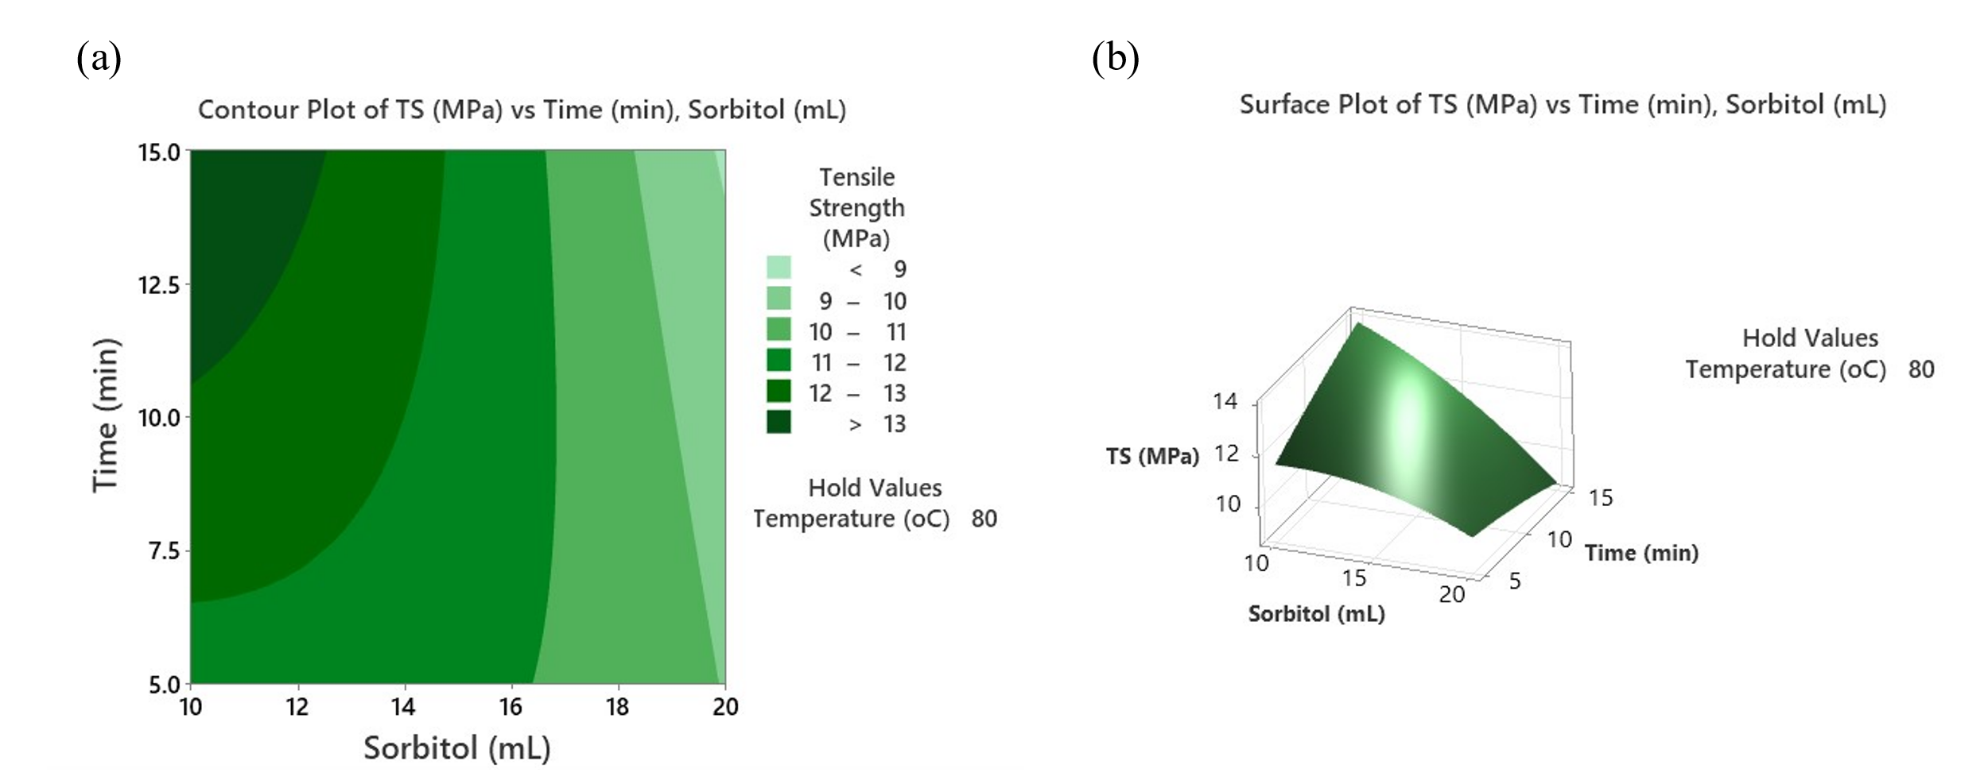
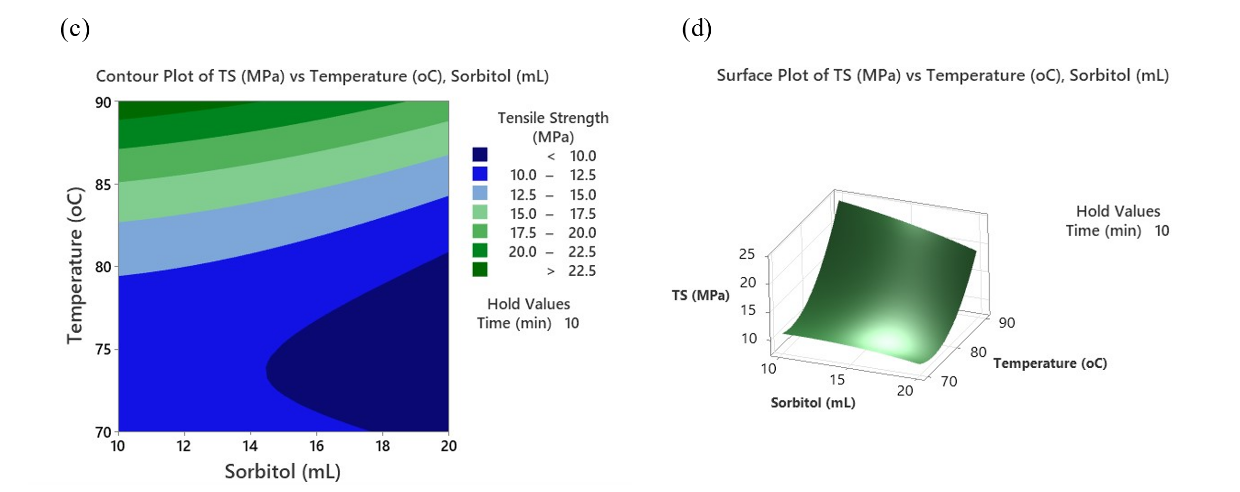
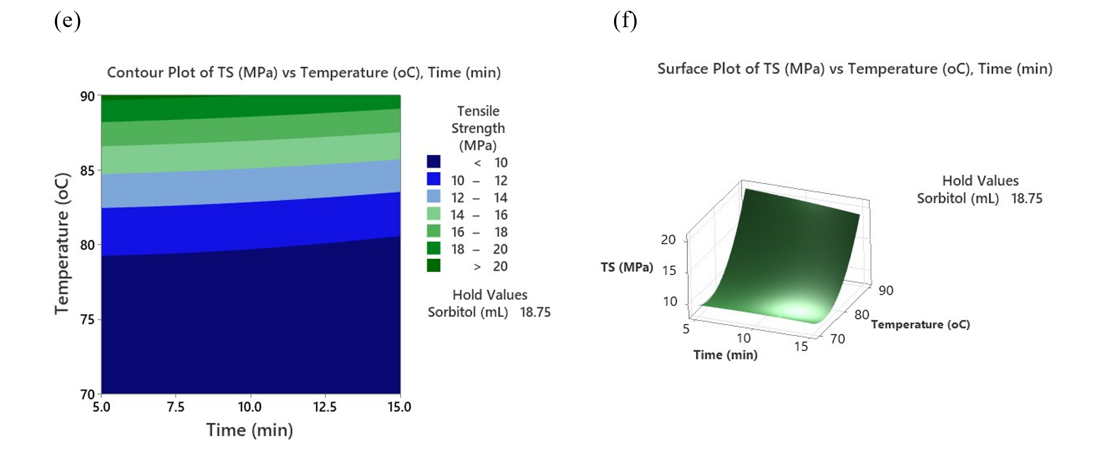
Figure 1: Contour and surface plots for the combined effect of time and sorbitol (a, b), temperature and sorbitol (c, d), and temperature and time (e, f) on tensile strength.
    - Optimization Analysis
Table 2 displays the result of Multiple Response Prediction utilizing the RSM analysis in Minitab Software while Figure 2 shows the Response Optimizer evaluation for the process condition taken from the identified 3 significant variables to achieve the maximized tensile strength.
In general, the Response Optimizer result showed that tensile strength could be maximized at 24.98 MPa (Table 2) with the controlled operating range as illustrated in Figure 2. All of the samples have met the minimum tensile strength of 1.343 MPa required of the biodegradable plastic standard (SNI 7818:2014) (Gabriel et al., 2021).
Table 2: Multiple Response Prediction for final equation model.
Response | Fit | SE Fit | 95% CI | 95% PI
TS (MPa) | 24.98 | 1.42 | (21.82, 28.15) | (20.02, 29.95)

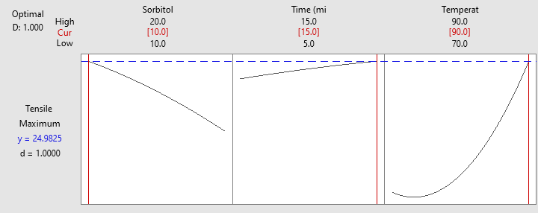
Figure 2: Process conditions to achieve maximized TS from Response Optimizer.
Figure 2 is helpful as a guide to control the process range condition for optimization of responses with a 95% confidence level. The high and low range setting in Figure 2 can also be referred to by panel operators and operations engineers in an industrial plant to maximize the dependent variables.
Furthermore, optimization of the responses was achieved with the following optimum values of the independent variables: 1:2:13 gelatin:sorbitol:acetic acid solution ratio, 15 min mixing time, and mixing temperature of 90 ºC. These were identified by also using the Response Optimizer of Minitab 20.
  - Conclusions
Gelatin was successfully recovered from janitor fish skin and bones with a yield of 7.43±0.57 %. The effects of sorbitol and time, sorbitol and temperature, and time and temperature on TS were investigated. An equation was developed using Minitab version 20 software. TS was maximized at 24.98 MPa using the response optimizer. The optimized response was within acceptable values according to SNI. These were achieved at the following optimized conditions (independent variables): 1:2:13 gelatin:sorbitol:acetic acid solution, 15 min mixing time, and 90 ºC mixing temperature. Based on the results, it can be concluded that it is possible to produce bioplastic using the gelatin extracted from janitor fish skin and bones as the raw material, which could aid in addressing environmental issues.
Acknowledgments
This research was made possible with the support of the College of Engineering Education of the University of Mindanao, utilizing the facilities of the chemical engineering and civil engineering laboratories. The study was also supported by the Philippine Council for Industry, Energy and Emerging Technology Research and Development (DOST-PCIEERD) through Human Resource Development Program (HRDP) Grant, with Project No. 1211374, which covers funding for presentation to conference and publication.
References
Arpi N., Novita M., 2018, Isolation of fish skin and bone gelatin from tilapia (Oreochromis niloticus): Response surface approach, IOP Conference Series: Materials Science and Engineering, 334, 1, 012061, IOP Publishing.
ASTM International, 2022, ASTM D638-22 Standard Test Method for Tensile Properties of Plastics, https://www.astm.org/d0638-22.html.
Chavez J. M., Carandang VI, J. S. R., 2014, Invasion Stages of Pterygoplichthys spp.(Pisces: Loricariidae) in the Luzon Island, Philippines.
Fisheries Aquaculture Circular, n.d., Fish Waste Management an Assessment of the Potential Production and Utilization of Fish Silage in Bangladesh, Philippines and Thailand, Vol 1216
Gabriel A. A., Solikhah A. F., Rahmawati A. Y., 2021, Tensile strength and elongation testing for starch-based bioplastics using melt intercalation method: a review, Journal of Physics: Conference Series, 1858, 1, 012028), IOP Publishing.
Harunsyah Y. M., Fauzan, R., 2017, Mechanical properties of bioplastics cassava starch film with Zinc Oxide nanofiller as reinforcement, IOP Conference Series: Materials Science and Engineering, 210, 012015.
Jumawan J., Herrera A., 2015, Histological and Ultrastructural Characteristics of the Testis of the Invasive Suckermouth Sailfin Catfish Pterygoplichthys Disjunctivus (Siluriformes: Loricariidae) from Marikina River, Philippines, Tissue and Cell, 47, 1, 17–26
Lusiana S. W., Putri D., Nurazizah, I. Z., 2019, Bioplastic properties of sago-PVA starch with glycerol and sorbitol plasticizers, Journal of Physics: Conference Series, 1351, 1, 012102, IOP Publishing.
Lv L. C., Huang Q. Y., Ding W., Xiao X. H., Zhang H. Y., Xiong L. X., 2019, Fish gelatin: The novel potential applications, Journal of Functional Foods, 63, 103581.
Mroczkowska M., Culliton D., Germaine K., Neves A., 2021, Comparison of Mechanical and Physicochemical Characteristics of Potato Starch and Gelatine Blend Bioplastics Made with Gelatines from Different Sources, Clean Technologies, 3(2), 424-436.
Neves E. M. P. X., Pereira R. R., da Silva Pereira G. V., da Silva Pereira G. V., Vieira L. L., Lourenço L. D. F. H., 2019, Effect of polymer mixture on bioplastic development from fish waste, Boletim do Instituto de Pesca, 45(4).
Oyekunle D. T., Oyekunle D. O., 2018, Biodiesel production from yellow oleander seed oil via heterogeneous catalyst: performance evaluation of minitab response surface methodology and artificial neural network. Journal of Materials and Environmental Sciences, 9(8), 2468-2477.
Prasteen P., Thushyanthy Y., Mikunthan T., Prabhaharan M., 2018, Bio-Plastics - An Alternative to Petroleum Based Plastics, International Journal of Research Studies in Agricultural Sciences, 4 (1): 1–7.
Putri R. W., Haryati S., Waristian H., Saputra A., Kurniawan R., 2022, Manufacture of Bioplastic Composite Method of Blending Synthetic Polymer (PP) with Natural Polymers from Kapok Fiber (Ceiba Pentandra), Chemical Engineering Transactions, 97, 241-246.
Quispetera C. A. O., Olivera C. A. C., Flores J. W. V., Alfaro E. G. B., Flores Y. V., 2021, Bioplastic made from manihot esculenta (Cassava) and ficus benjamina as an ecological alternative for food products, Chemical Engineering Transactions, 87, 67-72.
Sagnelli D., Kirkensgaard J. J. K., Giosafatto C. V. L., Ogrodowicz N., Kruczala K., Mikkelsen M. S., Maigret J. E., Lourdin D., Mortensen K., Blennow A., 2017, All-natural bio-plastics using starch-betaglucan composites, Carbohydrate Polymers, 172, 237-245.
Said N. S., Sarbon N. M., 2022, Physical and mechanical characteristics of gelatin-based films as a potential food packaging material: a review, Membranes, 12(5), 442.
Sadasivuni K. K., Ponnamma D., Kim J., Cabibihan J.-J., AlMaadeed M. A., 2017, Biopolymer Composites in Electronics, Elsevier.
Vallejo B. Jr., Soriano K., 2011, A Matrix Population Model of the ‘Janitor Fish’ Pterygoplichthys (Pisces: Loricariidae) in the Marikina River, Luzon Island, Philippines and the Possibility of Controlling This Invasive Species, 4 (1), 11–17.

