CHEMICAL ENGINEERING TRANSACTIONS  VOL. , 2023 | A publication of
The Italian Association
of Chemical Engineering
Online at www.cetjournal.it

Guest Editors:
Copyright © 2023, AIDIC Servizi S.r.l.
ISBN 979-12-81206-XX-X; ISSN 2283-9216

Life Cycle Assessment to support waste valorisation to biocomposite in French olive oil circular economy

Gabriela ESPADAS-ALDANA¹, Claire VIALLE¹, Jean-Pierre BELAUD², Caroline SABLAYROLLES^{1*}
¹Laboratoire de Chimie Agro-industrielle (LCA), Université de Toulouse, INRAE, Toulouse INP, Toulouse, France; caroline.sablayrolles@ensiacet.fr
²Laboratoire de Génie Chimique (LGC), Université de Toulouse, CNRS, Toulouse INP, Toulouse, France

This study is focused on Life Cycle Assessment (LCA) method to support the waste valorisation to bio-based composite material in French olive oil circular economy (CE). Its aim is to demonstrate how to shift from a traditional linear production to a circular olive production system that recovers materials from organic residues. On one hand, a comprehensive environmental assessment of eleven scenarios representing French olive oil production is performed. A comparison of the environmental performance from a life cycle perspective is made among the different scenarios. This analysis is conducted from a business-as-usual perspective: a linear production without valorisation of by-products. On the other hand, the environmental performance of an Olive Pomace based-composite for the decking sector is evaluated. The last part addresses the connection of the LCA from a business-as-usual perspective with the LCA of olive pomace valorisation to demonstrate how LCA can support the transition from traditional linear to circular olive production and can feed decision-making process. In the transition to a circular system in which waste is recovered for recycling, a new product is created that can replace another product with the same function. The results confirm that LCA method contributes to objectify the expected environmental benefits of the circular economy approach.

  - Introduction
Since 2015, French authorities have developed “the Energy Transition Law for Green Growth”. This law focuses on waste management as an essential pillar to ensure the transition to a circular economy (CE) model (Belaud et al., 2019). The use of the CE is becoming increasingly important, especially in the field of agriculture, one of the main suppliers of waste. The CE aims to create a closed-loop system; therefore, the utilisation of plant residues and agricultural fibbers play a key role in bio-based composite material sector. Residues treated before as waste can become the feed for a new process (Kaya et al., 2018). This vision has allowed the development of new companies and projects that use agricultural wastes disposal as filler for polymeric matrices.
The estimated production of olive oil in the European Union is 1.9 million tonnes for May 2020 (European Commission, 2020). Olive pomace is one of the major outputs of olive oil production. The production of olive pomace is around 6.8-8.0 million tonnes per year in Europe (Cossu et al., 2013). Usually, olive oil by-products are discharged on agricultural land by controlled spreading (Dermeche et al., 2013).

Despite all the circular opportunities provided by the by-products of olive oil production, there has not been enough effort to evaluate the sustainability of the potential side production processes and compare the linear and business-as-usual paradigms with circular patterns (Ncube et al., 2022). Few studies compare circularity indicators (EMF, 2015) with environmental performance or link the circularity indicators between society levels. Adequate tools exist at each level (e.g. LCA at the micro-level) to provide the ability to adequately assess and track the CE performance if placed within a suitable framework. The challenge of connecting the micro and macro levels is still ongoing (Harris et al., 2021).
  - Life Cycle Assessment of traditional linear olive oil production in France
    - Material and methods
The LCA methodology was adopted for each of its four phases (goal and scope definition, life cycle inventory analysis, life cycle impact assessment, and life cycle interpretation) (ISO 14040-44, 2006). The functional unit (FU) was to "produce one litre of virgin/extra virgin olive oil" from cradle-to-grave, using the attributional approach. The system boundary is presented in Figure 1. Eleven scenarios of the agricultural upstream part, with the 2-phase extraction technology, were elaborated. Data’s on olive cultivation were collected in 2014 with the help of the Centre Technique de l'Olivier (France). They came from eleven different orchards in the south of France for the agricultural part and from seven mills located in the same geographical area for the processing part. An average of these seven mills was used for the different scenarios. The choice of French olive oil producers was guided by the three options chosen to construct the scenarios: (1) Principle of agriculture (Conventional/Organic), (2) Type of farming (Traditional/Intensive), and (3) Irrigation system (Irrigated/Dry). A complete inventory of the life cycle of all types of olive growing systems in France was provided. The background data was from the Ecoinvent v3.6 database (Allocation, cut-off by classification). The system scenarios were developed with SimaPro PhD 9.1 software and assessed by ReCiPe 2016 Midpoint and Endpoint v1.1 (Hierarchist; H). The results analysis focused on the Climate Change impact category (IPCC, 2006).

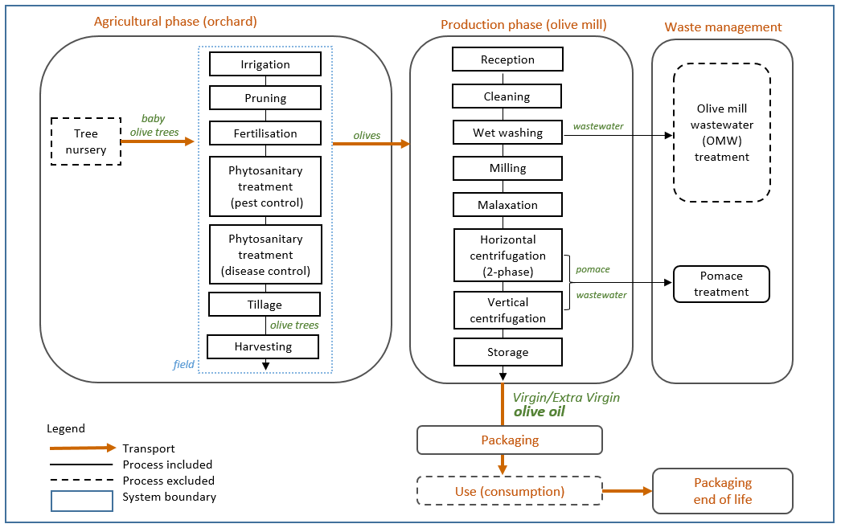
Figure 1. Process tree of the olive oil production in France.
    - Results and discussion
Figure 2 shows the distribution of the impact of the life cycle of olive oil production in the Climate change category. The results went from 2.80 to 7.10 kg CO₂-eq/L. These values are in concordance with previous studies (El Hanandeh and Gharaibeh, 2016; Espi et al., 2013; Pattara et al., 2016; Proietti et al., 2017). The climate change impact results showed that the irrigated systems turned out to have a positive environmental impact (i.e. less CO₂-eq emissions) compared to the scenarios with the same type of agriculture and intensity. This suggested that the large difference in olive productivity per hectare is positively influenced mainly by the use of irrigation. The best scenario among the eleven cases was S5-CTI (conventional, traditional and irrigated) and the least environmentally attractive was S9-CID (conventional, intensive and dry) which had almost three times less oil per hectare. This arises the question of how the FU significantly influences the way an LCA is performed, as well as its results and their interpretation. This issue has been also addressed by several authors in the assessment of organic vs conventional food products (Roy et al., 2009; van der Werf et al., 2020).
Moreover, the agricultural upstream was shown to be an unambiguously environmental hotspot as already demonstrated in literature (Espadas-Aldana et al., 2019). In comparison the extraction technologies appeared to be the less variable step of all stages in olive oil production. The hotspot in the agricultural phase is fertilisation followed by tillage, which is mainly due to the nitrogen fertiliser employed and to use of the tractor for the spreading of fertilisers and pesticides.

The biogenic carbon from the permanent tree components was taken into account. Calculations of the CO2 sources and sinks to obtain the net carbon stock of the olive grove and its relation to the impact on climate change were done. Fernández-Lobato et al. (2021) also reported negative C footprint values and found a significant relationship between olive fruit yield and the magnitude of C footprint: the higher the olive fruit yield, the more negative the C footprint was.

Figure 2. Distribution of the impact of the life cycle of olive oil production in the Climate change category. The code name is “SX-Y₁Y₂Y₃”; S: scenario, X: 1 to 11 (eleven scenarios), Y₁: type of agriculture (C: Conventional - O: Organic), Y₂: type of farming (T: Traditional – I: Intensive), Y₃: irrigation system (I: Irrigated - D: Dry).
  - Environmental assessment of olive pomace valorisation in composite materials
During the olive oil extraction process, the olive stone is crushed and discarded in the olive pomace (OP). However, olive stone flour can be recovered as a filler for polymer composites.
    - Material and methods
An LCA of the valorisation of olive pomace was carried out focusing on the manufacturing process of a biocomposite composed of olive stone fraction (OSF) and polyethylene (PE) thermoplastic matrix. The development of the bio-based lath was carried out in the Laboratory (Université de Toulouse, France) (Uitterhaegen et al., 2018). Data for the compounding process come from a pilot-scale experiment. The composite had been produced by mixing the OP (60% filler) in a PE matrix. The addition of a coupling agent was necessary to reinforce the matrix/fibre interface. The functional unit was the production of 1 m² of olive pomace-based biocomposite lath (building material), from cradle-to-gate. The detailed model is provided in Espadas-Aldana et al. (2021).
    - Results and discussion
The results indicate that the hotspot of the whole process in both scenarios was the twin-screw compounding process in most of the midpoint impact categories (Figure 3). Compounding was mainly affected by the production of the polymer.

The comparison of the olive pomace-based composite with the business-as-usual scenario of decking materials indicated that the biocomposite released half of the pollution produced by the polyvinylchloride (PVC) decking when considering the same functional unit. Besides, given the long lifespan of the biocomposites, the CO₂ stored into them can mitigate climate change because of the delay in the carbon emissions into the technosphere.

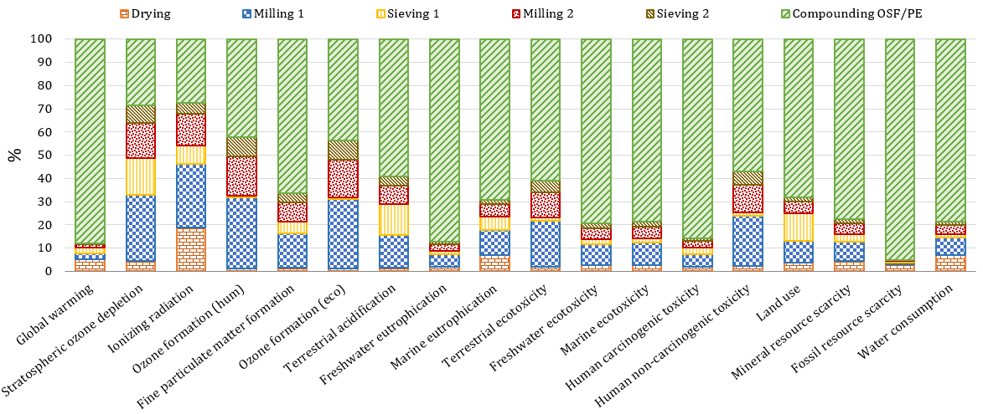
Figure 3. Contribution of each process to potential environmental impact of OSF/PE scenario. ReCiPe 2016 Midpoint (H).
  - Discussion on Life Cycle Assessment method to support the transition towards a circular economy
In the business-as-usual scenario, 100% of the olive pomace is spread out in the agricultural field (Figure 4). The production of this waste is estimated at 4.4 kg OP/L olive oil, and the pomace spreading is estimated at 4 tons per hour with the help of a tractor. Accordingly, 100% of the impacts caused by OP spreading are allocated to olive oil production. The direct emission of OP in the field was not quantified. No avoided product is considered as the spreading does not replace amendment or fertilising use. Figure 5 shows how the system is bounded if the OP valorisation in composite materials is included to conduct a circular olive production system that recovers materials from organic residues. This is assuming that 100% of the OP is used for the production of OP-based composite laths for the decking sector. The dotted lines mean that it is an avoided impact, i.e. laths avoided to be produced with other materials. These other decking materials that serve an equivalent function include plastic (cellular PVC) and wood-plastic composites (WPCs) (Bergman et al., 2013).

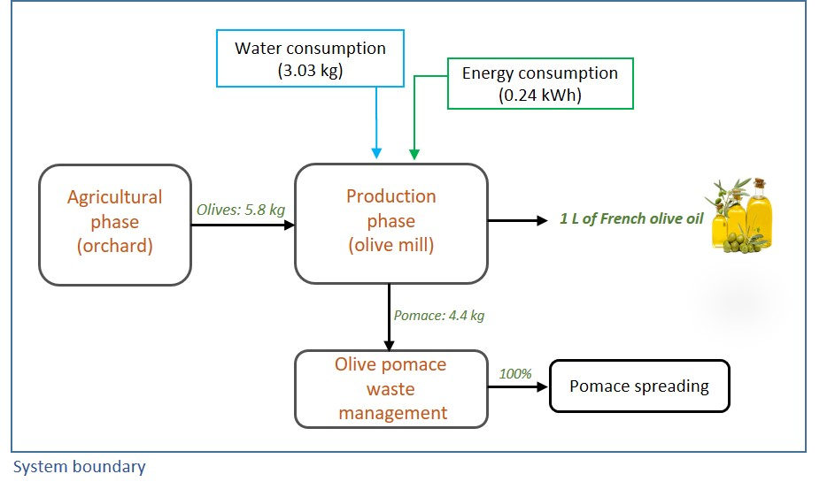 | 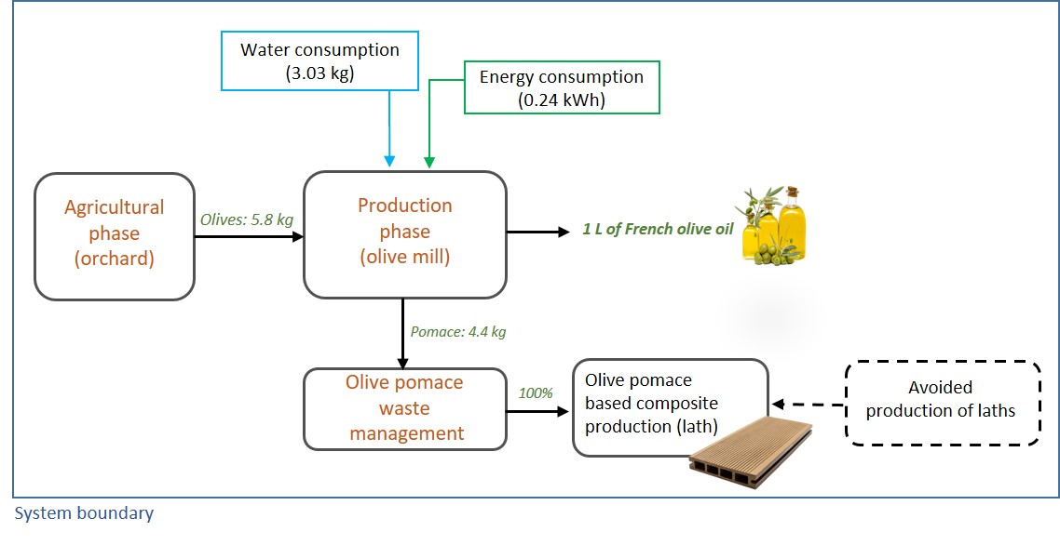
Figure 4. System boundary of linear production, focus on waste management. | Figure 5. System boundary including olive pomace valorisation to conduct a circular olive production system.

Hence, it can be observed that when moving to a circular system in which waste is recovered for valorisation, a new product is created that can replace another product with the same function. In this case, it is possible to avoid the production of decking by another route. Now these avoiding decking can be from three types: cellular PVC, virgin WPC, and recycled WPC. The results show that it is interesting from an environmental point of view to move to a circular production approach when the objective is to replace the production of cellular PVC and virgin WPC decking. Figure 6 illustrates the comparison in Climate change of the linear production of 1 L of French olive oil compared to three circular production pathways.

Figure 6. Linear production of 1 L of French olive oil compared to three circular production pathways.
Thanks to the valorisation of waste and residues by expanding the boundaries of the study system, the sustainability of a linear system is ensured through the development of circular models that feedback material residues to previous stages of the same process. In doing so, the overall impact on a larger scale decreases and real benefits are achieved promoting circularity throughout the production chain of this highly valued product in the Mediterranean region. The great advantage of valorising co-products and by-products in the framework of the CE is based on the avoided impacts derived from feeding them to replace some (or all) of the conventional production inflows. In this case, the first two principles of CE (EMF, 2021) are touched:
1) Eliminate waste and pollution: eliminate the olive pomace by-product to convert it into a co-product (olive pomace-based composite laths).
2) To circulate products and materials at their highest value keeping the materials in use: with the production of the laths made of olive pomace, this olive pomace remains in use during the lifespan of the lath and then as spread material on the agricultural soil at the end-of-life of the lath.

When considering the circular options, the use and end-of-life phase of some by-products is included in a recycling/recovery perspective. Unfortunately, although the circularity of materials is often taken to be synonymous with environmental efficiency, in many cases a properly conducted LCA reveals that this is not true. When considering a circular approach to reduce impacts and optimise the reuse of co-products, some choices have to be made. These choices represent one of the challenges of the bioeconomy: while environmental benefits may be obvious, in some cases, increased circularity may lead to a worse performance in terms of environmental sustainability (Ncube et al., 2022). For the CE to be effective, there is a need to evaluate and assess the sustainability aspects and its performance before decision and implementation, especially in the absence of coherent policies at a micro (local, product level), meso (industrial state) and macro level (global level) (Harris et al., 2021). The current understanding of CE strategy modelling lacks a systemic view to link the micro-levels and the consequences at the macro-scale. A CE assessment tool should account for both scales to drive the transition toward a holistic circularity (Lonca et al., 2018).
  - Conclusion
In this article, environmental concerns linked to linear olive oil production were assessed by a cradle-to-grave LCA method. Inventory data was obtained from collection protocol on real site in the south of France. Eleven scenarios with six different configurations of culture were studied. Identification of hotspots and comparison of different alternative systems related to olive cultivation and processing were performed.
Moreover, the LCA of the manufacturing process of an olive pomace biocomposite was conducted in order to evaluate the environmental performance of a biocomposite composed of olive pomace and a thermoplastic matrix. Data for the compounding process come from a pilot-scale experiment to produce lath for terraces.
When moving to a circular system in which waste is recovered for valorisation, a new product is created that can replace another product with the same function. In this case, it is possible to avoid the production of three types of decking (cellular PVC, virgin WPC, and recycled WPC). The results showed that it is interesting from an environmental point of view to move to a circular production approach when the objective is to replace the production of cellular PVC. It would be worth studying all the possible options of valorisation of all the vegetal residues produced throughout the olive oil life cycle (permanent and non-permanent parts of the tree).
References
Belaud, J.-P., Adoue, C., Vialle, C., Chorro, A., Sablayrolles, C., 2019. A circular economy and industrial ecology toolbox for developing an eco-industrial park: perspectives from French policy. Clean Technol. Environ. Policy 21, 967–985. doi.org/10.1007/s10098-019-01677-1
Bergman, R., Suo-Han, H., Oneil, E., Eastin, I., 2013. Life-cycle assessment of redwood decking in the United States with a comparison to three other decking materials. Consort. Res. Renew. Ind. Mater. 101.
Cossu, A., Degl’Innocenti, S., Agnolucci, M., Cristani, C., Bedini, S., Nuti, M., 2013. Assessment of the Life Cycle Environmental Impact of the Olive OilExtraction Solid Wastes in the European Union. Open Waste Manag. J. 6, 12–20. doi.org/10.2174/1876400220131014001
Dermeche, S., Nadour, M., Larroche, C., Moulti-Mati, F., Michaud, P., 2013. Olive mill wastes: Biochemical characterizations and valorization strategies. Process Biochem. 48, 1532–1552. doi.org/10.1016/j.procbio.2013.07.010
El Hanandeh, A., Gharaibeh, M.A., 2016. Environmental efficiency of olive oil production by small and micro-scale farmers in northern Jordan: Life cycle assessment. Agric. Syst. 148, 169–177. doi.org/10.1016/j.agsy.2016.08.003
EMF, 2021. Circular economy introduction [WWW Document]. URL ellenmacarthurfoundation.org/topics/circular-economy-introduction/overview (accessed 2.24.22).
Espadas-Aldana, G., Guaygua-Amaguaña, P., Vialle, C., Belaud, J.-P., Evon, P., Sablayrolles, C., 2021. Life Cycle Assessment of Olive Pomace as a Reinforcement in Polypropylene and Polyethylene Biocomposite Materials: A New Perspective for the Valorization of This Agricultural By-Product. Coatings 11, 525. doi.org/10.3390/coatings11050525
Espadas-Aldana, G., Vialle, C., Belaud, J.-P., Vaca-Garcia, C., Sablayrolles, C., 2019. Analysis and trends for Life Cycle Assessment of olive oil production. Sustainable Production and Consumption. 19, 216–230. doi.org/10.1016/j.spc.2019.04.003
Espi, J.J., Clarens, F., Busset, G., Sablayrolles, C., Montrejaud-Vignoles, M., Carvalho, J., Fonseca, B., Delgado, F., Chacon, L., Capiscol, C., Trillo, R., 2013. Enhancing the competitiveness and reducing the carbon footprint of the olive oil sector through waste management optimisation: OILCA (with critical revision) [in spanish].
European Commission, 2020a. Monthly EU Olive Oil production (2019-2020) [WWW Document]. Eur. Comm. - Eur. Comm. URL ec.europa.eu/info/food-farming-fisheries/farming/facts-and-figures/markets/prices/price-monitoring-sector/plant-products/olive-oil_en (accessed 6.3.20).
Fernández-Lobato, L., López-Sánchez, Y., Blejman, G., Jurado, F., Moyano-Fuentes, J., Vera, D., 2021. Life cycle assessment of the Spanish virgin olive oil production: A case study for Andalusian region. J. Clean. Prod. 290, 125677. doi.org/10.1016/j.jclepro.2020.125677
Harris, S., Martin, M., Diener, D., 2021. Circularity for circularity’s sake? Scoping review of assessment methods for environmental performance in the circular economy. Sustain. Prod. Consum. 26, 172–186. doi.org/10.1016/j.spc.2020.09.018
IPCC, 2006. 2006 IPCC Guidelines for National Greenhouse Gas Inventories, Prepared by National Greenhouse Gas Inventories Programme, Eggleston H.S., Buendia L., Miwa K., Ngara T., Tabane K. ed. IGES, Japan.
ISO 14040-44: Environmental Management: Life Cycle Assessment, Principles and framework Assessment, Requirements and Guidelines. International Organization for Standardization (ISO). Geneve, Switzerland., 2006.
Kaya, N., Atagur, M., Akyuz, O., Seki, Y., Sarikanat, M., Sutcu, M., Seydibeyoglu, M.O., Sever, K., 2018. Fabrication and characterization of olive pomace filled PP composites. Compos. Part B Eng. 150, 277–283. doi.org/10.1016/j.compositesb.2017.08.017
Lonca, G., Muggéo, R., Imbeault-Tétreault, H., Bernard, S., Margni, M., 2018. Does material circularity rhyme with environmental efficiency? Case studies on used tires. J. Clean. Prod. 183, 424–435. doi.org/10.1016/j.jclepro.2018.02.108
Ncube, A., Fiorentino, G., Panfilo, C., De Falco, M., Ulgiati, S., 2022. Circular economy paths in the olive oil industry: a Life Cycle Assessment look into environmental performance and benefits. Int. J. Life Cycle Assess. doi.org/10.1007/s11367-022-02031-2
Pattara, C., Salomone, R., Cichelli, A., 2016. Carbon footprint of extra virgin olive oil: a comparative and driver analysis of different production processes in Centre Italy. J. Clean. Prod. 127, 533–547. doi.org/10.1016/j.jclepro.2016.03.152
Proietti, S., Sdringola, P., Regni, L., Evangelisti, N., Brunori, A., Ilarioni, L., Nasini, L., Proietti, P., 2017. Extra Virgin Olive oil as carbon negative product: Experimental analysis and validation of results. J. Clean. Prod. 166, 550–562. doi.org/10.1016/j.jclepro.2017.07.230
Roy, P., Nei, D., Orikasa, T., Xu, Q., Okadome, H., Nakamura, N., Shiina, T., 2009. A review of life cycle assessment (LCA) on some food products. J. Food Eng. 90, 1-10. doi.org/10.1016/j.jfoodeng.2008.06.016
Uitterhaegen, E., Parinet, J., Labonne, L., Mérian, T., Ballas, S., Véronèse, T., Merah, O., Talou, T., Stevens, C.V., Chabert, F., Evon, Ph., 2018. Performance, durability and recycling of thermoplastic biocomposites reinforced with coriander straw. Compos. Part Appl. Sci. Manuf. 113, 254–263. doi.org/10.1016/j.compositesa.2018.07.038
van der Werf, H., Knudsen, M., Cederberg, C., 2020. Towards better representation of organic agriculture in life cycle assessment. Nat. Sustain. 3, 419–425. doi.org/10.1038/s41893-020-0489-6

