CHEMICAL ENGINEERING TRANSACTIONS  VOL. , 2023 | A publication of
The Italian Association
of Chemical Engineering
Online at www.cetjournal.it

Guest Editor: Sauro Pierucci
Copyright © 2023, AIDIC Servizi S.r.l.
ISBN 978-88-95608-98-3; ISSN 2283-9216

Heavy Metals Separation in Wastewater Comparing Different Types of Nanostructured Adsorbents
Elisabetta Sieniª, Barozzi Marco^{b}, Paolo Sgarbossa^{c}, Eleonora Russo^{c}, Annalisa Sandon^{d}, Copelli Sabrina^{b,*}
ª University of Insubria, Department of Theoretical and Applied Sciences, via Jean Henry Dunant 3, 21100 Varese, Italy
^{b} University of Insubria, Department of Science and High Technology, via Valleggio 9, 22100, Como, Italy
^{c} University of Padova, Department of Industrial Engineering, via F. Marzolo 9, 35131, Padova, Italy
^{d} University of Padova, Department of Civil, Environmental and Architectural Engineering, via F. Marzolo 9, 35131, Padova, Italy]
* sabrina.copelli@uninsubria.it
In the framework of sustainability, proposing new technologies to improve the current linear economy system is one of the most challenging aspects for both academics and industries. In this context, the optimization of wastewater recovery and re-use are among the most crucial aspects to improve; in fact, contaminated waters come from a wide range of industries: cooking, refineries, food, pharmaceuticals, textile and agriculture. Heavy metals are among the most critical pollutants, being widely spread (especially in the textile sector) and difficult to remove. In this work, two different sets of Magnetic Nanostructured Adsorbents (MNAs) to clean wastewaters containing Chromium (III), Nickel (II) and Copper (II) ions were studied and compared. The first type of MNA was a 2-D nanosheet structure generated using iron (II/III) salts and sodium (or ammonium) hydroxide solution to decorate a dispersion of graphene oxide (GO) in water. The second type of adsorbent was a 3-D structure composed of GO-MNAs embedded in cross-linked alginate beads. Performed experiments (in a wide range of metal ions concentrations) showed very promising results in terms of removal efficiencies (almost complete abatement could be achieved using a proper amount of MNAs) with respect to all tested contaminants, highlighting better performances of the beads with respect to the corresponding 2-D structure.
  - Introduction
Wastewater treatment takes an important part in the field of sustainability, involving almost every type of industry (Guven et al., 2023). Clean water scarcity is continuously indicated as one of the most crucial problems that afflicts our environment. Wastewater may contain a wide set of hazardous substances, including organic and inorganic chemicals, dust, solids and biological agents (Wang and Serventi, 2019). It is important to properly treat wastewaters, removing the highest quantity of substances that should not be released in the environment. At the current state, the most common methods for wastewater treatment include ultrafiltration, flocculation, coagulation, adsorption and biological processes (Lee et al., 2012). Focusing on removing heavy metal compounds, typical in the textile framework, related to the use of dies, it is possible to exploit chemical methods (Ali et al., 2019). However, such methods are generally expensive and they exhibit low yields when applied at the industrial scale. On the contrary, adsorption is acknowledged as an optimal method of removal, as it is easy to operate, cost-effective and efficient for both organic and inorganic substances in aqueous media.
When dealing with potential adsorbents for wastewater treatment, nanomaterials offer several advantages in the field, mainly related to their high surface-volume ratio. As shown in the current literature, composite nanomaterials are considered a generally sustainable and effective solution (Tang and Lo, 2013).
The aim of this work was to create composite nanomaterials synthesized by combining nanostructures of Graphene Oxide (GO), whose properties can be customized by adding other materials (i.e. combined with magnetic nanoparticles) (Barozzi et al., 2021).
GO is among the most used materials to develop nanoadsorbents (An et al., 2023), due to: i) presence of both hydrophobic sp2-hybridized domains and hydrophilic ones; ii) capability of generating 2-D and 3-D nanostructures; iii) cost-efficiency (it can be developed starting from graphite); and iv) high adsorption capacity, capable of competing with that of zeolites. Adding to these nanoparticles magnetic properties allows for an easy to mix and remove adsorbent for industrial applications.
In this work, we compared the removal efficiency of Cr³⁺, Ni²⁺ and Cu²⁺, very common pollutants in the textile sector, at 298 K under different concentrations, using two different sets of Magnetic Nanoparticle Adsorbents (MNAs). The first set was made of 2-D nanosheets of GO decorated with magnetite nanoparticles. This adsorbent had been already analysed in a former work (Barozzi et al., 2022), and it was used here as a reference. The new system was represented a set of MNAs, made of a 3-D structure of GO embedded in cross-linked alginate beads. There are multiple reasons behind the use of alginate. At first, the beads allow for an easier separation of the adsorbent, as nanoparticles are embedded inside the structure, resulting as small spheres with a diameter of about 3-4 mm. The unique properties of alginate and MNAs can develop a higher adsorption capacity adsorbent (Asadi Haris et al., 2023). In addition, those beads have the potential to set up a base to design a packed column that can be used in for real industrial purposes. Langmuir isotherms were also evaluated and compared referring to two different data sets.
  - Materials and methods
    - Alginate beads production
Within 30 mL of a 10.0 g/L solution of sodium alginate (C₆H₉NaO₇) in deionized water, 0.150 g of MNAs were added (concentration equal to 2.5 mg/mL). Separately, the hardener solution was prepared by dissolving 1.00 g of calcium chloride (CaCl₂) in 100 mL of water (10 mg/mL). The beads were produced by drop-wise addition of the alginate/MNA suspension in the hardener solution, under magnetic stirring. The beads were then recovered from the solution, washed four times with deionized water and stored in deionized water, in a Falcon® tube before use in the treatment experiments. Figure 1 shows the preparation method used for beads production.
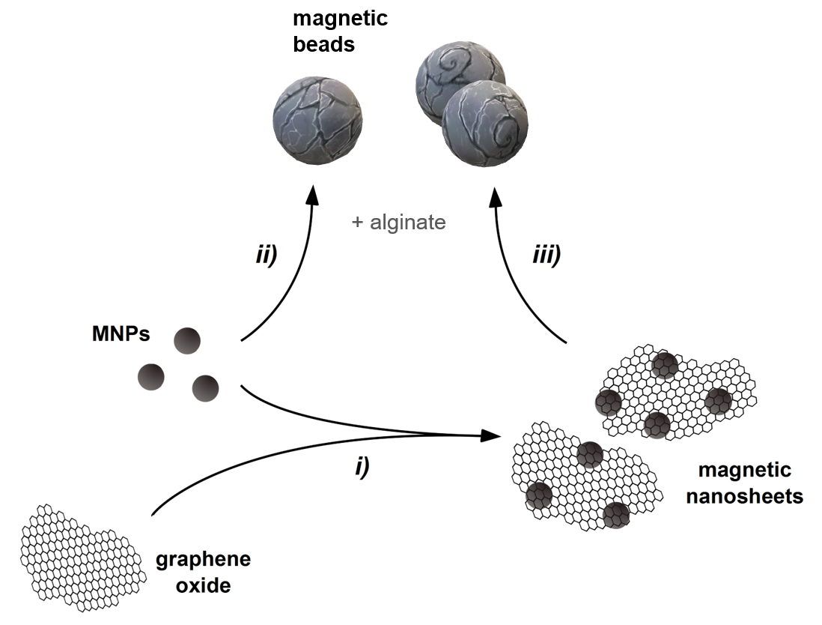
Figure 1 Preparation of magnetic nanoadsorbents. i) preparation of graphene oxide nanosheets decorated with the magnetic nanoparticles; ii) formation of cross-linked alginate beads decorated with MNPs at different concentrations; iii) production of cross-linked alginate beads carrying magnetic GO-based nanosheets from i) in different mass ratios.
    - Experimental protocol
Adsorbents were tested on artificial samples made by mixing deionized water with inorganic salts. The two sets were used to treat wastewater polluted by three different heavy metal ions:
- Cu²⁺ (Copper (II) sulphate, CuSO₄ ∙ 5H₂0, 99% Sigma Aldrich)
- Ni²⁺ (Nickel (II) chloride, NiCl₂ ∙ 6H₂0, 99% Sigma Aldrich)
- Cr³⁺ (Chromium (III) chloride, CrCl₃ ∙ 6H₂0, 99% Sigma Aldrich)
Tests with 2-D nanosheet MNAs were performed in a stirred lab glass flask (100 mL nominal volume). For chromium tests, 50 mL of solution was used, and 20 mL for nickel and copper. Stirring time was 30 min. MNAs content was always equal to 1 mg/mL.
Alginate beads were dosed in the proportion of 5 beads per 2 mL of solution for each test, resulting in a concentration of MNAs equal to 0.27 mg/mL. Stirring time was 10 minutes in this case, due to the increased mixing efficiency of a smaller sample.
MNAs separation was performed by using a Neodymium magnet, coupled with an additional filtering to eliminate eventual residuals of adsorbent. Note that alginate beads do not require a filtering in theory, as MNAs are trapped within the tridimensional structure. Table 1 resumes the concentrations used with 2-D and alginate beads MNAs. As it will be shown in the results, for alginate beads it was necessary to investigate higher concentrations than 2-D MNAs to get adequate data to fit the isotherms.
Table 1: Concentrations tested with the 2 sets of MNAs
Ion | 2-D (Barozzi et al., 2022) | Beads
Cu²⁺ | 300, 500, 700, 1000, 2000, 6000 μg/L | 150,300,600,1000,3000,5000,10000 µg/L
Ni²⁺ | 1000, 2000, 4000,5000 μg/L | 500,1000,2000,4000,5000 µg/L
Cr³⁺ | 500, 600, 1000, 2000, 5000 μg/L | 150,200,300,500,600, 2000,5000,10000 µg/L
Concentration measurements were carried out by Inductively Coupled Plasma Optical Emission Spectroscopy (ICP-OES) on a Perkin Elmer Optima 4200DV (Perkin Elmer Italia S.p.A., Milano, Italy).
Each test was performed according to the following protocol:
- Solution preparation at target concentration
- Preparation of the blank sample
- Loading of solution in the flask
- Loading of adsorbent
- Stirring
- Separation (magnet + filtration)
- Final sample ICP analysis
    - Adsorption Isotherm Definition
A standard Langmuir isotherm model is usually described by Eq. (1):
$$η_{eq}=\frac{Q∙b∙C_{e}}{1+b_{eq}∙C_{e}}$$ | (1)
where Q and b are constants, C_{e} is the equilibrium concentration of the chemical to be removed from the fluid phase and η_{eq} is the equilibrium load of the same compound onto the adsorbent. Anyway, obtaining effective equilibrium conditions (both for fluid and solid phases) is difficult to be achieved experimentally inside a batch system, as it requires a constant concentration in the fluid phase till the reaching of the maximum load onto the solid phase at that compound concentration. Due to this fact, alternative definitions of the equilibrium load are found in the literature for analogous systems, where the initial pollutant concentration lowered overtime until the equilibrium with the adsorbent was reached.
Particularly, referring to the adsorption of a generic i-th metal ion on MNAs dispersed into an aqueous solution, Eq. (1) can be modified as follows (Eq. 2) (Barozzi et al., 2022):
$$η_{end,i}=\frac{Q_{max,i}∙b_{i}∙C_{0,i}}{1+b_{i}∙C_{0,i}}=\frac{{(C}_{end,i}-C_{0,i})∙V_{sol}}{m_{MNAs,i}}$$ | (2)
where Q_{max,i} and b_{i} are constants, C_{0,i} represents the initial concentration of the metal ion(s) (µmol/L) into the analyzed solution (fluid phase), C_{end,i} is the concentration of the metal ion(s) in the fluid phase at the end of the treatment, $V_{sol,i}$is the volume of the aqueous solution (L), $m_{MNAs,i}$ is the mass of MNAs used for a single treatment (mg), and η_{end,i} is the final load of metal ion(s) which is adsorbed onto the MNAs (µmol/mg).
The removal (or adsorption) efficiency, χ, can be therefore evaluated using (Eq. 3):
$$χ_{i}=\frac{C_{0,i}-C_{end,i}}{C_{0,i}}$$ | (3)
  - Results
Tables 2 and 3 report the results with the first and second set of MNAs, respectively. For what concerns pollutants removal efficiencies, values up to 95% were found using alginate beads for all investigated ions. As it is shown from results, alginate beads exhibited a remarkably increased pollutant load for each heavy metal ion studied. For Nichel, a 527% increase in the equilibrium load was found with a reference concentration of 5000 µg/L and a 137.5% increase for Chromium at 2000 µg/L.
Table 2 Results of the 2-D Nanosheets tests
Cu²⁺ |  | Ni²⁺ |  | Cr⁺³
C₀ [µg/L] | η_{end} [mg/g] | C₀ [µg/L] | η_{end} [mg/g] | C₀ [µg/L] | η_{end} [mg/g]
296±1 | 0.27 | 935±1 | 0.85 | 440±1 | 0.43
501±1 | 0.46 | 1900±10 | 1.60 | 580±1 | 0.57
690±1 | 0.64 | 3980±10 | 2.28 | 1060±10 | 1.04
1020±10 | 0.97 | 5120±10 | 2.90 | 1810±10 | 1.44
2000±10 | 1.81 |  |  | 4990±10 | 2.23
6430±10 | 4.56
Table 3 Results of the alginate beads tests
Cu²⁺ |  | Ni²⁺ |  | Cr⁺³
C₀ [µg/L] | η_{end} [mg/g] | C₀ [µg/L] | η_{end} [mg/g] | C₀ [µg/L] | η_{end} [mg/g]
123±1 | 0.32 | 443±1 | 0.91 | 139±1 | 0.35
302±1 | 0.90 | 1020±10 | 3.14 | 225±1 | 0.66
587±1 | 1.87 | 2120±10 | 7.48 | 273±1 | 0.77
838±1 | 2.87 | 4394±10 | 13.97 | 423±1 | 1.36
2770±10 | 7.98 | 5123±10 | 15.31 | 605±1 | 1.98
4820±10 | 15.05 |  |  | 1915±1 | 6.65
10040±10 | 29.85 |  |  | 5120±10 | 13.39
 |  |  |  | 9980±10 | 19.96
This aspect has been already reported in the current literature (Asadi Haris et al., 2023), where the use of alginate with SPIONs led to a 20 times magnification of the adsorption capacity with respect to a classic 2-D composite nanoparticles.
Tables 4 and 5 reports the adsorption efficiencies. For alginate beads, it was possible to notice that removal efficiency was low when working with small concentrations. This is due to the accuracy of the instrument: as residual concentration was very low, a small error in the measure could generate a greater error in the estimation of the removal efficiency. When working above 300 µg/L, we experienced more significant results, with an adsorption yields around 95%. Even with higher concentrations, removal efficiency was very high (above 80% for all metals tested), highlighting the fact that site-saturation was not yet achieved.
Alginate beads had a larger capacity to absorb heavy metals than the corresponding 2-D MNPs, and they could be tested with higher starting concentrations.
Table 4 Adsorption efficiencies for 2-D Nanosheet tests (Barozzi et al., 2022)
Cu²⁺ |  | Ni²⁺ |  | Cr⁺³
C₀ [µg/L] | χ [-] | C₀ [µg/L] | χ [-] | C₀ [µg/L] | χ [-]
296±1 | 0.912 | 935±1 | 0.914 | 440±1 | 0.977
501±1 | 0.910 | 1900±10 | 0.843 | 580±1 | 0.983
690±1 | 0.930 | 3980±10 | 0.573 | 1060±10 | 0.984
1020±10 | 0.947 | 5120±10 | 0.566 | 1810±10 | 0.796
2000±10 | 0.907 |  |  | 4990±10 | 0.447
6430±10 | 0.710
Table 5 Adsorption efficiencies for alginate beads
Cu²⁺ |  | Ni²⁺ |  | Cr⁺³
C₀ [µg/L] | χ [-] | C₀ [µg/L] | χ [-] | C₀ [µg/L] | χ [-]
123±1 | 0.707 | 443±1 | 0.558 | 139±1 | 0.676
302±1 | 0.801 | 1020±10 | 0.831 | 225±1 | 0.795
587±1 | 0.960 | 2120±10 | 0.952 | 273±1 | 0.761
838±1 | 0.926 | 4394±10 | 0.856 | 423±1 | 0.868
2770±10 | 0.778 | 5123±10 | 0.807 | 605±1 | 0.883
4820±10 | 0.843 |  |  | 1915±1 | 0.934
10040±10 | 0.803 |  |  | 5120±10 | 0.968
 |  |  |  | 9980±10 | 0.940
From these data, MNAs load vs initial pollutant concentrations graphs were developed. Figure 2 shows the comparison of the absorption isotherms fitted for the two nanoadsorbents. It is interesting to observe that, with 2-D nanosheets, nanoparticles saturation was reached for almost each pollutant studied in the range involved.
a) | b)
Figure 2 Comparison between Langmuir isotherms: a) 2-D nanosheet (Barozzi et al., 2022); b) Alginate beads
In addition, in both cases, the same ion affinity was found: Cu(II) showed the largest capacity, while Cr(III) showed the lowest one. Langmuir isotherms parameters, reported in Tables 6 and 7, were obtained fitting experimental data.
Table 6 Langmuir isotherms for 2-D nanosheets (Barozzi et al., 2022)
Cu²⁺ |  |  | Ni²⁺ |  |  | Cr⁺³
Q_{max} [mg/g(MNA)] | b [L/mg] | R² [-] | Q_{max} [mg/g(MNA)] | b [L/mg] | R² [-] | Q_{max} [mg/g(MNA)] | b [L/mg] | R² [-]
31.3 | 2.75∙ 10⁻² | 0.9987 | 5.45 | 0.20 | 0.9900 | 3.42 | 0.38 | 0.9978
Table 7 Langmuir isotherms for alginate beads
Cu²⁺ |  |  | Ni²⁺ |  |  | Cr⁺³
Q_{max} [mg/g(MNA)] | b [L/mg] | R² [-] | Q_{max} [mg/g(MNA)] | b [L/mg] | R² [-] | Q_{max} [mg/g(MNA)] | b [L/mg] | R² [-]
659.55 | 4.70∙ 10⁻³ | 0.9996 | 101.45 | 0.0354 | 0.9980 | 41.08 | 9.48∙ 10⁻² | 0.9997
From results, significantly higher adsorption capacities Q_{max} of the alginate beads were found for all the investigated ions. For Copper and Nichel, an increment of about 20 times with respect to the 2-D nanosheets was observed. These results were similar to those reported in the work of Asadi Haris et al. (2023), where an analogous increase was found for As(III). For Chromium, the maximum adsorption capacity was about 12 times higher. This increased adsorption capacity can be ascribed to the structure of alginate, which presents a high number of sites available for cations, magnifying the removal capacity of the composite adsorbent.
  - Conclusions
In the present work, adsorption isotherms comparison between magnetic nanoparticles coupled with 2-D GO nanosheets and 3-D GO structures embedded with alginate beads were compared.
Ni(II), Cr(III) and Cu(II) removal efficiencies were measured under concentrations conditions similar to those already tested with the previous 2-D nanosheet trials.
According to results, alginate beads showed a remarkably greater adsorption capacity compared to 2-D nanosheets. This was probably due to the additional adsorption properties granted using alginate, that provided a higher number of sites available for the adsorption process.
Hence, alginate beads, showing such a high adsorption affinity with many different ions, along with their reusability, are a potential tool to enhance the portfolio of alternatives for heavy metals contaminated wastewater treatment.
In future works, it will be crucial to study the desorption of beads, i.e. with the use of basic solutions, and the maximum number of effective adsorption-desorption cycles.
Nomenclature
Q– adsorption capacity, mg/g Q_{max} – maximum adsorption capacity, mg/g

b – affinity parameter, L/mg b_{eq} – affinity parameter at equilibrium, L/mg
C₀ – initial ion concentration, µg/L, µmol/L C_{eq} – equilibrium ion concentration, µg/L, µmol/L
C_{end} – final ion concentration, µg/L, µmol/L V_{sol} – Sample volume, L
m_{MNA} – mass of magnetic nanoparticles, mg χ – Adsorption efficiency, [-]
References
Ali I., Basheer A.A., Mbianda X.Y., Burakov A., Galunin E., Burakova I., Mkrtchyan E., Tkachev A., Grachev V., 2019. Graphene based adsorbents for remediation of noxious pollutants from wastewater. Environment International 127, 160–180. https://doi.org/10.1016/j.envint.2019.03.029
An Y.-C., Gao X.-X., Jiang W.-L., Han J.-L., Ye Y., Chen T.-M., Ren R.-Y., Zhang J.-H., Liang B., Li Z.-L., Wang A.-J., Ren N.-Q., 2023. A critical review on graphene oxide membrane for industrial wastewater treatment. Environmental Research 223, 115409. https://doi.org/10.1016/j.envres.2023.115409
Asadi Haris S., Dabagh S., Mollasalehi H., Ertas Y.N., 2023. Alginate coated superparamagnetic iron oxide nanoparticles as nanocomposite adsorbents for arsenic removal from aqueous solutions. Separation and Purification Technology 310, 123193. https://doi.org/10.1016/j.seppur.2023.123193
Barozzi M., Copelli S., Russo E., Sgarbossa P., Lavagnolo M.C., Sandon A., Morosini C., Sieni E., 2022. Implementation of Magnetic Nanostructured Adsorbents for Heavy Metals Separation from Textile Wastewater. Sustainability 14. https://doi.org/10.3390/su141811785
Barozzi M., Scotton M., Sieni E., Sgarbossa P., Sandon A., Copelli S., 2021. Magnetically Separable Nanoparticles for Wastewater Treatment. Chemical Engineering Transactions 86, 1033–1038. https://doi.org/10.3303/CET2186173
Guven H., Ersahin M.E., Ozgun H., Ozturk I., Koyuncu I., 2023. Energy and material refineries of future: Wastewater treatment plants. Journal of Environmental Management 329, 117130. https://doi.org/10.1016/j.jenvman.2022.117130
Lee K.E., Morad N., Teng T.T., Poh B.T., 2012. Development, characterization and the application of hybrid materials in coagulation/flocculation of wastewater: A review. Chemical Engineering Journal 203, 370–386. https://doi.org/10.1016/j.cej.2012.06.109
Tang S.C.N., Lo I.M.C., 2013. Magnetic nanoparticles: Essential factors for sustainable environmental applications. Water Research 47, 2613–2632. https://doi.org/10.1016/j.watres.2013.02.039
Wang Y., Serventi L., 2019. Sustainability of dairy and soy processing: A review on wastewater recycling. Journal of Cleaner Production 237, 117821. https://doi.org/10.1016/j.jclepro.2019.117821

