CHEMICAL ENGINEERING TRANSACTIONS  VOL. , 2023 | A publication of
The Italian Association
of Chemical Engineering
Online at www.cetjournal.it

Guest Editor: Sauro Pierucci
Copyright © 2023, AIDIC Servizi S.r.l.
ISBN 978-88-95608-98-3; ISSN 2283-9216

Intensification of Processes for the Production of Active Pharmaceutical Ingredients: Increase in Safety and Sustainability
Valentina Businiª, Federico Florit^{b}, Marco Barozzi^{c}, Elisabetta Sieni^{d}, Sabrina Copelli*^{,c}
ªDepartment of Chemistry Materials and Chemical Engineering , Politecnico di Milano, Via Mancinelli 7, 20133, Milano, Italy
^{b}Department of Chemical Engineering, Massachusetts Institute of Technology, 77 Massachusetts Ave, MA 02139, Cambridge, USA
^{c}Department of Science and High Technology, Università degli Studi dell’Insubria – Via Valleggio 9, 22100, Como, Italy
^{d}Department of Theoretical and Applied Science, Università degli Studi dell’Insubria – Via Dunant 3, 21100, Varese, Italy
* sabrina.copelli@uninsubria.it
Fine chemical compounds and so-called "specialties" are generally synthesized through batch or semi-continuous processes. This is largely because such syntheses often involve complex and highly exothermic reactions, to be performed in semi-batch reactors for safety and/or selectivity reasons.
An effective way to reduce costs and improve the reproducibility of such batch processes is to transform them into their continuous counterparts to reduce volumes and investment costs, while increasing the inherent safety of the process thanks to fewer hold-ups. The “shift to continuous” allows to reduce both the overall process times, with a general decrease in operating costs, and the content of solvents used as thermal flywheels, thanks to the greater efficiency of the heat exchange systems. All these aspects are defined as process intensification. In this work, the intensification of the production process of N-(4-nitro, 2-phenoxyphenyl) methanesulfonamide (NIM) by nitration in glacial acetic acid of N-(2-phenoxyphenyl) methanesulfonamide (FAM) will be proposed. Starting from the original semi-batch recipe two different continuous configurations will be proposed: a series of tubular reactors and a series of continuous reactors with complete mixing, in both cases with intermediate injections. The solvent content (glacial acetic acid) has been drastically reduced (from 82.5% to 50% by weight) to increase the levels of environmental sustainability of the synthesis.
The high exothermicity of the process and the extremely rapid reaction kinetics were two fundamental aspects which had to be considered in the transition to the continuous process of the new formulation with reduced solvent content. For this reason, an ad hoc procedure was developed which allows the semi-batch recipe to be transformed into a corresponding one conducted in a tubular reactor with continuous lateral injections; this reactor was then discretized in the two reactor configurations mentioned above. The results obtained have shown how it is possible to obtain the desired product with practically unitary conversions using: a) a series of 4 isoperibolic tubular reactors, each with 4 discrete lateral feeds; b) a series of 5 mixed reactors with discrete side feeds. In both cases, the correct distribution of both the flow rate fed between the reactors in series and the temperatures of the cooling fluid (defined on the basis of the procedure developed for the passage of the process from discontinuous to continuous) was decisive for obtaining the desired performance. The series of tubular reactors was found to be optimal from the point of view of thermal control of the process, confirming that a series of tubular reactors is to be preferred in terms of safety compared to its counterpart with mixed reactors.
  - Introduction
Process intensification is one of the most crucial aspects that will impact the future of chemical engineering (Ouyang et al., 2022). While about 5-10 years ago the concept of process intensification was intended as a way to increase productivity, with maximizing economical income as major factor, today additional elements embrace the same cause. Process intensification is a way to potentially reduce workup volumes, leading to intrinsically safer processes (the net amount of energy that can be released by a potentially runaway reaction is automatically reduced) (Copelli et al., 2018). Energy management, which became by far the most important challenge to be faced, in particular after the Ukraine war (Cui et al., 2023), can be also approached with process intensification, by optimizing the energy required to heat and cool reaction volumes. At the current state, no general methods are available to perform process intensification. This is due to the extremely high variety of chemical processes. Since most of the industrial production, including pharmaceuticals, is currently performed using semi-batch (Jähnisch et al., 2004), many works can be found with the aim of transforming discontinuous processes into continuous ones (Zhang et al., 2018). Also, kinetic-free approaches are very attractive, since they do not require a detailed kinetic parameters study, that may be very costly for complex syntheses (Maestri et al., 2020).
A Lateral Injection Reactor (LIR) is a reactor designed as a simple Plug-Flow Reactor (PFR) but, instead of having a single inlet at the beginning of the reactor, it has a distributed injection over all the reactor length (Figure 1).
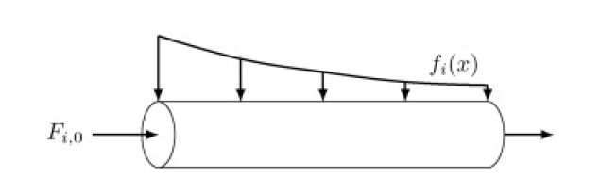
Figure 1: LIR scheme ($F_{i,0}$ is the massive inlet flowrate of component i; $f_{i}(x)$ is the distributed lateral injection flowrate)
It has been demonstrated that a LIR can be developed from a semi-batch recipe (SBR), maintaining the same productivity, conversion and temperature profiles of the original process (Florit et al., 2018). However, such a solution is not feasible in practice, due to the physical constraints of realizing a continuous lateral feed. For this reason, a discretized solution for this problem has been proposed: starting from the LIR configuration, it is possible to develop a set of in-series discrete tubular reactors (d-LIR) with lumped lateral feeds located in correspondence of given points along the single tubular element (Florit et al., 2019). The same approach can be applied to a series of mixed reactors (s-CSTR).
The aim of this work is to propose a new recipe to perform the nitration of N-(2-phenoxyphenyl) methanesulfonamide (FAM) to N-(4-nitro, 2-phenoxyphenyl) methanesulfonamide (also called nimesulide, NIM) strongly reducing the amount of solvent employed. To accomplish such a task, it was necessary to perform a shift to a continuous operating mode of a standard semi-batch recipe (Copelli et al., 2017). Particularly, the proposed continuous configurations were: 1) a set of isoperibolic tubular reactors with a defined number of lateral injections, and 2) a series of mixed reactors (as a series of CSTRs), with a “lumped side feed” linked to the inlet of each CSTR. The theoretical method was developed by Florit et al. (2020), and it was applied to this specific study. Several simulations were carried out taking care of fulfilling the following constraints: a) maintain a productivity close to the original semi-batch recipe, b) increase of FAM concentration, c) work under safety conditions (that is, keep temperature below 90°C).
    - FAM nitration to NIM
In this work, the production of NIM through the FAM nitration was investigated. Nimesulide is a nonsteroidal anti-inflammatory drug (NSAID) with pain medication and fever reducing properties. Its use is often controversial, due to its hepatotoxicity if used over long periods. According to the European Medicines Agency, NIM is authorised in 10 Member States: Austria, Belgium, Finland, France, Greece, Ireland, Italy, Luxembourg, Portugal and Spain. The final production step consists in the nitration of FAM to NIM, as reported in Figure 2.

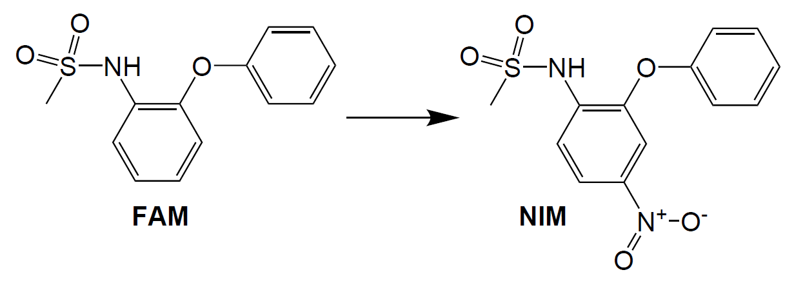
Figure 2: Nitration of FAM to NIM
This nitration reaction is particularly exothermic, with a heat or reaction equal to -127 kJ/mol (Maestri et al., 2006). Due to such a high heat released, safety is a major concern when dealing with this chemical reaction. Usually, this is solved by using a high dilution recipe in semi-batch reactors, leading to significant energy consumption due to the use of huge amounts of solvent. Nitration can be achieved by using acetic acid as solvent and an aqueous solution of nitric acid as co-reagent. The reaction mixture is liquid and homogeneous. Working temperatures should be kept reasonably below 120°C (in literature, this Maximum Available Temperature was estimated for the semi-batch recipe (Maestri et al., 2006)). The main issue is the decomposition of nitric acid, which is known to be particularly unstable over 88°C (if highly concentrated). Nowadays, optimizing reaction productivity, safety and sustainability is a factor that must be assessed in any chemical process.
  - Materials and methods
The procedure followed to obtain the shift of a given semi batch process into either a series of tubular reactors with lateral discrete injections or a series of CSTRs passing through the LIR transformation has been already reported in the literature (Florit et al., 2020). Such a method is applied within this work according to the following scheme: at first, SBR recipe is shifted into a LIR, checking for the consistency of the transformation. After this, d-LIR and s-CSTR are designed basing on LIR results. In the last step, it is possible to customize the number of reactors, lateral feeds, and volumes. Usually, it is recommendable to work with a total number of either tubular or mixed in-series reactors between 2 and 5. This is due to practical reasons: it is not convenient to build and control a real process with an excessive number of reactors, even if small. Overcrowding of control loops and joints can occur in real chemical processes.
    - Summary of parameters
Table 1 reports the chemo-physical properties of the chemical compounds involved in the reaction. All chemicals involved in the synthesis are reported in the following: nitric acid (HNO₃), FAM, NIM, acetic acid (AcAc) and water (H₂O). MW_{i} is the molecular weight the i-th chemical, cp_{mix} is the average specific heat of the solution of FAM with acetic acid; cp_{dos} is the specific heat of the nitric acid solution. ρ_{mix} is the density of the FAM solution and ρ_{dos} is the density of nitric acid solution.
Table 1: Summary of properties of the chemicals involved
Property | Value | Property | Value | Property | Value
MW_{H2O} [kg/mol] | 18.00 | MW_{HNO3} [kg/mol] | 63.01 | MW_{FAM} [kg/mol] | 263.3
MW_{NIM} [kg/mol] | 308.31 | MW_{AcAc} [kg/mol] | 60.05 | c_{pmix} [J/(kg °C)] | 2060
cp_{dos} [J/(kg °C)] | 2598 | ρ_{mix} [kg/m³] | 1137.1 | ρ_{dos} [kg/m³] | 1495.2
ρ_{H2O} [kg/m³] | 978

For the original semi-batch recipe, a total mass of 8238.5 kg is used at a working temperature of 80°C (FAM concentration is 17.3% w/w.) HNO₃ is dosed by means of a concentrated solution (65% w/w), with a stoichiometric ratio with respect to NIM (1:1 molar ratio), in 120 min, at 25°C. The semi-batch reactor is kept under control by a water jacket, whose inlet temperature is controlled with a Proportional-Integral controller (static gain=6, integral time=3600s), with a setpoint temperature of 80°C. The semi-batch reactor has a global heat exchange coefficient equal to 163 W/(m² °C). The kinetics of FAM nitration is described according to the following Arrhenius equation (Copelli et al., 2018),
$$r=1.001∙{10}^{12}∙\exp{(-10337∙T)}∙C_{HNO3}^{2}∙C_{FAM}^{0.2}$$ |  | (1)
where r is the global reaction rate [kmol/(m³ s)], C_{HNO3} is nitric acid concentration and C_{FAM} [kmol/m³] is FAM concentration [kmol/m³]. LIR is represented as a linear tubular reactor with a diameter equal to 0.1 m.
  - Results
At first, SBR and LIR comparison was performed to test the consistency of the method proposed. According to the parameters showed in chapter 2.1, the LIR model was solved. To account for a reduction of the solvent, several simulations were carried out by modifying the level of dilution of FAM, with the constraint of keeping maximum temperature below 90°C. In this way, it was possible to increase the FAM content up to 50% w/w (also taking into account its solubility in acetic acid). Figure 3 shows the results of the SBR to LIR transformation with the new FAM starting concentration. With a diameter of 0.1 m, a total length of 53.75 m was found. It is possible to notice that the maximum reactor temperature is kept below the imposed safety limit (the maximum is about 88°C), and the conversion is almost complete, showing the effectiveness of the method. With this improvement, the FAM/AcAc ratio was increased almost 5 times. This is one of the advantages of the LIR approach: working with smaller diameters, heat exchange with an external jacket is more favored. Indeed, as shown in Figures 3c and 3d, increasing the initial concentration of FAM would require coolant temperatures up to 0°C, while the LIR can work with temperatures always above 70°C. LIR is the initial condition to perform the d-LIR ad s-CSTR designs.

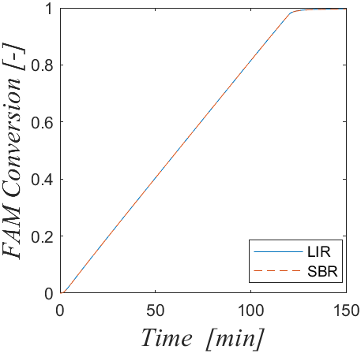 a | 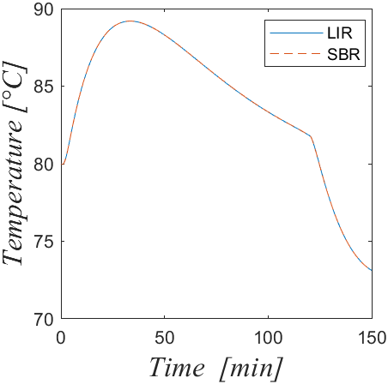 b
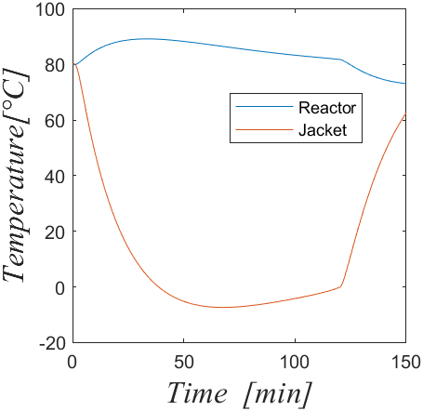 c | 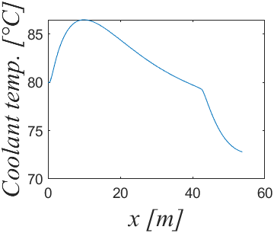d
Figure 3: Results for LIR, compared with SBR: a) FAM conversion vs. time, b) Temperature vs. time, c) Reactor and jacket temperature for SBR recipe, d) Coolant temperature of LIR
    - Shift to a series of tubular reactors with localized lumped lateral feeds
From LIR, d-LIR design was carried out. Several conditions were tested, ranging between 2 and 5 reactors and the same number of lateral feeds, with the constraints of keeping reactor temperature below 90°C and trying to work with a maximum of 5 reactors. From simulations, the best result was obtained using 4 reactors, and results are reported in Figure 4. The total length of the set of d-LIR is always equal to the LIR (53.75 m), resulting in a length of each d-LIR equal to 13.44 m.
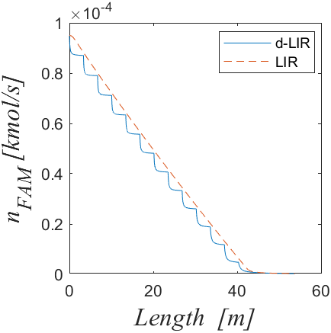 a | 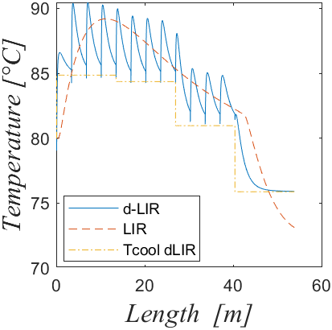 b
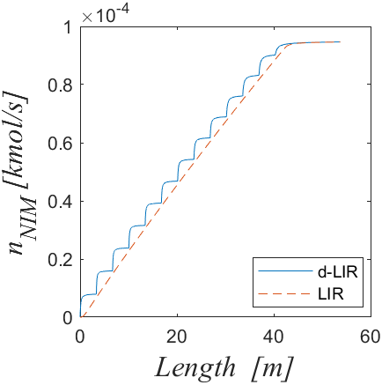 c | 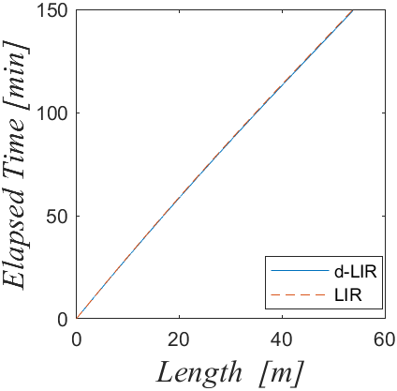 d
Figure 4: Results for a set of 4 d-LIR, compared with LIR, a) FAM content vs. length, b) Temperature vs. length, c) NIM content vs. length, d) Elapsed time vs. length.
As it is possible to observe from Figure 4b, the SB temperature profile is globally maintained showing only minor deviations (less than 5/6 °C). Moreover, from Figures 4a and 4c, it is possible to notice the high reaction rate exhibited by such nitration reaction: in correspondence of each lateral injection a step-like behavior of the FAM/NIM number of moles is evident.
    - Shift to a series of CSTRs
Similarly to the d-LIR case, the shift to a series of CSTR was performed under the same constraints previously proposed. It was found that the optimal solution was constituted by 5 CSTR with lateral feeds on the inline stream entering each reactor. Each CSTR had a workup volume of 0.0872 m³. Results are reported in Figure 5. In this case, the maximum temperature occurring during the process was reached inside reactor 2, with a working temperature of less than 91°C. Such a value is higher than the acceptable one, but it could be considered a good compromise in between safety and process layout effectiveness in terms of total reactors required to meet the desired degree of conversion. On the contrary, discrete coolant temperature inside the CSTRs jackets were quite close to those ones required by the LIR.
Therefore, s-CSTR working conditions may lead to safety issues, and it is preferrable to work with the d-LIR solution, which also required a lower number of reactors (4 vs. 5).
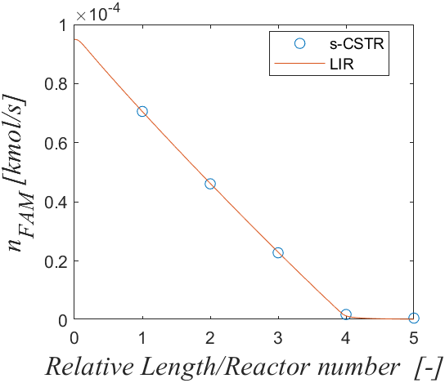 a | 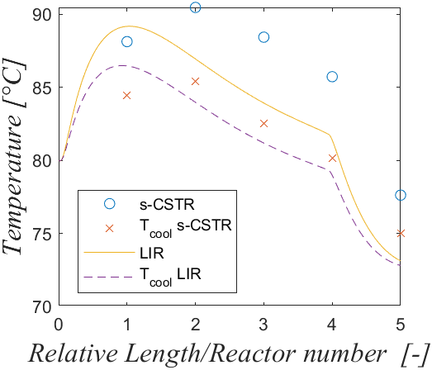 b
Figure 5: Results for a set of 5 s-CSTR, compared with LIR, a) FAM content vs. Relative length/reactor number, b) Temperature vs. Relative length/reactor number.
  - Conclusions
In this work the relevant problem of shifting to continuous the synthesis of Nimesulide was analysed, also proposing an intensification approach capable of reducing the amount of solvent used within the recipe. Particularly, FAM concentration in acetic acid was increased of almost five times maintaining safe conditions in terms of maximum temperature reached during the synthesis. Two different continuous configurations were simulated: a series of isoperibolic tubular reactors with multiple lateral injections and a series of CSTRs with co-feeds in between one reactor and its following. Considering the first continuous configuration, four reactors with four lateral injections were found to be the best solution in terms of original recipe reproduction; while, for the second configuration, five reactors were required to partially fulfilled all the required safety and productivity constraints. This work proved that process intensification permits not only to enhance the overall productivity maintaining safe operating conditions but also to increase the process sustainability reducing the amount of solvents used within the industrial recipe.
References
Copelli S., Barozzi M., Maestri F., Rota R., 2018. Safe optimization of potentially runaway reactions: From fedbatch to continuous stirred tank type reactor. Journal of Loss Prevention in the Process Industries 55, 289–302. https://doi.org/10.1016/j.jlp.2018.07.003
Copelli S., Barozzi M., Maestri F., Rota R., 2017. Safe Intensification of Potentially Runaway Reactions: from Semibatch to Continuous Processes. Chemical Engineering Transactions 57, 1687–1692. https://doi.org/10.3303/CET1757282
Cui L., Yue S., Nghiem X.-H., Duan M., 2023. Exploring the risk and economic vulnerability of global energy supply chain interruption in the context of Russo-Ukrainian war. Resources Policy 81, 103373. https://doi.org/10.1016/j.resourpol.2023.103373
Florit F., Busini V., Storti G., Rota R., 2019. Kinetics-free transformation from non-isothermal discontinuous to continuous tubular reactors. Chemical Engineering Journal 373, 792–802. https://doi.org/10.1016/j.cej.2019.05.050
Florit F., Busini V., Storti G., Rota R., 2018. From semi-batch to continuous tubular reactors: A kinetics-free approach. Chemical Engineering Journal 354, 1007–1017. https://doi.org/10.1016/j.cej.2018.08.044
Jähnisch K., Hessel V., Löwe H., Baerns M., 2004. Chemistry in microstructured reactors. Angew Chem Int Ed Engl 43, 406–446. https://doi.org/10.1002/anie.200300577
Maestri F., Copelli S., Barozzi M., Rota R., 2020. Kinetic-free discontinuous to continuous transformation of fine chemical reactions: A general experimental procedure. Chemical Engineering Journal 395. https://doi.org/10.1016/j.cej.2020.125061
Maestri F., Re Dionigi L., Rota R., Gigante L., Lunghi A., Cardillo P., 2006. Safe and Productive Operation of Homogeneous Semibatch Reactors. II. The Nitration of N-(2-Phenoxyphenyl) Methane Sulfonamide. Ind. Eng. Chem. Res. 45, 8014–8023. https://doi.org/10.1021/ie060262v
Ouyang Y., Heynderickx G.J., Van Geem K.M., 2022. Development of intensified reactors: A process intensification methodology perspective. Chemical Engineering and Processing - Process Intensification 181, 109164. https://doi.org/10.1016/j.cep.2022.109164
Zhang P., Weeranoppanant N., Thomas D.A., Tahara K., Stelzer T., Russell M.G., O’Mahony M., Myerson A.S., Lin H., Kelly L.P., Jensen K.F., Jamison T.F., Dai C., Cui Y., Briggs N., Beingessner R.L., Adamo A., 2018. Advanced Continuous Flow Platform for On-Demand Pharmaceutical Manufacturing. Chemistry 24, 2776–2784. https://doi.org/10.1002/chem.201706004

