CHEMICAL ENGINEERING TRANSACTIONS  VOL. 98, 2023 | A publication of
The Italian Association
of Chemical Engineering
Online at www.cetjournal.it

Guest Editors:
Copyright © 2023, AIDIC Servizi S.r.l.
ISBN 979-12-81206-XX-X; ISSN 2283-9216

Experimental validation of a numerical model for the prediction of the vulcanization degree of a Fiber Reinforced Elastomeric Isolator (FREI)
Gaetano Pianese^{a,*}, Gabriele Milaniª, Federico Milani^{b}
ªPolitecnico di Milano, Piazza Leonardo da Vinci 32, 20133 Milano, Italy
^{b}Chem. Co Consultant, Occhiobello, Italy
gaetano.pianese@polimi.it
Seismic isolation of a structure can be achieved by interposing a rubber device between the foundation and superstructure, which increases the period of the superstructure, resulting in a structure relatively transparent to seismic excitation. Alternating layers of rubber pads and steel laminas or Fiber Reinforced Polymer (FRP) dry textiles suitable treated, typically constitute an elastomeric seismic isolator. The rubber should be processed through several stages to be ready for structural application. One of the most critical is vulcanization. During this stage, rubber is heated with sulfur or peroxides, accelerators, and activators at around 130-160°C. This process triggers the formation of cross-links between long rubber molecules, creating the so called polymer network. The chains are prevented from sliding along each other thanks to cross-links, and the rubber becomes elastic. This study proposes a combined numerical and experimental approach to predict the vulcanization degree for a Fiber-Reinforced Elastomeric Isolator (FREI). According to the numerical results, two typologies of vulcanization have been considered: one suboptimal at 145°C for 5400 seconds and one optimal at 145°C for 7200 seconds. Results, in terms of Shore A hardness measurements, have shown a non-homogeneous distribution within the isolator suboptimal vulcanized. Instead, as expected, the hardness distribution is homogeneous for the optimal one.

  - Introduction
An elastomeric seismic isolator is a type of seismic isolation device that is used to reduce the effects of earthquakes on buildings and other structures. Typically, they are constituted by several alternating layers of rubber and steel (Steel Reinforced Elastomeric Isolators) or fiber (Fiber Reinforced Elastomeric Isolators). This system isolates the energy transmission of the earthquake from the foundation to the upper structure. Damping performance is a prerequisite for isolation-bearing materials (Kelly, 1999). Besides, the materials must have a good overall performance, such as high strength to resist damage (Wang et al., 2016)(Choun et al., 2014). To be ready for structural applications, the rubber is vulcanized. The vulcanization process has a significant effect on mechanical properties such as tensile strength, hardness, and elongation at break. In this study, a combined numerical and experimental approach is presented to evaluate the crosslinking degree. The aim is to determine the optimal vulcanization time and temperature to obtain a homogeneous curing level distribution within an Unbonded Fiber Reinforced Elastomeric Isolator (UFREI) made of Natural Rubber and Ethylene Propylene Diene Monomer (NR-EPDM) blend.
  - The geometry of the isolator and materials adopted
The isolator under investigation, conceived by the authors for the installation at the base of low-rise masonry buildings in developing countries without any bond, see Figure 1, is a circular device with a base of 200 mm, a height equal to 67 mm (h) and is constituted by 15 rubber pads 4 mm thick (h_{r})$,$interspersed by 14 Glass Fiber Reinforced Polymer (GFRP) laminas 0.5 mm thick (h_{f}). Table 1 shows a summary of the main geometrical characteristics.

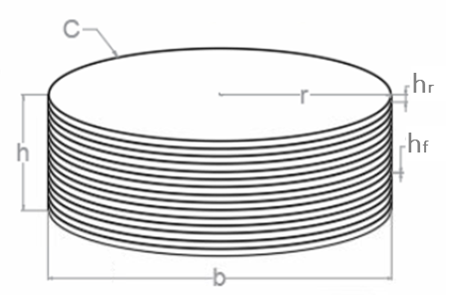 | 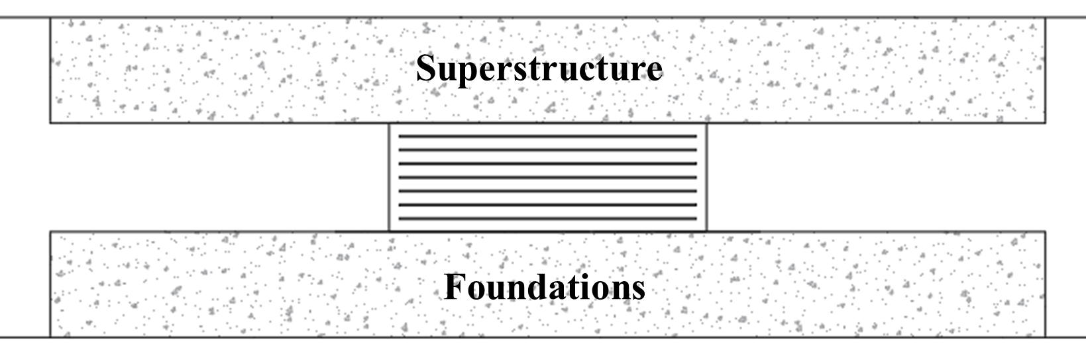
a) | b)
Figure 1 – UFREI design (a) and structural application (b)
Table 1 – Geometrical characteristics of UFREI
h | b | A | h_{r} | h_{f} | n°rubber layers | n°fiber laminas | h_{rtot} | h_{ftot} | R=b/h
[mm] | [mm] | [mm²] | [mm] | [mm] | [-] | [-] | [mm] | [mm] | [-]
67 | 200 | 31415.92 | 4 | 0.5 | 15 | 14 | 60 | 7 | 2.98
A high-performance rubber composition (good durability and cyclic dissipation) made of an NR-EPDM blend has been proposed for the production of UFREIs. The rubber composition has been first chemically characterized with a rheometer test. The rheometer measures the viscoelastic properties of rubber compounds during the vulcanization process. When a specimen in the rheometer gets heated under pressure, the viscosity drops and the torque decreases. The lowest torque recorded on the curve is called ML and represents the stiffness of uncured rubber at a given temperature. As the curing begins, the torque rises. TS₂ is the time from the beginning of the test to the time the torque has typically increased two units above the ML value. It represents the scorch time, or at which point the curing starts. As the curing progresses, the torque rises further. The gradient depends on the compound and curing method used. The highest recorder torque on the curve is called MH. The time from the start of the test to the point where 90% of the MH value is reached is called T₉₀. Such a description also applies to T₁₀ and T₅₀. To evaluate the effect of different temperatures, the NR-EPDM blend has been subjected to a rheometric test at four different temperatures: 140°C, 150°C, 160°C, and 170°C (413.5K, 423.15K, 433.5K and 443.15K respectively) (Figure 2-Table 2).
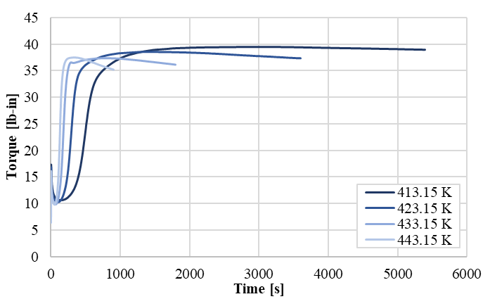 | 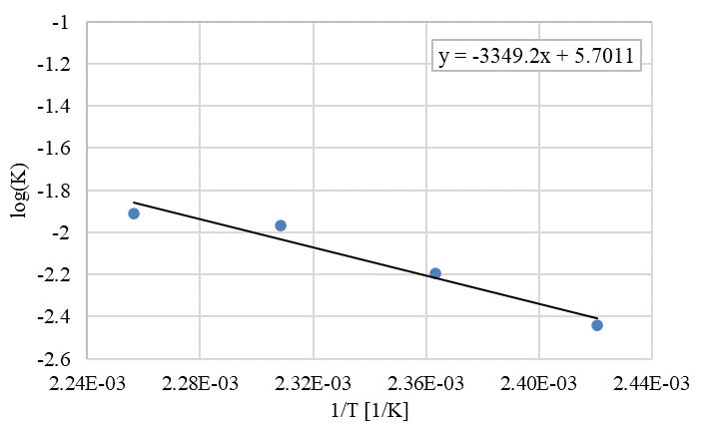
a) | b)
Figure 2 – NR-EPDM rheometer curves (a) and experimental determination by the linear best fitting of the reaction kinetic constant for the rubber blend (b)
Table 2 – Rheometer experimental results
Test temp | Test temp | Test time | ML | TS₂ | T₁₀ | T₅₀ | T₉₀ | MH
[K] | [°C] | [min] | [lb-in] | [min.ss] | [min.ss] | [min.ss] | [min.ss] | [lb-in]
413.15 | 140 | 90 | 10.56 | 5.29 | 5.59 | 8.31 | 15.01 | 39.48
423.15 | 150 | 60 | 10.22 | 3.14 | 3.29 | 4.59 | 7.5 | 38.49
433.15 | 160 | 30 | 9.76 | 1.58 | 2.07 | 3.01 | 3.59 | 37.38
443.15 | 170 | 12 | 9.56 | 1.19 | 1.25 | 2.01 | 2.4 | 37.36
The rubber compounds mechanical behavior has been characterized through several experimental tests, such as tensile test, tear-resistance test, compression set, relaxation test, accelerated air oven aging, and hardness measurement, according to the UNI EN 15129 (Medeot, 2010), for high damping rubber compound for elastomeric seismic isolator. Results are summarized in Table 3, Table 4, and Table 5. The NR-EPDM rubber compound has met the minimum requirements of the code.
Table 3 - NR-EPDM mechanical and physical properties
Density | Hardness | Tensile Strength  at break | Elongation  at break | Young  Modulus | Tear  Resistance
[g/cm³] | [IRHD] | [MPa] | [%] | [MPa] | [kN/m]
1.129 | 59.98 | 16.06 | 693.0 | 1.63 | 22.84
Table 4 - NR-EPDM mechanical properties after accelerated aging and compression set
Accelerated air oven aging |  |  | Compression  Set
Δ H | Δ TS_{break} | Δ E_{break}
[IRHD] | [%] | [%] | [%]
1.00 | -4.51 | -9.51 | 35
Table 5 - Shear test results
Fresh |  | Aged* |  | Frequency* |  |  |  | Temperature*
ξ | G  Modulus | Δξ | ΔG | 0.1Hz |  | 2.0 Hz |  | 40°C |  | 0°C |  | -10°C |  | -15°C
 |  |  |  | Δξ | ΔG | Δξ | ΔG | Δξ | ΔG | Δξ | ΔG | Δξ | ΔG | Δξ | ΔG
[%] | [MPa] | [%] | [%] | [%] | [%] | [%] | [%] | [%] | [%] | [%] | [%] | [%] | [%] | [%] | [%]
8.38 | 0.77 | -12 | +19 | +2 | +1 | +4 | -6 | +10 | -15 | +12 | +30 | +29 | +47 | +45 | +68
*Difference in percentage with the fresh aged results (23°C, 0.5 Hz)
  - Rheometer curves and determination of the kinetic behavior
According to the experimental rheometer curves obtained at 4 different temperatures (from 150°C to 180°C), it is found that the rubber compound follows a classic crosslinking law ruled by the following equation (Milani and Milani, 2014)(Milani and Milani, 2021):
$$I\underset{→}{ K_{a} }A\underset{→}{ K_{P }}P$$ | (1)
where I is the rubber before induction, A is the rubber after the induction time (activated), P is the cured polymer, K_{a} is the activation kinetic constant, and K_{P} is the polymerization kinetic constant. The two reactions occur with a kinetic velocity depending on the temperature reaction associated with the two kinetic constants. Differential equations associated with chemical reactions (I-A-P) are the following:
$$\left\{\begin{aligned}\frac{dI}{dt}= -K_{a}I \\ \frac{dA}{dt}=K_{a}I-K_{p}A \\ \frac{dP}{dt}=K_{p}A \end{aligned}\right.$$ | a)  b)  c) | (2)
When K_{a} and K_{p} are independent of T, or T is constant (rheometer test),
$$P\left(t\right)= \frac{K_{a}}{K_{p}-K_{a}}e^{-K_{p}t}+\frac{K_{p}}{K_{p}-K_{a}} e^{-K_{a}t}+1$$ | (3)
Note that $I\left(0\right)=I_{0}$(initial concentration of $I(t))$, $A\left(0\right)=0$, and $P\left(∞\right)=+1$.
When K_{a} and K_{p} are dependent on T and T depends on t (real device vulcanization):
$$\left\{\begin{aligned}\frac{dI}{dt}= -K_{a}(T(t))I \\ \frac{dA}{dt}=K_{a}(T(t))I-K_{p}(T(t))A \\ \frac{dP}{dt}=K_{p}(T(t))A \end{aligned}\right.$$ | a)  b)  c) | (4)
To solve these differential equations is possible to use a numerical solver like ODE45 (Runge-Kutta), available in MATLAB (MathWorks, 2020)(Milani, 2013).

  - Cross-linking prediction
The curing level of the UFREIs has been evaluated numerically, modeling the actual manufacturing process, where the overall device (i.e. rubber pads and GFRP laminas) is cured inside a steel mold (Figure 3) under a forming press at 145°C. 3D geometric models of the isolator and the mold have been meshed into Abaqus.
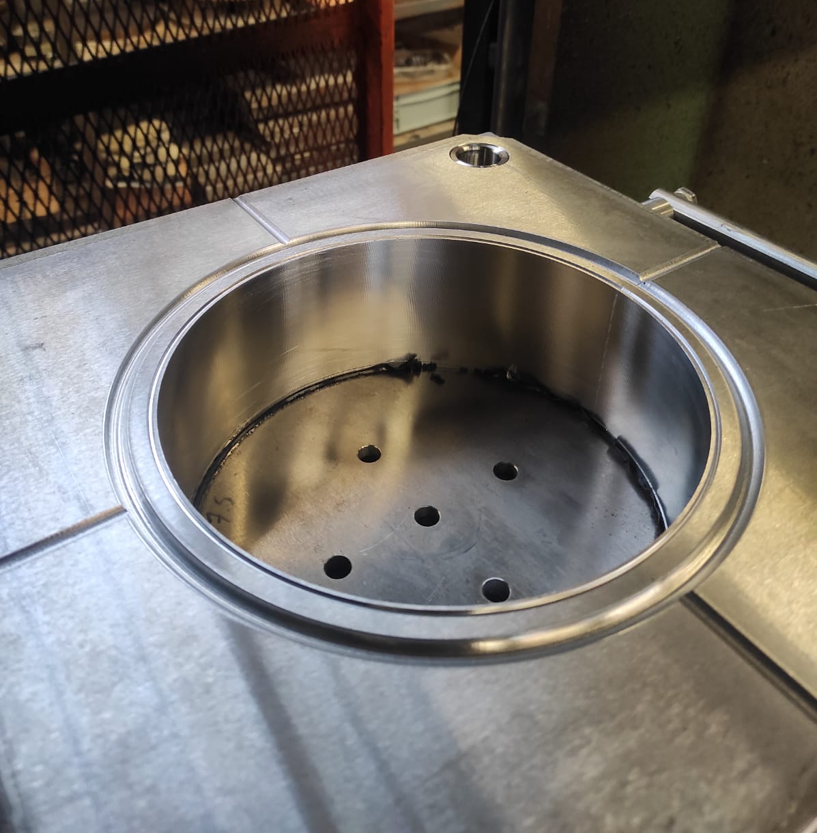 | 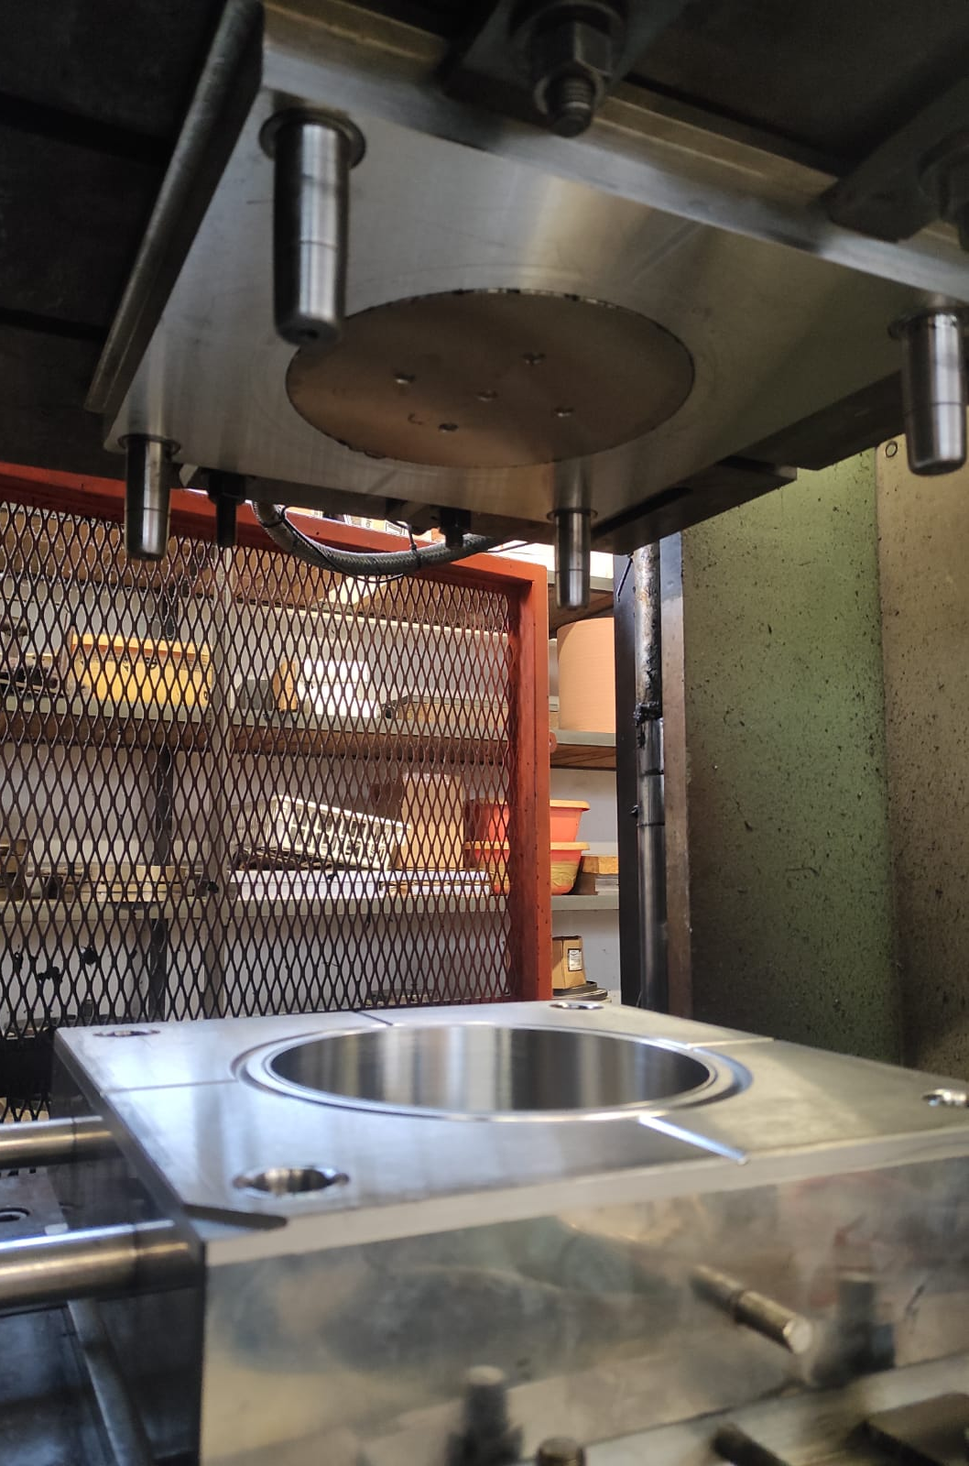 | 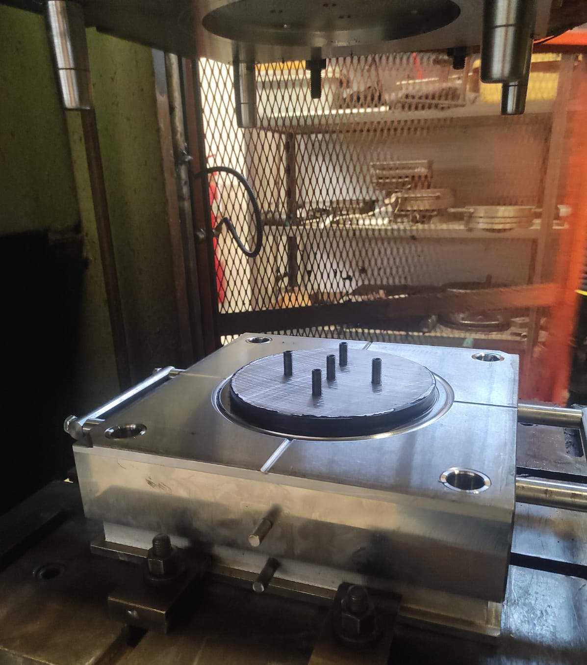
Figure 3: Steel mold for the UFREI fabrication
Table 6 - Thermal properties of materials
Property/Material | NR-EPDM | Steel | GFRP
Specific heat Capacity[J/(kgK)] | 1240 | 434 | 1000
Heat Conductivity [W/mK] | 0.50 | 50 | 0.30
The analysis performed, namely a heat conduction problem, has considered a steel mold surrounding the UFREI (Pianese et al., 2021). In Figure 4, the FE discretization used in the analysis is shown. The thermal properties assumed for GFRP laminas and rubber pads are summarized in Table 6 (Sandberg and Bäckström, 1979). The faces of the isolator have been assumed to be perfectly bonded to the steel mold using surface-to-surface tie constraints. Linear hexahedral elements of type DC3D8 have been used. In the initial step, the top and bottom surfaces of the steel mold have been set at the temperature of 145°C. Instead, all the other parts have been assumed at the room temperature of 23°C.
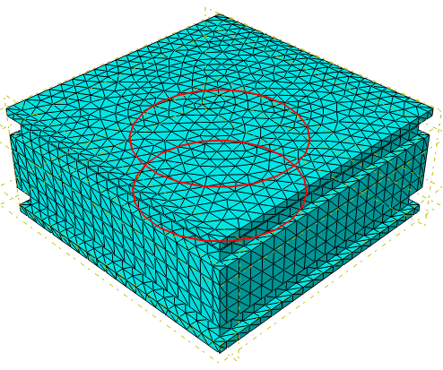 | 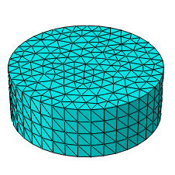 | 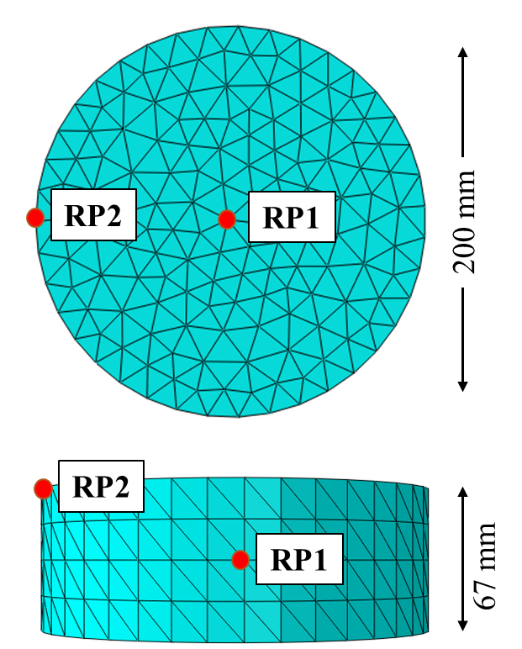
a) | b) | c)
Figure 4: FE model of the steel mold for the vulcanization of UFREI (a) and rubber device with the two reference points for the evaluation of the temperature profile (b-c)
Subsequently, the analysis started, and the evolution of the temperature of two control points of the rubber device, one in the core (RP1) and one in the corner (RP2) (Figure 4c), have been monitored for 18000 seconds.
The results obtained are shown in Figure 5. Having at disposal the temperature profile T(t) of the two points of the isolator, the evolution of the degree of vulcanization point by point has been estimated with the cross-linking model. Figure 6, shows the curing level for the two points. Results obtained have shown an optimum vulcanization time of 7200 seconds.
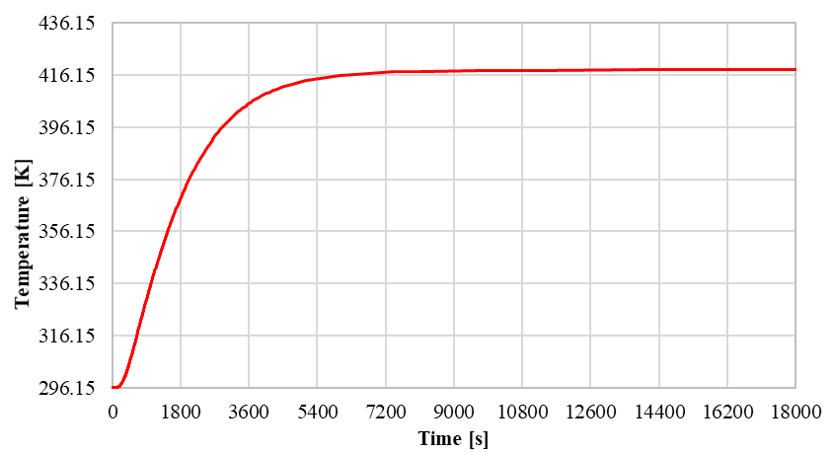 | 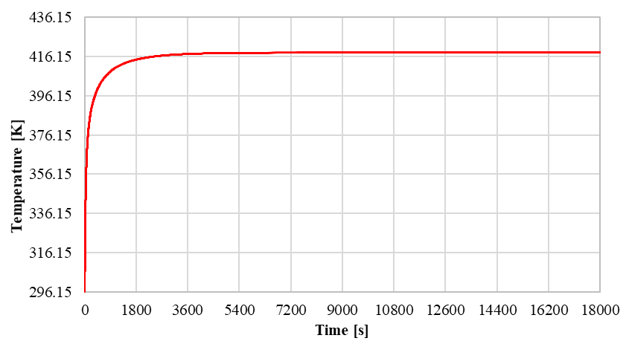
a) | b)
Figure 5 - RP1 (a) and RP2 (b) temperature profile during vulcanization of the UFREI
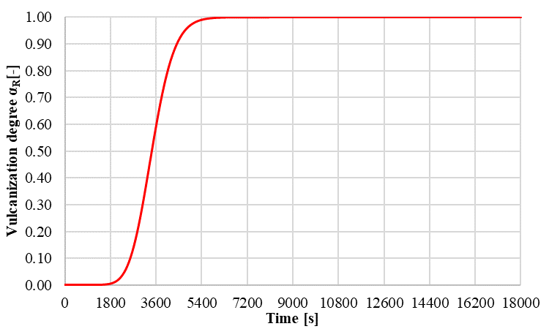 | 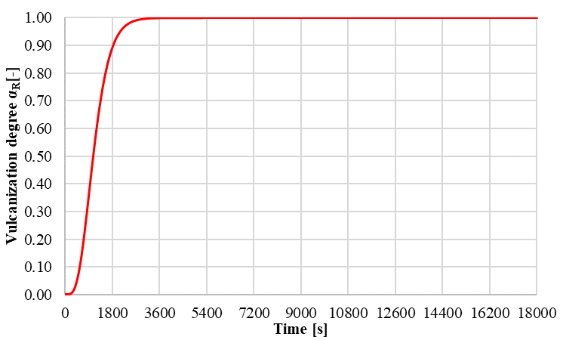
a) | b)
Figure 6 - Evolution of vulcanization degree for RP1 (a) and RP2 (b) of the UFREI

Experimental validation
Defined the optimal vulcanization time, the devices have been fabricated. Two vulcanizations have been considered: one at 145°C for 7200 seconds (optimal) and one at 145°C for 5400 seconds (sub-optimal). Esthetically the devices obtained with the two vulcanizations were almost identical. The one suboptimal vulcanized presented a little swell on the top surface. This is a typical problem due to under-vulcanization. For a deep investigation, both the devices have been cut along the middle vertical section (Figure 7), and Shore A hardness measurements have been performed on the surfaces.
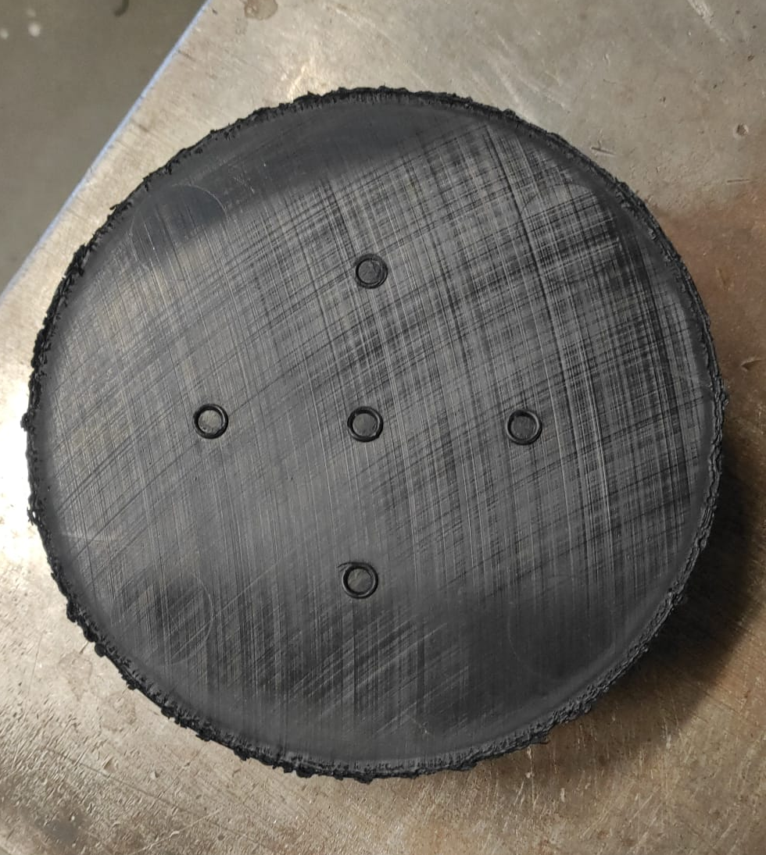
Figure 7 – UFREI cut for the measurements of the Shore A hardness
The reason for these measurements is that the mechanical properties are directly related to the cross-linking degree. Consequently, with optimal vulcanization, all the mechanical properties, and Shore A hardness are homogeneous within the isolator. On the other hand, suboptimal vulcanization would have led to a non-uniform mechanical properties distribution (Habieb et al., 2022). As expected, hardness varies from inner to outer points for the sub-optimal vulcanization (5400 seconds), increasing from 55 Shore A in the core to 60 Shore A near the skin. Furthermore, the fiber layers presented a curvature due to the swelling of the unvulcanized rubber (Figure 8). Instead, for the optimal vulcanization (7200 seconds), the hardness is constant within the device, with a value of 59±1 Shore A hardness measured along all the cut surfaces.
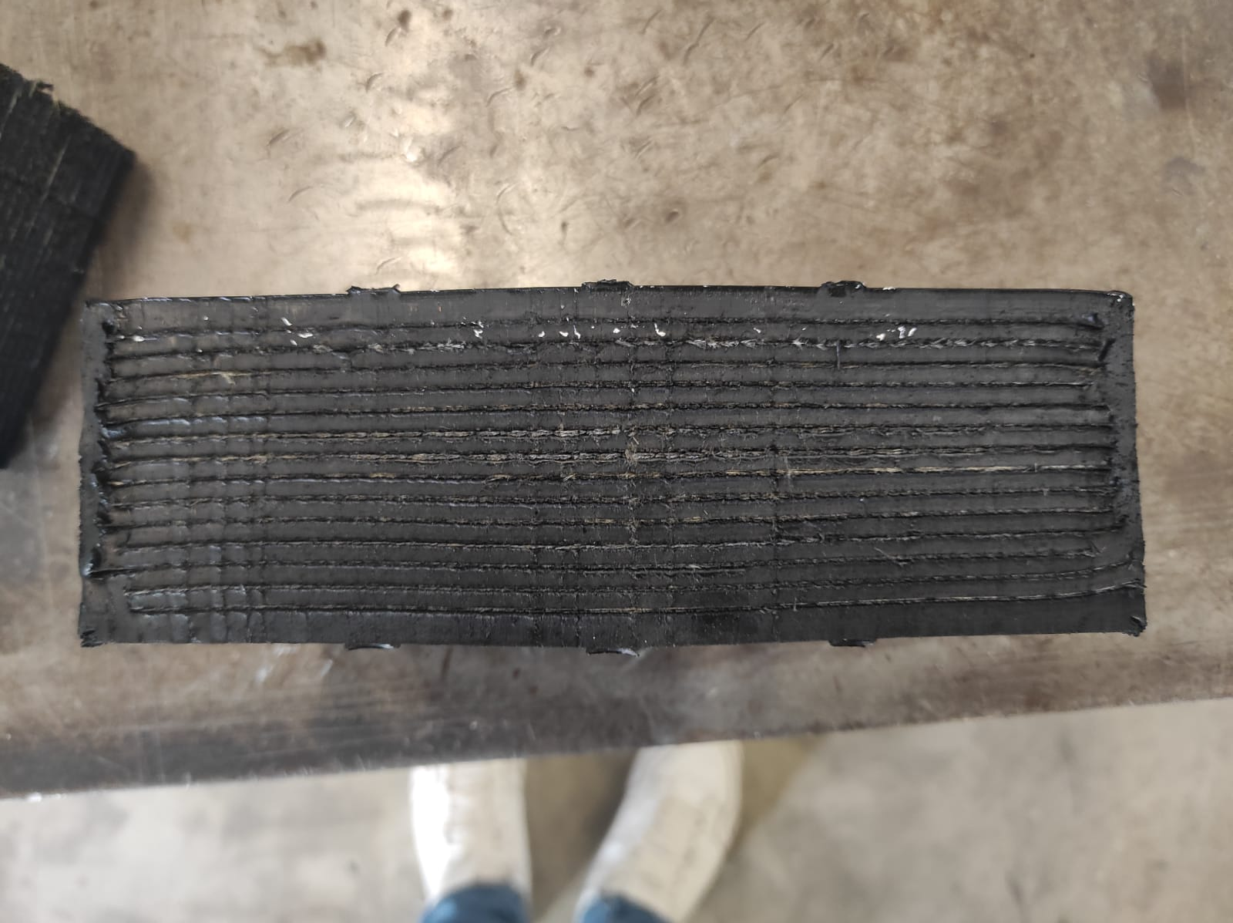
Figure 8 – Swelling of the under-vulcanized device.
  - Conclusions
The paper presents a combined numerical and experimental approach for accurately evaluating the cross-linking degree of Fiber-Reinforced Elastomeric Isolators (FREIs) made of NR-EPDM rubber blend. In particular, the study aimed to predict the optimum vulcanization for the fabrication of the seismic device, obtaining a homogeneous distribution of the cross-linking degree and so of the mechanical properties within it. First, the numerical model has been implemented to predict the vulcanization time and temperature. Then, two vulcanizations, one optimal and one sub-optimal have been considered to produce the devices. The UFREIs obtained were aesthetically almost identical. The suboptimal vulcanized one has shown a swell on the top surface, a typical production problem due to the rubber under-vulcanization. For further investigation, they have been cut along the middle vertical section and the Shore A hardness has been measured from the inner to the outer point. The device obtained with the sub-optimal vulcanization has highlighted a non-uniform hardness within the surface and so non-homogeneous mechanical properties. Furthermore, the fiber layers have shown a curvature due to the rubber swelling. Instead, the second device obtained from the vulcanization for 7200 seconds, has shown a uniform Shore A distribution, and so homogeneous mechanical properties, validating the numerical vulcanization model proposed.
References
Choun, Y.S., Park, J., Choi, I.K., 2014. Effects of mechanical property variability in lead rubber bearings on the response of seismic isolation system for different ground motions. Nuclear Engineering and Technology 46.
Habieb, A.B., Milani, F., Milani, G., Pianese, G., Torrini, D., 2022. Vulcanization degree influence on the mechanical properties of Fiber Reinforced Elastomeric Isolators made with reactivated EPDM. Polym Test 108.
Kelly, J.M., 1999. The role of damping in seismic isolation. Earthq Eng Struct Dyn 28.
MathWorks, T., 2020. MATLAB (R2020b). The MathWorks Inc.
Medeot, R., 2010. The European standard on anti-seismic devices. In: Large Structures and Infrastructures for Environmentally Constrained and Urbanised Areas.
Milani, G., 2013. Closed form analytical approach for a second order non-linear ODE interpreting EPDM vulcanization with peroxides. J Math Chem 51.
Milani, G., Milani, F., 2014. Effective closed form starting point determination for kinetic model interpreting NR vulcanized with sulphur. J Math Chem 52.
Milani, G., Milani, F., 2021. Relation between activation energy and induction in rubber sulfur vulcanization: An experimental study. J Appl Polym Sci 138.
Pianese, G., Milani, G., Cerchiaro, R., Milani, F., 2021. Optimal vulcanization of unbonded fiber reinforced elastomeric isolator devices. Chem Eng Trans 86.
Sandberg, O., Bäckström, G., 1979. Thermal properties of natural rubber versus temperature and pressure. J Appl Phys 50.
Wang, W., Zhao, D., Yang, J., Nishi, T., Ito, K., Zhao, X., Zhang, L., 2016. Novel Slide-Ring Material/Natural Rubber Composites with High Damping Property. Sci Rep 6.

