CHEMICAL ENGINEERING TRANSACTIONS  VOL. , 2023 | A publication of
The Italian Association
of Chemical Engineering
Online at www.cetjournal.it

Guest Editor: Sauro Pierucci
Copyright © 2023, AIDIC Servizi S.r.l.
ISBN 978-88-95608-98-3; ISSN 2283-9216

Techno-Economic Analysis of the Syngas Conditioning from Biogas using PSA and PSWA: case study of methanol synthesis
Rafael Santosª, Kristiano Prifti^{b}, Diego Prata^{c}, Argimiro Secchiª, Flavio Manenti^{b,}*
ªUniversidade Federal do Rio de Janeiro, Rua Moniz Aragão 360, Rio de Janeiro, Brazil
^{b}Politecnico di Milano, Piazza Leonardo da Vinci 32, 20133 Milano
^{c}Universidade Federal Fluminense, Rua Passo da Pátria 156, Niterói, Brazil
flavio.manenti@polimi.it
The use of biogas as renewable source for syngas production has been gaining attention in recent years, representing an alternative clean and sustainable path from fossil fuels. Syngas is used as feedstock for a large number of chemicals and the required composition will be defined based on the desired product. Thus, a syngas conditioning step is essential to ensure the necessary stoichiometric ratio. This work analyses the use of pressure swing adsorption (PSA) and pressure swing water absorption (PSWA) units for the conditioning of the syngas to evaluate the impact of the use of cleaner carbon capture technologies. A 100 kmol/h biogas plant was simulated to evaluate the technical and economic aspects of the syngas synthesis process. Aspen HYSYS V11 was used to simulate the reforming and conditioning sections. As a case study, syngas for methanol synthesis was chosen. A sensitivity analysis on the most biogas composition was performed to study the impact on process costs and technical parameters. The results shows that the PSA is slightly less expensive, but the difference of overall costs is less than 2% between both technologies. In addition, the PSWA pathway showed a decrease in energy consumption with a biogas with higher methane content, while the PSA pathway maintained around the same energy consumption level.

  - Introduction
Biogas, a gaseous mixture obtained by the anaerobic digestion of biomass, is an important renewable source for syngas generation. Syngas, a mixture of hydrogen and carbon oxides, can be used to produce a diverse range of chemicals such as methanol, DME and olefins (Santos et al., 2018). Since each technology needs a different syngas composition, most syngas synthesis processes have a conditioning step in which the stoichiometric ratio between components is adjusted to the required value. The stoichiometric number (SN) can be calculated by Eq(1).
$$SN = \frac{H_{2}-{CO}_{2}}{CO + {CO}_{2}}$$ | (1)
Current conventional carbon capture technologies are mostly based on chemical absorption, adsorption or membrane-based separation (Munoz et al., 2015). Chemical absorption involves the dissolution of CO₂ in solvents, commonly amine solutions. These processes have a high energetic demand and the use of chemical solvents means also the need to account for toxicity and refined control during plant operation. In this context, pressure swing adsorption (PSA) and pressure swing water absorption (PSWA) are clean alternatives, as their operation is less complex and there is no presence of toxic chemicals, making it more advantageous for small scale plants.

In this work, a syngas generation plant from biogas is investigated, using PSA and PSWA units as possible configuration for the syngas conditioning step. Syngas with properties needed for methanol production was chosen as a case study. Methanol is an important chemical that can be used as solvent, fuel and as a feedstock for a distinct range of industrial sector such as plastics, coatings and explosives. The optimal reaction conditions require the syngas stochiometric number to have a value around 2 (Bozzano and Manenti, 2016).
  - Methods
The syngas synthesis process can be divided into two main steps: the syngas generation from the biogas reforming and the syngas conditioning. The process superstructure is shown in Figure 1. In this work, a biogas with a CH₄/CO₂ ratio of 1.5 is utilized for the base case, based on the average composition of biogas from different sources (Santos et al., 2018).
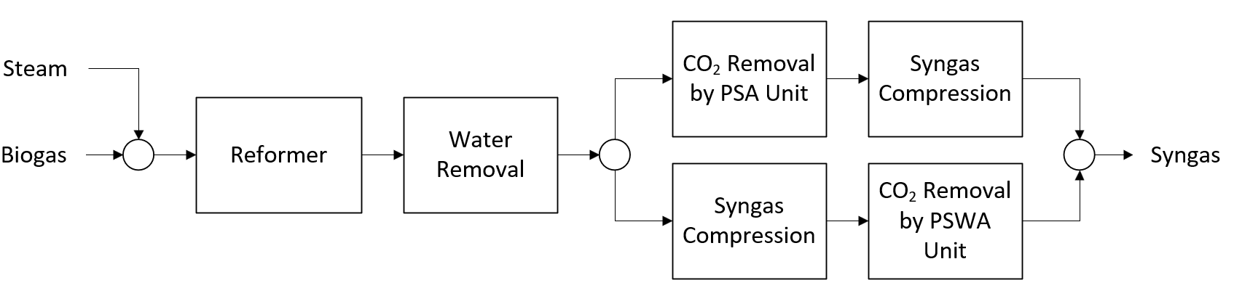
Figure 1: Syngas generation process superstructure
The biogas feedstock, with a flowrate of 100 t/h is sent to the reformer, in addition to steam. The steam flow rate is obtained from the specification of the ratio between steam and methane at the reformer inlet. The crude syngas from the reforming is then sent to the conditioning section to adjust the stoichiometric number. The main difference in the structure is that the syngas needs to be compressed before the PSWA unit whereas for the PSA unit, the compression step can be performed using the conditioned syngas.
The CO₂ removal can be performed by the PSA or the PSWA unit. The PSA unit is composed of four fixed beds vessels filled with activate carbon as adsorbent. It works with an adsorption capacity of 4.17 mols of CO₂ per kg of adsorbent, that allows the removal of 90% of the CO₂ in the syngas stream (Ribeiro et al., 2012). The energy consumption of the PSA Unit comes from the power needed by the vacuum pumps and it can be assumed that the energy expenditure is on average 600 kJ/kgCO₂ for a 4-bed unit (Riboldi & Bolland, 2017). A part of the syngas stream can be bypassed from the PSA unit to adjust the SN to the desired number. The PSA unit flowsheet is shown in Figure 2a.
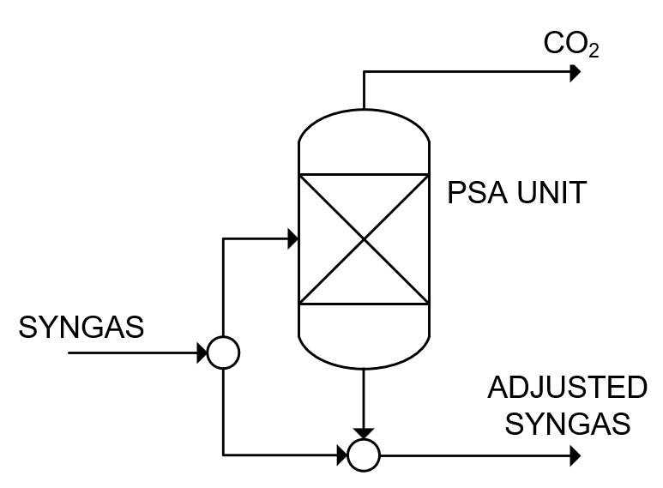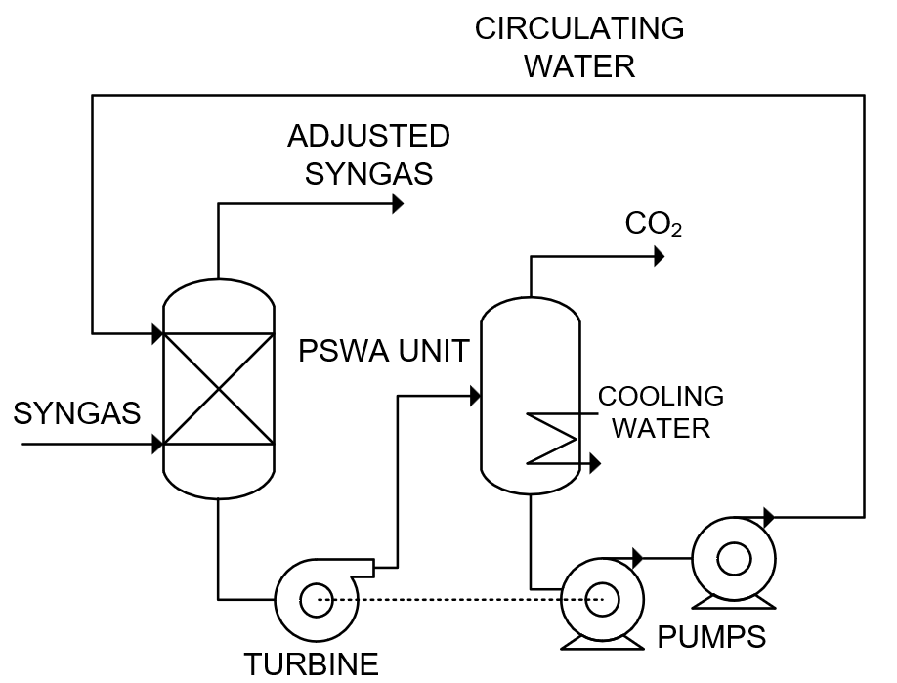
Figure 2a: Pressure Swing Adsorption Flowsheet Figure 2b: Pressure Swing Water Absorption Flowsheet
In the PSWA unit, the syngas passes through the water inside a packed tower in a counter-current configuration. The adjusted syngas leaves the system at the top of the column. The acid water is expanded in a hydraulic turbine to atmospheric pressure, and then sent to a gas-liquid separator, in which high purity CO₂ is obtained. Water is pressurized in two steps: the first pumps share its shaft with the hydraulic turbine while the second pump covers the remaining pressure gap for the adsorption pressure. The PSWA unit flowsheet is shown in Figure 2b.
The biogas plant was simulated in Aspen HYSYS, using the Sour Peng-Robinson thermodynamic package. The layout of the simulation flowsheet is described in Figure 3. The steam/methane ratio for the base case was defined as 3 for the reformer feed. The reformer was modeled as a Gibbs Reactor, operating at 900°C and 10 bar. The post-reformer flash vessel operates at 40 °C. The compressors pressurize the syngas stream to 60 bar. The PSWA and the PSA unit are designed so that the Conditioned Syngas has a SN equal to 2.0. The pressure drop inside the coolers is assumed to be negligible.
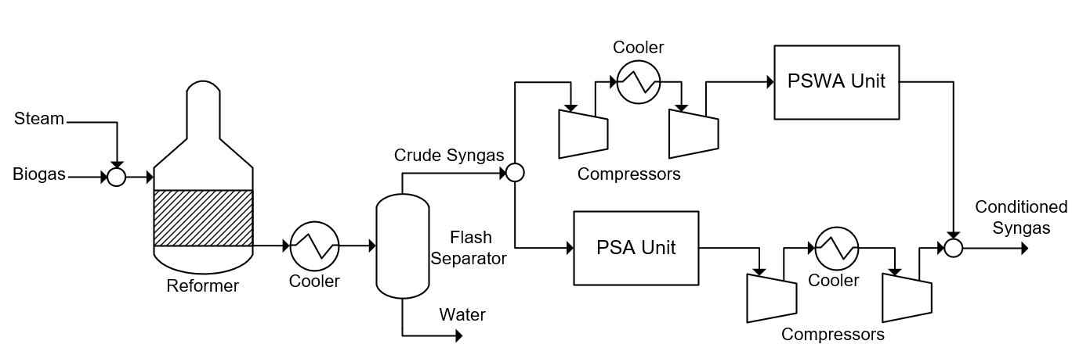Figure 3: Syngas generation process layout
For the economic analysis, the capital costs (CAPEX) were calculated based on the total module costs of each equipment, following the method proposed by Turton et al. (2018). The equipment cost was calculated using correlations obtained from Turton et al. (2018) and adjusted to the recent year using the Chemical Engineering Plant Cost Index (CEPCI). The operating costs were obtained by the sum of the fixed costs (labour, maintenance,) and the variable costs (raw material and utilities). Fixed costs were calculated following the methodology proposed by Turton et al. (2018). An annual operating time of 8000h is assumed. Table 1 describes the prices used in the economic calculation.
Table 1: Economic Parameters
Parameter | Value | Reference
Electricity Cost | 46 €/GJ | ARERA (2022)
Biogas Cost | 6 €/GJ | IRENA (2021)
Cooling Water Cost | 0.359 €/GJ | Turton et al. (2018)
Steam Cost | 4.53 €/GJ | Turton et al. (2018)
The total annualized cost (TAC) can be obtained by the sum of the annual operating costs (OPEX) and the annual investment costs. The annual investment costs are obtained by dividing the CAPEX by the payback period, which is assumed to be 5 years. The TAC calculation is described by Eq(2).
$$TAC [\$/yr] = \frac{CAPEX}{payback period}+OPEX$$ | (2)
The production cost of the syngas from biogas can be calculated by the ratio between the TAC and the annual syngas production from the biogas plant, as expressed by Eq(3). The annual production is obtained by the mass flow rate of conditioned syngas from the outlet of the biogas plant.
$$Syngas Cost \left[\$/kg\right] = \frac{TAC}{Syngas Production}$$ | (2)

  - Results
The performance summaries of the base case of the biogas plant considering both paths with PSA and PSWA units in the syngas conditioning step are given in Table 2.
Table 2: Performance Summary of the Base Case with the Pathway for the PSA and PSWA unit.
Parameter | PSA Pathway | PSWA Pathway
Syngas Production [t/h] | 2.82 | 2.82
Equipment Cost – Reforming [€] | 4,014,651.00 | 4,014,651.00
Equipment Cost – Syngas Conditioning [€] | 1,800,420.43 | 1,939,713.43
CAPEX [€] | 7,537,960.00 | 7,699,461.00
OPEX [€/yr] | 5,860,726.00 | 5,961,595.00
TAC [€/yr] | 7,368,318.00 | 7,501,487.00
Syngas Cost [€/kg] | 0.327 | 0.333

The results shows that the difference between the overall costs considering the different paths is approximately 2%. Considering the equipment cost profiles, the reforming section corresponds to near 70% of the total module costs of the entire process. For these reasons, while capital and operating costs are higher for the PSWA configuration, the syngas production cost are only 2% different.
To better understand the cost profile of the syngas conditioning step, Figure 4 shows the breakdown of the equipment costs for the syngas conditioning step of both configurations.
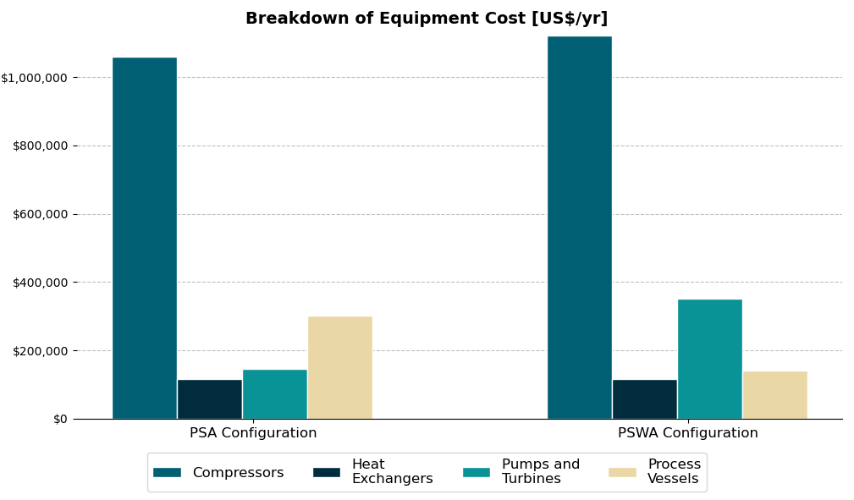
Figure 4: Breakdown of equipment cost
The syngas compressors are the second most expensive equipment of the biogas plant after the reformer. Accounting for only the cost of the CO₂ removal technologies, the vessels costs are higher for the PSA, since these costs account for the multiple adsorbent beds which are the main components of the PSA unit. The pumps costs are higher in the PSWA because of the higher energy power and the turbine-pump system utilized for energy recovery. The overall equipment cost for the PSWA is 8% higher than the PSA. However, it is important to remark that both PSA and PSWA units account for around 12% of the entire biogas plant equipment cost, thus these units have a minor influence on the process’ CAPEX.
Variable production costs makeup more than 67% of the process’ OPEX. For further investigation of the impact of the configuration on these costs, the variable costs profiles for both pathways are described in Table 3.

Table 3: Variable production costs.
Parameter | PSA Pathway | PSWA Pathway
Biogas Costs – Raw Material [€/yr] | 2,069,451.15 | 2,069,451.15
Fuel Costs [€/yr] | 886,311.32 | 886,311.32
Process Water Costs [€/yr] | 235,110.03 | 235,110.03
Electricity Costs [€/yr] | 800,855.35 | 880,318.38
Cooling Water Costs [€/yr] | 27,990.64 | 33,115.14

The biogas costs, counting the use as raw material and fuel, are the main contributors of the operating costs, which highlights the importance of the biogas price in the economic viability of the process. The PSWA unit consumes more electricity overall than the PSA unit, because the compressors need to work with the larger flowrate of the crude syngas, consuming more power. However, the difference of less than 10% between the values shows the high energy efficiency of the turbine-pump system of the PSWA unit.
A sensitivity analysis was performed to investigate the influence of the biogas composition on the economic performance of the plant. Figure 5 shows the influence of the methane content in biogas in the equipment cost of each section while Figure 6 shows the influence in the variable product costs.
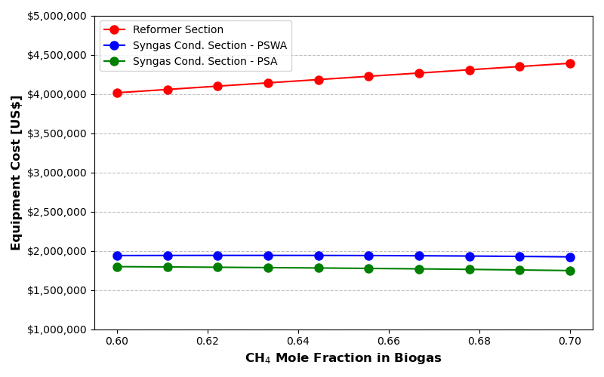
Figure 5: Influence of the biogas composition on the equipment cost
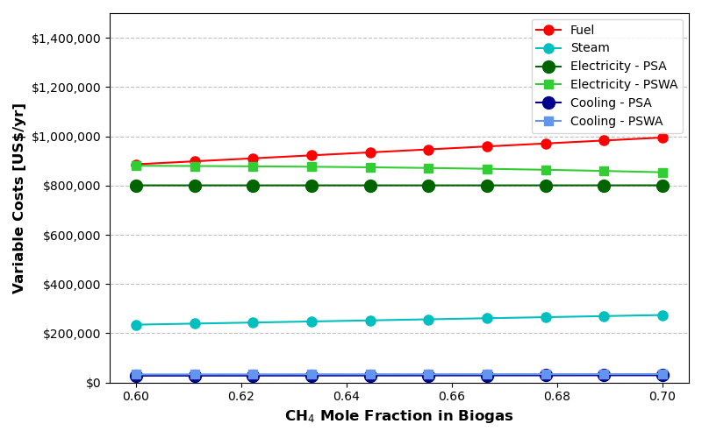
Figure 6: Influence of the biogas composition on the variable product costs
The reformer and fuel costs increase with the higher methane content because the energy demand of the reformer increases, since the reactor yield is higher and the methane reforming reaction is endothermic. The syngas conditioning steps equipment and operating costs decreases, since less CO₂ needs to be removed, allowing for smaller units and less energy to be consumed. As expected, the steam costs also rise with the higher methane content, since the steam/methane ratio was fixed, higher methane at the reformer feed consumes a higher amount of steam.
For the equipment costs, the variation of reforming section costs is more significant than the syngas conditioning expenses (an increase of 10% of reformer costs, compared to a decrease of around 1% for the syngas condition equipment cost). Comparing the carbon capture technologies, the conditioning with the PSWA consumes less energy with higher quality biogas (from 705 kW at 60% CH₄ to 685 kW at 70% CH₄) while the PSA stays relatively the same (around 640 kW), as can be seen in Figure 6, where the reduction of the PSWA costs are larger than the reduction for the PSA pathway with a higher methane content.
  - Conclusions
This study provided an investigation of the economic performance of a biogas reforming process with two distinct configurations for the syngas conditioning, utilizing clean CO₂ removal technologies. The PSA pathway showed a lower syngas production cost, but the overall cost disparity was insufficient to rule out the viability of the PSWA, since other factors such as complexity of process control were not considered in the present work.
The biogas composition sensitivity analysis showed that the change in the reforming section capital expenses is much more significant than the syngas adjusting section. The results from the PSWA also showed a decreasing energy consumption with higher methane content when compared to the PSA, which can indicate favourable scenarios for the application of this particular technology. Further works, such as an optimization of the process variables conditioned to each configuration can be performed to try and obtain higher efficiency and increase economic viability.
Nomenclature
CAPEX – Capital Expenditure, €
OPEX – Operational Expenditure, €/yr
PSA – pressure swing adsorption
PSWA – pressure swing water absorption
SN – Stoichiometric Number, -
TAC – Total Annualized Cost, €/yr
Acknowledgments
The authors would like to thank the Coordination for the Improvement of Higher Education Personnel (CAPES) and the Conselho Nacional de Desenvolvimento Científico e Tecnológico Brazil (CNPq - 316842/2021-4), which financed in part this research.
References
ARERA, 2022, Fares for measurement services – Electricity (in Italian), 2022. <www.arera.it/it/elettricita/mis.htm> accessed 20.12.22.
Bozzano, G., Manenti, F., 2016, Efficient methanol synthesis: Perspectives, technologies and optimization strategies. Progress in Energy and Combustion Science, 56, 71–105.
International Renewable Energy Agency (IRENA), Methanol Institute, 2021, Innovation Outlook: Renewable Methanol.
Muñoz R., Meier L., Diaz I., Jeison D., 2015, A review on the state-of-the-art of physical/chemical and biological technologies for biogas upgrading, Reviews in Environmental Science and Bio/Technology, 14, 727-759.
Ribeiro, A. M., Santos, J. C., Rodrigues, A. E., Rifflart, S., 2012, Syngas Stoichiometric Adjustment for Methanol Production and Co-Capture of Carbon Dioxide by Pressure Swing Adsorption, Separation Science and Technology, 47, 6, 850-866.
Riboldi, L., Bolland, O., 2017, Overview on Pressure Swing Adsorption (PSA) as CO2 Capture Technology: State-of-the-Art, Limits and Potentials, Energy Procedia, 114, 2390-2400.
Santos R., Santos L., Prata D., 2018, Simulation and optimization of a methanol synthesis process from different biogas sources, Journal of Cleaner Production, 186, 821–830.
Turton, R., Shaeiwitz, J. A., Bhattacharyya, D., 2018. Analysis, synthesis and design of chemical processes, 5th Edition. Prentice Hall.

