|  |  |
| --- | --- |
| cetlogo ***CHEMICAL ENGINEERING TRANSACTIONS***  ***VOL. , 2023*** | A publication of  aidiclogo_grande |
| The Italian Association  of Chemical Engineering  Online at www.cetjournal.it |
| Guest Editors: Sauro Pierucci  Copyright © 2023, AIDIC Servizi S.r.l. **ISBN** 979-12-81206-XX-X; **ISSN** 2283-9216 | |

Life Cycle assessment of a new synthesis route: which degree of modelling is necessary?

Laurent Astruc, Caroline Sablayrolles, Ivonne Rodriguez-Donis, Claire Vialle\*

Laboratoire de Chimie Agro-industrielle (LCA), Université de Toulouse, INRAE, Toulouse, France

claire.vialle@ensiacet.fr]

The environmental assessment of innovative bio-based technologies at an early stage is necessary. A promising solution is to couple a process modeling/simulation tool with life cycle assessment in order to provide inventory data. However, the impact of the modeling of the reaction and of separation steps on the environmental impacts has to be studied. This article deals with the impact of the degree of complexity of the modeling of a reaction route on the environmental performance. The corresponding case study is the production of dimethyl carbonate (DMC) via methanolysis of urea. Three scenarios were designed to model the three reactions composing the reaction pathway, which correspond to different degrees of knowledge of these reactions at the laboratory scale. Scenarios were evaluated from an environmental point of view. Hot spots analysis highlighted the low contribution of the reaction (R1) for the production of the methyl carbamate, of the separation by distillation of the mixture resulting from this reaction, of the infrastructure. Raw materials appear as the major contributor. The reaction (R2) for the production of DMC and the separation for purification of the DMC present significant impacts due to energy requirements. For the three scenarios, heating has a preponderant impact on a large number of categories. The three studied scenarios conducts to a coherent material balance that are quite similar, but the results of the energy balance diverge. As a result, it is necessary to increase the precision of the modeling to consider the energy aspect of the process.

* 1. Introduction

Dimethyl carbonate (DMC) is currently a clean alternative to toxic phosgene and dimethyl sulfate in methylation or carbonylation reactions (Shukla and Srivastava, 2017). Urea methanolysis is a promising pathway as reactants can be produced from circular CO2 and ammonia for urea production and bio-based methanol for DMC (Huang et al., 2015). The reaction pathway is composed of three reactions: (R1) produces the methyl carbamate intermediate (MC: NH2COOCH3), (R2) produces DMC and (R3) is a side reaction that produces N-Methyl Methyl Carbamate (NMMC: CH3NH2COOCH3) from the MC and DMC:

|  |  |
| --- | --- |
| (R1) NH2CONH2(s) + CH3OH(l) → NH2COOCH3(s) + NH3(g) | (1) |
| (R2) NH2COOCH3(s) + CH3OH(l) → (CH3O)2CO(l) + NH3(g) | (2) |
| (R3) NH2COOCH3(s) + (CH3O)2CO(l)→ CH3NH2COOCH3(l)+ CO2(g) + CH3OH(l) | (3) |

Modeling/simulation of the urea methanolysis process is very little studied in the scientific literature. Studies have considered (R1) to be instantaneous with complete conversion and without catalyst and the side reaction (R3) is generally neglected. The main limits of this chemical pathway are based on the thermodynamic limitations of the reaction (R2) requiring a high excess of methanol and severe reaction conditions. Zn-based catalysts showed the best efficiencies with a yield between 30% and 50% (Shukla and Srivastava, 2017). Kongpanna et al. (2015) proposed a thermodynamic equilibrium model considering that the reaction (R2) takes place in the vapor phase in an ideally stirred reactor. However, this equilibrium model is not correct because in reality the reactions take place in the liquid phase. This thermodynamic model for (R2) was adopted by Vazquez et al. (2018) for the simulation of a reactive distillation column including the reaction (R3) with a conversion rate of 2% (Shukla and Srivastava, 2017). Several authors have performed an environmental assessment based on process simulation results using atom economy, energy efficiency and CO2 emission. Kongpanna et al., (2015) concluded that an increase in the reaction yield (R2) is essential for a favorable effect on the environment. Sanchez et al. (2019) also performed an environmental assessment using a polynomial model of the yield of DMC and NMMC as a function of temperature and pressure in a plug-flow reactor. The optimal values of temperature and pressure avoided the formation of NMMC but with a yield of 48% for DMC. To our knowledge, no environmental assessment using Life cycle assessment (LCA) has been carried out for this synthesis route. The environmental results will make it possible to (1) determine which unit steps and/or elements are the major contributors to each scenario and (2) quantify the total environmental impacts generated by each scenario in order to compare them.

* 1. Modeling and simulation of DMC production process by urea methanolysis
     1. Modeling of the DMC production process

Three scenarios were designed to model the reactions (R1), (R2) and (R3), which correspond to different degrees of knowledge of these reactions at the laboratory scale. Table 1 shows the parameters of each model used for the simulation of reactions with adapted technologies. The parameters of the kinetic model of the reaction (R1) were calculated from experimental data without catalyst reported by Sun et al. (2004). In the case of reactions (R2) and (R3), an experimental kinetic study was carried out by Zhao et al. (2012) using ZnO as a catalyst. We used the FactSage software (Bale et al., 2016) to obtain the model of the equilibrium constant in the temperature interval 373 – 443 K suggested by Huang et al. (2015). The equilibrium constant calculated at 160°C of 7.34 is very close to the value determined experimentally by Zeng et al. (2010) of 7.23.

Table 1. Scenarios description for the modeling of the reactions rj (mol.L-1) is the reaction rate with the reactant concentrations expressed in mol.L-1, the activation energy in J.mol-1 and the temperature T in K. R is the gas constant (J.mol-1.K-1).

|  |  |  |
| --- | --- | --- |
| 🡪 Increasing level of knowledge 🡪 | | |
| Scenario I  Conversion rate | Scenario II  Equilibrium model (T,K) | Scenario III  Kinetic model |
| Reaction R1 | | |
| τurea = 100% | K =36.74 - 0.1993 T - 3.10-3 T2 |  |
| Ideal reactor | Ideal reactor | Plug flow reactor |
| Reactions R2 + R3 | | |
| τMC(R2) = 50%  τDMC(R3) = 2% | KR2 = 15.5 - 1.702 T - 6.8.10-3 T2 + 10-5 T3  τDMC(R3) = 2% | $$r_{MC}=-2.35.{10}^{6}.e^{-\frac{104000}{R.T}}.C_{MC}^{1.09}-6,2.{10}^{9}.e^{-\frac{135000}{R.T}}.C_{MC}^{1.11}.C_{MC}^{1.5}$$ $$r_{DMC}=2.35.{10}^{6}.e^{-\frac{104000}{R.T}}.C_{MC}^{1.09}-6.2.{10}^{9}.e^{-\frac{135000}{R.T}}.C_{MC}^{1.11}.C_{DMC}^{1.5}$$ $$r_{NMMC}=6.2.{10}^{9}.e^{-\frac{135000}{R.T}}.C_{MC}^{1.11}.C_{DMC}^{1.5}$$ |
| Ideal reactor+  Distillation | Reactive Distillation | Reactive Distillation |



Figure 1. DMC production process for each reaction modeling scenario

A thermodynamic model based on the calculation of activity coefficients in the liquid phase was chosen while the vapor phase is considered ideal. The Wilson model was selected for the reactive distillation column and the NH3 purification columns as proposed by Wang et al. (2007) for the pressure range 5 – 10 bar. The NRTL model with binary coefficients described by Matsuda et al. (2019) makes it possible to better calculate the methanol – DMC azeotrope at higher pressures. Figure 1 shows process flow diagrams for the production of DMC. For the reaction stage (R1), a perfectly stirred ideal reactor (RI) is appropriate for scenario I, because the reaction is instantaneous, while a plug flow reactor (RP) was chosen for scenarios II and III. For the reaction step (R2), an ideal reactor connected to a distillation column (RI+D) was chosen for scenario I. A reactive distillation column (DR) makes it possible to optimize the production yield of the DMC using the equilibrium model of scenario II and the kinetic model of scenario III. The separation of NH3 from mixtures resulting from each reaction in the separation (S1) and separation (S2) stages is carried out by a distillation column with partial condenser (CDCP) for all scenarios. The purification of DMC in the last part of the separation step (S2) is carried out by a distillation column with a total condenser (CDCT). The process feed is made with 4,165 kg/h of methanol (stream 1, figure 1) and 6,006 kg/h of urea (stream 2). Then, the CH3OH - DMC mixture (stream 8) is recycled in the reaction step (R2) for both technologies (RI+D) and (DR). The CH3OH/MC molar ratio in the reaction step (R2) is ensured by the control loop (SPEC) which regulates the supply of pure methanol. Stream 5 from the bottom of the distillation column is returned to the reactor (scenario I) or the reactive distillation column (scenarios II and III). The simulation of each scenario was carried out with the ProsimPlus® software.

* + 1. Results of the simulation

Table 2 shows the optimal operating conditions calculated by the genetic algorithm method available in ProsimPlus® to maximize the production of DMC to 99.5%. The feed mass flow rates for each component (kg/h) and for each unit operation, as well as the output streams (see legend figure 1), are shown in the table with the energy consumption for the cold utilities (water at 15°C) and hot utilities (steam at 60 bar). For reaction (R1), the equilibrium model gives the lowest urea conversion rate of 98.5% for a pressure of 10 bar at the bubble temperature of the reactive mixture. Then, the column (CDCP1) makes it possible to recover almost 100% of NH3 with a purity greater than 99.9% in order to send this molecule back to the urea production process and avoid this waste. The same solution is applicable for the column distillate (CDCP2) containing CO2, a reagent also essential to produce urea. Scenario I requires 1.8 times more methanol due to a lower MC conversion rate (49.55%). The use of a reactive distillation column (RD) for scenarios II and III makes it possible to increase the conversion rate of MC to 93.2%. A slightly lower MC conversion rate (88.5%) is obtained in scenario III due to the significant effect of the liquid volume in the reaction trays. It should be noted that an instantaneous equilibrium was considered for scenario II. As a result, the energy consumption is higher in Scenario III, because the reflux ratio of the reactive distillation column is 4 times higher. However, Scenario III is more representative of the actual performance of reaction step 2 (R2+R3) in a reactive distillation column. Stream 5 (Figure 1) is the only process waste to be treated. Scenario I without a reactive distillation column generates 6 times more waste.

Table 2. Simulation results with ProsimPlus® software of each scenario

|  |  |  |  |  |  |  |  |  |  |  |  |
| --- | --- | --- | --- | --- | --- | --- | --- | --- | --- | --- | --- |
| **Scenario I** | RI | CDCP1 | (3) | (4) | RI | D | CDCP2 | (7) | CDCT | (8) | (9) |
| P(bar) | 10 | 5 | 5 | 5 | 5 | 5 | 5 | 5 | 16 | 16 | 1 |
| T(K) | 388.15 | 372.15 | 282.15 | 437.15 | 394.15 | 423.15 | 384.15 | 283.15 | 385.15 | 428.15 | 363.15 |
| Methanol | 4,165 | 961 | 0 | 961 | 18,334 | 15,306 | 15,306 | 2 | 15,304 | 15,289 | 15 |
| Urea | 6,006 | 0 | 0 | 0 | 0 | 0 | 0 | 0 | 0 | 0 | 0 |
| MC | 0 | 7,507 | 0 | 7,505 | 14,317 | 7,095 | 0 | 0 | 0 | 0 | 0 |
| DMC | 0 |  | 0 | 0 | 770 | 9,283 | 8949 | 0 | 8,949 | 454 | 8,495 |
| NMMC | 0 |  | 0 | 0 | 1,830 | 1,906 | 0 | 0 | 0 | 0 | 0 |
| NH3 | 0 | 1,703 | 1,703 | 0 | 78 | 1,702 | 1,702 | 1,624 | 78 | 78 | 0 |
| CO2 | 0 |  | 0 | 0 | 0 | 38 | 38 | 38 | 0 | 0 | 0 |
| Energy | Hot utility : 27,677 kW | | | | | Cold utility : 27,058 kW | | | | | |
| **Scenario II** | RI | CDCP1 | (3) | (4) | DR | | CDCP2 | (7) | CDCT | (8) | (9) |
| P(bar) | 10 | 5 | 5 | 5 | 5 | | 5 | 5 | 16 | 16 | 1 |
| T(K) | 388.15 | 363.15 | 279.15 | 435.15 | 382.15 | | 351.15 | 284.15 | 383.15 | 423.15 | 363.15 |
| Methanol | 4,165 | 1,007 | 0 | 1,006 | 1,1535 | | 9,125 | 1 | 9,124 | 9,109 | 16 |
| Urea | 6,006 | 85 | 0 | 85 | 85 | | 0 | 0 | 0 | 0 | 0 |
| MC | 0 | 7,400 | 0 | 7,400 | 7,605 | | 0 | 0 | 0 | 0 | 0 |
| DMC | 0 | 0 | 0 | 0 | 331 | | 9,073 | 0 | 9,073 | 234 | 8,838 |
| NMMC | 0 | 0 | 0 | 0 | 288 | | 0 | 0 | 0 | 0 | 0 |
| NH3 | 0 | 1,679 | 1,679 | 0 | 242 | | 1,916 | 1,672 | 244 | 244 | 0 |
| CO2 | 0 | 0 | 0 | 0 | 0 | | 6 | 6 | 0 | 0 | 0 |
| Energy | Hot utility : 35,364 kW | | | | | Cold utility : 33,139 kW | | | | | |
| **Scenario III** | RI | CDCP1 | (3) | (4) | DR | | CDCP2 | (7) | CDCT | (8) | (9) |
| P(bar) | 10 | 5 | 5 | 5 | 5 | | 5 | 5 | 16 | 16 | 1 |
| T(K) | 388.15 | 366.15 | 302.15 | 518.15 | 384.15 | | 344.15 | 293.15 | 430.15 | 429.15 | 363.15 |
| Methanol | 4,165 | 3,209 | 1 | 3,177 | 9,792 | | 9,740 | 10 | 9,730 | 9717 | 14 |
| Urea | 6,006 | 9 | 0 | 9 | 9 | | 0 | 0 | 0 | 0 | 0 |
| MC | 0 | 7,495 | 0 | 7,495 | 8,468 | | 0 | 0 | 0 | 0 | 0 |
| DMC | 0 | 0 | 0 | 0 | 929 | | 8,507 | 3 | 8,504 | 929 | 7,575 |
| NMMC | 0 | 0 | 0 | 0 | 428 | | 0 | 0 | 0 | 0 | 0 |
| NH3 | 0 | 1,700 | 1,699 | 1 | 6 | | 1,539 | 1533 | 0 | 0 | 0 |
| CO2 | 0 | 0 | 0 | 0 | 0 | | 211 | 211 | 7 | 7 | 0 |
| Energy | Hot utility : 53,457 kW | | | | | Cold utility : 52,139 kW | | | | | |

* 1. Environmental assessment of the chemical process at an early stage of development
     1. Material and methods

This work is based on the coupling of process modeling-simulation and life cycle analysis (LCA). LCA is a standardized method, the framework of which is defined by the international standards ISO 14040 (ISO, 2006a) and ISO 14044 (ISO, 2006b). The four interrelated parts that compose it are at the center of the methodology used (in the green frame in Figure 2). The first phase of data collection allows to collect data from laboratory experiments and literature review. The definition of objectives and the study framework correspond to the establishment of geographical and temporal perimeters. The functional unit must also be established. The simulation results provide the flow of mass and energy and feed the life cycle inventory. These streams are reported to the functional unit of the system to provide foreground data. Background data comes from dedicated databases. The inventory data is then converted into environmental impacts in the environmental assessment phase. The interpretation of each impact category is carried out according to the quantitative results as well as the quality of the data collection, in accordance with the objective of the study. The identification of environmental hotspots makes it possible to identify which process of the production scheme must be optimized using advanced techniques: energy integration, recycling of flows, among others. Then, the last step of the method is decision making. Comparison with LCA results from other industrial processes or alternative chemical routes is strongly recommended.

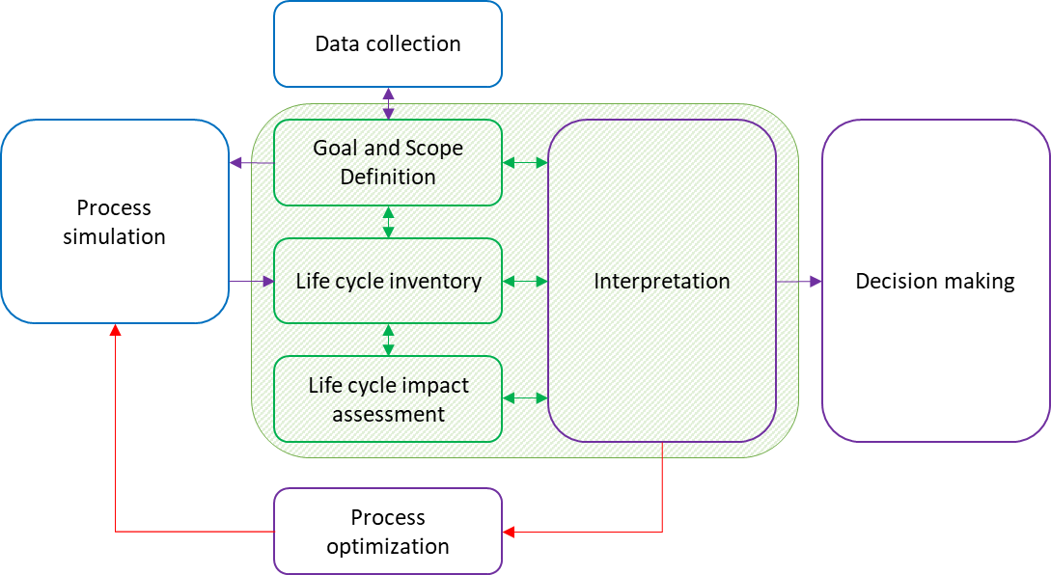Figure 2. Coupling process modelling/simulation and LCA



Figure 3. Process tree of the DMC production process

The main function of this process is the production of DMC. The functional unit is to produce 1 kg of DMC with a purity greater than 99.5%. The boundaries of the study system are illustrated in figure 3. The study is carried out from the cradle to the gate. The process is divided into 6 sub-parts: the supply of raw materials, the production of MC (reaction 1), the separation of MC from ammonia (separation 1), the production of DMC and NMMC (reaction 2), the purification of DMC and co-products (separation 2) and infrastructures. Background data, consisting of chemical production, utility and waste treatment data, is provided by the ecoinvent v3.7, Cut-Off database. The impact assessment method used is EF 3.0 which includes 16 impact categories of different levels of robustness (PEFCR Guidance v6.3, 2017): Level I: recommended and satisfactory / Level II: recommended but requiring improvement / Level III: recommended but to be applied with caution. The model for considering multifunctionality is system expansion.

* + 1. Environmental assessment results

The three scenarios differ in the models used for the design of the chemical reactions. The scenarios evolve with the knowledge of the process, from scenario I to scenario III. The results for Scenario I are presented in Figure 4. Several conclusions are equivalent for the three scenarios. The raw materials stage appears as the majority contributor for all categories except eutrophication – freshwater and climate change. For Scenario II the impacts of the raw materials stage is the greatest, while for scenario III it is comparatively lower. The reaction 2 and separation 2 stages have significant impacts on a majority of categories, which is essentially due to the heat consumption. For scenario III, step reaction 2 and separation 2 present more impact than the raw material in two high robustness categories, which is not the case for scenarios II and III. The reaction 1 and separation 1 stages correspond to negligible stages in the life cycle analysis. Infrastructure is a weak contributor on a majority of categories, but is important for the resource depletion category – minerals and metals.

The comparison of the environmental results obtained for the three cradle-to-gate scenarios is presented on Figure 5. Scenario III presents the most impacts and Scenario II presents the least. The impacts of Scenario I lie between the other two scenarios. A sensitivity analysis was carried out using the ReCiPe 2016 method showing that the results are generally not very sensitive to the impact evaluation method used.

Scenario III is the one that delivers the most robust results, and it can be identified as the closest to industrial reality. Scenario I provides information that may be useful for designing a new process with less modeling difficulty. For the three scenarios, the analysis of hot spots reveals that heating has a preponderant impact on a large number of categories. For the climate change category, the contributions are different according to the scenarios, but this represents more than 45% of the impacts. This is why it seems important to model the process as finely as possible from an energy point of view. The calculation of the energy flows involved in the process proposed for this synthesis route is only possible by applying a tool allowing the rigorous simulation of the processes. This information is impossible to obtain on a laboratory scale. Only the simulation/LCA coupling makes it possible to carry out an assessment of the environmental impacts on a sure basis which will also allow comparison with other production alternatives.

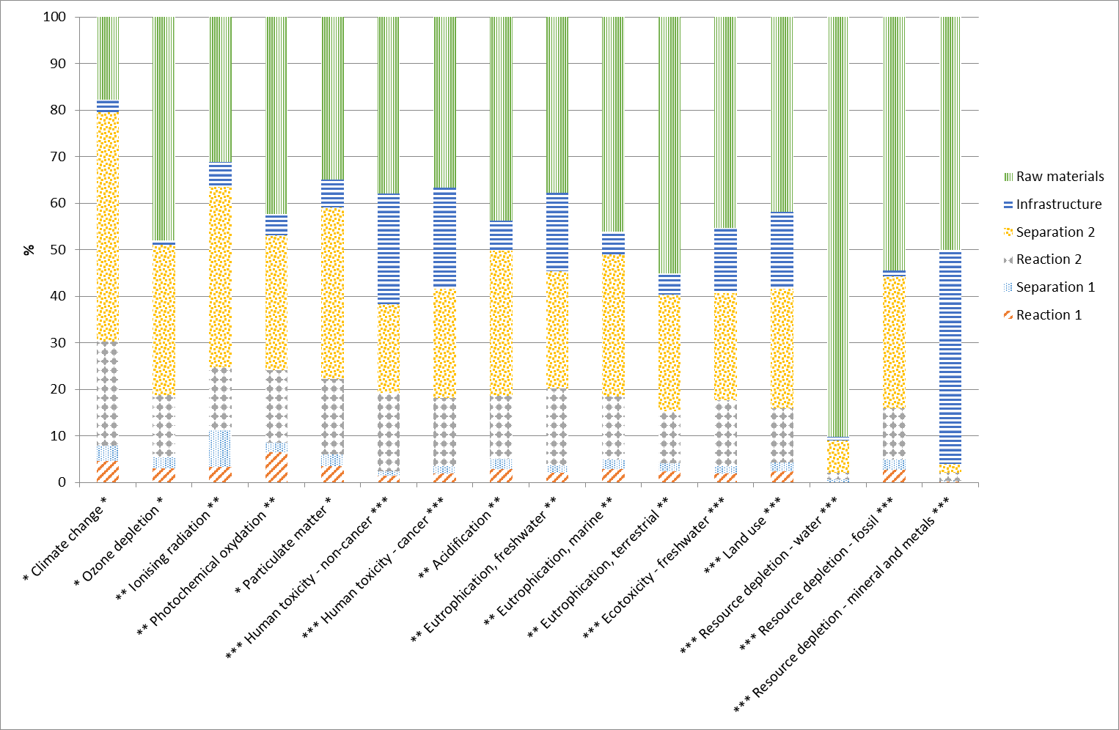

Figure 4. Analysis of hot spots for the different impact categories using the EF 3.0 method for scenario I "conversion" (\*robustness I, \*\*robustness II, \*\*\*robustness III)

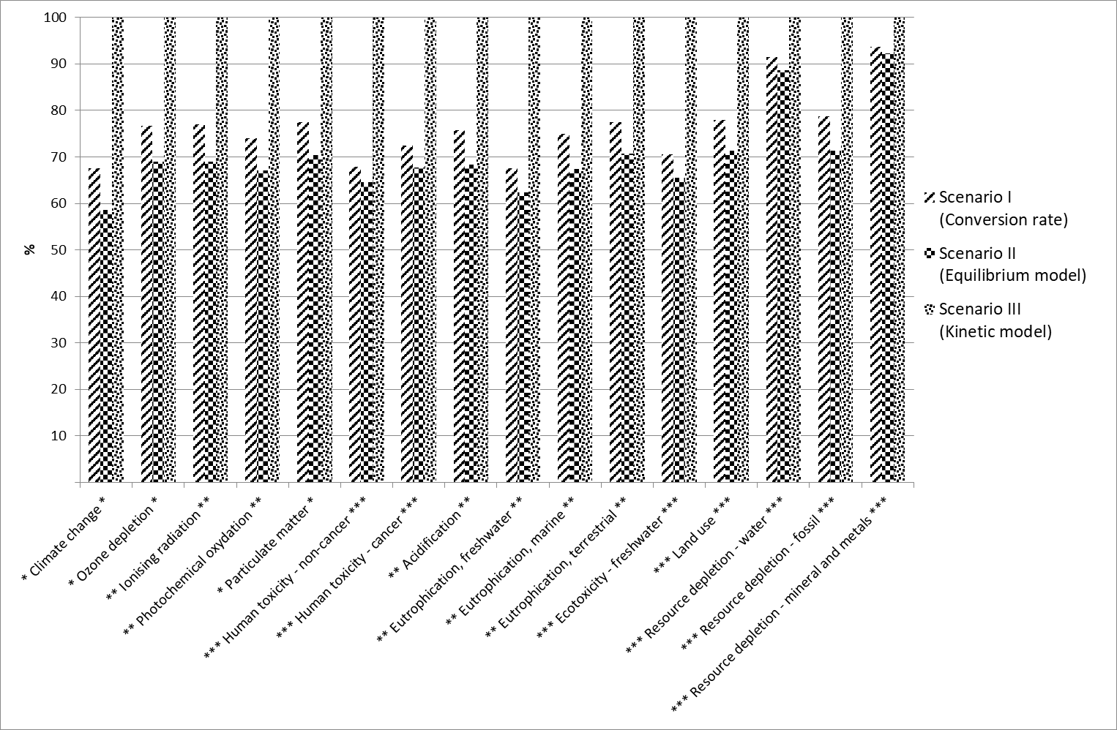

Figure 5. Comparison of the three scenarios with the EF 3.0 method (The robustnesses of the categories are identified by stars, \* for robustness I, \*\* for robustness II and \*\*\* for robustness III)

* 1. Discussion on the degree of modeling of the reaction necessary to support a user in his choice of synthetic route

The simplest process simulation corresponds to scenario I with a modeling of the reaction pathway based on the conversion rate, while the most complete modeling corresponds to scenario III based on the kinetics. Scenario I allows the identification of problematic steps from an environmental point of view at an early stage of the design. It is sufficient in our case study to identify the importance of the impact linked to the raw materials and to the purification step of the DMC by the presence of heating in the boiler in the distillation column and in the column dedicated to the separation of the methanol – DMC azeotrope in order to obtain the DMC with the desired purity. The scenario based on an instantaneous equilibrium model demonstrated the feasibility of using a reactive distillation column to carry out reactions (R2) and (R3) as well as the separation of reactants and products, allowing the production yield of DMC to be doubled. Nevertheless, the fact that the main reaction is actually controlled by the kinetics distorts the design of the reactive distillation column with an instantaneous equilibrium which leads to a drop in the energy consumption of the column. Moreover, in the absence of equilibrium data to model the secondary reaction, this scenario uses the same conversion rate as that considered for scenario I to produce the NMMC. Consequently, scenario II underestimates the environmental impacts. Scenario II, however, made it possible to obtain initial values of the parameters for the design of the reactive distillation column used in scenario III. In general, the results obtained with the three scenarios give quite similar material balances, but the results of the energy balance diverge. Also in the literature, the results of energy consumption are varied, with from 5 MJ/kg (Monteiro et al., 2009) to 72 MJ/kg (Kongpanna et al., 2015) for similar production capacities. Our simulations show a lesser variation in consumption with 11 MJ/kg (Scenario II "balance") to 25 MJ/kg (Scenario III "kinetic"). This result can be explained by the influence of liquid retention in the trays of the reactive section of the reactive distillation column on the conversion rate of MC and the selectivity to produce DMC. In conclusion, although it allows to identify the hot spots, the simulation based on the conversion rate is not enough for the choice of the synthesis route. The environmental results indeed appear quite far from the results of the most rigorous scenario based on a kinetic model.

* 1. Conclusions

In this article an environmental assessment of a new DMC production process was carried out by the cradle-to-gate LCA method. Inventory data was obtained from process simulation with ProsimPlus® software. Three scenarios with different increasing degrees of complexity for modeling reactions were studied. Scenario I is based on a conversion rate model, scenario II on an equilibrium model and scenario III on a kinetic model. The raw materials step appears to be the major contributor and the reaction/separation steps for the production and purification of DMC have significant impacts, linked to energy needs. The environmental results show that scenario I makes it possible to identify the impact linked to the raw materials and the heating for the distillation columns. The use of a reactive distillation column for scenarios II and III considerably reduces the production of waste. Scenario III is the most contributory in all the categories because the impact of heating is greater due to the influence of liquid retention in the reactive column requiring a reflux rate 20 times higher than that of scenario II with an instantaneous equilibrium model. The study of another technology for the purification of DMC (two distillation columns operating at different pressures, extractive distillation) as well as the energy integration seem to be essential studies to be carried out in order to reduce the environmental footprint of the proposed process.

References

Bale, C.W., Bélisle, E., Chartrand, P., Decterov, S.A., Eriksson, G., Gheribi, A.E., Hack, K., Jung, I.H., Kang, Y.B., Melançon, J., Pelton, A.D., Petersen, S., Robelin, C., Sangster, J., Spencer, P., Van Ende, M.A., Reprint of FactSage thermochemical software and databases, 2010–2016. Calphad 55, 1–19.

Huang, H., Samsun, R.C., Peters, R., Stolten, D., Greener production of dimethyl carbonate by the Power-to-Fuel concept: a comparative techno-economic analysis, 2021, Green Chemistry, 23, 1734–1747.

Kongpanna, P., Pavarajarn, V., Gani, R., Assabumrungrat, S., Techno-economic evaluation of different CO2-based processes for dimethyl carbonate production, 2015, Chemical Engineering Research and Design, 93, 496–510.

ISO, 2006a. ISO 14040: Environmental Management – Life Cycle Assessment –Principles and framework. International Organization for Standardization . Geneve, Switzerland

ISO, 2006b. ISO 14044: Environmental Management – Life Cycle Assessment – Requirements and Guidelines. International Organization for Standardization. Geneve, Switzerland

Matsuda, H., Negishi, M., Inaba, Iino, S., Constantinescu, D., Kurihara, K., Katsumi, T., Ochi, K., Gmehling, J., Isothermal vapor–liquid equilibria at 383.15–413.15 K for the binary system methanol + dimethyl carbonate and the pressure dependency of the azeotropic point, 2019, Fluid Phase Equlibria, 492, 101-109.

Monteiro, J.G.M.-S., de Queiroz Fernandes Araújo, O., de Medeiros, J.L., Sustainability metrics for eco-technologies assessment, Part II. Life cycle analysis, 2009, Clean Technologies and Environmental Policy, 11, 459–472.

Sánchez, A., Gil, L.M., Martín, M., Sustainable DMC production from CO2 and renewable ammonia and methanol, 2019, Journal of CO2 Utilization, 33, 521–531.

Shukla, K., Srivastava, V.C.. Synthesis of organic carbonates from alcoholysis of urea: A review, 2017, Catalysis Reviews, 59, 1–43.

Sun, J., Yang, B., Lin, H., A Semi-continuous Process for the Synthesis of Methyl Carbamate from Urea and Methanol, 2004. Chemical Engineering & Technology, 27, 435–439.

Vázquez, D., Javaloyes-Antón, J., Medrano-García, J.D., Ruiz-Femenia, R., Caballero, J.A., Dimethyl Carbonate Production Process from Urea and Methanol, 2018, Computer Aided Chemical Engineering, 731–736.

Wang, F., Li, J., Zhao, W., Xiao, F., Wei, Sun, Y. Modeling of the Catalytic Distillation Process for the Synthesis of Dimethyl Carbonate by Urea Methanolysis Method, 2007, Industrial & Engineering Chemistry Research, 46, 8972–8979.

Zeng, Z.-X., Li, X.-N., Xue, W.-L., Zhang, C.-S., Bian, S.-C., Heat Capacity, Enthalpy of Formation, and Entropy of Methyl Carbamate, 2010, Industrial & Engineering Chemistry Research, 49, 5543–5548.

Zhao, W., Han, B., Zhao, N., Xiao, F., Wei, W., Macro kinetics for synthesis of dimethyl carbonate from urea and methanol on Zn-containing catalyst, 2012, Journal of Central South University of Technology, 19, 85–92.