|  |  |
| --- | --- |
| cetlogo ***CHEMICAL ENGINEERING TRANSACTIONS***  ***VOL. , 2023*** | A publication of  aidiclogo_grande |
| The Italian Association  of Chemical Engineering  Online at www.cetjournal.it |
| Guest Editors: Sauro Pierucci, Jiří Jaromír Klemeš  Copyright © 2023, AIDIC Servizi S.r.l. **ISBN** 978-88-95608-98-3; **ISSN** 2283-9216 | |

Simulation-based Assessment of 2,5 Furandicarboxylic Acid Production from Oxidation of 5-Hydroxymethylfurfural

Dang Saebeaa๕, Soipatta Soisuwata, Amornchai Arpornwichanopb, Yaneeporn Patcharavorachotc

aResearch Unit of Developing technology and Innovation of Alternative Energy for Industries, Department of Chemical Engineering, Faculty of Engineering, Burapha University, Chonburi, 20131, Thailand

bCenter of Excellence in Process and Energy Systems Engineering, Department of Chemical Engineering, Faculty of Engineering, Chulalongkorn University, Bangkok 10330, Thailand

cDepartment of Chemical Engineering, Faculty of Engineering, King Mongkut's Institute of Technology Ladkrabang, Bangkok 10520, Thailand

[dangs@eng.buu.ac.th](mailto:dangs@eng.buu.ac.th)

2,5 Furan dicarboxylic acid (FDCA) is a bio-based chemical that has the potential to replace petroleum-based chemicals. The production and use of FDCA have been shown to have less environmental impact compared to traditional petrochemicals. FDCA can be produced from 5-hydroxymethylfurfural which is synthesized by biomass. In FDCA production, the main reaction is the oxidation of HMF in an aqueous acetic solution. The study on the combined process of FDCA production and separation is important in the development of the FDCA production process on a commercial scale. This work aims to study the combined process and the performance assessment of FDCA production from the oxidation of HMF consisting of FDCA synthesis, FDCA separation, and solvent recovery. The Aspen Plus software was used for the simulation of the FDCA production process. Moreover, the performances of the FDCA production process using air and pure oxygen are compared. The simulation results indicated that the solvent recovery in the FDCA production process can increase the amount of FDCA product and decrease the amount of fresh water and acetic acid in the feed by 96.45% and 97.24%, compared to the system without solvent recovery. When considering the energy consumption of the process, the energy consumption of the air compressor is the highest at 63.52% of the total energy consumption. The use of a multi-stage compressor and pure oxygen as an oxidant in the FDCA production process can reduce the energy consumption of the process.

* 1. Introduction

Due to environmental problems and the rapid depletion of fossil resources, biomass has been increasingly used to replace the use of fossil fuels because of its environmentally friendly and sustainable. This brings about the development of biorefineries to convert biomass to fuels and value-added chemicals. Among chemicals and fuels obtained from biomass, 2,5 furan dicarboxylic acid (FDCA) is one of the Top-12 bio-based building blocks identified by the U.S. Department of Energy in 2004. FDCA is used in various expensive applications, i.e., polymer and pharmacy (Zhu et al., 2021). The molecular structure of FDCA is similar to petroleum-based terephthalic acid which is used for polyethylene terephthalate (PET) production. PET is an important polymer in beverage packaging, clothes, and electronic appliances (Wang et al., 2022). However, PET is not biodegradable. Polyethylene furanoate (PEF) produced from the polymerization reaction of FDCA with ethylene glycol can replace the use of PET as a petroleum-based product that reduces the consumption of non-renewable energy sources. Kim et al. (2022) reported that biogenic carbon uptake credits for PEF were the dominant factor in the reduction of greenhouse gas emissions. Thus, the PEF has lower greenhouse gas emissions from material and energy input compared to fossil- PET. Moreover, PEF has fully biodegradable, high gas barrier properties, and strong mechanical properties (Pandey et a., 2021).

FDCA can be produced from the oxidation of 5-hydroxymethylfurfural (HMF), which is a key intermediate obtained from the dehydration of hexose sugars present in biomass. HMF can be obtained from a variety of biomass sources such as corn stover, sugarcane bagasse, and wood chips (Junior et al., 2022). Furthermore, the production of FDCA from biomass-derived HMF represents a promising alternative to the traditional petrochemical-based process, as it is renewable and sustainable (Santiago & Guirardello, 2020). The advantages of FDCA production from the oxidation of HMF compared to other methods are high yield, mild reaction conditions, and versatile reactants making it more cost-effective. The pathways for the oxidation of HMF to FDCA are important steps in FDCA yield. Thus, the oxidation of HMF to FDCA using homogeneous or heterogeneous catalysts has been extensively studied. Saha et al. (2012) studied the oxidation of HMF using homogeneous Co(OAc)2/Zn(OAc)2/Br−, and heterogeneous Au–TiO2 and Au–CeO2 nanoparticulate catalysts. Their results showed that homogeneous oxidation catalysts achieved higher FDCA selectivity than the oxidation with Au–TiO2 catalyst under the same condition at 1 atm of O2 at 90 ◦C. However, oxidation with homogeneous catalysts faces problems, i.e., difficult separation, difficult recycling, less environmentally friendly, and low yields under mild conditions (Deshan et al., 2020). The oxidation of HMF with heterogeneous catalysts is a more practical application. The noble-metal heterogeneous catalysts such as platinum (Pt), ruthenium (Ru), palladium (Pd), and gold (Au) have been commonly used for the oxidation of HMF (Gong et al., 2017). Verdeguer et al. (1993) indicated that Pt-supported on carbon as the catalyst for the HMF oxidation achieved an FDCA yield of 81%. Davis et al. (2011) reported that FDCA yield of 71% and HMF conversion of 100% by using Pt-supported carbon as catalysts in the oxidation of HMF.

The oxidant type for the HMF oxidation has a significant effect on the FDCA yield. Air is the most common oxidant used for the oxidation of HMF to FDCA because of its availability and inexpensiveness. Lilga et al. (2012) studied the conversion of HMF to FDCA using Pt/ZrO2 and air as oxidants under 100 °C and 10 bar in the plug flow reactor. Their results indicated the FDCA yield of 90%wt, FFCA yield of 2 %wt, and DFF yield of 0.05 %wt at the volumetric air ratio to the liquid feed of 100/1. The FDCA production from the oxidation of HMF requires a high air-to-feed stream ratio to obtain a high FDCA yield, leading to high energy consumption in the process. To develop FDCA production to an industrial scale, the studies of the process design and the combined process of FDCA production and separation are substantially important. The study of the combined process for FDCA production has been limited. This work aims to study the combined process and the performance assessment of FDCA production from the oxidation of HMF consisting of FDCA synthesis, FDCA separation, and oxidant and solvent recovery.

* 1. Process description



Figure 1: Process flow diagram of FDCA production from the HMF oxidation using air as oxidant.

In this study, the Aspen Plus® process simulator was used for the simulation of FDCA production. FDCA production process consists of the HMF oxidation to FDCA, gas separation, FDCA purification, and solvent recovery. Figure 1 shows the process flow diagram of FDCA production from HMF oxidation. From Figure 1, a solution of 0.5 wt% HMF in aqueous acetic acid at the water/acetic acid ratio of 1.5 increases the pressure of 10 bar through a pump before introducing it to the reactor. Meanwhile, fresh air and recycled air from flash2 are compressed at 10 bar and fed to the reactor. The reactor for the HMF oxidation reactions operates at 100 °C and 10 bar (Liga et al., 2011). In the HMF oxidation reactions, the intermediates produced during the conversion of HMF to FDCA are 2,5-diformylfuran (DFF) and 5-formyl-2-furancarboxylic acid (FFCA). The reactions of HMF oxidation to FDCA are concluded in Table 1. The product from the reactor is fed the Flash1 to separate the gas product (8-F1V stream) and liquid product (9-F1L stream) at 150 °C and 9.5 bar. The gas produced in the 8-F1V stream is introduced to the Flash2 under 30°C and 9.5 bar to further separate the air (9-F2V stream) and the remaining liquid product (10-F2L stream). The recycling air is mixed with fresh air in the mixer while the remaining liquid product in the 10-F2L stream is mixed with a fresh solution of HMF. The liquid product from the Flash1 is sent to the crystallizer to produce the crystalline solids of FDCA. The crystallizer is operated at 25°C and 2.5 bar. The FDCA solid as product and liquid mixture in the outlet stream of the crystallizer are separated in the filter. Then, the liquid mixture from the filter is recovered to use in the process. To remove the water formed in the reactor, some liquid mixture from the filter is vented from the process.

Table 1: Reactions of HMF oxidation to FDCA.

|  |
| --- |
| ***Reactions*** |
| (R1) |
| (R2)  (R3) |
| (R4) |
| (R5) |

* 1. Results and discussion
     1. Simulation results of FDCA production using air as oxidant

The mass flow rate of streams in the combined process of HMF oxidation, FDCA purification, and solvent recovery are presented in Table 2. In FDCA production, a solution of 0.5 wt% HMF in aqueous acetic acid with excess air is required for HMF oxidation. The solvent recovery from the filter can reduce the amount of acetic acid and water in the feed for the process by about 96.45% and 97.24%, compared to the system without solvent recovery. From Table 2, the decrement of water required in the feed is higher than acetic acid. This is because of water produced in the HMF oxidation The reduction of using the amount of water and acetic by recycling solvent can reduce the operating cost. FDCA2-, remaining HMF, and intermediates, i.e., DFF and FFDCA are the products from HMF oxidation. The FDCA2- is converted to FDCA solid in the crystallizer. FDCA solid is separated in the filter. The liquid stream from the filter consists of DFF, FFCA, FDCA2-, and FDCA. Therefore, recycling liquid from the filter to mix with fresh feed also increases the FDCA yield. In this system, the product of FDCA solid is 12.92 tons/day which is about 98.24% yield of FDCA.

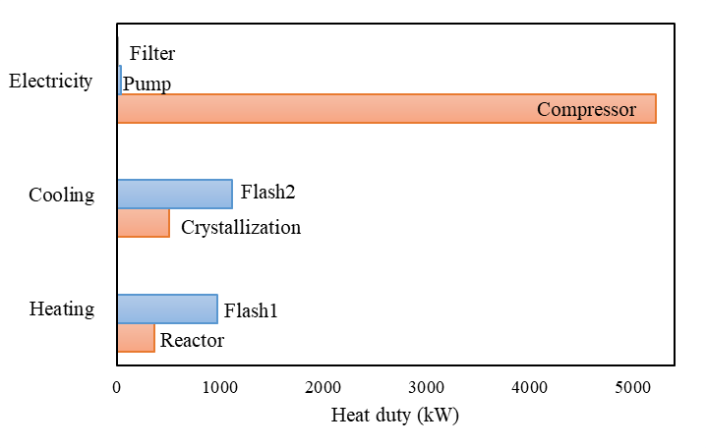

Figure 2: Distribution of energy consumption in the FDCA production process from the HMF oxidation using air as oxidant.

Table 2: Results obtained from process simulation of FDCA production.

|  |  |  |  |  |  |  |  |  |  |
| --- | --- | --- | --- | --- | --- | --- | --- | --- | --- |
| **Variables** | **Unit** |  | **Stream** | | | | |  | |
|  |  | **1** | | **5** | **6** | **7** | **16** | | **17** | |
| Temperature | °C | 25 | | 404.88 | 100 | 150 | 25 | | 25 | |
| Pressure | bar | 1 | | 10 | 10 | 9.5 | 2.5 | | 2.5 | |
| Mass flow rate | tons/day | 79.71 | | 1232.5 | 3530.1 | 1422.87 | 1422.87 | | 12.92 | |
| Mass faction | (-) |  | |  |  |  |  | |  | |
| HMF |  | 0.1311 | | 0 | 0.0002 | 0.0006 | 0.0006 | | 1.15e-5 | |
| Acetic acid |  | 0.3952 | | 0 | 0.2518 | 0.4407 | 0.4407 | | 0.0089 | |
| Water |  | 0.4742 | | 0 | 0.3885 | 0.5459 | 0.5452 | | 0.0110 | |
| FDCA2- |  | 0 | | 0 | 0.0039 | 0.0096 | 0.0008 | | 1.65e-5 | |
| FDCA |  | 0 | | 0 | 0.0000 | 0.0000 | 0.0089 | | 0.9800 | |
| FFCA |  | 0 | | 0 | 0.0005 | 0.0012 | 0.0012 | | 2.36e-5 | |
| DFF |  | 0 | | 0 | 0.0001 | 0.0003 | 0.0003 | | 5.080e-6 | |
| H+ |  | 0 | | 0 | 5.07e-5 | 0.0001 | 1.08e-5 | | 2.19e-7 | |
| N2 |  | 0 | | 0.8104 | 0.2880 | 0.0016 | 0.0016 | | 3.22e-5 | |
| O2 |  | 0 | | 0.1865 | 0.0669 | 0.0008 | 0.0008 | | 1.56e-5 | |

The energy consumption in the FDCA production from the HMF oxidation using air as an oxidant is presented in Figure 2. From Figure 2, the compressor’s energy consumption is the highest at 63.52% of total energy consumption because of the high excess air at the air-to-liquid feed ratio of 100 required for the HMF oxidation reaction to obtain high HMF conversion. Consequently, the energy consumption of flash2 and flash1 to separate the remaining oxygen from a liquid product is about 13.60% and 11.83% of total energy consumption. When considering the energy consumption type, flash1 and reactor require heating duty while cooling utilities are crystallizer and flash2. Compressor, pump, and filter require electrical energy consumption. The overall reaction of HMF oxidation as an endothermic process requires a heating duty of 361.43 kW for producing FDCA of 12.22 tons/day. The crystallizer requires a cooling duty of about 506.65 kW to crystallize FDCA solid.

Electricity is a high-cost utility, compared to heating duty and cooling duty. To reduce the electricity of the compressor, the multistage compressor takes the place of a single compressor for increasing the pressure of air before feeding to the reactor. Figure 3 shows the effect of cooler temperatures on the total cooling duty and electricity consumption of the compressor at various compressor stages. For considering the influence of a multi-stage compressor, the isentropic efficiency of the compressor is 72%, and the pressure discharge of the final compressor of 10 bar. From Figure 3, the decrease in cooling temperature of heat exchange in the middle of compressors decreases the overall electricity consumption of the compressor whereas the cooling duty of the heat exchanger increases. For varying the stages of the compressor, the increase in the stage of the compressor decreases the electricity consumption. The electricity consumption of a multi-stage compressor of 5 is higher than that of a multi-stage compressor of 4 at the upper cooling temperature of 90 °C. Thus, the increase of the compressor stage cannot reduce power consumption at a high cooling temperature. However, the electric energy consumption of the five-stage compressor at the cooling temperature of 50 °C is the lowest and can be reduced by 21.31% when comparing the single-stage compressor.

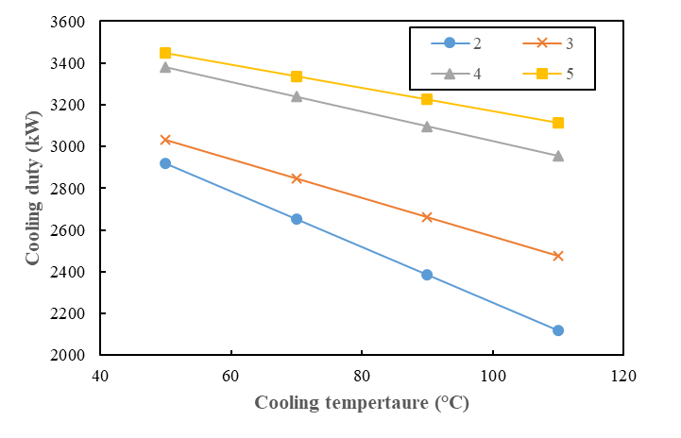

(a)

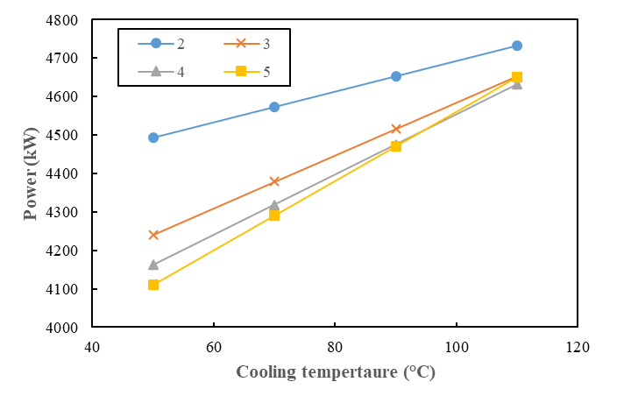

(b)

Figure 3: Effect of cooler temperature in the multi-compressor on (a) cooling duty and (b) electricity consumption of the compressor.

* + 1. Simulation results of FDCA production using oxygen as an agent

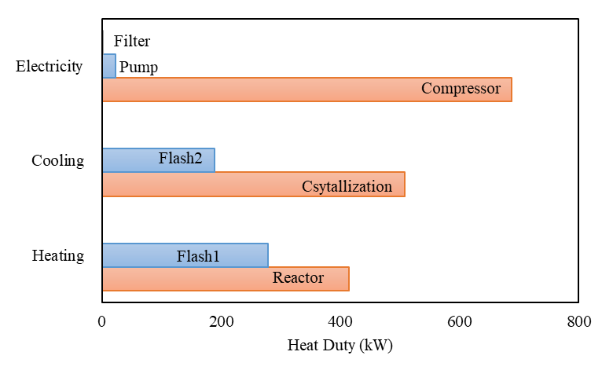

Figure 4: Energy consumption of units in the FDCA production process from the HMF oxidation using pure oxygen as an oxidant.

For the simulation of the FDCA production process using pure oxygen as an oxidant, the amount of oxygen fed to the reactor was specified as the same as the process using air as an oxidant. Five-stage compressor with the cooling between stages at the temperature of 50 °C was considered for the simulation of the FDCA production process using pure oxygen. Figure 4 shows the energy consumption of the FDCA production process using oxygen as an oxidant. From Figure 4, the electrical energy consumption of the compressor in the FDCA production process using pure oxygen as an oxidant is 687.67 kW which is substantially lower than that of using air as an oxidant at a five-stage compressor. Moreover, the use of pure oxygen can reduce the cooling energy consumption of coolers between multi-compressors and flash2 by about 99% and 82.26%, respectively. The use of pure oxygen substituting for using air as an oxidant in the conversion of HMF to FDCA can reduce the gas flow rate of the overall process. This results in decreasing in the power consumption of the compressor and heat duty of heat exchangers and flash.

* 1. Conclusions

This work studied the FDCA production process by combining FDCA synthesis from HMF, FDCA separation, and solvent recovery, simulated by using Aspen Plus software. The efficiency improvement of the FDCA production process to increase the FCDA yield and decrease energy consumption was studied. The simulated results found that the amount of fresh water and acetic acid in the feed was reduced by 96.45% and 97.24% with recycling solvent from the filter. The solvent recovery in the FDCA product process can also recycle the remaining HMF, DFF, and FFDCA which increases the amount of FDCA product, compared to the process without solvent recovery. In the FDCA production process, excessive air is required for the HMF oxidation reaction. The electrical energy consumption of the compressor is high about 5222 kW for the FDCA product of 12.66 tons/day. To reduce electrical energy consumption, the multi-stage compressor was considered to replace the single-stage compressor. The electricity consumption decreases with increasing the stage of the compressor and decreasing the cooling temperature in the middle of the compressors. The five-stage compressor can reduce electricity consumption by 21.31%. When comparing the FDCA production processes using air and pure oxygen as an oxidant, the electricity consumption of a five-stage compressor in the process using pure oxygen is significantly lower than that using air. The energy consumption of coolers and flash in the process also decreases when using pure oxygen instead of using air as an oxidant. Nevertheless, the use of pure oxygen increases the cost of FDCA production. The economic analysis of the FDCA production process to evaluate the suitability of pure oxygen should be considered in future work.

Acknowledgments

This work was financially supported by (i) Burapha University (BUU), (ii) Thailand Science Research and Innovation (TRSI), and (iii) National Science Research and Innovation Fund (NSRF) (Fundamental Fund: Grant no. 432/2566). Additional thanks to the Research and Innovation Administration Division and Faculty of Engineering, Burapha University.

Reference

Davis S.E., Houk L.R., Tamargo E.C., Datye A.K., Davis R.J., 2011, Oxidation of 5-hydroxymethylfurfural over supported Pt, Pd and Au catalysts, 160(1), 55-60.

Deshan A.D.K., Atanda L., Monghaddam L., Rackemann D.W., Beltramini J., Doherty W., 2020, Heterogeneous catalytic conversion of sugars into 2,5-Furandicarboxylic acid, Frontiers in Chemistry, 8, 659.

Gong W., Zheng K., Ji P., 2017, Platinum deposited on cerium coordination polymer for catalytic oxidation of hydroxymethylfurfural producing 2,5-furandicarboxylic acid, RSC Advances, 7, 34776-34782.

Junior M.M.J., Rodrigues F.A., Costa M.M., Guirardello R., 2022, Economic Evaluation for Bioproducts Production from Carbohydrates Obtained from Hydrolysis of Sugarcane Bagasse, Chemical Engineering transactions, 92, 703-707.

Kim T., Bamford J., Gracida-Alvarez U.R., Benavides P.T., 2022, Life Cycle Greenhouse Gas Emissions and Water and Fossil-Fuel Consumptions for Polyethylene Furanoate and Its Coproducts from Wheat Straw, ACS Sustainable Chemistry & Engineering, 10(8), 2830-2843.

Liga M., Hallen R.T., Hu J., White J.F., Gray M.J., 2011, Hydroxymethyl furfural oxidation methods. U.S: 8193381.

Pandey S., Dumount M.J., Orsat V., Rodrique D., 2021, Biobased 2,5-furandicarboxylic acid (FDCA) and its emerging copolyesters’properties for packaging applications, European Polymer Journal, 160, 110778.

Saha B., Dutta S., Abu-Omar M.M., 2012, Aerobic oxidation of 5-hydroxylmethylfurfural with homogeneous and nanoparticulate catalysts, Catalysis Science & Technology, 2(1), 79-81.

Santiago B.L.S., Guirardello R., 2020, 5-Hydroxymethylfurfural Production in a Lignocellulosic Biorefinery: Techno-economic Analysis, Chemical Engineering transactions, 80, 139-144.

Verdeguer P., Merat N., Gaset A., 1993, Oxydation catalytique du HMF en acide 2,5-furane dicarboxylique, Journal of Molecular Catalysis, 85(3), 327–344.

Wang Z., Wang J., Pang Y., Zhu J., Zheng W., 2022, Dependence of the foaming window of poly(ethylene terephthalate-co-ethylene 2,5 furandicarboxylate) copolyesters on FDCA content, Polymer, 254, 12501.

Zhu B., Chen, C., Huai L., Zhou Z., Wang L., Zhang J., 2021, 2,5-Bis(hydroxymethyl)furan: A new alternative to HMF for simultaneously electrocatalytic production of FDCA and H2 over CoOOH/Ni electrodes, Applied Catalysis B: Environmental, 297, 120396.