CHEMICAL ENGINEERING TRANSACTIONS  VOL. , 2023 | A publication of
The Italian Association
of Chemical Engineering
Online at www.cetjournal.it

Guest Editor: Sauro Pierucci
Copyright © 2023, AIDIC Servizi S.r.l.
ISBN 978-88-95608-98-3; ISSN 2283-9216

Mix Design of Geopolymeric Formulations for Environmentally Sustainable Structural Applications
Paola Meloniª, Gianfranco Carcangiu^{b}, Roberta Licheri^{a,c}*
ªDepartment of Mechanical, Chemical and Materials Engineering, University of Cagliari, Via Marengo 2, 09123 Cagliari, Italy
^{b}Institute of Atmospheric Sciences and Climate ISAC-CNR, via Piero Gobetti 101, Bologna 40129, Italy
^{c}Interdepartmental Centre of Environmental Science and Engineering (CINSA), University of Cagliari, Via San Giorgio 12, 09124 Cagliari, Italy
*roberta.licheri@unica.it
Traditional binders, such as Ordinary Portland Concrete, suffer for hygrometric shrinkage and require high production temperature, involving high energy consumption. It is therefore necessary an integrated approach, leading to new solutions for the optimization of the physical and mechanical characteristics of alternative binders, raw materials, by-products and for the implementation of the available technologies.
The present work aims to explore the field of binders obtained by geopolymerisation, which has been gaining increasing interest in recent years, due to their lower process temperatures compared to traditional cementitious binders, and their reduced carbon footprint. Geopolymers could represent valuable alternative to products normally used in mortars and concrete production. Their use as a printing material in 3D printing technology is also promising in the field of sustainable construction for the valorisation of wastes from building industry and the production of high quality and readily available products.
In this work, a basic geopolymer mix design is proposed to meet the specific requirements dictated by the 3D extrusion printing process. Alkali activated metakaolin and fly ash are considered as binders. Powders of marble waste are selected as aggregate for the achievement of both functional and high aesthetic value in the final products.
  - Introduction
Geopolymers refer to a class of inorganic compounds having a polymeric structure (Davidovits, 2017). They are typically obtained by alkali chemical activation reaction starting from an aluminosilicate source, through a process called geopolymerization. Although the reaction mechanism is not yet clearly understood (Rahier et al., 2007), it is generally accepted that the first step consists in a hydrolysis reaction, with the dissolution of aluminosilicate materials in an alkaline solution at room temperature, to form a three-dimensional amorphous network, almost like a zeolitic structure. Only the amorphous component solubilizes while the semi-crystalline phase, being much more chemically resistant, is only superficially activated with possible detachments of alumina or silica tetrahedron (Cong and Cheng, 2021).
Dissolution results in a sol, with solid particles of starting components suspended into a liquid phase. A gel is subsequently formed through polycondensation of isolated monomers to form lattices of [Si(OH)₄] and [Al(OH)₄]⁻ tetrahedron connected by oxygen molecules (Lee et al., 2020). Curing and hardening processes involve migration of water, obtained as by-product, and xero-gel formation. At this stage, drastic evaporation of water must be limited to avoid the formation of zones with different densities, which would lead to stress conditions on the final structure (Cong and Cheng, 2021).
Another fundamental issue to be mentioned is the balance of oxides during the polymerizations steps of the alkaline activated system to achieve a complete polymerization and the compensations of electrical charge by Na⁺ ions (Geraldes et al.,2016). Subsequently types and proportions of activators should be also carefully considered for the obtainment of a workable and extrudable mixture to withstand mechanical load and avoiding system failure during fast layer consolidation (Buswell et al., 2018).
Metakaolin, fly ash, and ground-granulated blast-furnace slags (GGBS) are commonly used as precursors and then alkali-activated Metakaolin is a high valuable material extensively used in the ceramic industries. One of the most important requirements is a high white grade for aesthetic appearance obtainable at high grade of kaolinite (Wu et al., 2019) and low content of chromophore (i.e., Fe, Mn, Co) constituents (Cara et al., 2006).
Fly Ash is a by-product from thermoelectric plants, produced in huge quantities and, as in the case of blast furnace slag, hardly finds relocation in the building construction industry (Wu et al., 2019).
Since early 1980s, geopolymers have been considered as an environmentally friendly alternative to Ordinary Portland Cement (OPC), both for the lower carbon footprint and good strength and durability, comparable to that of traditional ceramics sintered at high temperatures (Xia and Sanjayan, 2016). Specifically, metakaolin (MTK) based geopolymers can be obtained at relatively low temperature (at about 650°C 700°C) and could incorporate waste materials or by-products such as fly ash or blast furnace slag (Tigue et al., 2021). They exhibit, durability, low shrinkage, chemical and high temperature resistance, that make them attractive for use in the building industry (Wasim et al., 2021).
On the other hand, 3D printing technology is recognised as promising in in the field of sustainable building construction aimed to the exploitation of resources for the obtainment of high quality and readily available products (Buswell et al., 2018). In this respect, geopolymers emerge as promising and valuable printing materials to produce components and building elements.
The performance of printing materials is undoubtedly a critical aspect of the entire printing process, being strongly influenced by deposition conditions (i.e., time and printing directions). The design of suitable geopolymeric mortars feedstock for 3D extrusion printing, with short curing time and high self-supporting capacity, becomes a priority to give product with required properties (Panda et al., 2017). Starting from characterization components (aggregates, additives, alkaline activators, etc.), some mortar mixes are formulated in this preliminary work to identify the best ones for further development and specific uses in 3D extrusion process for building construction. Specifically, metakaolin and waste from the thermoelectric industry, such as fly ash, are used as binders, while marble sawing sand is used as aggregate. This choice allows the recycle of a material that represent a serious environmental hazard, and, at the same time, the obtainment of functional and aesthetical products.
  - Experimental
Characteristics of materials used in this work are reported in Table 1. Geopolymer mortars (GPM) were prepared with aggregate/binder weight ratio of 4:1, to maximize the use of marble sand waste as aggregate. Activation of the starting mix was achieved using NaOH solutions of different molarity (5, 8, 10 M). Only mixtures from 10 M solution resulted in cohesive bonding mass with rapid hardening, low shrinkage, and good 3D printability. Liquid to solid (L/S) ratio was varied in the range 0.34-0.56 while the SiO₂/Al₂O₃ molar ratio was changed from 2 up to 10, when partially or totally replacing MTK with Fly Ash. In this work Calcic Hydraulic Fly Ashes (W HFA) from thermoelectric plant were used.
Preliminary screening tests of mix design were made and then the most promising ones were considered in this work (Table 2). Better mixtures for the specific objective (3D extrusion printing) were poured into cubic and prismatic steel moulds to assess linear shrinkage and other mechanical properties during curing time.
Ultrasonic transit pulse velocity (USv) was measured using the portable P.U.N.D.I.T. apparatus (Farrel SNC), equipped with emitting and receiving cylindrical transducers (3.5 cm diameter) with frequency of 150 kHz.
Skeletal and bulk density were measured by a He pycnometer (Micromeritics Accupyc II) on free-macroscopic defects samples and hydrostatic balance respectively.
Capillary water absorption tests (cubic samples, 5 cm side) were performed following the UNI EN 15801:2010 standard. Open porosity (%) and pore size distribution was obtained by Mercury Intrusion Porosimetry - MIP (Micromeritics Autopore IV) on irregular centimetric specimens.
Morphological and structural characterization was performed by SEM microscopy (Zeiss Evo LS 15) on polished thin sections.
Uniaxial compressive strength tests were measured on cubic specimens at 25 °C and UR 65-70%, and on samples subjected to sensitization with aqueous solution at 25 °C for prolonged contact times (t > 800 h capillarity uptake + 7 days total water saturation).
Laboratory extrusion mortars tests were performed through a ram extruder consisting of a syringe (1 cm diameter nozzle) and a plunger, allowing for a constant extrusion flow rate of the GPM.

Table 1: Materials used for the preparation of GPM
Starting materials | function | notes
Calcium carbonate  CaCO₃ | Aggregate | Marble sand  < 2 mm (Bresciani srl, Italy)
Metakaolin (MTK)  Al₂O₃ + SiO₂ (95 wt %) | Binder | Argicall M 1000 (Bal-Co)  Particle size D₅₀ =2 µm
Calcic Lime | Binder | Calcic Lime CL90 from  Calcidrata S.p.A. (Samatzai, Cagliari, Italy)
Ca-Fly Ash  SiO₂ + Al₂O₃ + Fe₂O₃ (30.4 wt %) | Artificial pozzolan | By-product from thermoelectric industry  (EON, Porto Torres, SS, Italy)
Sodium Hydroxide 10M | Alkali activator | -
Table 2: Selected mortars for 3D extrusion printing
Mix design | Aggregate | Binder s | L/S wt ratio
M25 | CaCO₃ | MTK | 0.560
M26 | CaCO₃ | MTK+W-HFA | 0.341
M28 | CaCO₃ | MTK+W-HFA+CL90 | 0.441
M37 | CaCO₃ | W-HFA | 0.358
  - Results
Figure 1 shows USv values of different mixtures after 1, 3, 7, 14 and 28 curing days. The transit rate increased slightly up to 7 days for all considered sample, then it stabilized at a constant value (about 2,700 – 3,000 m/s). This finding suggests the achieved structural stability being USv dependent on changes in microstructure, bulk density and materials porosity. To evaluate the effect of soluble phases, even expansive phases (i.e., sodium carbonate salts), responsible for mechanical detriment, USv was measured also on samples subjected to prolonged water stress, until complete saturation. Selected systems proved to be quite stable also after long water contact time (> 7 days). After 28 days of curing, samples prepared with MKT binder showed a skeletal density in a narrow range between 2.30-2.36 g/cm³. On the other hand, when W-HFA content increased, density decreased reaching the minimum value (1.60 g/cm³) when only fly ashes were used. Analogous trends were observed when considering bulk density and MIP pore size distribution (Figure 2).
MTK based mortars showed a bimodal pore size distribution with micro and sub-micrometric voids (0.30 - 0.02 μm). Specifically, MTK systems exhibited a lower porosity and a distribution shifted towards smaller voids, with respect to the W-HFA homologue.
Secondary electron (SE) SEM images for different mortars are shown in Figure 3. Some micro-cracks were observed within the matrix and grains. Alongside the development of the geopolymer matrix, it was found that porosity increased with W-HFA content.
Water capillary uptake (i.e., Absorption Coefficient C.A. and M* Asymptotic final value) are described in Figures 4a – 4b. The C.A. values refer to the slope of the quite linear segment of uptake absorption curves, while M* is the final asymptotic value (M*; t > 800 h), UNI EN15801:2010. Mix 25, 26 and 28 were characterized by low C.A. and M* values because of their low open water porosity, 11.2%, 9.8% and 14.9% respectively. In turn, mix 37 was characterized by significant higher value (18.2%).
Compressive uniaxial strength (CS) tests were conducted on both normally cured and water stressed specimens. Mechanical strength is undoubtedly conditioned by the aggregate content and microstructure (intergranular micro-fractures and open boundaries grains) strictly related to the marble original granoblastic texture (Azarsa and Gupta, 2020). A further contribution to mechanical strength deriving from the pozzolanic reaction could also be considered in the mixture containing MTK and Lime (system 28). Systems subjected to longer water contact show a significant decrease in compressive strength as compared to normally cured ones, due to a weakening effect on the binding matrix. As previously mentioned, apart from the case of the sample 37 (W-HFA), USv were slightly higher in normally cured samples, resulting in more compact and homogenous mortars (Table 3).

Figure 1: USv for samples obtained with MTK (M25), with MTK partially and totally substituted by W-HFA (M26, M28, M37), after 1, 3, 7, 14 and 28 curing days

Figure 2: MIP pore size distribution for selected samples (28 days curing)

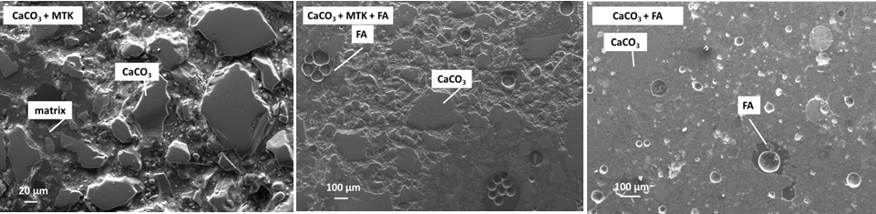

Figure 3: SEM thin section micrographs for different geopolymers prepared with MTK and or W-HFA as aggregate (28 days curing). Signal from secondary electrons

(b)
(a)

Figure 4: Water uptake absorption for selected mortars, (a) Absorption Coefficient C.A., and (b) asymptotic final absorption value (M*) at t = 850 h

Table 3: Compressive strengths CS, US_{V} and Δ% values for selected GPM samples
Samples | CS [MPa]  Ordinary cured | USv [m/s]  Ordinary cured | ΔCS %  Water stressed | ΔUSv %  Water stressed
25 | 14.5 | 2,793.3 | -1.38 | -2.61
26 | 21.6 | 2,994.0 | -20.8 | -4.02
28 | 21.8 | 2,979.2 | -22.1 | -4.64
37 | 13.4 | 2,890.2 | -26.9 | -9.90

Geopolymeric mortars for printing were selected based on physical-mechanical performance of corresponding hardened products. Although automated deposition (Buswell et al., 2018) is required to keep the extrusion process constant and achieve dimensionally stable parts over time, the adopted method provided valid description of mortars rheological behaviors. The best result was obtained with mix 28, that showed sufficient flowability, developing a good hardening and self-supporting capacity within short time interval. Mortars 25 and 26 resulted in less homogeneous extrusion and high stiffness due to fast setting time (Figure 5), leading to the decay of the adhesion properties between layers and low mechanical properties (Panda et al., 2017).

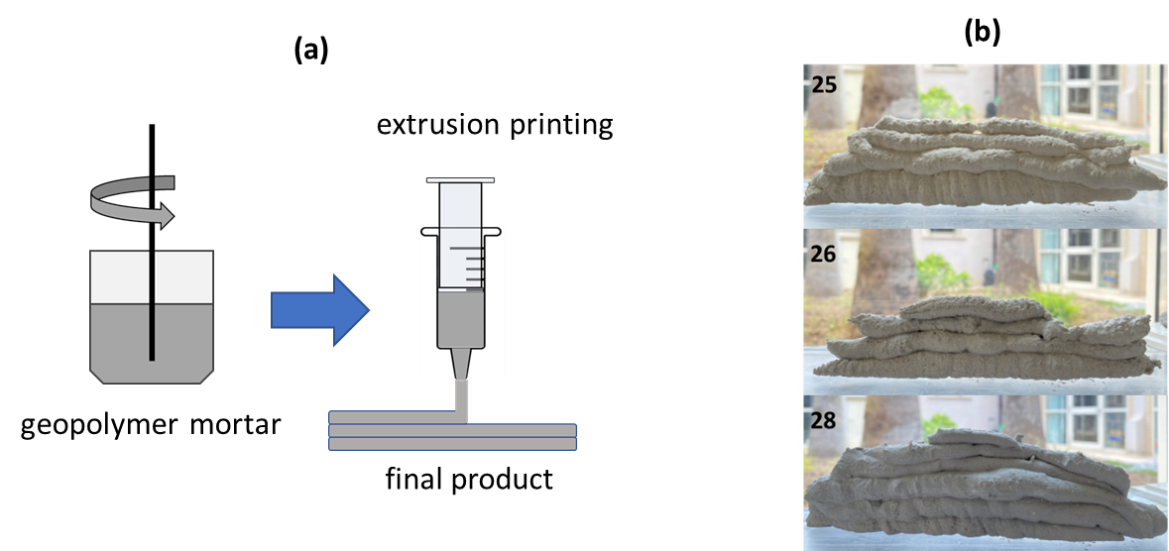

Figure 5: Extrusion printing, (a) set-up used in this work, (b) visual aspect of printed mortars

Conclusions
Quarries industry sawing wastes represent an environmental and human health hazard, especially in highly exploited areas such as the Carrara marble basin. The present work described preliminary investigation on the use of marble sand wastes in combination with metakaolin and calcic fly-ash for the development of sustainable geopolymeric mortars to be employed in 3D extrusion printing.
A worst-case scenario was considered in choosing the aggregate content which exceeds the standard ratio used in traditional mortars. The quality of aggregate was critical due to intrinsic defects related to the granoblastic marble texture. Also, calcic fly ashes with lower and hydraulically active SiO₂ and Al₂O₃ amounts, than those more commonly used in OPC-based concrete, were used.
Mixtures workability was found to be affected by their composition. The partial replacement of the MTK with variable percentages of W-HFA (max 20% by weight) has not significantly altered the Liquid/Solid ratio and workability leading to a smooth and flowable systems. GPM mortars were mechanically tested before and after a water sensitization, to evaluate their stability. A loss in compressive strength was observed for systems affected by salt crystallization.
Although examples of better-performing mixtures are found in the literature, this work was targeted to design mixtures for sustainable use of marble waste in the 3D extrusion printing technology.
The main critical issues associated with this specific application were identified. It is essential that GPM were able to properly flow during the layer deposition steps. Once extrusion is completed, mortars should develop fast setting and rapid reaction development, for the achievement of suitable load bearing capacity when successive layer is added.
Although still preliminary, results obtained in this work are promising for future applications of geopolymers. The building construction, with incorporation up to 80% of carbonate scraps in mortars, could concern the modular creation of artificial stone architectural elements, coatings, interiors design and urban furniture.
Further investigations will have certainly to be focused on understanding reaction mechanism, kinetics, and the specific role of chemicals. Other important features to be addressed will be durability and resistance to atmospheric and chemical agents, minimum shrinkage, and resistance to wear or other stress actions induced by machinery (i.e., milling, impact, cutting or drilling) during customizing step.
References
Azarsa P., Gupta R., 2020, Comparative Study Involving Effect of Curing Regime on Elastic Modulus of Geopolymer Concrete, Buildings, 10, 101.
Buswell R.A., Leal de Silva W.R., Jones S.Z., Dirrenberger J., 2018, 3D printing using concrete extrusion: A roadmap for research, Cement and Concrete Research, 112, 37-49.
Cara S., Carcangiu G., Massidda L., Meloni P., Sanna U., Tamanini M., 2006, Assessment of pozzolanic potential in lime–water systems of raw and calcined kaolinic clays from the Donnigazza Mine (Sardinia–Italy), Applied Clay Science, 33, 66-72.
Cong P., Cheng Y., 2021, Advances in geopolymer materials: A comprehensive review, Journal of Traffic Transportation Engineering (Engl. Ed.), 8(3) 283-314.
Davidovits J., 2017, Geopolymers: Ceramic-Like Inorganic Polymers, Journal of Ceramic Science and Technology, 8(3) 335-350.
Geraldes C. F. M., Lima A. M., Delgado-Rodrigues J., Mimoso J.M., Pereira S. R. M., 2016, Geopolymers as potential repair material in tiles conservation, Applied Physics A, 122:197.
Lee W.H., Lin K.L., Chang T.H., Ding Y.C., Cheng T.W., 2020, Sustainable Development and Performance Evaluation of Marble-Waste-Based Geopolymer Concrete, Polymers, 12, 1924.
Panda B., Paul S.C., Hui L.J., Ta Y.W.D., Tan M.J., 2017, Additive manufacturing of geopolymer for sustainable built environment, Journal of Cleaner Production, 167, 281-288.
Rahier H., Wastiels J., Biesemans M., Willlem R., Van Assche G., Van Mele B., 2007, Reaction mechanism, kinetics and high temperature transformations of geopolymers, Journal of Materials Science, 42(9), 2982–2996.
Tigue A.A.S., Longos A. L.Jr., Malenab R.A. J., Dollente J.R.I., Promentilla M.A.B., 2021, Compressive Strength and Leaching Characteristic of Geopolymer Composite from Coal Fly Ash and Nickel Laterite Mine Spoils, Chemical Engineering Transactions, 88,1165-1170.
Wasim M., Tuan Duc Ngo, Law D., 2021, A state-of-the-art review on the durability of geopolymer concrete for sustainable structures and infrastructure, Construction and Building Materials, 291, 123381.
Wu Y. et al., 2019, Geopolymer, green alkali activated cementitious material: Synthesis, applications and challenges, Construction and Building Materials, 224, 930-949.
Xia M., Sanjayan J., 2016, Method of formulating geopolymer for 3D printing for construction applications, Materials and Design, 110, 382-390.

