CHEMICAL ENGINEERING TRANSACTIONS  VOL. , 2023 | A publication of
The Italian Association
of Chemical Engineering
Online at www.cetjournal.it

Guest Editor: Sauro Pierucci
Copyright © 2023, AIDIC Servizi S.r.l.
ISBN 978-88-95608-98-3; ISSN 2283-9216

Exploring the Impact of Repetitive Exercise on Physical Fatigue: A Study of Industrial Task Simulation in a Controlled Fitness Setting
Carlos Albarrán Morillo*, Micaela Demichela
Department of Applied Science and Technology, Politecnico di Torino, Italy
carlos.albarran@polito.it
The human element plays a crucial role in industries, particularly manufacturing and process. Effective management of human factors improves product quality and efficiency while reducing the risk of operational errors that may result in incidents or accidents. Even with the advancements in technology and automation, repetitive manual work and challenging tasks still strain workers, resulting in physical fatigue and increasing the chances of errors, production delays, and potential accidents. For this reason, the significance of physical fatigue on industry operations and employee well-being cannot be overstated. The implementation of wearable technology to handle physical fatigue in the industry is a cutting-edge solution. Wearable devices provide real-time data on worker physical fatigue levels, allowing employers to respond quickly to any changes in conditions that may increase the risk of accidents in the wokplace. This paper aims to present a framework for a fitness setting that simulates the repetitive movements commonly seen in the industrial sector. The data collected in this controlled environment will be used to train a physical fatigue classification model, which can then be applied in real-world industrial facilities to advance operator safety and reduce the risk of workplace accidents in future applications.

  - Introduction
Managing physical fatigue is crucial in the workplace. Repetitive manual tasks and material handling can cause fatigue in operators, leading to decreased performance and increased risks of casualties in the work environment (Valentina et al., 2018). Further, over time, physical fatigue can result in more severe illnesses such as Chronic Fatigue Syndrome (CFS) and Work-related Musculoskeletal Disorders (WMSDs). CFS is a long-term condition characterized by extreme fatigue that is not relieved by rest and may worsen with physical or mental activity (Balachander et al., 2014). WMSDs are a group of conditions that affect the muscles, nerves, and tendons and are caused or made worse by work-related activities, such as repetitive manual tasks, prolonged periods of uncomfortable postures, and exposure to vibration (Punnett and Wegman, 2004). These disorders cause pain and discomfort and lead to long-term disabilities, affecting the well-being of workers (Younan et al., 2019). Therefore, it is imperative to manage physical fatigue to maintain a safe and efficient work environment, protect the well-being of workers, and boost the organization's success through high-quality production and efficiency (Sadeghniiat-Haghighi and Yazdi, 2015). Managing physical fatigue can be done using both subjective and objective measures (Völker et al., 2016). Subjective measures involve asking workers to self-report their fatigue levels, usually through surveys or interviews. These methods rely on the worker's perception of fatigue and may be influenced by factors such as motivation, mood, or cultural differences. On the other hand, objective measures include wearable devices (Moshawrab et al., 2023) or other technology to physically monitor and track indicators of fatigue, such as heart rate, skin temperature, and muscle activity. These measures provide a more precise representation of the worker's physical state and are less affected by subjective tendencies (Luo et al., 2020). Some wearable devices, such as those that require electrical connections or wires, can be intrusive and interfere with the worker's activities and movements, resulting in discomfort, reduced compliance, and even safety hazards in the workplace. One example of an intrusive wearable device is an EEG (electroencephalogram) headset, which requires the placement of electrodes on the scalp to measure brain activity. This device can be uncomfortable for extended periods and may interfere with a worker's activities and movements, making it less suitable for real-time monitoring in an industrial setting. On the other hand, non-invasive wearable devices, such as wristbands or smartwatches, are more comfortable, convenient, and safer to use for extended periods, making them the preferred choice for managing physical fatigue in industrial settings (Yu et al., 2019).
This research aims to explore the relationship between repetitive exercises and physical fatigue by conducting a controlled study in a fitness environment. The setup will simulate industrial tasks by having participants perform repetitive exercises similar to those in actual industrial settings. Physiological indicators, such as heart rate, breath rate, and skin temperature, will be measured to classify the participants' physical fatigue levels. Additionally, subjective measures, such as surveys or interviews, will gather participants' perceptions of fatigue. The results of this study will contribute to understanding the impact of repetitive motions on the human body. By collecting data on various physiological indicators and subjective perceptions of physical fatigue, the study will train a physical fatigue classification model that will be used to better understand and manage physical fatigue in future applications in the workplace.
In the subsequent sections, the paper presents a theoretical foundation for a physical fatigue classification system. Then, the model's practicality is demonstrated through a controlled fitness environment that mimics repetitive industrial tasks. Finally, the fitness setup's limitations and potential future applications in industrial settings are discussed.
  - Comprehensive model of physical fatigue classification
In this benchmark, an automated system for detecting physical fatigue levels was created using data from a smartwatch, the Empatica EmbracePlus. This device was designed to be worn comfortably in everyday activities and does not inhibit the wearer's ability to perform their job. Instead, the system collects information from various physiological signals, such as heart rate, breathing patterns, skin conductivity and temperature, and movement using respectively, a photoplethysmography (PPG) sensor, an electrodermal activity (EDA) sensor, a temperature sensor and accelerometers. The data is preprocessed using proprietary algorithms to extract specific digital biomarkers and metrics that provide physiological and behavioral state information. The digital biomarkers have an aggregated per-minute resolution. Finally, Empatica provides software tools and APIs for researchers to access and analyze the data collected by EmbracePlus. Using this data, the proposed framework employs classification algorithms to classify physical fatigue levels into three or five categories (see Figure 1).

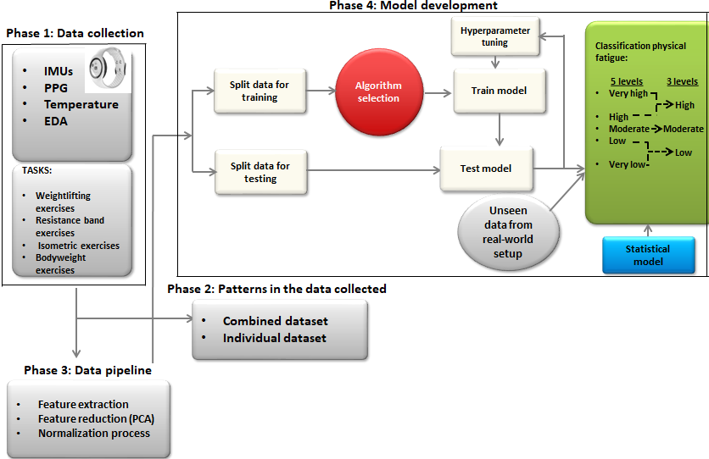

Figure 1: Overall flowchart of the proposed model
The model is developed using a combination of deep neural networks, including Convolutional Neural Networks (CNNs), Recurrent Neural Networks (RNNs), and fully connected layers (Ebrahimian et al., 2022). The training and a first testing of the model will be conducted using physiological data collected from a controlled fitness environment. The collected data will be preprocessed by performing feature extraction and reduction employing Principal Component Analysis (PCA), and normalization. The model's performance will be evaluated using metrics such as accuracy, precision, recall, and F1-score, and hyperparameter tuning will be conducted to optimize the model's performance. Besides, the study will investigate the potential benefits of incorporating Bayesian inference into the deep learning structure to improve the model's robustness and interpretability. Further, physiological data collected during physical activity could reveal fatigue and physical performance changes. These changes may include increased heart rate, respiration rate, and skin temperature. So, the framework will also analyse combined and individual datasets to identify common trends and patterns related to physical fatigue.
  - Simulated industrial tasks in a fitness setup
This research investigates the correlation between repeating physical exercises and physical fatigue through a controlled experiment in a fitness setting by measuring physiological indicators. In addition, employing this fitness setting, that simulates the repetitive motions commonly seen in industrial settings, is a viable method for collecting data to train the physical fatigue classification model previously discussed. This approach provides the machine learning algorithm with examples similar to those it will encounter in real-world industrial environments. Using a fitness setup allows for collecting large amounts of data in a consistent and controlled manner, minimizing noise and variability. Moreover, it reduces the risk of exposing participants to hazards commonly found in industrial settings.
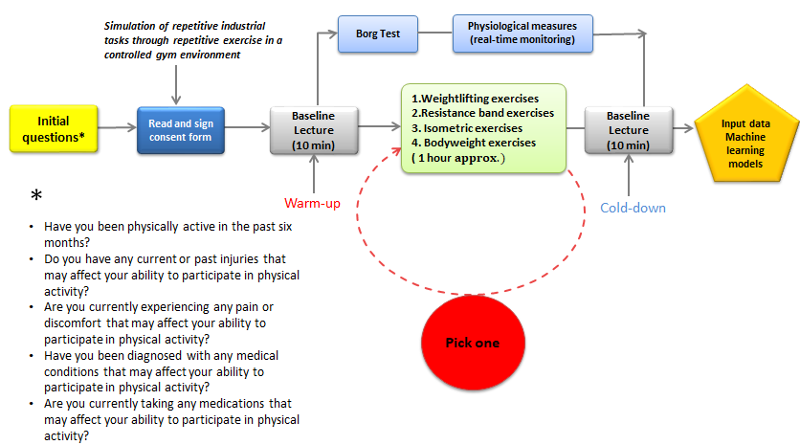
Figure 2: Data collection procedure in the fitness setup
    - Participants selection
One way to avoid any injuries or health hazards is to choose participants with a good fitness level and a willingness to participate who are familiar with weightlifting exercises and can handle heavy weights. These participants will be able to lift heavier weights and perform more repetitions, increasing the level of physical fatigue and providing more realistic data for the model. Besides, splitting the participants into groups is beneficial based on the type of exercise they will perform and their preferences. This way, each participant will be more likely to enjoy their exercises and be more motivated to continue the program. Some initial questions (Figure 2) will be used to confirm a participant's fitness level and identify any current or past injuries, pain or discomfort, medical conditions, medications, and clearance from a medical professional that may affect their ability to participate in the physical activity of the fitness setup.
    - Ethics
Each participant will receive an informed consent form that describes the nature of the research, the benefits, the risks, and the alternatives. In addition, it allows the participant to make an informed decision about whether or not to participate in the study. Politecnico di Torino approved the study protocol following the Declaration of Helsinki.
    - Exercise selection
The following exercises will be utilized safely and effectively to simulate industrial tasks:
- Weightlifting exercises, such as bench press, squats, and deadlifts, target the major muscle groups used in these activities, such as the chest, legs, and back. By recruiting these muscle groups, weightlifting exercises mimic the physical demands of lifting, pushing, and pulling heavy objects.
- Resistance band exercises like rows and bicep curls emulate tasks like pulling and pushing objects. Also, resistance bands are a good alternative because they are portable, lightweight and versatile, providing a range of resistance levels and a variety of exercise that can be performed.
- Isometric exercises, like walls, sits, planks, and bridges, simulate holding objects or maintaining a specific position. Isometric exercises are low-impact and can be done with minimal equipment, making them a good option for those who may have mobility issues or are recovering from an injury.
- Bodyweight exercises, including push-ups, pull-ups, and lunges, simulate climbing, crawling, and bending.
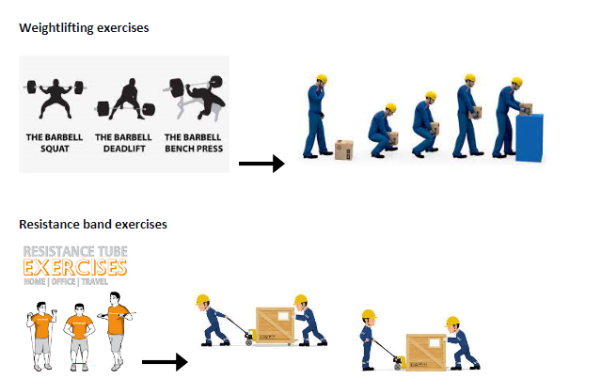

Figure 3: Some proposed exercises and their industrial correspondence task

A proper warm-up routine that includes stretching, low-impact cardio, and dynamic exercises that simulate the movement patterns of the workout is essential to prepare the body for the upcoming workout, reduce the risk of injury and improve performance. Similarly, a proper cool-down routine that includes stretching, low-impact cardio, and breathing exercises are essential to prevent blood from pooling in the legs, reduce muscle soreness, and help the body to return to a resting state.
    - Data collection
The participant will have the ability to select their preferred type of exercise. The exercises they pick will reflect their current fitness level and preferences and will ensure that the participant is comfortable and able to perform the exercises effectively, providing more meaningful data for the study. During the whole physical activity, the participant will wear the EmbracePlus device that will continuously collect data. Capturing real-time physiological data, the EmbracePlus provide insights into the participant's physical performance and the effects of physical fatigue on their body.
In scientific research, baseline measurements are a benchmark for comparing other data. In the context of the fitness setup, baseline measurements are taken 10 minutes before and after the exercises to gather data on the participant's physiological state. These data help establish the participant's starting and ending level of physical fatigue and monitor any changes that have occurred. The total duration of each trial for a participant is estimated to be 1 hour and a half, including also the time taken for the baseline measures.

The physical fatigue classification model is based on supervised learning. It is trained on a labelled dataset from the fitness setting. The labelled data allows the algorithm to learn the patterns that indicate physical fatigue and make predictions based on new, unseen data in real-world setups. The Borg Test (Borg, 1982), also known as the Borg Rating of Perceived Exertion (RPE) scale, is a commonly used tool for rating physical exertion during exercise. During the fitness setup, the Borg Test will employ to label the collected data. Participants are asked to rate their perceived physical exertion on a scale of 6 to 20, with 6 representing no exertion and 20 representing maximum exertion. The Borg test will be conducted during short rest periods between different exercises.
Furthermore, the EmbracePlus is equipped with a 3-axis accelerometer sensor that continuously collects participant movement intensity data. The data collected by this sensor is processed by the ActivityCounts algorithm to estimate the participant's movement intensity. The algorithm outputs an integer value corresponding to a unit defined by Empatica and indicating the movement intensity. This value categorize the data into different physical activity levels, with values less than ten typically indicating stillness and values greater than 100 indicating intense physical activity. By combining the Borg RPE score with the ActivityCounts output, it may be possible to classify physical fatigue levels and label the data more accurately. For example, suppose a participant reports a high level of exertion (high Borg RPE score), and the ActivityCounts algorithm also indicates high-intensity physical activity. In that case, this is classified as a high level of physical fatigue.
This research project will involve the collection of both labelled and unlabeled data. The labelled data will be used to train the model, while the unlabeled data will be held aside for later testing of the model.
  - Potential case studies
After collecting labelled data in the fitness setup, the algorithm can be tested on new, unseen data collected in real-world setups to classify physical fatigue levels. The algorithm will use the patterns it learned from the labelled data in the fitness setup to predict the new data collected. This approach is known as "transfer learning" and allows the model to be used in different settings without being retrained from scratch. The practical applications of this approach include industrial environments, construction sites, and sports and fitness. In industrial environments, workers are often required to perform physically demanding tasks such as heavy lifting or repetitive motions. These tasks can lead to physical fatigue and increase the risk of workplace accidents and injuries. Employees accomplish physically demanding tasks in construction sites, such as digging, shovelling, and lifting. In the sports and fitness industry, athletes and fitness enthusiasts complete physically demanding activities such as running, weightlifting, and other forms of exercise. These activities conduct to physical fatigue and increase the risk of overtraining or improper exercise. The benchmark can identify athletes at risk of physical fatigue and adjust training schedules or intensity accordingly.

A potential application of the physical fatigue detection model in industrial environments could be within the process industry. The process industry refers to the branch of manufacturing involved in producing goods through a chemical or physical process. The process sector includes petrochemical, chemical, pharmaceutical, food and beverage, and oil and gas production and involves specialized equipment and large-scale operations to produce high volumes of goods, and operators are often required to perform repetitive and strenuous tasks, such as operating machinery, handling materials, cleaning and maintenance, monitoring equipment, and conducting quality control checks. For this reason, the process industry duties require monitor and manage workers' physical fatigue to ensure safe and efficient operations. The proposed model for physical fatigue detection is well-suited for industrial environments, including the process industry, because it utilizes smartwatches to collect real-time data. The use of smartwatches to collect data on physical fatigue is considered non-intrusive as they do not interfere with the worker's task execution. This method of collecting data is less disruptive than other techniques that require workers to stop their jobs and participate in a separate measurement process. In addition, including an already training dataset, the model will use transfer learning to apply what it has learned to the new, unseen data collected in the process industry setting. This makes using the model more manageable and more efficient in real-world situations, as it does not require re-labelling of the data.

  - Conclusions and limitations
The study aims to explore the impact of repetitive exercises on physical fatigue by collecting data on physical exertion levels during repetitive exercises in a gym or controlled fitness setting. The collected data will be used to train an algorithm to detect physical fatigue levels. The algorithm can use the patterns learned from the training dataset to make predictions on new, unseen data collected in real-world industrial settings. This approach eliminates the need to collect new labelled data for every new application, as the training dataset can be used for future uses.
The controlled fitness setting employed to collect the training data has its limitations and drawbacks, which should be acknowledged when using the data to train the classification algorithm. The controlled environment of a fitness setting may not accurately reflect the physical demands of industrial work. Workers in industrial environments often perform physically demanding tasks unique to their work which needs to be captured in the data collected in the fitness setting. In addition, industrial work requires workers to perform tasks in confined spaces, at heights, or in other hazardous conditions, which are not typically present in a gym or fitness setting. As a result, hyperparameter tuning is a crucial aspect of overcoming these limitations; It involves finding the optimal configuration of hyperparameters that will lead to the best performance for the model on a specific task. Another limitation of the approach is ethical considerations related to collecting data from operators in real-world applications. Companies may be reluctant to collect data from their employees for various reasons, such as privacy, security, or intellectual property concerns. Therefore, it is necessary to communicate the benefits of the model and the measures that will be taken to protect the privacy and security of the data collected to build trust and gain buy-in from workers and companies.
Despite these limitations, the approach holds promise for improving our understanding of physical fatigue levels and developing more effective ways to monitor and manage it in industrial environments.

Acknowledgments
This work is funded by CISC project, which is part of the grant H2020-MSCA-ITN-2020 grant agreement no.955901.
References
Balachander S., Rao P., Sarkar S., Singh S., Chronic fatigue syndrome: A review, Medical Journal of Dr. D.Y. Patil University, 7(4), pp. 415–422. doi: 10.4103/0975-2870.135252.
Borg G., 1982, Psychophysical bases of perceived exertion, Medicine and Science in Sports and Exercise, 14(5), 377-381.
Ebrahimian S., Nahvi A., Tashakori M., Salmanzadeh H., Mohseni O., Leppänen T., 2022, Multi-Level Classification of Driver Drowsiness by Simultaneous Analysis of ECG and Respiration Signals Using Deep Neural Networks, International Journal of Environmental Research and Public Health, 19(17). doi: 10.3390/ijerph191710736.
Luo H., Lee P. A., Clay I., Jaggi M., De Luca V., 2020, Assessment of Fatigue Using Wearable Sensors: A Pilot Study, Digital Biomarkers, 4(suppl 1), pp. 59–72. doi: 10.1159/000512166.
Moshawrab M., Adda M., Bouzouane A., Ibrahim H., Raad A., 2023, Smart Wearables for the Detection of Cardiovascular Diseases: A Systematic Literature Review, Sensors, 23(2), pp. 1–25. doi: 10.3390/s23020828.
Punnett L., Wegman D. H., 2004, Work-related musculoskeletal disorders: The epidemiologic evidence and the debate, Journal of Electromyography and Kinesiology, 14(1), pp. 13–23. doi: 10.1016/j.jelekin.2003.09.015.
Sadeghniiat-Haghighi K., Yazdi Z., 2015, Fatigue management in the workplace, Industrial Psychiatry Journal, 24(1), 12-17. https://doi.org/10.4103/0972-6748.160915.
Valentina V., Fabio S., Martina C., Alessandro P., 2018, Fatigue accumulation in the assignment of manual material handling activities to operators, IFAC-PapersOnLine, 51(11), pp. 826–831. doi: 10.1016/j.ifacol.2018.08.441.
Völker I., Kirchner C., Bock OL., 2016, On the relationship between subjective and objective measures of fatigue, Ergonomics, 2016 Sep;59(9):1259-63. doi: 10.1080/00140139.2015.1110622.
Younan L., Clinton M., Fares S., El Jardali F., Samaha H., 2019, The relationship between work-related musculoskeletal disorders, chronic occupational fatigue, and work organization: A multi-hospital cross-sectional study, Journal of Advanced Nursing, 75(8), pp. 1667–1677. doi: 10.1111/jan.13952.
Yu Y., Li H., Yang X., Kong L., Luo X., Wong A. Y. L., 2019, An automatic and non-invasive physical fatigue assessment method for construction workers, Automation in Construction, 103(March), pp. 1–12. doi: 10.1016/j.autcon.2019.02.020.

