CHEMICAL ENGINEERING TRANSACTIONS  VOL. , 2023 | A publication of
The Italian Association
of Chemical Engineering
Online at www.cetjournal.it

Guest Editors:
Copyright © 2023, AIDIC Servizi S.r.l.
ISBN 979-12-81206-XX-X; ISSN 2283-9216

Photocatalytic Activity of P-doped TiO₂ Coatings Obtained at Room Temperature on pre-treated corona polypropylene films
Raffaella Rescignoª, Olga Saccoª*, Mariateresa Lettieri^{b}, Rosalba Fittipaldi^{b}, Vincenzo Vaiano^{c}, Vincenzo Vendittoª.
ªUniversity of Salerno, Department of Chemistry and Biology “A. Zambelli”, Via Giovanni Paolo II, 132, 84084 Fisciano (SA), Italy
^{b}CNR-SPIN, c/o University of Salerno, Via Giovanni Paolo II, 132, 84084 Fisciano (SA) Italy
^{c}University of Salerno, Department of Industrial Engineering, Via Giovanni Paolo II, 132, 84084 Fisciano (SA), Italy
osacco@unisa.it

In this work, P-doped TiO₂ (P-TiO₂) photocatalyst was prepared by a modified sol-gel method at room temperature and then coated on corona discharge pre-treated polypropylene films (P-TiO₂/PP). The obtained photoactive P-TiO₂/PP was characterized with different techniques (XRD, SEM and SSA) and the photocatalytic effect under UV and visible light was analyzed in the degradation of methylene blue (MB), used as model organic pollutant. The photocatalytic tests were carried out in a batch photoreactor irradiated by a visible lamp (nominal power of 32 W and wavelength emission > 400 nm).
The experimental results showed that the coating of P-TiO₂ onto PP films allowed to achieve a MB discoloration of 63% after about 240 min of visible light irradiation.

  - Introduction
TiO₂-mediated photocatalysis has applications in various fields, such as air purification, self-cleaning devices, water disinfection, and wastewater treatment (Pelaez et al. 2012). However, the main problem in using TiO₂ is its commercial availability only in powder. This presents a series of drawbacks, including the separation of photocatalysts in powder from the treated water (Krýsa et al. 2006). Hence, the interest in the immobilization of TiO₂ on different types of macroscopic supports has grown over the years, as it can eliminate the needing for post-treatment separation processes (Vaiano et al. 2015). Various substrates were used to support TiO₂-based photocatalysts (Singh, Mahalingam, e Singh 2013), among which polymers are very interesting, because they are chemically inert, cheap and easily available (Shan, Ghazi, e Rashid 2010). Due to the absence of binding sites on the polymer surface, that is commonly hydrophobic, the research has focused on identifying methods to immobilize TiO₂ on the polymeric surface, such as the sol-gel method (Chen, Stathatos, e Dionysiou 2008), the chemical vapor deposition method, the heat treatment method (Fabiyi e Skelton 2000) and so on. However, all these techniques require high temperature calcinations and complex procedures to form highly crystalline TiO₂ in anatase phase, which ensures a high photocatalytic activity. So, these preparation methods can be used only when the polymeric substrates are characterized by high thermal stability (Langlet et al., s.d.). The idea is therefore to find new methods for the preparation of TiO₂-based photocatalysts, and not only, avoiding the use of calcination processes, which would make it difficult to prepare them directly on polymeric supports which cannot be brought to high temperatures. Hence, a low temperature preparation method for both TiO₂ preparation and its coating on polymeric surface is desiderable.
Many research studies have been conducted in order to obtained highly crystalline TiO₂ in anatase phase at low temperature. For instance, Peiro´ et al. applied microwave heating to enhance the crystallization to form anatase at 60 °C (Peiró et al. 2001), instead Li et al. synthesized TiO₂ at a temperature of 100 °C by a simple method using anhydrous diethyl ether as a solvent (Li, Ye, e Chen 2009). However, due to the low crystallinity of the obtained TiO₂ sample, the same authors reported a very low photocatalytic activity. One method for increasing the activity could be the doping of TiO₂ structure, that can induce defects in the semiconductor lattice and decrease the band-gap energy, increasing the photocatalytic efficiency. Recent paper (Sacco et al. 2019) reports that V-doped TiO₂ prepared by a sol-gel method at room temperature provides a potentially promising strategy to improve the properties of photocatalytic materials synthetized in mild conditions.
For this reason, in this paper phosphorus doped TiO₂ (P-TiO₂) photocatalysts prepared at room temperature, were immobilized on pre-treatment corona discharge activated polypropylene films and the photocatalytic activity of the samples was studied in the degradation of methylene blue under (MB) visible light irradiation.
  - Experimentals
    - Preparation and characterization of the samples
The samples named TiO₂ and P-TiO₂ were prepared by adding 5 mL of titanium (IV) isopropoxide (C₁₂H₂₆O₄Ti) (TTIP) (Sigma-Aldrich, 98%) dropwise into 100 mL of bi-distilled water containing 0.1 mL of nitric acid (Sigma-Aldrich, 99.8%) (Sacco et al. 2019) or 2 μL of H₃PO₄ (Riedel-de Haën, 80%) (Rescigno et al. 2023), respectively. The suspension was vigorously stirred at room temperature for 1 h to obtain a milky colloidal suspension (at pH=2.5 in the presence of nitric acid and at pH=6 in the presence of H₃PO₄). Then it was centrifuged, and the obtained precipitate was dried in air overnight at room temperature.
After, two new colloidal suspensions were prepared with the same technique and the corona pre-treated PP film (dimensions: 10 cm × 3 cm, thickness: 0.01 mm), provided by MACA srl, were then dipped inside for 2 h (TiO₂/PP and P-TiO_{2/}PP) and left to air dry overnight, thus obtaining at the end a surface catalyst deposition of 0.41 mg*cm² for TiO₂/PP, while 0.2 mg*cm² for P-TiO₂/PP. All these samples were characterized from the physico-chemical characterization point of view.
The X-Ray diffraction (XRD) patterns were obtained with a Brucker D8 Advance diffractometer, using a nickel filtered Cu-Kα radiation and Bragg–Brentano θ–θ geometry. The Brunauer, Emmett and Teller (BET) specific surface area (SSA) of the catalysts was obtained from the dynamic N₂ adsorption measurement at −196 °C, using a Costech Sorptometer 1042 instrument, after a pre-treatment of the samples at 35 °C for 180 min in He flow. The surface morphology was analyzed by scanning electron microscope (SEM) (LEO Evo 50, Carl Zeiss AG) using an acceleration voltage of 10 kV, a working distance ranging from 8 to 10 mm and a beam current of 30 μA. The investigated samples were coated with gold to provide conductive surfaces and prevent their charging. Energy dispersive X-ray (EDX) spectrometer, coupled to the SEM, was employed to detect the elemental composition of the films’ surface. The Oxford Inca software was used to acquire the spectra; the applied electron beam of energy was 20 keV and probe current 230 pA.
    - Photocatalytic activity tests
Photocatalytic tests were performed using a polystyrene batch reactor (ID = 3.5 cm, h = 2 cm, V = 19.2 mL). Irradiation was performed with four UV or Vis lamps (Philips, nominal power: 32 W, emission at 365 nm for UV and > 400 nm for Vis irradiation) placed at 5 cm up to the body of the reactor in order to uniformly irradiate the suspension. The photocatalysts were added to 10 mL of aqueous solution containing MB (at the initial concentration of 5 mg/L) at a dosage of 3 mg/mL in the case of powder photocatalysts. Instead, for the photoactivated films, small squares measuring 2 x 2 cm were used. The lamps were switched on at the beginning of the photocatalytic test, which lasted 240 min. A solution volume of 1 mL was withdrawn at different time to analyze the MB dye concentration during the experiments. A UV-Vis spectrophotometer Duetta (Horiba Scientific) was used to analyze the absorbance of MB at a wavelength of 663 nm. A kinetic analysis of the photocatalytic discoloration of MB was carried out. The Langmuir–Hinshelwood model is used to describe the kinetics of photocatalytic process (Mancuso Antonietta et al. 2021). The derivation is based on the degradation rate (r), which is expressed as follows:

$$r=-\frac{dc}{dt}=\frac{k_{r} K_{ad} c}{1+K_{ad} c }$$ | (1)

where k_{r}, K_{ad} and c are the intrinsic kinetic constant (mg/L min), adsorption equilibrium constant (L/mg) and concentration of MB dye (mg /L), respectively.
Since, the concentration of MB used in the tests is low, the equation (1) can be simplified to the first order kinetics expression with an apparent discoloration kinetic constant named k. The equation employed is reported below:
$$\ln\left(\frac{c_{0}}{c}\right)= k_{r} K_{ad} t= k t$$ | (2)

(b)
(a)
Figure 1: XRD spectra of TiO₂ and P-TiO₂ (a) PP, TiO₂/PP and P-TiO₂/PP (b); A = anatase.
The value of k (1/min) can be calculated by the slope of the straight line obtained from plotting ln(c₀/c) vs irradiation time t.
  - Results and Discussion
    - Characterization of powders and coated films
The XRD spectra of the samples are presented in Figure 1, together with the spectrum of the PP film. The XRD pattern of TiO₂ and P-TiO₂ in powder form (Figure 1(a)) shows reflexes typical from the anatase phase of TiO₂ at 2θ 25.5°, 38°, 47.9° and 54.5°, corresponding to (101), (004), (200), (105), and (211) diffraction planes, respectively (ICDD No. 21-1272). The spectrum of P-TiO₂ in powder form shows a small shift of the (101) peak towards lower diffraction angles, (from 25.5° to 25.3°), confirming the inclusion of phosphorus in the TiO₂ lattice (Dosa et al. 2019; Rescigno et al. 2023). Figure 1(b) reports the XRD patterns of TiO₂/PP and P-TiO₂/PP. For both samples, the peak of TiO₂ at about 25.5°is detectable, despite its very weak intensity. Moreover, reflexes at about 14.5°, 17.1°, 22.1° and 23.7°, corresponding to (040), (130), (111) and (131) diffraction planes, are attributable to isotactic polypropylene (Lima, Vasconcellos, e Samios 2002). The specific surface area (SSA) was measured for both powder samples (TiO₂ and P-TiO₂). In detail, the SSA for the TiO₂ sample, almost equal to 333 m²/g (Sacco et al. 2019), was more than double of that of P-TiO₂ (SSA=145 m²/g). Therefore, the presence of P included into TiO₂ crystalline structure led to an important SSA decrease. A similar decrease, was also reported by Sacco et al. (Sacco et al. 2019) in the room temperature preparation process of V doped-TiO₂, which can be justified considering the pH difference of the sol-gels being prepared, as low pH values favor the formation of crystallites smaller and therefore a higher SSA (Tsega e Dejene 2017).
Figure 2 (a-c) shows the SEM micrograph of PP, TiO₂/PP and P-TiO₂/PP samples. For the PP film, the surface appears to be quite smooth and flat, while for the coated films, individual particles and agglomerates of the photocatalyst are visible. In fact, the EDX analyses reveal the presence of Ti on the surface of both TiO₂/PP and P-TiO₂/PP samples (Figure 2 (b’, c’)); as expected, Ti is not detected on the uncoated PP film (Figure 2 (a’)). The presence of photocatalyst particles on the surface of the corona treated films can be justified based on the hypothesis that polar functional groups (hydroxyl, carbonyl and carboxyl) are induced on the film surface by corona treatment (Leroux et al. 2008). These functional groups improve the interaction between film surface and TiO₂ precursors present in the sol-gel.(Sacco Olga et al. 2021).

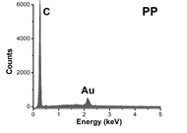
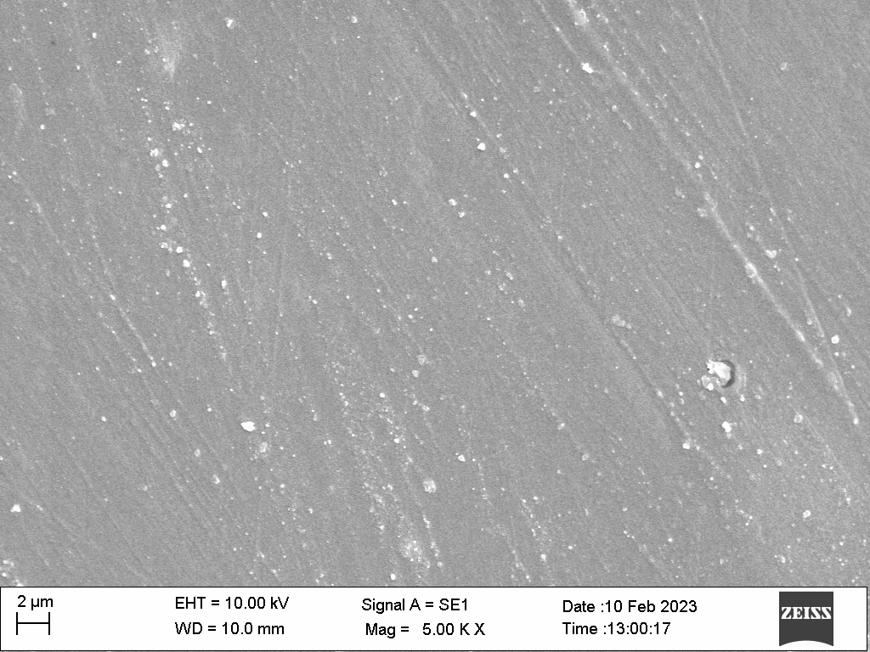
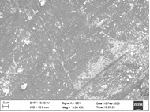
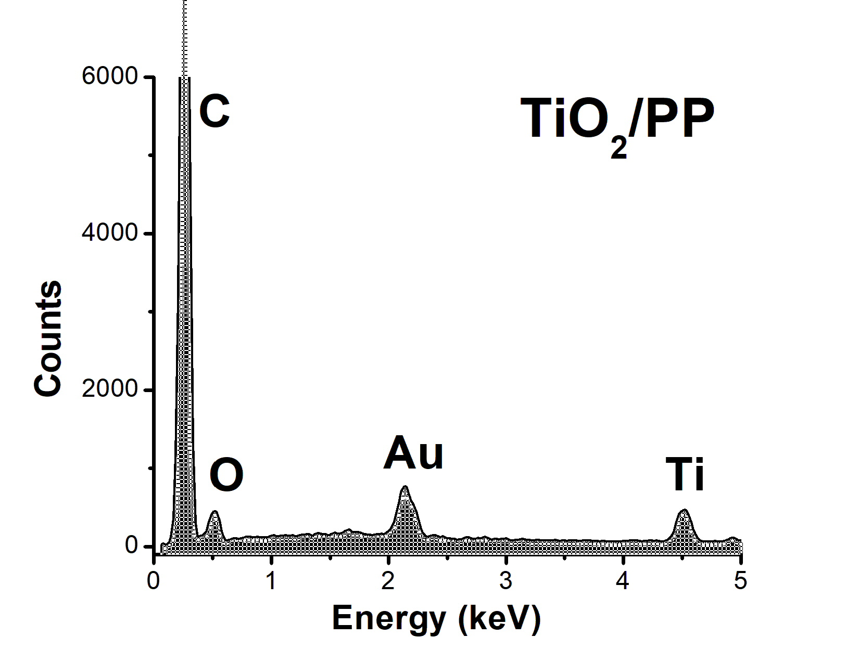
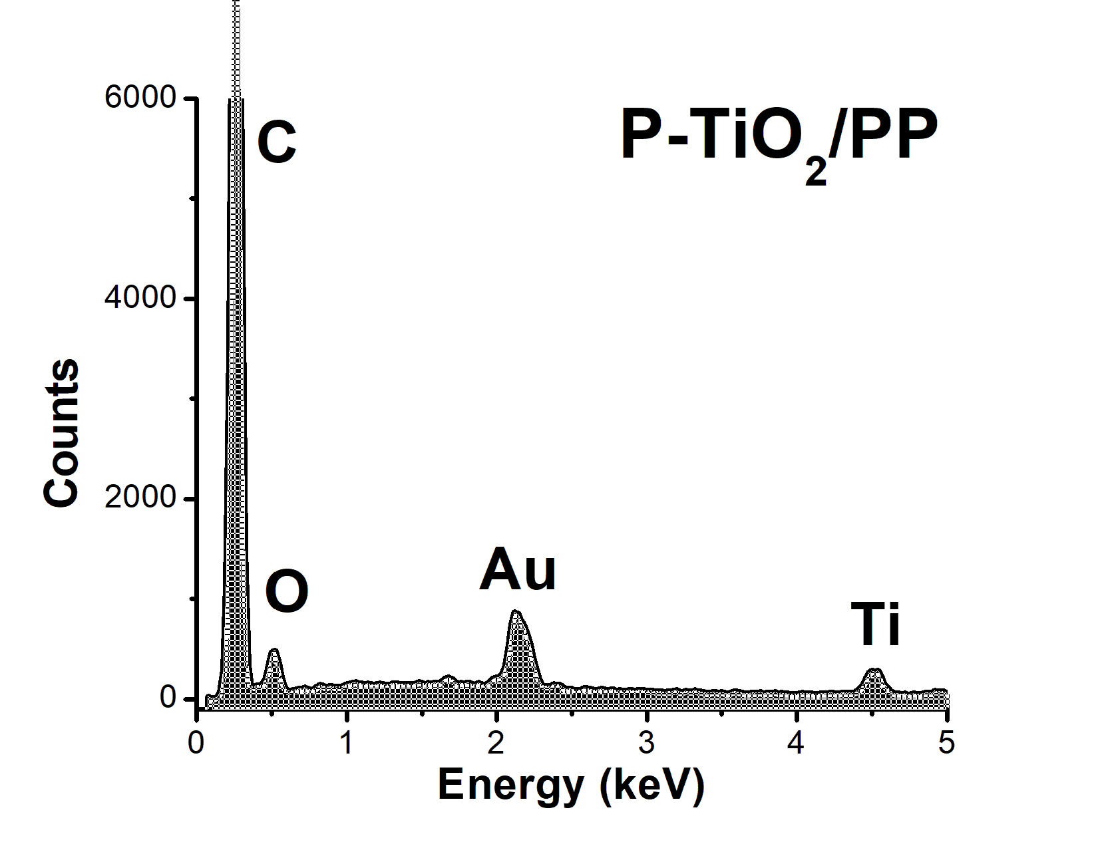
(a)
(a’)
(b)
(b’)
(c)
(c’)
Figure 2: SEM images and EDX spectra (in the range 0-5 keV) of PP [(a), (a’)], TiO₂/PP [(b), (b’)] and P-TiO₂/PP [(c), (c’)].

    - Photocatalytic activity
The photocatalytic activity of the samples was evaluated in MB discoloration under UV and visible light irradiation (Figure 3). Sample-free control tests were performed to verify the contribution of light sources (photolysis) and demonstrated that the MB concentration did not change significantly during the overall test time (3% under UV light and 12% under Vis light). Considering the TiO₂ samples, the powder has a high photocatalytic activity under UV light (Figure 3a), as it leads to 97% discoloration after 240 min of UV irradiation. Also, the TiO2/PP film showed a significant photoactivity under UV light, since 85% of MB discoloration was achieved at the end of irradiation time. The result under visible light (Figure 3b) showed that, by using P-TiO₂ in powder form, the almost total MB discoloration (95%) was obtained after 240 min while the MB discoloration was 63% with P-TiO₂/PP sample after the same irradiation time. As regards the rate constants for the degradation of MB, they were found to be higher by an order of magnitude for the photoactivated films with respect to the corresponding powders (Figure 4).
The photocatalytic activities of doped TiO₂ coated on polymeric materials obtained by different methods it is difficult to compare from one work to another due to the different experimental conditions. However, considering the sample area and dye concentration, the rate constants for MB dye degradation of our work are relatively high (Singh, Mahalingam, e Singh 2013).

(b)
(a)
Figure 3: Photocatalytic discoloration of MB using (a)TiO₂, TiO₂/PP under UV light irradiation and (b) P-TiO₂, P-TiO₂/PP under visible light irradiation.
(b)
(a)
Figure 4: Evaluation of MB discoloration kinetic (a) for TiO₂ and TiO₂/PP under UV light irradiation and (b) for P-TiO₂ and P-TiO₂/PP under visible light.
  - Conclusions
In this work undoped TiO₂ and P-doped TiO₂ were prepared through a modified sol-gel method at room temperature. Both photocatalysts were then used to coat polypropylene films activated with corona discharge. The XRD analysis results showed the presence of TiO₂ in anatase phase, despite the absence of calcination step in the sample preparation procedure. The coated films were further characterized with SEM-EDX analyses which highlighted the presence of TiO₂ particles anchored on the PP surface. Photocatalytic performances were evaluated by analyzing the discoloration of methylene blue (MB) dye under UV and visible light irradiation. The undoped TiO₂ sample led to 97% discoloration of the MB after 240 min of UV irradiation, while the TiO₂/PP film showed a MB discoloration of about 85%. The photocatalytic results under visible light evidenced that that the almost total MB discoloration (95%) was observed after 240 min with P-TiO₂ whereas the 63 % of MB discoloration was achieved after the same irradiation time in presence of P-TiO₂/PP film.
Consequently, this modified sol-gel preparation method without using a calcination step can be considered valid for the preparation of photocatalysts supported on polymeric structures without leading to the damage of the support and obtaining a good photocatalytic activity.

Acknowledgments
The authors thank the company MACA srl which supplied the polypropylene film previously subjected to corona discharge.
References
Chen Y., Elias S., D. D. Dionysiou. 2008. «Microstructure Characterization and Photocatalytic Activity of Mesoporous TiO2 Films with Ultrafine Anatase Nanocrystallites». Surface and Coatings Technology 202 (10): 1944–50. https://doi.org/10.1016/j.surfcoat.2007.08.041.
Dosa M., Piumetti M., Bensaid S. Tahrizi A., Galletti C., Fino D., Russo N. 2019. «Photocatalytic Abatement of Volatile Organic Compounds by TiO2 Nanoparticles Doped with Either Phosphorous or Zirconium». Materials 12 (13): 2121. https://doi.org/10.3390/ma12132121.
Fabiyi, M.E, Skelton R.L. 2000. «Photocatalytic Mineralisation of Methylene Blue Using Buoyant TiO2-Coated Polystyrene Beads». Journal of Photochemistry and Photobiology A: Chemistry 132 (1–2): 121–28. https://doi.org/10.1016/S1010-6030(99)00250-6.
Krýsa J., Waldner G., Měšt’ánková H., Jirkovský J., Grabner G., 2006. «Photocatalytic Degradation of Model Organic Pollutants on an Immobilized Particulate TiO2 Layer». Applied Catalysis B: Environmental 64 (3–4): 290–301. https://doi.org/10.1016/j.apcatb.2005.11.007.
Langlet M., Kim A., Audier M., Herrmann J. M. s.d. «Sol-Gel Preparation of Photocatalytic TiO2 Films on Polymer Substrates», 12.
Li, Sifang, Guoliang Ye, Guoqin Chen. 2009. «Low-Temperature Preparation and Characterization of Nanocrystalline Anatase TiO ₂». The Journal of Physical Chemistry C 113 (10): 4031–37. https://doi.org/10.1021/jp8076936.
Lima M. Fogliato S., Marcos A. Zen V., Samios D. 2002. «Crystallinity Changes in Plastically Deformed Isotactic Polypropylene Evaluated by X-Ray Diffraction and Differential Scanning Calorimetry Methods». Journal of Polymer Science Part B: Polymer Physics 40 (9): 896–903. https://doi.org/10.1002/polb.10159.
Mancuso A., Sacco O., Vaiano V., Sannino D., Venditto V., Pragliola S., Morante N. 2021. «Visible Light Active Fe-N Codoped TiO₂ Synthesized through Sol Gel Method: Influence of Operating Conditions on Photocatalytic Performances». Chemical Engineering Transactions 86 (giugno): 565–70. https://doi.org/10.3303/CET2186095.
Peiró A. M., Peral J., Concepción D., Xavier D., Ayllón J.A..2001. «Low-Temperature Deposition of TiO ₂ Thin Films with Photocatalytic Activity from Colloidal Anatase Aqueous Solutions». Chemistry of Materials 13 (8): 2567–73. https://doi.org/10.1021/cm0012419.
Pelaez M., Nolan N.T., Pillai S. C., Seery M. K., Falaras P., Kontos A.G., Dunlop P.S.M., et al. 2012. «A Review on the Visible Light Active Titanium Dioxide Photocatalysts for Environmental Applications». Applied Catalysis B: Environmental 125 (agosto): 331–49. https://doi.org/10.1016/j.apcatb.2012.05.036.
Rescigno R., Sacco O., Venditto V., Fusco A., Donnarumma G., Lettieri M., Fittipaldi R., Vaiano V.. 2023. «Photocatalytic Activity of P-Doped TiO2 Photocatalyst». Photochemical & Photobiological Sciences, gennaio. https://doi.org/10.1007/s43630-023-00363-y.
Sacco O., Sannino D., Matarangolo M., Vaiano V. 2019. «Room Temperature Synthesis of V-Doped TiO2 and Its Photocatalytic Activity in the Removal of Caffeine under UV Irradiation». Materials 12 (6): 911. https://doi.org/10.3390/ma12060911.
Sacco O., Venditto V., Fittipaldi R., Vaiano V., Daniel C. 2021. «Composite Polymeric Films with Photocatalytic Properties». Chemical Engineering Transactions 86 (giugno): 571–76. https://doi.org/10.3303/CET2186096.
Shan, A. Y.,Ghazi T.I.M., Rashid S.A.. 2010. «Immobilisation of Titanium Dioxide onto Supporting Materials in Heterogeneous Photocatalysis: A Review». Applied Catalysis A: General 389 (1–2): 1–8. https://doi.org/10.1016/j.apcata.2010.08.053.
S., Hari M., P.K. Singh 2013. «Polymer-Supported Titanium Dioxide Photocatalysts for Environmental Remediation: A Review». Applied Catalysis A: General 462–463 (luglio): 178–95. https://doi.org/10.1016/j.apcata.2013.04.039.
Tsega M., Dejene F.B. 2017. «Influence of Acidic PH on the Formulation of TiO 2 Nanocrystalline Powders with Enhanced Photoluminescence Property». Heliyon 3 (2): e00246. https://doi.org/10.1016/j.heliyon.2017.e00246.
Vaiano V., Sacco O., Sannino D., Ciambelli P. 2015. «Nanostructured N-Doped TiO2 Coated on Glass Spheres for the Photocatalytic Removal of Organic Dyes under UV or Visible Light Irradiation». Applied Catalysis B: Environmental 170–171 (luglio): 153–61. https://doi.org/10.1016/j.apcatb.2015.01.039.

