|  |  |
| --- | --- |
| cetlogo ***CHEMICAL ENGINEERING TRANSACTIONS***  ***VOL. , 2023*** | A publication of  aidiclogo_grande |
| The Italian Association  of Chemical Engineering  Online at www.cetjournal.it |
| Guest Editors: Sauro Pierucci, Jiří Jaromír Klemeš  Copyright © 2023, AIDIC Servizi S.r.l. **ISBN** 978-88-95608-98-3; **ISSN** 2283-9216 | |

Assessment of CO2 Conversion in a Biorefinery Concept: a Biomethane Plant Case Study

Giuliana V. G. Lesak\*, Nadia M. V. Ramos, Luiz Fernando L. Luz Jr., Marcos L. Corazza

Department of Chemical Engineering, Federal University of Paraná. 210 Coronel Francisco Heráclito dos Santos St., Jardim das Américas, Curitiba – PR – Brazil. CEP 81531-990.

giulianavarela@ufpr.br

One of the main challenges imposed by the climate crisis is to reduce the greenhouse gases emissions while keeping high levels of social and economic development. Therefore, the deployment of process alternatives that use residues as raw materials and integrate the conversion of by-products in added value products of interest is mandatory and integrated biorefineries play a major role in this context. In this work, thermodynamic analyses were performed to assess the conversion of a residual CO2 stream captured from the flue gases of a biomethane-based thermal power plant into syngas or methane. Results showed that the syngas production from CO2 is favored at high temperatures (>700 ˚C), low pressures (1 bar) and low H2/CO2 ratios (e.g. 1). Conversely, methane formation is favored at lower temperatures and higher H2/CO2 ratios. Simulations were also carried out considering the conversion of an off-gas stream from a biomethane plant, with different concentrations of CH4. Considering the syngas formation, the presence of CH4 in the feed stream enhances the CO2 conversion and increases the production of CO and H2 (desired products), while decreasing H2O formation (unwanted side product), possibly due to the simultaneous occurrence of the methane bi-reforming, RWGS and methanation reactions. Therefore, from the thermodynamic point of view, the use of the off-gas from a biomethane plant for syngas production could be a potential alternative for the destination of this residual stream, converting it into interesting chemical platforms and intermediates for fuels and chemicals production.

* 1. Introduction

The climate crisis and its associated targets and restrictions urgently demand the development of technological alternatives for industrial production that allows the human development in a socially and environmentally responsible way. Among the greenhouse gases (GHGs), CO2 is of major importance since large amounts of this gas are released into the atmosphere daily by anthropogenic activities (IPCC, 2021). As such, the use of CO2 as a raw material for the production of highly demanded added value products represents a potential alternative for GHGs mitigation.

Integrated biorefineries play a major role in this context, promoting the production of a wide variety of products, utilizing the maximum as possible the by-products and consequently generating less residues compared with conventional processes, employing renewable sources of raw materials or even residues. Biogas production from organic matter is a sustainable approach for residue recycling, as it can be produced from multiple sources such as wastewater sludge (Cortez et al., 2022) and industrial (Donkor et al., 2021) and agricultural residues (Caiardi et al., 2021). As an example, the generated biogas (or the purified biomethane) can be destined to chemical conversion, heat or electricity generation (Caiardi et al., 2021). The biomethane could be used as a fuel in a thermal power plant (TPP), generating the required (or part of the) electricity demanded in a biorefinery, which could be fed with CO**2** captured from the TPP flue gases as the process raw material. This work aimed to perform a thermodynamic assessment of CO**2** conversion to CO (or CH**4**) in this biorefinery context. Besides the captured CO**2** stream, the chemical conversion of an off-gas stream from biogas purification containing different amounts of CH**4** was also considered.

* 1. Materials and methods

The integrated biorefinery model is represented in Figure 1. It considers the utilization of biomethane in a TPP, in which electricity is generated and the flue gases are further purified to CO2, which is processed to fuels and chemicals. The off-gas stream from biogas purification, consisting of CO2 and CH4, was also considered in the process simulations. The H2, necessary for conversion and purification, is considered to be generated by water electrolysis with renewable electricity. Thus, organic residues could be transformed into fuels and chemicals with *in situ* renewable electricity generation and minimum input of raw materials and residue generation.

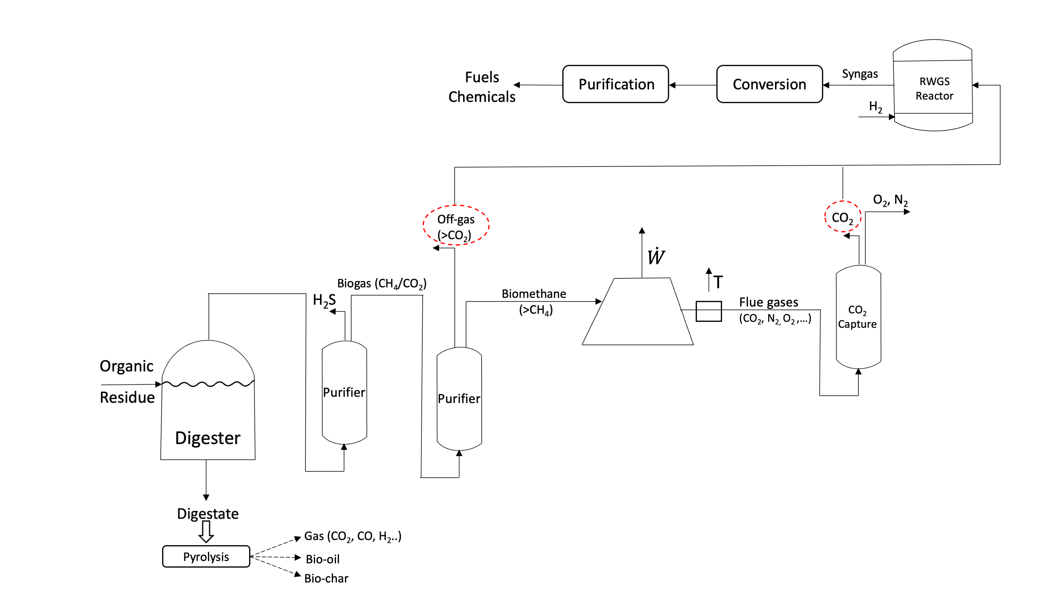

Figure 1: Integrated biorefinery process model

The process simulation was performed in the Aspen Plus® software, using the Peng-Robinson equation of state to calculate the system properties. The RGibbs reactor model, based on Gibbs free thermodynamic equilibrium energy minimization, was chosen to model and evaluate the thermodynamic equilibrium. No reaction was specified, and the following components were considered: CO, CO2, H2, H2O, CH4 and C (graphite). Among the reactions taking place, it is expected the occurrence of two competing side reactions, the RWGS and CO2 methanation, represented by Eq(1) and Eq(2), respectively. As the RWGS reaction produces CO, the CO methanation (Eq(3)) can also take place. The CH4 produced by the methanation reactions may also be converted to syngas in the presence of water by the methane bi-reforming reaction (Eq(4)). Solid carbon formation (reactions equations presented in the literature (Xing et al., 2020)) may also occur. The $\text{∆}{\text{H}}_{\text{298K}}^{\text{O}}$ and $\text{∆}{\text{G}}_{\text{298K}}^{\text{O}}$ values for each reaction were calculated with data taken from the Aspen Plus® databank.

|  |  |
| --- | --- |
| $\text{C}{\text{O}}_{\text{2}}\text{ + }{\text{H}}_{\text{2}}\text{⇌}\text{ CO + }{\text{H}}_{\text{2}}\text{O } \text{ ∆}{\text{H}}_{\text{298K}}^{\text{O}}\text{=} \text{41.}\text{1}\text{ kJ }\text{mo}{\text{l}}^{\text{-1}} \text{∆}{\text{G}}_{\text{298K}}^{\text{O}}\text{=} \text{28.}\text{6}\text{ kJ }\text{mo}{\text{l}}^{\text{-1}}$ | (1) |
| $$\text{C}{\text{O}}_{\text{2}}\text{+}{\text{ 4 H}}_{\text{2}} \text{⇌}\text{ C}{\text{H}}_{\text{4}}\text{ + 2} {\text{H}}_{\text{2}}\text{O } \text{ ∆}{\text{H}}_{\text{298K}}^{\text{O}}\text{=} \text{-164.}\text{8}\text{ kJ }\text{mo}{\text{l}}^{\text{-1}} \text{∆}{\text{G}}_{\text{298K}}^{\text{O}}\text{=} \text{-11}\text{3}\text{.}\text{3}\text{ kJ }\text{mo}{\text{l}}^{\text{-1}}$$ | (2) |
| $$\text{C}\text{O}\text{+}{\text{ 3 H}}_{\text{2}} \text{⇌}\text{ C}{\text{H}}_{\text{4}}\text{ +} {\text{H}}_{\text{2}}\text{O ∆}{\text{H}}_{\text{298K}}^{\text{O}}\text{= -205.9 kJ }\text{mo}{\text{l}}^{\text{-1}} \text{∆}{\text{G}}_{\text{298K}}^{\text{O}}\text{=}\text{ -141.9 }\text{kJ }\text{mo}{\text{l}}^{\text{-1}}$$ | (3) |
| $${\text{3 CH}}_{\text{4}}\text{ + 2}{\text{ H}}_{\text{2}}\text{O + C}{\text{O}}_{\text{2}}\text{ ⇌ 4 CO + 8 }{\text{H}}_{\text{2}}\text{ ∆}{\text{H}}_{\text{298K}}^{\text{O}}\text{=658.8 kJ }\text{mo}{\text{l}}^{\text{-1}}\text{ ∆}{\text{G}}_{\text{298K}}^{\text{O}}\text{=454.3 kJ }\text{mo}{\text{l}}^{\text{-1}}$$ | (4) |

The influence of temperature (50 to 1100 ˚C), pressure (1 to 20 bar) and H2/CO2 molar feed ratio (1:1 to 1:4) on the CO2 conversion (Eq(5)) and CO global selectivity (Eq(6)) was assessed. In these equations, $\dot{\text{n}}$ represents the molar flow rates and the suffixes in and out are related to inlet and outlet reactor streams. Furthermore, the effect of temperature and H2/CO2 ratio on the product composition (H2/CO ratio) was also considered.

|  |  |
| --- | --- |
| $\text{C}{{\text{O}}_{\text{2}}}_{\text{Conversion}}\left(\text{\%}\right)\text{=}\frac{{\dot{\text{n}}}_{\text{C}{\text{O}}_{\text{2}}\text{in}}\text{-}{\dot{\text{n}}}_{\text{C}{\text{O}}_{\text{2}}\text{out}}}{{\dot{\text{n}}}_{\text{C}{\text{O}}_{\text{2}}\text{in}}}\text{x100}$ | (5) |
| $$\text{C}{\text{O}}_{\text{Selectivity}}\left(\text{\%}\right)\text{=}\frac{{\dot{\text{n}}}_{\text{COout}}}{\text{(}{\dot{\text{n}}}_{{\text{CH}}_{\text{4,out}}}\text{-}{\dot{\text{ n}}}_{{\text{CH}}_{\text{4,in}}}\text{)}}\text{x100}$$ | (6) |

Different compositions were analyzed for the off-gas stream, with the molar CH4 content varying between 1 % and 20 %. When considering this stream, the methane conversion (Eq(7)) was also analyzed. For the off-gas stream the feed ratio of H2/CO2 was fixed at 1.

|  |  |
| --- | --- |
|  | (7) |

* 1. Results and discussion

3.1 Pure CO2 stream

3.1.1 Pressure effect

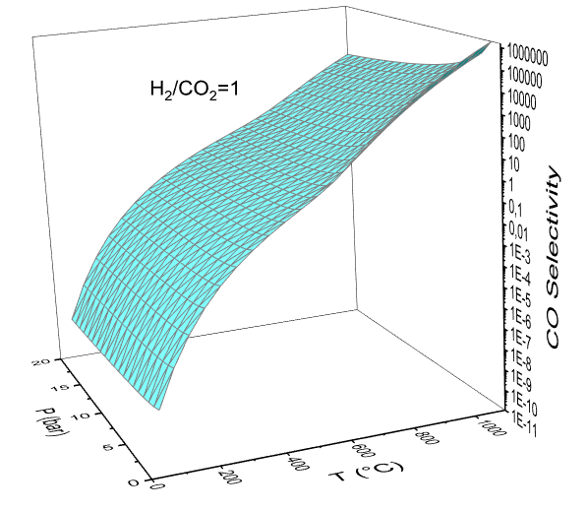Firstly, the pressure effect on the analyzed responses was evaluated for a purified residual gas stream, comprising only CO2. Examples of results obtained regarding pressure, temperature and CO2 conversion or CO selectivity are presented in Figure 2a, 2b and 2c.

a)

b)

c)

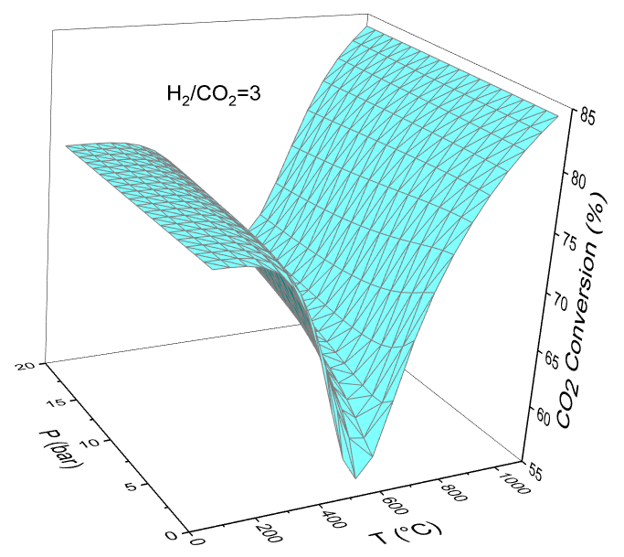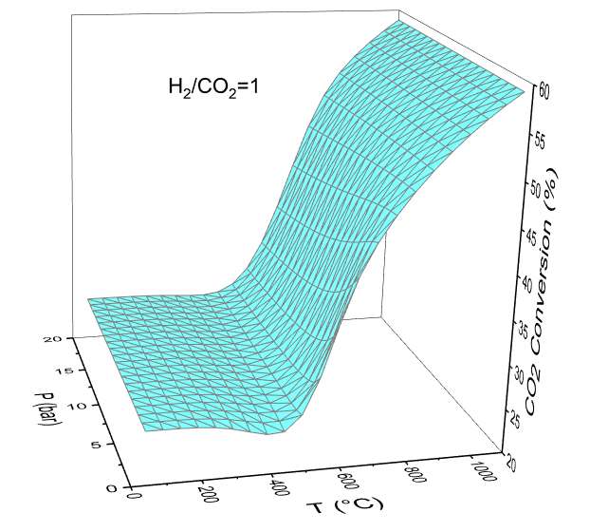

b)

Figure 2: CO2 conversion and CO selectivity as a function of temperature and pressure. a) CO2 conversion with H2/CO2=1; b) CO2 conversion with H2/CO2=3; c) CO selectivity with H2/CO2=1

In general, it was observed that pressure increases lead to a reduction in CO selectivity, which can be related to the displacement in the methanation reactions equilibria towards the products according to the Le Chatelier’s principle (higher pressures favor methane formation). Consequently, CO selectivity is reduced. It should be noted that the RWGS reaction equilibrium is not affected by pressure variations since Eq(1) is equimolar.

In most of the studied reaction conditions, the conversion is not significantly affected by the pressure, and in the cases that it is affected, it occurs in the intermediate temperatures analyzed (450-750 ˚C). Since the main focus of this work is to study the syngas generation from CO2 (that is favored, by its turn, at higher temperatures) and since the CO selectivity is benefited by lower pressures, the pressure effect in the studied variables will no longer be considered in the analysis, and from this point the results will be reported at the pressure of 1 bar.

3.1.2 Temperature and H2/CO2 ratio effects

Figure 3 depicts the results of CO2 conversion, CO selectivity and product H2/CO ratio as a function of temperature and H2/CO2 ratio, at 1 bar. A temperature increase causes a reduction in conversion at lower temperatures (until approx. 500˚C) and a conversion increase at higher temperatures. The CO selectivity is benefited with a temperature increase. The methanation reactions are exothermic while the RWGS is endothermic. Thus, the formers are favored at lower temperatures while the latter benefits from higher temperatures, which may explain the observed results.

At conditions of H2/CO2=1 (Figure 2a), low conversions of CO2 are obtained at low temperatures. However, when H2/CO2 ratio is increased (Figure 2b), the simulations indicate higher conversion of CO2 with a minimum valley around 500 ˚C. When the H2/CO2 ratio is increased the CO2 conversion increases (Figure 3a) and the methane formation is favored over the CO formation (the CO selectivity is reduced (Figure 3b)). This can be partially explained by the fact that the CO2 and CO methanation reactions require 4 and 3 mols of H2, respectively, for each mol of CO2, and thus methanation reactions are favored with higher H2 concentrations.

It should be noted that despite the fact that higher H2 initial concentrations cause an increase in CO2 conversion, at all the evaluated temperatures less CO and more CH4 are formed when increasing the H2/CO2 ratio. Accordingly, if the aim of a process is to produce syngas, lower H2/CO2 feed ratios (e.g. 1) are recommended. If one aims to feed the RWGS product in a FT reactor (after water condensation), it is important to consider the amount of CH4 generated by the methanation reactions, using reactional conditions that generate the desired syngas composition and avoiding an additional step of syngas purification. It is noteworthy that even with higher H2/CO2 ratios (e.g. 3 or 4), at elevated temperatures (>~800-850 ˚C) and low pressures (e.g. 1 bar) the amount of generated CH4 is considerably lower than the amount of CO, and high CO selectivity is obtained.



b)

a)



c)

Figure 3: CO2 conversion, CO selectivity and H2/CO ratio as a function of temperature for different H2/CO2 feed ratios (P=1 bar). a) CO2 conversion; b) CO selectivity; c) H2/CO ratio

To analyze the syngas composition (H2/CO product ratio), only temperatures above 600 ˚C were considered, since at lower temperatures small amounts of CO are formed. The higher the H2 concentration in the feed stream the higher the H2/CO product ratio (Figure 3c). Thus, if the syngas stream is destined to a FT reactor, for example, it is possible to adjust the H2/CO2 feed ratio to obtain a syngas with the appropriate composition. A H2/CO ratio of 2 is usually recommended in the literature for cobalt catalyzed FT synthesis (Ghogia et al., 2021; Hannula et al., 2020). In summary, from a thermodynamic equilibrium perspective, if the process focus is syngas generation for a FT process, high temperatures (>700 ˚C) and low pressures (1 bar) should be used, and the appropriate H2/CO2 ratio must be chosen so high CO2 conversions, small amounts of CH4 and the desired H2/CO product ratio are obtained. It is important to mention that the considerations about the process operating conditions apply only to the reactor, and when a whole process is considered other reactor operating conditions may imply in a better overall process performance. In this case, optimization should be carried out considering the integrated process (Adelung et al., 2021). The amount of solid carbon (Cgraphite) formed was negligible and thus no coke formation was detected at the thermodynamic equilibrium in the evaluated conditions.

3.2 Off-gas

The qualitative behavior of the CO2 conversion and CO selectivity as a function of pressure and temperature was the same as the observed in the previous analysis. However, at temperatures above approximately 500 ˚C negative values for the CO selectivity are observed, once the amount of CH4 in the product stream is lower than in the feed stream (the denominator of Eq(5) becomes negative), that is, there is a global consumption of CH4. As the amount of CH4 in the feed stream is increased, higher CO selectivity is obtained, and again the higher the temperature the higher CO selectivity. When the CH4 concentration is increased in the off-gas, higher CO2 conversions at high temperatures (T>~500 ˚C) are obtained (Figure 4a), higher amounts of CH4 are present in the product stream (Figure 4c), and more CO is present in the resulting product (Figure 4d). The product H2/CO ratio (Figure 4b) is also increased with the amount of CH4 in the feed stream. These results can be partially related with the fact that when increasing the CH4 content in the system, the methanation reactions equilibria are displaced towards the reactants, implying that more reactants are available for the RWGS reaction. Furthermore, the higher presence of CH4 in the system (once it is present also in the feed stream) may imply in a greater occurrence of the methane bi-reforming reaction (Eq(6)), favoring even more the CO formation.

d)

a)

c)

b)

Figure 4: Results for the off-gas stream (H2/CO2=1). a) CO2 conversion; b) H2/CO ratio; c) CH4 flow in the product; d) CO flow in the product

a)

b)

Figure 5: CH4 conversion and H2 flow in the product stream (H2/CO2=1). a) CH4 conversion; b) H2 product flow

Negative methane conversion (Figure 5a) are obtained until approx. 550 ˚C, indicating a global production of this species (${\dot{\text{n}}}_{\text{C}{\text{H}}_{\text{4}}\text{out}}\text{>}{\dot{\text{n}}}_{\text{C}{\text{H}}_{\text{4}}\text{in}}\text{ in }\text{Eq(}\text{7)})$. From 800-850 ˚C, CH4 conversions close to 100 % are obtained, reinforcing that methane bi-reforming reaction may simultaneously occur with the RWGS reaction, once methane reforming reactions are endothermic and temperatures above 800-900 ˚C are recommended (Kumar et al., 2015). The presence of CH4 in the reactants contributes with higher amounts of H2 in the product (Figure 5b), and the higher the CH4 concentration the higher the H2 amount in the product, explaining the enhancement of the H2/CO product ratio. The results of the product water flow obtained in the simulations supported again the simultaneous occurrence of the RWGS and methane bi-reforming reactions when the CO2 stream contains CH4. The higher the amount of CH4 in the feed stream, the lower the product H2O content. As an example, when increasing the CH4 content in the feed stream from 0 to 10 % at 900 ˚C (1 bar, H2/CO2=1), the CO2 conversion is increased from 52.9% to 67.5%, the CO flow is increased from 2.6 to 4.0 kmol/h, the CH4 flow is increased from 8.9.10-5 to 8.3.10-4 kmol/h, the H2 flow increases from 2.4 to 4.5 kmol/h and the water flow decreases from 2.6 to 2.0 kmol/h. Considering the thermodynamic analysis results, using an off-gas stream from a biomethane plant (or a CO2 stream doped with CH4) could be a potential alternative for syngas production, once the possible simultaneous occurrence of the RWGS and the methane bi-reforming reactions allows higher CO2 conversions and the production of higher amounts of CO and H2, while consuming H2O, an unwanted RWGS by product, reducing the need of water condensation before syngas conversion.

* 1. Conclusions

The CO2 conversion presents technical thermodynamic feasibility, and its application in an integrated biorefinery plant could be an interesting approach for the production of highly demanded products with potential GHGs mitigation. The CO formation is favored at high temperatures (>700 ˚C) and low pressures (1 bar). The ideal H2/CO2 feed ratio must be selected so high CO2 conversions can be obtained with adequate product CH4 content as well as the desired H2/CO product ratio. Alternatively, if a certain process is destined for methane production from CO2,the reaction must be carried out at lower temperatures and higher H2/CO2 ratios (e.g. 3) allowing higher CO2 conversions. A complete economic feasibility analysis integrated with optimization techniques must be performed when selecting the operational parameters, considering the whole process. In this way it is possible to find the best operating conditions that matches both overall performance and economic criteria. Experimental testing and catalyst selection are also necessary to certify whether the thermodynamic equilibrium is achievable at feasible time intervals, and if other molecules than the considered ones are present in the product. The utilization of a biogas upgrading off-gas stream (or a CO2 stream doped with CH4) showed itself as a potentially interesting alternative for syngas production from a thermodynamic equilibrium perspective, since the presence of CH4 in the reactants allows higher CO2 conversions, higher CO and H2 production as well as smaller H2O production when compared to a pure CO2 stream. For example, when CH4 content in the feed stream is increased from 0 to 10 % at 900 ˚C (1 bar, H2/CO2=1), the CO2 conversion and CO flow are increased from 52.9% to 67.5% and from 2.6 to 4.0 kmol/h, respectively. The operating conditions must be carefully chosen to comply with syngas composition limitations, considering, for example, the concentration of CH4 in the final stream. In this way, this residual off-gas stream could be applied to generate added value products. In a biorefinery scenario, this can represent smaller residue output and higher amounts of the desired products.

Acknowledgments

The authors acknowledge with gratitude the Federal University of Paraná (UFPR) for infrastructural support. They also acknowledge the Laboratory of Kinetics and Applied Thermodynamics (LACTA) from UFPR, the Araucária Foundation for financial support (Grant number 164/2021) and the New Arrangement for Research and Innovation (NAPI). The authors thank the Human Resources Program of the National Agency of Petroleum, Natural Gas and Biofuels – PRH - ANP.

References

Adelung S., Maier S., Dietrich R. U., 2021, Impact of the reverse water-gas shift operating conditions on the Power-to-Liquid process efficiency, Sustainable Energy Technologies and Assessments, 43, 100897.

Caiardi F., Belaud J.-P., Vialle C., Monlau F., Tayibi S., Barakat A., Oukarroum A., Zeroual Y., Sablayrolles C., 2021, Environmental assessment of a multifunctional process coupling anaerobic digestion and pyrolysis, Chemical Engineering Transactions, 86, 709-714.

Cortez C.M.C, Pantoja K.L.D., Oliveira C.C., Benites-Alfaro E., 2022, Non-conventional Energy from Biogas Recovered from Wastewater Sludge, Chemical Engineering Transactions, 96, 73-78.

Donkor K.O., Gottumukkala L.D., Diedericks D., Görgens J.F., 2021, An advanced approach towards sustainable paper industries through simultaneous recovery of energy and trapped water from paper sludge, Journal of Environmental Chemical Engineering, 9, 4.

Ghogia A.C., Nzihou A., Serp P., Soulantica K., Pham Minh D., 2021, Cobalt catalysts on carbon-based materials for Fischer-Tropsch synthesis: a review, Applied Catalysis *A*: General, 609, 117906.

Hannula I., Kaisalo N., Simell P., 2020, Preparation of Synthesis Gas from CO2 for Fischer–Tropsch Synthesis—Comparison of Alternative Process Configurations, C—Journal of Carbon Research, *6*(3), 55.

IPCC, 2021, Climate Change 2021: The Physical Science Basis - Summary for the Policymakers, Working Group - Contribution to the Sixth Assessment Report of the Intergovernmental Panel on Climate Change <https://www.ipcc.ch/report/ar6/wg1/downloads/report/IPCC\_AR6\_WGI\_SPM\_final.pdf> acessed 03.01.2023.

Kumar N., Shojaee M., Spivey J.J., 2015, Catalytic bi-reforming of methane: From greenhouse gases to syngas, Current Opinion in Chemical Engineering, *9*, 8–15.

Xing Y., Ma Z., Su W., Wang Q., Wang X., Zhang H., 2020, Analysis of Research Status of CO2 Conversion, Catalysts, 10(370), 1–18.