CHEMICAL ENGINEERING TRANSACTIONS  VOL. , 2023 | A publication of
The Italian Association
of Chemical Engineering
Online at www.cetjournal.it

Guest Editors: Sauro Pierucci, Jiří Jaromír Klemeš
Copyright © 2023, AIDIC Servizi S.r.l.
ISBN 978-88-95608-98-3; ISSN 2283-9216
Exploiting tannery sludge as renewable resource for biogas and short-chain fatty (SCFAs) acids production

Marco Gottardo*, Giulia A. Tuci, Francesco Valentino, Paolo Pavan
Department of Environmental Sciences, Informatics and Statistics, Ca’ Foscari University of Venice, Via Torino 155, 30172, Mestre-Venice, Italy
marco.gottardo@unive.it

The tannery industry is a very lucrative and widespread sector in Italy, and it is yet one of the most polluting, mainly due to the tannery sludge’s disposal in landfills, as it is considered a special residue by Italian legislation. An evaluation of the performance of the anaerobic fermentation process to obtain biogas and short-chain fatty acids (SCFAs) has been performed in this paper in different conditions concerning temperature, total solids content, and oxidizing and/or thermal pretreatments. The batch test trials revealed that the hydrogen peroxide pretreatment proved to be effective in increasing the biogas production, already at low doses but reaching the highest amount of 204 mL with the dose of 0.6 g H₂O₂/gTS. Regarding the SCFAs production, the combined microwave and hydrogen peroxide (MW-H₂O₂) pretreatment followed by thermophilic conditions gave the best results, with maximal SCFA concentration above 24 g COD_{SCFA}/L.
In the tests conducted without pretreatment, the mesophilic temperature seem preferable since the acidification performances were comparable to or even better than their thermophilic counterparts while being less energy intensive. The obtained results proved that tannery sludge can be employed in different ways and provide a viable alternative to landfilling, to handle this waste in a greener way, in a circular economy approach.

Introduction
The tannery industry is considered one of the most polluting sectors, as it is chemical intensive and characterized by large volumes of effluents as well as the production of a sludge, which contains high amounts of organics and inorganics such as toxic metal salts, usually employed in the tanning process (Mpofu et al., 2021; Basegio et al., 2022). This sludge is also characterized by the presence of chromium; for this reason, it is considered a special non-hazardous waste by the Italian legislation (Ronchi Decree, 1997) and consequently has to be disposed of in special landfills, namely a second-class type B controlled landfill (D.Lgs. 04/06).
Consequently, the environmental impact of this industry is non-negligible, and the costs sustained by the tannery industries to dispose of the generated waste are very high, creating the need to find more sustainable and less costly alternatives.
Anaerobic fermentation is a stage of anaerobic digestion in which organisms digest organic matter, transforming it into mainly short-chain fatty acids (SCFAs) and CO_{2,} and producing H₂ in a wide range of gas percentage, through three steps: hydrolysis, acidogenesis, and acetogenesis. The SCFAs are produced when fermentative bacteria break down soluble chemicals derived from the hydrolysis phase during the acetogenesis phase (Valentino et al., 2022). The final step of anaerobic digestion is methanogenesis during which biogas is produced mainly by utilizing H₂ as electron donor and CO₂, in the process known as hydrogenophilic methanogenesis. The whole process allows the recovery of bio-products, while significantly reducing the mass of the waste, thus decreasing the disposal costs and the environmental impact. Consequently, tannery waste is a great candidate for this process due to its high organic load and high costs for its disposal.
Several pretreatments have been explored to improve the efficiency of the process on different substrates and one of the most promising is oxidation, for example with hydrogen peroxide (H₂O₂) employed to oxidize the organic compounds and increase their availability to the microorganisms. This pretreatment has been previously employed with good results due to its promising characteristics, namely its effectiveness, low costs, easy availability and conduction, and harmless by-products (Achouri et al., 2021, Liu et al., 2017).
Additionally, it has been demonstrated that this oxidizing treatment increases its effectiveness when coupled with a thermal pretreatment, making use of the advantages of the synergism between individual techniques (Ambrose et al., 2020). Consequently, different combinations of these pretreatments have been assessed in this study to verify their effectiveness on this substrate in terms of SCFAs production.
The aim of this work is to provide a viable alternative to the wasteful disposal of tannery sludge in landfills and use it instead to produce added-value products, since SCFAs are frequently employed in the chemical industry due to their functional groups, in line with the EU strategy.
2. Materials and methods
  - Substrate’s characteristics and inoculum
The tannery sludge used for this study is a mixture of primary and secondary sludge obtained from the wastewater treatment plant (WWTP) of Montebello Vicentino (northeast Italy), where the wastewaters from 23 tannery plants (about 10000 m³/d) are treated both with primary treatment (alkaline flocculation) and secondary biological treatment (anoxic/aerobic process).
In terms of chemical and physical characteristics, the tannery sludge showed an average total and volatile solids content of 830 ± 14 g TS/kg and 590 ± 4 g VS/kg respectively. The chemical oxygen demand (COD) was 793 ± 18 g COD/kg TS; the total phosphorus (TP) and nitrogen (as TKN) were 7.9 ± 0.4 g P/kg TS and 32.8 ± 0.9 g N/kg TS, respectively.

  - Experimental setup and parameters
All the batch tests were set up in 250 mL glass bottles sealed with a cap with a silicon plug, with 180 mL working volume, and each test was performed in duplicate. As anaerobic inoculum, 50 mL of mesophilic anaerobic digestate (35 g VS/L) from a full-scale digester located in Treviso (northeast Italy) was used in the biomethane potential tests (BMP) and in the mesophilic fermentation tests. A thermophilic inoculum from a parallel pilot-scale reactor was instead used for the thermophilic fermentation tests. Both full-scale and pilot-scale reactors were fed with sewage sludge and squeezed food waste mixture. All the tests were performed at neutral pH; the operating conditions for each test are presented in table 1. In both BMP and fermentation tests, the bottles were subjected to a constant temperature (37 °C and 55 °C for mesophilic and thermophilic tests, respectively) and kept in an oven. The slurry was manually mixed twice a day. For the BMP tests, the produced biogas was measured every 24 h by inserting a syringe into the silicon plug; for the fermentation tests, the sampling was similarly performed, and the slurry was easily taken from each bottle by using the overpressure generated by the fermentation tests.
Table 1: Summary of the operating conditions investigated in the batch tests and the assigned names; H₂O₂ at 35 % w/w. ª(g H₂O₂*/ g TS); ^{b}H₂O₂ at 35 % w/w; 80-90 °C, 600 W, 10 min, 0.2 g H₂O₂/ g TS
Operating Conditions |  | Biomethanation and acidogenic fermentation batch test (series)
 | BMP |  |  |  |  | Acidogenic Fermentation
 | 0.0 | 0.1 | 0.2 | 0.4 | 0.6 | M8 | M12 | MP | T8 | T12 | TP
Temperature  (°C) | 40 | 40 | 40 | 40 | 40 | 40 | 40 | 40 | 55 | 55 | 55
Solid content  (g TS/L) | 80 | 80 | 80 | 80 | 80 | 80 | 120 | 80 | 80 | 120 | 80
Pre-treatment | - | 0.1ª H₂O₂ | 0.2ª H₂O₂ | 0.4ª H₂O₂ | 0.6ª  H₂O₂ | - | - | M_{W}-H₂O₂^{b} | - | - | M_{W}-H₂O₂^{b}

Each test was prepared by diluting the dried sludge with tap water to reach the required TS concentrations, which have been chosen based on the performances of a dynamic sludge thickening. The MW-H₂O₂ pretreatment was performed based on the strategy proposed by Liu et al., 2018 and Ambrose et al., 2020 with some adaptations. Namely, after sludge dilution, the bottles were heated to 80 °C with a microwave oven set at 600 W for 10 min; the treatment was carried out with intermittent breaks every 1.30 min to avoid water loss by evaporation and to allow manual mixing of the sludge. After the sludge was allowed to cool to room temperature, the H₂O₂ was added at the chosen dosage of 0.2 g H₂O₂/ g TS, using H₂O₂ at 35 %. The bottles were left for 40 min to rest allowing the H₂O₂ to react and then were heated again with the MW at 90 °C, with the same method described before. The pretreatment with only H₂O₂ instead was simply performed by adding the desired amount of hydrogen peroxide to the diluted sludge and allowing it to react for at least 24 h. In this case, the chosen amounts were 0.1, 0.2, 0.4, and 0.6 g H₂O₂/ g TS, based on previous work (Tyagi and Lo, 2011; Liu et al., 2017).

  - Analytical methods and calculations
The substrate was analyzed according to Standard Methods (APHA, 2005) for total Kjeldahl Nitrogen (TKN), N-NH₄⁺, total phosphorus, P-PO₄³⁻, [Cr(VI)], volatile solids (VS), dry matter (TS), and COD.
The determination of the SCFAs was performed using an Agilent 6890 N gas chromatograph equipped with a flame ionization detector (FID) (T = 250 °C). Samples were analyzed through an Agilent J&W DB-FFAP fused silica capillary column (15 m length, 0.53 mm i.D., 0.5 mm film) using hydrogen as carrier, with the inlet working in split mode, with a split ratio of 20:1. The instrument was programmed with a ramp temperature from 80 °C to 100 °C (10 °C/min)., Samples were centrifuged at 4.500 rpm for 5 min and the supernatant was filtered at 0.2 mm using acetate cellulose syringe filters (Whatman), before GC analyses.
The assessment of the acidogenic fermentation was performed through the SCFA concentration, the ratio between the SCFAs and the soluble COD, and the fermentation yield (Y_{F}), which was calculated as Y_{F} = [COD_{SCFA}]_{t}/VS₀, where [COD_{SCFA}]_{t} is the produced SCFAs over time (“t”), and VS₀ is the initial VS concentration in the batch tests. The assessment of the release of nutrients, namely [N-NH₄⁺] and [P-PO₄³⁻], was calculated considering their final concentrations in the liquid phase and the initial content in the substrate according to these equations: N-NH₄⁺ release (%) = [N-NH₄⁺]/TKN; P-PO₄³⁻− release (%) = [P-PO₄³⁻]/TP.

3. Results and discussion
3.1 Biogas production
Figure 1 shows the specific gas production (SGP) for the BMP trials for tests 0.0, 0.1, 0.2, 0.4, and 0.6; the related cumulative biogas productions were 130, 185, 190, 196 and 204 mL respectively.
Both data showed that there was a significant improvement in the biogas production in the tests conducted with pre-treated sludge, even at the lowest dosage of H₂O₂ (0.1), where an increase of SGP of almost 10 times compared to the test conducted with untreated sludge was observed. The effect of the pretreatment becomes less affecting in tests 0.4 and 0.6, making the lower H₂O₂ doses preferable (in a perspective of process scale-up), due to the comparable results obtained at the different H₂O₂ dosage. However, the overall best performing test was 0.6, in which a maximum SGP of 0.26 m³/kg VS (in 24 days) and cumulative biogas production of 204 mL were obtained. Both results were very similar to those reported in Simioni et al., 2022, working on the co-digestion of tannery sludge and leather shavings (203.25 ± 1.80 mL), whereas leather shavings are characterized by a much higher organic content (94 % g VS/g TS) (Augustini et al., 2018), compared to tannery sludge (70 % g VS/g TS), thus representing a promising result for the H₂O₂ pretreatment and a necessary step as pre-treatment.
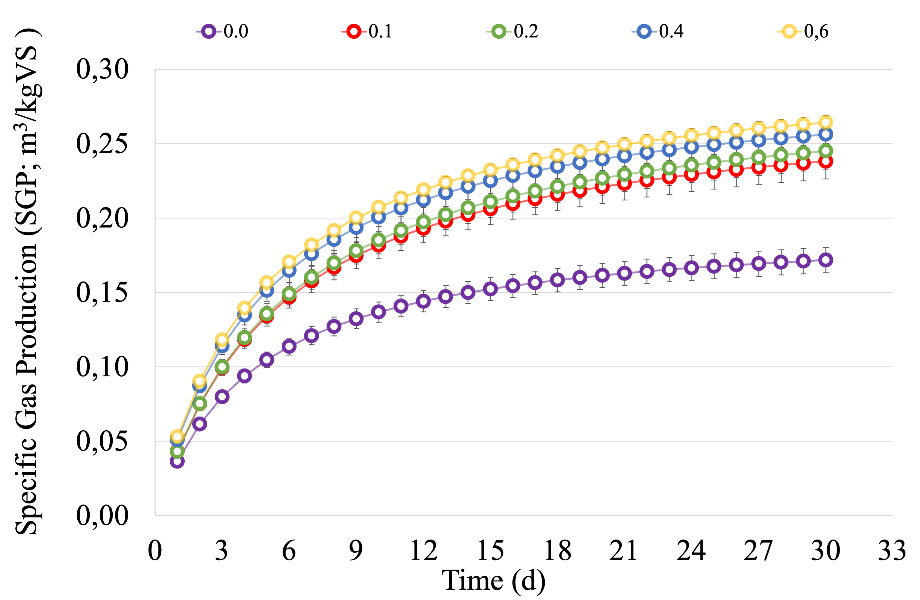
Figure 1: Specific Gas Production (SGP) of the batch tests at mesophilic temperature.
3.2 Short-chain fatty acids production
Given the increased biodegradability of the tannery sludge due to the H₂O₂ dosage, as demonstrated by the BMP tests, the following fermentation tests have been conducted including the oxidizing pretreatment in order to set the best condition for the SCFAs production. As shown in Figure 2A–B, all the tests showed similar behavior of a fast initial SCFAs production until a plateau in the concentration was reached, around 10-15 days for all tests (except for the TP tests). Regarding the maximum concentration of SCFAs achieved, the pretreated sludge (MP) showed the highest result between the mesophilic tests, reaching values of 16.4 g COD_{SCFA}/L, demonstrating how the partial oxidation of the organic matter coupled with the microwave treatment, can substantially boost the acidification performances. In addition, the maximum SCFA concentration depended on the initial TS level, being around 9.27 g COD_{SCFA}/L and 14.97 g COD_{SCFA}/L in the series M8 and M12, respectively. In practice, the applied pretreatment almost doubled the SCFA production (M8 vs. MP).
The thermophilic series T8 and T12 gave a lower peak of the SCFA concentration compared to the corresponding mesophilic series M8 and M12, with maximum SCFAs levels of 7.04 and 14.7 g COD_{SCFA}/L for the series T8 and T12, respectively. However, the TP series had a different behavior, since it was characterized by a continuous increase in the production of SCFAs for the whole duration of the experiment, with only a slight slowdown during the final days, reaching values up to 24.2 g COD_{SCFA}/L in 27 days. This can be caused by a synergetic effect of a higher operating temperature (55 °C) and the pre-oxidization of the sludge, as the solubilization of the organic matter is favored by both, triggering an almost continuous fermentation mechanism.
Apart from the TP test, where the highest SCFAs concentration was achieved under the combined treatment, the mesophilic conditions could offer a good compromise for the tannery sludge acidification process, obtaining slightly higher peaks than the thermophilic tests with a less energy-intensive process. However, the high concentration of SCFAs in the TP tests (24.2 g COD_{SCFA}/L) was a remarkable achievement, which has to be considered in its possible improvement, such as the increase of the initial kinetics, which in turn can led to such high SCFAs concentration in a shorter time. The maximal SCFA concentration obtained was higher than the values reported in the literature for municipal sludge (Zhang et al., 2019; Presti et al., 2021).

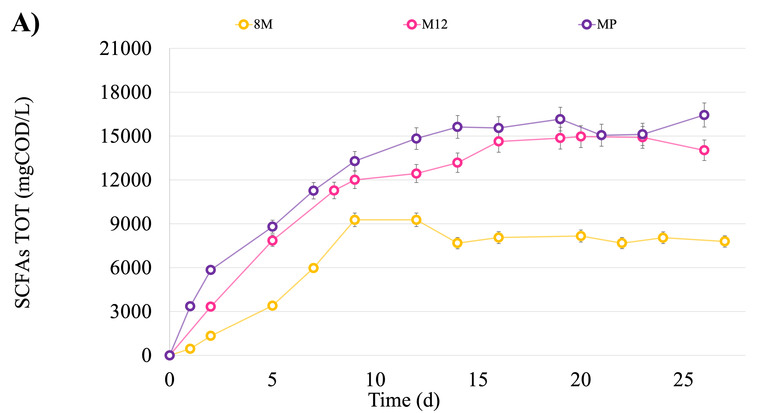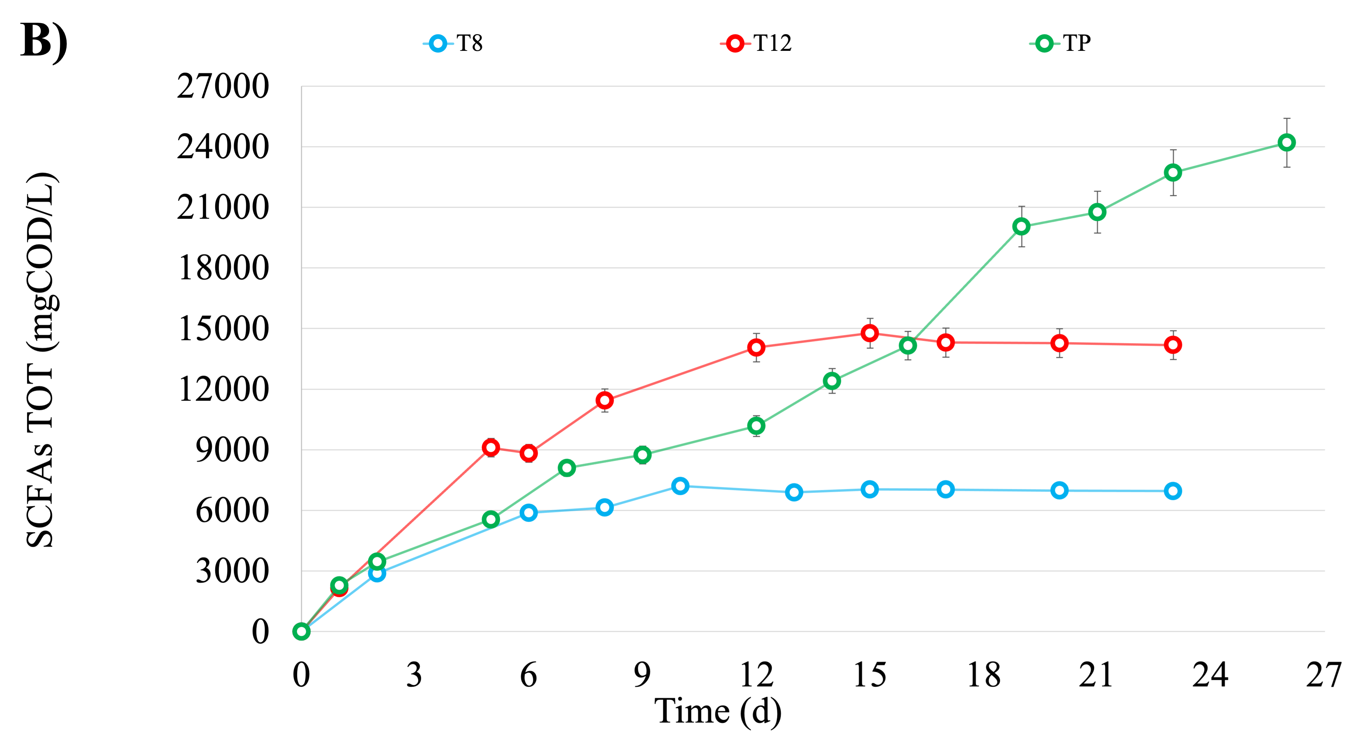
Figure 2: SCFAs concentration trends (mg COD/L) of the mesophilic (A) and thermophilic tests (B).
Another tested parameter was the SCFAs composition in the different tested conditions: acetic and butyric acids were dominant in all tests, collectively making up for more than half of the obtained SCFAs. All tests were quite comparable in terms of SCFAs distribution, except for the mesophilic pretreated tests (MP), in which the pretreatment caused a shift in the acid’s composition towards acetic acid, making up 52% of the total. Consequently, it appears that this pretreatment moved the metabolic fermentation pathways closer to the final fermentation products (e.g., acetic acids).
In addition, the higher temperature in the thermophilic series eliminated the MW-H₂O₂ impact on SCFAs distribution. In contrast to the corresponding mesophilic series, valeric acid disappeared completely. This was the only significant change brought about by the two applied temperature regimes. The observed distribution was quite similar to those found in the literature from batch sewage sludge test without a pH-control strategy, thermally, and non-thermally pretreated: (Zhang et al., 2019; Morgan-Sagastume et al., 2015).
In terms of potential Cr(VI) production, due to the oxidizing pretreatment adopted, Cr(VI) was not released during the whole duration of the experiments and remained below the limit of quantification (LOQ) of 0.03 mg/L (table 2), demonstrating that the recovery of SCFAs from this substrate is viable, without risks associated to the Cr(VI) release.
Table 2: Summary of the main results obtained in the anaerobic fermentation of tannery sludge.
Parameter | Unit | Test name
 |  | M8 | M12 | MP | T8 | T12 | TP
SCFAs | g COD/L | 9.3 ± 0.2 | 15.0 ± 0.3 | 16.4 ± 0.4 | 7.0 ± 0.2 | 14.7 ± 0.2 | 24.2 ± 0.1
SCFAs/COD_{SOL} | COD/COD | 0.72 ± 0.02 | 0.73 ± 0.02 | 0.75 ± 0.03 | 0.57 ± 0.02 | 0.63 ± 0.01 | 0.73 ± 0.02
Y_{F} | g COD_{SCFA}/g VS₀ | 0.16 ± 0.01 | 0.17 ± 0.01 | 0.29 ± 0.01 | 0.12 ± 0.01 | 0.17 ± 0.01 | 0.30 ± 0.01
COD_{SOL} | g COD/L | 13 ± 1 | 21 ± 1 | 23.4 ± 0.6 | 12.8 ± 0.3 | 23.5 ± 0.4 | 34.6 ± 0.2
N-NH₄⁺ | mg/L | 780 ± 10 | 1181 ± 30 | 1615 ± 20 | 789 ± 20 | 1225 ± 40 | 1586 ± 50
P-PO₄³⁻ | mg/L | 1.2 ± 0.3 | 2.0 ± 0.3 | 2.4 ± 0.3 | 2.4 ± 0.1 | 2.8 ± 0.1 | 2.8 ± 0.2
Chromium VI | mg/L | < 0.03 | < 0.03 | < 0.03 | < 0.03 | < 0.03 | < 0.03

4. Conclusions
The results obtained from the anaerobic treatment of tannery sludge showed that such substrate can effectively produce biogas and SCFAs. In particular, the oxidizing pretreatment improved the methanogenic activity by increasing the cumulative biogas production from 129.7 mL (no H₂O₂ dosage) to 204 mL (0.6 g H₂O₂/g TS). The maximum SGP (0.26 m³/kg VS) was obtained with the highest H₂O₂ dosage adopted. Once the biodegradability of this sludge was proved, as well as the increased biodegradability with the oxidizing pretreatment, the acidogenic fermentation trials were carried out under both mesophilic and thermophilic conditions.
The maximum SCFAs concentration were 16.4 g COD_{SCFA}/L (achieved in approximately two weeks) and 24.2 g COD_{SCFA}/L (achieved in approximately three weeks) in mesophilic and thermophilic conditions respectively, starting from a thermally oxidized (MW-H₂O₂) pre-treated sludge. The absence of the pretreatment was associated with lower performances, and the various initial VS levels had no significant effect. Overall, these results proved that tannery sludge can be employed to produce biogas or SCFAs with promising results; hence, anaerobic digestion as well as acidogenic fermentation can be both applied as already established and more innovative bio-technologies for its valorization. More efforts need to be dedicated on this research to create a robust knowledge, which in turn can be useful to strongly limit the landfilling, which still represents the only and not-sustainable disposal practice at this moment.

Acknowledgments
This work was supported by PON “Ricerca e Innovazione”, founded by the European Union NextGenerationEU. The authors wish to thank Medio Chiampo S.p.a. for providing the raw material for this research. Alto Trevigiano Servizi S.r.l. is also gratefully acknowledged for the hospitality.

References
Achouri O., Panico A., Bencheikh-Lehocine M., Derbal K., Arias D., Iasimone F., Padulano R., Bouteraa M., Rebahi A., Pirozzi, F., 2021, Role of H2O2 dosage on methane production from tannery wastewater: experimental and kinetic study, Journal of Water Process Engineering, 43, 102313.
Agustini C., da Costa M., Gutterres M., 2018, Biogas production from tannery solid wastes–Scale-up and cost saving analysis, Journal of Cleaner Production, 187, 158-164.
Ambrose H. W., Chin C. T. L., Hong E., Philip L., Suraishkumar G. K., Sen T. K., Khiadani M., 2020, Effect of hybrid (microwave-H2O2) feed sludge pretreatment on single and two-stage anaerobic digestion efficiency of real mixed sewage sludge, Process Safety and Environmental Protection, 136, 194-202.
Apha Awwa, W. E. F., 2005, “Standard Methods for the Examination of Water and Wastewater”, American Public Health Association, American Water Works Association, and Water Environment Federation.
Basegio T., Berutti F., Bernardes A., Bergmann C. P., 2002, Environmental and technical aspects of the utilisation of tannery sludge as a raw material for clay products, Journal of the European ceramic Society, 22(13), 2251-2259.
Liu J., Jia R., Wang Y., Wei Y., Zhang J., Wang R., Cai X., 2017, Does residual H 2 O 2 result in inhibitory effect on enhanced anaerobic digestion of sludge pretreated by microwave-H 2 O 2 pretreatment process? Environmental Science and Pollution Research, 24, 9016-9025.
Liu J., Yang M., Zhang J., Zheng J., Xu H., Wang Y., Wei Y., 2018, A comprehensive insight into the effects of microwave-H2O2 pretreatment on concentrated sewage sludge anaerobic digestion based on semi-continuous operation, Bioresource technology, 256, 118-127.
Morgan-Sagastume F., Hjort M., Cirne D., Gérardin F., Lacroix S., Gaval G., Karabegovic L.,
Alexandersson T., Johansson P., Karlsson A., Bengtsson S., Arcos-Hernández M.V., Magnusson P., Werker, A., 2015. Integrated production of polyhydroxyalkanoates (PHAs) with municipal wastewater and sludge treatment at pilot scale, Bioresource technology, 181, 78-89.
Mpofu A. B., Kibangou V. A., Kaira W. M., Oyekola O. O., Welz P. J., 2021, Anaerobic Co-digestion of tannery and slaughterhouse wastewater for solids reduction and resource recovery: Effect of sulfate concentration and inoculum to substrate ratio, Energies, 14(9), 2491.
Presti D., Cosenza A., Capri F.C., Gallo G., Alduina R., Mannina G., 2021, Influence of volatile solids and pH for the production of volatile fatty acids: Batch fermentation tests using sewage sludge, Bioresource Technology 342, 125853.
Ronchi Decree. 1997. Available online: www.parlamento.it/parlam/leggi/deleghe/97022dl.htm (accessed on 24 January 2023).
Simioni T., Agustini C. B., Dettmer A., Gutterres M., 2022, Anaerobic co-digestion of tannery wastes and untreated/pretreated oat straw, BioEnergy Research, 15(1), 589-601.
Tyagi V. K., Lo S. L., 2011, Application of physico-chemical pretreatment methods to enhance the sludge disintegration and subsequent anaerobic digestion: an up to date review, Reviews in Environmental Science and Bio/Technology, 10, 215-242.
Valentino F., Parmar A. C., Micolucci F., Dosta J., Pavan P., Gottardo M., 2022, Valuable Routes for Sewage Sludge Utilization: Effect of Temperature and Hydraulic Retention Time in the Acidogenic Fermentation Process, Chemical Engineering Transactions, 93, 193-198.
Zhang D., Jiang H., Chang J., Sun J., Tu W., Wang H., 2019, Effect of thermal hydrolysis pretreatment on volatile fatty acids production in sludge acidification and subsequent polyhydroxyalkanoates production, Bioresource technology, 279, 92-100.

